Global Trends in Crime Prevention Research: A Bibliometric Analysis of Authorship and Regional Representation

.
ABSTRACT

Aims: This study aimed to analyze global authorship patterns, institutional affiliations, funding support, and international collaborations in the field of crime prevention research from 2005 to 2024. The objective was to identify the most prolific contributors, examine regional disparities, and visualize global scholarly networks.
Study design: A descriptive bibliometric study.
Place and Duration of Study: School of Criminal Justice Education, J.H. Cerilles State College (JHCSC) and Northwestern Mindanao State College of Science and Technology (NMSCST), between January and April 2025.
Methodology: A total of 3,563 records were retrieved from the Scopus database using the keywords “Crime Prevention” OR “Crime Prevention Strategies*.” After applying inclusion criteria—limiting by subject area, document type, language, and manual relevance screening—a final dataset of 656 publications from 2005 to 2024 was analyzed. VOSviewer (v1.6.20) was used to generate co-authorship maps, overlay visualizations, and density plots. Citation counts, country-level contributions, collaboration clusters, and top funding agencies were also examined.
Results: Journal articles comprised the majority (68.81%) of documents. The annual publication output increased steadily, peaking in 2024 with 76 publications. The United States and the United Kingdom were the most prolific countries, with strong international linkages. A total of 26 countries formed 7 collaboration clusters with 52 total links. Emerging contributors such as India, Nigeria, and Colombia were identified through overlay mapping. Top funding sponsors included NIH (USA), the European Commission, and the Australian Research Council. However, significant disparities in research participation and funding were observed between high-income and low-to-middle-income countries.
Conclusion: The global landscape of crime prevention research is expanding but remains uneven. Strategic investments in inclusive collaboration and research capacity-building are essential to democratize knowledge production and ensure contextually responsive crime prevention strategies worldwide.

Keywords: Crime Prevention, Bibliometric Analysis, Authorship Patterns, International Collaboration

1. INTRODUCTION

Crime prevention has evolved into a vibrant and interdisciplinary field, integrating both theoretical and practical perspectives from criminology, sociology, psychology, urban planning, and public health. This evolution underscores the intricate interplay of individual, social, and environmental factors that contribute to criminal behavior (Amante et al., 2021; Battams et al., 2021; Songole, 2021). At its core, the objective of crime prevention is to proactively mitigate risks and eliminate opportunities for crime before it occurs, ultimately fostering safer, more resilient communities (Wood et al., 2022).
Crime prevention strategies are generally organized into three levels: primary, secondary, and tertiary. Primary prevention tackles the root causes of crime—such as poverty, inequality, and limited access to education—before any criminal behavior appears (Porat et al., 2024). Secondary prevention targets individuals or communities at greater risk of offending, utilizing early intervention strategies to address potential issues before they escalate. Tertiary prevention is focused on reducing recidivism by supporting rehabilitation, reintegration, and restorative justice programs (Piza & Welsh, 2022; Hosford et al., 2021), promoting a more holistic and comprehensive approach to crime reduction.
Technological advances have greatly changed crime prevention by helping us better understand when and where crimes happen (Freilich et al., 2019; Woodward et al., 2016). Tools like crime mapping, spatial analysis, and predictive policing use technology such as geographic information systems, machine learning, and statistical models to find crime hotspots and predict where crimes might occur next (Ho & Luong, 2022). While these new methods help police use their resources more effectively, they also raise important questions about privacy, data bias, and the risk of these tools being misused for illegal activities (Akah, 2024).

As the field grows, bibliometric analysis provides a helpful way to explore how it has developed over time. By using quantitative methods, researchers can assess the amount of published work, recognize key publications, and trace patterns of collaboration and citation (Ganti et al., 2025; Roman, 2022; Weisburd et al., 2014). This study focuses on analyzing authorship in crime prevention research. It looks at which scholars are the most productive and influential, what institutions they are linked to, and which countries are making major contributions. By doing this, the study aims to show global research trends, spotlight leading contributors, and guide the future direction of crime prevention research (Cesario, 2023).

2. material and methods

This study employed a bibliometric analysis to explore authorship patterns, institutional affiliations, and country-level contributions to global research on crime prevention. The data were extracted from the Scopus database on April 2, 2025, which is recognized for its extensive coverage of peer-reviewed scientific literature across diverse disciplines. The initial search query applied was: TOPIC: ("Crime Prevention") OR TOPIC: ("Crime Prevention Strategies*"), resulting in 3,563 documents. No restrictions were placed on access type, allowing the inclusion of both open access and subscription-based articles to ensure a comprehensive dataset.
To maintain focus on the thematic relevance of crime prevention, a series of refinement steps were conducted. First, the timeframe was limited to 2005–2025, encompassing 21 years of research output. Then, the subject area was filtered to include only those most pertinent to crime prevention: Social Sciences (1,546 documents), Medicine (1,035), Psychology (647), Computer Science (538), Engineering (401), Arts and Humanities (188), and Business, Management and Accounting (170). Disciplines with limited relevance—such as Mathematics, Nursing, Agricultural and Biological Sciences, and Pharmacology—were excluded. After subject area refinement, 3,185 documents remained. The selection was further narrowed by limiting the document types to include only journal articles (2,133), conference papers (413), book chapters (280), reviews (212), and books (101). Editorials, meeting abstracts, and proceedings papers were excluded to retain only peer-reviewed and scholarly publications, reducing the dataset to 3,139 articles.
Language and content relevance were then assessed. Publications in five languages other than English, totaling 12 documents, were excluded to ensure consistency in text mining and analysis. Subsequently, a manual screening of titles and abstracts was performed on the 2,920 remaining documents to evaluate their relevance to the crime prevention theme. This process led to the exclusion of 2,266 irrelevant or marginally related articles, resulting in a final corpus of 656 articles for bibliometric analysis. This rigorous screening ensured the dataset reflected high relevance and thematic alignment with crime prevention research.
The final dataset was analyzed using VOSviewer (version 1.6.20), a specialized software tool for creating and visualizing bibliometric networks. The analysis focused on co-authorship patterns, citation networks, and institutional and geographical contributions. The authorship analysis identified the most prolific scholars and mapped collaborative structures within the field. Additionally, country-level analysis highlighted regional trends and dominant contributors in global crime prevention research. The use of VOSviewer enabled the generation of visual maps to depict author clusters, institutional linkages, and international collaboration patterns. These bibliometric insights provide a foundational understanding of the intellectual landscape, knowledge production, and research dynamics in the evolving field of crime prevention.

3. results and discussion

3.1. Evolution of Crime Prevention Publications (2005–2024)

Table 1 presents the annual number of publications and corresponding growth rates in crime prevention research indexed in Scopus between 2005 and 2024, with a total of 654 publications over the 20-year period. The results demonstrate a clear upward trajectory in scholarly output, highlighting the growing academic attention and intellectual investment in crime prevention as a multidisciplinary field. In the initial period (2005–2010), the number of publications remained relatively low and unstable, ranging from 11 to 14 articles per year, with fluctuations in growth such as a decline in 2009 (–21.43%) and moderate increases in 2007 (18.18%) and 2010 (9.09%). A significant spike occurred in 2011, where publication output surged by 83.33%, suggesting a potential turning point in scholarly interest, likely influenced by emerging global discussions around crime control, urban safety, and preventive policing strategies.
The mid-phase (2012–2017) reflects increasing momentum, with notable growth in 2016 (32.00%) and 2017 (27.27%), indicating a shift toward more sustained academic productivity. During this time, crime prevention research increasingly intersected with technological applications, public health, and social policy, potentially driving publication output. The most substantial growth is observed during the last seven years (2018–2024), culminating in a peak of 76 publications in 2024, the highest annual output recorded. While 2020 showed a minor contraction (–6.25%), the field rebounded strongly in subsequent years, notably in 2023 (26.00%) and 2024 (20.63%). This consistent rise in recent years aligns with global challenges such as cybercrime, community violence, and the integration of data analytics in crime prevention strategies, further amplifying scholarly engagement.
Table 1. Number of Publications and Annual Growth Rate between 2005–2024

Year | Number of Publications | Annual Growth Rate (%)
2024 | 76 | 20.63
2023 | 63 | 26.00
2022 | 50 | 06.38
2021 | 47 | 04.44
2020 | 45 | -06.25
2019 | 48 | 14.29
2018 | 42 | 00.00
2017 | 42 | 27.27
2016 | 33 | 32.00
2015 | 25 | 13.64
2014 | 22 | -15.38
2013 | 26 | 4.00
2012 | 25 | 13.64
2011 | 22 | 83.33
2010 | 12 | 09.09
2009 | 11 | -21.43
2008 | 14 | 07.69
2007 | 13 | 18.18
2006 | 11 | -15.38
2005 | 13 | –
Total | 654

Overall, the steady increase in publications reflects the field’s evolution into a complex and high-priority research domain, encompassing not only criminology but also public health, technology, psychology, and urban planning. The trend underscores the expanding role of crime prevention in shaping evidence-based policy and interdisciplinary research initiatives worldwide.

3.2. Publications by document type and Their Contributions to Total Publications
Table 2 presents the distribution of crime prevention research publications by document type, providing insight into the preferred modes of scholarly dissemination within the field. Among the 654 documents analyzed, journal articles accounted for the largest share, totaling 450 publications or 68.81% of the dataset. This dominance reflects the central role of peer-reviewed journals as the primary platform for academic discourse, theory development, and empirical findings in crime prevention research.
The second most common document type was book chapters with 78 publications (11.93%), followed by books with 49 entries (7.49%). These formats suggest the relevance of in-depth, often interdisciplinary, discussions and edited volumes in the field, especially for synthesizing concepts across criminology, sociology, and policy studies. Review articles, though fewer in number (44 publications or 6.73%), provide critical overviews and integrative perspectives on emerging themes, theories, and practices in crime prevention.
Conference papers represented the smallest portion of the dataset, with 33 publications (5.05%). While less prevalent, they indicate the presence of ongoing scholarly dialogue in academic and professional forums and often serve as precursors to more comprehensive journal publications. Overall, the distribution of document types demonstrates a strong emphasis on peer-reviewed research outputs while also reflecting the value of scholarly books and reviews in consolidating crime prevention knowledge.

Table 2. Publications by document type and Their Contributions to Total Publications

Document Type | Number of Publications | Percentage of Total Publications (%)
Article | 450 | 68.81
Book chapter | 78 | 11.93
Book | 49 | 7.49
Review | 44 | 6.73
Conference paper | 33 | 5.05
Total | 654 | -

3.3. Top Funding Sponsors to Crime Prevention Studies

Figure 1 highlights the leading organizations that fund research in crime prevention. Most funded studies come from high-income countries, particularly those with well-established public safety and criminal justice research systems. Notably, the National Institutes of Health (NIH) and the U.S. Department of Justice are among the top sponsors, together accounting for about 19% of the funded publications in the dataset. This reflects the United States’ strong commitment to community safety, violence reduction, and innovation in law enforcement.
In Europe, the European Commission and UK Research and Innovation (UKRI), including the Economic and Social Research Council (ESRC), fund about 14% of crime prevention research. Their support shows they care about policies based on evidence, helping young people in the justice system, and making cities safer. In Australia, organizations like the Australian Research Council (ARC) provided funding for 6% of the studies. This shows Australia is focused on reducing prison rates by preventing crime before it happens and stopping repeat offenses.
Other important contributors include the Social Sciences and Humanities Research Council of Canada (SSHRC) and several national public health agencies, especially those in Scandinavian countries. These organizations focus on restorative justice, public safety, and rehabilitation. Overall, about 40% of the funded publications come from just ten major sponsors. This shows that a small group of agencies provides most of the support for research in this field, but their impact is significant.
These findings show that research funding for crime prevention is global, but not distributed equally. Wealthier countries provide most of the funding and have a stronger influence on crime prevention research. This highlights the need to expand funding in the Global South, so countries there can develop crime prevention strategies that fit their cultures and help build a more inclusive worldwide understanding.

Figure 1. Top Funding Sponsors to Crime Prevention Studies

3.4. Network Visualization of Countries publishing Crime Prevention Studies

Figure 2 presents a network visualization map of country-level collaborations in crime prevention research, as generated using VOSviewer. The map includes 26 countries, grouped into 7 distinct clusters, connected through 52 collaborative links with a total link strength of 118. These linkages represent co-authorships and co-publications, indicating the extent of research cooperation among countries contributing to the field.

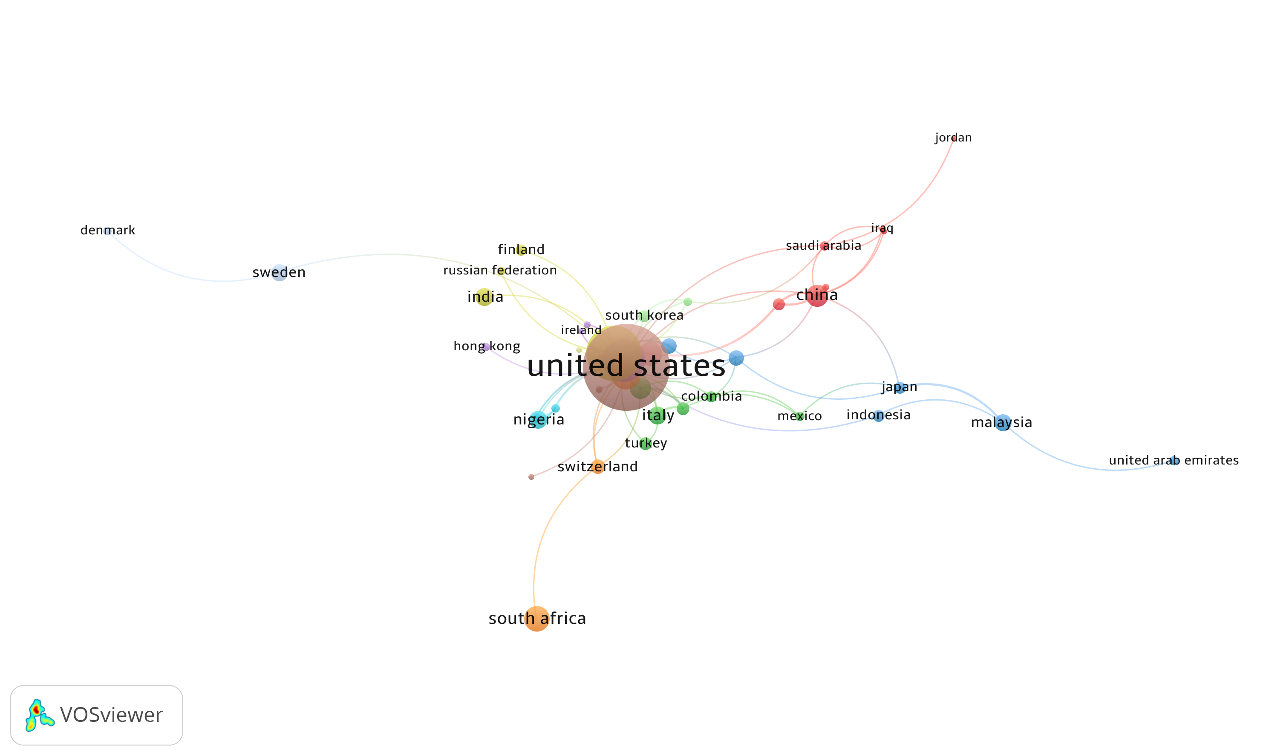

Figure 2. Network Visualization of Countries publishing Crime Prevention Studies

The United States and the United Kingdom are the main centers in the network, with the biggest roles and the most connections. These two countries serve as key hubs for international collaboration, with strong ties to countries like Canada, Australia, Israel, South Korea, Sweden, India, and many other European and Asian nations. Their leading positions are due to their strong academic systems, steady funding for criminal justice research, and leadership in evidence-based policy development. Australia, Canada, and the Netherlands also play important roles in the network, connecting with both Western and non-Western countries. South Africa, Italy, Spain, China, and Japan are in smaller, but still important, collaborative groups, showing that they are becoming more involved in worldwide crime prevention research. Some Global South countries, like Nigeria, Colombia, and Malaysia, are part of the network, but with fewer and weaker connections, which means they are just starting to join in and are not yet fully integrated.
The network has seven groups or clusters that likely reflect shared research interests, similar funding, or institutional partnerships. While English-speaking countries remain at the center, international collaboration is growing. Still, there are differences in how much countries participate and influence publications. Building stronger partnerships between countries in the Global South and Global North is important to make sure crime prevention strategies consider diverse, local perspectives from around the world.
3.5. Temporal Evolution of Country Collaborations in Crime Prevention Research

Figure 3 displays an overlay visualization of international collaborations in crime prevention research from 2017 to 2022, highlighting both the frequency of contributions and the average year of publication activity per country. In this visualization, darker blue nodes indicate earlier activity (around 2017–2018), while yellow nodes represent more recent engagement (2021–2022). This temporal mapping allows for a nuanced understanding of the evolving participation of countries in the global research landscape on crime prevention. The United States and United Kingdom remain dominant both in terms of publication volume and collaborative centrality, with the largest and darkest blue nodes, signifying sustained contributions over time. These countries form the core of the global research network and continue to lead in early and foundational work in the field. Their central positions and strong linkages with other countries suggest deep-rooted collaborative structures.
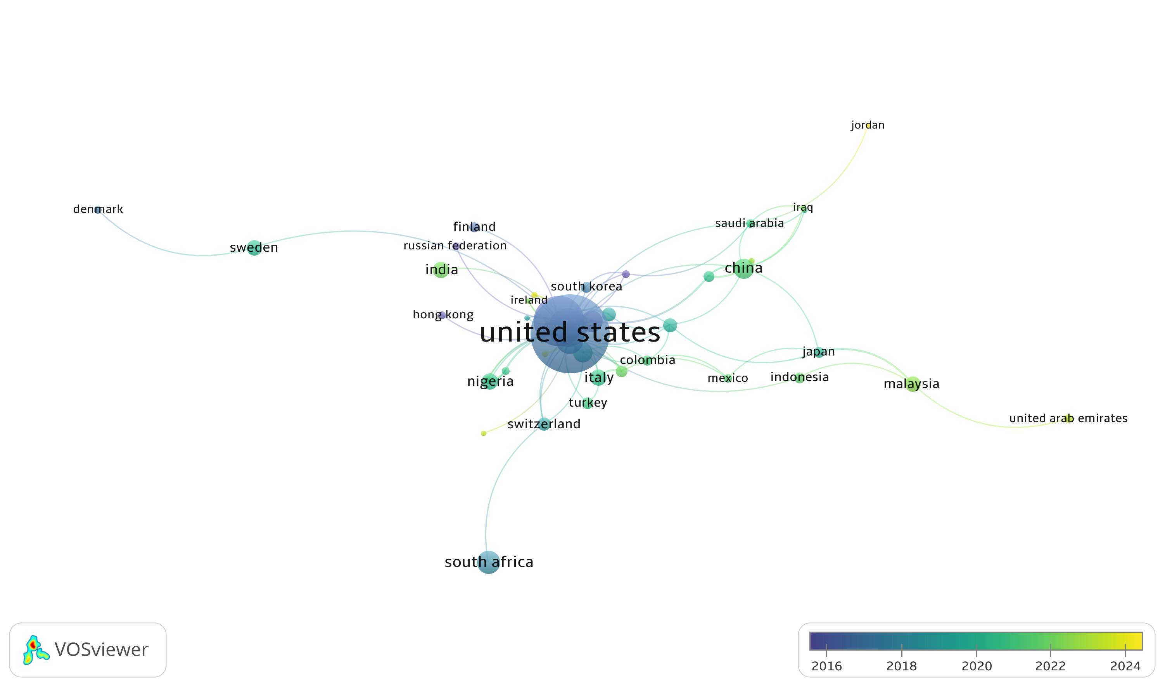
Figure 3. Country Collaborations in Crime Prevention Research

Notably, countries like India, Spain, Sweden, and Nigeria show up in brighter yellow on the map, which means they’ve become more active in recent years, especially around 2021–2022. This suggests that these countries are starting to contribute more to crime prevention research, possibly because of new challenges like cybercrime, urban violence, and post-pandemic public safety issues. Their increased activity may also be due to more research funding and stronger international partnerships. In contrast, China, Malaysia, Japan, and South Africa have moderate roles, with most of their research dating from 2018 to 2020, showing steady but less intense involvement. Regions like Colombia and Israel have links with both Global North and South, reflecting broad international cooperation even though their research output is smaller.
This analysis shows that crime prevention research is becoming more inclusive, with more countries getting involved—even though the leading countries still set the pace. The growing participation from emerging economies is a good sign for more geographically diverse research. To strengthen this trend, it’s important to support fair collaboration and help build research capacity, especially in the Global South. This will lead to more well-rounded and locally relevant crime prevention strategies.
3.6. Density Visualization of Country Contributions to Crime Prevention Research

Figure 4 displays a density visualization of countries publishing in the field of crime prevention, illustrating the volume and concentration of research output across nations. In this map, areas with higher publication density are indicated by brighter yellow regions, while countries with fewer publications appear in darker green to blue tones. The visualization offers a spatial understanding of the global research landscape, with node size and color intensity reflecting the magnitude of contribution. The United States clearly dominates the field, as shown by the brightest and most centralized yellow region. This confirms its position as the most prolific contributor to crime prevention literature, likely driven by sustained federal funding (e.g., National Institute of Justice, NIH), a large academic base, and strong institutional infrastructure. The United Kingdom also appears as a major contributor, represented by a significant yellow-green density cluster, reflecting its leadership in community safety programs, policing reform research, and criminological theory.
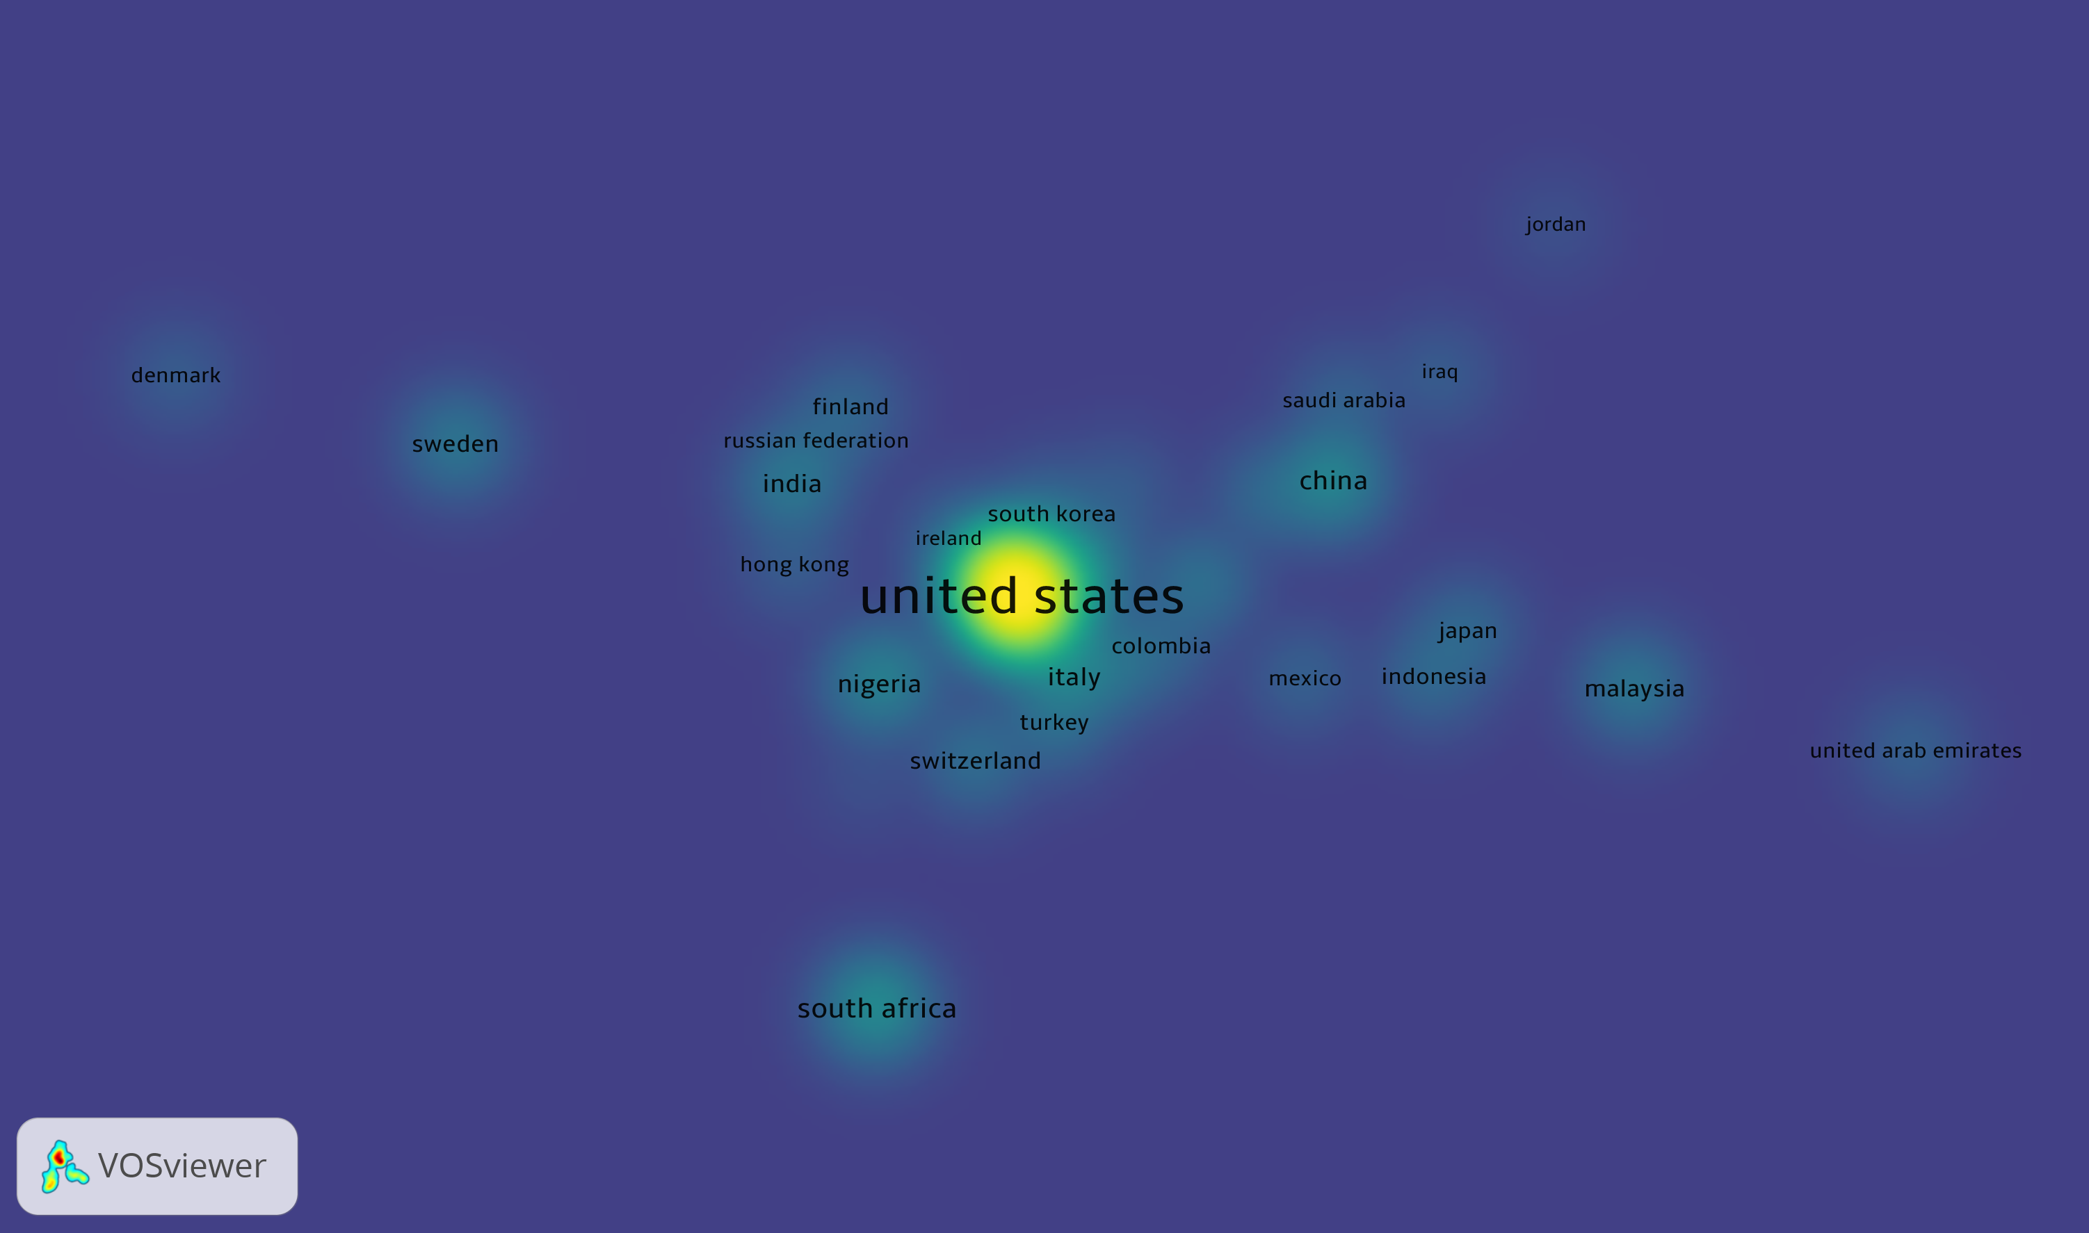
Figure 4. Density Visualization of Country Contributions to Crime Prevention
Other high-density contributors include Australia, Canada, and the Netherlands, each with moderately bright clusters, suggesting consistent and impactful publication activity. These countries are known for their integration of evidence-based policing, public health approaches to crime, and progressive criminal justice policies. Notably, South Africa, China, Japan, Malaysia, and South Korea also appear as active nodes, though with lower density, indicating growing but comparatively limited contributions. Emerging research activity is observed from countries such as India, Nigeria, Colombia, and Finland, visible in light green zones. While their output is less concentrated, their presence in the visualization reflects increasing scholarly engagement in global crime prevention discourse. However, large portions of the Global South and underrepresented regions remain absent or faint, emphasizing ongoing disparities in research capacity and visibility.

This density map underscores the global imbalance in research production and the concentration of scholarly output in high-income, English-speaking countries. It highlights the importance of fostering inclusive international research collaboration, capacity-building initiatives, and equitable funding mechanisms to strengthen the contributions of underrepresented regions in shaping future crime prevention scholarship.

4. Conclusion

This bibliometric analysis provides a comprehensive overview of the intellectual landscape of crime prevention research from 2005 to 2024. The steady increase in publication output—culminating in 76 publications in 2024—attests to the field’s maturation and the growing recognition of crime prevention as a multidisciplinary imperative. Peer-reviewed journal articles comprise the majority of scholarly output, reflecting an emphasis on empirical inquiry and theory-building. The thematic scope has expanded to integrate public health, urban planning, digital forensics, and behavioral sciences, mirroring the complexity of contemporary crime phenomena. Moreover, the analysis confirms that funding and scholarly productivity are highly concentrated in a few high-income countries, particularly the United States and the United Kingdom, which not only lead in output but also act as principal nodes in global collaboration networks.
The visualization of country-level collaboration and density further underscores the asymmetry in global scholarly engagement. While countries like Australia, Canada, the Netherlands, and South Africa have established strong publishing and collaborative profiles, emerging economies—such as India, Nigeria, and Colombia—are only beginning to gain visibility. The presence of seven distinct clusters, as well as temporal and spatial shifts in participation, suggests that crime prevention research is not only expanding but also diversifying. Nevertheless, systemic inequalities persist in terms of research funding access, international partnerships, and capacity-building mechanisms, which disproportionately affect scholars and institutions in the Global South. These disparities limit the development of culturally nuanced and locally responsive crime prevention strategies, thereby reinforcing a Western-centric knowledge paradigm.
To foster a more inclusive and equitable research ecosystem, several policy and scholarly interventions are recommended. First, international funding bodies and development agencies should invest in South–South and South–North research collaborations that elevate underrepresented voices and local expertise. Second, regional academic networks must be strengthened to facilitate knowledge exchange, training, and methodological innovation tailored to local contexts. Finally, journals and research institutions should actively promote diversity in authorship, review panels, and editorial boards to ensure that crime prevention research reflects the global plurality of experiences and challenges. By democratizing access to knowledge production and fostering intellectual pluralism, the field of crime prevention can more effectively respond to the shifting contours of global security, justice, and social cohesion.

Disclaimer (Artificial intelligence):
Authors hereby declare that generative AI technologies such as Large Language Models, etc. have been used during the writing or editing of manuscripts. This explanation will include the name, version, model, and source of the generative AI technology and as well as all input prompts provided to the generative AI technology
Details of the AI usage are given below:
1. ChatGPT
2. ChatPDF
3. Jenni Ai

References
Akah, J. (2024). The impact of technology on crime detection and prevention. SSRN Electronic Journal. https://doi.org/10.2139/ssrn.4734637
Amante, A., Saraiva, M., & Marques, T. S. (2021). Community crime prevention in Portugal: An introduction to Local Safety Contracts. Crime Prevention and Community Safety, 23(2), 155–173. https://doi.org/10.1057/s41300-021-00112-2
Battams, S., Delany‐Crowe, T., Fisher, M., Wright, L. N., McGreevy, M., McDermott, D., & Baum, F. (2021). Reducing incarceration rates in Australia through primary, secondary, and tertiary crime prevention. Criminal Justice Policy Review, 32(6), 618–635. https://doi.org/10.1177/0887403420979178
Brantingham, P., & Brantingham, P. L. (2021). Crime pattern theory. In Oxford Research Encyclopedia of Criminology and Criminal Justice. https://doi.org/10.1093/acrefore/9780190264079.013.8
Cesario, E. (2023). Big data analytics and smart cities: Applications, challenges, and opportunities. Frontiers in Big Data, 6, Article 1149402. https://doi.org/10.3389/fdata.2023.1149402
Ganti, L., Persaud, N. A., & Stead, T. S. (2025). Bibliometric analysis methods for the medical literature. Deleted Journal. https://doi.org/10.62186/001c.129134
Ho, H. T. N., & Luong, H. T. (2022). Research trends in cybercrime victimization during 2010–2020: A bibliometric analysis. SN Social Sciences, 2(1), Article 305. https://doi.org/10.1007/s43545-021-00305-4
Piza, E. L., & Welsh, B. C. (2022). Evidence-based policing is here to stay: Innovative research, meaningful practice, and global reach. Cambridge Journal of Evidence-Based Policing, 6, 42–50. https://doi.org/10.1007/s41887-022-00074-x
Porat, R., Gantman, A. P., Green, S. A., Pezzuto, J.-H., & Paluck, E. L. (2024). Preventing sexual violence: A behavioral problem without a behaviorally informed solution. Psychological Science in the Public Interest, 25(1), 4–38. https://doi.org/10.1177/15291006231221978
Roman, M. (2022). Sustainable transport: A state-of-the-art literature review. Energies, 15(23), Article 8997. https://doi.org/10.3390/en15238997
Songole, H. S. (2021). The role of geographical juxtaposition in Kabalagala. Urban Planning and Transport Research, 9(1), 132–149. https://doi.org/10.1080/21650020.2021.1873175
Wood, M. A., Ross, S., & Johns, D. (2022). Primary crime prevention apps: A typology and scoping review. Trauma, Violence, & Abuse, 23(4), 1093-1110.
Freilich, J. D., Gruenewald, J., & Mandala, M. (2019). Situational crime prevention and terrorism: An assessment of 10 years of research. Criminal justice policy review, 30(9), 1283-1311.
Hosford, K., Aqil, N., Windle, J., Gundur, R. V., & Allum, F. (2021). Who researches organised crime? A review of organised crime authorship trends (2004–2019). Trends in organized crime, 1-23.
Woodward, V. H., Pelletier, D., Griffin III, O. H., & Harrington, J. R. (2016). University policies and programs for crime prevention and awareness: An examination of online reports and resources. Criminal justice review, 41(2), 140-158.
Weisburd, D., Groff, E. R., & Yang, S. M. (2014). The importance of both opportunity and social disorganization theory in a future research agenda to advance criminological theory and crime prevention at places. Journal of research in crime and delinquency, 51(4), 499-508.

