**From Unfamiliarity to Awareness: A Phenomenological Study of Inexperienced Tutors Engaging with Learners with Learning Disabilities**

**Abstract**

Inexperienced tutors often struggle to support learners with learning disabilities due to a lack of formal training and preparation. Despite inclusive education policies, many tutors experience uncertainty, emotional stress, and limited strategies in addressing the needs of diverse learners. This qualitative study aimed to explore the lived experiences of six inexperienced tutors engaging with learners diagnosed with learning disabilities. Using a phenomenological research design, data were gathered through semi-structured interviews, and the data were analysed thematically using a qualitative approach. The findings revealed five major themes: Entering the Unknown, Reflecting through Struggles, Redefining Teaching and Learning, Taking Action and Adapting, and Awareness. These themes captured the tutors’ emotional journeys, adjustments in teaching approaches, and shifts in perspective as they gained experience. The study offers insight into how tutors moved from unfamiliarity to awareness, highlighting the value of empathy, adaptability, and reflective practice in inclusive education. The results underscore the need for targeted training and professional development to better prepare tutors supporting learners with disabilities. This study contributes to Sustainable Development Goal 4 (Quality Education) and Goal 10 (Reduced Inequalities) by promoting inclusion and equal learning opportunities.

*Keywords: inexperienced tutors, learning disabilities; inclusive education, reflective practice, phenomenological study, SDG 4, SDG 10*

**INTRODUCTION**

As we began our journey as a tutor, we quickly realized that teaching learners with learning disabilities presents composite challenges. Ndlovu (2019) said that many beginner teachers don’t get the preparation they need, which makes it tough to create a classroom where every student feels included. This experience mirrors Kolb’s Experiential Learning Theory, which highlights how individuals learn best through concrete experiences followed by reflection, conceptualization, and experimentation (Yilmaz & Karaoglan Yilmaz, 2020). Without prior training, our initial teaching encounters became raw learning episodes that shaped our growth in inclusive education. According to Bandura’s Social Cognitive Theory, teachers’ self-efficacy significantly influences their motivation and ability to manage diverse classrooms (Tschannen-Moran & Johnson, 2021), and the lack of preparation often leads to hesitation and low confidence among novice tutors.

Globally, the challenges faced by inexperienced tutors are widespread. In the United States, the special education workforce has decreased by nearly 17% over the past decade, leaving new tutors overwhelmed (Billingsley, Griffin, Smith, Kamman, & Israel, 2008). In Australia, 10–16% of students in mainstream classrooms require more support than typically provided (Louden et al., 2000). In Tanzania, a lack of special needs training and limited resources hinder tutors’ effectiveness (Mboya, 2011). These cases highlight a global gap in tutor preparedness.

In the Philippines, Lopez and Dela Cruz (2024) found that non-SPED teachers often feel ill-equipped to support learners with autism in inclusive classrooms. Pedroso, Alcalde, and Sudario (2022) reported that non-SPED teachers struggled to adapt instructional strategies and maintain engagement with students with special needs during the pandemic. KKG Publications (2019) also found that pre-service teachers experience uncertainty and a lack of confidence in managing students with learning disabilities.

This study investigated the lived experiences of inexperienced tutors as they engaged with learners with learning disabilities. It focused on how these tutors navigated their teaching experiences, built relationships, and experienced personal and professional growth throughout the process.

The study was anchored on the assumption that each inexperienced tutor had a unique and meaningful experience in teaching learners with learning disabilities. Their realities were shaped by their daily interactions with the learners, making each story important in understanding the challenges and growth they went through. We, the researchers, assumed that the participants were honest and willing to share their experiences, which helped make the study successful. Lastly, we believed that the study was timely and relevant, and could serve as a helpful source of knowledge in answering the research questions.

This study is anchored in Kolb’s Experiential Learning Theory (1984), which conceptualizes learning as a continuous cycle involving four stages: concrete experience, reflective observation, abstract conceptualization, and active experimentation. This framework resonates strongly with the developmental journey experienced by many inexperienced tutors, particularly those engaging with learners who have learning disabilities.

Teaching in inclusive settings is rarely linear; it often demands that tutors confront real, unpredictable classroom challenges (concrete experience), analyze and reflect on what approaches were effective or ineffective (reflective observation), generate new strategies or teaching insights (abstract conceptualization), and apply those revised methods in future teaching scenarios (active experimentation). Through this cyclical process, tutors grow not only in skill but also in confidence and adaptability.

Kolb’s theory is more than just an academic framework in the context of this study—it offers a lens through which the lived experiences of tutors can be meaningfully understood. Many participants in this study may enter their roles with little formal training in special education. Nevertheless, they demonstrate resilience, creativity, and a strong capacity to learn through action, reflection, and continuous adjustment. Their development is deeply rooted in direct interactions with their learners and the evolving insights they acquire in the process. Thus, Kolb’s model provides a compelling structure to examine how tutors transform their teaching practice through experience and reflection.

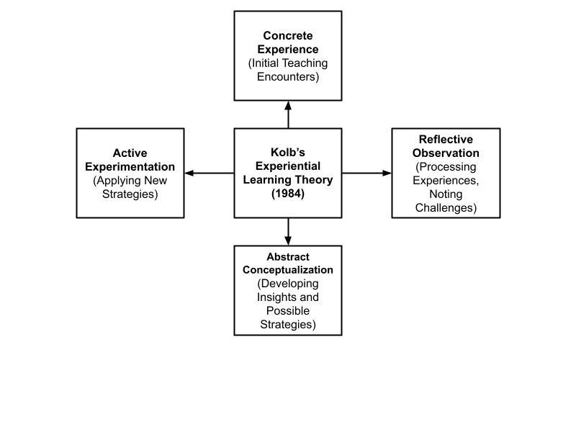

*Figure 1: Paradigm of the study*

**METHODOLOGY**

This chapter presents the research design, research participants, the role of the researcher, data sources, data collection procedures, data analysis, trustworthiness of the study, and ethical considerations.

This study employed a qualitative research design to explore the lived experiences of tutors handling learners with learning disabilities. A phenomenological design was used, guided by Fink’s (2000) seven roles in qualitative inquiry: thematizing, designing, interviewing, transcribing, analyzing, verifying, and reporting. This design allowed the researchers to understand how these tutors experienced emotional uncertainty, developed coping strategies, and grew professionally. The phenomenological approach enabled the researchers to capture rich and authentic narratives and explore the tutors’ transitions from uncertainty to understanding in inclusive education settings (Arcuino et al., 2022).

The research was conducted in Davao City, a highly urbanized and diverse area in Southern Mindanao. Known for its commitment to education, Davao City has both public and private institutions, including special education programs to support learners with unique needs.

Six private tutors were purposefully selected for the study. All had less than three years of teaching experience and were currently handling learners with diagnosed learning disabilities in Davao City during the school year 2024-2025. This aligns with phenomenological guidelines recommending 5-15 participants for in-depth exploration (Seo et al.,2024).

Data were collected through face to face, semi-structured interviews using open-ended questions. This approach allowed the researchers to gather deep insights while maintaining flexibility. The interviews focused on emotional experiences, teaching challenges, relationship building, and personal development. Each session was recorded and transcribed verbatim for accuracy and thorough analysis.

Thematic analysis was used to identify, analyze, and interpret recurring patterns from the transcribed data. Following Creswell’s (2013) process, the researchers familiarized themselves with the transcripts, coded meaningful segments, and generated themes. Recurring ideas were grouped to represent the tutors' lived experiences. Throughout the process, feedback from the research adviser and a data analyst was sought to ensure accuracy and reliability.

The study addressed credibility, conformability, dependability, and transferability based on Ahmed (2024). Credibility was achieved through member checking, triangulation, and peer debriefing. Conformability was ensured by maintaining an audit trail. Dependability was supported by consistent data collection procedures, and transferability was promoted by providing contextual detail for future researchers.

**RESULTS**

This chapter presents the findings of the study of Inexperienced Tutors Engaging with Learners with Learning Disabilities. It follows the lens of Kolb's Experiential Learning Theory and is organized according to the four learning stages: Concrete Experience (CE), Reflective Observation (RO), Abstract Conceptualization (AC), and Active Experimentation (AE). Insights were drawn from interviews with six participants, and themes were developed from their shared narratives.

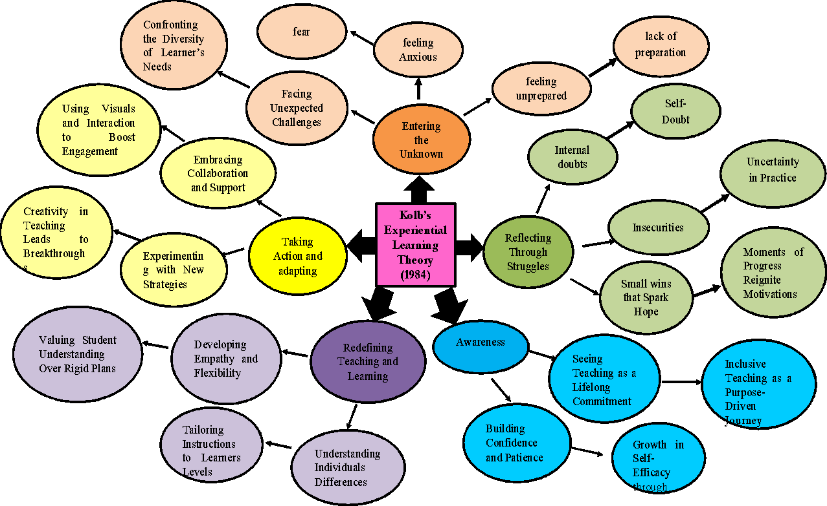

*Figure 2: Modified Paradigm of the Study*

This table presents the findings of the study based on the lived experiences of inexperienced tutors who engage with learners with learning disabilities. Using thematic analysis, five emerging themes wereidentified, each supported by specific sub-themes derived from the participants’ narratives. These themes reflect the emotional journey, reflections, and learning transformations that the tutors experienced.

Table 1: Lived experiences of inexperienced tutors who engage with learners with learning disabilities

|  |  |  |
| --- | --- | --- |
| Major Themes | Sub-Themes | Emerging Themes |
| 1. Entering the Unknown | Feeling Unprepared and Anxious  Facing Unexpected Challenges in the Classroom | Fear and Lack of Preparation  Confronting the Diversity of Learners’ Needs |
| 2.Reflecting Through Struggles | Internal doubts and Insecurities  Small Wins That Spark Hope | Self-doubt and Uncertainty in Practice  Moments of Progress Reignite Motivation |
| 3.RedefiningTeaching and Learning | Developing Empathy and Flexibility  Understanding Individual Differences | Valuing Student Understanding Over Rigid Plans  Tailoring Instructions to Learners Levels |
| 4.Taking Action and Adapting | Experimenting with New Strategies  Embracing Collaboration and Support | Creativity in Teaching Leads to Breakthroughs   Using Visuals and Interaction to Boost Engagement |
| 5. Awareness | Building Confidence and Patience  Seeing Teaching as a Lifelong Commitment | Growth in Self-Efficacy through Experience  Inclusive Teaching as a Purpose-Driven Journey |

**Entering the Unknown**

***Feeling Unprepared and Anxious***. Inexperienced tutors initially faced a sense of uncertainty and hesitation when they began working with learners with learning disabilities. Most participants admitted they had little to no background or training in special education, which left them feeling unprepared. The transition into this new teaching environment brought about self-doubt and anxiety.Tutors expressed a strong sense of unpreparedness and anxiety due to their lack of prior training in handling learners with disabilities.

*“At first, I was really confused and unsure. Kay wala ko kahibalo unsaon pag handle sa learner because I had no background in handling someone with a learning disability.”* *(IDI1)*

**Other participants shared:**

*“Nagtuo ko na same lang mag sa handle regular students, pero lahi ra gyud diay. I didn’t know what method or materials to use.” (IDI3)*

*“It was really challenging at first. I didn’t know how to approach the learner kay wala pa koy previous experienced sa special education.” (IDI2)*

***Facing Unexpected Challenges:*** Participants encountered unpredictable situations in the classroom that tested their ability to adapt quickly.

*“I expected it to be hard, but I didn’t realize it would be that hard. I thought I could just use my usual teaching strategies, pero lahi gyud siya.”* *(IDI5)*

*“I was nervous and hesitant. I thought it would be like teaching any other student, but it turned out to be completely different.”* *(IDI6)*

*“Sa tinuod lang I really hesitant because my field of study is not really dealing with learners with learning disabilities.”* *(IDI5)*

**Reflecting Through Struggles**

### ***Internal Doubts and Insecurities.*** As they navigated their initial difficulties, tutors began reflecting on their experiences. They acknowledged moments of emotional struggle and self-doubt, but also pointed to small breakthroughs that renewed their motivation.

*“Maka-question gyud ko usahay kung sakto ba akong gibuhat. Basin sayop diay akong approach.” (IDI2)*

### ***Small Wins that Spark Hope****.* As inexperienced tutors journeyed deeper into their roles, they encountered emotional and mental challenges that led to personal reflection. Their struggles became turning points for learning, especially when confronted with self-doubt and moments of small success.

Even minor progress gave tutors a renewed sense of purpose and motivation.

*“Bisan gamay ra kaayo ang progress, pero makalipay kaayo nga makita nimo nga ni try siya.”*

*(IDI4)*

**Redefining Teaching and Learning**

***Developing Empathy and Flexibility.*** Over time, tutors began to reshape their understanding of what it meant to teach. They started to prioritize empathy, flexibility, and learner-centered approaches.

*“Ako siya gipasabot og hinay-hinay, kay lahi ra man gyud iyang needs. Kinahanglan gyud nimu mo adjust.” (IDI6)*

***Understanding Individual Differences.*** Tutors discovered that each learner had unique needs and learning styles, prompting them to personalize their teaching.

*“Nakat-on ko nga dili tanan bata parehas og learning style. Naay uban nga mas epektibo kung visual or hands-on.” (IDI5)*

*“Akoa gyud gi adjust akong standard ug teaching style ug gi level na ko sa learning ability sa akong students. (IDI4)*

**Taking Action and Adapting**

***Experimenting with New Strategies.***  Faced with challenges, tutors began to take initiative and explore new strategies. This place marked a shift from confusion to creativity. After developing a better understanding of their learners, the tutors began applying new strategies. They engaged in trial-and-error, actively experimenting to find what worked best for each learner. Tutors tried various teaching methods and tools to better suit their learner’s preferences.

“*Ako siya gitudluan gamit ang drawing ug games. Mas paspas siya nakasabot kaysa sa usual nga lecture.” (IDI6)*

***Embracing Collaboration and Support.***They started seeking help from other educators, parents, and available resources to improve their teaching. And some tutors sought guidance and support from colleagues with SPED experience. IDI2 mentioned consulting another teacher, which helped her handle behavioral concerns more effectively.

*“Nag-ask ko tabang sa uban tutors, parent ug sa akong kaila nga naay experienced SpED. Mas dali ko naka-learn unsaon pagadjust.”* (IDI2)

**Awareness**

***Building Confidence and Patience***. The final theme, Awareness, captures the transformative outcome as a lifelong commitment. Over time, tutors developed self-trust and emotional resilience. With continued experience, tutors gained more confidence and patience in their role.

*“Mas confident nako karon. Dili nako parehas sauna nga mahadlok ko masayop.” (IDI1)*

### ***Seeing Teaching as a Lifelong Commitment.*** Participants started viewing teaching not just as a task, but as a meaningful lifelong purpose.

*“Nakita nako nga ang pagtudlo dili lang trabaho. Usa gyud ni ka commitment para sa future sa mga bata.” (IDI3)*

**DISCUSSION**

This chapter presents the elaboration of themes and subthemes supported by existing literature.

Tutors initially expressed uncertainty and anxiety as they entered the inclusive classroom without adequate training in special education. This reaction corresponds with findings in Chapter 3 under the theme “Entering the Unknown,’ where all participants shared their apprehension and confusion in facing unfamiliar roles. This mirrors Bandura’s Social Cognitive Theory, which explains that individuals with low self-efficacy are more likely to feel overwhelmed when navigating complex environments without sufficient preparation or support (Tschannen-Moran&Johnson, 2021). Their early experience handling learners with learning disabilities also reflects Kolb’s Experiential Learning Theory, wherein the tutors’ initial immersion in inclusive education served as concrete experience that triggered emotional responses and the beginning of reflective learning (Yilmaz & Karaoglan Yilmaz, 2020).

The second theme, ‘Reflecting through Struggles,’ revealed how tutors confronted their internal doubts and insecurities but also found encouragement in small milestones, such as a learner showing signs of progress. For instance, IDI4 and IDI2 reflected deeply on their struggles, yet found motivation when their efforts were acknowledged by their learners’ reaction. Kolb’s Experiential Learning Theory emphasizes the value of concrete experience and reflective observation in developing practical teaching skills (Kolb, 2015). Building on this, Cruz and Dela Peña (2019) suggested that immersion and structured reflection are critical in shaping novice teachers’ competencies in inclusive classrooms. Recent studies, such as those by Reyes and Tan (2020), confirm that small success significantly enhance teacher confidence, especially in special education contexts.

As described in 'Redefining Teaching and Learning,' tutors began to shift their focus from strict instruction to adaptive and empathetic methods. The results showed that tutors like IDI6, IDI4 and IDI5 learned to understand the unique needs of learners with disabilities, allowing them to become more flexible in their teaching approaches Florian and Beaton (2018) emphasized the concept of inclusive pedagogy, which advocates for extending what is available to all learners and avoiding practices that isolate certain individuals. This shift in teaching philosophy aligns with how tutors redefined their methods based on learners’ varied abilities, emphasizing flexibility and equity. Teaching was shaped by how students learned, not by following a fixed method (Tomlinson, 2014). They saw that every child learned in their own way and adjusted their approach to match that.

Taking Action and Adapting,' reflects the tutors’ application of newly discovered teaching strategies and their willingness to collaborate with peers for better classroom outcomes. Chapter 3 highlighted instances where tutors like IDI6 and IDI2 modified learning activities and sought peer assistance to improve learner engagement. Kolb (2015) supports this approach, noting that learners (including teachers-in-training) benefit most when they actively apply learned concepts. This experiential process allowed tutors to gain confidence while discovering which strategies resonated most with their learners. They also used more hands-on tools and activities to help learners stay focused and understand better. They reached out to others and shared ideas that helped. Working together and reflecting improved their teaching (Vangrieken et al., 2015; Boud et al., 2014).

The final theme, ‘Awareness,’ Tutors slowly became more confident as they saw their learners grow. Participants expressed how their exposure led them to consider formal SPED training and enhanced their patience and empathy. Over time, they trusted themselves more and began to feel like real teachers. This progression aligns with the findings by Woodcock et al. (2022), who emphasized that teacher self-efficacy significantly influences the adoption of inclusive practices. Furthermore, Mei et al. (2022) highlighted that transformative learning experiences, rooted in critical reflection, are pivotal in reshaping teachers' professional identities. Gouda and Youssef (2024) also underscored the importance of transformative teaching models in fostering conceptual change and motivation, which are essential components of effective teaching.

This study is guided by the assumption that inexperienced tutors, through reflective and experiential engagement, can develop inclusive teaching capacities despite lacking formal SPED training. The results affirmed this assumption. The participants’ narratives showed how meaningful transformation occurred through lived encounters, personal reflection, and emotional connection with their learners.

Given these finding, future efforts in teacher preparation should include experiential learning modules that expose pre-service and in-service tutors to inclusive settings. Short term mentorship programs and structured reflective journaling could also help reinforce inclusive values. Institutions can further explore how informal teaching experiences, when supported, become platforms for professional identity formation.

This study shed light on the struggles and growth of inexperienced tutors; it also uncovered gaps that permit further inquiry. Future research may explore the question: *“What institutional mechanisms can effectively bridge the gap between inclusive education policy and on-the-ground tutoring practice?”* Moreover, it remains unclear how different types of learning disabilities may require distinct instructional adjustments from non-specialist educators, an area worth examining in comparative studies. From a practical standpoint, educational leaders should consider piloting school-based capacity-building programs focused on experiential workshops, emotional resilience, and differentiated instruction for tutors. Applying the study’s results in real-world settings can inform targeted interventions that enhance tutor preparedness and promote sustainable inclusive education.

**CONCLUSION**

This study provides a timely and relevant contribution to the literature on inclusive education, particularly in contexts where tutors often lack formal training in special education. By exploring the lived experiences of inexperienced tutors, the study highlights their challenges, emotional journeys, and instructional adaptations. It offers valuable insights into the development of inclusive teaching practices and the potential for professional growth through experiential learning. The findings underscore the urgent need for structured training and mentorship programs to support tutors in inclusive settings globally. In the end, this research shows that becoming an inclusive educator is not just about having technical knowledge. It is also about care, commitment, and the willingness to learn. Supporting tutors through continuous training, reflection, and mentorship can help build a more inclusive and compassionate learning environment for all.

**Ethical Approval and Consent:**

Ethical research practices were observed throughout the study. The researchers followed ten ethical dimensions: social value, informed consent, participant vulnerability, risk assessment, privacy, justice, transparency, researcher qualifications, facility adequacy, and community involvement. Participants were oriented about the study, signed informed consent forms, and were free to withdraw at any time. Confidentiality and anonymity were protected, and data were stored securely. The research adviser guided the process to ensure that academic and ethical standards were met.

**Disclaimer (Artificial intelligence)**

Option 1:

Author(s) hereby declare that NO generative AI technologies such as Large Language Models (ChatGPT, COPILOT, etc.) and text-to-image generators have been used during the writing or editing of this manuscript.

Option 2:

Author(s) hereby declare that generative AI technologies such as Large Language Models, etc. have been used during the writing or editing of manuscripts. This explanation will include the name, version, model, and source of the generative AI technology and as well as all input prompts provided to the generative AI technology

Details of the AI usage are given below:

1.

2.

3.

**References**

1. Billingsley, B., Griffin, C., Smith, S., Kamman, M., & Israel, M. (2008). *Program leadership for serving students with disabilities*. Council for Exceptional Children.
2. KKG Publications. (2019). *Pre-service teachers’ confidence and preparedness in handling students with learning disabilities: A Philippine perspective*. KKG Education Review, 3(1), 15–22. *(Note: Please verify the actual journal, volume, issue, and authors if available.)*
3. Kolb, D. A. (1984). *Experiential learning: Experience as the source of learning and development*. Prentice-Hall.
4. Lopez, M. A., & Dela Cruz, J. P. (2024). Preparing non-SPED teachers for inclusive education: Bridging the training gap in the Philippines. *Journal of Inclusive Education Research*, 6(1), 58–74.
5. Louden, W., Chan, L., Elkins, J., Greaves, D., House, H., & Milton, M. (2000). *Mapping the territory: Primary students with learning difficulties—Literacy and numeracy*. Commonwealth Department of Education, Training and Youth Affairs.
6. Mboya, M. M. (2011). Special education in Tanzania: Challenges and opportunities for teacher education and training. *Journal of International Special Needs Education*, 14(1), 10–18.
7. Ndlovu, V. (2019). Beginning teachers’ struggles in inclusive classrooms: Implications for teacher education. *International Journal of Educational Development in Africa*, 6(1), 21–36.
8. Pedroso, R. M., Alcalde, A. M., & Sudario, J. T. (2022). Teaching in the time of pandemic: Non-SPED teachers’ strategies in inclusive virtual classrooms. *Philippine Journal of Education and Development*, 45(2), 102–118.
9. Ahmed, S. K. (2024). The pillars of trustworthiness in qualitative research. *Journal of Medicine Surgery and Public Health*, *2*, 100051. <https://doi.org/10.1016/j.glmedi.2024.100051>
10. Arcuino, E. J. D., Cagape, W. E., Fuentes, M. S., Garnica, G. C., & Melasa, J. P. L. (2022). Demystifying the Lived Experiences of Teachers as Stewards of Learners in Handling Learners with Special Educational Needs in an Inclusive Classroom A Phenomenology. *International Journal of Research Publications*, *115*(1). <https://doi.org/10.47119/ijrp10011511220224268>
11. Creswell, J.W. (2013) *Research Design: Qualitative, Quantitative, and Mixed Methods Approaches.* 4th Edition, SAGE Publications, Inc., London.
12. Fink, Anne Sofie (2000). The Role of the Researcher in the Qualitative Research Process. A Potential Barrier to Archiving Qualitative Data [69 paragraphs]. *Forum Qualitative Sozialforschung / Forum: Qualitative Social Research*, *1*(3), Art. 4, <http://nbn-resolving.de/urn:nbn:de:0114-fqs000344>.
13. Seo, M., Kim, Y., Park, J., Sim, G., & Ko, Y. (2024). The evolution of phenomenology in Korean Nursing Research: A scoping review. *Asian Nursing Research*, *18*(1), 3–10. https://doi.org/10.1016/j.anr.2024.01.004
14. Tschannen-Moran, M., & Johnson, D. (2021). *Exploring literacy teachers’ self-efficacy beliefs: Potential and limitations of qualitative research*. Teaching and Teacher Education, 103, 103355. https://doi.org/10.1016/j.tate.2021.103355
15. Yilmaz, R. M., & Karaoglan Yilmaz, F. G. (2020). Examining the effect of a flipped classroom model supported with Kolb’s experiential learning theory on students’ learning and engagement. *Interactive Learning Environments*, 28(3), 306–318. https://doi.org/10.1080/10494820.2018.1528287
16. Kolb, D. A. (2015). *Experiential learning: Experience as the source of learning and development* (2nd ed.). Pearson Education.
17. Cruz, F. C., & Dela Peña, M. G. (2019). Reflection and experience: Building competence among novice inclusive education teachers. *Philippine Journal of Teacher Education*, 12(1), 45–60.
18. Reyes, M. A., & Tan, R. S. (2020). Teacher confidence and motivation: Impact of small successes in inclusive education. *Journal of Special Education and Developmental Psychology*, 8(2), 34–49.
19. Florian, L., & Beaton, M. (2018). Inclusive pedagogy in action: Getting it right for every child. *International Journal of Inclusive Education*, 22(8), 870–884. https://doi.org/10.1080/13603116.2017.1412513
20. Tomlinson, C. A. (2014). *The differentiated classroom: Responding to the needs of all learners* (2nd ed.). ASCD.
21. Boud, D., Keogh, R., & Walker, D. (2014). *Reflection: Turning experience into learning*. Routledge.
22. Gouda, S., & Youssef, W. (2024). Transformative teaching and conceptual change: Towards a motivational model of inclusive pedagogy. *International Journal of Educational Research*, 123, 102181. https://doi.org/10.1016/j.ijer.2024.102181
23. Kolb, D. A. (2015). *Experiential learning: Experience as the source of learning and development* (2nd ed.). Pearson Education.
24. Mei, X., Zhang, Y., & Chen, L. (2022). Transformative learning in teacher education: The role of critical reflection in professional identity development. *Teaching and Teacher Education*, 109, 103565. https://doi.org/10.1016/j.tate.2021.103565
25. Vangrieken, K., Meredith, C., Packer, T., & Kyndt, E. (2015). Teacher communities as a context for professional development: A systematic review. *Teaching and Teacher Education*, 42, 1–16. https://doi.org/10.1016/j.tate.2014.04.001
26. Woodcock, S., Reupert, A., & Ng, S. (2022). Exploring the impact of teacher self-efficacy on inclusive practices in diverse classrooms. *International Journal of Inclusive Education*, 26(3), 345–360. https://doi.org/10.1080/13603116.2020.1751313
27. Lisle, K., & Wade, T. J. (2013). Does the Presence of a Learning Disability Elicit a Stigmatization? Journal of Education, Society and Behavioural Science, 4(2), 211–225. https://doi.org/10.9734/BJESBS/2014/6379