**The Relationship between ICT Usage and English Language Proficiency among TVL-ICT Senior High School Students: A correlational study**

**ABSTRACT**

|  |
| --- |
| In language learning, Information and Communications Technology (ICT) supply the learner with diverse sources, live communications, and cooperative learning, absolutely indispensable to the development of basic vital language skills. There are many Asians who do not know this language. In reality, there are some prevalent reasons, such as poor access to quality ICT resources, inadequate integration into the curriculum, and differential language proficiency. This research explored the relationship between ICT usage and English language proficiency among 251 senior high school TVL-ICT students at St. Mary’s College of Bansalan, Inc., in 2024. Aiming to understand how ICT impacts language skills, the study analyzed the correlation between ICT engagement and English proficiency, focusing on aspects like reading, writing, speaking, and vocabulary. Given the growing influence of ICT on language acquisition, this research aimed to provide insights for educators seeking to enhance language learning through technology. Using a correlational research design, the study surveyed students to assess ICT usage (e.g., social media, online learning, multimedia, digital content creation) and their English language proficiency (grammar, vocabulary, reading comprehension, writing, and oral communication). After completing the survey, data was safely stored for analysis, guaranteeing participant confidentiality all along the way. The findings revealed a significant positive correlation (r = 0.504) between ICT usage and English communication skills. Students who engaged more frequently with ICT exhibited higher levels of proficiency in English. The research also highlighted that activities like watching English-language films, listening to English music, and engaging in online discussions contributed to language development. The study concluded that both the traditional and multimedia-based approaches of learning were the key contributing factors to the 32.70% variability of the English language competency of ICT student perception. These results suggest that ICT, particularly in multimedia formats, plays a vital role in enhancing English proficiency. The study emphasized the potential of ICT as a powerful tool for language learning, offering practical implications for educators to optimize teaching strategies and better integrate technology into their classrooms to improve language skills. |

***Keywords:*** *ICT usage, English Language Skills, ICT Engagement, Correlational Research, Technical-Vocational-Livelihood (TVL)*

**1. INTRODUCTION**

* 1. **Background of the Study**

        Technology is changing all spheres of our lives, including teaching and learning. The internet, technology and the media, and the use of English in face-to-face communication as well as virtual social networks provide greater opportunities for meaningful and authentic language use than are available in the classroom (Abraham et al., 2022). In the digitalized age, students are now able to access a plethora of content in almost every language, with content in English dominating the internet (Muth & Lüftenegger, 2024). The inclusion of information and communication technology or ICT in education has revolutionized the traditional learning system, filling the gap between the conventional teaching method, practices, and the demands of a technologically driven world. ICT comprise many technologies for capturing, interpreting, storing and transmitting information. ICT in education include technologies such as computers, internet, broadcasting technologies (radio and television), and telephony that can facilitate both the delivery of instruction and learning processes (Sharma, 2023). Provision of ICT tools gives students an interactive and engaging platform and tools that improve the learning experience and enhance it (Mazhar et al, 2021). It also offers opportunities for personalized learning methods and self-directed education. In language learning, ICT will especially supply the learner with diverse sources, live communications, and cooperative learning, absolutely indispensable to the development of basic vital language skills.

     This implies that the smoothness of fluency to communicate correctly in English is a basic requirement of academic accomplishment as well as the future vocation for technical vocational livelihood or specialization in ICT. Since ITC is a technical vocational livelihood or specialization track in a highly technology-literate world where people communicate, this is an expression of language of communicating, and this covers every corner of the world. There are many Asians who even know this language. In reality, these are some of the prevalent reasons such as poor access to quality ICT resources, inadequate integration into the curriculum, and differential language proficiency (Seram, 2019). Challenges such as these require research on the relationship between the use of ICTs and English language skills for appropriate handling of such results.

     This study will determine how the applications of ICT have affected the proficiency of the English language among students in the context of St. Mary's College of Bansalan in relation to students undergoing the course of study for TVL-ICT. Investigating how the frequency and purpose, in type, of ICT engagement affect language skills such as listening-speaking-reading-writing- offers useful insights to educators and curriculum developers, even aiding us to pass the quantitative subject. It will hence inform improvement in teaching strategies towards creating an environment in which technology and language acquisition merge to enhance the educational outcomes for the learners.

**1.2 Theoretical framework**

    The study draws from fundamental theories to understand the relationship between information and communication technology or ICT usage and English language proficiency, constructivism learning theory, and Krashen's second language acquisition theory that will provide a comprehensive lens for the exploration of how digital tools and resources support active learning and language learning.

    This is very much aligned by the Constructivist learning theory, saying knowledge is constructed through active involvement, interaction, and engagement in order to construct the knowledge rather than receiving it passively and the ICTs are well aligned with this purpose in terms of facilitating with tools such as the e-learning platforms, the multimedia resources, and collaborative application, which make the way for learners to explore and practice the knowledge in completely new, engaging, and meaningful ways, which students build upon from previous knowledge, therefore, real-world context and scenarios come to end. Constructivist classrooms change the role of the instructor from that of a traditional instructor to being a facilitator and, therefore, ensuring that the learning is collaborative and reflective through small groups' task simulations in social engagement discussions. In that setting, people get much deeper engagement and know it for longer periods. The theory of Krashen's second language acquisition, on the other hand, emphasizes comprehensible input and meaningful interaction in acquiring a language. ICT tools such as online language learning programs, communication applications, and virtual platforms expose the learner to authentic language experience. It has exposed the learner to a wide variety of linguistic inputs, thus offering avenues for practical and real life-to-life communication.

    This allows an instance of a virtual chat room that contains multimedia content and exercises with collaborative work in a realistic setting where students can train their listening, speaking, reading, and writing abilities. These practices align well with Krashen's hypothesis that meaningful and interactive exposure is critical for language acquisition. The integration of these theories emphasizes the multi-dimensional impact that ICT has on education. Both pay attention to learning environments in a different way, for constructionism and the crunched up stories on linguistic benefits about ICT-mediate interaction, together they put a strong framework for grasping how technology may positively contribute to the cognitive as well as communicative sides of learning, especially developing the ability to use English properly in multiple educational situations.

* 1. **Conceptual Framework**

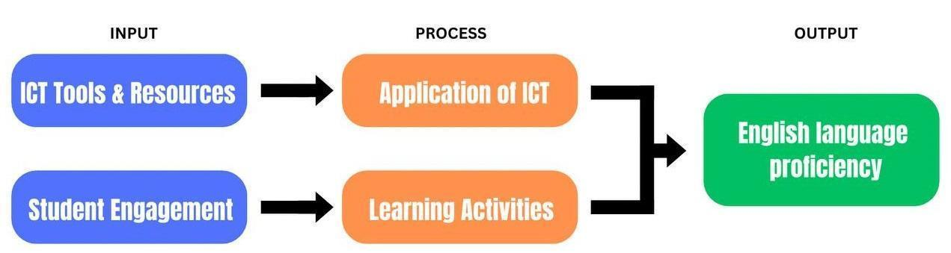

**Figure 1. Conceptual Framework of the Study**

The diagram shows the ICT tools as input, student engagement and application as process, and language proficiency as output. Hypothesized relationships and interactions are inferred from arrows between these elements. The proposed framework suggests that the application of ICT has a very significant impact on language learning outcomes. The study, through the examination of these relationships, aims to identify effective strategies for incorporating technology into teaching methods, furthering the improvement of educational practices among TVL-ICT students. The literature and data from this research will validate the proposed framework, which will open the doors for further studies in ICT and language education.

**1.4. Research Question**

The following questions guide the investigation into the relationship of information and communications technology usage and English language proficiency among TVL-ICT Senior High School students. Specifically, it sought answers to the following questions:

1. How does the use of ICT affect the adoption of:

* Traditional Learning
* Traditional Content
* Multimedia E-learning
* Multimedia Learning Method

1. What is the level of English language Proficiency in terms of:

* Listening Field
* Speaking Field
* Reading Field
* Writing Field

1. Is there a significant relationship between ICT student perception and the English language proficiency of Senior High School students in St. Mary’s College of Bansalan Inc.?
2. To what extent does ICT usage contribute to improving English language proficiency among TVL-Senior high School students in St. Mary’s College of Bansalan Inc.?

**1.5 Null Hypothesis**

**Ho1**: The use of ICT does not significantly affect the adoption of:

* Traditional Learning
* Traditional Content
* Multimedia E-Learning
* Multimedia Learning Methods

**Ho2:** There is no significant difference in the level of English language proficiency in terms of:

* Listening Field
* Speaking Field
* Reading Field
* Writing Field

**Ho3:** There is no significant relationship between ICT Senior High School students in St. Mary’s College of Bansalan Inc.

**Ho4:** ICT use does not significantly improve English Language proficiency among Senior High School Students in St. Mary’s College of Bansalan Inc.

**2. methodology**

**2.1 Research Design**

     The researcher of this study used a correlational research design to explore the relationship between Information and Communications technology (ICT) usage and English Language proficiency among TVL-ICT Senior High School students in St. Mary’s College of Bansalan Inc. Correlational research is a type of non-experimental research that facilitates prediction and explanation of the relationship among variables (Seeram, 2019).

The correlational design is appropriate for this study. Since our primary goal is to ascertain whether there is a significant relationship between two variables—ICT usage (Variable 1) and English language proficiency (Variable 2)—the correlational design is suitable for this study.  This design does not involve manipulating variables but rather assessing the natural association between them. Examples, Types, and Methods of Correlational Research. A non-experimental correlational design is the most sensible and moral course of action because the study will not include interventions or manipulations (Chandran et al., 2017). Since the study will not involve interventions or manipulations, a non-experimental correlational design is the most practical and ethical approach.

**2.2 Research Locale**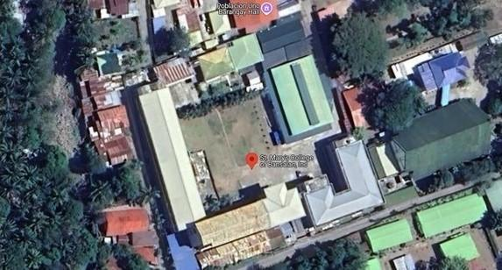

**Figure 2. Research Locale**

     This study will be conducted at St. Mary’s College of Bansalan, Inc. The respondents will be surveyed through Google Forms. The specific location of the study is within St. Mary’s College of Bansalan, Inc. where TVL-ICT Senior High School students or students who have ICT subject which is enrolled at St. Mary’s College of Bansalan, Inc. will be selected. By focusing on this specific locale, the researcher aims to gain a deep understanding of the relationship between Information and Communication Technology usage and English language proficiency among TVL-ICT senior high school students within this particular academic setting.

**2.3 Participants of the Study**

  The participants in this study consisted of 251 senior high school students of the Technical-Vocational-Livelihood (TVL) strand specializing in Information and Communications Technology (ICT). They were all enrolled at St. Mary's College of Bansalan, Inc., in Bansalan, Davao Del Sur. All participants were 16 to 19 years of age.

    The participants were selected by means of a purposive sampling method that focused on active students in ICT-related courses under the TVL strand. Participants had to be able to possess the basic knowledge of the tools and systems of ICT and had to be currently studying English in the curriculum. Students who were limited or had no exposure at all to the use of ICT tools or to instruction in the English language were excluded from this study.

     Recruitment was made easy by inviting the students during their break time and free time. It was also announced in common areas and through direct communication with the students to ensure that their participation did not interfere with their academic activities. This particular group of participants was selected to examine the relationship between their ICT usage and their proficiency in the English language since these areas are integral to their academic and vocational preparation.

**2.4 Sampling Techniques**

    For this research, purposive sampling was used. It targets participants who are the most relevant in contributing insights about the relationship between ICT usage and English language proficiency. The target population in this case consisted of high school seniors under the TVL track specializing in Information and Communication Technology (ICT), for it is the group directly related to the subject matter.

     The participants were chosen according to the following criteria: Enrollment in the TVL-ICT strand for the Academic Year 2024-2025; They frequently use ICT tools both in their study and even in their extra-curricular activities; They possess varying English language proficiency, which would be determined through a pre-assessment survey. Students would have to give consent for participation. All students not taking the TVL-ICT strand and those who did not participate were screened out of the study. To ensure adequate representation of various levels of proficiency and experiences of ICT use, the sample size was set at 251. The purpose of selecting this sample is to target most students who are relevant to the research objectives, allowing the study to gather in-depth, specific data directly relevant to the questions posed in the research.

**2.5 Data Analysis Procedure**

     Descriptive statistics will be used in analyzing data gathered from the respondents. This will involve using mean, median, and standard deviation for summarizing and describing the general trends of ICT usage and proficiency in the English language of the students who enroll in TVL-ICT.

**2.6 Data Collection Procedure**

     For conducting research, it is a must to collect data. Data is basically the information that is required for investigating a research problem after proper designing. The importance of data collection lies in the fact that without gathering the particular information, the research could not be carried out. (Mazhar, S. A. et al., 2021). At St. Mary's College of Bansalan Inc., the researcher conducted a study with TVL-ICT Senior High School pupils. Survey tools for both ICT use and English language competency were used to collect data. To ascertain the degree and importance of the correlation between the variables, statistical techniques will be employed. An online survey created with Google Forms was used to collect data for this investigation. This approach was selected to give the pupils convenient access. To help us with the process of creating an online survey, we first developed a survey instrument. Through group conversations, the survey link was distributed to TVL-ICT Senior High School students at St. Mary's College of Bansalan Inc. Participants were shown an informed consent section outlining the goal of the study after they accessed the Google Form. The researchers made sure that every ethical requirement was fulfilled. The data was used exclusively for this study, and the personal information of the participants was kept private.

**2.7 Research Instrument**

Assessment is very important in ELT (Thuan, 2018; Wiemken et al., 2018). It is their aim to obtain useful data to improve the quality of learning. A profound reality shows that without any assessment, the process of learning will be pointless (Sari et al., 2020). Therefore, assessment plays a central role in the learning process (William, 2013). This study uses a Google Forms-based questionnaire as its research tool. Three parts made up the survey instrument: an introduction with informed permission, questions concerning ICT use and English language skills, and a thank-you note at the end. TVL-ICT Senior High School students were given the survey link via group conversations, and they were asked to rate it on a scale of 1 (strongly disagree) to 5 (strongly agree).

Students completed the survey questionnaires within the allotted time. The researchers kept an eye on the responses and contacted those who hadn't finished. Following that, the data was safely stored for analysis, guaranteeing participant confidentiality all along the way. The Likert scale is applied as one of the most fundamental and frequently used psychometric tools in educational and social sciences research. Likert scales have probably become the most popular attitude scale format for measuring public opinion on any issue. (It is an attitude scale, then, and is not appropriate for measuring behaviors, as it is often mistakenly claimed, in terms of frequency scales running from doing an activity “quite often” to “sometimes” to “never.”) (Robinson, 2024). A series of Likert-scale questions gauges how often, for what reason, and what kind of ICT tools or platforms people utilize. The purpose of making this survey instrument is to be able to explore the relationship between ICT-usage and English language proficiency among Senior high School student in St. Mary’s College of Bansalan Inc. by making an online survey, the researcher evaluate respondents self-perceived abilities in reading, writing, speaking, and listening in English using a Likert Scale. The survey will support in determining the relationship between students’ use of ICT and their level of English proficiency, allowing the researchers to define the interaction between the two variables.

**2.8 Ethical Considerations**

The respondents’ rights and well-being will be protected strictly. This study, therefore, observes high ethical standards: participation is voluntary, and prior informed consent will be obtained before collecting the data. This survey will ensure the confidentiality and anonymity of the participants. During this research, no identifiable information of any participants will be obtained. furthermore, the data acquired during this survey will be encoded to ensure their anonymity as well. All answers received will remain private for purposes related to only this research.

**3. RESULTS AND DISCUSSIONS**

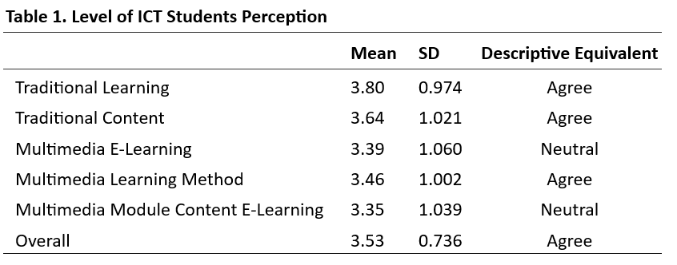

**Table 1:** Level of ICT students’ perception

Table 1 presents the level of ICT student perception. Utilizing the mean, the overall mean score of 3.53 indicates an overall favorable level of ICT student perception, with a standard deviation (SD) of 0.736 and a descriptive equivalent of “Agree.”

Furthermore, the analysis reveals that “Traditional Learning” exhibited the highest mean score of 3.80, with an SD of 0.974 and a descriptive equivalent of “Agree.” This is followed by “Traditional Content” and “Multimedia Learning Method,” with mean scores of 3.64 (1.021) and 3.46 (1.002), respectively, and descriptive equivalents of “Agree.” The remaining indicators, including “Multimedia E-learning” and “Multimedia Module Content E-Learning,” have mean scores of 3.39 (1.060) and 3.35 (1.039), respectively, and descriptive equivalents of “Neutral.”

     Table 1 presents the level of ICT student perception. Utilizing the mean, the overall mean score of 3.53 indicates an overall favorable level of ICT student perception, with a standard deviation (SD) of 0.736 and a descriptive equivalent of “Agree.”

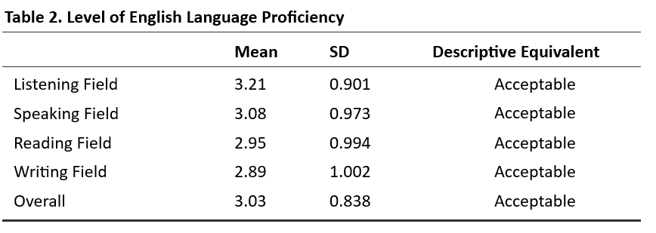     Furthermore, the analysis reveals that “Traditional Learning” exhibited the highest mean score of 3.80, with an SD of 0.974 and a descriptive equivalent of “Agree.” This is followed by “Traditional Content” and “Multimedia Learning Method,” with mean scores of 3.64 (1.021) and 3.46 (1.002), respectively, and descriptive equivalents of “Agree.” The remaining indicators, including “Multimedia E-learning” and “Multimedia Module Content E-Learning,” have mean scores of 3.39 (1.060) and 3.35 (1.039), respectively, and descriptive equivalents of “Neutral.”

**Table 2:** Level of English Language Proficiency

Table 2 presents the English language proficiency levels of the students. The mean was employed to determine the proficiency level. The results indicate that the overall mean score is 3.03, with a standard deviation of 0.838 and a descriptive equivalent of acceptable. This suggests that the students have a satisfactory level of English language proficiency.

Furthermore, the analysis revealed that among the indicators of English language proficiency, the listening field achieved the highest mean score of 3.21, accompanied by a standard deviation of 0.901. This is followed by the speaking field, which attained a mean score of 3.08 (0.973), the reading field, with a mean score of 2.95 (0.994), and the writing field, with a mean score of 2.89 (1.002). All of these scores have descriptive equivalents of acceptable.

**Table 3:** Correlation between ICT student perception and English Language Proficiency

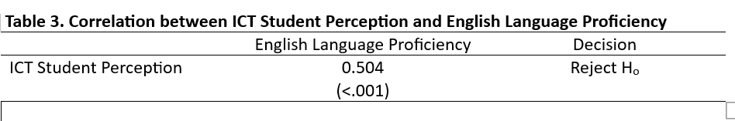

Table 3 presents the correlation between ICT student perception and English language proficiency. The study employed Pearson’s r to investigate the relationship between the two variables. The results indicate a moderate positive monotonic correlation between ICT student perception and English language proficiency (r=0.504, n=200, p<0.001). Statistically, this suggests that as ICT student perception increases, the level of English language proficiency remains stable or may even increase.

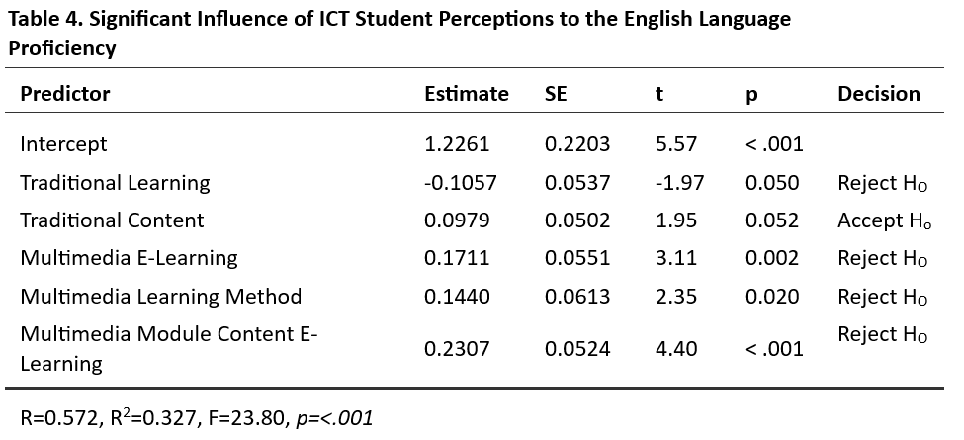Table 4 presents the substantial impact of ICT student perception on English language proficiency. Utilizing linear regression analysis, the significant influence of ICT student perception on English language proficiency was ascertained. The findings indicate that 32.70% of the indicators of ICT student perception influence English language proficiency,

**Table 4:** Significant Influence of ICT Student Perceptions to the English Language Proficiency

suggesting that 67.70% of the indicators were not included in the scope of this investigation. Furthermore, among the indicators of ICT student perception, traditional learning, multimedia e-learning, multimedia learning methods, and multimedia module content e-learning exhibited unique and significant contributions to the model, thereby impacting English language proficiency.

**Scatter Plot**

**Fig 3** Scatter plot showing ICT student perception

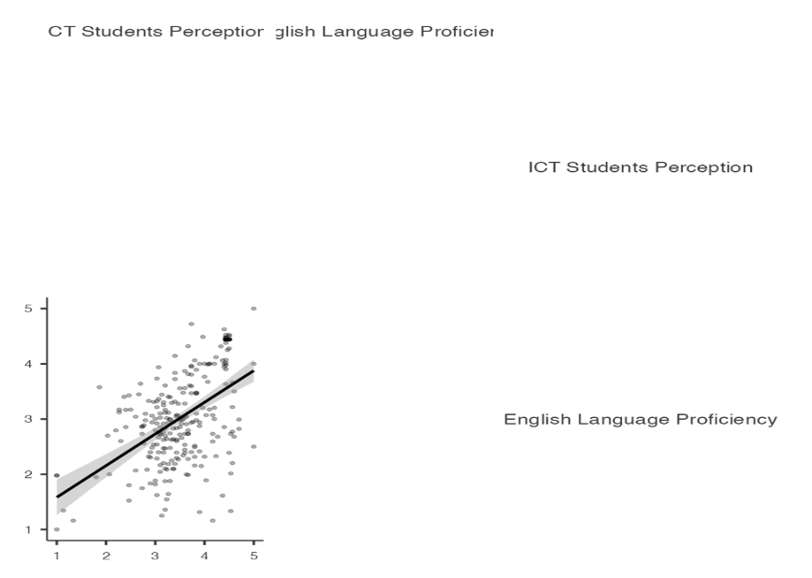

**Table 5**: **ICT Students Perception in terms of:**

**INDICATORS/STATEMENTS     Mean** SD

**1.1 Traditional Learning**

1.The use of traditional learning methods makes       3.81         1.101

 me more interested in learning sessions.

2. Traditional learning teaching helps me improve       3.86           1.195

in understanding the subject that I take.

3. The traditional learning was interesting and         3.74           1.133

pleasant to use.

**1.2 Traditional Content**

1. The use of traditional methods is one way to         3.65           1.148

attract students to concentrate in class.

2. The information presented is easy for me         3.63           1.132

understand.

**1.3 Multimedia E-Learning**

1. E-learning helps me in the learning process.         3.38           1.130

2. I use e-learning to get learning information.

**1.5 Multimedia Learning Method**

1. The use of multimedia learning methods         3.40           1.220

(e-learning) makes me more interested in learning       3.40           1.153

sessions.

2**.** Multimedia learning and teaching help me improve in       3.45           1.1200

understanding the subject.

**3.** E-learning is very useful for me.             3.63                       1.167

**1.6 Multimedia Module Content in E-Learning**

1. The use of multimedia modules is one way to attract       3.36                1.183

students to concentrate in class

**Table 6**: **Level of English Language Proficiency**

**INDICATORS/STATEMENTS           Mean             SD**

**2.1 Listening Field**

1. Weakness of students in following the instructions of         3.19             1.077

the course in English language by listening.

2. Not linking the listening material to real-life situations.         3.16             1.205

3. Poor ability of students to form correct sentences.         3.32             1.122

4. Poor ability of students to connect sentences by         3.25             1.183

listening.

5**.** Difficulty distinguishing students by hearing similar         3.17             1.095

words.

6. Lack of sufficient audio materials to get students         3.22             1.205

used to listening

7. Poor comprehension of the listening material.          3.17                      1.130

**2.2 Speaking Field**

1. Not focusing on speaking experiences during the                 3.07             1.138

lessons.

2. Poor ability of students to express their thoughts orally.        3.05             1.214

3. Poor ability of students to form correct sentences.

4. Poor ability of students to synthesize language terms.          3.12                      1.262

**2.3 Reading Field**

1. Difficulty reading and summarizing English texts by the.        2.96                     1.107

teacher.

2. Difficulty pronouncing vowels in English.             2.98                     1.236

3.Difficulty understanding the meanings of the reading             2.86                     1.178

material.

4. Difficulty reading English sentences.                                 2.99                     1.230

**2.4 Reading Field**

1. Difficulty writing English sentences.                                      2.91                     1.075

2. Difficulty distinguishing letters and syllables.                        2.91                     1.256

3. Difficulty expressing in writing life situations.                        2.86                     1.142

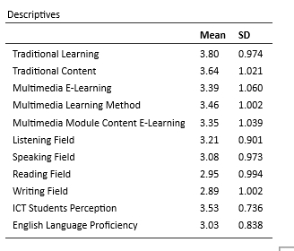**Table 7:** Descriptive Statistics Result

**CONCLUSIONS AND RECOMMENDATIONS**

**4.1 Conclusions**

   The study exhibited a moderate positive relationship between the perception of ICT students and English language proficiency. Students perceived ICT tools as commendatory, particularly in traditional learning methods, which obtained the highest score in the analysis. However, unbiased assessment of multimedia e-learning and module content showed areas for improvement in the effectiveness and integration of several digital learning techniques. It has been well received, indicating ICT's potential as a convenient tool for academic progress.

     In addition, the hearing and speaking skills of students received a better score than the reading and writing skills, and it proves that their English language proficiency is sufficient. This underlines the practical communication ability of students while at the same time pointing out that more effort is required in developing more refined language skills such as writing. The positive effect of ICT-based learning, which supports the dynamic and interactive opportunities of skill development, can be inferred from the sustained proficiency levels across language domains.

     Significantly, the findings indicated that both the traditional and multimedia-based approaches of learning were the key contributing factors to the 32.70% variability of the English language competency of ICT student perception. This research further underlines how effective the tool of ICT has proven to be for the learners in the language but further establishes that there are also other, yet unknown elements, which are significant as well. Thus, this research calls for other creative ICT approaches to strengthen this influence on academic performance. Further, to enrich our perception of these aspects and more improvements toward ICT strategies on comprehensive skill development in languages, a further research recommendation is urged.

**4.2 Recommendations**

 Implementing ICT in language learning, particularly improving aspects in terms of writing, reading and engagement. The new means of resources and collaborative tools will enhance active learning amongst teachers and instructor training to have an effective use of aligned ICTs with the current curriculum.

   Upgrading infrastructures such as labs that are equipped with multimedia capabilities for internet access, especially Internet and ICT, could not place more emphasis on this to create a more interactive but friendly environment. Programs on writing and reading through real-world applications will contextualize the learning.

     More research has to be conducted on the effects of socio-economic influences and long-term effects of ICT. Promoting self-directed learning and collaborative work of students through virtual exchange and interactive platforms will enhance the student's involvement and linguistic skill, and maximize the use of ICT in education.

**Consent:**

Participation is voluntary, and prior informed consent will be obtained before collecting the data.

**Disclaimer (Artificial intelligence)**

Option 1:

Author(s) hereby declare that NO generative AI technologies such as Large Language Models (ChatGPT, COPILOT, etc.) and text-to-image generators have been used during the writing or editing of this manuscript.

Option 2:

Author(s) hereby declare that generative AI technologies such as Large Language Models, etc. have been used during the writing or editing of manuscripts. This explanation will include the name, version, model, and source of the generative AI technology and as well as all input prompts provided to the generative AI technology

Details of the AI usage are given below:

1.

2.

3.

**References**

[[1] Mazhar, S. A., Anjum, R., Anwar, A. I., & Khan, A. A. (2021). Methods of data collection: A fundamental tool of research. *Journal of Integrated Community Health (ISSN 2319-9113)*, *10*(1), 6-10.

[2] Seeram, E. (2019). An overview of correlational research. *Radiologic technology*, *91*(2), 176-179.

[3] Chandran, A., Dewaras, T., & Guna Segaran, H. (2017, June 1). *Real time bus tracking application*. Institutional Repository at Politeknik Sultan Salahuddin Abdul Aziz Shah: Home. http://repository.psa.edu.my/handle/123456789/98

[4] Google forms questionnaire design interface | download scientific diagrams. (2021). Retrieved from<https://www.researchgate.net/figure/Fig-1-Google-Forms-Questionnaire-Design-Interface_fig1_326831738>

[5] Robinson, J. (2024). Likert scale. In *Encyclopedia of quality of life and well-being research* (pp. 3917-3918). Cham: Springer International Publishing.

[6] Woolfolk, A. E. (1993). Educational Psychology. Boston: Allyn and Bacon. Summary based on content in educational references. https://educationaltechnology.net/constructivist-learning-theory/

[7] Kurt, S. (2023). Constructivist Learning Theory. Retrieved from https://educationaltechnology.net/constructivist-learning-theory/.

[8] Krashen, S. D. (1982). Principles and Practice in Second Language Acquisition. Pergamon Press. Summary available in theory-related research discussions. https://ijcrt.org/papers/IJCRT2103077.pdf

[9] Aisiyah, Y. F. (2020). Constructivism and ICT in Language Learning. Retrieved from <https://www.sciencegate.app/document/10.30587/postulat.v1i1.1778>.

[10] Abraham, M., Arficho, Z., Habtemariam, T., & Demissie, A. (2022). Effects of information communication technology-assisted teaching training on English language teachers’ pedagogical knowledge and English language proficiency. *Cogent Education*, *9*(1), 2028336.

[11] Sharma, T. P. (2023). Impact of Incorporating ICT Skills into the Curriculum of the Bhutanese Education System. *South Asian Journal of Social Studies and Economics*, *18*(2), 47–61.

[12] Muth, J., & Lüftenegger, M. (2024). Associations between autonomy-supportive teaching, the use of non-academic ICTs, and student motivation in English language learning. *Sustainability*, *16*(3), 1337.