**Assessing the Role of Urbanization and Government Interventions on the Water Quality of Shahpura Lake, Bhopal, India**

**ABSTRACT**

Urbanization comprises planned infrastructure development to cater to the growing population and economic activities by ensuring efficient and sustainable spatial land use, creating a liveable environment. A well-planned urban development improves infrastructure, healthcare, education, economic activities, and the urban environment; fast or unplanned development may lead to unfavourable changes such as environmental pollution, traffic congestion, insufficient or excess housing, and informal encroachments of natural habitats. Urban developmental activities need greater use of natural resources like water and land. This may strain the limited resources. Key objective was to understand the impact of different aspects of urbanization and actions taken by the local governing bodies under various national schemes and policies on the water quality of an urban lake. Published literature on physicochemical and biological parameters of Shahpura Lake water and water quality index were comprehended to identify the longitudinal water quality. Developmental activities in Bhopal, India are still in a nascent phase. In 2016, 'City of Lakes' Bhopal was included in the 'Smart Cities Mission'. Hence, an attempt has been made to understand how urban development has impacted this Lake situated within the city. The Shahpura Lake, a rain-fed lake, continuously receive sewage. Also, the recently increased urban developmental activities have put tremendous pressure on its water quality. **It** was observed that the local urban bodies’ have continuously made efforts to improve the quality of lake water. Marginal improvements are seen in the lake water quality in recent years, but due to the continuous inflow of sewage, the lake remains moderately to heavily polluted. The lake restoration efforts should also focus on the nutrient enrichment. The study points out that planning and management strategies specific to the lake and combined efforts by all the stakeholders are needed.

***Keywords:*** *Urbanization, Water Quality, Shahpura Lake, National River Conservation Plan (NRCP), Lake Conservation.*

**1. INTRODUCTION**

Urbanization is crucial in economic development because it provides employment opportunities, attracts investment, and fosters innovation and entrepreneurship. Urban development has many facets and is important as it allows for industrial and infrastructure developments, technological advancements, and social integration by providing opportunities for environmental sustainability, cultural exchange, cultural and heritage preservation, and improved living standards by providing housing, healthcare, education and recreation facilities like parks, community centers, maintaining lakes etc. All these have increased the urban population almost 11-fold in the last 100 years, from 26 million to 285 million in India. Its share in the total population has also increased nearly 3 fold from 10.84% in 1901 to 28.5% in 2001, which indicates faster growth of the urban population (Jaysawal and Saha, 2014). One of the conspicuous features of urbanization in India is the skewed distribution of population, with as much as 28.3% of the urban population in 35 metro cities alone. Annual change in urbanization in India is about 1.1% against the global rate of 0.9%. It is expected that 50% of the 814 million Indian population will reside in urban areas in 2050 (Bhagat, 2014). Globally, in 2018, about 55% (4.2 billion) of the population lived in the cities. It is expected to increase to about 6.5 billion in 2050. It is also opined that about 90% of urban expansion will be in the developing countries. This will increase pressure on the urban resources (UN DESA).

India ranks thirteenth among the world's 17 'extremely water-stressed' countries. The availability of freshwater resources is also declining in India per capita due to increased population. The per capita annual water availability in India may fall to 1,235 m3 by 2050, and if it declines to around 1,000-1,100 cubic meters, then India could be declared a water-stressed country (thehindubusinessline.com). Moreover, India possesses only 4% of the world's freshwater to meet the needs of 17% of the global population. In northern India, groundwater levels declined to>8 cm/year between 1990 and 2014 (Trivedi et al., 2023). Depletion of available freshwater resources, falling groundwater levels and deteriorating water quality are all posing a variety of challenges in managing India's water resources (CPCB, 2011). This is even more problematic in the urban environment, which is already struggling to support the ever-increasing human population inflow. It should be noted that lakes play a crucial role in an urban landscape. One of the primary roles is to regulate the micro-climate of any urban area, hence acting as an ecological barometer of health (Ravinder, 2018). Lakes of all sizes are significant as not only do they provide drinking water in the cities facing water stress/scarcity or lacking other sources, but they also play a significant role in regulating the micro-climate of an urban area and, hence, act as ecological barometers of the health (Ravinder, 2018). Highly concentrated buildings along with intensive use of air-conditioners in urban areas have led to increased Urban Heat Islands intensity (Krishnan et al., 2024). In a study, Qi et al., 2025 found that a small lake could extend a cooling effect up to 30 m from the boundary, reducing the temperature up to 2 oC in summer. The cooling effect is affected by the lake size and shape, climate, and associated land use and vegetation around it. Strategically located larger water bodies with sufficient vegetation surrounding it in urban areas could deal with Urban Heat Islands (Jandaghian & Colombo, 2024). Additionally, lakes also serve to control floods by storing excess rainwater. Lakes conserve biodiversity and maintain cultural and historical heritage, as they are often associated with traditional beliefs and practices. Many have significant histories attached to them. Lakes also provide us with ecosystem services like fisheries, improve the area's scenic view or aesthetic appeal and offer many recreational activities like boating, swimming, and picnics (Schallenberg et al., 2013, Deines et al., 2017).

Much effort has been made to study the physical and biological aspects of lakes and manage pollution. Different lake morphologies give rise to varying productivity levels and physical effects of water retention, circulation, current and waves. The health of the aquatic ecosystem is determined by the water quality parameter, which includes the physical, chemical, and biological characteristics (Kangabam et al., 2017). To determine the quality of water, various Water Quality Index (WQI) have been developed globally. Some of them include Weight Average Water Quality Index (WAWQI), Canadian Council of Ministers of Environment Water Quality Index (CCMEWQI), National Sanitation Foundation Water Quality Index (NSFWQI), Oregon Water Quality Index (OWQI), Prati’s Index of Pollution, Bhargava’s Index, Dinius’ Second Index, Indian Pollution Index, Irish Water Quality Index (Tyagi et al., 2013, Zotou et al., 2020, Mogane et al., 2023, Chidiac et al., 2023). These were developed for lotic and/or lentic water system and may be suitable for the specific type of water use. Researchers regularly use selected WQI to identify the lake water quality.

About 70% of natural wetlands have been lost globally in the last century. From 1970 to 2015, natural wetlands have reduced by almost 35%. Yao et al., 2023 studied about 1972 of the world's largest lakes from 1992 to 2020 and observed that water storage has declined by about 53%. Anthropogenic activities have affected the water quality in numerous water bodies, affecting their intended use and have accelerated the rate and amount of eutrophication in aquatic ecosystems by point-source discharges and non-point loadings of limiting nutrients like nitrogen and phosphorus. About 80% of the wastewater enters different water bodies without complete treatment (unwater.org). Urban development is altering the hydrological regimes of the lake and causing changes in the groundwater recharge and lake water levels. It also leads to the degradation of lake water quality from stormwater runoff and industrial and domestic wastewater discharge, leading to changes in nutrients, heavy metals, and pesticide contents. All this leads to bio-magnification in aquatic organisms, algal blooms, eutrophication, and loss of aquatic biodiversity.

Urban stormwater run-off and the resultant *E. coli* contamination of lakes is still poorly understood and addressed (Hong et al. 2021). Moreover, climatic conditions also have an impact on the quality of urban lakes water. In a study on 12 urban lakes, it was observed that lakes with different trophic status responded differently to varying climate conditions. Eutrophic lakes were affected more and their parameters responded more to climatic variations than the cleaner lakes, and hence would face greater challenges for restoration and conservation (Wu et al. 2014). A spatiotemporal study (2011-2020) of an industrial and domestic sewage fed Chaohu Lake located in an urban area in China revealed that major pollutants included the total nitrogen and total phosphorus. Water quality was found to be heterogeneous. However, the overall quality of the lake water improved over the period attributed to implementation of remedial measures (Wang et al., 2023). Banani Lake, located in an urban area in Dhaka, Bangladesh has shown seasonal variation in the physicochemical parameters often exceeding limits. The Trophic Status Index revealed oligotrophic to hypereutrophic nature indicating nutrient enrichment (Kabir et al., 2025). Pollutants are not the only concern for the Lakes, but siltation, lake-drought, and encroachment are some other factors affecting the urban lakes.

Continuously increasing population and urban developmental activities require increasing use of natural resources like water and are adding tremendous pressure on the available water (Krishnan et al., 2024). Within this context, the present study deals with how historical urban development, population growth, and economic activities impact the available water reservoirs in an urban ecosystem. Hence, an attempt has been made through a case study of Shahpura Lake, situated within Bhopal city, to understand how urban development has affected its water quality.

**2. METHODOLOGY**

**2.1 Study Area**

The creation of Bhopal dates back to around 1010-1015 AD and is credited to the Raja Bhoj, who was also responsible for creating the Upper Lake (also known as Bhojtaal). The district, with an area of 2772 Km2,is situated in the central part of the state between latitude 23°04´ and 23°53´ North and longitude 77°12´ and 77°40´ East. Bhopal has a moderate climate, and on average, it receives about 1008.1 mm of rainfall annually. About 90% of this is received during the rainy season. Bhopal is known as the ‘City of Lakes’. Bhopal was among the first 20 cities to be included in the ‘Smart Cities Mission’ in January 2016.

Shahpura Lake, an urban lake, is also known as the third Lake of Bhopal (Fig. 1). It is a manmade reservoir (23°12'17" N and 77°25'35" E) that was formed in 1974-75 under the Betwa irrigation project (Trivedi 2012). The lake has a catchment area of 8.29 km2, a gross storage capacity of 2.29x106 m3, and a submergence area of 0.96 km2 (Munoth & Nagaich, 2015). The lake is shallow, with a mean depth of 1-2 m (Saxena, 2014) and a maximum depth of 5.60 m (Munoth & Nagaich, 2015).

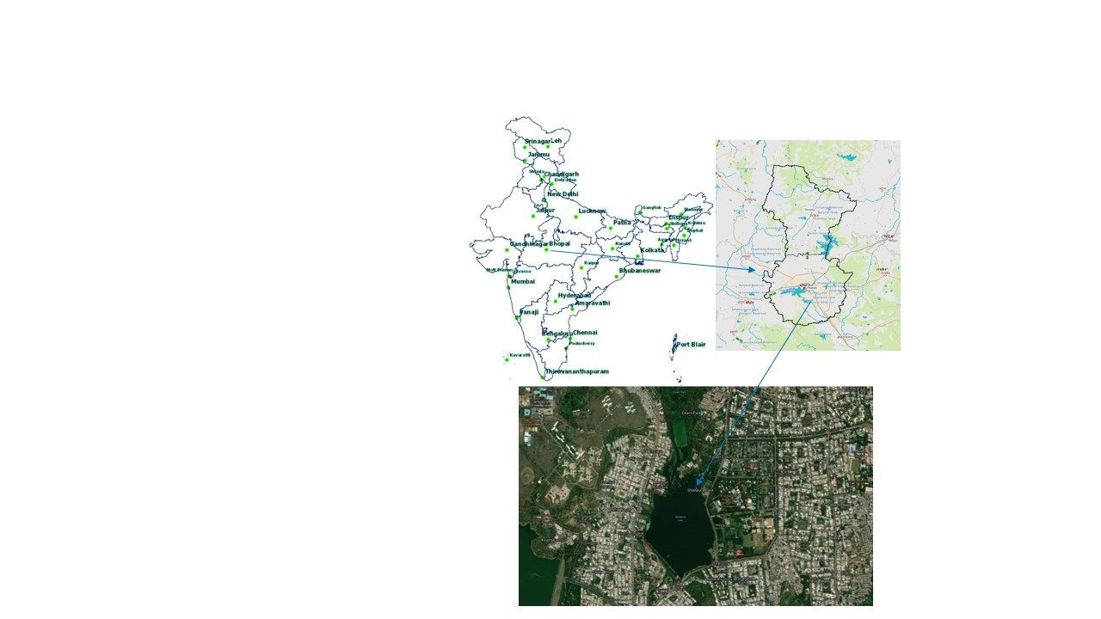

Figure 1: Location of Shahpura Lake

**2.2 Data Collection**

The study is based on Secondary Data. Research literature was collected from Web of Science, Scopus, and Google Scholar. Information was also collected from various websites and reports. Data for the population was collected from different Census of India. Urban development and planning information was collected from the Bhopal Development Plans and research articles. Information related to Water quality parameters was collected from research papers and websites like Central Pollution Control Board (CPCB) and Madhya Pradesh Pollution Control Board (MPPCB).

**3. RESULTS**

**3.1 Urban Development**

**3.1.1 Population growth**

The population of Bhopal district increased by 1547 times in 110 years from 1901 to 2011. A wide variation in growth was observed in the population of Bhopal. There was a drastic in the population from 1901 to 1921; thereafter, a gradual increase in population growth was observed. It more than doubled from 1951 to 1961 (~118%), which can be attributed to Bhopal being made the Capital of Madhya Pradesh. The decreased decadal growth in the population in the Bhopal city from 1981 onwards may be due to the Bhopal Gas Tragedy (1984), slowdown in industrial growth, and the newly constituted state of Chhattisgarh in 2000. The data reveals that in 1941, only 23.2% of the Bhopal District population resided in Bhopal city, but in 2011, about 75.8% of the total population was concentrated in the city. It is interesting to note that, in 2011, almost 94% of the total urban population of the Bhopal District resided in the Bhopal city (**Table 1**).

Table 1: Population growth profile of Bhopal District

|  |  |  |  |  |  |
| --- | --- | --- | --- | --- | --- |
| **Year** | **Bhopal District** | **Bhopal District Urban population** | **Urban Population of Bhopal** | | |
| **Number** | **Percentage (%) (of Bhopal District)** | **Decadal growth rate (%)** |
| 1901 | 143958 | 81299 | 77023 | 53.5 |  |
| 1911 | 156354 | 58828 | 56204 | 35.9 | -27.0 |
| 1921 | 140300 | 47289 | 45094 | 32.1 | -19.8 |
| 1931 | 163747 | 63256 | 61037 | 37.3 | 35.4 |
| 1941 | 188608 | 79380 | 75228 | 39.9 | 23.2 |
| 1951 | 235665 | 102333 | 100258 | 43.4 | 36.0 |
| 1961 | 371715 | 229186 | 222948 | 60.0 | 117.9 |
| 1971 | 572169 | 392641 | 384859 | 67.3 | 72.6 |
| 1981 | 894739 | 681853 | 671018 | 75.0 | 74.4 |
| 1991 | 1351479 | 1080802 | 1062771 | 78.6 | 58.4 |
| 2001 | 1843510 | 1482718 | 1458416 | 79.1 | 37.2 |
| 2011 | 2371061 | 1917051 | 1798218 | 75.8 | 23.3 |

*Source: Census of India, BDP 1991, BDP 2031*

To understand how the population growth around Shahpura Lake has impacted its water quality, the population of the 11 different wards surrounding the lake and its catchment area was studied (**Table 2**). **Fig. 2** shows the location of these wards surrounding the catchment area. From 2001 to 2011, only a 5.5% increment is observed in the overall population in the wards. In 2001, ward no 52 had the maximum population (16.15%), followed by ward 31 (13.67%), and then ward 49 (11.02%). In 2011, the maximum population was in Ward 52 (23.29%), followed by Ward 50 (11.59%), Ward 51 (10.69%), and Ward 28 (10.18%). A 78% increase in the decadal population of Ward 50 is seen, whereas a 55% increase in Ward no 30 and a 50% increase in the Ward 52 population is observed. Located in the Southeast of the Shahpura Lake in Ward 52, Shahpura drain carries the sewage into the lake continuously. With the increase in the population, sewage input has also increased. The domestic sewage contains phosphate from personal and household cleaning products (Kundu et al., 2015), which is the leading cause of eutrophication besides nitrogen (Conley et al., 2009, Paerl and Otten, 2013).

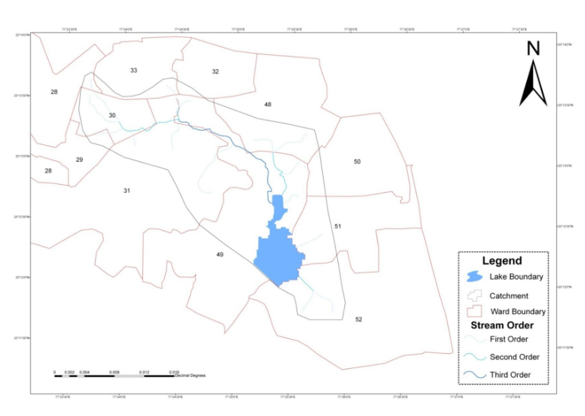

Figure 2. Wards located around the Shahpura Lake catchment area (Madhya Pradesh Water Resources Department, 2012)

Table 2: Decadal population growth in Wards surrounding the Shahpura Lake

|  |  |  |  |  |  |  |  |  |
| --- | --- | --- | --- | --- | --- | --- | --- | --- |
| **Ward No.** | **2001** | | | **2011** | | | **Change (2001-2011)** | |
| **NH** | **TP** | **TP (%)** | **NH** | **TP** | **TP (%)** | **NH** | **TP** |
| **28** | 4869 | 23395 | 8.99 | 6607 | 27968 | 10.18 | 1738 | 4573 |
| **29** | 5391 | 25260 | 9.7 | 3997 | 17898 | 6.51 | -1394 | -7362 |
| **30** | 3275 | 15264 | 5.86 | 5323 | 23652 | 8.61 | 2048 | 8388 |
| **31** | 7374 | 35577 | 13.67 | 6521 | 26621 | 9.69 | -853 | -8956 |
| **32** | 3636 | 17507 | 6.73 | 3157 | 15832 | 5.76 | -479 | -1675 |
| **33** | 2181 | 11220 | 4.31 | 2843 | 13591 | 4.95 | 662 | 2371 |
| **48** | 4507 | 19859 | 7.63 | 1797 | 7880 | 2.87 | -2710 | -11979 |
| **49** | 6011 | 28692 | 11.02 | 4063 | 16090 | 5.86 | -1948 | -12602 |
| **50** | 3799 | 17855 | 6.86 | 7245 | 31830 | 11.59 | 3446 | 13975 |
| **51** | 5290 | 23621 | 9.08 | 7238 | 29382 | 10.69 | 1948 | 5761 |
| **52** | 9450 | 42035 | 16.15 | 14859 | 63984 | 23.29 | 5409 | 21949 |
| **Total** | 55783 | 260285 |  | 63650 | 274728 |  |  | 14443 |

*NH = No of households, TP = Total Population, AP/H = Average no of persons/Household*

*\*rounded off to a single decimal*

*Data source: Census of India 2001 and 2011*

**3.1.2 Urban Sprawl in Bhopal**

The distribution of the population in the Bhopal District is highly skewed. Over 80% of the total population reside in the urban areas. Of the urban population, about 94% reside in the Bhopal city alone. Of the total 2772 km2 area of the Bhopal District, the urban area is only about 350.05 km2, of which Bhopal Municipal Corporation has an area of about 285.88 km2. Urbanization peaked after Bhopal was made the capital of Madhya Pradesh. The land area under planning by the Bhopal Development Authority grew from 5326.48 ha in 1989, urban sprawl increased to 20719.36 ha in 2018 (**Fig. 2 and Fig. 3**). Maximum increase in the sprawl can be seen from 1994 to 1999 (48.97%) and from 2005 to 2011 (40.77%). The land use was conducted by the Land Use and Urban Survey Division of the MPCSTC. The land use was categorised into industrial, commercial, residential, public and semi-public, transportation, public utilities and recreation activities.

With the rapid urbanization of Bhopal city, planned urban development was undertaken to provide the necessary infrastructure, health, education, and employment to support the requirements of the growing population. There was a change in the land use planning of the city as well. In 1961, the maximum area (1056 ha) was used for residential purposes to cater to the population, which more than doubled over the last decade. Industrial land increased by 335% from 1961 to 1994. Area under transport also tripled from 1961 to 1994 to provide for easy commute to the people, workers, and for economic development. A major land use change was seen for recreation purposes. It increased by 1323% in 33 years (from 1961 to 1994). This can be attributed to providing a good quality of life to the residents. Recently researchers have undertaken Land Use Land Change studies to understand the changing landscape of Bhopal city. As there are differences in the area under study and the land use category across different studies, it is difficult to compare result. But it is observed that over the years, there has been rise seen in the built-up area, whereas a decline is observed in the agricultural land, forest land, vegetation, and lakes/water bodies. Built-up area has increased rapidly (**Ghosh, 2019, Jain et al., 2019, Das & Mehrotra, 2022, Garg & Mishra, 2024**).

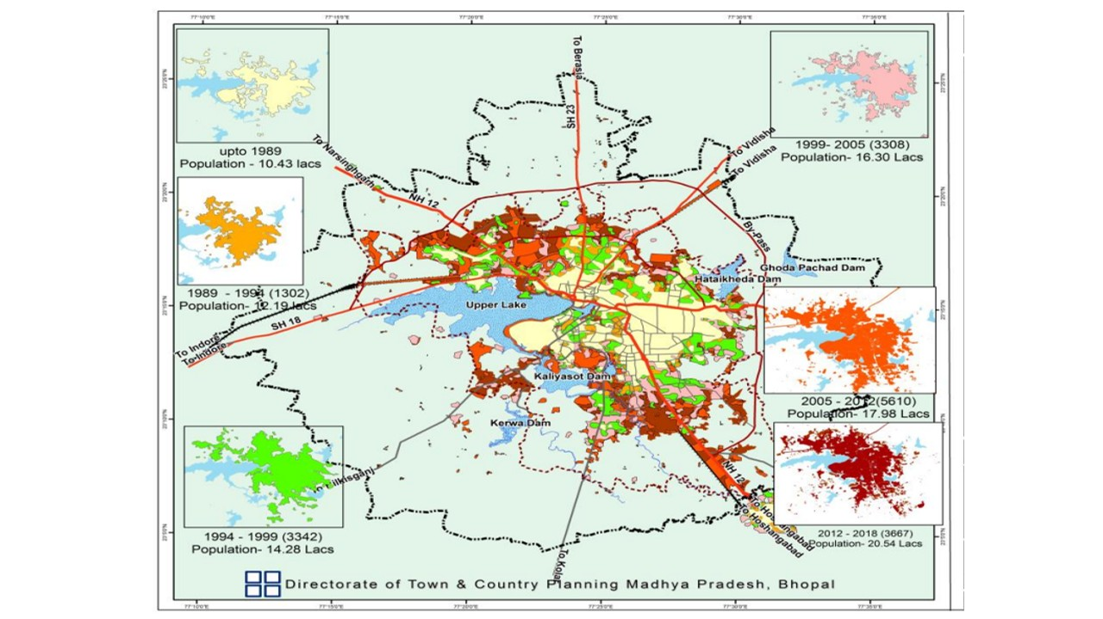

Source: Bhopal Development Plan 2031

Figure 3. Map showing change in the area under urban sprawl of Bhopal city from 1989 to 2018.

Figure 4. Area under urban sprawl of Bhopal city, Madhya Pradesh, India from 1989 to 2018.

**3.1.3 Industrial Development**

Heavy Electricals (India) Limited, i.e., HE(I)L (Now BHEL), was established on 29th August 1956 to manufacture heavy electrical equipment. For this, an agreement was made by the Indian Government with Associated Industries (AEI), UK, on 17th November 1955. Next to BHEL, in the central region of the city, an ancillary unit was developed in the Govindpura area, which was developed around 1966. It is now an identified Engineering Cluster. In the 1970s, a major industrial area was developed in the south of Bhopal city in Mandideep. In 1989, Nishatpura Coach Factory and Railway workshop for rehabilitation of Indian Railways coaches was established just 2 km away from the Bhopal Railway Station. Many dedicated industrial areas have been developed in Bhopal like Govindpura (317 ha), Acharpura (147.34 ha), Bagroda (128.02 ha), Bandikheda (78.54 ha), Kaliparad (10.22 ha), and Press Complex (0.3 ha) (Madhya Pradesh Industrial Development Corporation).

A total of 10,989 MSMEs were registered between 1984 and 2011, with an average of 407 registration per year. From July 2020 to October 2023, a total of 9,28,327 Micro, Small, and Medium Enterprises (MSMEs) were registered in Madhya Pradesh, of which 62,410 (6.72%) no MSMEs were registered in the Bhopal District itself. Almost 96.68% of the MSMEs, i.e., 60,337, were Micro enterprises. The remaining 3.06 % (1912) were Small Enterprises, and 0.26% (161) were Medium Enterprises (MPSIDC).

**3.1.4 Sewage and Storm water discharge**

No underground sewerage existed in the city of Bhopal until the 1950s, except for the Ahmedabad area. Around 1973, only two areas, namely TT Nagar and BHEL, had well-planned sewerage systems. There were two sewage treatment plants in TT Nagar, namely in 'Char-imli' and behind the Shahpur hills. The sewage treatment plant in BHEL was maintained by its own management. By 2011, about 240 MLD of sewage was being generated in the Bhopal District, but the treatment capacity was limited to only 67 MLD, being carried out from the five STPs located at Maholi Damkheda, Badwai, Singpur Bhadhada, Gandhinagar, and Bawadiya Kalan. This catered to only about 30% of the population. The remaining sewage (~173 MLD) was being disposed of untreated.

With the launch of Atal Mission for Rejuvenation and Urban Transformation (AMRUT) in 2015, a total of 9 new STPs were added, making a total of 17 operational STPs all over Bhopal City with a total capacity of about 174 MLD **(Table 3)**. Additionally, with the renovation of existing and construction of new sewage pumping stations, laying 320 Km of sewerage network, and connecting them with the households across the city, now about 45% of the population of Bhopal City is connected to the sewerage network (NGT).

Table 3. STPs operational in the Bhopal City

|  |  |  |
| --- | --- | --- |
| **S. No.** | **Location** | **STP Capacity (MLD)** |
| 1 | STP Badwai, Village Badwai | 16.67 |
| 2 | STP Bawadiya Kalan, Jhuggi Basti, Shahpura | 13.56 |
| 3 | STP Gondarmau, Airport Road | 2.36 |
| 4 | STP Mata Mandir, T.T. Nagar | 4.56 |
| 5 | STP Kotra, Bhadbhada road | 10 |
| 6 | Bhopal BHEL, Barkheda | 4.5 |
| 7 | Bhopal BHEL, Piplani | 2.27 |
| 8 | STP Ekant Park# | 8 |
| 9 | STP Shirin River Beside Koh-e-fiza Square, VIP Road* | 5 |
| 10 | STP Misrod, Misrod, Bhopal* | 20.5 |
| 11 | Professor Colony, Bhopal* | 2 |
| 12 | STP Sankhedi, BMC* | 32 |
| 13 | STP Maholi Damkheda, Itkhedi Sadak* | 35 |
| 14 | STP Neelbad, BMC* | 6 |
| 15 | STP Char Imli, BMC* | 4.5 |
| 16 | STP Bansal Hospital, Chuna Bhatti, Bhopal* | 9.5 |
| 17 | Jamunia Jheer (Kalukhedi), Bhopal* | 3.5 |

*#Constructed under NRCP, *Constructed under AMRUT*

**3.1.5 Water Quality of Shahpura Lake**

Dixit *et al.* (2005) studied the nutrient load (nitrate and phosphate) of the lake and found that although the nitrate content was within the permissible limits, phosphate concentration was very high. Moreover, the nitrate content increased sharply from 2003 to 2004. Whereas the phosphate concentration decreased from 2003 to 2004. The concentrations were least during the rainy season due to the dilution effect of rain. The nitrate value was found to vary between 4.58 to 5.60 ppm and phosphate value between 6.11 to 7.93 ppm during Jan to June 2007 (Joshi et al., 2008). During winter, Trivedi and Kataria (2012) observed the total phosphorus value to range between 0.1 to 1.9 mg P/l. Recently, Wani and Dixit (2018) observed the level of orthophosphate to range from 2.28 ˗ 2.84 mg/l in summer to 2.18 ˗ 2.65 in Monsoon. They found the nitrate concentration to be within 2.31 – 2.76 mg/l.

Very high BOD and COD were observed in the months from March to June, indicating organic pollution (Joshi et al., 2008). Based on the hardness value (222.00+2 mg/l) observed in 2008, Chouhan et al., classified Shahpura Lake water as Hard. Similarly, Trivedi and Kataria (2012) also observed that all the sampling locations had the total hardness value of more than 220 mg/l. During winter, the DO value ranged from 0.8 to 7.0 mg/l, and COD between 8.0 to 130 mg/l (Trivedi and Kataria 2012). In another study carried out at different locations of the lake in the month of December, Dixit and Rahi (2017) observed the DO value to range between 5.0 ˗ 5.7 mg/l and the BOD value ranged between 100 to 200 mg/l. They found TDS ranged between 573 ˗ 596 mg/l and pH ranged from 7.2 ˗ 7.9. The average value of BOD and COD was lesser in Monsoon than in the Summer season (Wani and Dixit, 2018). Earlier in the Winter of 2011, the pH value between 7.5 and 8.4, TDS between 369 and 580 mg/l and EC between 655 and 980 µmho/cm was observed (Trivedi and Kataria 2012). Cu, Cr, Pb, Cd, and Mn were present in concentrations above the permissible limits of USPH (Dixit & Tiwari, 2008). Anu et al. (2011) found that the Pb and Cu were found more during the monsoon season than in summer.

MPPCB tests the Shahpura Lake water at the spillover site near Bansal Hospital, Shahpura Lake, on a monthly basis. The data was collected for a period from 2016 to 2022. A compilation of observed values of various physicochemical and biological parameters as observed in various studies and MPPCB is given in **Table 4**. The pH value is seen to vary from 6.8 to 8.8. Overall, a gradual decrease in the minimum and maximum values of pH was observed from 2016 to 2022. Value is found to be within the range for the class D designated use of water for the Propagation of wildlife and Fisheries. The minimum value of conductivity has also gradually decreased from 2016 to 2022, but no clear trend has been observed in the maximum value. The maximum amount of DO is observed to be gradually increasing over the years. Recently, in 2021 and 2022, the minimum value of DO has fallen below the recommended value of >4.0 mg/l. The recommended value of BOD is <3.0 mg/l, but the maximum value throughout (2016-2022) remained more than that with the maximum in 2020, i.e. 20 mg/l. Also, in 2020, the maximum load of faecal coliform and Total coliform was way too high, which decreased gradually in 2021 and 2022.

Data was collected from the CPCB from 2016 to 2022 to understand the recent changes in the water quality of Shahpura Lake. CPCB and MPPCB calculate the Water Quality Index (WQI) by using the four parameters, namely DO, BOD, FC, and TC and categorize the water quality as satisfactory or not satisfactory (**Fig. 5**). The water quality was not satisfactory from 2017 to 2021. In 2022 and 2023, for a few months, the water quality was satisfactory.

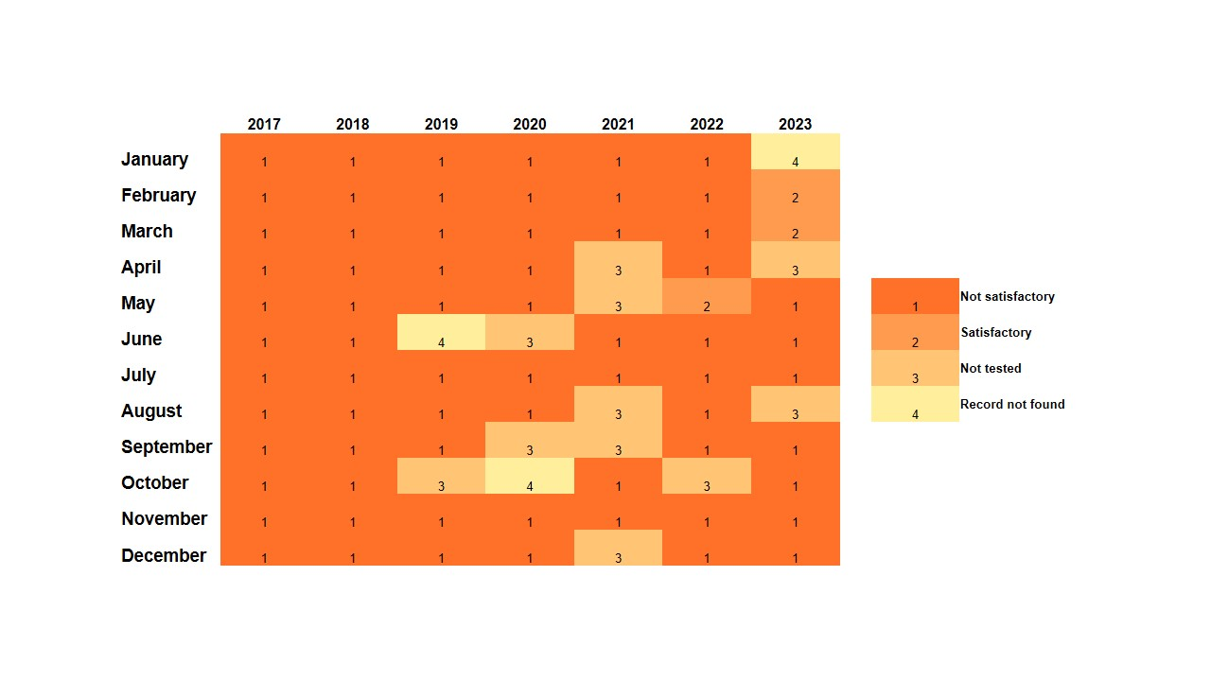

Figure 5: Water Quality status of Shahpura Lake (Data Source: MPPCB)

Table 4. Physicochemical and biological parameters of the water of Shahpura Lake, Bhopal, India

|  |  |  |  |  |  |  |  |  |  |  |  |  |  |  |  |
| --- | --- | --- | --- | --- | --- | --- | --- | --- | --- | --- | --- | --- | --- | --- | --- |
| Year | Temperature (°C) | | pH | | Conductivity (μmhos/cm) | | Dissolved O2 (mg/L) | | BOD (mg/L) | | Faecal Coliform (MPN/100ML) | | Total Coliform (MPN/100ML) | | Reference |
| **Min** | **Max** | **Min** | **Max** | **Min** | **Max** | **Min** | **Max** | **Min** | **Max** | **Min** | **Max** | **Min** | **Max** |  |
| 2006  (June-Nov) | 24.7 | 36.6 | 7.0 | 8.6 | 280 | 380 | 3.2 | 7.5 | 2.6 | 15.2 | - | - | - | - | Dubey et al., 2013 |
| 2012-2013 | 12 | 26 | 7.21 | 8.71 | 301 | 830 | 1.6 | 16.2 | 1.3 | 20 | - | - | - | - | Shivhare et al. 2014 |
| 2015  (Summer & Monsoon) | 30.4 | 38.7 | 7.6 | 8.3 | 390 | 780 | 3 | 4 | 24 | 32 | - | - | - | - | Wani & Dixit,2018 |
| 2016* (July-Dec) | 18.5 | 25.4 | 7.55 | 8.37 | 539.4 | 689.4 | 5.5 | 11.7 | 6.2 | 18.4 | - | - | - | - | Shukla & Thakur, 2017 |
| 2016 |  |  | 7.4 | 8.7 | 546 | 963 | 5.6 | 7 | 2.8 | 14 | 120 | 240 | 1600 | 1600 | Madhya Pradesh Pollution Control Board (MPPCB) |
| 2017 | 19 | 34 | 7.3 | 8.8 | 526 | 677 | 5.5 | 7.6 | 3.1 | 3.8 | 12 | 230 | 920 | 1600 |
| 2018 | 16 | 31 | 7.4 | 8.8 | 6 | 826 | 4.2 | 7.8 | 2.5 | 14 | 2 | 430 | 130 | 2400 |
| 2019 | 18 | 28 | 7.8 | 8.4 | 278 | 548 | 6.3 | 8.2 | 1.7 | 14 | 2 | 240 | 70 | 2600 |
| 2020 | 19 | 31 | 7.2 | 8.4 | 512 | 667 | 5.9 | 10.3 | 1.2 | 20 | 10 | 35000 | 540 | 1600000 |
| 2021 | 20 | 33 | 6.8 | 8.6 | 445 | 738 | 2.0 | 10.2 | 4.8 | 12 | 14 | 2100 | 280 | 220000 |
| 2022 | 18 | 31 | 6.8 | 8.2 | 424 | 883 | 3.3 | 9.9 | 1.8 | 11.6 | 6 | 1600 | 1600 | 1600 |  |
| CPCB WQI criteria |  |  |  |  |  |  | **> 4.0 mg/l** | | **< 3.0 mg/l** | | **<2500 MPN/100 ml** | | **<5000 MPN/100 ml** | |  |

*Average of five sites

**3.2 Acts, Policies and Schemes related to urban lakes in India**

In the ‘Constitution of India’, Article 51A (Fundamental Duties), section g states that It shall be the duty of every citizens of India “to protect and improve the natural environment including forests, lakes, rivers and wild life, and to have compassion for living creature”. To ensure that natural environment is available to all and is sustainably conserved and continuously improved, different acts and policies are formulated from time to time. Policies and Acts are made on national level by the Central Government, but the responsibility to ensure that it is implemented lies with the State Government, and is implemented by the local governing bodies. In India, various policies, schemes, and institutions responsible for ensuring the urban lakes have been formed. While some of the policies and schemes are dedicated exclusively to this, others include a component dedicate to urban lake within them. Some of these are given in the Table 5.

Table 5. Some of the Government policies, acts, and schemes for the conservation and improvement of urban lakes

|  |  |  |
| --- | --- | --- |
| Policy/Scheme | Enactment Year | Salient features concerning urban lakes |
| The Water (Prevention & Control of Pollution) Act, 1974 | 1974 | * Authorises Government to maintain the quality of the water bodies * Gives regulations for controlling the flow of sewage, industrial effluents, and pollutants into water bodies * Highlights the powers of Central and State Pollution Control Boards to accomplish the water bodies quality management and formulate standards, undertake monitoring of water bodies tasks |
| Environment Protection Act (EPA) | 1986 | * Authority to Central Government for conserving and improving environment (includes water, land, and air) * It enables Central Government to form authorities to tackle environmental problems * Conduct nation-wide awareness programs * Formulate standards |
| National Lake Conservation Plan (NLCP), Ministry of Environment, Forest and Climate Change | 2001 | * Focuses on conservation and restoration of urban, semi-urban, and unique lakes polluted with waste water inflow from point sources. * Includes diversion as well as interception and treatment of wastewater in the catchment area. * Funds for these are contributed by both the Central and State Government * NLCP was merged with National Wetlands Conservation Program (NWCP) and a new Scheme “National Plan for the Conservation of Aquatic Ecosystems’ was formed in 2013 |
| National Project on Repair, renovation and restoration of water bodies with domestic/external assistance, Ministry of Water Resources | 2005 | * Deals with renovation of selected large polluted water bodies receiving agricultural runoff to ensure availability of drinking water * Provide funds |
| National Environment Policy (NEP), Ministry of Environment, Forest and Climate Change | 2006 | * Provide guidance on Preserving critical environmental resources and their efficient use * Cultivate partnership between different stakeholders * Promote livelihood of people dependent on an environmental resource * Action Plan for water bodies focusing on conservation and judicious use * Formulation of a legal implementable regulatory mechanism for water bodies. |
| Guidelines for idol immersion, CPCB, Ministry of Environment, Forest and Climate Change | 2010  2020 (Revised Guidelines) | * Includes Guidelines for idol makers, Festival organizing committees, idol immersion in lakes, rivers, pond, and sea, responsibilities and role of local and urban bodies, state pollution control boards and pollution control bodies * Provides for temporary construction of ponds/tanks in open ground or selected areas of water bodies, disposal of generated waste * Construction of separate permanent cemented tanks for idol immersion |
| National Plan for Conservation of Aquatic Eco-systems (NPCA), Ministry of Environment, Forest and Climate Change | 2013 | * Deals with holistic conservation and restoration of lakes and wetlands * Also includes beautification surrounding the lakes * Funds provided to state governments |
| Urban and Regional Development Plans Formulation And Implementation (URDPFI) Guidelines, Ministry of Urban Development | 2014 | * Lists Land use classification of water bodies including lakes * Directs State and ULBs to conserve lakes as per the MoEF’s ‘Advisory Report for Conservation and Restoration of Water Bodies in Urban Areas’ in the City Development Plans. |
| Atal Mission for Rejuvenation and Urban Transformation (AMRUT), Ministry of Housing and Urban Affairs (MoHUA) | 2015 | * Aim is to provide water supply (rejuvenation of water bodies for drinking water and recharge of ground water) to all * Provide sewerage facilities and septage management (New, augmentation and rehabilitation of sewerage systems and treatment plants; Faecal sludge management) * storm water drains to reduce flooding (Construction & improvement of drains and storm water drains) * Funds provided by the Central Government to State Governments and Union Territories * Brought out ‘Waterbody Rejuvenation Advisory’ in 2023 to help stakeholders devise a detailed plan to restore and manage urban lakes |
| Guidelines on Water Quality Monitoring, CPCB, Ministry of Environment, Forest and Climate Change | 2017 | * To ensure uniformity in testing by the water quality assessment agencies for water bodies including lakes, it provides guideline for frequency of sampling, minimum number of parameters to be analysed, and methodology to be used |

**3.3 Government Interventions in Shahpura Lake**

**3.3.2 Madhya Pradesh Pollution Control Board (MPPCB)**

MPPCB is the state-level body responsible for monitoring the quality of the water reservoirs in the state. Every month, as per the CPCB guidelines, MPPCB monitors Shahpura lake water near the spillout, which is located near the Bansal hospital.

**3.3.3 Bhopal Municipal Corporation (BMC)**

Lake Conservation Cell in the Health and Environment Division of the BMC. The budget includes provision for lakefront park development, the expenses for the lifeguards at the Lakes, expenditure for idol immersion, operation and maintenance activities like the cleaning of lakes, installation and maintenance of fountains, maintenance of machinery for lake conservation, beautification of Lake, and maintenance of STP Plant/Sewage pump. At the suggestion of the NGT in 2014, BMC installed wire mesh at certain locations of the lake to prevent solid waste from entering the lake. In the case of Shahpura Lake, a separate area has been constructed for idol immersion near the Campion School Road (**Fig. 6**).

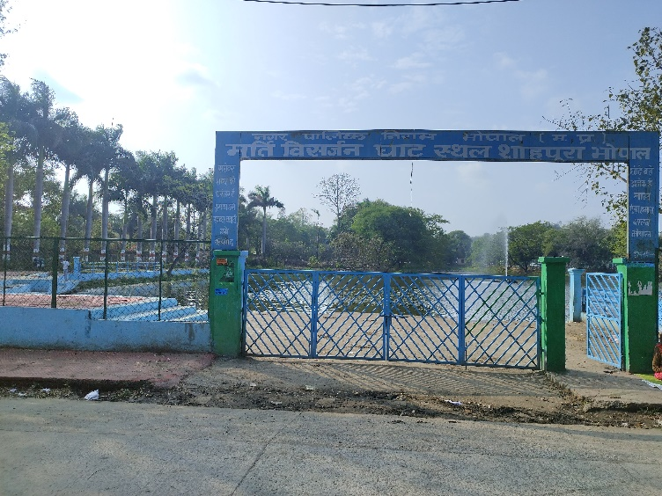

Figure 6. A separate idol immersion site at Shahpura Lake

**3.3.4 Atal Mission for Rejuvenation and Urban Transformation (AMRUT)**

AMRUT, under the Ministry of Housing and Urban Affairs, Govt of India, was created to provide facilities like the water supply, sewage, and urban transport. Under AMRUT 1.0, four new STPs have been constructed with a collective capacity of 23.5 MLD in the catchment area of Shahpura Lake. In addition, 13 sewage pump houses have been built, and about 100 Km of sewerage network has been laid in the Shahpura Lake catchment area. Further, of the 68 drains across the city, 57 have been intercepted and diverted through the sewerage network to the STPS, thereby reducing the pollution load to the lakes. It is expected to improve the lake water quality. In AMRUT 2.0, a project, "Rejuvenation of Shahpura Lake in the city of Bhopal", has been sanctioned with the project cost of INR 12 crores for a period of two years, i.e., 2024 to 2026. Further, it is also planned to increase the sewerage coverage in Bhopal city with a project cost of INR 1177.79 crores.

**3.3.5 National River Conservation Plan (NRCP)**

NRCP is a scheme of the Ministry of Jal Shakti, Govt of India, under the Department of Water Resources, River Development & Ganga Rejuvenation. In this scheme, funds are provided to the State Government/ Local Bodies for pollution mitigation. Under this scheme, one Waste Stabilization Pond with 8 MLD capacity was built for the treatment of the sewage carried from the New Bhopal area by the Panchsheel Nallah, which leads to Shahpura Lake. The interception was done near the Patrakar Colony to a sewage line and then to WSP of the size 255 m X 140 m and the retention time of 5 days.

**3.3.6 Directorate of Town and Country Planning**

DTCP is responsible for the Bhopal Development Plan (BDP). In the BDP 2005, about 6225 ha of land was earmarked for recreational purposes. Through this, parks adjoining the Shahpura Lake, namely Shahpura and Ekant Park, were developed.

**3.3.7 Environmental Planning & Coordination Organization (EPCO)**

EPCO was established in 1981 by the Housing and Environment Department of the Govt of Madhya Pradesh. It is now under the Urban Development and Environment Division. In 2007-2008, 88.26 lacs and in 2013-2014, 50 lakh for the Shahpura Lake was given to BMC for its conservation and maintenance.

**4. Discussion**

Irrigation was the primary designated use of this reservoir water, but gradually, after 1975, fisheries, Aquaculture, and recreational activities were also promoted (Munoth & Nagaich, 2015). Earlier, Shahpura Lake used to receive untreated sewage and wastewater from the Eastern, Northern and Southern parts of the lake (Wani and Dixit 2018). Areas adjoining the Shahpura Lake are also sensitive and prone to floods and water logging during the rainy seasons. Urban developmental activities may cause changes in the natural drainage of an area. Substantial rainfalls can cause floods in low-lying areas. Stormwater from the New Bhopal area, which is located in the central region of Bhopal city, is drained into the Shahpura Lake through the 8 km long Katsi Nallah. The excess water from the Shahpura Lake during the heavy rains flows through the spill outlet behind the Bansal Hospital and meets the *Kaliasote River*, which ultimately drains into *River Betwa*.

To solve the problem of untreated sewage water entering the Shahpura Lake, a waste Stabilization/Oxidation Pond was constructed in the North of the Shahpura Lake. This was done to prevent the sewage from the Panchsheel Nalla from directly entering the lake. The sewage treated at the STP located at Mata Mandir enters the Panchsheel Nalla through the Anjali Nalla and ultimately enters the Shahpura Park. Under the AMRUT (2015) scheme, a focus has been placed on sewage treatment and management in and around Shahpura Lake. It is expected that the sewage load of the lake will now be reduced. Metallic fencing around the lake has been done to prevent the dumping of solid waste and idols into the lake. Dixit & Tiwari (2007) found that following immersion of idols, there was an increase seen in the physic-chemical parameters like the pH and hardness and heavy metals like Cr, Ca and Pb. Two of urban lakes in Bangalore (Nagavara and Ulsoor lake) showed increase in the nitrate, BOD, COD and metal ion post idol immersion (Gorain & Paul, 2019). Vyas et al. (2007) also observed increased levels of heavy metals in the water of the upper lake after idol immersion. To overcome this, a separate area has been earmarked for the dispersal of idols during religious festivals (**Fig. 3**).

All these interventions have contributed to some improvement in the lake water quality, as visible in **Table 4**. The pH of lake water is within the permissible limit of 6.5-8.5 as specified in the CPCB's designated best-use water quality for class D (Propagation of wildlife and fisheries). Improvement in DO and BOD is still needed. Similar observations were seen in Sukhna Lake which receives sewage through drains and is one of the lakes selected under National Lake Conservation Plan (NLCP). Different WQI studied indicate the lake quality to range between marginal to fair category. The lake was observed to be alkaline and showed increasing alkalinity and hardness. Quality was better during monsoon and post-monsoon season than summer and winter (Maansi et al., 2022). Chaohu Lake, an urban lake in China showed a marked improvement over the period of ten years (2011-2020) due to action taken under government policies. An improvement ranging from 7% to 35% was observed in the east and the west sides of the lake. The lake has been under protection since 1996. (Wang et al., 2023).

As fisheries are done in Shahpura Lake for human consumption, regular monitoring of fish should be undertaken. It is not enough to restrict human activity; we should also focus on dissolved contaminants and nutrient enrichment. Urbanization and population growth create pressure on available resources, including water. Chen et al., 2025 found that accelerated urbanization was one of the factors that caused a reduction in the area of Dianchi Lake, China. Yao et al. (2023) observed that spatiotemporal changes of LULC affected river water quality due to rapid urbanization. The BOD, Total Nitrogen, Total Phosphorus positively correlated with construction land, and DO was negatively correlated. Although predicted value of Total Nitrogen in 2030 indicated no increase, but value of Total Phosphorus did, if urbanization continued. Anthropogenic activities leading to land use changes and increased addition of nutrients (nitrogen and phosphorus) have negative impact on lakes making restoration difficult (Schallenger et al., 2013).

Nur et al. (2024) also found that anthropogenic activities have impacted the water quality of Lake Victoria and that specific pollution control measures, along with regular monitoring, should be undertaken to prevent further deterioration of the water quality. There is a direct correlation between sewage, agricultural waste, and industrial effluent generation to pollution. The urban population in India was about 20% in 1950. By 2018, it was 34% and is expected to more than double by 2050 (UNDESA, 2019). Hence, with continued migration towards urban areas, it will be important to take timely actions to prevent further deterioration of urban lake water and to restore them keeping in view their significance in urban settings. To counterattack the effect of rapid urbanization, proper urban planning with efforts at local, national and international of various stakeholders is needed and critical to ensure survival and health of urban water bodies (Krishnan et al., 2024).

**5. CONCLUSION**

The study highlighted that it is of utmost importance that water resources be conserved in a water-stressed nation. It is also important that all the stakeholders come together, as concerted efforts are needed on everyone's part. The physicochemical parameters reveal that there is a need to reduce the nutrient load (nitrogen and phosphorus) and also the organic load. Regular biological monitoring may also be adopted to assess the lake water quality, as their presence is dependent on and is a reflection of the total changes in the physicochemical parameters. There is a need for further research to understand the complex interactions between urban development and lakes. As each lake has unique characteristics, measures for conservation may be specific, too.

**DISCLAIMER (Artificial intelligence)**

Author(s) hereby declare that NO generative AI technologies such as Large Language Models (ChatGPT, COPILOT, etc.) and text-to-image generators have been used during the writing or editing of this manuscript.

**7. REFERENCES**

Jaysawal, N., & Saha, S. (2014). Urbanization in India: An impact assessment. *International Journal of Applied Sociology*, 4(2), 60-65. https://doi.org/10.5923/j.jas.20140402.04

Bhagat, R. B. (2014). Urban migration trends, challenges and opportunities in India, World Migration Report 2015. Background Paper. International Organization for Migration. https://www.iom.int/sites/g/files/tmzbdl2616/files/2018-07/WMR-2015-Background-Paper-RBhagat.pdf

Population Division, Department of Economic and Social Affairs, United Nations. (2019). World Urbanization Prospects. The 2018 Revision. https://population.un.org/wup/assets/WUP2018-Report.pdf

https://www.thehindubusinessline.com/economy/agri-business/indias-per-capita-water-availability-to-decline-further-icar/article29342714.ece

Trivedi, K., Kapshe, M., Das, V. M., & Bade, S. (2023). Groundwater pricing strategies for Indian cities – a case of Kanpur. *Urban Water Journal*, 20(4), 498-512. https://doi.org/10.1080/1573062X.2023.2184701

Central Pollution Control Board. (2011). Status of Water Quality in India.

Kumar, R. (2018). Assessment of water quality status of lakes in Haryana, India, *International Journal of Recent Scientific Research*, 9, 27831-27835.

Krishnan, G., Radha Krishnan, S. P. & Senthil, R. (2024). Ecological effect of land use and land change changes on lakes in urban environments. *Sustainable Development*. 32, 6801-6818. https://doi.org/10.1002/sd.3065

Qi, X., Wang, J., & Yao, F. (2025). Impact of small lakes and underlying surface characteristics on local thermal environments in summer. *Water*. 17, 1327. https://doi.org/10.3390/w17091327

Jandaghian, Z., & Colombo, A. (2024). The Role of Water Bodies in Climate Regulation: Insights from Recent Studies on Urban Heat Island Mitigation. *Buildings*. 14, 2945. https://doi.org/10.3390/ buildings14092945

Schallenberg, M., de Winton, M. D., Verburg, P., Kelly, D. J., Hamill, K. D., & Hamilton, D. P. (2013). Ecosystem services of lakes. *In* Dymond JR ed. Ecosystem services in New Zealand – conditions and trends. Manaaki Whenua Press, Lincoln, New Zealand.

Deines, A. M., Bunnell, D. B., Rogers, M. W., Bennion, D., Woelmer, W., Sayers, M. J. (2017). The contribution of lakes to global inland fisheries harvest. *Frontiers in Ecology and the Environment*. 15(6), 293-298. https://doi.org/10.1002/fee.1503

Kangabam, R. D., Bhoominathan, S. D., Kanagaraj, S. & Govindaraju, M. (2017). Development of a water quality index (WQI) for the Loktak Lake in India. *Applied Water Science*, 7 (6), 2907–2918.

Tyagi, S., Sharma, B., Singh, P., & Dobhal, R. (2013). Water Quality Assessment in Terms of Water Quality Index. *American Journal of Water Resources*. 1(3), 34-38. https://doi.org/10.12691/ajwr-1-3-3

Zotou, I., Tsihrintzis, V. A., & Gikas, G. D. (2020). Water quality evaluation of a lacustrine water body in the Mediterranean based on different water quality index (WQI) methodologies. *Journal of Environmental Science and Health, Part A*, *55*(5), 537–548. https://doi.org/10.1080/10934529.2019.1710956

Mogane, L.K., Masebe, T., Msagati, T.A.M., & Ncube, Esber. (2023)*.* A comprehensive review of water quality indices for lotic and lentic ecosystems. *Environmental Monitoring and Assessment*. **195**, 926. https://doi.org/10.1007/s10661-023-11512-2

Chidiac, S., El Najjar, P., Ouaini, N., El Rayess, Y., & El Azzi, D. (2023). A comprehensive review of water quality indices (WQIs): history, models, attempts and perspectives. *Reviews in Environmental Science and Biotechnology*. **22**, 349–395. https://doi.org/10.1007/s11157-023-09650-7

Yao, F., Livneh, B., Rajagopalan, B., Wang, J., & Cretaux, J-F., Wada, Y., et al. (2023). Satellites reveal widespread decline in global lake water storage. *Science*, 380, 743-749. https://doi.org/10.1126/science.abo2812

https://www.unwater.org/sites/default/files/app/uploads/2018/10/WaterFacts_water_and_watewater_sep2018.pdf

Hong, Y., Soulignac, F., Roguet, A., Li, C., Lemaire, B. J., Martins, R. S., *et al.* (2021). Impact of *Escherichia coli* from stormwater drainage on recreational water quality: an integrated monitoring and modelling of urban catchment, pipes and lake. *Environmental Science and Pollution Research*. 28, 2245–2259. https://doi.org/10.1007/s11356-020-10629-y

Wu, Q., Xia, X., Li, X., & Mou, X. (2014). Impacts of meteorological variations on urban lake water quality: a sensitivity analysis for 12 urban lakes with different trophic states. *Aquatic Sciences*. 76:339351. DOI 10.1007/s00027-014-0339-6

Wang, X., Yang, Y., Wan, J., Chen, Z., Wang, N., Guo, Y. (2023). Water quality variation and driving factors quantitatively evaluation of urban lakes during quick socioeconomic development. *Journal of Environmental Management*. 344, 118615. https://doi.org/10.1016/j.jenvman.2023.118615.

Kabir M. H., Hanif A., Moon N. A., Shammi R. S., Choity M. M. H., Kabir M. S., et al. (2025). Trophic State and Water Quality Dynamics of Banani Lake in Bangladesh: Insights from Physicochemical and Biological Indicators. *Journal of Materials and Environmental Science*. 16(7), 1177-1188

Directorate of Town and Country Planning, Government of Madhya Pradesh. https://mptownplan.gov.in/plan_bhopal.html

Trivedi, S., & Kataria, H. C. (2012). Physico-Chemical Studies of Water Quality of Shahpura Lake, Bhopal (M.P) with Special Reference to Pollution Effects on Ground Water of its Fringe Areas, *Current World Environment*, 7(1), 139-144.

Munoth, N., & Nagaich, A. A. (2015). Planning interventions for lake conservation: A case of Shahpura Lake, Bhopal, India. *Journal of the Institution of Engineers (India)*: *Series A*. 96, 193-205. https://doi.org/10.1007/s40030-015-0127-x

Saxena, S. (2014). The role of benthic invertebrate species in freshwater ecosystem zoobenthic species influence energy flows and nutrient cycling in Shahpura Lake, Bhopal (M.P.). *International Journal of Advanced Research*. 2(8), 686- 693.

Central Pollution Control Board. https://cpcb.nic.in/nwmp-data/

Madhya Pradesh Pollution Control Board. <https://www.mppcb.mp.gov.in/XGNView.aspx?h=Water%20Quality%20Index%20(WQI)&u=https://xgn.mp.nic.in//File_Upload/view_WQI%20River_report.aspx>

Kundu, S., Coumar, M. V., Rajendiran, S., Ajay, & Rao, A. S. (2015). Phosphates from detergents and eutrophication of surface water ecosystem in India. Current Science. 108(7), 1320-1325.

Conley, D. J., Paerl, H. W., Howarth, R. W., Boesch, D. F., Seitzinger, S. P., Havens, K. E., et al. (2009). Controlling Eutrophication: Nitrogen and Phosphorus. *Science*. 323, 1014-1015. https://doi.org/10.1126/science.1167755

Paerl, H.W., Otten, T.G. (2013). Harmful Cyanobacterial Blooms: Causes, Consequences, and Controls. *Microbial Ecology*. 65, 995–1010. https://doi.org/10.1007/s00248-012-0159-y

Madhya Pradesh Water Resources Department. (2012). The impact of Shahpura Lake on Ground Water Environment, Bhopal. World Bank Aided Hydrology Project.

Ghosh, S. (2019). A city growth and land-use/land-cover change: A case study of Bhopal, India. Modeling Earth Systems and Environment. 5, 1569–1578. https://doi.org/10.1007/s40808-019-00605-y

Jain, S., Kumar, A., Jaiswal, R. K., & Nayak, T. R. (2019). Land Use Dynamics of Bhopal City Using Free & Open Source Geospatial Techniques. *National Conference on Recent Developments in Civil Engineering Infrastructure (RDCI 2019)*

Das, N., & Mehrotra, S. (2023). Impact of Urban Expansion on Wetlands: A Case Study of Bhoj Wetland, India. *Journal of the Indian Society of Remote Sensing*. 51, 1697–1714 (2023). https://doi.org/10.1007/s12524-023-01728-7

Garg, K., & Mishra, H. (2024). Analysis of land use and land cover changing patterns of Bhopal using geographical information system (GIS). *International Journal of Progressive Research in Engineering Management and Science*. 4(8), 601-606.

Madhya Pradesh State Industrial Development Corporation Limited. <https://mpsidc.com/>

Dixit, S., Gupta, S. K., & Tiwari, S. (2005). Nutrient Overloading of fresh water Lake of Bhopal. *Electronic Green Journal*. 21. https://doi.org/10.5070/G312110588

Joshi, S., Udhalikar, P., & Rawtani, P. M. (2008). Nutrient load on sewage fed Shahpura Lake and possible eutrophication. *Current World Environment*. 3(2), 311-312.

Trivedi, S., & Kataria, H. C. (2012). Physico-chemical studies of water quality of Shahpura Lake, Bhopal (M.P) with special reference to pollution on ground water of its fringe areas. *Current World Environment*. 7(1), 139-144.

Bhopal Municipal Corporation, Bhopal. https://www.bmconline.gov.in/

Atal Mission for Rejuvenation and Urban Transformation (AMRUT). AMRUT.gov.in

National River Conservation Directorate. https://nrcd.nic.in/

Environmental Planning & Coordination Organisation. <https://epco.mp.gov.in/>

Wani, M. A., & Dixit, M. (2018). Water quality assessment of Shahpura Lake, Bhopal (M.P) India using benthic macro-invertebrates. *Flora and Fauna*. 24(1), 126-134. https://doi.org/10.33451/florafauna.v24i1pp126-134

Chouhan, S., Shukla, G., Mulchandani, V., Sharma, V. K., & Mehrotra, N. N. (2009). Physico-chemical characteristics of certain water bodies of Bhopal, India. *Current World Environment*. 4(1), 55-62. https://doi.org/10.12944/CWE.4.1.08

Dixit, D., & Rahi, D. C. (2017). Assessment of water quality index of Shahpura Lake Bhopal and its restoration. *International Journal for Research in Applied Science & Engineering Technology*. 5(1), 222-228.

Dixit, S., and Tiwari, S. (2008). Impact Assessment of Heavy Metal Pollution of Shahpura Lake, Bhopal, India, *International Journal of Environmental Research*. 2(1): 37-42.

Anu, Upadhyaya, S. K., & Bajpai, A. (2011). Heavy Metal Analysis of Various Water Bodies Located in and around Bhopal, M.P. (India), *International Journal of Environmental Science and Development*, 2(1), 27-29.

Dubey, M., Tiwari, A. K., & Ujjania, N. C. (2013). The study of physico-chemical parameters of Shahpura Lake, Bhopal (India). *International Journal of Advanced Research*. 1(8), 158-164.

Shivhare, S., Singh, P., Tiwari, A., Mishra, A. K., & Bhadoria, A. K. S. (Nov 2013-Jan 2014). Physicochemical analysis of water quality of Shahpura Lake Bhopal in reference to *Scenedesmus obliquus* and *Monoraphidium minutum* algae. *Journal of Chemical, Biological and Physical Sciences*. Section D. 4(1), 782-786.

Shukla, S., & Thakur, R. (2017). Distribution pattern of algal species in Shahpura Lake, Bhopal, with respect to physic-chemical parameters. *International Journal Pharmaceutical & Biological Archives*. 8(5), 29-32.

Dixit S., & [Tiwari](https://www.tandfonline.com/author/Tiwari%2C+Suchi), S. (2007). Effects of religious practices on water quality of Shahpura Lake, Madhya Pradesh, India, *Water International*, 32(sup1), 889-893.

Gorain. B., & Paul, S. (2019). Effect of idol immersion activities on the water quality of urban lakes in Bengaluru, Karnataka. *Current World Environment*. 14(1). https://doi.org/10.12944/CWE.14.1.13

Vyas, Anju, Bajpai, A, Verma, N, Dixit, S. (2007). Heavy metal contamination cause of idol immersion activities in urban lake bhopal, India. *Journal of Applied Sciences and Environmental Sciences*. 2007, 11(4), 37 – 39

Maansi, Jindal, R., & Wats, M. Evaluation of surface water quality using water quality indices (WQIs) in Lake Sukhna, Chandigarh, India. *Appl Water Sci* **12**, 2 (2022). https://doi.org/10.1007/s13201-021-01534-x

Chen, C., Xie, M., Du, Y., & Jia, B. (2025). Impact of urbanization on hydrological balance in urban lakes: a case study of Dianchi Lake. *Discover Applied Sciences*. 7, article no 462. https://doi.org/10.1007/s42452-025-06905-6

Yao, S., Chen, C., He, M., Cui, Z., Mo, K., Pang, R., & Chen, Q. (2023). Land use as an important indicator for water quality prediction in a region under rapid urbanization. *Ecological Indicators*.146, 109768. https://doi.org/10.1016/j.ecolind.2022.109768.

Nur, M. S., Nabukonde, A., & Barakagira, A. (2024). Uncovering the anthropogenic influences on the water quality: A case of Lake Victoria shores, Entebbe, Uganda. *Asian Journal of Environment and Ecology*. 23(11), 72-83. https://doi.org/10.9734/ajee/2024/v23i11623