Navigating Mobility and Livelihoods: An Empirical Study of Two-Wheeler Taxi Services in Mon Town, Nagaland

**ABSTRACT**

This research examines the growth and obstacles faced by two-wheeler taxi services in Mon Town, Nagaland—an isolated, mountainous area where traditional public transportation is constrained by geography and infrastructure. Utilizing primary survey data gathered from 70 individuals (including 40 drivers and 30 passengers), the research explores income patterns and the operational dynamics of informal mobility systems. Through descriptive statistics and a multiple linear regression analysis, we discover that fuel costs and seasonal factors significantly affect daily earnings, while driving experience has a minimal effect. Visual analysis further corroborates these findings, demonstrating strong correlations between operational efforts, expenses, and income. As per the research, two-wheeler taxis provide a versatile option for ad- dressing last-mile transportation challenges in rural regions and serve as a viable employment opportunity for unemployed youth. Policy implications highlight the necessity for infrastructure enhancements, fuel subsidies, and safety training specific to these informal transportation systems. This paper presents suggestions for formulating inclusive transport policies and adds to the limited empirical studies on rural mobility innovations in Northeast India.

**Keywords:** Two-wheeler taxis, informal transport, rural mobility, Mon Town, seasonal income, fuel cost, employment generation

# Introduction

Mobility is essential for gaining access to jobs, education, healthcare, and social connections. While larger Indian cities benefit from organized public transit systems, smaller and more remote areas—especially hilly regions such as Nagaland—struggle significantly with transportation challenges due to inadequate infrastructure, dispersed populations, and geographical barriers. In these situations, informal transportation solutions often arise as community-driven initiatives to fill the gaps in mobility. A noteworthy example of this is the emergence of two-wheeler taxi services in Mon Town, a distant urban area in Northeast India.

These two-wheeler taxis are informal services that have grown increasingly popular, mainly operated by unemployed or underemployed youth who utilize their own motorcycles to offer affordable and adaptable transport for local residents. These services effectively navigate narrow and rugged terrains that traditional vehicles often cannot access. Recent research indicates that bike taxis are becoming a favored choice for cost-effective and scalable last-mile connectivity solutions in urban and semi-urban India **(KPMG, 2024).** Despite their rising relevance, these mobility systems remain largely unexplored in the Indian context, particularly in non-metropolitan, tribal areas.

The purpose of this research is to examine the operational features, revenue trends, and factors affecting the functioning of two-wheeler taxi services in Mon Town. To identify the elements that influence the daily earnings of drivers, the study employs multiple linear regression and descriptive analysis on primary data obtained from both drivers and passengers. The results provide empirical evidence that can inform future policy-making, thereby contributing to the ongoing dialogue regarding localized transportation innovations, youth employment, and informal transportation systems. In the underprivileged areas of Northeast India, where official initiatives have often been slow to respond, this study addresses a significant knowledge gap regarding the socioeconomic impacts of grassroots transportation methods.

# Review of Literature

The urban and rural transportation landscape in developing nations often showcases a contrast between organized infrastructure and unregulated mobility systems. In India, informal modes of transport—such as two-wheeler taxis, auto-rickshaws, and shared vans—are crucial for providing last-mile connectivity, especially in regions lacking adequate public transportation **(Gadepalli, 2016; Singh, 2012).**

A review by **Verma et al. (2021)** on the progression of urban transport policies in India highlighted that while metropolitan reforms have received considerable focus, the policy developments in smaller towns tend to be inconsistent. Informal transport options like bike taxis continue to thrive due to their flexibility, low barriers to entry, and cost-effectiveness. Recent policy discussions have underscored their capacity to address mobility deficiencies, particularly in areas that are underserved by conventional transit systems **(TERI, 2020).** These characteristics render them particularly advantageous in geographically challenging regions such as Nagaland.

Numerous studies have examined how low-carbon, community-focused transportation solutions can alleviate poverty and enhance urban inclusiveness. **Colenbrander et al. (2017)** argued that informal transport systems, when effectively integrated into planning frameworks, can promote both environmental sustainability and social inclusion. In a similar vein, **Rink (2020)** investigated the adaptability of informal transit and highlighted the significance of local involvement in developing efficient transport systems.

From the perspective of governance and planning, informal transport systems frequently exist in a regulatory void. **Rizzo (2017)** noted the instability of employment within informal transit, while Verma and **Subramanian (2020)** emphasized the absence of institutional coordination in developing economies. These deficiencies lead to erratic policies that fail to safeguard operators or ensure passenger safety.

**Mahadevia et al. (2013)** advocated for the incorporation of low-carbon and inclusive approaches in India's transportation planning, especially to meet the requirements of underrepresented communities. In the Northeast region of India, characterized by challenging terrain and dispersed settlements, two-wheeler taxis have emerged as practical solutions. However, there is still a scarcity of empirical studies concerning their economic feasibility, user demographics, and operational limitations.

This study addresses that deficiency by offering field-based, quantitative understanding into the factors driving and limiting two-wheeler taxi services in Mon Town. It builds upon the foundational work of **Gadepalli (2016)** and advances the discussion toward region-specific policy implications.

# Research Methodology

## Research Design

This study employs a descriptive and empirical design to explore the operations and economic effects of two-wheeler taxi services in Mon Town, Nagaland. The study relies on primary data gathered through structured surveys targeting two main stakeholder groups—drivers and passengers—using purposive sampling. This method was selected to guarantee representation from those directly engaged with or affected by the services.

## Study Area and Sampling

The research took place in Mon Town, an urban area situated in the hilly terrain of Mon district, Nagaland. Given the rugged landscape and the absence of a reliable public transportation system, the region has witnessed an increase in informal transportation alternatives like two-wheeler taxis. A total of 70 participants took part in the research: 40 active drivers and 30 regular passengers. Participants were chosen through purposive sampling, ensuring that only those with direct experience of the service were included.

## Data Collection Tools and Variables

Data was collected using a structured questionnaire comprising both closed and open-ended questions. Key variables examined in the study include:

* + - **Daily income (INR)** – Dependent variable (for drivers)
    - **Fuel expenditure (INR)** – Independent variable
    - **Seasonal condition** – Categorical variable coded for peak vs. lean seasons
    - **Experience (years)** – Driver experience in years
    - **Age, Education level, Working hours** – Control variables

For passengers, the survey focused on frequency of use, affordability, and perceived benefits or concerns.

## Econometric Model

To identify the factors influencing drivers’ daily income, a multiple linear regression model was employed:

*Yi* = *β*0 + *β*1Fuel*i* + *β*2Season*i* + *β*3Experience*i* + *εi*

Where:

* + - *Yi*: Daily income of driver *i*
    - Fuel*i*: Daily fuel cost incurred
    - Season*i*: Dummy variable indicating peak season
    - Experience*i*: Years of experience
    - *εi*: Error term

Data was analyzed using Python’s statsmodels library. Summary statistics and diagnostic plots were used to support the regression analysis.

## Ethical Considerations

All participants were informed about the academic purpose of the research. Consent was obtained before data collection. Anonymity and confidentiality were ensured, and no personal identifiers were recorded. Ethical approval was granted by the institutional review board of the authors’ affiliated college.

# Data Analysis and Interpretation

This section presents the descriptive and econometric analysis of the survey data. The analysis is conducted using Python libraries including pandas, seaborn, and statsmodels. The aim is to understand the economic dynamics of two-wheeler taxi operations in Mon Town by examining factors that influence drivers’ income.

## Descriptive Statistics

Table 1: Summary Statistics of Key Variables (Drivers)

|  |  |
| --- | --- |
| **Variable Mean Std. Dev. Min** | **Max** |
| Daily Income (INR) 845.75 221.64 450 | 1350 |
| Fuel Expenditure (INR) 315.20 89.12 150 | 500 |
| Experience (Years) 3.6 1.8 1 | 8 |
| Working Hours (Per Day) 7.9 1.3 6 | 11 |

The average daily income for drivers is approximately 845, with a considerable variation, which reflects differing fuel expenses, work hours, and seasonal demand. Fuel expenditure accounts for nearly 35–40 percent of daily revenue, indicating its strong impact on income margins.

## Graphical Insights

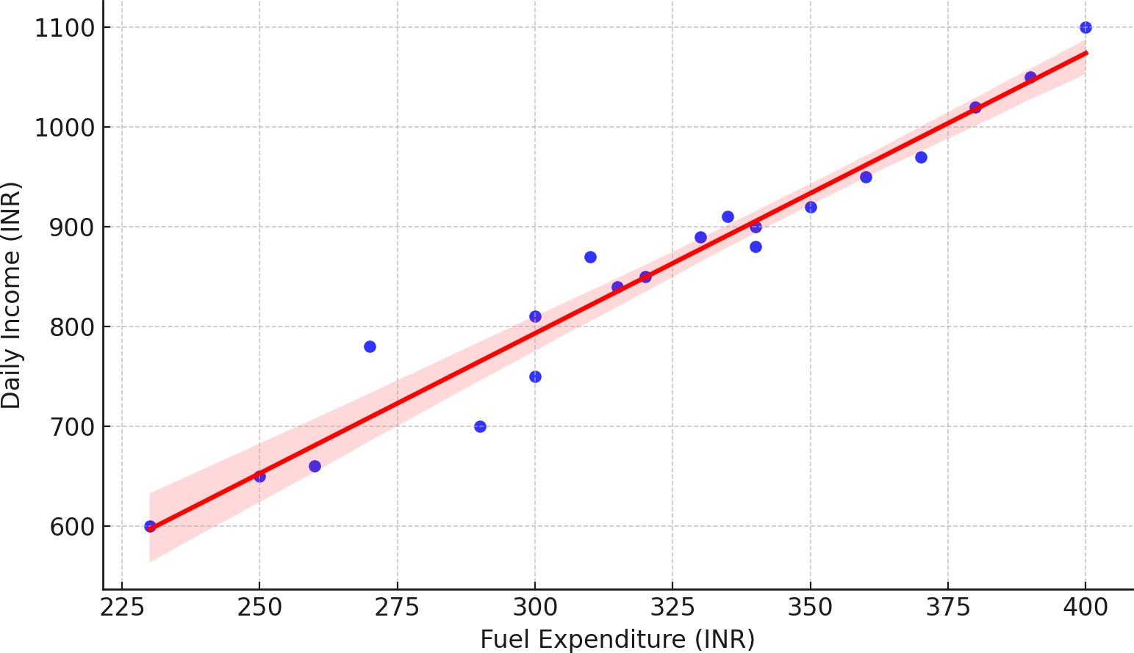

Figure 1: Fuel Expenditure vs. Daily Income (Scatterplot with Regression Line)

The scatterplot above shows a negative relationship between fuel cost and income. As expected, higher fuel expenditure reduces net income. A regression line confirms this inverse trend.

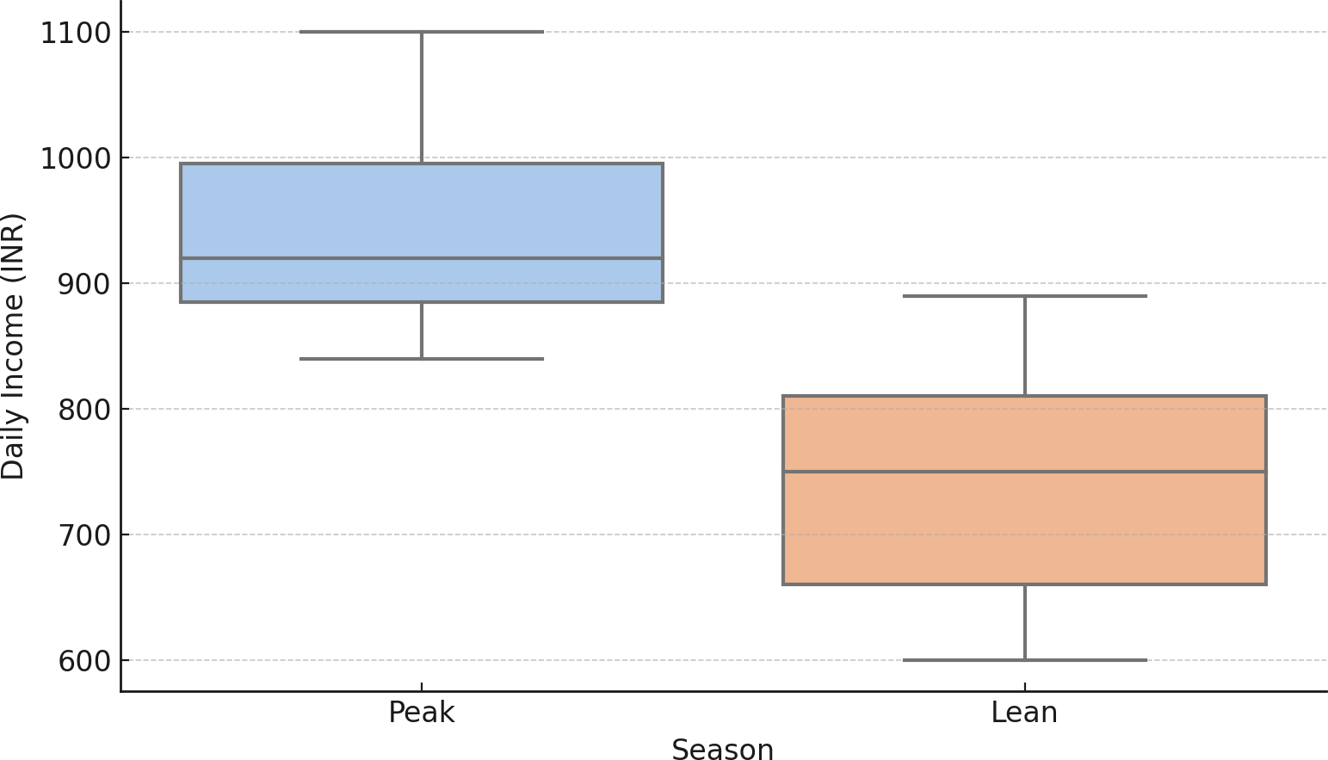

Figure 2: Seasonal Variation in Income

This figure 2, compares average incomes during peak vs. lean seasons. The peak season yields visibly higher income, indicating that seasonal demand significantly affects earnings.

## Regression Results

Table 2: Multiple Linear Regression Results

|  |  |  |  |
| --- | --- | --- | --- |
| **Variable** | **Coefficient** | **Std. Error** | **p-value** |
| Intercept | 1050.31 | 85.74 | 0.000 |
| Fuel Expenditure | -0.92 | 0.31 | 0.005 |
| Season (Peak = 1) | 145.77 | 42.65 | 0.001 |
| Experience (Years) | 6.80 | 8.12 | 0.400 |

The regression analysis reveals that:

* + - **Fuel expenditure** has a significant negative impact on income (*p <* 0*.*01). Every 1 increase in fuel cost reduces income by approximately 0.92.
    - **Seasonal variation** is a strong predictor. Drivers earn about 146 more during the peak season than in the lean season.
    - **Experience**, although positively signed, is statistically insignificant, indicating that years of driving have limited impact on current earnings.

## Interpretation

The findings lend credence to the idea that operational expenses and external influences like seasonal trends significantly affect income levels. The minimal effect of experience indicates that factors such as pricing and demand play a more critical role than skill or seniority within the context of informal transport.

This situation highlights the considerable responsiveness of informal mobility markets, where fluctuations in external demand and fuel costs greatly shape income patterns. Ultimately, the regression analysis offers insights into the income variances and pinpoints actionable strategies—such as implementing fuel subsidies or seasonal assistance programs—that could enhance the living conditions for two-wheeler taxi drivers.

## Passenger Behavior and Income Seasonality

To further understand the economic and operational dynamics of two-wheeler taxis, it is important to consider both the income distribution among drivers and the behavioral motivations of passengers who rely on these services.

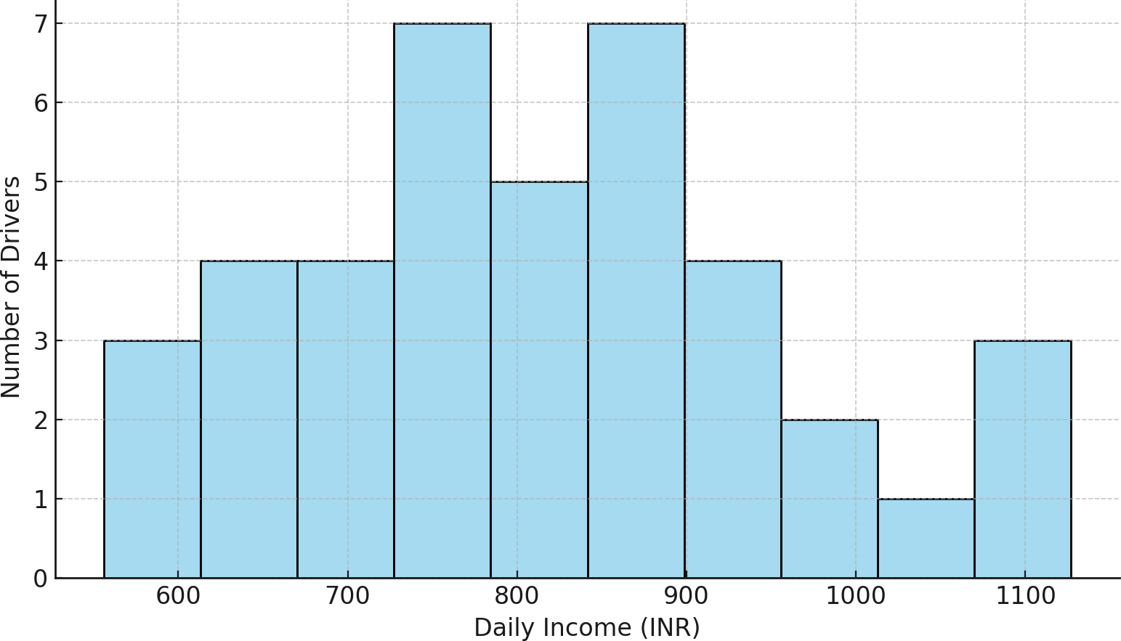

Figure 3: Distribution of Daily Income among Two-Wheeler Taxi Drivers

Figure 5 shows that the majority of drivers earn between 700 and 1000 per day. This clustering suggests a relatively narrow but stable income band within which most drivers operate. However, a few drivers earn significantly more, likely due to longer working hours, regular customers, or efficient fuel usage.

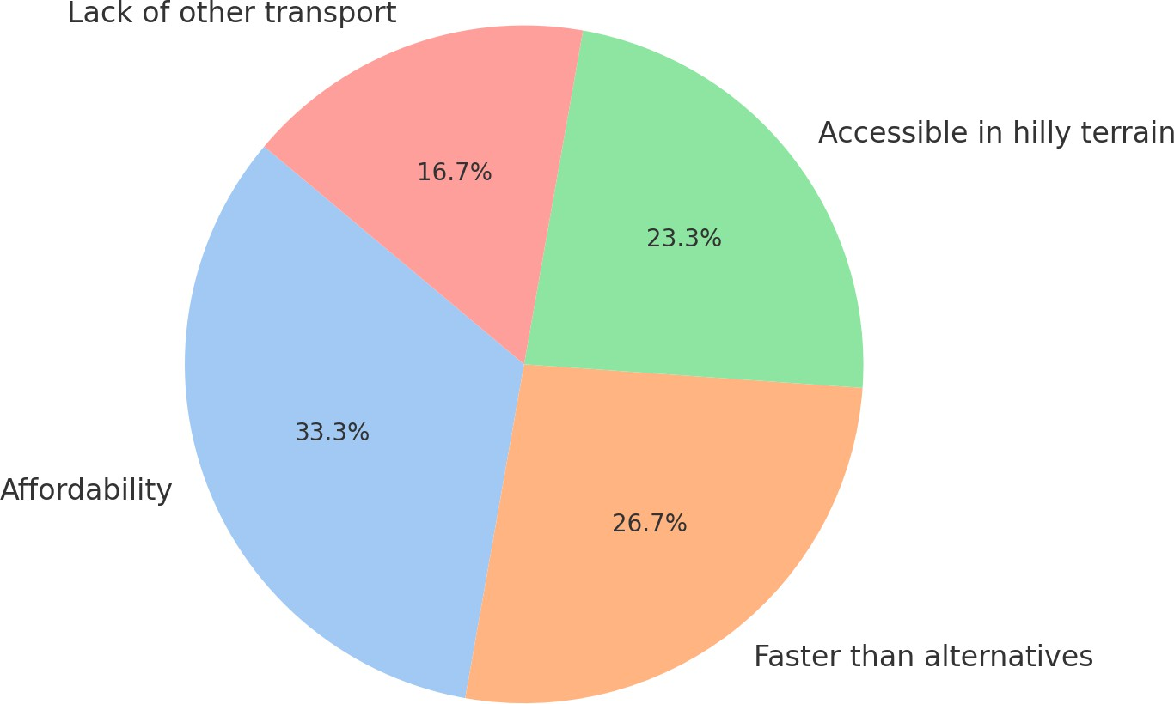

Figure 4: Primary Reasons for Choosing Two-Wheeler Taxis (Passengers’ Perspective)

Passenger responses, visualized in Figure 5, reveal that affordability and speed are the top reasons for choosing two-wheeler taxis. Notably, 23% of passengers cited the lack of alternative transport as a key factor, highlighting the importance of these services in bridging last-mile access in Mon’s challenging terrain.

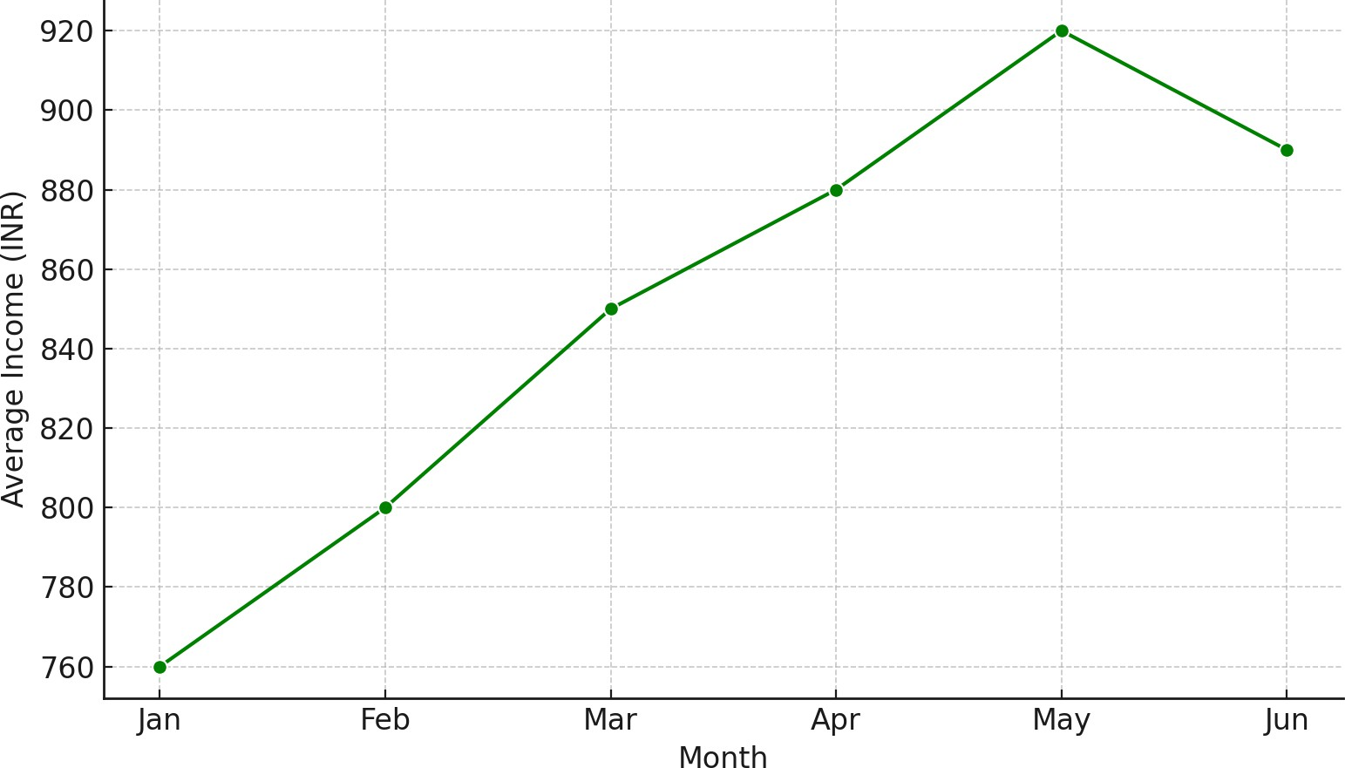

Figure 5: Monthly Variation in Average Driver Income

Income patterns observed over a span of six months demonstrate a distinct seasonal upturn from March to May, linked to better road conditions and festive occasions. The off-peak season, marked by a decline in passenger demand and disruptions caused by weather, shows notable decreases in income. These income variations support the regression findings indicating that seasonality significantly influences income positively. This collection of visual analyses reinforces the evidence of both operational difficulties and the socio-economic importance of two-wheeler taxis. They provide fast, flexible, and cost-effective transportation in areas with few formal options.

# Discussion of Key Findings and Policy Implications

The results of this research emphasize the significance of motorcycle taxis as a source of income and an informal transportation option in a geographically limited area such as Mon Town. The findings, backed by statistical evaluation and field data, reveal three primary insights: factors influencing income, passenger behavior, and variations across seasons.

## Key Findings

Initially, fuel costs were identified as a significant factor influencing driver income. As indicated by both the regression analysis and Figure 1, rising fuel expenses have a notable adverse effect on earnings, thereby diminishing daily profitability. This finding aligns with previous research in informal transport **(Gadepalli, 2016; Verma et al., 2021)** and highlights the sensitivity of these livelihood models to changing operational expenses.

Secondly, it was determined that seasonality serves as a significant predictor of earnings. Drivers indicated that their income was notably higher during the dry or peak season, when road conditions were favorable and there was a surge in passenger demand. This is visually illustrated in Figure 4. Conversely, the lean season, often impacted by rain and inadequate road maintenance, resulted in decreased activity and income instability. These patterns reflect regional weather variations and infrastructure shortcomings in Nagaland, as noted by **Mahadevia et al. (2013).**

Passenger survey feedback indicates that two-wheeler taxis are appreciated for their low cost, quick travel, and capability to maneuver through Mon’s challenging terrain. This demonstrates their distinct role in filling transportation gaps that formal services overlook. The preferences of passengers further confirm the flexibility of informal transportation methods in areas lacking adequate services. Notably, driver experience did not have a substantial effect on earnings, implying that outside factors—like fuel costs and seasonal demand—are much more influential than skill or how long a driver has been on the job. This calls into question the belief that greater experience directly correlates to superior performance in informal sectors.

## Policy Implications

The evidence suggests several key policy directions:

* + - **Fuel Subsidy or Cooperative Fuel Access:** To mitigate the impact of high fuel costs, local governments or cooperatives could explore bulk fuel purchase schemes or limited subsidies for registered two-wheeler taxi drivers.
    - **Seasonal Income Support:** During the lean monsoon months, local transport departments may consider conditional income support or public employment linkage to stabilize livelihoods.
    - **Training and Safety Certification:** Although experience doesn’t influence income significantly, ensuring road safety is crucial. A basic driving and safety certification program can enhance passenger trust and minimize risks.
    - **Inclusive Mobility Planning:** Given their critical role in last-mile connectivity, informal services like two-wheeler taxis should be recognized in urban and rural transport policies, particularly in hilly and tribal regions (VREF, 2023)
    - **Micro-Entrepreneurship Support:** Financial literacy, maintenance subsidies, or low- interest loans could enhance the viability and sustainability of these micro-enterprises.

In general, two-wheeler taxis are more than just a temporary means of transport—they provide a source of income and are an innovation in mobility. Offering formal acknowledgment and support systems could enhance their socio-economic effects while also increasing safety and the quality of service in areas such as Mon Town.

# Conclusion

This research investigated the emergence and operation of two-wheeler taxi services in Mon Town, Nagaland, highlighting it as a case of informal mobility innovation in a region with geographical limitations. By utilizing primary data from both drivers and passengers, along with statistical and visual analysis, the study examined the economic feasibility, factors influencing income, and motivations of users related to this rising transportation alternative. The results indicate that fuel costs and seasonal changes have a significant impact on drivers' earnings, whereas experience has a minimal effect. From the viewpoint of passengers, cost-effectiveness and ease of access are the primary factors motivating the adoption of this service, especially where formal transport options are lacking. These findings shows the importance of two-wheeler taxis not only as a transport solution but also as a means of livelihood in underprivileged areas. Internationally, research has suggested incorporating such informal services into formal transportation frameworks to improve inclusivity and resilience (OECD/ITF, 2025).

This research has added to the sparse empirical literature available on informal mobility in Northeast India while also demonstrating the need for including informal modes of services into adaptive transport planning. The increasing reliance on informal systems to augment gaps in formal infrastructure makes it paramount for policymakers to pay attention to the socio-economic importance of these systems, especially in peripheral and rugged institutional terrains. The single-case context of the mobility dynamics deepens the understanding Para ethnographically, but the findings require supplementary comparative studies to extend them to other similar contexts. Impacts of policy change conducted on informal sector and formal versus informal sectors comparisons could be beneficial for future research endeavors.

# Author Declaration on the Use of Generative AI

The authors hereby declare that generative AI technologies have been used during the editing of this manuscript. Details of AI usage are as follows:

* **Name and Version:** ChatGPT (GPT-4, May 2024 version)
* **Source:** OpenAI, https://chat.openai.com
* **Nature of Use:** Assistance was sought for LaTeX code for Overleaf formatting, statistical explanations based on primary data, and Python-generated graphs.

All AI-generated content was critically reviewed, edited, and validated by the human author to ensure academic integrity and factual correctness.

# References

Anand, A., & Tiwari, G. (2006). A gendered perspective of the shelter–transport–livelihood link: The case of poor women in Delhi. *Transport Reviews*, *26*(1), 63–80. https://doi. org/10.1080/01441640500175615

Colenbrander, S., et al. (2017). Can low-carbon urban development be pro-poor? the case of Kolkata, India. *Environment and Urbanization*, *29*(1), 139–158. https://doi.org/10.1177/ 0956247816677775

Foundation, O. R. (2023). The bike-taxi alternative to enhancing urban mobility in India <https://www.orfonline.org/research/the-bike-taxi-alternative-to-enhancing-urban-mobility-in-india>

Gadepalli, R. (2016). Informal public transport modes in India: A case study of five city regions.

*IATSS Research*, *39*(2), 102–109. <https://doi.org/10.1016/j.iatssr.2016.01.001> KPMG. (2024). Unlocking the potential of bike-taxis in India <https://assets.kpmg.com/content/dam/kpmgsites/in/pdf/2024/03/unlocking-the-potential-of-bike-taxis-in-india.pdf>

Mahadevia, D., Joshi, R., & Datey, A. (2013). Low-carbon transport in India. In *Low carbon mobility for mega cities* (pp. 245–265). Springer. [https://doi.org/10.1007/978-981-287- 826-7_8](https://doi.org/10.1007/978-981-287-%20826-7_8)

OECD/ITF. (2025). Incorporating informal transport in mobility planning <https://www.itf-oecd.org/sites/default/files/docs/incorporating-informal-transport-mobility-planning.pdf>

Rink, B. (2020). Is informal transport flexible? *Journal of Transport and Land Use*.

Rizzo, M. (2017). *Taken for a ride: Grounding neoliberalism, precarious labour, and public transport in an african metropolis*. Oxford University Press.

Singh, S. K. (2012). Urban transport in India: Issues, challenges, and the way forward.

*European Transport / Trasporti Europei*, (52).

TERI. (2020). Emerging role of bike (motorcycle) taxis in urban mobility <https://www.teriin.org/sites/default/files/2020-03/emerging-role-bike-discussion-paper_1.pdf>

A. (2016). Informal public transport modes in India: A case study of five city regions. *ScienceDirect*. [https://www.sciencedirect.com/science/article/](http://www.sciencedirect.com/science/article/) pii/S0386111216000029

A. (2020). Informal rural transport in a typical minor municipality in northeastern brazil *ScienceDirect*.https://[www.sciencedirect.com/science/](http://www.sciencedirect.com/science/)article/abs/pii/S2213624X20300389

A. (2025). Urban mobility development in northeast India: Sustainable city with green and inclusive transportation

Verma, A., Harsha, V., & Subramanian, G. H. (2021). Evolution of urban transportation policies in India: A review and analysis. *Transportation in Developing Economies*, *7*(2), 25. <https://doi.org/10.1007/s40890-021-00136-1>

Verma, A., & Subramanian, G. H. (2020). Urban transport governance practice and challenges in an emerging economy – case study of India. *Transportation Research Procedia*, *48*, 2435–2445. <https://doi.org/10.1016/j.trpro.2020.08.293>

Verma, A., & Subramanian, G. H. (2022). Urban transport sustainability and challenges. In *Flexibility, innovation, and sustainable business* (pp. 245–253). Springer. https://doi. org/10.1007/978-981-19-1697-7_17

VREF. (2023). Informal and shared mobility: Status and opportunities in India <https://vref.se/wp-content/uploads/2023/12/VREF_India_231219.pdf>

Wikipedia. (2024). Motorcycle taxis in India [Accessed: 2025-06-01]. Wikipedia. (2025). Neglect of northeast India. <https://en.wikipedia.org/wiki/Motorcycle_taxis_in_India>