EFFECT OF ALMOND SEED EXTRACT, GRAPE SEED EXTRACT ON IMMEDIATE BONDING OF COMPOSITE TO BLEACHED SURFACES: AN INVITRO STUDY

ABSTRACT
Background: Tooth whitening methods like bleaching can change the enamel surface, which may weaken the bond strength of composite materials. To address this issue, several surface treatment techniques have been developed.
Aim: The present study aimed to assess the effect of almond seed extract, grape seed extract on the immediate bonding of composite to bleached surfaces.
Materials and Methods: forty-five human maxillary anterior teeth, were divided into 3 groups. Bleaching was done and treated with Group 1- control, No surface treatment is done, Group 2 –grape seed extract (GSE),Group 3 – Almond seed extract (ASE). Composite resin was placed on the labial surface and stored in artificial saliva for 24 hours. Subsequently, shear bond strength (SBS) testing was performed on all specimens. The analysis was done using one-way analysis of variance (ANOVA). For post hoc analysis, Bonferroni correction was applied to evaluate multiple comparisons among the study groups with P < 0.05 considered statistically significant.
Results: The results indicated that Group 2 exhibited the highest bond strength among all groups, while Group 1 demonstrated the lowest values. Statistically significant differences were observed between the groups. In this study, the immediate bonding of composite resin to bleached enamel without any surface treatment resulted in the lowest bond strength. Many natural ingredients were used as an antioxidant in the field of adhesive dentistry. There has been a significant rise in scientific and commercial interest in plant-derived natural antioxidants in recent years. In this study, almond seed extract was employed as an antioxidant and applied immediately prior to the placement of the composite restoration. This approach demonstrated enhanced bonding performance compared to other experimental groups.
Conclusion: The bleaching application of ASE and GSE significantly enhanced the shear bond strength of the composite resin. Among all the antioxidants evaluated, almond seed extract demonstrated the highest efficacy.
Keywords: Almond Seed Extract, Bleaching, Grape Seed Extract, Proanthocyanidins.

INTRODUCTION
“Due to an increase in patient awareness and search for aesthetic treatments, dental whitening has become a frequent, safe and conservative procedure. It has an ability to remove stains and to whiten discoloured teeth in need of aesthetic improvement. whitening procedures are known to reduce bond strength of dental adhesives to enamel and dentin. Whitening agents generate free radicals and reactive oxygen species, a subproduct of the reaction, which remain on the tooth surface. These subproducts in turn can neutralize the free-radicals generated during the addition polymerisaiton reaction of resin monomers, inhibiting it and interfering with the infiltration of the resin phase during the bonding procedure” (Lobo et al., 2021). Intrinsic enamel defects, including opacities and brown discoloration, can negatively influence the enamel's color and translucency. As dental materials and technologies have advanced, the focus in clinical practice has transitioned from invasive procedures to minimally invasive (MI) esthetic treatments(1). Bleaching agents are frequently used in dental practice, both in-office and at home, to treat extrinsic and intrinsic tooth stains. Although bleaching is generally well-accepted by patients and produces consistent results, research has shown that it can have several side effects. These include reduced bond strength, alterations in the morphology of enamel and dentin, decreased wear resistance of enamel, and increased surface roughness (Zhang et al., 2020). “Depending on the degree of the enamel defects, a range of therapeutic options such as bleaching, microabrasion, veneers, and crowns are employed. Bleaching continues to be a promising treatment for intrinsic stains. The bleaching agent gradually interacts with the discoloration present in the outer layers of the tooth, effectively lightening the tooth's surface” (2). “Hydrogen peroxide (H2O2) can cause side effects like tooth sensitivity, external cervical resorption, and a decrease in the bond strength of composites when applied immediately to a bleached surface. To mitigate these issues, it is recommended to wait up to 4 weeks before performing bonding after bleaching.” (2) . “Several strategies have been suggested to address this issue, including superficial tooth reduction, the application of alcohol prior to bonding, the use of acetone-based adhesives, and the application of antioxidants like alpha-tocopherol and sodium ascorbate.” (3)
Proanthocyanidins are present in significant amounts in natural sources like grape seed extract, pine bark extract, cranberries, lemon tree bark, and hazelnut tree leaves. As a naturally occurring plant metabolite, it has been shown to be safe for use as an antioxidant in various clinical treatments and dietary supplements.
“Grape seed extract (GSE) is a natural antioxidant comprising 98% oligomeric proanthocyanidin complexes (OPCs). It is important to compare the effects of applying these antioxidants to bleached surfaces with other surface treatment methods.”(3)
Almond seed extract (ASE) is also a natural antioxidant are considered a rich source of polyphenols, especially proanthocyanidins (PA). Like all flavonoids, PA is derived from the shikimate/phenylpropanoid pathway, originating directly from leucoanthocyanidins.(4)
Several studies have reported an improvement in the bond strength of composite resins to tooth surfaces using proteolytic enzymes, grape seed extract, and plasma (2). The application of antioxidants was reported to be a reversal in the bonding due to its protective role against free-radical reactions. However, there is limited research available on the impact of almond seed extract on the bond strength of composites immediately after tooth whitening procedures. Hence this study is taken up to prepare a novel platform for preparing antioxidant solution using almond for immediate bonding of composite restoration after bleaching.
MATERIALS AND METHODS :
After obtaining ethical clearance from the institutional ethics committee forty five human maxillary anterior teeth (n = 45), extracted for various reasons, were selected for the study. The specimens were meticulously cleaned and then placed into plastic molds filled with self-curing acrylic resin up to the cementoenamel junction. The facial surfaces of the teeth were polished using pumice slurry. The labial surfaces of the teeth were thoroughly dried prior to application. A Pola Office syringe (SDI Limited, Australia) was used by retracting the plunger to relieve internal pressure and dispense the contents into the manufacturer-provided mixing pot. The gel components were immediately blended using an applicator tip until a uniform consistency was achieved. The bleaching gel was then applied to the labial surfaces and left in place for 8 minutes. Following this, the gel was thoroughly rinsed off and the surfaces were gently blot-dried. The samples were then divided into three groups according to the type of antioxidants applied.
Group 1- control, No surface treatment is done.
Group 2 –grape seed extract (GSE)
Group 3 – Almond seed extract (ASE)
Preparation of solutions
ALMOND SEED EXTRACT :
The samples were dried and powdered, then extracted with distilled water at a ratio of 20 mL water to 1 g of sample. The mixture was cooled on ice and filtered through a sieve with a 45 μm pore size. The clarified liquid was then centrifuged at 3000 rpm for 10 minutes at 4 °C, and the supernatant was collected and stored. A 5% ASE solution was placed in an incubator at 37°C and the extract was stored in a sealed bottle.
GRAPE SEED EXTRACT :
The clean grape seeds were dried and crushed using a blender, and then 5 g of the dry powder was mixed with distilled water in a 100 mL glass container. To this, 3 mL of absolute ethyl alcohol was added. The mixture was kept in a vibrator for 30 minutes, and then filtered through gauze. A 5% GSE solution was placed in an incubator at 37°C and the extract was stored in a sealed bottle.
The extracted solutions were then used. Then these solutions were applied over labial surfaces with the applicator tip for 10 mins and then rinsed with distilled water.

PLACEMENT OF COMPOSITE RESTORATION
Composite placement was done immediately following surface treatment across all experimental groups. A self-etch adhesive (Fusion Bond 7, Prevest DenPro) was applied uniformly to the labial surfaces of the teeth. A cylindrical plastic matrix measuring 3 mm in diameter and 3 mm in height was fabricated and positioned onto the labial surface. The composite resin (Tetric N-Ceram, shade A2, Ivoclar Vivadent) was placed within the matrix incrementally and subsequently cured using a LED light-curing device (SmartLite Focus, Dentsply) for 60 seconds from all directions. After curing, the matrix was carefully removed.
SHEAR BOND STRENGTH TEST
The specimens were then stored in artificial saliva at 37°C for 24 hours. Shear bond strength (SBS) testing was performed using a Universal Testing Machine (Instron, Model 8801). Each specimen was mounted in the machine such that the leading edge of the plunger was aligned with the interface between the composite and the labial enamel surface. A crosshead speed of 1 mm/min was applied until failure occurred. The force required to debond the composite was recorded, and SBS was calculated in N/mm² by dividing the peak load by the area of the composite base.

FIGURE 1- MOUNTED SAMPLE FIGURE 2 –BLEACHING GEL 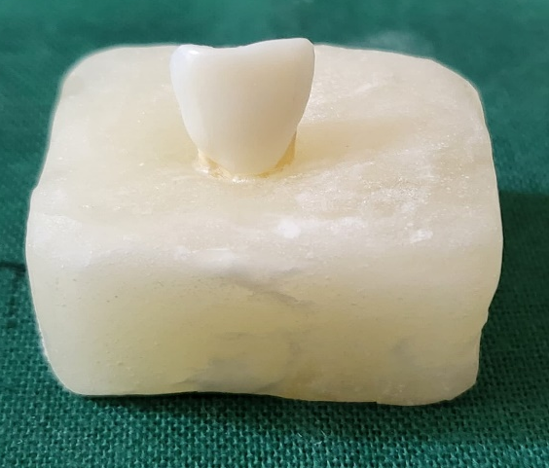 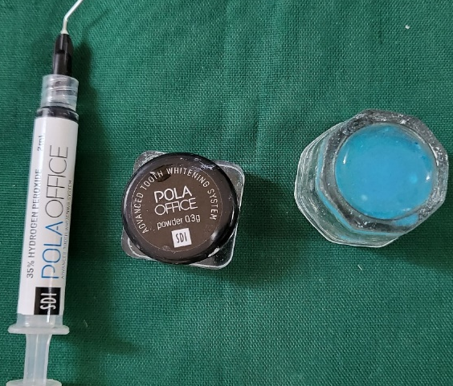

FIGURE 3 – BLEACHING
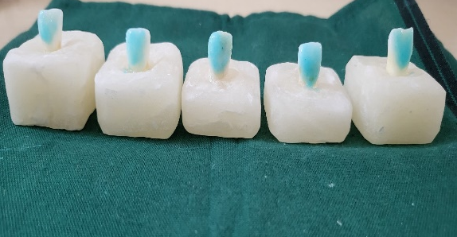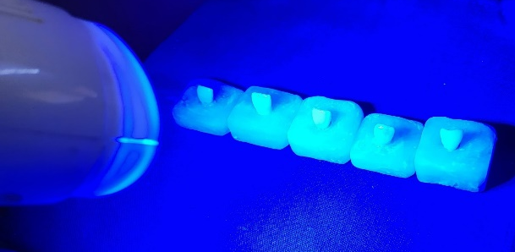

FIGURE 4 APPLICATION OF SOLUTIONS
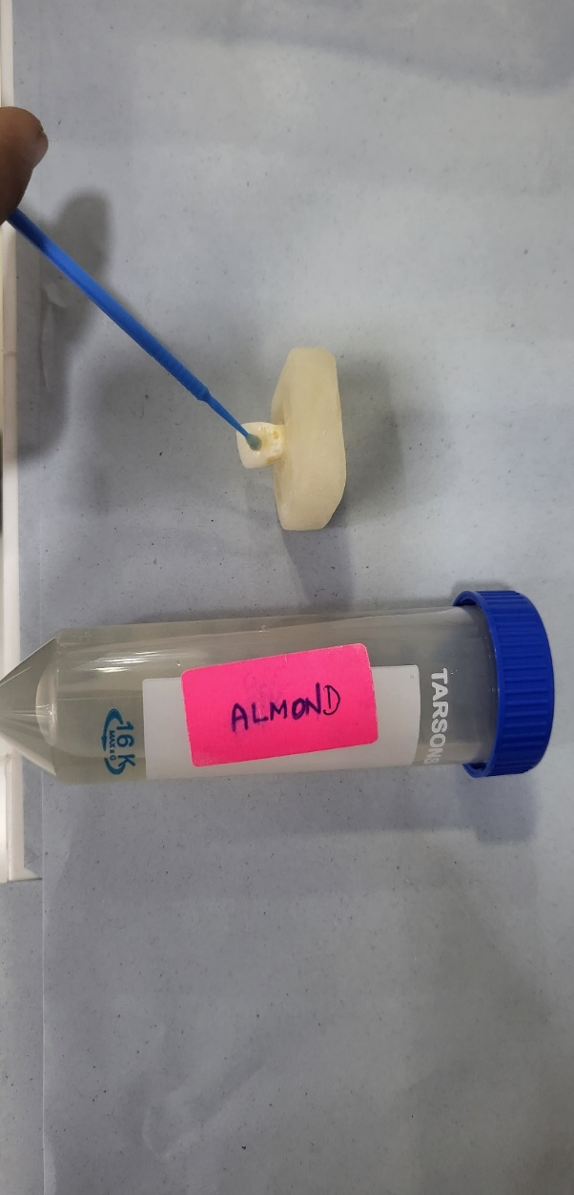
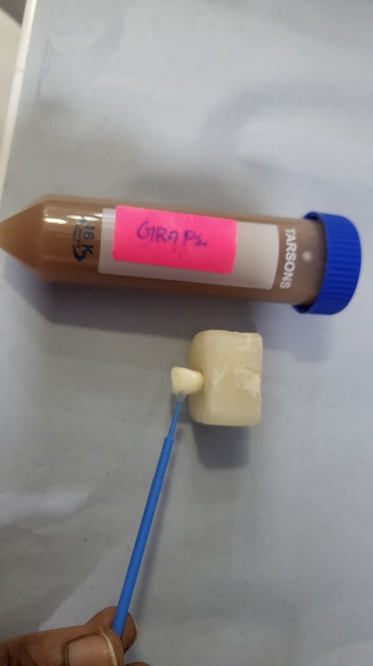

FIGURE 5 –COMPOSITE PLACEMENT
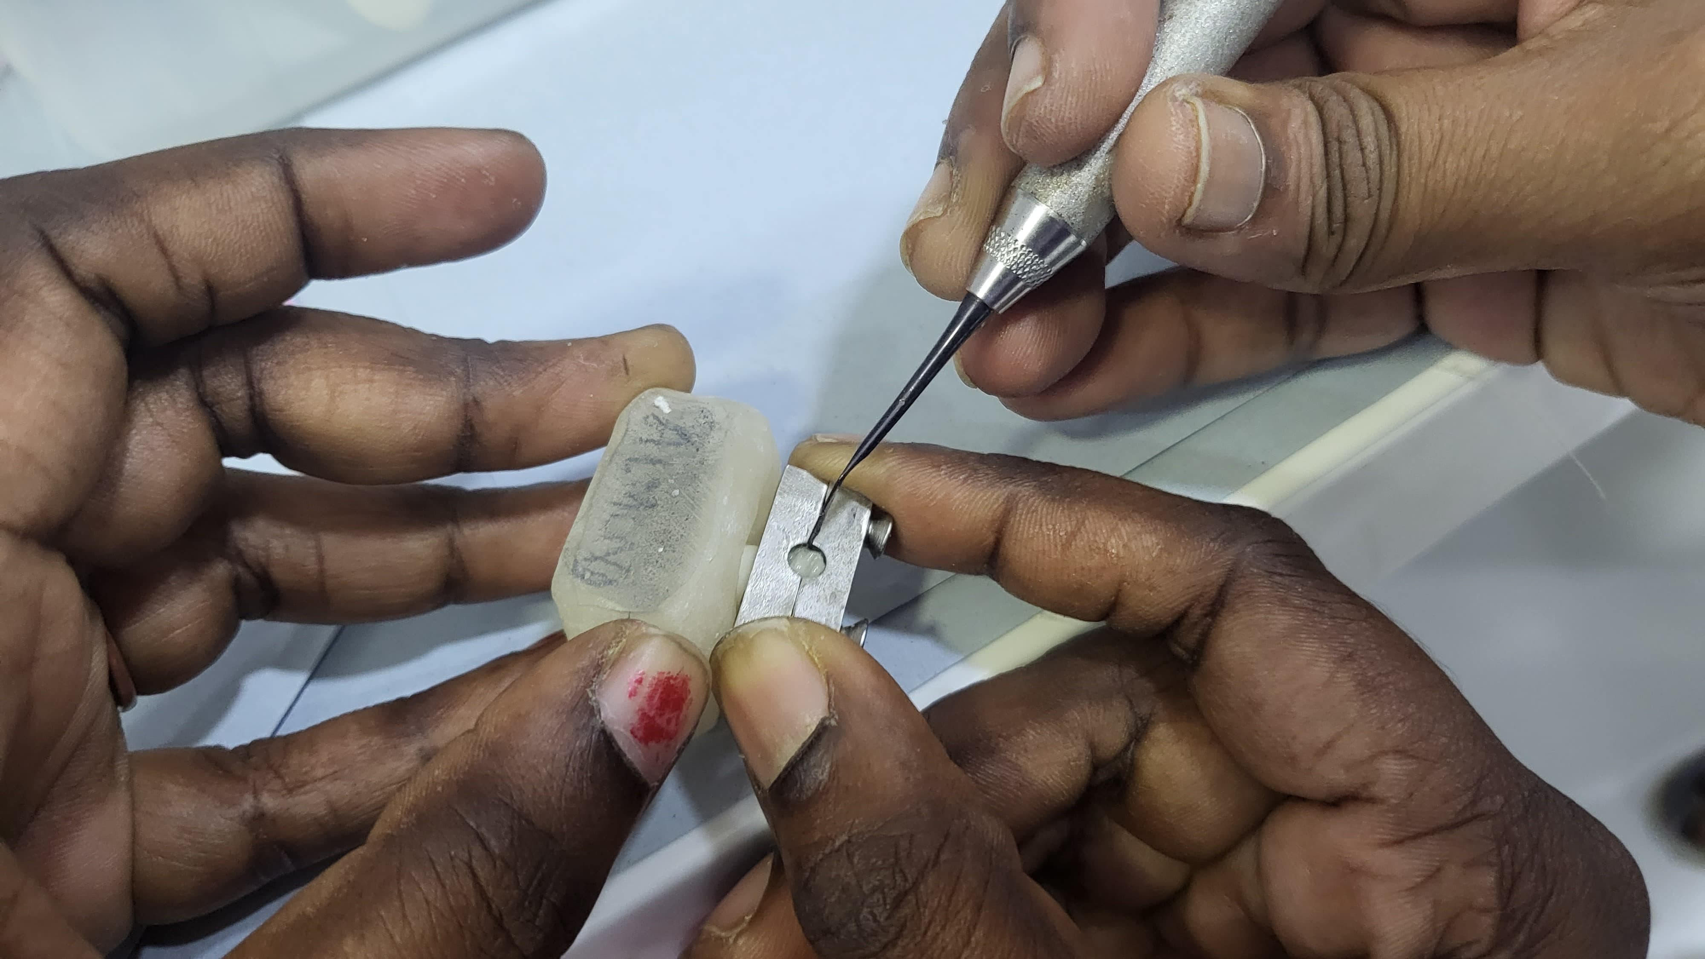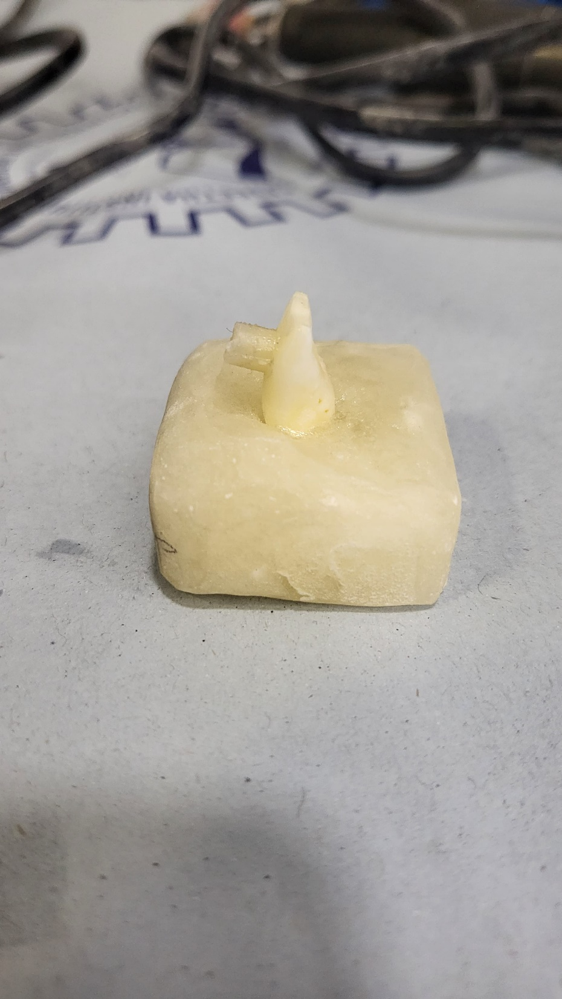

FIGURE 6–SBS TESTING
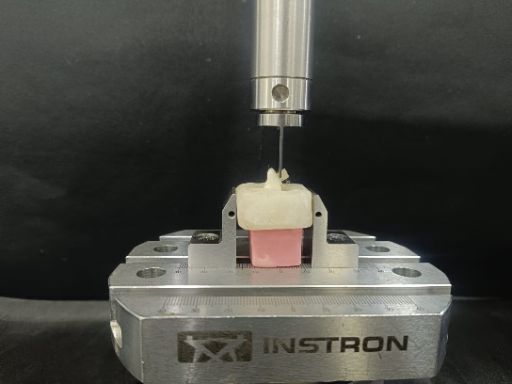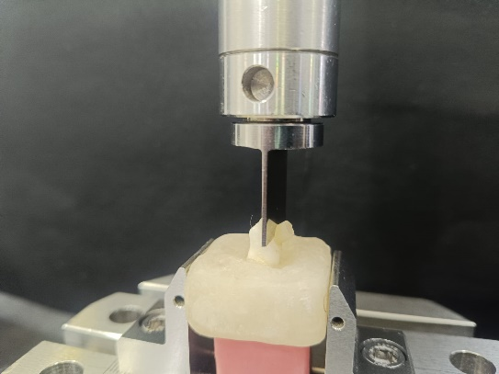

STATISTICAL ANALYSIS
The collected data were statistically analyzed using SPSS software version 16.0 (Statistical Package for the Social Sciences, IBM Corp., Armonk, NY, USA). Intergroup comparisons of the mean shear bond strength values (expressed in MPa) were conducted using one-way analysis of variance (ANOVA). For post hoc analysis, Bonferroni correction was applied to evaluate multiple comparisons among the study groups. A significance level of P < 0.05 was considered statistically significant.

RESULT
The results showed that Group 2 had a higher bond strength (8.90 Mpa) out of all the groups, and Group 1 with least bond strength value (6.86 Mpa). Significant differences were observed between all the groups.
TABLE 1 REPRESENTS THE INTERGROUP COMPARISON BETWEEN THE STUDY GROUPS BASED ON MPa
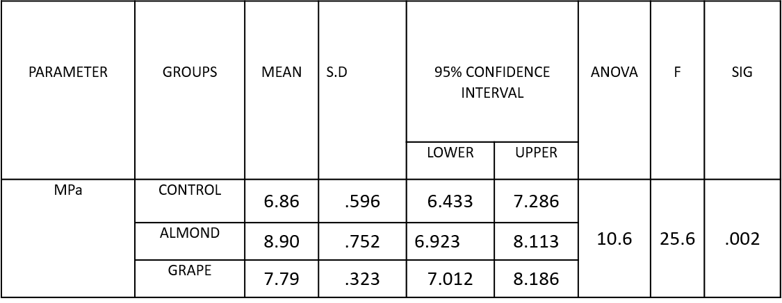

TABLE 2 REPRESENST THE MULTIPLE COMPARISON AMONG THE STUDY GROUPS USING A BONFERRONI CORRECTION TEST
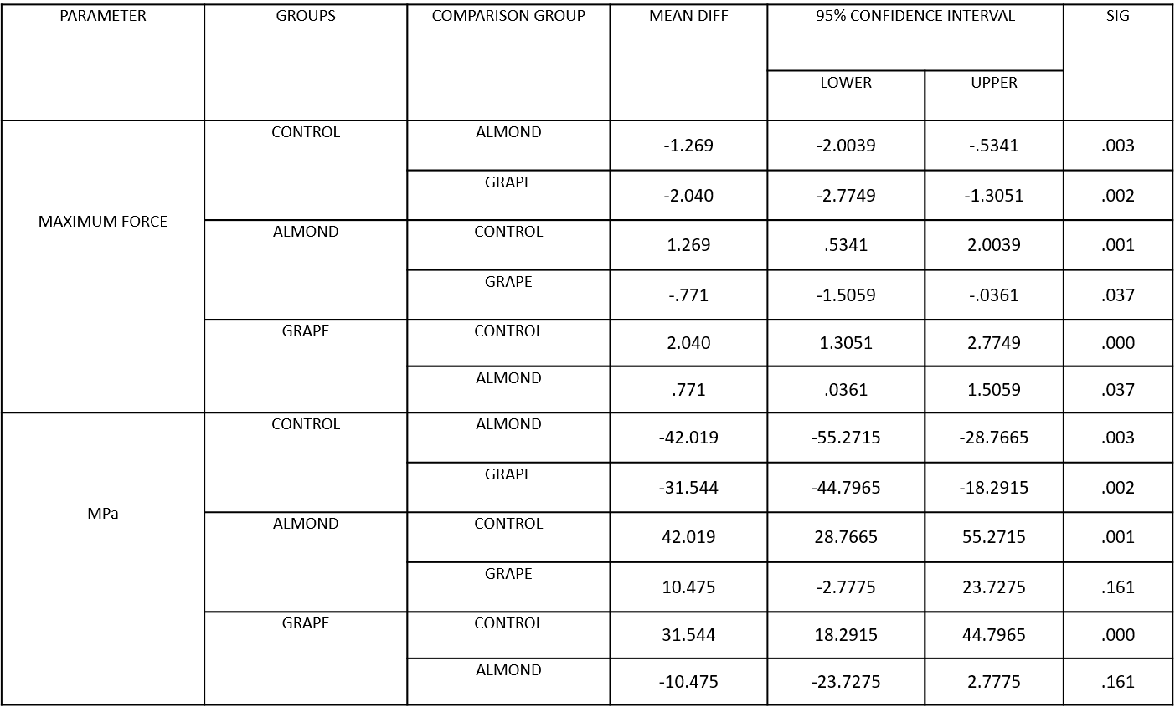

GRAPH 1 INTERGROUP COMPARISON OF MEAN VALUES IN THE STUDY AT Mpa

GRAPH 2 INTERGROUP COMPARISON OF MEAN VALUES IN THE STUDY AT MAXIMUM FORCE

DISCUSSION
The American Dental Association defined Bleaching as the process that involves an oxidative agent, which alters the light-absorbing and/or light-reflecting nature of the material/structure thereby increasing its value. The bleaching process can potentially have adverse effects on enamel, leading to a reduction in surface microhardness along with morphological and compositional alterations(5). The alterations in the composition may result in the least bond strength.
The most plausible explanation for these findings is that a significant amount of oxygen remains trapped within the enamel’s surface porosities following bleaching. The residual peroxide from the bleaching agent decomposes and releases oxygen into these areas. Given that oxygen is known to inhibit the polymerization of contemporary bonding agents, the polymerization of resin tags within the enamel was compromised. Consequently, this led to a reduction in the average bond strength observed in specimens bonded immediately after the bleaching procedure.(6). Unlu et al., proposed that poor bonding surfaces arise due to structural changes in the enamel, primarily caused by increased porosity. Furthermore, the loss of calcium and modifications in the organic components of enamel may significantly contribute to the reduction in bond strength.(7)
Monroe et al., stated that Dental adhesives undergo polymerization via a free radical mechanism, initiated by light-activated redox systems. During this process, hydrogen peroxide can decompose, releasing oxygen that becomes entrapped within the adhesive upon light activation. This phenomenon likely explains the frequent appearance of nearly spherical, bubble-like formations observed along the resin-enamel interface and near the base of the adhesive layer.(8) Rinsing primarily removes residual hydrogen peroxide from only the outermost layer of enamel, within a depth of approximately 0.5 to 5 nanometers.(9)however these free radicals remaining deeply within the enamel may have contributed to the reduction in bond strength. Botta AC et al concluded that the most reliable approach to restoring the diminished bond strength of bleached enamel is to allow a waiting period of at least one week. Alternative strategies involve the use of alcohol, acetone, and antioxidant agents at various concentrations, applied for a brief duration to ensure clinical feasibility and effectiveness.(10)
In this study, the immediate bonding of composite resin to bleached enamel without any surface treatment resulted in the lowest bond strength. This result aligns with the earlier study by Nimet et al., who observed a 50% reduction in the average bond strength of the composite following the application of 35% hydrogen peroxide (H₂O₂).(7)The Grape seed extract and almond seed extract were used as an antioxidant for the purpose of immediate bonding of composite to the bleached tooth surface. These were the antioxidants which were obtained naturally. The use of antioxidants counteracts the effects of the residual oxygen layer, permitting the free radical polymerization of resin-based materials to continue without early interruption. By restoring the modified redox potential of the oxidized bonding surface, it effectively reverses the impaired bond strength.(11)
Many natural ingredients were used as an antioxidant in the field of adhesive dentistry. There has been a significant rise in scientific and commercial interest in plant-derived natural antioxidants in recent years. Grape seed extract is a natural antioxidant known to contain up to 98% oligomeric proanthocyanidin complexes (OPCs). These proanthocyanidins are abundantly present in various natural sources, including cocoa beans, pine bark extract, cranberries, lemon bark, and hazelnut leaves. OPCs possess several electron-donating hydroxyl groups, enabling them to neutralize free radicals through hydrogen atom donation. Additionally, the inclusion of Gallic acid enhances their free radical scavenging efficiency.(12) The antioxidant potential of OPCs is reported to be up to 50 times greater than that of many conventional antioxidants. According to S. Vidhya et al., applying 5% proanthocyanidin to bleached enamel surfaces can restore diminished bond strength and may serve as a viable alternative to postponing the bonding procedure.(13)
Prunus Dulcis, a member of the Rosaceae family, is recognized for its high content of polyphenols and flavonoids, which contribute significantly to its antioxidant properties. Among these compounds, caffeic acid plays a key role in enhancing overall antioxidant effectiveness. This elevated antioxidant activity is primarily attributed to the ability of these bioactive compounds to neutralize free radicals, quench singlet and triplet oxygen species, and break down peroxides(14). According to Saiful Singar et al., almonds are an excellent source of vitamin E, a vital fat-soluble antioxidant that safeguards cellular structures against oxidative damage by effectively neutralizing free radicals.(15) In dentistry, only limited studies are available regarding the use of almond seed or extract. Joseph De Leon stated that almond extract has been utilized as a surface treatment during implant placement procedures to promote and enhance osseointegration.(16)
In this study, almond seed extract was employed as an antioxidant and applied immediately prior to the placement of the composite restoration. This approach demonstrated enhanced bonding performance compared to other experimental groups.
Conclusion
Composite resin application immediately following bleaching showed decreased mean SBS values. Following bleaching, ASE and GSE application significantly improved the SBS of composite resin. It is also concluded that Almond seed extract was identified as the most effective antioxidant among all tested groups.
Limitations of the study
In this study, even though almond and grape seed extract has shown better results of increased bond strength, the discolouration potential has no been explained.The findings require confirmation through large-scale and in vivo studies to ensure their reliability and clinical relevance.

Disclaimer :
Author(s) hereby declare that NO generative AI technologies such as Large Language Models (ChatGPT, COPILOT, etc.) and text-to-image generators have been used during the writing or editing of this manuscript.

REFERENCES

1. Al-Angari SS, Al-Maflehi NS, AlNowaiser A, AlSenaidi J. Effects of microabrasion and bleaching on color and shear bond strength of simulated stained-remineralized caries lesions. Saudi Dent J. 2024 Sep;36(9):1190–6.
2. Banu MA, Bolla N, Tammineedi S, Vemuri S, Basam RC, Ganapati AK. Effect of nonthermal atmospheric plasma, grape seed extract, and bromelain on immediate bonding of composite to bleached and microabraded surfaces. J Conserv Dent. 2022;25(1):42–6.
3. Effect of grape seed extract on the bond strength of bleached enamel - PubMed [Internet]. [cited 2025 Mar 8]. Available from: https://pubmed.ncbi.nlm.nih.gov/21834712/
4. Analysis of proanthocyanidins in almond blanch water by HPLC–ESI–QqQ–MS/MS and MALDI–TOF/TOF MS - ScienceDirect [Internet]. [cited 2025 Mar 8]. Available from: https://www.sciencedirect.com/science/article/abs/pii/S096399691200364X
5. Rahul M, Kumar PA, Nair AS, Mathew S, Amaladas AS, Ommen A. Effects of at-home and in-office bleaching agents on the shear bond strength of metal, ceramic, and composite brackets to enamel. Indian J Dent Res. 2017;28(5):566–73.
6. Dishman MV, Covey DA, Baughan LW. The effects of peroxide bleaching on composite to enamel bond strength. Dental Materials. 1994 Jan;10(1):33–6.
7. Unlu N, Cobankara FK, Ozer F. Effect of elapsed time following bleaching on the shear bond strength of composite resin to enamel. J Biomed Mater Res B Appl Biomater. 2008 Feb;84(2):363–8.
8. Object object. Reversal of compromised bonding in bleached enamel. [cited 2025 Apr 28]; Available from: https://core.ac.uk/reader/37889843?utm_source=linkout
9. Xu Y, Zhou J, Tan J. Use of grape seed extract for improving the shear bond strength of total-etching adhesive to bleached enamel. Dental Materials Journal. 2018;37(2):325–31.
10. Ac B, Ln F, M G, Albm O. Methods for Reversing the Bond Strength to Bleached Enamel: A Literature Review. Dentistry. 2018 Mar 29;6(1):1–5.
11. Kimyai S, Valizadeh H. The effect of hydrogel and solution of sodium ascorbate on bond strength in bleached enamel. Oper Dent. 2006;31(4):496–9.
12. Nair R, Bandhe S, Ganorkar OK, Saha S, Sial S, Nair A. A comparative evaluation of the three different antioxidant treatments on the bond strength of composite resin to bleached enamel: An in vitro study. J Conserv Dent. 2019;22(1):82–6.
13. Vidhya S, Srinivasulu S, Sujatha M, Mahalaxmi S. Effect of Grape Seed Extract on the Bond Strength of Bleached Enamel. Operative Dentistry. 2011 Jul 1;36(4):433–8.
14. Gallardo-Rivera CT, Lu A, Treviño-Garza MZ, García-Márquez E, Amaya-Guerra C, Aguilera C, et al. Valorization of Almond (Prunus serotina) by Obtaining Bioactive Compounds. Front Nutr [Internet]. 2021 May 31 [cited 2025 May 10];8. Available from: https://www.frontiersin.orghttps://www.frontiersin.org/journals/nutrition/articles/10.3389/fnut.2021.663953/full
15. Singar S, Kadyan S, Patoine C, Park G, Arjmandi B, Nagpal R. The Effects of Almond Consumption on Cardiovascular Health and Gut Microbiome: A Comprehensive Review. Nutrients. 2024 Jun 20;16(12):1964.
16. Home - Frontiers of Oral and Maxillofacial Medicine . [cited 2025 May 10]. Available from: https://fomm.amegroups.org/
17. Lobo, S., Santos, I. C., Delgado, A. H., Proença, L., Polido, M., Azul, A. M., & Mendes, J. J. (2021). Antioxidant pre-treatments are able to reduce waiting time for restorative treatment after dental bleaching: A microtensile bond strength exploratory study. Applied Adhesion Science, 9(1), 4.
18. Zhang, H., Shao, S., Du, A., Wang, Y., Cheng, B., & Zhang, Z. (2020). Comparative evaluation of two antioxidants on reversing the immediate bond strength of bleached enamel: in vitro study. Medical Science Monitor: International Medical Journal of Experimental and Clinical Research, 26, e920481-1.

