***Case report***

**SAILOLITHIASIS AND SAILADINITIS – A CASE REPORT**

**ABSTRACT**

Sialadenitis refers to inflammation of the major salivary glands. It is a gradually progressing inflammation-related condition that can result in the formation of fibrous tissue within the affected glands. Sialadenitis is generally caused by the existence of salivary duct stone, known as a sialolith. Sialolithiasis, the term for the formation of these stones within the salivary glands, typically presents with localized pain and tenderness. A 70-year-old male patient reported the chief complaints painful swelling on the left side lower jaw region for the past 3 days. Upon examination, a diffuse swelling is noted of about 3x3 cm in size located in the left submandibular region which is tender on palpation. Floor of the mouth on the left side appears elevated on palpation, it feels firm in consistency. OPG reveals a radio-opaque structure approximately 1x1 cm in size, surrounded by an ill-defined radiolucent lesion in the left mandibular region in relation to periapical region of 36. **Conclusion:** Based on histopathological examination a final diagnostic evaluation for sialolithiasis (interlobular ducts) with sialadenitis (submandibular salivary gland) was confirmed.

**KEY WORDS**: sialolithiasis, sialadenitis, submandibular gland, calculi

**INTRODUCTION:**

In addition to numerous minor salivary glands scattered throughout the oral cavity, there are three pairs of major salivary glands: parotid, submandibular, and sublingual salivary glands. The largest of the primary salivary glands the parotid, is located anterior to the sternocleidomastoid muscle and lateral to the mandibular ramus. (1) This gland secretes serous saliva and is encapsulated. The submandibular glands are the second largest among the salivary glands. This gland secretes a combination of mucous and serous saliva. The sublingual glands, which are the smallest among the major salivary glands, are located above the mylohyoid muscle and beneath the floor of the mouth's mucosa. Unlike the parotid and submandibular glands, which are encapsulated, the sublingual gland is spread throughout the sublingual region. (1) Mucous saliva is produced by the sublingual gland. Saliva includes immunoglobulin A (IgA) and compounds that start the digestion associated with food into to preserve and help defend the environment of the oral cavity. It is low in salt and rich in potassium. Salivary stasis causes inflammation in submandibular sialadenitis, which results in an oral bacterial infection. (2)

Less frequently than parotid involvement, sialadenitis occurs. Acute sialadenitis usually manifests as sudden onset pain and swelling and is caused by bacterial or viral infections. Usually accompanied by swelling but without erythema, Chronic sialadenitis is marked by repeated or ongoing inflammation, often resulting from obstructions like strictures or salivary stones. (2) Sialolithiasis is a non-cancerous condition marked by the development of calculi (salivary stones) within the ducts of the three major salivary glands: the parotid, submandibular, and sublingual glands. It represents the most frequent cause of salivary gland enlargement, with an estimated occurrence ranging from 1 in 10,000 to 1 in 30,000 individuals. (3)

Sialoliths may occasionally block the salivary ducts, causing inflammation known as sialadenitis—a bacterial infection that may occur as a secondary complication, and in rare cases, may progress to abscess formation. The most prevalent presenting symptoms are decreased salivary flow and recurrent cyclical postprandial enlargement of the afflicted gland. (4)

**Case presentation:**

History: A 70 years old male patient came with the chief complaint painful swelling in the left lower jaw region for the past 3 days. Patient gives a history of diabetes and hypertension for the past 20 years and is under medication. On intraoral examination: Floor of the mouth on the left side appears elevated and on palpation, Firm in consistency and tender. Root stumps in 16, 18 Dental caries in 36, 27, 28 missing 26. During extraoral examination a diffuse swelling of about 3x3 cm in size present in the left submandibular region which is tender on palpation.

On radiographic examination, OPG reveals radio-opaque structure of about 1x1cm in size surrounded by an ill- defined radiolucent lesion in the left mandibular region in relation to

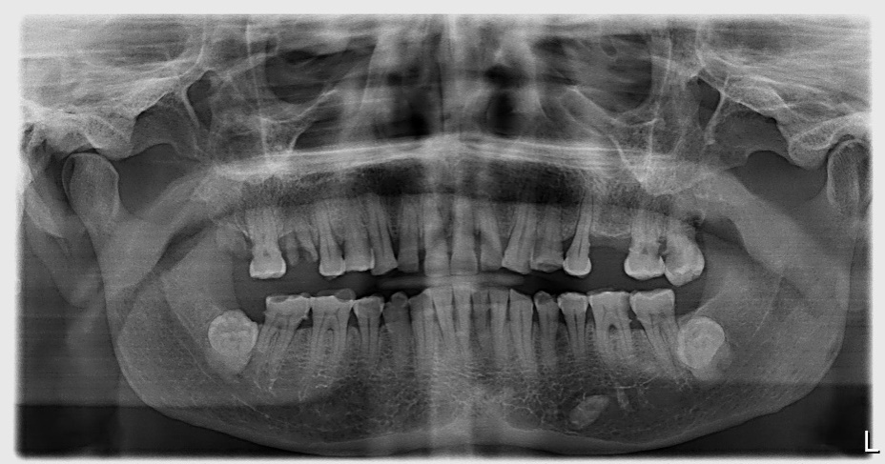periapical region of 36 and CT facial bone reveals the hyperechoic foci in the floor of the mouth measuring 5.4 mm and 9.6 mm respectively.

**Figure 1:** OPG reveals radio opaque structure of about 1x1cm in size surrounded by an ill-defined radiolucent lesion in the left mandibular region in relation to periapical region of 36.

An excisional biopsy was performed, and the left submandibular gland was submitted for histopathological examination. Tissue specimen (submandibular gland) fixed in 10% Neutral Buffer Formalin, size of the specimen measured 5.5 x 3.5cm. Color: Whitish yellow in colour. Consistency: soft, Surface: Irregular, Shape: Irregular. These large tissue specimens fig:2 and tissue bits fig:3 were routinely processed, sectioned and stained for histopathological evaluvation.

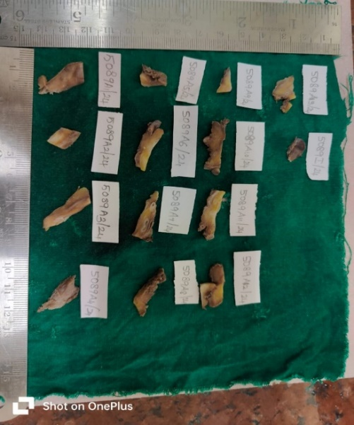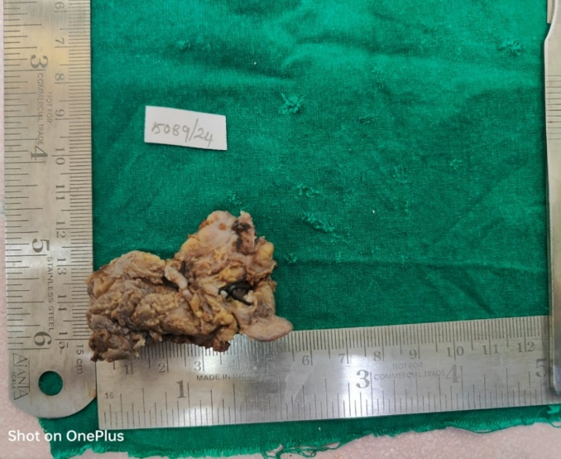

**FIGURE 3**: RETRIVED MARGINS

**FIGURE 2**: PRIMARY SPECIMEN

On Histopathological examination the H & E stained series of sections of the soft tissue specimen (submandibular salivary gland) were examined, which revealed salivary gland parenchyma predominantly lobules of serous acini and few mucous acini along with dispersed intralobular ducts. Within the connective tissue stroma surrounding the aggregates of glandular lobules are seen dispersed interlobular ducts with some of them appearing dilated. Few of the interlobular ducts within the lumen showed an acellular eosinophilic linear amorphous structure with no definite pattern and with few dispersed inflammatory cells. The main excretory duct showed hyperplasia and also mucous metaplasia. Focal collections of inflammatory cells predominantly lymphocytes were seen around the secretory acini and the ducts. Aggregates of adipose tissues were seen within the connective tissue areas. Dispersed blood vessels, neurovascular bundles and sections of muscles and nerves are also seen. Focal areas of salivary acini undergoing degeneration are also seen and a single lymph node was detected with normal architecture. Based on these findings, a diagnosis of 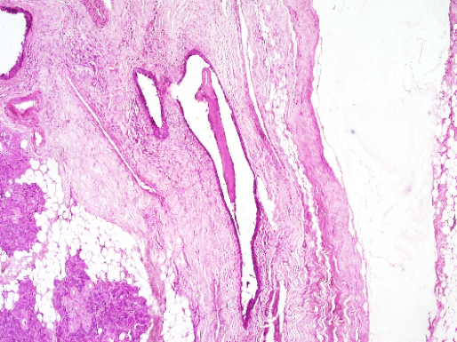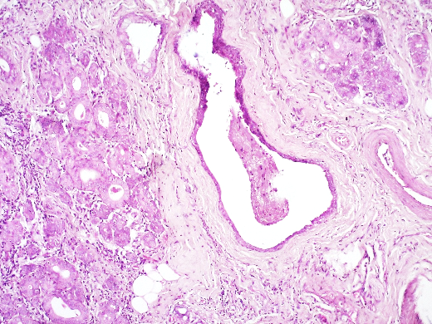salivary gland stones (interlobular ducts) with sialadenitis (submandibular salivary gland).

40X

10X

**FIGURE 5**: THIS ARROW RED REPRESENTS MINOR SALAIVARY GLANDS

**FIGURE 4**: THIS BLACK ARROW REPRESENTS SIALOLITH [INTERLOBULAR DUCTS]

**DISCUSSION:**

"Sialolithiasis is a benign condition characterized by the development of stones within the ducts of the major salivary glands, which are situated in the submandibular triangle and surrounded by the investing layer of the deep cervical fascia." (4) The estimated incidence of sialolithiasis is approximately 1 in 10,000 to 30,000 individuals.

Sialadenitis is caused by a persistent sialolith. The causes of acute sialadenitis include immune-mediated processes (Sjogren syndrome), bacterial and viral infections, and non-infectious inflammatory conditions (such sarcoidosis). The human immunodeficiency virus, coronavirus, influenza A, paramyxovirus (also known as the mumps), and parainfluenza virus are among the viruses that can cause salivary infections. (5)

Salivary gland lithiasis, also known as sialolithiasis, represents the primary prevalent illness of the main salivary glands following mumps. It is thought to afflict affecting 0.01% to 1.0% of the population, with an increased frequency in men aged between the ages of 30 and 60. It represents around comprises 30% of all salivary gland disorders. (6)

It is unknown exactly what causes sialolithiasis or the first calculi to form. Uric acid-based salivary calculi are only known to occur in gout, a systemic illness. (7) The exact cause of sialolith formation is not clearly understood. (8). Incidence was low in the first decade and rising in the third to sixth decades (9). A transoral technique can be used to remove intraductal stones, while an intra-oral method can be used to remove intraglandular stones, according to Soares et al (10).

As alternatives to traditional submandibular gland surgery more recent therapeutic techniques such endoscopic intracorporeal shock wave lithotripsy and extracorpeal shockwave lithotripsy have been introduced. (11)

Sialoliths consist of different proportions of organic and inorganic substances, structured around a central core." This core forms the initial sialolith, which gradually enlarges as additional organic and inorganic materials accumulate to form concentric outer layers known as lamellae. The inorganic components mainly consist of hydroxyapatite, whitlockite, and octacalcium phosphate, with hydroxyapatite being the most dominant. The specific composition of these minerals is influenced by the chemical environment at the time of the stone's formation. The organic components of sialoliths typically include glycoproteins, cellular debris, bacteria, and mucopolysaccharides. (3).

In cases of acute suppurative submandibular sialadenitis, there is infiltration of neutrophils in the interstitial tissue along with necrosis and acinar destruction. In viral sialadenitis, formation of vacuoles in the acinar cells and increased Lymphocytic infiltration is more commonly observed. Chronic sialadenitis due to sialolithiasis shows enlarged ducts containing stones, along with long-lasting inflammation and tissue thickening. In sialadenosis, atrophy is present of the functional tissue, accompanied by a compensatory rise in fat tissue. Inflammatory infiltrates are present. (12) IgG4-positive plasma cell infiltrates were observed equally in the periductal areas and throughout the gland. Previous studies generally distinguished IgG4-related disease of the salivary gland and sialolithiasis as two separate entitie. (13)

**CONCLUSION:**

Sialolithiasis and sialadenitis are closely associated conditions that most commonly affect the submandibular salivary glands, typically presenting with pain, swelling, and evidence of ductal obstruction. Prompt identification through clinical evaluation, imaging, and histopathology is essential for effective treatment, which may include surgical excision of the stone or the gland. Recent advancements in minimally invasive procedures offer alternative therapeutic approaches, underlining the significance of early intervention lies in preserving glandular function and minimizing the risk of recurrence.

Disclaimer (Artificial intelligence)

Option 1:

Author(s) hereby declare that NO generative AI technologies such as Large Language Models (ChatGPT, COPILOT, etc.) and text-to-image generators have been used during the writing or editing of this manuscript.

Option 2:

Author(s) hereby declare that generative AI technologies such as Large Language Models, etc. have been used during the writing or editing of manuscripts. This explanation will include the name, version, model, and source of the generative AI technology and as well as all input prompts provided to the generative AI technology

Details of the AI usage are given below:

1.

2.

3.

**REFERENCE:**

1. Ogle OE. Salivary gland diseases. Dental Clinics. 2020 Jan 1;64(1):87-104.
2. Silvers AR, Som PM. Salivary glands. Radiologic clinics of north America. 1998 Sep 1;36(5):941-66.
3. Adhikari R, Soni A. Submandibular sialadenitis and sialadenosis. InStatPearls 2022 Aug 8. StatPearls Publishing.
4. Huoh KC, Eisele DW. Etiologic factors in sialolithiasis. Otolaryngology--Head and Neck Surgery. 2011 Dec;145(6):935-9.
5. Young A, Okuyemi OT. Malignant salivary gland tumors [Internet]. In: StatPearls. Treasure Island (FL): StatPearls Publishing; 2023 Jan 12 [cited 2025 Jun 4]
6. Chern A, Famuyide AO, Moonis G, Lalwani AK. Sialadenitis: a possible early manifestation of COVID‐19. The Laryngoscope. 2020 Nov;130(11):2595-7.
7. Andretta M, Tregnaghi A, Prosenikliev V, Staffieri A. Current opinions in sialolithiasis diagnosis and treatment. Acta Otorhinolaryngologica Italica. 2005 Jun;25(3):145.
8. Austin T, Davis J, Chan T. Sialolithiasis of submandibular gland. Journal of Emergency Medicine. 2004 Feb 1;26(2):221-3.
9. Arifa SP, Christopher PJ, Kumar S, Kengasubbiah S, Shenoy V. Sialolithiasis of the submandibular gland: report of cases. Cureus. 2019 Mar 6;11(3).
10. Lustmann J, Regev E, Melamed Y. Sialolithiasis: a survey on 245 patients and a review of the literature. International journal of oral and maxillofacial surgery. 1990 Jun 1;19(3):135-8.
11. Sikkerimath S, Anshu A, Jose A. Perforating Sialolith: A Case Report. Asian J. Dent. Sci. 2020;3:12-5.
12. Hammett JT, Walker C. Sialolithiasis In: StatPearls. Treasure Island (FL): StatPearls Publishing; 2024 Sep 10 [cited 2025 Jun 4]
13. Peuraharju E, Hagström J, Tarkkanen J, Haglund C, Atula T. IgG4-positive plasma cells in nonspecific sialadenitis and sialolithiasis. Modern Pathology. 2022 Oct;35(10):1423-30.