***Case report***

Exploring Dual Chamber Pacemakers in the Presence of Persistent Left Superior Vena Cava: Two Case Reports.

**Abstract:**

**Aims:**  
To report two cases of persistent left superior vena cava (PLSVC) diagnosed during pacemaker implantation and emphasize its clinical relevance and procedural implications.

**Introduction:**  
PLSVC is the most common thoracic venous anomaly, often asymptomatic and discovered incidentally. It may be associated with arrhythmias or conduction disorders and complicates cardiac device implantation due to its atypical venous course.

**Case Presentation:**  
We present two male patients, aged 82 and 65, admitted for bradyarrhythmia-related symptoms. Both underwent transthoracic echocardiography revealing a dilated coronary sinus, raising suspicion of PLSVC. During pacemaker implantation via the left subclavian vein, the guidewires took an unusual path through a PLSVC and coronary sinus into the right atrium. The first case involved an isolated PLSVC with absent right SVC. In both cases, pacemaker leads were successfully positioned with satisfactory thresholds.

**Discussion:**  
Although PLSVC occurs in only 0.3–0.5% of the general population, it is more common in patients with congenital heart disease. Its presence may lead to procedural challenges due to the acute angle between the coronary sinus and tricuspid valve. The presence of a retro-aortic innominate vein may further complicate catheter manipulation and increase the risk of venous injury. A dilated coronary sinus is a key echocardiographic clue, and contrast studies or CT/MRI may confirm the diagnosis.

**Conclusion:**  
PLSVC should be suspected in patients with an enlarged coronary sinus. Its presence requires awareness and adapted techniques during device implantation to avoid complications and ensure procedural success.

*Keywords: persistent left superior vena cava, conduction disorders, pacemaker Implantation.*

1. **Introduction:**

The persistent left superior vena cava (PLSVC) is the most common variant of thoracic venous drainage. It results from a failure of obliteration of the left common cardinal vein and drains the left subclavian and jugular veins into the right atrium via the coronary sinus[1]. It affects approximately 0.5% of the population[2]. This peculiar venous pathway often goes unnoticed due to Its asymptomatic nature. The diagnosis is usually incidental. While. It is benign, PLSVC can be associated with arrhythmias or conduction disorders. It also creates a procedural challenge approaching the left cephalic or subclavian vein and ensuring a stable fixation of the leads[2].

We highlight 2 case reports of patients diagnosed with the PLSVC with conduction abnormalities who underwent successful pacing.

1. **Clinical cases**

**Case 1**

An 82-year-old man with a history of hypertension and prior pulmonary embolism secondary to deep vein thrombosis presented to the emergency department with dyspnea and extreme fatigue. On examination, he was hypertensive (160/74 mmHg) and bradycardic (43 bpm), with audible pulmonary wheezing.

Electrocardiography revealed sinus node dysfunction with a junctional escape rhythm at 30 bpm (Figure 1). Laboratory tests showed elevated NT-proBNP, while the chest X-ray appeared unremarkable.

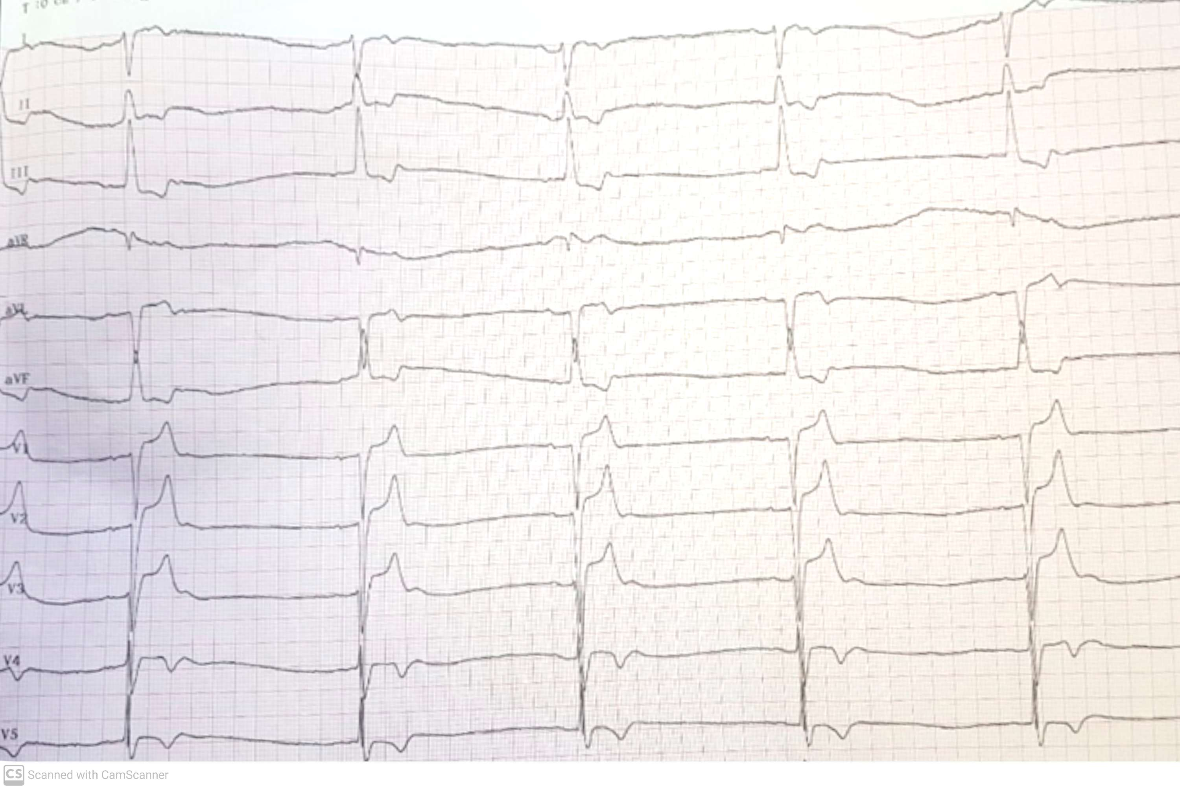

Figure 1: ECG showing a sinus dysfunction with a junctional escape rhythm at 30bpm

Transthoracic echocardiography (TTE) identified a dilated coronary sinus, raising suspicion of a persistent left superior vena cava (PLSVC). Cardiac structure and function were otherwise normal, with preserved chamber sizes, intact interatrial and interventricular septa, and a left ventricular ejection fraction of 70% (Figure 2).

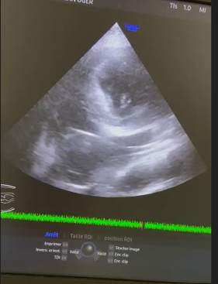

Figure 2: ETT: 4 chamber view showing a large coronary sinus

Given the symptomatic bradyarrhythmia, a dual-chamber pacemaker was indicated. During the procedure via a left subclavian approach, the guidewires followed an unusual course through a dilated coronary sinus and into the right atrium, confirming an isolated PLSVC with absence of the right superior vena cava (Figure 3,A). The atrial and ventricular leads were successfully placed in a retrograde fashion via the coronary sinus into the right heart chambers (Figure 3, B). Pacing thresholds and lead function were optimal post-implantation.

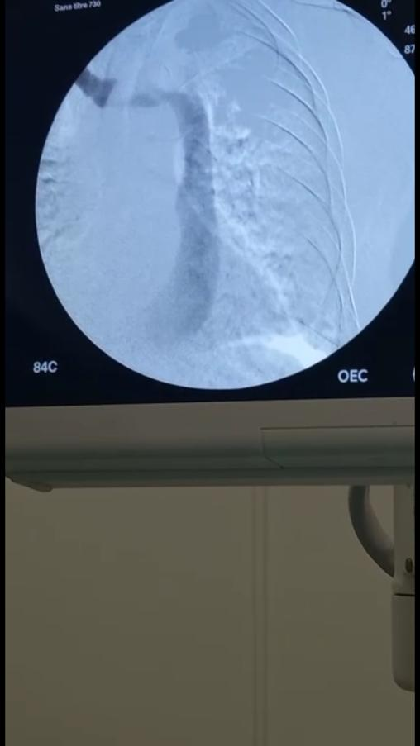 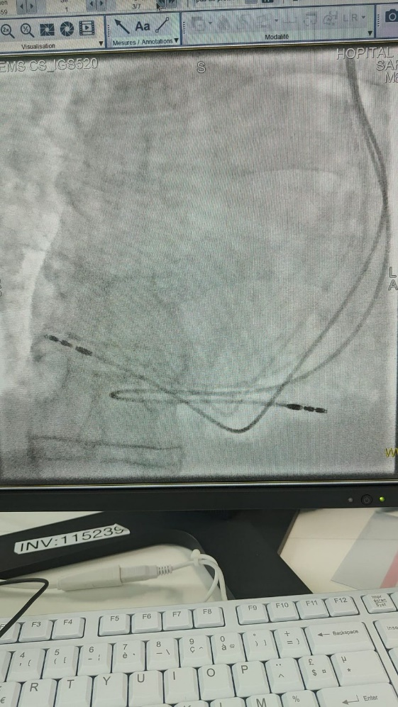

**B**

**A**

Figure 3 :A: venography of an isolated PLVSC and a dilated CS. B: lead placement through the PLVCS in the right atrium and ventricle.

**Case 2**

A 65-year-old man with multiple cardiovascular risk factors (hypertension, diabetes, and dyslipidemia) and a history of atrial fibrillation (AF) presented to the emergency with dyspnea and two episodes of syncope. He was hypertensive (170/89 mmHg) and profoundly bradycardic (25 bpm) on initial assessment.

ECG showed a regular AF at 37 bpm (Figure 4). Blood tests were normal, and the chest X-ray showed no abnormalities.

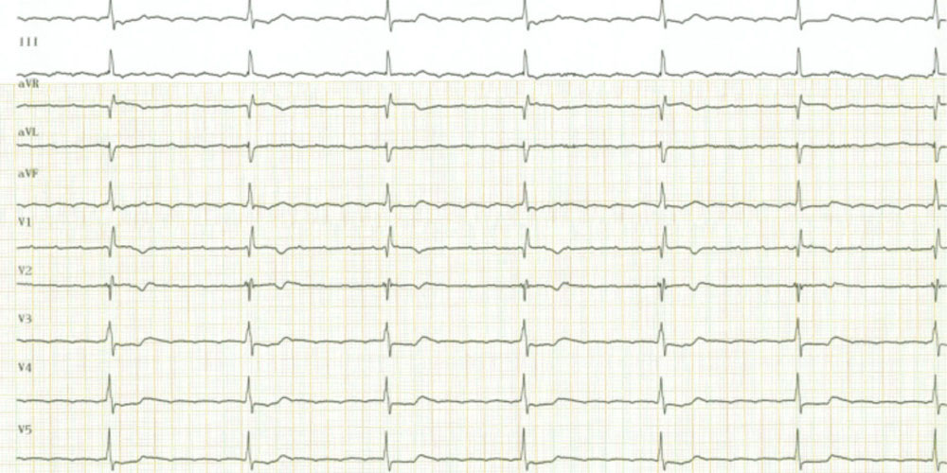

Figure 4: ECG with regular atrial fibrillation at 37 bpm

TTE demonstrated right atrial enlargement and a markedly dilated coronary sinus, again suggestive of PLSVC (Figure 5). Chamber sizes were otherwise normal, and the ejection fraction was preserved at 55%.

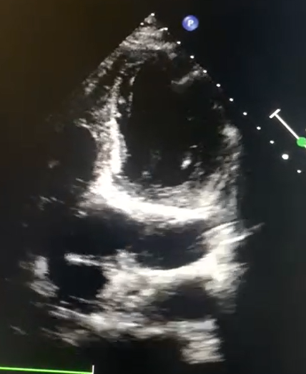

Figure 5: ETT: 4 chamber view showing a large coronary sinus.

A single-chamber pacemaker was indicated. During left subclavian access, the guidewire was seen passing through a PLSVC and dilated coronary sinus into the right atrium (Figure 6, A). The ventricular lead was advanced and successfully implanted at the right ventricular apex (Figure 6, B). The patient had an uneventful recovery with stable device function.

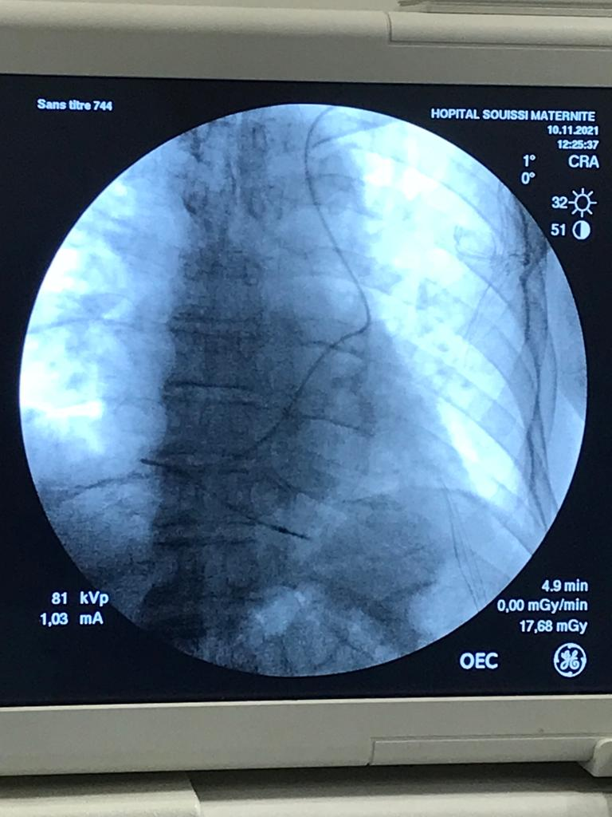 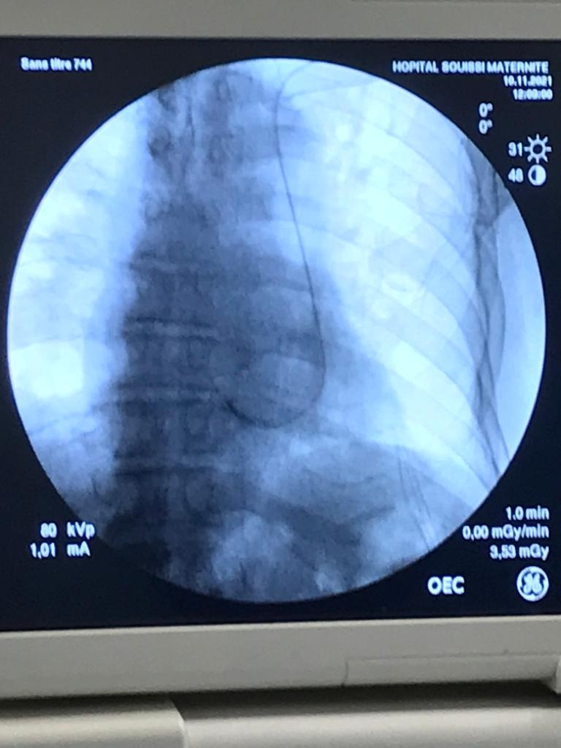

**A**

**B**

Figure 6: A and B: lead placement through the PLVCS and CS to the right ventricle

1. **Discussion**

Persistent left SVC is known to be the most common congenital thoracic venous anomaly. Its prevalence is 0.3–0.5% in the general population and up to 10% of those who have established congenital heart disease [2]. It results from a failure of obliteration of the left common cardinal vein and drains the left subclavian and jugular veins into the right atrium via the coronary sinus[1].

Anatomically, the PLSVC courses vertically along the left side of the aortic arch and pulmonary artery, adjacent to the left atrium, before piercing the pericardium and entering the posterior atrioventricular groove [3,4].

In most cases (90%), both right and left SVCs coexist, sometimes connected by a bridging brachiocephalic vein [3,5]. However, in approximately 10% of cases—as observed in our first patient—the right SVC is absent, and the entire upper systemic venous return drains through the PLSVC into the coronary sinus [2,6]. In rarer cases (10–20%), drainage may occur directly into the left atrium via an unroofed coronary sinus or anomalous pulmonary venous return, resulting in right-to-left shunting and possible neonatal cyanosis[2].

The enhanced venous return through the CS increases its dimensions and leads to the atrophy of the Vieussens, Thebesian, and other heart vein valves [7].

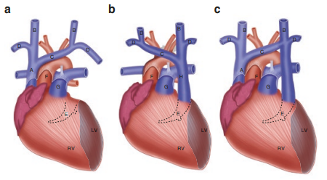

Figure 7: Three major subtypes of the SVC anatomy. (a) Normal anatomy, (b) Left SVC with absent right SVC, and (c) double SVC. A bridging brachiocephalic vein may be present in 30% of cases.

The diagnosis of a persistent left SVC is usually incidental; either during cardiovascular imaging or surgery. The ECG may show a left-axis deviation of the P wave with a normal PR interval. Chest X‑ray may demonstrate a crescentic vascular shadow extending from the upper left border of the aortic arch to the middle third of the left clavicle or an anomalous course of a catheter [2].

Transthoracic echocardiography shows a dilated coronary sinus while the TEE shows the PLSVC near the LA appendage and left pulmonary vein in the mid esophageal view. The diagnosis can be confirmed by an IV agitated saline injection ("bubble study"). In isolated PLSVC, as in our case, the CS opacifies first before the RA [2,4]

In Case 2, right atrial dilatation was noted on transthoracic echocardiography. While persistent left superior vena cava (PLSVC) is not typically associated with right atrial enlargement, this finding prompted consideration of alternative or contributing causes. Differential diagnoses include anomalous pulmonary venous return, volume overload from long-standing bradycardia, pacing-induced hemodynamic effects, or tricuspid regurgitation. However, no evidence of anomalous pulmonary venous drainage was found on available imaging. Additional evaluation, including transesophageal echocardiography or advanced cross-sectional imaging, may be considered to further assess the etiology of RA dilatation.

MRI and CT can be useful to the diagnosis, to identify associated defects, and to differentiate between the variations of venous drainage [1].

A dilated CS could explain arrhythmias and conduction abnormalities that are commonly seen in patients with PLSVC, either by stretching the AV nodal tissue and predisposing to reentrant tachycardia or by a dysfunction of the SA node. Because the specialized pacemaker cells forming the SA node originate in the sinus venosus, an abnormal development of the right horn of the sinus venosus and the right superior cardinal vein may threaten the normal development of the SA node resulting in an SA dysfunction [4,8–10].

Other complications include cerebral abscess, difficulty in pulmonary artery catheterization, or left-sided right heart and cardiac venous system catheterization. The presence of large CS can also change cardiac hemodynamics by reducing the left atrium size and obstructing. Its outflow via the mitral valve [7].

Pacemaker implantation in patients with PLVCS can be arduous. In such cases, the left subclavian vein is the favorite route. Often the appendage of the right atrium is hard to reach and the atrial lead has to be fixed in the free atrial wall. Due to the acute angle between the CS ostium and the tricuspid valve; the implantation of the right ventricular lead is also difficult, but various techniques have been developed, such as curving the stylet into a pigtail, using an L-shaped lead or looping the lead in the right atrium and then entering the right ventricle. [4,8,11]

Several complications may arise when accessing the right heart through the coronary sinus in the setting of PLSVC [2]:

* **Coronary sinus perforation**, potentially leading to hemorrhagic pericardial effusion and tamponade.
* **Coronary sinus thrombosis**, which can result in a functional “SVC syndrome.”
* In 10–20% of patients, PLSVC drains into the **left atrium**, posing a risk of **systemic embolization** from thrombus or air during catheter manipulation. Therefore, it is critical to delineate the venous anatomy using imaging modalities such as contrast echocardiography, CT, or MRI before introducing central venous catheters in suspected cases.

**Surgical Considerations**  
PLSVC can also interfere with several cardiac surgical procedures[2]:

* During **cardiopulmonary bypass**, it may impair standard **retrograde cardioplegia** infusion via the coronary sinus [11].
* In **heart transplantation**, PLSVC may complicate the **venous anastomosis** required to establish systemic venous return.

Although rare, other complications such as arrhythmia, cardiogenic shock, cardiac tamponade, or coronary sinus thrombosis have been reported when pacemaker leads or catheters have been inserted via PLSVC. Luckily, their incidence is very low and the presence of PLSVC does not necessarily prevent successful placement of a pacemaker with excellent long-term pacing and sensing results [11,12].

**Treatment**  
PLSVC itself typically does not require direct intervention unless associated with hemodynamic compromise or anomalous drainage into the left atrium. Management is primarily guided by the underlying clinical condition. In patients with conduction disorders—such as sinus node dysfunction or atrioventricular block—pacemaker implantation is the standard of care. When PLSVC is present, especially with absent right SVC, transvenous device implantation can be technically challenging due to the acute angle between the coronary sinus ostium and the tricuspid valve. In such cases, procedural adaptations—such as using pre-shaped or L-shaped leads, curving the stylet into a pigtail shape, or looping the lead in the right atrium—can facilitate successful placement [4,8,11]. For patients with PLSVC draining into the left atrium, there is a risk of paradoxical embolism; therefore, anticoagulation may be considered [6]. Importantly, pre-procedural imaging to define venous anatomy is essential for planning and safe execution of device implantation [6,7].

1. **Conclusion:**

In conclusion, PLSVC is a rare, usually asymptomatic congenital anomaly often discovered incidentally. However, its presence is associated with a higher incidence of congenital heart disease, arrhythmias, and conduction abnormalities. It also poses procedural challenges for right heart access via the left subclavian approach. Specifically shaped stylets and active fixation leads can help overcome these technical difficulties during device implantation.

**Consent:**

All authors declare that ‘written informed consent was obtained from the patient (or other approved parties) for publication of this case report and accompanying images. A copy of the written consent is available for review by the Editorial office/Chief Editor/Editorial Board members of this journal.

Disclaimer (Artificial intelligence)

Author(s) hereby declare that NO generative AI technologies such as Large Language Models (ChatGPT, COPILOT, etc.) and text-to-image generators have been used during the writing or editing of this manuscript.

References

[1] R. B. Irwin, M. Greaves, and M. Schmitt, “Left superior vena cava: revisited,” Eur. Heart J. - Cardiovasc. Imaging, vol. 13, no. 4, pp. 284–291, Apr. 2012, doi: 10.1093/ehjci/jes017.

[2] D. DeFaria Yeh and A. Bhatt, Eds., Adult Congenital Heart Disease in Clinical Practice. in In Clinical Practice. Cham: Springer International Publishing, 2018. doi: 10.1007/978-3-319-67420-9.

[3] M. G. Cormier, J. W. Yedlicka, R. J. Gray, and R. Moncada, “Congenital anomalies of the superior vena cava: A CT study,” Semin. Roentgenol., vol. 24, no. 2, pp. 77–83, Apr. 1989, doi: 10.1016/0037-198X(89)90028-X.

[4] S. Bisoyi et al., “Isolated persistent left superior vena cava: A case report and. Its clinical implications,” Ann. Card. Anaesth., vol. 20, no. 1, p. 104, 2017, doi: 10.4103/0971-9784.197847.

[5] H. L. Ratliff et al., “Persistent left superior vena cava: Case reports and clinical implications,” Int. J. Cardiol., vol. 113, no. 2, pp. 242–246, Nov. 2006, doi: 10.1016/j.ijcard.2005.08.067.

[6] S. P. Povoski and H. Khabiri, "Persistent left superior vena cava: Review of the literature, clinical implications, and relevance of alterations in thoracic central venous anatomy as about the general principles of central venous access device placement and venography in cancer patients," World J. Surg. Oncol., vol. 9, no. 1, p. 173, Dec. 2011, doi: 10.1186/1477-7819-9-173.

[7] K. W. Tyrak, J. Hołda, M. K. Hołda, M. Koziej, K. Piątek, and W. Klimek- Piotrowska, “Persistent left superior vena cava,” Cardiovasc. J. Afr., vol. 28, no. 3, pp. e1–e4, Jun. 2017, doi: 10.5830/CVJA-2016-084.

[8] H. C. Hsiao, C. Woon, J. Wang, L. Chan, S. Pu, and S. Chang, “Right Ventricular Electrode Lead Implantation via a Persistent Left Superior Vena Cava An Improved Technique”.

[9] C. C. Lenox, Y. Hashida, R. H. Anderson, and J. D. Hubbard, “Conduction tissue anomalies in absence of the right superior caval vein,” Int. J. Cardiol., vol. 8, no. 3, pp. 251–260, Jul. 1985, doi: 10.1016/0167-5273(85)90216-5.

[10] A. J. Camm, D. Dymond, and R. A. Spurrell, “Sinus node dysfunction associated with absence of right superior vena cava.,” Heart, vol. 41, no. 4, pp. 504–507, Apr. 1979, doi: 10.1136/hrt.41.4.504.

[11] MEIJBOON, Willem B. And VANDERHEYDEN, Marc, “Biventricular pacing and persistent left superior vena cava,” Acta Cardiol., no. 4, pp. 287–290, 2002, doi: 10.2143/AC.57.4.2005428.

[12] S. K. Goyal, S. R. Punnam, G. Verma, and F. L. Ruberg, “Persistent left superior vena cava: a case report and review of literature,” Cardiovasc. Ultrasound, vol. 6, no. 1, p. 50, Dec. 2008, doi: 10.1186/1476-7120-6-50.