*Case report*

Navigating Primary Coronary Angiography in Acute Myocardial Infarction with Dextrocardia: A Case Report on Diagnostic and Procedural Adaptations

ABSTRACT

|  |
| --- |
| **Aims:** Dextrocardia is a rare congenital anomaly characterized by the right-sided position of the heart within the thoracic cavity. Although the prevalence of coronary artery disease (CAD) in this population is comparable to that of the general population, the diagnostic approach and therapeutic strategy can be challenging.  **Presentation of case:** We report the case of a 66-year-old female with a history of type 2 diabetes and known dextrocardia who presented to our emergency department with acute chest pain, signs of ischemia on electrocardiogram, and regional wall motion abnormalities with reduced ejection fraction on echocardiography. The patient was immediately transferred to the catheterization laboratory for emergency coronary angiography for ongoing pain, the angiography revealed a completely occluded left anterior descending artery (LAD), as for the right coronary artery (RCA), the engagement was difficult with the radial approach, we therefore switched to a femoral access and the injection revealed severe stenosis of the RCA. Primary angioplasty of the culprit LAD lesion was subsequently performed with excellent results.  **Discussion:** Dextrocardia necessitates technical adjustments during coronary angiography and percutaneous coronary intervention (PCI). Coronary views and catheter engagement techniques must be adapted to the anatomical variations. Reports on PCI in patients with dextrocardia remain scarce, particularly in the context of acute myocardial infarction, and no standardized guidelines currently exist.  **Conclusion:** This case highlights the feasibility of primary PCI in such cases using adjusted imaging views and catheterization techniques. |

*Keywords: congenital heart disease, coronary angiography technique, primary percutaneous coronary intervention (pci), acute anterior myocardial infarction, isolated dextrocardia*

1. INTRODUCTION :

Dextrocardia is defined as the abnormal positioning of the heart on the right side of the thoracic cavity, with the apex oriented to the right. It is a rare congenital condition, occurring in approximately 1 in 10,000 individuals in the general population [1]. Patients with dextrocardia typically have a life expectancy comparable to that of the general population. Furthermore, the incidence of atherosclerotic coronary artery disease (CAD) in this group mirrors that seen in individuals without dextrocardia [2].

Managing acute myocardial infarction (AMI) in the context of dextrocardia presents numerous challenges due to the unique anatomical features. These challenges include achieving a prompt and accurate diagnosis [3], complicated by an atypical clinical presentation, as well as the need for mirrored lead placement during electrocardiography. Additionally, technical considerations arise during coronary angiography and percutaneous coronary intervention (PCI), including the arterial access route, selection of appropriate equipment, catheter manipulation techniques, and interpretation of mirrored angiographic views [4].

In this case report, we highlight the technical complexities encountered during PCI for AMI in a patient with known dextrocardia.

2. Case presentation:

We present the case of a 66-year-old female, known to have dextrocardia and a history of type 2 diabetes treated with oral antidiabetics. She was admitted to our ward after multiple episodes of acute chest pain the day of consultation. To note, the patient did not present any exertion symptoms such as dyspnea or angina. As admission, the physical exam was unremarkable with stable vital signs, and the electrocardiogram (ECG) obtained with right-sided chest leads and reversed limb leads showed a poor R wave progression, but no ST-elevation or other anomalies of the ST segment. (Figure 1).

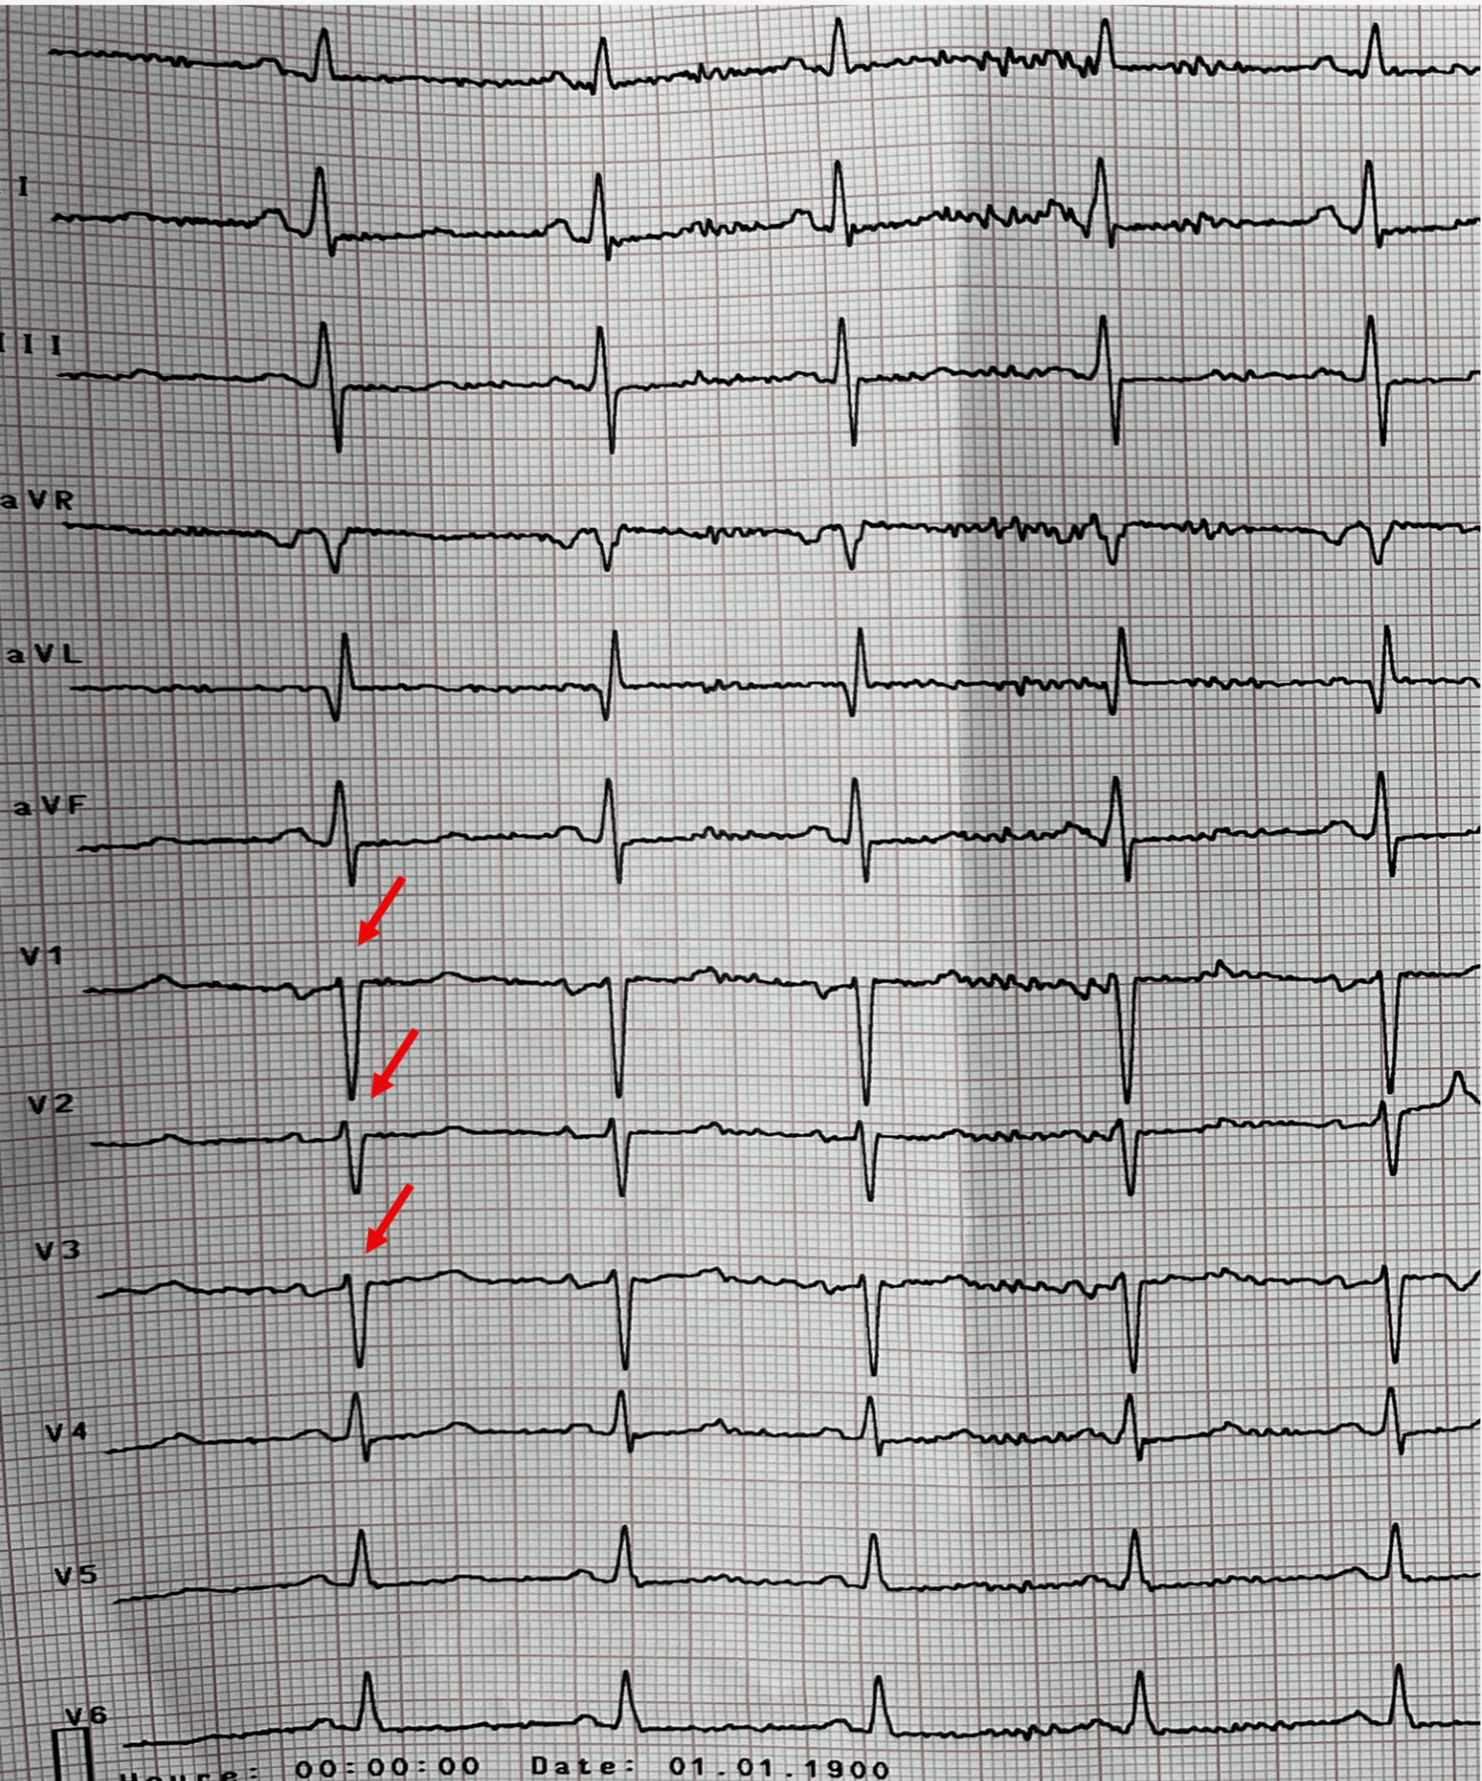

***Figure 1: ECG at admission with adapted electrode placement for dextrocardia.***

High sensitivity cardiac troponin (Hs-cTn) was elevated at 45.6 ng/L. A chest X-ray depicted dextrocardia with situs inversus. (Figure 2).

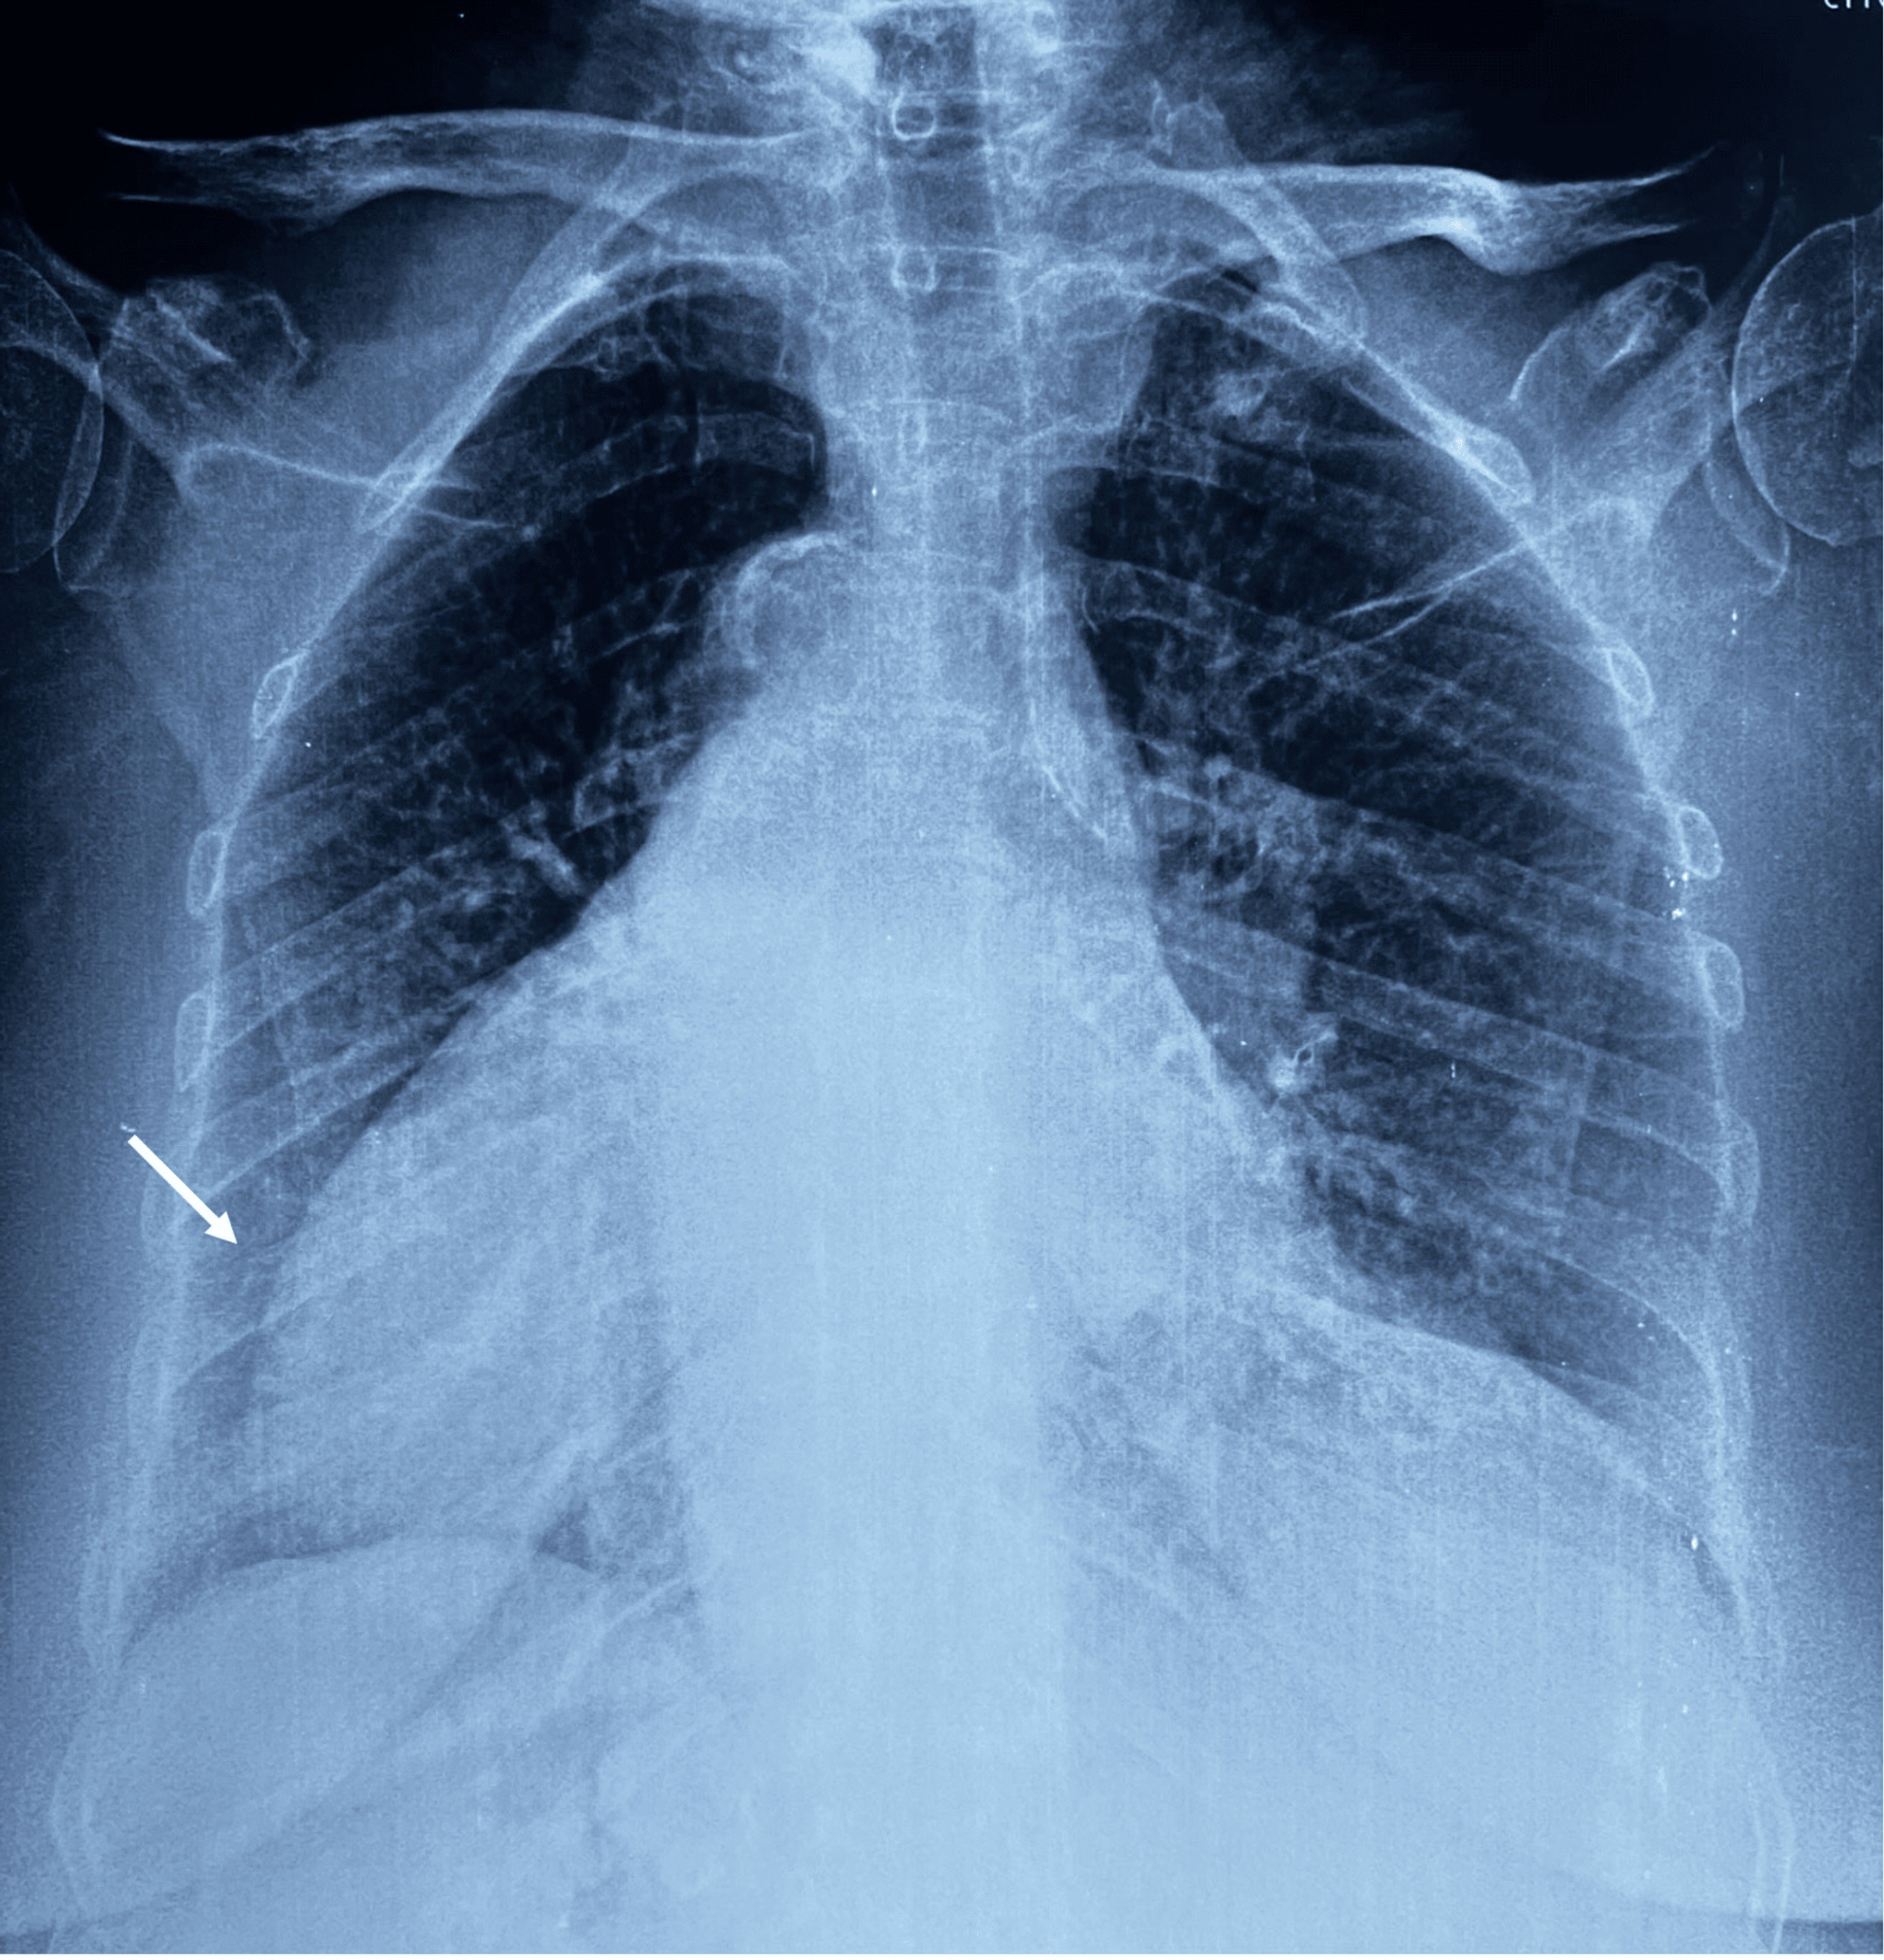

***Figure 2: Chest X-ray showing the heart apex pointing to the right.***

The rest of the biology results and chest X-ray were obtained after the coronary angiography. Initial transthoracic echocardiography (TTE), performed using adapted views for dextrocardia, revealed global hypokinesia with more pronounced wall motion abnormalities in the anterior wall, and a reduced left ventricular ejection fraction (LVEF) of 35%. Biology tests revealed a hypochromic microcytic anaemia and iron deficiency, with Hb 9.5 g/dL in addition to thrombocytopenia: 70.000 units/ul, TSH US 6.35 uui/ml, but T3 and T4 were within normal range.

Given the ongoing thoracic pain described by the patient, with a VAS of 8 out of 10 (Visual Analogue Scale for pain), and the high suspicion of Non-ST Elevation Myocardial Infarction (NSTEMI) the patient was immediately admitted to the catheterisation laboratory. We initiated the exam with a radial approach using a 6 French (Fr) sheath. Engagement in the left main (LM) coronary artery, anatomically situated at the right side, was obtained using mirror views of the standard coronary angiographic views. The engagement of the right coronary artery (RCA), which was located on the left side, proved to be more difficult. We decided to switch to a femoral approach using a 6Fr sheath. The engagement of the RCA was eventually achieved using an Amplatz Left (AL1) diagnostic catheter.

The angiography revealed an acute thrombotic occlusion at the proximal segment of the Left Anterior Descending (LAD) coronary artery as well as a significant stenosis of the proximal portion of the RCA. (Figure 3).

Given the ongoing thoracic pain, the ischemia in the anterior territory as well as the angiographic aspect of the LAD occlusion, we decided to perform a primary PCI of the culprit lesion of the proximal LAD. The LM was engaged using an Extra Back Up (EBU) 6 Fr guiding catheter. The lesion was calcified and difficult to cross using a first-line SAMURAI guidewire that tended to go in the false lumen with subintimal crossing. The lesion was eventually crossed with a JUDO 3 guidewire (Figure 3). We then performed a pre-dilatation using a Non-compliant (NC) 2.5x12 mm Balloon inflated to a maximal pressure of 16 atmospheres (ATM), allowing us to obtain a TIMI 3 flow and revealing a long severe stenosis of the LAD. We subsequently proceeded with the stenting using a 3.0*48 mm Everolimus eluting stent deployed at 11 ATM. The final result was excellent with a TIMI 3 flow (Figure 3). The thoracic pain dissolved after the arevascularization.

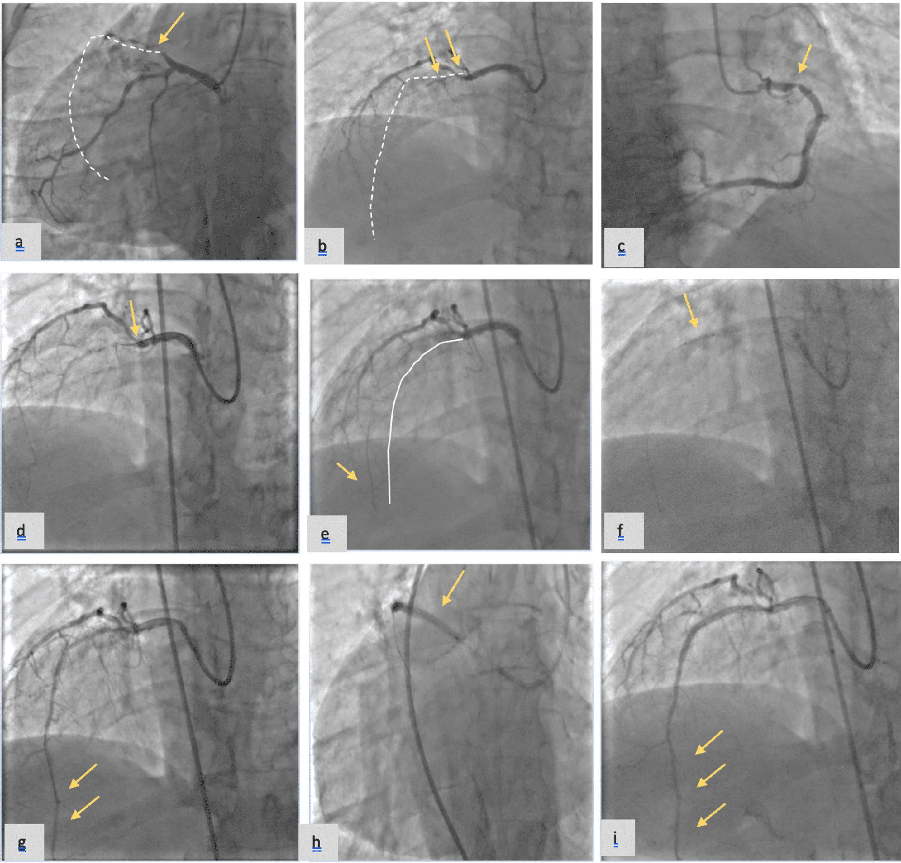

***FIGURE 3: Emergent percutaneous coronary intervention (PCI) in a patient with dextrocardia.*** *Figure 3a: Anteroposterior (AP) view with caudal tilt showing right-sided LM that bifurcates to Circumflex and and occluded LAD dotted yellow line. 3b: AP view with cranial tilt showing an occluded LAD. 3c: RAO view showing severe lesion of the RCA. 3d: First attempt at crossing the LAD occlusion 3e: JUDO 3 wire successfully wiring the LAD (white line). 3f: Pre-dilatation with balloon. 3g: Result post-dilatation. 3h: Stent deployment 3i: TIMI 3 flow after stent placement (yellow arrows).*

As for the RCA, the revascularization was postponed after the anemia and thrombopenia workup. There were no post-procedural complications, during the in-hospital surveillance period, the patient remained asymptomatic, with no recurrence of thoracic pain, no modification to the ECG were observed (no ST changes and no arrythmia episodes), the troponin levels decreased, and an exhaustive panel of complementary exams was realized to explore the anemia and thrombopenia.

3. discussion

This case report highlights the particularities of dealing with dextrocardia in the setting of AMI. Starting from the diagnostic challenges -the need of adjusted lead placement while realizing the ECG as well as adapted views for the echocardiography- to the particularities of the angiography and PCI. It is therefore essential for clinicians to be familiar with dextrocardia in order not to miss the diagnosis, especially in the setting of AMI. As well as for the interventional cardiologists to master the particular techniques required for rapidly engaging the coronary arteries and the adapted views necessary to address the image orientation issue.

Dextrocardia with complete situs inversus is a rare congenital anomaly characterized by a complete mirror-image reversal of the internal organs [1]. In contrast, dextrocardia with situs solitus refers to the normal positioning of the internal organs, except for the heart, which is reversed with a right-sided apex [2].

In the setting of dextrocardia, risk factors of atherosclerosis and acute myocardial infarction (AMI) do not differ from the general population [4]. However, Dextrocardia, when not previously known, proves to be challenging on multiple levels, starting from the diagnosis to the technical aspects of coronary angioplasty [5]. The clinical presentation differs from conventional settings, which exposes to the risk of misdiagnosis. Thoracic pain is usually described on the right side with no irradiation to the left arm, additionally the right-left symmetry abnormalities are responsible for a mirrored cardiac silhouette in chest X-ray as well as ECG particularities where standard ECG may be misleading; showing usually a poor progression of R-wave in precordial leads and right axis deviation [6].

In our case, the diagnosis of dextrocardia was previously established, which allowed us to directly use adapted placement of the precordial electrodes with a rightward orientation and reversed limb electrodes.

In addition to these diagnostic challenges, CAD in the setting of dextrocardia, especially when it presents in AMI, poses technical difficulties for the realization and interpretation of the angiography owing to the non-adaptation of the usual angiographic views as well as the challenge of engaging the coronary arteries. Previously reported cases have established the feasibility of performing angiography using both femoral [7] and radial [8,9] approaches. The Cannulation of the coronary artery requires a reverse torquing motion when handling guiding catheters and wires (clockwise instead of counterclockwise, or vice versa). The unfamiliar manipulation may increase the risk of catheter‑induced injury such as dissection and induced ventricular arrythmias.

Regarding the interpretation of angiography, it presents certain challenges compared to conventional angiography owing to the mirror-image anatomy. This may lead to a prolonged fluoroscopy time and radiation exposure [9]. The most commonly described technique to overcome this difficulty involves reversing the right anterior oblique (RAO) and left anterior oblique (LAO) angulations while maintaining the usual cranial and caudal tilts [4,7]. Jain et al. further suggest optimal angiographic projections and tilts to replicate conventional working views for coronary artery lesions [4].

Another alternative is the double inversion technique, where, additionally, the right/left reversal is used during image acquisition by using the “horizontal sweep reverse” button on the machine, to obtain angiographic views resembling those typically seen in patients with levocardia [10,11,12].

In our case, we used a femoral approach to perform primary emergent PCI. The coronary arteries were engaged by using a reverse torque of the conventional angioplasty catheter. Regarding the optimal views, the patient's anatomy allowed for an anteroposterior (AP) projection with limited use of LAO and RAO projections. The AP was therefore the optimal view for LAD angioplasty in the setting of dextrocardia, with no need to swap LAO and RAO projections, thus reducing the time of the angioplasty. This projection has been previously described by Jain et al. as a good alternative for the double inversion technique and we found that it offers a good visualization of the LAD and thus shortening the time of angioplasty [4].

4. Conclusion

This case reports enriches the available data on interventions on complex CAD in patients with dextrocardia. Dextrocardia is a rare occurrence in clinical practice. The Cardiovascular risk factors are the same as in the general population. Dextrocardia should nonetheless be known and recognized by physicians to allow timely diagnosis of AMI in this category of patients, i.e the clinical particularities of chest pain, the right-sided axis deviation and poor progression of R wave in precordial leads in addition to the Chest X-ray findings.

Moreover, coronary angiography and PCI -especially primary PCI requires some adjustments of conventional techniques. In our case, we were able to perform a coronary angiography followed by angioplasty of the LAD without any complications and with excellent results using a femoral approach by using the reverse torque technique and mostly an AP projection with caudal and cranial tilts.

Disclaimer (Artificial intelligence)

Option 1:

Author(s) hereby declare that NO generative AI technologies such as Large Language Models (ChatGPT, COPILOT, etc.) and text-to-image generators have been used during the writing or editing of this manuscript.

References

1. Kieran M. Hynes, Gerald T. Gau, Jack L. Titus,: Coronary heart disease in situs inversus totalis . The American Journal of Cardiology . 1973, Volume 31, Issue 5,:Pages 666-669. 10.1016/0002-9149(73)90341-X

2. M. J. Yoo, R. E: Bridwell, and J. J. Oliver, “Acute coronary syndrome in Dextrocardia,” Am. J. Emerg. Med., vol. 42, p. 262.e1-262.e2, Apr. 2021. 10.1016/j.ajem.2020.08.100

3. Roma N, Shah K, Ferraro B, et al.: (January 09, 2023) A Rare Case of ST-Segment Elevation Myocardial Infarction and Left Ventricular Thrombus in a Dextrocardia Patient With COVID-19 Infection. Cureus. 15:33527. 10.7759/cureus.33527

4. A. Jain, K. Jagadheesan, S. Satheesh, and A: Anantharaj, “Primary PCI for acute myocardial infarction in a patient with situs inversus totalis and dextrocardia,”. J. Cardiol. Cases, vol. 23, no. 6, pp. 267-270, Jun. 2021, 10.1016/j.jccase.2021.01.002

5. K. L. Liem and J. H. ten Veen: Inferior Myocardial Infarction in a Patient with Mirror-Image Dextrocardia and Situs Inversus Totalis,. CHEST, vol. 69, no. 2, pp. 239-241, Feb. 1976, 10.1378/chest.69.2.239

6. Alzand, B. S. N., Dennert, R., Kalkman, R., & Gorgels, A. P. M. (2009). Acute anteroseptal myocardial infarction in a patient with dextrocardia. Journal of Electrocardiology, 42(3), 254–257. <https://doi.org/10.1016/j.jelectrocard.2008.11.004>

7. R. Jauhar, E. Gianos, K. Baqai, M. Roethel, and B. M. Kaplan: Primary Angioplasty in a Patient with Dextrocardia,. J. Intervent. Cardiol., vol. 18, no. 2, pp. 127-130, Apr. 2005, 10.1111/j.1540-8183.2005.00350.x

8. J. E. Macdonald, R. Gardiner, and A. Chauhan: Coronary angioplasty via the radial approach in an individual with dextrocardia, . Int. J. Cardiol., vol. 131, no. 1, pp. e10-e11, Dec. 2008, 10.1016/j.ijcard.2007.07.035

9. He J, Sun Y, Zhang X, et al.: Emergent percutaneous coronary intervention for acute myocardial infarction in patients with mirror dextrocardia: case reports and brief review. 6:267-273. 10.21037/cdt.2015.12.12

10. Goel, P. K. (2005). Double-inversion technique for coronary angiography viewing in dextrocardia. Catheterization and Cardiovascular Interventions, 66(2), 281–285. <https://doi.org/10.1002/ccd.20473>.

11. Vijayvergiya, R., Gawalkar, A. A., Kasinadhuni, G., Kaushal, S., Batta, A., & Kumar, B. (2022). Percutaneous coronary intervention in dextrocardia patients with situs inversus. AsiaIntervention, 8(2), 132–135. <https://doi.org/10.4244/AIJ-D-22-0000>.

12. Angellotti, D., Esposito, G., & Piccolo, R. (2023). Double Inversion Technique for Multivessel Primary PCI in Dextrocardia. *JACC: Cardiovascular Interventions*, *16*(7), 868–869. <https://doi.org/10.1016/j.jcin.2023.01.019>.