*Case report*

**A case of peritonitis due to hollow organ perforation in a patient with unresectable pancreatic adenocarcinoma discovered incidentally during surgery**

**Abstract  :**

Pancreatic cancer represents a significant challenge in digestive oncology, a cancer with a poor prognosis, with an increasing incidence[1], without clearly identified risk factors allowing screening or diagnosis at an early stage. Surgery remains the only curative treatment today, but is only possible for 15% of patients. For other cases, chemotherapy is currently attempting to prolong survival. Progress in understanding pancreatic carcinogenesis remains insufficient. The study of tumor and circulating molecular markers[2] aims to identify targets for diagnosis and treatment as early as possible in order to extend survival.Carcinomatous peritonitis is a rare complication of pancreatic adenocarcinoma, in which cancer cells spread to the membrane lining the abdomen, the peritoneum, causing inflammation and fluid accumulation (ascites).This spread can occur directly (invasion of the peritoneum by the primary tumor) or via hematogenous (spread via the blood) or lymphatic routes.The presence of carcinomatous peritonitis suggests an advanced stage of the disease and a less favorable prognosis, which is what we will highlight in this article.

**KEYWORDS:**

Pancreatic adenocarcinoma, targeted therapies, pancreatectomy.

**INTRODUCTION :**

Pancreatic cancer is the 7th leading cause of death worldwide and remains the digestive cancer with the worst prognosis, with a 5-year overall survival rate of 7 to 8%, ranking second among digestive cancers after colorectal cancer[3]. The prognosis of pancreatic adenocarcinoma remains very poor despite progress in imaging and multidisciplinary management. This mainly depends on the delay in diagnosis, and the fact that it is asymptomatic for a long time, at an advanced unresectable stage. The aim of this work is to highlight the picture of delayed diagnosis of pancreatic cancer encountered in the emergency setting.

**CASE PRESENTATION:**

This is a 52-year-old patient, a chronic smoker of 40 packs/year with no particular personal or family history. The history of his illness dates back to 1 month before his admission with the appearance of fixed epigastralgia for which he underwent an oesophagastroduodenal fibroscopy which revealed erythematous pangastritis with crossing of the pylorus and duodenal exploration without abnormality. His anatomopathology showed discreet inflammatory changes without metaplasia or dysplasia. The symptoms worsened with the appearance of generalized abdominal pain associated with an occlusive syndrome, without externalized digestive hemorrhage, without jaundice or signs of cholestasis, without weight loss, all evolving in a context of apyrexia and deterioration of the general condition. The clinical examination upon admission found the patient conscious, hemodynamically and respiratory stable, with blood pressure:80/05 mmHg, heart rate: 65 beats/min, respiratory rate: 24 cycles/min, BMI: 22 kg/m , with a distended and tender abdomen, Troisier's lymph node, and a digital rectal examination without any specific features.

Abdominopelvic CT revealed segmental distension of the small intestine, transverse colon, and ascending colon with the presence of several fluid-air levels, measuring 47 mm in maximum diameter at the small intestine and 60 mm in the transverse colon, with a collapsed appearance of the descending colon. This distension is located upstream of an irregular, stenosing parietal thickening of the left colic flexure measuring 15 mm in maximum thickness with surrounding fat infiltration. Presence of a large intraperitoneal effusion located in the peri-hepatic, peri-splenic, inter-loops, at the level of the parieto-colic gutters and iliac fossae as well as at the pelvic level associated with a diffuse thickening of the peritoneal layers more marked on the left and infiltration of the mesenteric fat. Presence of multiple coelio-mesenteric, lumbo-aortic, para-aortic and inter-aortocaval adenopathies, some of which are confluent at the mesenteric level and the largest of which is mesenteric measuring 24mm in short axis. Circumferential and regular thickening of some small intestine loops at the ileal level of reactional appearance. Liver of normal volume, regular contours, site of at least three small, well-circumscribed lesions, at the level of segments VI and VIII, enhanced in the arterial phase with portal phase wash-out, the largest of which is located at the level of segment VIII, measuring 10x7.5mm. For lower thoracic sections: presence of a large right pleural effusion with signs of collapse.

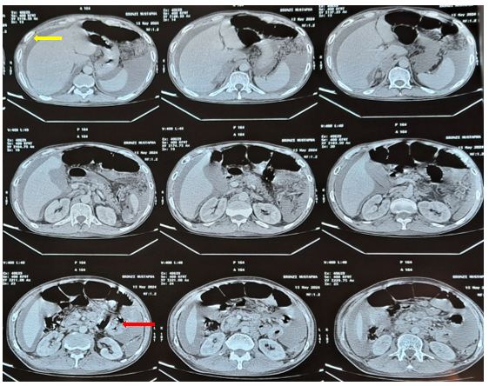

**Figure 1 :** Sagittal sections of an abdominopelvic CT scan showing: mechanical digestive occlusion, small intestine and right colon upstream of parietal thickening of the left colic angle (red arrow) with a large intraperitoneal effusion (yellow arrow) with thickening of the peritoneal layers.

The patient was rushed to the operating room and placed on a central catheter and noradrenaline. After the midline incision, exploration revealed the presence of a large peritoneal effusion of purulent fluid, the presence of carcinomatous nodules throughout the peritoneal cavity, Sugarbaker index 30/39, the presence of a magma of small bowel loops at the level of the last ileal loop plugging a 2cm perforation at the level of the anti-mesenteric edge of the small bowel, and 15cm from the duodenojejunal angle, the jejunal loop is riddled with carcinomatous nodules and is the site of a 0.5cm perforation at the level of the anti-mesenteric edge. The right, transverse and left colons are unremarkable. Liver with a 1cm nodule in segment VI that appeared to be metastatic, which was biopsied. After colo-omental detachment, a 4cm mass was found in the tail of the pancreas, fixed relative to the posterior plane, which was biopsied.

The procedure consisted of a 10cm segmental small bowel resection removing the perforation 15cm from the duodenojejunal flexure with end-to-end small bowel anastomosis, ileocecal resection removing the magma of small bowel loops with ileocolostomy, biopsy of a 4cm mass in the tail of the pancreas, biopsy of a 1cm hepatic nodule in segment VI, peritoneal cleansing, and drainage of the pouch of Douglas using a Salem catheter. Pathology: Liver and pancreatic biopsies and a small bowel specimen suggested poorly differentiated and invasive pancreatic adenocarcinoma.

Before the wall was closed, the patient suffered cardiorespiratory arrest that remained unresolved despite resuscitation measures.

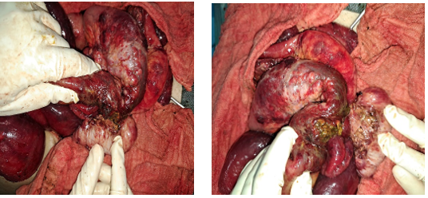

**Figure 2 :** Intraoperative images of the magma of small intestine loops at the level of the last ileal loop. **Left:** before disconnection of the loops. **Right:** disconnection of the magma and highlighting of the sealed perforation.

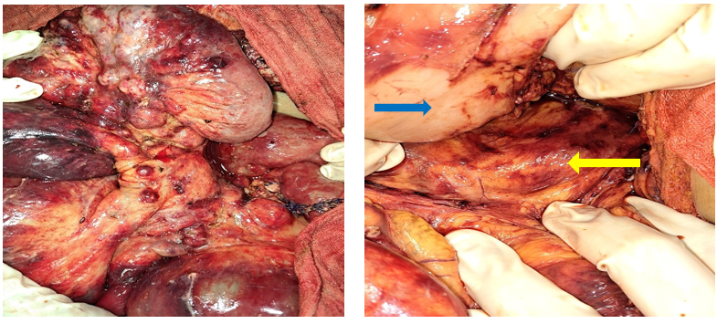

**Figure 3 :** Intraoperative image highlighting:

**Left:** Several carcinomatosis nodules in the small intestine and its mesentery.

**Right:** After colo-omental detachment, a mass in the tail of the pancreas (yellow arrow) is revealed at the posterior cavity of the omentum, not invading the posterior surface of the stomach (blue arrow).

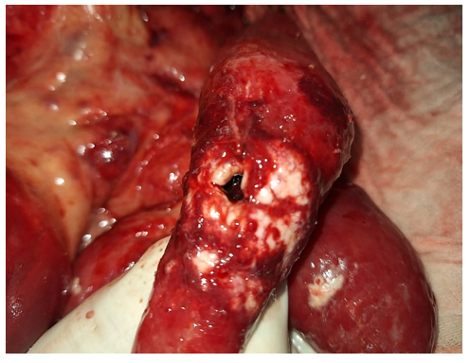

**Figure 4 :** Intraoperative image showing the first jejunal loop which is riddled with carcinomatosis nodules and the site of a perforation.

**II. DISCUSSION**

Pancreatic adenocarcinoma (PADC) is a pathology with a poor prognosis due to its late diagnosis and its intrinsic resistance to existing anti-tumor therapies, which reduces overall survival to 5% beyond 5 years[4]. Poor lifestyle (smoking, alcohol consumption, poor diet leading to obesity and type 2 diabetes, sedentary lifestyle) as well as certain forms of chronic pancreatitis increase the risk of developing pancreatic cancer and the familial form where 5 to 10% of cases of malignant tumors are found.

Adenocarcinoma presents a glandular phenotype with ductal structures[5] exhibiting varying degrees of cellular atypia. It infiltrates surrounding tissues and is associated with a very strong fibrous and inflammatory reaction, called desmoplasia.

This cancer is very often associated with dysplastic lesions of the pancreatic ducts. Three types of precancerous lesions have been described: pancreatic intraepithelial neoplasms (PanINs), the most common, pancreatic papillary and mucinous intraductal tumors, and mucinous cystadenomas.

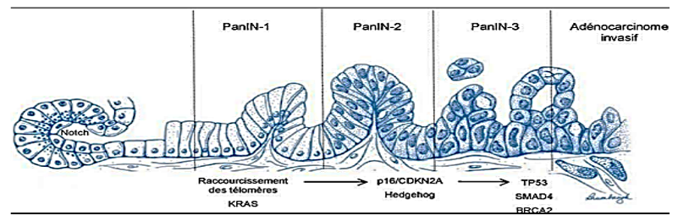

**Figure 5 :** Genetic progression model of pancreatic adenocarcinoma (left to right): Progression from histologically normal epithelium to low-grade pancreatic intraepithelial neoplasia (PanIN), then to high-grade PanIN, and then to invasive carcinoma. Molecular abnormalities can be classified as early (KRAS2 mutation, telomere shortening), intermediate (p16/CDKN2A loss), or late (DPC4/SMAD4, TP53, BRCA2 mutations).

The poor prognosis of pancreatic adenocarcinomas is more likely to be related to late diagnosis due to the deep anatomical topography of the pancreas. Furthermore, these tumors are resistant to both chemotherapy and radiotherapy.

The resistance of pancreatic cancers to anticancer treatments can be explained by:

The poor prognosis of pancreatic adenocarcinoma results from a particular histological aggressiveness and a powerful invasive power linked to multiple genetic alterations. The most common mutations are those of the KRAS, TP53 (Tumor protein 53KD), CDKN2A (cyclin-dependent kinase Inhibitor 2A) genes, also known as p16 or INK4A, and Smad4 (Mothers Against Decapentaplegic homolog), also known as DPC4 (Deleted in pancreatic carcinoma 4).

Clinically, the manifestation is more likely to be the appearance of abdominal pain, which appears mainly in the body and caudal areas (30 to 40% of pancreatic cancers). In its typical form, the pain resembles pancreaticosolar syndrome, located supraumbilically and epigastically (45 to 65% of cases), with transverse and especially transfixing radiation. These symptoms are not always as evocative and may appear as vague pain. They can, in particular, mimic functional colopathy, dyspeptic syndrome, or a rheumatic condition for several months. The determining element is represented by significant weight loss which, unfortunately, is not always early in the natural history. Jaundice represents the essential sign of cancer of the head of the pancreas (this location represents nearly two thirds of pancreatic cancers). It is typically retentional, insidious in onset, continuous evolution, without remission, in the absence of painful crisis or hyperthermic episode (we speak of naked jaundice). Metastatic and advanced forms can also be elements of discovery by hepatic metastases, peritoneal carcinomatosis[6], duodenal stenosis, supraclavicular lymph node, pulmonary, pleural, bone or medullary metastases.

* For a positive diagnosis, it will be confirmed by markers or radiology.
* The CA 19-9 level provides prognostic information. At the time of diagnosis, if it exceeds 500 U/ml without cholestasis, it strongly suggests its metastatic nature. After neoadjuvant treatment, it should be less than 100 U/ml. For therapeutic monitoring, its significant decrease of more than 40%-60% under chemotherapy plus or minus radiotherapy favors satisfactory tumor control, and its normalization after surgery is a good prognosis.
* Imaging has a three-fold goal: positive diagnosis of the pancreatic mass, confirmation of the nature of this mass, and performance of pre-treatment staging. • Ultrasound is the first-line examination in the investigation of jaundice or abdominal mass syndrome, and highlights indirect signs such as dilation of the intra- and extrahepatic bile ducts, dilation of the Wirsung duct, and vascular thrombosis (portomesenteric venous system).
* Abdominal CT is the gold standard examination for the detection of pancreatic tumor syndrome in the form of a generally hypodense mass, irregular in its contours, enhancing contrast and associated or not with bile duct and/or pancreatic dilation, or even atrophy of the non-tumoral pancreatic parenchyma. Thanks to 3D reconstructions, CT allows for a good assessment of the extension not only locoregionally (especially vascular) but also at a distance.
* MRI cholangiopancreatography currently provides accurate images of the bile and pancreatic ducts, allowing for a reliable diagnosis of neoplastic biliary strictures and helping to guide the diagnosis of the nature of a pancreatic mass.
* Endoscopic ultrasound is the most accurate examination for visualizing small tumors, particularly at the biliopancreatic confluence (diagnostic accuracy of 93 to 100%). It is also a very effective examination for assessing locoregional extension. It will only be performed if the CT scan has not clearly visualized the pancreatic tumor or if there is doubt about the resectability of this tumor. The fine needle aspiration cytology performed during endoscopic ultrasound provides reliable cellular material, thanks to concentration and thin-layer techniques, with a diagnostic certainty of 85 to 90% of cases.
* Endoscopic retrograde cholangiopancreatography (ERCP) has therapeutic value with the placement of a biliary stent in the palliative or preoperative management of obstructive jaundice and for the placement of a duodenal prosthesis in cases of obstruction of the digestive lumen by the tumor.
* Positron emission tomography (PET-scan) is useful in cases of doubt about metastases not or poorly seen on thoraco-abdomino-pelvic CT scan.

For curative purposes, surgical resection remains the only treatment, provided the tumor is small (less than 2 to 2.5 cm in diameter), does not invade nearby vessels or organs, and has no metastases.

These procedures are major and are reserved for patients in good general condition, under the age of seventy-five, and without associated organ failure.

Head pancreatectomy with lymph node dissection is the standard procedure for head cancers, with a postoperative mortality rate of less than 2%. Morbidity ranges from 10% to 25% due to fistulas, infections, or hemorrhage.

Left splenopancreatectomy is reserved for cancers of the body and tail.

Total pancreatectomy is rarely offered, except for pre-neoplastic lesions such as extensive mixed IPMNs.

The standard chemotherapy is gemcitabine[7]. It is applied to locally advanced and unresectable cancers and/or metastatic cancers. It sometimes allows for an extension of survival, even if this remains modest, and above all provides an improvement in general signs and quality of life. Unfortunately, the median survival of metastatic cancers is around four months, while that of locally advanced cancers is around six months[8].

The study of targeted therapies[9] at the preclinical and clinical levels has not really been a success: anti-EGFR antibodies (cetuximab), antiHER-2 (trastuzumab) have produced very promising results in combination with gemcitabine in animals and in phase II, while the phase III results have unfortunately not lived up to expectations. Regarding small molecule kinase inhibitors, only erlotinib provides a survival benefit in combination with gemcitabine compared to gemcitabine alone, but this survival benefit remains very modest. Anti-angiogenic agents (anti-VEGF, bevacizumab) have also failed to meet the expectations of preclinical studies, as phase III trials remain disappointing.

Finally, metalloproteinase inhibitors (marimastat) have also been used, but without success.

Palliative treatments[10], whether surgical or not, are reserved for patients in poor general condition, with an unresectable tumor, or in a situation of escape. This involves treating jaundice due to neoplastic compression of the common bile duct and possible obstruction of the second duodenum by the tumor (prostheses, diversions), and treating pain (opioids, alcoholization of the celiac plexus).

In our case, the patient had age, male gender, and smoking (40 packs/year) as risk factors. The clinical picture did not suggest pancreatic pathology, with only epigastralgia without significant weight loss. Despite a normal esophagogastroduodenal endoscopy with biopsy, further investigations were necessary by requesting tumor markers or at least an abdominal ultrasound given these risk factors. As for the rapid progression of the disease, this data is consistent with the literature supporting the poor prognosis of pancreatic cancer if diagnosis is delayed.

**III. CONCLUSION :**

Pancreatic adenocarcinoma remains complex in terms of early diagnosis as has been supported in our article, its rapid dissemination, its unresectability and its aggressive nature in a patient whose only risk factor was smoking and whose clinical picture was poor which was at the origin of the fortuitous discovery of pancreatic adenocarcinoma in a picture of peritonitis complicating its management and threatening the patient's life prognosis. A better understanding of the complex cascades of molecular genetic modifications is necessary, as well as the development of targeted drugs and appropriate treatment plans to prevent tumor progression, remain the only hope for the future.

Consent

As per international standards or university standards, patient(s) written consent has been collected and preserved by the author(s).

Disclaimer (Artificial intelligence)

Option 1:

Author(s) hereby declare that NO generative AI technologies such as Large Language Models (ChatGPT, COPILOT, etc.) and text-to-image generators have been used during the writing or editing of this manuscript.

Option 2:

Author(s) hereby declare that generative AI technologies such as Large Language Models, etc. have been used during the writing or editing of manuscripts. This explanation will include the name, version, model, and source of the generative AI technology and as well as all input prompts provided to the generative AI technology

Details of the AI usage are given below:

1.

2.

3.

**IV. REFERENCES :**

1. Kpossou, Aboudou Raïmi, Dansou Gaspard Gbessi, Freddy Houéhanou Rodrigue Gnangnon, Meissarath Modoukpè Ba Boukari, Rodolph Koffi Vignon, Comlan N´déhougbéa Martin Sokpon, and Jean Sehonou. “Pancreatic cancers at the National University Hospital of Cotonou: epidemiological, diagnostic, therapeutic and prognostic aspects.” The Pan African Medical Journal 39 (May 6, 2021): 18. https://doi.org/10.11604/pamj.2021.39.18.26261.
2. Christenson, Eric S., Elizabeth Jaffee, et Nilofer S. Azad. « Current and Emerging Therapies for Patients with Advanced Pancreatic Ductal Adenocarcinoma: A Bright Future ». *The Lancet Oncology* 21, no 3 (1 mars 2020): e135‑45. <https://doi.org/10.1016/S1470-2045(19)30795-8>.
3. Vasseur, Sophie, and Fabienne Guillaumond. “Pancreatic adenocarcinoma: a lipoprotein-dependent tumor.” Medicine/Sciences 31, no. 8-9 (August 2015): 728-30. https://doi.org/10.1051/medsci/20153108009.
4. Lambert, Aurélien, Lilian Schwarz, Ivan Borbath, Aline Henry, Jean-Luc Van Laethem, David Malka, Michel Ducreux, et Thierry Conroy. « An Update on Treatment Options for Pancreatic Adenocarcinoma ». *Therapeutic Advances in Medical Oncology* 11 (1 janvier 2019):  <https://doi.org/10.1177/1758835919875568>.
5. Maitra, Anirban, et Ralph H. Hruban. « Pancreatic Cancer ». Annual review of pathology 3 (2008): 157 88. https://doi.org/10.1146/annurev.pathmechdis.3.121806.154305.
6. Tentes, Antonios-Apostolos, Nicolaos Pallas, Christina Karamveri, Dimitrios Kyziridis, et Christos Hristakis. « Cytoreduction and HIPEC for Peritoneal Carcinomatosis of Pancreatic Cancer », JBUON 2018; 23(2): 482-487
7. « Activity of gemcitabine in patients with advanced pancreatic carcinoma: A review - Moore - 1996 - Cancer - Wiley Online Library ».
8. Zoungrana, Steve, and Thierry Piche. “A Randomized Trial of Chemoradiotherapy and Chemotherapy After Resection of Pancreatic Cancer.” Hépato-Gastro & Oncologie Digestive 12, no. 1 (January 1, 2005): 79-80.
9. Renard, Emma. “Design of molecular imaging and theranostic agents for the detection and targeted therapy of cancers.” PhD, Université Bourgogne Franche-Comté, 2020.
10. Sacko, O., Z. Z. Sanogo, A. Camara, S. Koumaré, A. Koïta, S. Keïta, L. Soumaré, M. Camara, D. Goïta, and D. Sangaré. “Bilio-Digestive Diversions in Palliative Surgery for Pancreatic Head Cancer: A Report of 45 Cases.” African Journal of Surgery and Specialties 6, no. 3 (2012): 35-38.