Case report

First psychotic episode revealing a spontaneous non-traumatic rupture of the spleen: a case report

Abstract :
Non-traumatic splenic rupture a rare condition in which establishing a positive diagnosis is often difficult, and delayed diagnosis can be life-threatening. The etiologies are multiple and the symptoms are not specific. It is often ultrasound or CT scan that confirms the diagnosis. We will shed light on a case of spontaneous non-traumatic rupture of the spleen revealed by acute psychiatric symptoms.
KEYWORDS:
Spontaneous rupture of the spleen, brief psychotic state, splenectomy.
INTRODUCTION :
In emergency surgery, splenic ruptures are most often of traumatic origin. Atraumatic etiology remains rare but any delay in diagnosis can be life-threatening (10-15%). The etiologies of spontaneous atraumatic rupture of the spleen are varied and can be: hematological, neoplastic, inflammatory, infectious, linked to drug intake or idiopathic. Clinically, it is the appearance of abdominal pain with sometimes scapular irradiation (Kehr sign) but it is radiology by ultrasound or abdominal CT scan that confirms the diagnosis. In our study, we report the diagnosis of spontaneous rupture of the spleen revealed by an episode of acute psychosis in a patient followed for suspected multiple myeloma complicated by terminal chronic renal failure.

CASE PRESENTATION:

This is a 46-year-old patient, chronic smoker (20 packs/year), occasional alcoholic, hypertensive under dual therapy (angiotensin converting enzyme inhibitor and calcium channel blocker), having an aunt followed for schizophrenia, followed in hematology for monoclonal gammopathy (suspected multiple myeloma) with serum protein electrophoresis (presence of a monoclonal gamma peak), immunofixation (presence of monoclonal immunoglobulin type Kappa), the myelogram showed a normal plasma cell rate between 2 and 3% as for the bone marrow biopsy (the bone marrow richness was reduced compared to the patient's age without obvious signs of tumor infiltration), the pathology was complicated by terminal chronic renal failure for which he benefits from 3 hemodialysis sessions per week, the renal biopsy puncture reveals the presence of deposits Randall-type monoclonal immunoglobulins. After 7 months of uneventful hemodialysis, the patient presented to the day hospital in the nephrology department in a state of mental agitation. The general examination upon admission found the patient conscious 15/15, blood pressure: 100/55 mmHg, heart rate: 100 beats/min, respiratory rate: 20 cycles/min, with an unremarkable clinical examination, including a soft abdomen. Laboratory assessment: CBC (on admission): hemoglobin: 4.1 g/dL, hematocrit: 13%, red blood cells: 1.37 106 /µL, white blood cells: 9,820/µL, platelets: 211,000/µL. Complete blood count (on day 2 of hospitalization after transfusion of 2 red blood cells): hemoglobin: 3.6g/dl, hematocrit: 11.5%, red blood cells: 1.22 106 /µl, leukocytes: 12,670/µl, platelets: 108,000/µl. Hemostasis assessment: PT: 88%, APTT: 0.9 seconds. Fluid and electrolyte balance: Na+: 141mmol/l, K+: 3mmol/l, Ca2+: 101mg/l, Mg2+: 21mg/l, creatine: 36mg/l, urea: 1.2g/l, Albumin: 36g/l. After the patient's assessment by psychiatrists, the interview revealed logorrhea, tangential speech, and a reference syndrome with grandiose ideas. The brain CT scan was normal. The abdominopelvic CT scan revealed a globular spleen, the site of a spontaneously hyperdense splenic subcapsular hematoma measuring 56 mm in maximum thickness, appearing to rupture intraperitoneally.
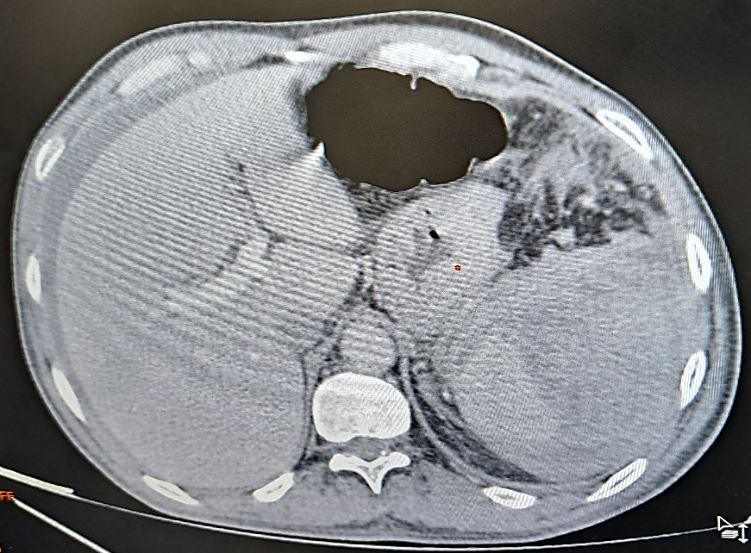
Figure 1 : Cross-section of an abdominopelvic CT scan revealing a splenic hematoma (triangle), with moderately abundant hemoperitoneum (star).

On day 2 of hospitalization, the patient presented with hemodynamic instability with tachycardia at 130 beats/min, hypotension at 0.6/0.3 mmHg, left hypochondrium tenderness, and deglobulization despite a transfusion of two red blood cells during his hemodialysis session, hence the indication for emergency transport to the operating room. The procedure was a laparotomy splenectomy, evacuation of moderately abundant hemoperitoneum, and drainage of the left subphrenic nerve via a Salem catheter. Surgical exploration revealed moderately abundant hemoperitoneum and a ruptured splenic hematoma in the peritoneal cavity. On the anatomopathology of the surgical specimen, presence of a splenic hematoma of 9cm in long axis, with presence of hemorrhagic and congestive changes of the splenic pulp and absence of signs of malignancy.
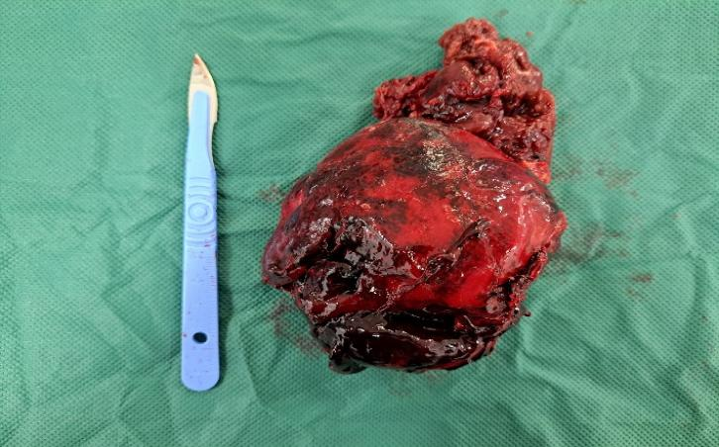 A 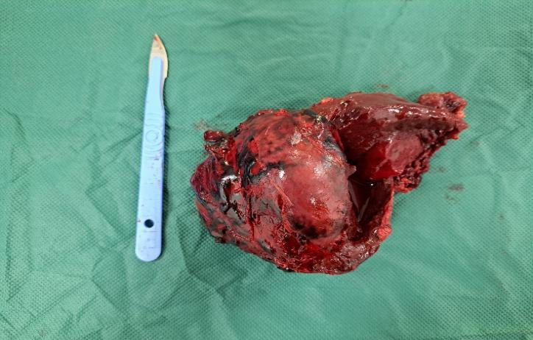 B
Figure 2 : Intraoperative image of splenic rupture:
A: Diaphragmatic surface
B: Medial surface
On postoperative day 1, the patient seemed less agitated and more psychologically stable, the hemodynamic and respiratory status was stable, the follow-up was simple with a soft abdomen, a clean dressing and a drain that was not returning anything. Psychiatric re-evaluation found an euthymic patient with a better ability to orient himself in time and space, the disappearance of logorrhea and the delusions of persecution expressed preoperatively towards the healthcare team. The patient was transferred to the nephrology department for specialized care, with a prescription for vaccines against pneumococcus, meningococcus and Haemophilus and penicillin antibiotic prophylaxis.
II. DISCUSSION
The spleen is a blood-filled organ due to its role in blood filtration and participation in immune responses. It receives 5 to 10% of cardiac output, or a blood flow of approximately 150 ml/min. For this reason, splenic rupture can cause fulminating hemorrhage that can quickly lead to fatal consequences if not treated promptly.
Atraumatic spontaneous rupture of the spleen is a rare condition. Rokitansky in 1861, Atkinson en 1874, and Weidemann in 1927 published the first description of spontaneous rupture of the spleen without prior trauma, thus highlighting the existence of this phenomenon unrelated to external causes. Knoblish in 1966 distinguished "non-traumatic rupture of a pathological spleen" from "non-traumatic splenic rupture of unknown etiology." The pathophysiology of atraumatic splenic rupture is not clearly defined, but three mechanisms have been formulated. The first is increased intrasplenic tension due to engorgement and cellular hyperplasia (massive lymphocytic cellular infiltration of the cords and vascular walls). The second is compression of the spleen by the abdominal musculature during physical activity, or weak triggers (such as coughing, defecation, or sneezing). The third is vascular occlusion caused by hyperplasia of the endothelial reticulum, which leads to thrombosis and infarction. These mechanisms interstitial cause and subcapsular hemorrhages as well as capsule detachment, which leads to subcapsular hemorrhage, loss of elasticity of the splenic capsule, and subsequent rupture.
Spontaneous rupture of the spleen is characterized by its etiological polymorphism: - Infections:
- Infectious mononucleosis, bacterial sepsis, bacterial endocarditis, tuberculosis, malaria, leishmaniasis, trypanosomiasis, AIDS, viral hepatitis, congenital syphilis, splenic abscess, disseminated histoplasmosis.
- Conditions associated with erythrocyte abnormalities: Spherocytosis, sickle cell disease, ovalocytosis, thalassemia.
- Immune diseases: Felty syndrome, systemic lupus erythematosus, immune hemolytic anemia, angioimmunoblastic lymphadenopathy, drug hypersensitivity with serum sickness, immunologic thrombocytopenia and neutropenia.
- Conditions with blood flow disorders: Postnecrotic cirrhosis and Laennec cirrhosis, portal, splenic, or hepatic vein obstruction, hepatic schistosomiasis, congestive heart failure, splenic artery aneurysm.
- Infiltrative diseases of the spleen: Benign (amyloidosis, Gaucher disease, Niemann-Pick syndrome, Hurler syndrome, Tangier disease, multifocal Langerhans cell granulomatosis, extramedullary hematopoiesis, hamartomas, fibromas, hemangiomas, lymphangiomas, cysts). Malignant (leukemias, lymphomas, primary splenic tumors, angiosarcomas, metastases, myeloproliferative disorders).
- Other conditions: Idiopathic splenomegaly, thyrotoxicosis, iron deficiency anemia, sarcoidosis, beryliosis, Kikuchi's histiocytic necrotizing lymphadenitis.
The clinical presentation is nonspecific: most often diffuse abdominal pain or pain localized to the left hypochondrium, either acute in onset with hypovolemic shock, or subacute or more progressive with low symptoms. Kehr's sign (radiation to the left scapula) is specific, reflecting diaphragmatic irritation related to peritoneal effusion, but is found in less than half of cases. In our case, the symptomatology was essentially of psychiatric origin.
The definition of a first psychotic episode in the international literature is based on the DSM (Diagnostic and Statistical Manual of Mental Disorders, developed by the American Psychiatric Association), and covers several situations: the first delusional episode with symptoms evolving for more than 6 months suggesting a diagnosis of schizophrenia or schizoaffective disorder (we speak of first episode schizophrenic disorder (FES)), then we have the brief psychotic state (which evolves from 1 day to 1 month) and whose etiology can be of mental or organic origin.
Exploring a first psychotic episode is a complex issue given the high prevalence of schizophrenia in the general population on the one hand, and the large number of rare conditions in the differential diagnosis on the other hand.
For additional examinations.
There is no international consensus on the examinations necessary to decide between the physical origin and the psychiatric symptomatology. A physical examination guided by the patient's history as well as a neurological examination are required.
The assessment performed must be complete: a blood count, blood sugar, blood electrolytes including calcemia, arterial oxygen saturation, a pregnancy test in women of childbearing age are generally recommended with, depending on the clinical picture, an HIV test and/or syphilis serology, thyroid tests and the search for toxic substances in the blood and urine. A brain CT scan (see brain MRI) will be requested if there are signs of head trauma or focal neurological signs, as well as in older patients, HIV positive, and without a family history of disorders, an EEG must be done if the clinical history suggests temporal epilepsy.
For therapeutic management, if an organic cause is found, it must be treated early. In the case of "primary" psychotic symptoms, international guidelines agree that the earlier treatment is initiated, the better the prognosis, particularly in cases of schizophrenic onset. In our case, the etiology of the spontaneous rupture of the spleen was confirmed by an abdominopelvic CT scan, and the resolution of the psychiatric disorder after splenectomy is consistent with international guidelines.

III. CONCLUSION
A large number of organic pathologies can induce psychotic symptoms, including surgical emergencies which must be investigated through careful and early anamnestic and clinical assessment, supplemented by a basic biological assessment to avoid any delay in treatment which could be life-threatening.

Disclaimer (Artificial intelligence)
Option 1:
Author(s) hereby declare that NO generative AI technologies such as Large Language Models (ChatGPT, COPILOT, etc.) and text-to-image generators have been used during the writing or editing of this manuscript.

IV. REFERENCES

Omar, Elmaghraoui, ‘Spontaneous Rupture of the Spleen : Case Report’, American Journal of Medical and Clinical Research & Reviews, 2.11 (2023), pp. 1–6, doi:10.58372/2835-6276.1092
Abbadi, Safae El, Fatima Zahra Rhouni, and Laila Jroundi, ‘Spontaneous Rupture of the Spleen: A Case Report and Literature Review’, The Pan African Medical Journal, 27 (2017), p. 62, doi:10.11604/pamj.2017.27.62.12451
Weaver, Helen, and others, ‘Spontaneous Splenic Rupture: A Rare Life-Threatening Condition; Diagnosed Early and Managed Successfully’, The American Journal of Case Reports, 14 (2013), pp. 13–15, doi:10.12659/AJCR.883739
Willi Jeanmonod, Muriel, and Alend Saadi, ‘Atraumatic-idiopathic splenic rupture’, Swiss Medical Forum, 2023, doi:10.4414/fms.2023.09449
Kaniappan, K., Lim, C.T.S. & Chin, P.W. Non-traumatic splenic rupture - a rare first presentation of diffuse large B-cell lymphoma and a review of the literature. BMC Cancer 18, 779 (2018). https://doi.org/10.1186/s12885-018-4702-1
Weaver, Helen, and others, ‘Spontaneous Splenic Rupture: A Rare Life-Threatening Condition; Diagnosed Early and Managed Successfully’, The American Journal of Case Reports, 14 (2013), pp. 13–15, doi:10.12659/AJCR.883739
Tsevi, Yawovi Mawufemo, and others, ‘Non-traumatic rupture of the spleen revealed by acute renal failure’, The Pan African Medical Journal, 33 (2019), p. 176, doi:10.11604/pamj.2019.33.176.19562
J.Goutte, M.Killian and others, First-episode psychosis as primary manifestation of medical disease: An update, La Revue de Médecine Interne Volume 40, Issue 11, November 2019, Pages 742-749,
Andreou, Adélie, ‘Qualitative assessment of the experience of the first psychotic episode by patients and their families. Reflections on the creation of a therapeutic education tool’, 2022
Berthet, F., and others, ‘Brief Psychotic Episode Revealing Encephalopathy Secondary to SARS-CoV-2 Infection in the Context of Autoimmune Myasthenia Gravis: A Case Report’, L’Encéphale, 49.2 (2023), pp. 202–04, doi:10.1016/j.encep.2022.04.001
Mathur, A. “The first delusional episode in the emergency room”, emergency 2007, SFMU French society of emergency medicine.

