***Case report***

***HYDATID CYST OF POUCH OF DOUGLAS: A CASE REPORT***

***ABSTRACT:***

Hydatid disease is a parasitosis considered benign and slow to develop, it can affect both sexes and at all ages. The hydatid cyst of pouch of Douglas is an exceptional form of the disease. It is either primary and isolated, or secondary to another location. We report a case of a 55 year old male patient with cyst of pouch of Douglas treated in the surgical department of the 5th military hospital of Guelmim.

Keywords: parasitosis, Hydatid disease, echinococcosis, *Echinococcus granulosus*

***INTRODUCTION:***

Hydatidosis or echinococcosis, also called hydatid disease, is a cosmopolitan zoonosis widespread throughout the world, which is due to the presence and development in humans, the accidental intermediate host, of the larval form of a cestode of the genus Echinococcus Granulosus (EG). It is in fact a small tapeworm living in the intestine of domestic carnivores, including dogs. It is endemic in countries around the Mediterranean such as Morocco and constitutes a real public health problem due to its frequency, morbidity and potential mortality. Although most organs can be affected by hydatids, more than 90% of human hydatid cyst are located in the liver and lungs. Exceptional locations of hydatid cysts include: brain, heart, thyroid, retrovesical.

Retrovesical localization of hydatid cyst is rare in humans compared to other hydatid localizations (0.1 to 0.5%). It is considered an “aberrant” or ectopic localization defined by the development of the parasite in the subvesical and retrovesical fat.

***CASE PRESENTATION:***

The patient is a 55 year old male with no particular medical history. The onset of his symptoms dates back to six months before his admission with the appearance of abdominal pain associated with dysuria, without significant transit disorders and developing in a context of preservation of the general condition and apyrexia.

There was no notion of contact with dogs. The clinical examination found a patient in good general condition, hemodynamically stable, with normally colored conjunctiva. Abdominal palpation and examination of the external genitalia were unremarkable. The rectal examination was normal. The serology of Hydatid cyst was positive. Abdominopelvic ultrasound showed a retrovesical mass measuring 74mm, a heterogeneous hypoechoic round image. The liver and spleen appear normal.

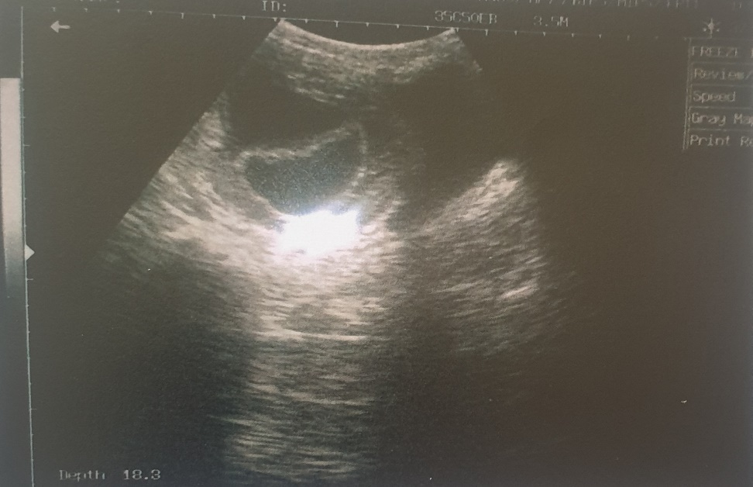

Image 1: Heterogeneous hypoechoic round image on transabdominal pelvic ultrasound, showing a retrovesical process measuring 74mm.

The chest X-ray is unremarkable. The abdominopelvic CT scan confirms the retrovesical location of the process, which is hypodense with a limited wall respecting the bladder wall. In our case, the hydatid cyst can be classified as a type 2 cyst according to the Gharbi classification. There isn’t other locations of the Hydatid cyst, particularly hepatosplenic and peritoneal.

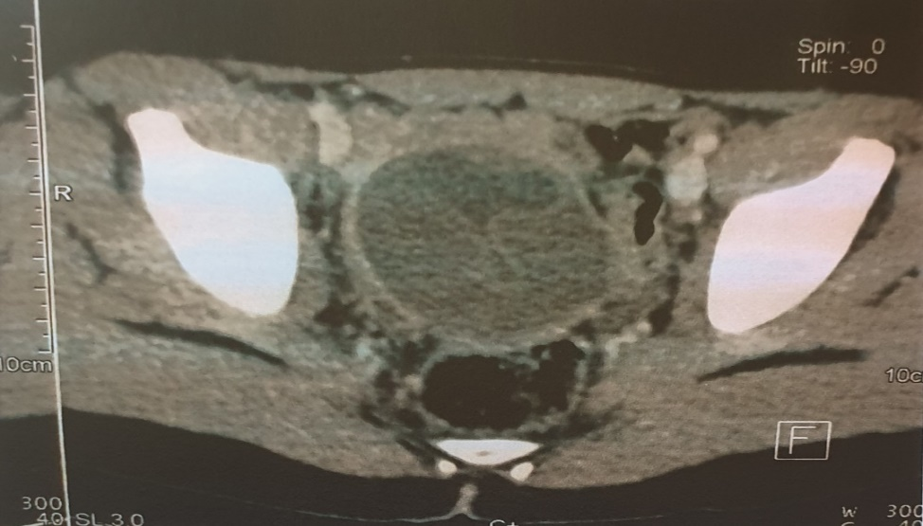

Image 2: Abdominopelvic CT scan confirming the retrovesical location of the process.

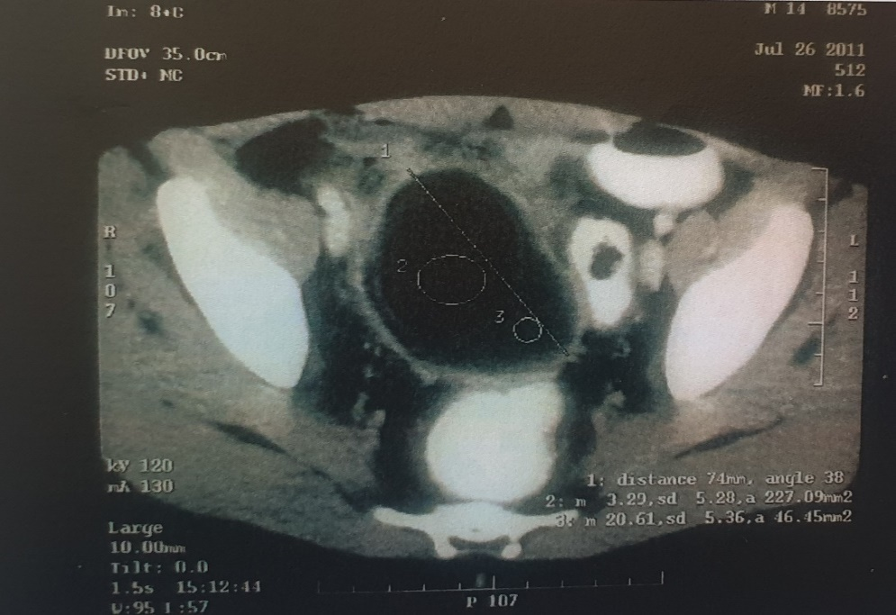

Image 3: CT appearance of the retrovesical Hydatid cyst.

The surgical intervention was scheduled. The cyst was approached via an infraumbilical midline incision with total resection of the hydatid cyst (total cystoperikystectomy). Medical treatment was started postoperatively, based on albendazole, at a dose of 10mg/kg/day for three cures spaced 21 days apart. Over a seven year follow up, no signs of recurrence have been reported.

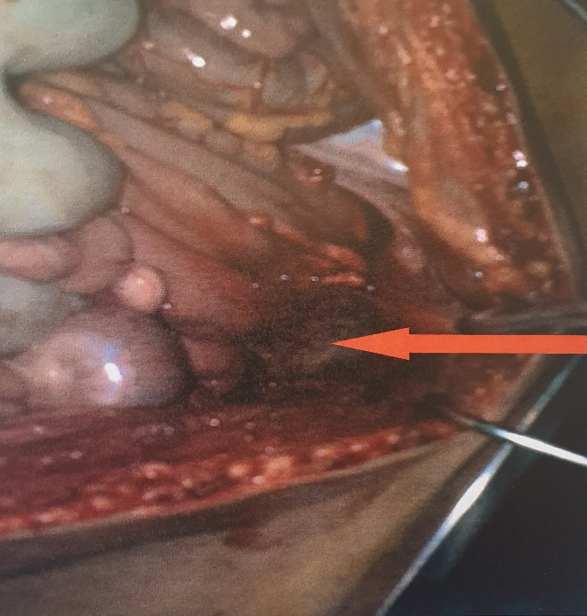 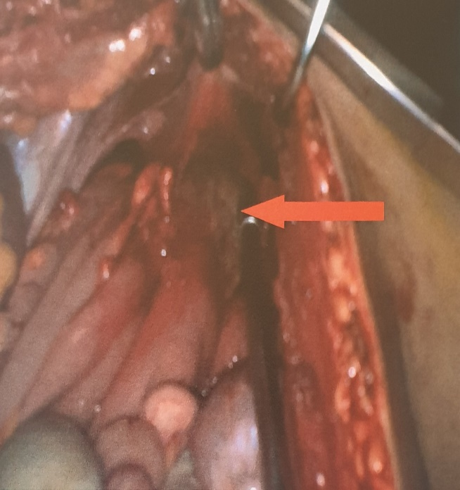Image 4: Intraoperative view: Individualization of the Hydatid cyst of the pouch of Douglas.

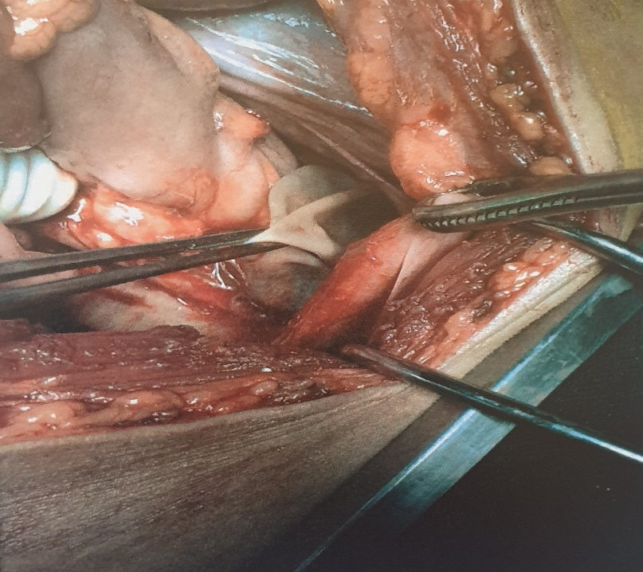

Image 5 : Intraoperative view : opening of the cyst and removal of the proliferation membrane.

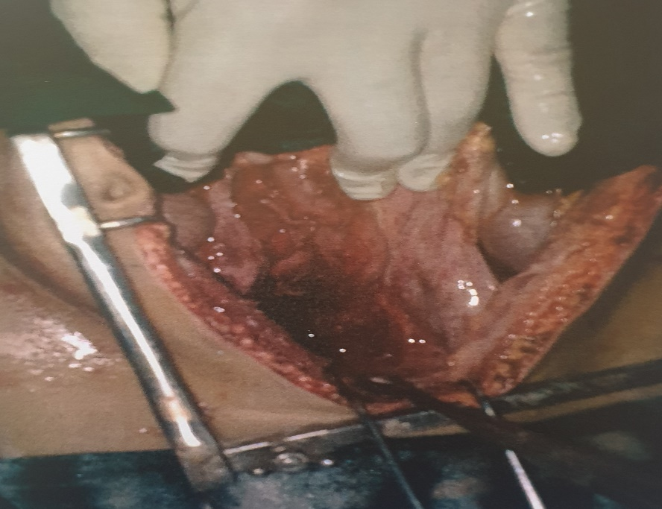

Image 6 : Intraoperative view showing the emptiness of the surgical field after removal of the proliferative membrane.

***Discussion:***

Hydatidosis also known as hydatid disease or hydatid cyst, is a parasitic disease caused by the development of a dog tapeworm larva in herbivores and humans: Echinococcus Granulosus. It is a cosmopolitan disease, present on all continents, especially in countries where sheep farming is a pastoral and traditional. It is an infectious, inoculable, non-contagious larval cestodosis common to humans and certain animals. It is caused by the development in the organism of the intermediate host, particularly in the liver, lungs and others organs (brain, uterus, kidneys, spleen, muscle…) of vesicular larvae of the echinococcus type (1). Wani et al. reported a case of a primary hydatid cyst in the thigh (26). Hydatid disease is often discovered incidentally, however patient may be symptomatic and may also revealed suddenly by a complication. Hydatid cysts of pouch of douglas are uncommon, considering them in the differential diagnosis of masses, particularly in endemic regions (25). In a study conducted in Morocco between 2011 and 2012 on the anatomical locations of Hydatid cysts, liver involvement predominated and was seen in 79,59% of cases, followed by pulmonary involvement, which is seen in 15,89% of cases (2).

Location of the cul-de-sac of Douglas is rare even in endemic countries and would only represent 0,1 to 0,5% in Moroccan series and 0,5 to 2% in Tunisian series(3). In the retrovesical tissue, the cyst develops very gradually and remains silent for a long time. It may be discovered incidentally during a radiological examination or during surgical exploration for intestinal obstruction (4). The clinical symptoms are nonspecific and stimulate those of a tumor or pelvic expansive process (5). We can find a genitourinary signs such as pollakiuria, dysuria, retentional episodes or anuria due to bilateral compression of the ureters (6). Hydaturia, a pathognomonic but exceptional sign, reflect the opening of the cyst into the bladder. (3,7). A digestive signs such as pelvic or hypogastric pain (8), constipation and abdominal distension secondary to rectal compression by the pelvic cyst are rarely reported in the literature (9), rectal signs in the form of tenesmus, stenosis and there is a possibility of fistulization of the hydatid cyst in the sigmoid (3). A gynecological signs such as metrorrhagia, sterility, or obstructed labor may also be diagnostic circumstances (8). The general condition remains unchanged for a long time, however weight loss, also known as Hydatid cachexia, is rare and is linked to hyper parasitism or a long course of the disease (10). The clinical examination is generally normal or reveals: An hypogastric mass that remains unchanged after bladder emptying (11). A well-defined painless lateral-uterine mass perceived by vaginal examination (12). The rectal examination may detect the lower pole of the mass, which is relentless. The physical examination must be systematic and complete, looking for other visceral locations, particularly hepatic, pulmonary, and splenic.

In our case, our patient had an abdominal pain associated with dysuria, the general condition is preserved, the abdominal palpation and the rectal examination were normal.

Paraclinical diagnosis is based on imaging, ultrasound can help us to determine the location, size, impact on the upper urinary tract, and the relationship of the hydatid cyst of the pouch of Douglas with the pelvic structures (13). Furthermore, ultrasound can distinguish between types of hydatid cyst according to GHARBI et all (14):

TYPE I: pure fluid collection. It appears as an anechoic formation with posterior enhancement and a shadow cone of the lateral wall. It corresponds to the young, uncomplicated univesicular cyst.

TYPE II: Fluid collection with double walls. This appearance is pathognomonic of the Hydatid cyst.

TYPE III: Septate fluid collection. In the most typical cases, it produces a characteristic “honeycomb” image. This appearance corresponds to the daughter vesicles and usually signals the diagnosis of multivesicular Hydatid cyst.

TYPE IV: heterogeneous echostructure formation. This appearance creates a pseudo-tumor formation, making etiological diagnosis difficult.

TYPE V: formation with dense reflective walls. It corresponds to the calcified cyst.

Computed tomography allows a better assessment of the cyst’s topography, a more detailed analysis of the wall and cyst contents, particularly in cases of questionable ultrasound appearance (5). In these cases, CT provides additional details, such as arcuate parietal calcifications, the multilocular appearance of the mass, and the absence of enhancement of the cyst’s density after injection of the contrast agent, which help correct the diagnosis (15). It facilitates the diagnosis of complications, particularly superinfection by highlighting intracystic gas. CT remains useful in the extension assessment. Magnetic resonance imaging is not a first-line technique in Hydatid disease. It is only justified when other cross-sectional imaging techniques cannot establish a definitive diagnosis. The cyst presents as a circumscribed mass, hypointense on T1-weighted sequences, hyperintense on T2-weighted images, and changes little or not at all after the injection of contrast agent. The demonstration of daughter vesicles with hypointense septa on T1 and T2-weighted images is pathognomonic of Hydatid cyst. If the cyst is complicated, it presents a heterogeneous signal on both T1 and T2-weighted images, with enhancement of the wall after intravenous injection of contrast agent (16). Intravenous urography allows the topography of the cyst to be clarified, it also allows us to assess the impact of this mass on the upper urinary tract, and to show opacification of the cyst cavity in the event of fistulization of the cyst in the bladder. Intravenous urography is currently being replaced by uroscanning, which is more effective. Chest X-ray front is a systematic examination that aims to look for an association with a pulmonary Hydatid cyst, the second most common site of Hydatid disease.

Clinical manifestations and radiological examinations do not always allow for a definitive diagnosis, biological methods are therefore of considerable importance and can quickly guide the diagnosis. Note that its negativity does not eliminate the diagnosis. Serodiagnosis is currently based on a combination of two techniques, one quantitative, the other is qualitative (17), followed, in the event of a positive result by a confirmation technique (Western blot). There is a lot of quantitative techniques: Indirect immunofluorescence (IIF), indirect hemagglutination (HAG), and the enzyme-linked immunosorbent assay (ELISA) which is the most sensitive at 84% (18). Immunoelectrophoresis (IE), electrosyneresis (ES), and the ELIFA (Enzyme linked immune Filtration Assay) are the qualitative techniques. By combining two techniques, one qualitative and the other quantitative, the sensitivity and specificity are between 90 and 95%. If they are positive, with a significant rate, the diagnosis is retained; if they are negative, no conclusions can be drawn. Western blot is a new technique that improves the specificity of serological reactions by eliminating false positives.

Direct parasitological examination can be useful for the parasitological diagnosis, the puncture must therefore be performed immediately preoperatively, followed by a microscopic and macroscopic study of the surgical specimen, which provides certainty by highlighting, characteristic scolices or hooks. It is absolutely forbidden to puncture a suspect cyst to establish a parasitological diagnosis, as it can lead to rupture of the cyst causing the dissemination and the occurrence of fatal anaphylactic shock.

Hypereosinophilia is only present in 20% to 50% of cases and it is neither specific nor constant. It is only of interest when its level is higher than 7% (19). Its absence does not rule out the diagnosis.

Medical treatment has its place in multiple and disseminated hydatidosis, in case of contraindications to other methods (inoperable subjects, etc.), and finally it can accompany surgical treatment to prevent recurrences. Albendazole (ABZ) is the standard treatment, the recommended dose is 10 to 12mg/kg/day in two doses or a dose of one 400mg tablet morning and evening with meals according to two protocols: the first involves repeated one-month courses with 15-days therapeutic windows between courses, the second involves continuous administration for 3 months. This second protocol, approved by the WHO, appears more effective than intermittent courses, which are more beneficial to the parasite than to the host (20). The response rate to albendazole is approximately 80%. Some teams have reported the superiority of the ABZ-Praziquantel (PZQ) therapeutic combination over the use of ABZ alone because it acts synergically with ABZ by potentiating its scolicidal action. PZQ is used in combination with ABZ at a dose of 40mg/kg for one week preoperatively. However, the efficacy of PZQ alone has not been demonstrated. Mebendazole (MBZ) is a therapeutic alternative when ABZ is unavailable or poorly tolerated. It is prescribed at a dose of 40 to 50 mg/kg/day in 3 doses.

The endoscopic treatment can be reserved for subjects at high risk or there is a contraindication for surgery. Touiti et al. (24) who proposed this treatment to a patient with a retrovesical hydatid cyst fistulized in the bladder and who had refused surgery. Bladder irrigation with hydrogen peroxide, via a dual-current indwelling catheter, was placed for 15days. The six-month follow-up was satisfactory, the patient no longer had hydaturia or a urinary tract infection.

Treatment of the hydatid cyst of the pouch of Douglas remains surgical, especially when it involves contact with noble and dangerous organs. The approach must be subumbilical midline incision, minimizing the risk of hydatid dissemination. However a midline approach is recommended whenever the diagnosis remains uncertain or when there is doubt about the existence of an associated intraperitoneal location (3). We can use a scolicidal solutions to sterilize the parasite before its extraction, and to prevent any secondary dissemination during surgery. Among the substances used, there are: Hypertonic sodium chloride solution with a concentration of 20%, and a contact time of 5 to 10 minutes. Hydrogen peroxide at 10 volumes is the most used scolicide, it is consistently and rapidly effective on protoscolices with a minimum contact time for 2 minutes. The technique of choice is total cystoperikystectomy because it allows the evacuated area to collapse and protects against local complications, but it is only performed in the absence of intimate adhesions to the urethers, vessels, digestive tract, seminal vesicles. It consists of the complete removal of the cyst and adventitia, but it is difficult to perform, particularly in cases of adhesion to neighboring structures, especially vascular ones. There is another method that should be preferred if there is a risk of damage to these noble organs, it’s the classic resection of the protruding dome or the partial perikystectomy. It removes the exteriorized and superficial part of the pericyst and leaves plaques in contact with the dangerous areas. Indeed, the pericyst or adventitia for the pelvis is very thin since there is no parenchyma or solid organ. This is the most commonly performed procedure. As a general rule, the more radical intervention, the less frequent the recurrence and the higher the immediate operative risk. Conversely, the more limited the procedure, the simpler the immediate postoperative course, but the greater the long-term risk of recurrence (21). Drainage of the residual cavity is essential but does not protect against collections, especially in cases of retrovesical hydatid cyst where the cavity is not inclined and difficult to drain.

For subjects receiving medical treatment alone, monitoring is based on ultrasound and serology. Ultrasound monitoring is monthly throughout the treatment. In serological monitoring, the persistence of the same rate is not necessarily proof of therapeutic ineffectiveness, but of the persistence of non-viable parasitic structures that maintain the antigenic stimulus, this is then referred to as a serological scar (22). For subject treated with surgery combined with medical treatment, immediate monitoring consists of detecting possible postoperative complications, particularly infectious and hemorrhagic. As for medium and long-term monitoring, it is based on regular clinical, serological, and ultrasound monitoring over many years, a follow-up of at least two years is necessary to judge the effectiveness of the treatment (23).

***CONCLUSION:***

The hydatid cyst of the pouch of Douglas is an exceptional pathology. Its symptoms are polymorphic and rarely specific, appearing only when the cyst reaches a considerable size, except for hydaturia, which is pathognomonic. The diagnostic elements are patient’s geographic origin, notion of contact with dogs and the patient’s occupation. Pelvic ultrasound is the first-line examination and often allows the diagnosis to be established. Serology or other imaging techniques are only necessary in doubtful cases. Treatment is essentially surgical; Total cystoperikystectomy is the gold standard technique when possible. The use of albendazole after surgery reduces the risk of recurrence.

Consent

As per international standards or university standards, patient(s) written consent has been collected and preserved by the author(s).

Disclaimer (Artificial intelligence)

Option 1:

Author(s) hereby declare that NO generative AI technologies such as Large Language Models (ChatGPT, COPILOT, etc.) and text-to-image generators have been used during the writing or editing of this manuscript.

Option 2:

Author(s) hereby declare that generative AI technologies such as Large Language Models, etc. have been used during the writing or editing of manuscripts. This explanation will include the name, version, model, and source of the generative AI technology and as well as all input prompts provided to the generative AI technology

Details of the AI usage are given below:

1.

2.

3.

***REFERENCES:***

(1) S. BELAMALEM, A. KHADMAOUI, H. HAMI, M. HARRAK, N. AUJJAR, A. MOKHTARI,A. SOULAYMANI1 Epidemiology of hydatidosis in region-Gharb (ChrardaBeniHssen) Morocco, 2014.

(2) HIDKI, F. Epidemiology of hydatid cyst in Morocco (2011-2012), Pharmacy thesis Rabat 2013; Thesis No.: 80

(3) BEN ADBALLAH R, HAJRI M, AOUN K, AYED L. Retrovesical and extrarenal retroperitoneal hydatid cyst: descriptive study of 9 cases. Prog Urol. 2000; 10: 424–431.

(4) EL HARRECH Y, JIRA H, QARRO A, GHADOUANE M, OUHBI Y, AMEUR A AND ABBAR M. Retrovesical hydatid cyst: diagnostic and therapeutic aspects, African Journal of Urology, Vol. 14, No. 1, 2008, 37-42

(5) TAHIRI EL OUSROUTI, L. RETROVESICAL HYDATID CYST IN ADULTS (About 3 cases) Medical thesis, Fez, 2012

(6) LAGHZAOUI BOUKAIDI M, BOUHYA S, SOUMMANI A, HERMAS S, BENNAN O, SEFRIOUI O et al. Pelvic hydatid cysts: A report of eight cases. GynecolObstetFertil. 2001 May;29(5):354-7.

(7) ZMERLI S. Hydatid cyst of the kidney, retrovesical hydatid cyst. Encycl Méd Chir (Elsevier, Paris), Nephrology-Urology, 18-245-A-10. 1996; 5 p.

(8) ELFAZAZI H, KOUACHB J, BABAHABIBA A, OUKABLI M, HAFIDI M.R, SALEK G, MOUSSAOUI R.D, DEHAYNI M. Primary pelvic hydatid cyst, Imaging of Women (2010) 20, 107—110.

(9) BOUNAIM A, SAKIT F, JANATI I M. A rare case of primary location of the hydatid cyst in the pelvis. Med Trop 2006; 66: 279-281.

(10) BOUREE P, GAYRAL F. Diagnosis and treatment of hydatid cyst. Enc Med Chir Mal Inf.1982;7023:7P.

(11) EL MOUSSAOUI A, ABOUTAIEB R, JOUAL A, EL MRINI M, MEZIANE F, BENJELLOUN S. Isolated retrovesical hydatid cyst (report of 2 cases). J Urol 1994; 100: 101-4.

(12) ZOUHAL A, OUTIFA M, EL AMRANI N, NEJJAR N, DEHAYNI EL FEHRI M.H, ALAOUI M.T. Hydatid cyst of the ovary: Report of a case with review of the literature. Maghreb Medicine 2000; 83: 4-6.

(13) BOUIHI J, MOUSTAIDE H, EL AMRANI B, MIMOUNI A. Primary pelvic hydatid cyst: Report of a case. Pan Afr Med J. 2016; 25: 239.

(14) GHARBI HA, HASSINE W, BRAUNER MW, DUPUCH K. Ultrasound examination of the hydatic liver. Radiology 1981; 139:459–63

(15) QUERARD, Joseph-Marie. “Douglas (James)”, La France littéraire, ou Dictionnaire bibliographique, vol. 2 e , Paris, 1828, p. 586

(16) HAFSA C, GOLLI M, KRIAA S, SALEM R, JERBI OMEZZINE S, BOUROGAA S, BELGUITH M, NOURI A, GANNOUNI A. Retrovesical hydatid cyst in children: a report of three cases. Journal of Radiology, Vol 88, No. 7-8-C1 - July-August 2007 pp. 968-971

(17) BIAVA M.F, KURES L. Biological diagnosis of echinococcosis. Rev Prat (Paris) 1990; 43:201-204.

(18) BABBA H, MESSEDI A, MASMOUDI S, ZRIBI M, GRILLOT R, AMBROISE-THOMAS P, BEYROUTI I, SAHNOUN Y. Diagnosis of human hydatidosis: comparison between imagery and six serologic techniques.Am J Trop Med Hyg1994; 50:64-68.

(19) SHEKHAR Y, BHOJRAJ, NITIN R, SHETTY N. Primary hydatid disease of the spine: an unusual cause of progressive paraplegia.J Neurosurg1999; 91:216-8.

(20) JEMAA MB, MARRAKCHI C, MAALOUL I, MEZGHANNI S, KHEMAKHEM B, ARAB NB, ET AL. Medical treatment of hydatid cyst: evaluation of albendazole in 3 patients (22 cysts). Medicine and infectious diseases. 2002;32(9):514-8.

(21) VUITTON D.A. The W.H.O. Informal Working Group on Echinococcosis: The coordinating board of the W.H.O.-I.W.G.E. Acta Trop 1997;15:147.

(22) SIRACUSANO A, VUITTON D.A. Immunology and immunopathology of Echinococcus granulosus and Echinococcus multilocularis infection. International Association of Hydatidology, Lisbon 1997: 132-135

(23) BOUIHI J, MOUSTAIDE H, EL AMRANI B, MIMOUNI A. Primary pelvic hydatid cyst: report of a case. Pan Afr Med J. 2016; 25: 239.

(24) TOUITI D, AMEUR A, CHOHOU K, ALKANDRY S, OUKHEIRA H, BORKI K. Hydatid cyst of the cul-de-sac of Douglas fistulized into the bladder. Report of two cases. Ann Urol 2001; 35: 216-9.

(25) Gurcan M, Ergul RB, Degirmenci E, Dursun M, Kadıoğlu A. A Rare Presentation of Hydatid Cyst: A Case Report of Uncommon Localization in the Pelvic Region and a Review of Current Literature. Cureus. 2024 May 14;16(5):e60312.

(26) Wani, A. H., Iqbal, J., & Singh, G. (2024). Echinococcosis in an Unusual Site: A Rare Case Report of a Primary Hydatid Cyst in the Thigh. International Journal of Medical and Pharmaceutical Case Reports, 17(4), 39–43. https://doi.org/10.9734/ijmpcr/2024/v17i4399