Case report

Very Long Cystic Duct and Cystic Artery During Laparoscopic Cholecystectomy for Chronic Calcular Cholecystitis: A Case Report

Abstract
Congenital anomalies of the gallbladder, cystic artery, and cystic duct that complicate surgical procedures are uncommon developmental abnormalities arising during embryogenesis. Surgeons must meticulously identify biliary anatomy to ensure procedural safety and prevent potentially catastrophic complications.
Herein, we present the case of a 59-year-old previously healthy male who searched for medical advice for recurrent right upper quadrant pain radiating to his back. The pain was characterised by a sudden onset with a progressive course over three days, accompanied by nausea and vomiting, but without fever or altered bowel habits. Laboratory investigations were within normal parameters, and abdominal ultrasonography confirmed chronic calculus cholecystitis. During laparoscopic cholecystectomy, we encountered an extremely rare congenital anomaly featuring an unusually elongated cystic duct and artery. The patient recovered well and was discharged four days postoperatively.

Keywords: Gallbladder, laparoscopic cholecystectomy, cholecystitis, cystic duct, cystic artery

Introduction
Gallstone disease has emerged as a prevalent surgical condition, with numerous patients seeking surgical intervention daily. “In contemporary practice, laparoscopic cholecystectomy has been established as the gold-standard therapeutic approach” [1]. Anatomical variations represent significant entities that may remain clinically silent throughout life. Preoperative identification of these variations through routine diagnostic modalities presents considerable challenges. Nevertheless, these anomalies necessitate heightened vigilance during surgical procedures as they are frequently encountered intraoperatively [2]. “These abnormalities may involve the presence or supernumerary variations (duplicate, triplicate), diverse morphologies and dimensions of the gallbladder (agenesis, rudimentary, transposition, "Phrygian cap" gallbladder, among others), mucosal heterotopias, or even anomalous mesentery predisposing to torsion and cystic duct malformations. Cystic duct anomalies encompass absence or duplication, giant cystic (choledochal cyst-like) transformation, and spiral or elongated configurations. The latter may present with aberrant course and low junction to the common bile duct, or occasionally with completely independent drainage into the duodenum” [3]. “Vascular and biliary variations within Calot's triangle contribute substantially to intraoperative complications during laparoscopic cholecystectomy”[4]. “Familiarity with potential variations facilitates the prevention of intraoperative and postoperative complications, thereby reducing morbidity and mortality. Previous research has not adequately compared intraoperative and postoperative complications between normal anatomical configurations and variant presentations” [5]. Laparoscopic cholecystectomy is routinely performed for the management of gallstones and associated complications. “Surgeons must carefully delineate biliary anatomy to ensure procedural safety and avoid hazardous, potentially disastrous complications” [5].
Case Presentation
We present the case of a 59-year-old previously healthy male patient who presented with recurrent episodes of right upper quadrant pain radiating to his back. The pain was characterised by a sudden onset with a progressive course over three days, accompanied by nausea and vomiting, but without fever or alterations in bowel habits. Comprehensive laboratory investigations revealed normal parameters (white blood cell count 5.3 × 10^9/L, haemoglobin 15 g/dL, platelet count 190 × 10^9/L, normal aspartate aminotransferase, alanine aminotransferase, total bilirubin, and direct bilirubin levels). Abdominal ultrasonography was initially performed at a private healthcare facility and subsequently repeated at our hospital, confirming chronic calcular cholecystitis (Figure 1).
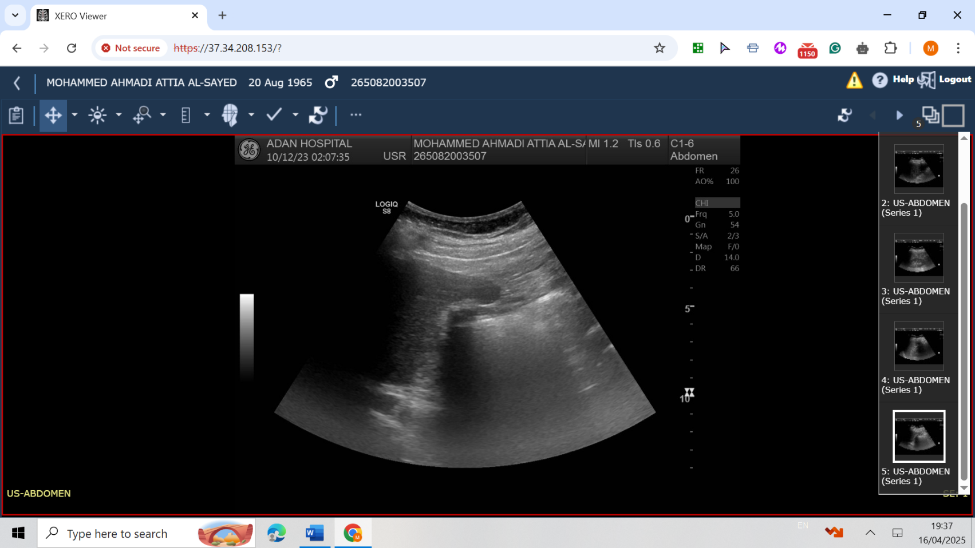
Figure 1: Abdominal ultrasound showed gall bladder stones.
The patient was admitted to the surgical ward, maintained nil per os, initiated intravenous fluid therapy, and administered potent analgesics. Subsequently, he was transferred to the operating theatre where a technically challenging laparoscopic cholecystectomy was performed. Intraoperatively, we observed that the gallbladder was notably diminutive and entirely occupied by a substantial calculus (Figure 2). Additionally, the gallbladder was encased within dense fibrous tissue. Of particular significance was the presence of a rare congenital anomaly characterised by an abnormally elongated cystic duct and artery (Figure 3). An intraoperative cholangiogram was not performed, as the anatomy of the gallbladder, cystic duct, cystic artery, and common bile duct was clear. No drain was placed. The patient's postoperative course was uneventful, allowing discharge four days following the procedure. At the two-week follow-up evaluation in our outpatient clinic, the patient demonstrated excellent recovery with all laboratory parameters within normal limits.
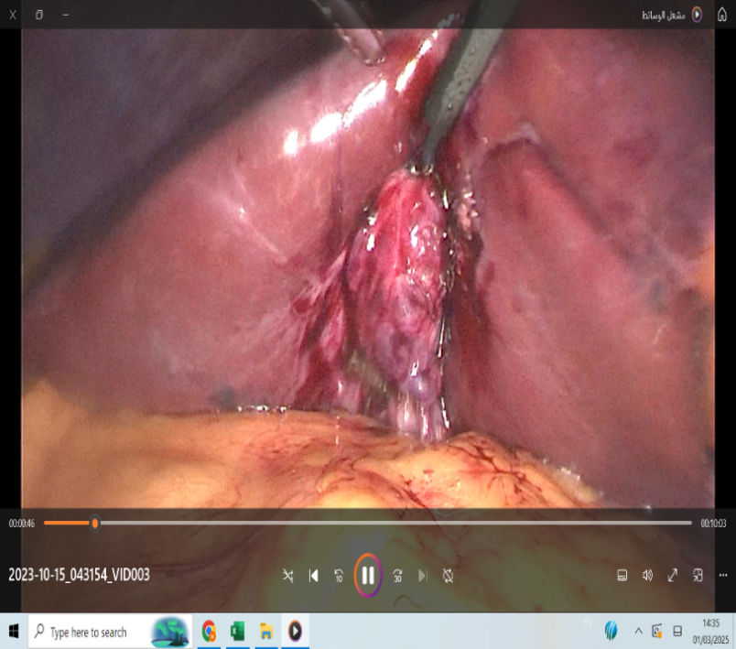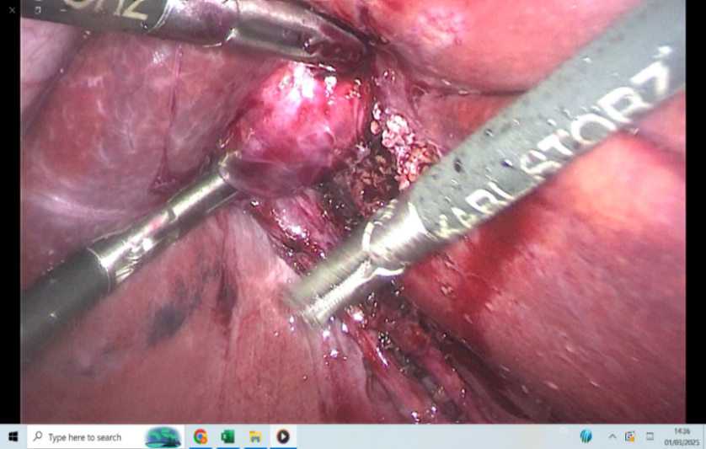
Figure 2: Small gall bladder containing a big stone.
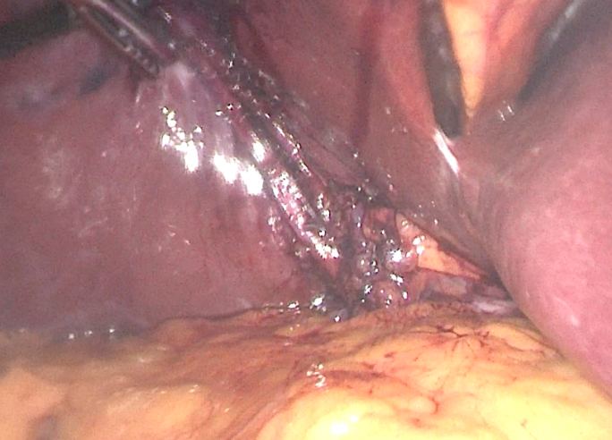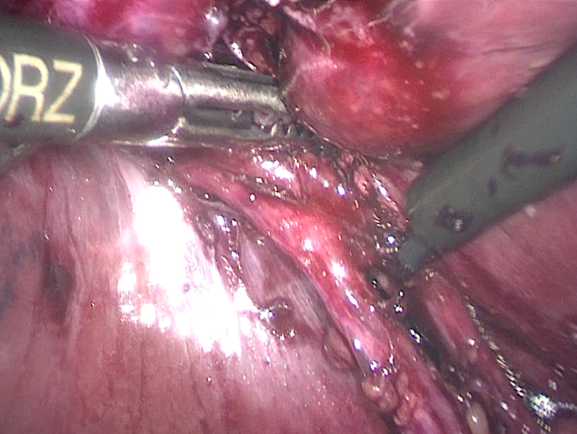

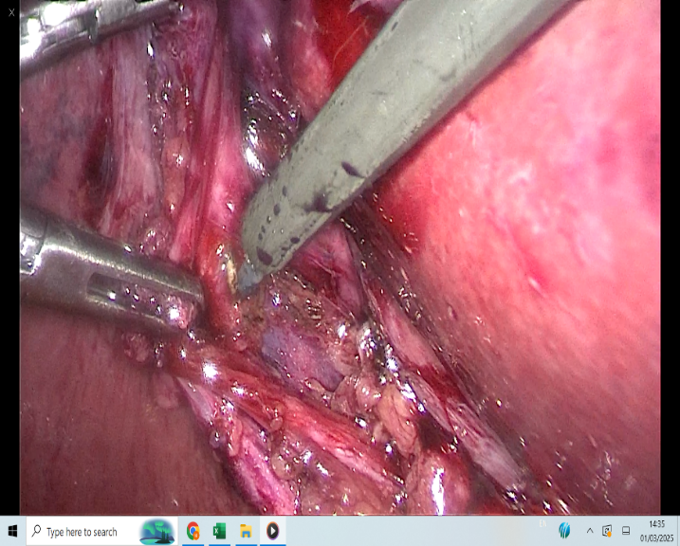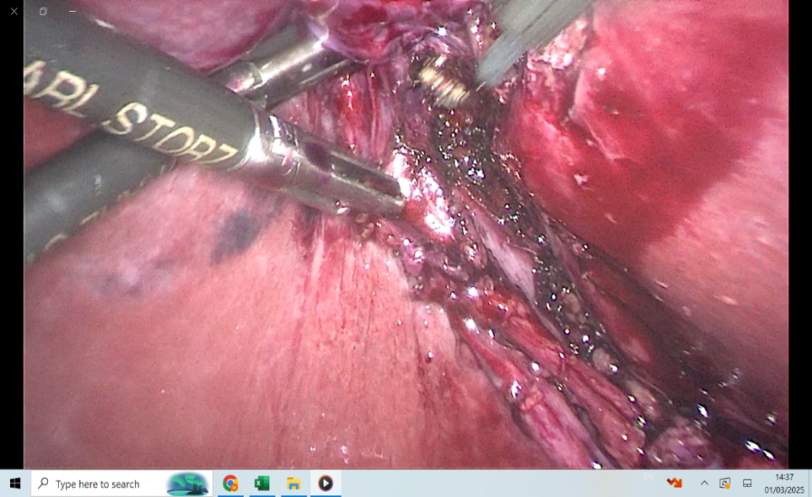
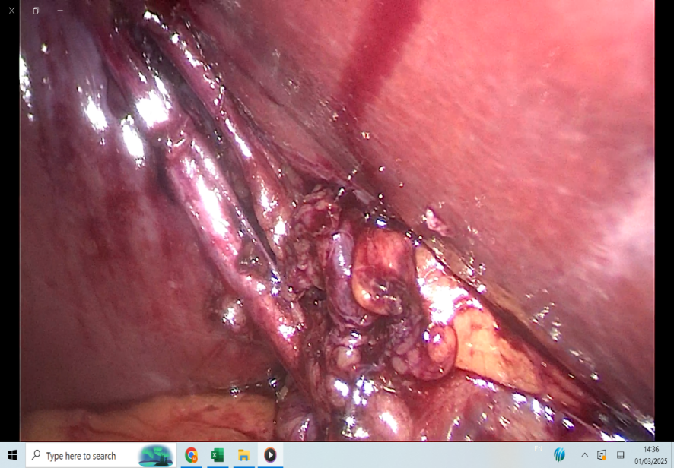
Figure 3: Laparoscopic images for the gall bladder, very long cystic duct and artery.

Discussion
The cystic duct typically measures approximately 3 mm in diameter, with a length ranging from 2 to 4 cm, though in our case, it exceeded 10 cm. “Surgeons unaware of abbreviated ducts may inadvertently enter the common bile duct. In exceedingly rare instances, the cystic duct may be absent, with the gallbladder opening directly into the common bile duct. Under such circumstances, the common bile duct might be misidentified as the cystic duct” [7]. “Dandekar's research revealed that the cystic artery demonstrates a mean length of 16.9 mm (range: 2-55 mm) and a mean diameter of 1.6 mm (range: 1-5 mm)” [8]. “Taimur and colleagues classified cystic arteries according to length into three categories: short (<1 cm, 7%), normal (1-3 cm, 82%), and long (>3 cm, 8%), placing our case within the long cystic artery classification” [9]. “It is well established that anatomical variants of the biliary tree constitute a major risk factor category for bile duct injury. Aberrant insertion of the right hepatic duct into the common hepatic duct, common bile duct, or cystic duct; parallel course of the cystic duct with hepatic ducts; low insertion of the cystic duct into the common hepatic duct; spiral course of the cystic duct with medial surface entry into the common hepatic duct; and abbreviated cystic duct represent variations that heighten the risk of bile duct injury”[10]. “Failure to recognise these variants may result in the misidentification of common bile and cystic ducts, potentially leading to inadvertent ligation or resection of common bile duct segments, or inappropriate dissection of the distal cystic duct portion in cases of median cystic duct insertion” [11]. Non-invasive techniques capable of preoperatively delineating biliary tract anatomy could provide significant clinical value. In most instances, normal-calibre cystic ducts remain undetectable on ultrasonography or computed tomography [10]. Intraoperative cholangiography is frequently employed to elucidate biliary tree anatomy and diagnose bile duct calculi, though its routine implementation remains controversial [10]. “Intravenous cholangiography often fails to opacify the cystic duct and rarely permits detailed visualisation of duct bifurcation. Endoscopic retrograde cholangiopancreatography (ERCP) represents a highly accurate but invasive modality for diagnosing choledocholithiasis” [11]. “Magnetic resonance cholangiopancreatography (MRCP) offers a non-invasive diagnostic approach, providing high-quality cross-sectional and projection images of the biliary tree that are nearly comparable in appearance to direct cholangiograms produced by endoscopic retrograde cholangiopancreatography (ERCP) or percutaneous transhepatic cholangiography. It’s completely non-invasive nature renders MRCP an attractive option for preoperative biliary tree evaluation” [10,11]. “The cystic duct most commonly joins the extrahepatic bile duct approximately midway between the porta hepatis and ampulla of Vater. However, the junction point varies considerably, ranging from high (porta hepatis level) to very low (ampulla level). The cystic duct demonstrates a parallel course relative to the extrahepatic bile duct in 10.6% of patients and exhibits length variation from 1.5 cm to 9.5 cm, as observed in our case” [12]. “Frequently, an elongated parallel course implies a common fibrous sheath encompassing both the cystic duct and common hepatic duct, as noted in our patient”[12].

Conclusion
Anatomical variations represent important entities that may remain asymptomatic throughout life. Preoperative diagnosis of these variations through routine investigations presents significant challenges. Nevertheless, these anomalies demand heightened attention during surgery as they are frequently encountered intraoperatively. Surgeons must exercise meticulous attention, and identify, and confirm the cystic duct and artery before applying clips or ligatures. Consequently, surgeons require comprehensive knowledge and awareness of cystic duct and cystic artery variations, which significantly contribute to cholecystectomy safety.

Ethical Approval
Following international and university standards, written ethical approval has been obtained and preserved by the authors.

Consent
Written informed consent was obtained from the patient for publication of this case report and accompanying images.

Disclaimer (Artificial intelligence)
Option 1:
Author(s) hereby declare that NO generative AI technologies such as Large Language Models (ChatGPT, COPILOT, etc.) and text-to-image generators have been used during the writing or editing of this manuscript.
Option 2:
Author(s) hereby declare that generative AI technologies such as Large Language Models, etc. have been used during the writing or editing of manuscripts. This explanation will include the name, version, model, and source of the generative AI technology and as well as all input prompts provided to the generative AI technology
Details of the AI usage are given below:
1.
2.
3.

NO AI WAS USED IN THIS ARTICLE.

References
[1] Benson EA, Page RE. A practical reappraisal of the anatomy of the extrahepatic bile ducts and arteries. Br J Surg 1976;63:853–60.
[2] Carbajo MA, Martín del Omo JC, Blanco JI, et al. Congenital malformations of the gallbladder and cystic duct diagnosed by laparoscopy: high surgical risk. JSLS 1999;3:319–21; PMID: 10694079; PMCID: PMC3015364.
[3] Carbajo MA, Martin del Omo JC, Blanco JI, et al. Congenital malformation of the gallbladder and cystic duct diagnosed by laparoscopy: high surgical risk. JSLS. 1999;3:319–321.
[4] Suhocki PV, Meyers WC. Injury to aberrant bile ducts during cholecystectomy: a common cause of diagnostic error and treatment delay. AJR Am J Roentgenol 1999;172:955–9.
[5] Gupta R, Kumar A, Hariprasad CP, Kumar M. Anatomical variations of the cystic artery, cystic duct, and gall bladder and their associated intraoperative and postoperative complications: an observational study. Annals of Medicine and Surgery. 2023 Aug 1;85(8):3880-6.
[7] Shanmugam G, and Natarajan S. Anomalous Insertion of the Cystic Duct into the Right Hepatic Duct: A Rare Presentation. Annals of Minimal Access Surgery & Allied Science. 2025 Jan 1;1(1):36-7.
[8] Dandekar U, and Dandekar K. Cystic artery: morphological study and surgical significance. Anatomy research international. 2016;2016(1):7201858.
[9] M. Taimur, A. Hasan, S. Ullah, R. Masood, and M. Imran, "Vascular variations in the Calot's triangle seen on laparoscopic cholecystectomy," Pakistan Armed Forces Medical Journal, vol. 61, no. 4, 2011.
[10] Taourel P, Bret P, Reinhold C, Barkun A, Atri M. Anatomic variants of the biliary tree: diagnosis with MR cholangiopancreatography. Radiology. 1996;199:521–527.
[11] Ausch C, Hochwarter G, Taher M, et al. Improving the safety of laparoscopic cholecystectomy: the routine use of preoperative magnetic resonance cholangiography. Surg Endosc. 2005;19:574–580.
[12] Turner M, Fulcher A. The cystic duct: normal anatomy and disease processes. Radiographics. 2001;21:3–22.
[13] Pavlidis, T. E., Triantafyllou, A., Psarras, K., Marakis, G. N., & Sakantamis, A. K. (2008). Long, parallel cystic duct in laparoscopic cholecystectomy for acute cholecystitis: the role of magnetic resonance cholangiopancreatography. JSLS: Journal of the Society of Laparoendoscopic Surgeons, 12(4), 407.

