***Case report***

**Gastrointestinal Stromal Tumor of the Anal Canal: A Rare Case Report and Literature Review**

### ABSTRACT

### Gastrointestinal stromal tumours (GISTs) are rare connective tissue tumours, accounting for only 1% of malignant tumours of the digestive tract, with a preferential location in the stomach (60%) and the small intestine (30%). Anorectal location is very rare and infrequently reported in the literature. GISTs are mesenchymal tumours that can occur in adults at any age, though they are rarely seen before 40 years old, with a peak incidence around 45-60 years and a gender ratio close to 1:1. Treatment is primarily surgical, sometimes combined with neo-adjuvant or adjuvant chemotherapy to improve resectability and reduce the potential for recurrence. The benefit of imatinib-based chemotherapy, which is an inhibitor of the transmembrane tyrosine kinase receptor (proto-oncogene), is clearly demonstrated in the management of stromal tumours, particularly those that are aggressive with a high grade of malignancy. A case of a stromal tumor in the anal canal was reported here. It was surgically treated by local excision, from the experience of the Medical-Surgical Proctology Department at Mohammed V Military Hospital in Rabat. Laboratory tests were within normal limits, with haemoglobin (Hb) at 13 g/dL, platelets (PLT) at 230,000/mm², prothrombin time (PT) at 90%, and normal tumour markers. The surgical treatment, performed under spinal anaesthesia with the patient in the lithotomy position, involved a vertical ischioanal incision, complete excision of the mass, and ensured clear surgical margins without capsular breach. The histopathological examination revealed an encapsulated lesion measuring 93 x 78 mm and weighing 110 grams. As Anorectal GISTs are rare, wide resection is generally recommended when the tumour is operable.

***Keywords:*** *Anal canal; Gastrointestinal stromal tumours; Surgical excision; polymorphic manifestations.*

### INTRODUCTION

Gastrointestinal stromal tumours *(*GISTs) are rare fibrous tumours that develop from the supportive tissue of cells: the connective tissue of the digestive tract wall. They most commonly develop in the stomach (60%), small intestine (30%), duodenum (5%), and colorectal region (5%). Although they are the most common mesenchymal tumours of the digestive tract, they account for only 1-2% of digestive tumours. Moreover, GISTs are mesenchymal tumors, sometimes revealing aggressive behaviour, thought to develop from the interstitial cells of Cajal bodies, which build a network in the gastrointestinal wall providing an interface between the autonomic nervous system and the muscle layer that they regulate like a pacemaker (Tonni et al., 2024; Satyanarayana et al., 2024). Anorectal location is very rare and infrequently reported in the literature **[1]**, with only 15 cases documented **[2]**. Globally, GISTs are most prevalent in China, Taiwan, Korea, Japan, and Norway. These tumours can range in size from less than 1 cm to more than 40 cm, with an average size of 5 cm at the time of clinical diagnosis (Jatal et al., 2024). These tumours present with polymorphic manifestations such as proctalgia, rectal bleeding, and constipation. Treatment is primarily surgical and involves a complete en bloc resection of the tumour without intraoperative rupture **[3,4]**. High-grade malignancy stromal tumours should be managed with aggressive surgery accompanied by neoadjuvant or adjuvant chemotherapy to improve resectability and reduce the risk of recurrence **[5]**. The aim of our work is to present a rare case of anorectal stromal tumour and discuss it in light of the literature.

**CASE PRESENTATION**

We report a case of a 43-year-old woman admitted to our emergency department with an ischio-anal mass. Her medical history was characterised by localised perianal pain on the right side and intermittent constipation. She did not report any rectal bleeding, weight loss, or general malaise. On proctological examination in the genupectoral position, a 10 cm diameter mass was identified at the 3 o’clock position. Digital rectal examination revealed a firm, regular mass, laterally located on the right, protruding into the anal canal and rectal mucosa, and mobile relative to the deeper tissues. Abdominal examination did not reveal any abdominal mass or inguinal lymphadenopathy. The gynaecological examination was unremarkable and ruled out adnexal or uterine causes. The rest of the clinical examination was normal. Laboratory tests were within normal limits, with haemoglobin (Hb) at 13 g/dL, platelets (PLT) at 230,000/mm², prothrombin time (PT) at 90%, and normal tumour markers. The pelvic MRI (Fig. 1) showed an oval mass in the ischial fossa with heterogeneous signal, slight hypointensity on T1 and hyperintensity on T2, with no central enhancement, measuring 93 x 78 mm, encapsulated with a separation rim except where it was in contact with the pelvic floor.

The surgical treatment (Fig. 2), performed under spinal anaesthesia with the patient in the lithotomy position, involved a vertical ischioanal incision, complete excision of the mass, and ensured clear surgical margins without capsular breach. A Delbet drain was placed and collected 30 cc of serohematic fluid. The patient was discharged on postoperative day (POD) 3.

The histopathological examination (Fig. 3) revealed an encapsulated lesion measuring 93 x 78 mm and weighing 110 grams. The cut surface of the mass appeared gray-white. Conventional slides stained with hematoxylin and eosin showed the presence of a spindle cell tumour with high cellularity and central areas of haemorrhage and necrosis. The neoplastic cells were arranged in fascicles and short whorls, with elongated, regular nuclei, no atypia, and perinuclear vacuolation.

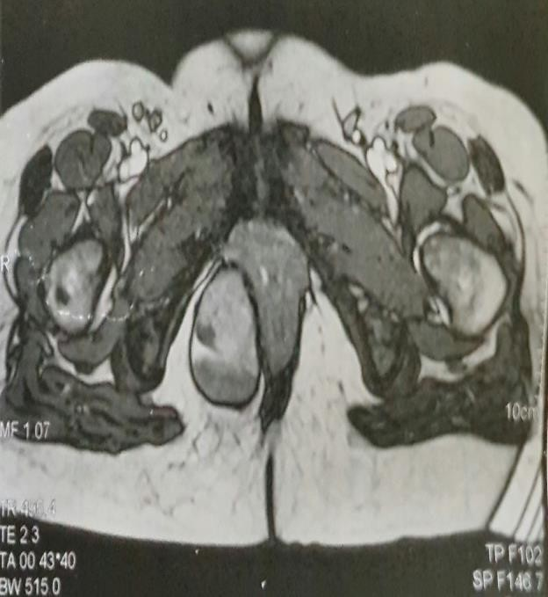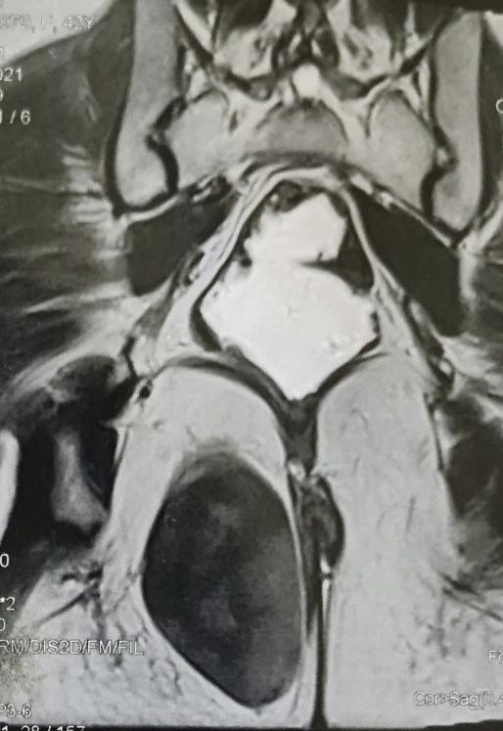

**Figure 1.** Axial cuts showing an encapsulated, heterogeneous mass (arrow) in the ischial fossa.

**A**

**B**

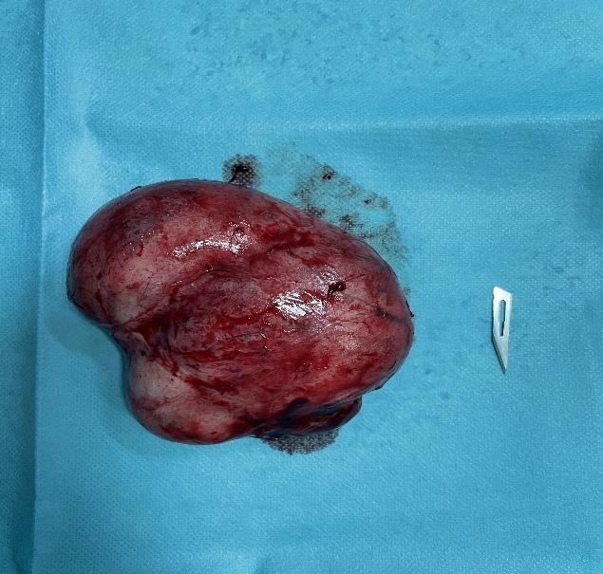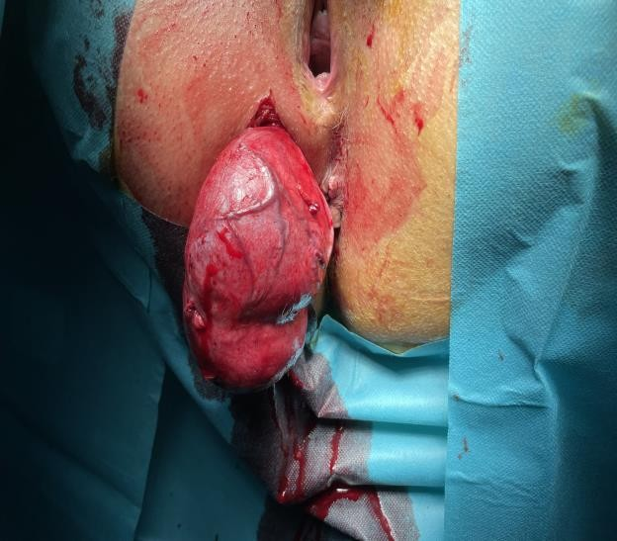

**Figure 2.** Intraoperative photos showing a large right ischioanal mass (A), with complete excision of the mass and clear surgical margins (B).

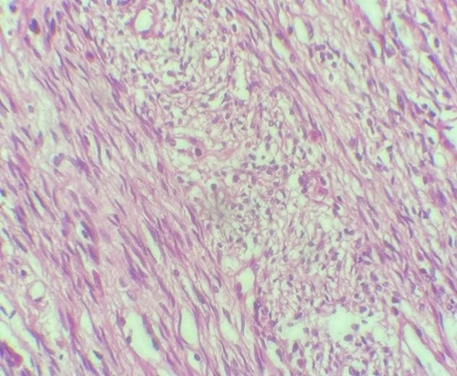 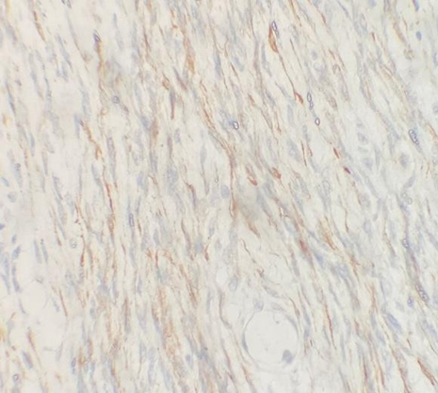

**A**

**B**

**Figure 3.** (**A**) The tumour cells are elongated, with nuclei that have a regular appearance and no atypia (H&E, Gx400). (**B**) Positive immunostaining of tumour cells with anti-AML antibody.

# DISCUSSION

The term “GIST” (*GastroIntestinal Stromal Tumour*) was initially used to refer to any mesenchymal tumour of the gastrointestinal tract, regardless of its degree of differentiation. These tumours originate from mesenchymal Pacemaker cells of Cajal, which control intestinal contractions (intestinal automatism) **[6]**. GISTs are a very rare form of digestive tract cancer, representing only 1% of digestive tumours, with an incidence ranging between 8 and 16 per million people. The average age at diagnosis ranges from 55 to 65 years, with a sex ratio of 1 to 1.5, showing a slight male predominance. It can affect all segments of the digestive tract, notably the stomach (70%), the small intestine (30%), the duodenum (5%), and the colorectal segment (5%) **[2]**. Mesenchymal tumours develop from connective tissue in the wall of the digestive tract. Historically, they were considered to be tumours of muscle cells (“*leiomyomas*”) or nerve cells (“*schwannomas*”) **[6]**. However, GISTs are recently recognised tumours characterised by the expression of c-kit (CD117) and CD34 antigens. The c-kit protein is a transmembrane receptor whose ligand is a growth factor. In cells expressing the mutated c-kit gene, uncontrolled activation of the protein leads to unchecked cell proliferation and the formation of a tumour **[1]**.

Anorectal GISTs most often affect men between the fifth and seventh decades of life, with a sex ratio of 2:1 **[1,7]**. The clinical presentation is variable. GISTs are generally asymptomatic and are often found incidentally in 50% of cases. They can present with a wide range of symptoms, from a true rectal syndrome with proctalgia, tenesmus, and false urges, to external bleeding or even lower intestinal obstruction due to extraluminal compression. Other observed signs may include transit disturbances, signs of compression, general deterioration, and even a palpable mass **[8]**. Since 2000, only 15 cases of anorectal GISTs have been reported in the literature, with a male predominance. Table 1 summarises the reported cases, including their sex, age, and the symptoms that led these patients to seek medical attention. Differential diagnosis mainly involves other anorectal tumours and tumours with a gynaecological origin, particularly uterine and cervical tumours. The diagnostic approach primarily involves rectosigmoidoscopy, which identifies a submucosal mass protruding into the digestive wall, often with associated ulcerations. Endoanal ultrasound (US) is a key examination that shows invasion of the layers of the digestive wall and assesses relationships with the sphincter apparatus. It also helps establish criteria indicative of malignancy (such as a size more than 3 cm, irregular margins, invasion of neighbouring organs, cystic areas, and satellite lymphadenopathy). Additionally, it allows for biopsy procedures **[9]**. Pelvic MRI provides a regional extension assessment, evaluating involvement of the rectal fascia and neighboring organs (vagina, cervix, prostate). The tumour is well-defined, with iso or slight hyperintensity on T2-weighted images and hypointensity on T1-weighted images, although hemorrhagic changes may show hyperintensity on T1.

Due to the rarity of anorectal GISTs and the lack of large series evaluating the various available treatments, it is difficult to establish the best approach for managing these tumours. However, it is generally accepted that surgery with complete resection of the tumour is the preferred treatment for these neoplasms. Local excision of anal GISTs can be curative in well-selected cases **[3,4]**. Further studies are needed to determine its role in combination with imatinib for treating cases with high malignant potential **[7]**. The choice between partial resection and radical treatment (abdominoperineal amputation) depends on the extent of the tumour and its wall invasion. The benefit of imatinib-based chemotherapy is well-established in the management of GISTs. It can be offered as adjuvant therapy to reduce the risk of locoregional recurrence or as neoadjuvant therapy to improve tumour resectability.

Distinguishing between benign and malignant stromal tumours is challenging. Some specialists believe that benign GISTs do not exist, as any stromal tumour, even those with very low malignancy, can recur up to 20 years after the initial diagnosis. As with any sarcoma, prognosis is correlated with tumour size and the aggressiveness of the cells, as indicated by the mitotic index. The initial location of the GIST is also a prognostic factor, with proximal GISTs (e.g., stomach) having a more favourable prognosis and distal sites (e.g., small intestine) having a less favourable prognosis **[6]**.

|  |  |  |  |
| --- | --- | --- | --- |
| **Author** | **Sex** | **Age** | **Symptoms** |
| Azzaza el al. **[7]** | F | 70 | Anal canal mass |
| Carvalho et al. **[10]** | M | 73 | Anal mass |
| Chak-man Li et al. **[11]** | F  M | 73  67 | Anal pain  Rectal bleeding |
| Duarte et al. **[12]** | M | 75 | Gluteal mass |
| Kumar et al. **[13]** | M | 60 | Dark color stool |
| Lanteri et al. **[14]** | F | 81 | Rectal bleeding  Abdominal colic pain |
| Nigri GR et al. **[15]** | M | 78 | Incidental finding |
| Oluyemi et al. **[16]** | M | 61 | Rectal Bleeding |
| Paramythiosis et al. **[2]** | M | 27 | Anal mass, pain |
| Ramzan et al. **[17]** | M | 65 | Pain during defecation, constipation |
| Singhal et al. **[18]** | M | 61 | Pain during defecation, constipation |
| Wachter et al. **[19]** | M | 56 | Anemia |
| Current case | F | 43 | Anal mass, pain |

**Table 1.** Characteristics of patients with anal canal gastrointestinal stromal tumors (GISTs) reported in the literature.

# CONCLUSION

Anorectal GISTs are rare. Therefore, wide resection is generally recommended when the tumour is operable. Local excision of anal GISTs is only considered curative in carefully selected cases **[3,4]**. Aggressive GISTs with high malignancy grades should be treated with neoadjuvant chemotherapy to enhance tumour resectability, or with adjuvant chemotherapy to decrease the risk of locoregional recurrence **[5]**.

Consent

As per international standards or university standards, patient(s) written consent has been collected and preserved by the author(s).

Disclaimer (Artificial intelligence)

Option 1:

Author(s) hereby declare that NO generative AI technologies such as Large Language Models (ChatGPT, COPILOT, etc.) and text-to-image generators have been used during the writing or editing of this manuscript.

Option 2:

Author(s) hereby declare that generative AI technologies such as Large Language Models, etc. have been used during the writing or editing of manuscripts. This explanation will include the name, version, model, and source of the generative AI technology and as well as all input prompts provided to the generative AI technology

Details of the AI usage are given below:

1.

2.

3.

# References

1. O. Benzekri, S. Benamer, S. El Mouhadi et al. Tumeur stromale anorectale: à propos d’une localisation rare des GIST. Journal Africain du Cancer / African Journal of Cancer, volume 2, issue 3, pages 203-206 (2010). DOI: 10.1007/s12558-010-0109-x.
2. Paramythiotis D, Bangeas P, Karakatsanis A, Karayannopoulou G, Michalopoulos A. Anal canal gastrointestinal stromal tumors - report of a rare case and review of the literature. Hippokratia. 2016 Oct-Dec;20(4):313-316. PMID: 29416307; PMCID: PMC5788233.
3. Ebihara Y, Okushiba S, Kawarada Y, et al. Neoadjuvant imatinib in a gastrointestinal stromal tumor of the rectum: report of a case. Surg Today 2008;38:174–7.
4. Eisenberg BL, Harris J, Blanke CD, et al. Phase II trial of neoadjuvant/adjuvant imatinib mesylate (IM) for advanced primary and metastatic/recurrent operable gastrointestinal stromal tumor (GIST): early results of RTOG 0132/ACRIN 6665. J Surg Oncol 2009;99:42–7.
5. Eisenberg BL, Judson I. Surgery and imatinib in the management of GIST: emerging approaches to adjuvant and neoadjuvant therapy. Ann Surg Oncol 2004;11:465–75.
6. N. Wachter, M.A. Wörns, D.P. Dos Santos, H. Lang, T. Huber, W. Kneist, Transanal minimally invasive surgery (TAMIS) approach for large juxta-anal gastrointestinal stromal tumour, J. Minim. Access Surg. 12 (2016) 289–291.
7. Azzaza, M., Ammar, H., Abdessayed, N., Gupta, R., Nakhli, M. S., Chhaider, A., … Ali, A. B. (2017). Wide local excision for anal GIST: A case report and review of literature. International Journal of Surgery Case Reports, 30, 97–100. doi:10.1016/j.ijscr.2016.11.046
8. Miettinen, Markku M.D.; Furlong, Mary M.D.; Sarlomo-Rikala, Maarit M.D.; Burke, Allen M.D.; Sobin, Leslie H. M.D.; Lasota, Jerzy M.D.. Gastrointestinal Stromal Tumors, Intramural Leiomyomas, and Leiomyosarcomas in the Rectum and Anus: A Clinicopathologic, Immunohistochemical, and Molecular Genetic Study of 144 Cases. The American Journal of Surgical Pathology 25(9):p 1121-1133, September 2001.
9. Tan GY, Chong CK, Eu KW, Tan PH. Gastrointestinal stromal tumor of the anus. Tech Coloproctol. 2003 Oct;7(3):169-72. doi: 10.1007/s10151-003-0030-8. PMID: 14628161.
10. N. Carvalho, D. Albergaria, R. Lebre, J. Giria, V. Fernandes, H. Vidal, et al., Anal canal gastrointestinal stromal tumors: case reportand literature review, World J. Gastroenterol. 20 (2014) 319–322.
11. Li JC, Ng SS, Lo AW, Lee JF, Yiu RY, Leung KL. Outcome of radical excision of anorectal gastrointestinal stromal tumors in Hong Kong Chinese patients. Indian J Gastroenterol. 2007 Jan-Feb;26(1):33-5. PMID: 17401234.
12. Duarte, A. L., Fouassier, S., & Herédia, V. (2017). *MR imaging features of anal gastrointestinal stromal tumor (GIST). Diagnostic and Interventional Imaging, 98(6), 513–514.* doi:10.1016/j.diii.2017.01.005
13. M. Kumar, M.M. Goel, D. Singh, Rare case of gastrointestinal stromal tumor of the anal canal, J. Cancer Res. Ther. 9 (2013) 736–738.
14. Lanteri R., Aliotta I., Racalbuto A., Licata A. Anal GIST in older old patient: a case report. *Il Giornale di chirurgia.*2005;**26**:135–137.
15. Nigri G.R., Dente M., Valabrega S., Aurello P., D’Angelo F., Montrone G. Gastrointestinal stromal tumor of the anal canal: an unusual presentation. *World J. Surg. Oncol.*2007;**5**:20.
16. Oluyemi A., Keshinro S., Jimoh A., Oshun P. Gastrointestinal stromal tumor of the anal wall in a Nigerian. *Pan Afr. Med. J.*2015;**22**:161.
17. Ramzan A, Sarfraz MD, Majeed H, Baig S, Inayat F. Recurrent anal canal gastrointestinal stromal tumor. Pakistan J Radiol. 2015; 25: 175-178.
18. S. Singhal, A. Singhal, R. Tugnait, V. Varghese, B. Tiwari, P.K. Arora, et al., Anorectal gastrointestinal stromal tumor: a case report and literature review, Case Rep. Gastrointest. Med. 2013 (2013) 934875.
19. Wachter N., Wörns M.A., Dos Santos D.P., Lang H., Huber T., Kneist W. Transanal minimally invasive surgery (TAMIS) approach for large juxta-anal gastrointestinal stromal tumour. *J. Minim. Access Surg.*2016;**12**:289–291.
20. Jatal, S. N., Jatal, S., Punpale, A., & Ingle, S. (2024). Gastrointestinal Stromal Tumor (GIST): About 3 Cases. *Journal of Advances in Medicine and Medical Research*, *36*(7), 24–33.
21. Tonni, G., Palicelli, A., Bassi, M. C., Torricelli, F., Vacca, I., Aguzzoli, L., & Mandato, V. D. (2024). Gastrointestinal Stromal Tumors (GISTs) Mimicking Primary Ovarian Tumors or Metastasizing to the Ovaries: A Systematic Literature Review. *Cancers*, *16*(13), 2305.
22. Satyanarayana, K., Sairam, S., Raksha, C. S., Pushpahaas, J., & Mahipal, R. (2024). Rectal Gastrointestinal Stromal Tumour: A Report of a Rare Case and Literature Review. *Cureus*, *16*(8).