*Case report*

Billiary Stent Migration with Duodenal Perforation in an Elderly Man: A review of Management Strategies

.

ABSTRACT

|  |
| --- |
| **Introduction:** Biliary stenting during endoscopic retrograde cholangiography (ERCP) is essential for managing biliary obstructions and leaks. It is often the preferred approach as its therapeutic advantages outweigh the relatively low risk of complications.  **Case Presentation:** This is a case of 83 years old gentleman who presented 2 weeks post ERCP with complaint of abdominal pain and fever. He underwent ERCP for biliary obstruction secondary to choledocholithiasis. He underwent laparotomy, stent removal, duodenal patch repair and gastrojejunostomy for duodenal perforation from biliary stent migration. The patient died day 3 post-operative due to acute coronary syndrome.  **Discussion:** ERCP is increasingly utilized in the management of biliary obstruction. Although ERCP related complications can occur, they remain relatively uncommon. One rare but serious complication is duodenal perforation secondary to stent migration. Nevertheless, in patient presenting with severe abdominal pain and clinical signs suggestive of acute abdomen, this diagnosis should be considered promptly to ensure timely intervention.  **Conclusion:** Duodenal perforation from stent migration can occur and when interventions is delayed, may lead to mortality and morbidity. Early recognition and high index of suspicion allows for early interventions and good outcomes. |

*Keywords: endoscopic retrograde cholangiopancreatography, biliary stent, stent migration, duodenal perforation, case report*

1. INTRODUCTION

Endoscopic retrograde cholangiopancreatography (ERCP) is a diagnostic and therapeutic endoscopic technique used primarily for the evaluation and management of biliary and pancreatic ductal systems. Initially developed as a diagnostic tool, ERCP has evolved into a predominantly therapeutic procedure with applications including biliary and pancreatic ductal stenting, stone extraction, sphincterotomy, and stricture dilatation[1]. Indications for ERCP include choledocholithiasis, malignant or benign biliary strictures, pancreatic ductal abnormalities, and biliary leaks[2].

Despite its clinical utility, ERCP is associated with a range of complications. These include pancreatitis (reported in up to 10% of cases), cholangitis, haemorrhage, perforation, and adverse reactions to sedation or contrast agents[3,4]. One of the less common but clinically significant complications is stent migration.

ERCP stents, typically placed for biliary drainage or stricture management, can migrate either proximally into the bile duct or distally into the duodenum or further along the gastrointestinal tract. Migrated stents may be asymptomatic or can cause serious sequelae such as bowel perforation, obstruction, or stent occlusion[5,6]. Less than 1% of migrated stent cause intestinal perforations with mortality rate below 1 % [7].

Early recognition and appropriate management of ERCP-related complications, particularly stent migration, are crucial to minimize morbidity and ensure optimal patient outcomes. Here, we presented a case of migrated stent causing duodenal perforation in an elderly man.

2. presentation of case

An 83-year-old gentleman with ischaemic heart disease, hypertension and dyslipidaemia presented with ascending cholangitis secondary to choledocholithiasis.An endoscopic retrograde cholangiopancreatography (ERCP) was done and common bile duct stent was inserted. After 3 months he was electively admitted for a change of stent. A new straight plastic stent (10F, 10mm) was inserted-procedure was uneventful, and the patient was discharged well after 24 hours of observation.

He presented after 2 weeks of ERCP with persistent epigastric pain. Clinically, he was haemodynamically stable; abdominal examination revealed distension and localized tenderness in the right hypochondrium. Chest X-ray showed no air under the diaphragm. Ultrasound and CT abdomen revealed stent malposition, with the distal tip penetrating the anterior D2 segment of the duodenum into the peritoneal cavity.

Decision was made for surgical intervention, as the patient later became haemodynamically unstable with peritonitis. An exploratory laparotomy, stent removal, duodenal patch repair, and gastrojejunostomy were performed. Unfortunately, the patient succumbed to acute coronary syndrome on postoperative day three.

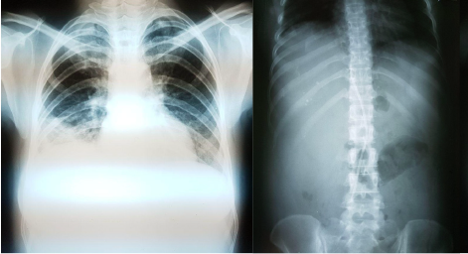

Figure 1: Chest X-Ray (left), Abdominal X-Ray supine (right) with no signs of pneumoperitoneum.

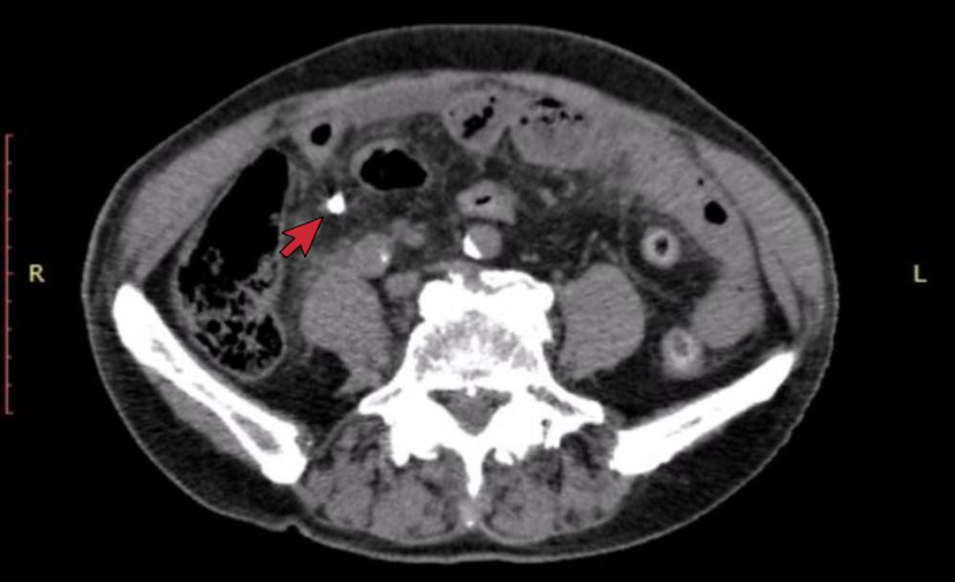

Figure 2: CECT abdomen showing the stent penetrating the 2nd part of duodenum into the peritoneal cavity

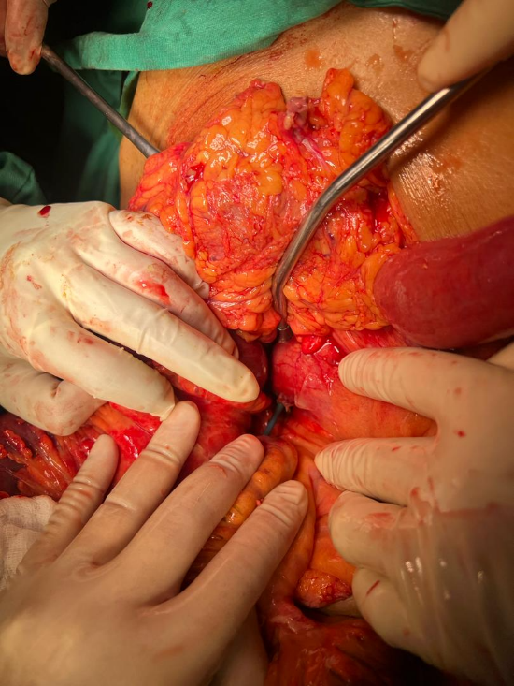

Figure 3: Stent protruding from the 2nd part of the duodenum

3. discussion

Stent migration, while uncommon, poses significant risks, including duodenal perforation. Management strategies depends on the perforation type and patient condition. Conservative management, including fasting, intravenous hydration, nasogastric suction, and antibiotics, is typically employed for small, contained perforations. However, surgical intervention is often necessary for uncontained perforations, persistent symptoms, or major leaks. Endoscopic therapies, such as fully covered self-expandable metal stents (SEMS), over-the-scope clips, and endoscopic suturing, offer less invasive alternatives for specific perforations. [8]

Biliary stents are broadly categorized into plastic stents (straight or pigtail) and self-expandable metal stents (SEMS). Straight plastic stents are commonly used for short-term drainage due to ease of insertion and cost-effectiveness, but they carry a higher risk of migration. Pigtail stents, with their curled ends, are designed to reduce migration by anchoring at both ends and are often preferred in patients at higher risk of complications, such as the elderly or those with altered anatomy. SEMS are typically reserved for malignant strictures or long-term drainage due to their longer patency but are costlier and harder to remove.

Review of literature reveals that the majority of complications associated with stent migration and perforation are seen with straight stents, as in our patient [9]. However, in this case;a straight plastic stent was selected during the elective procedure due to its availability, ease of placement, and the expectation of short-term use. However, in retrospect, considering the patient’s advanced age and increased risk of mucosal injury, a pigtail stent might have reduced the risk of distal migration.

Nonetheless for this patient, endoscopic retrieval of the migrated stent followed by placement of a fully covered self-expandable metal stent (SEMS) and initiation of broad-spectrum antibiotics was considered. However, at the time of re-presentation, the patient exhibited signs of generalized peritonitis and progressive hemodynamic instability. Imaging confirmed an uncontained perforation with the stent tip breaching the second part of the duodenum into the peritoneal cavity. In the absence of a well-formed, drainable peritoneal abscess, and given the acute deterioration, the multidisciplinary team determined that emergency laparotomy offered the most definitive and timely intervention. On the other hand, in stable patients with localized perforation, a less invasive approach—combining endoscopic stent retrieval, SEMS insertion, and radiologically guided percutaneous drainage—could be considered, particularly in elderly patients with high operative risk.

Risk factors for stent migration include anatomical variations, previous surgeries, and procedural complexities. Other potential risk factor for perforation include impaired mucosal healing and integrity. Our patient is 83 years old with multiple co-morbidities, which could impair his mucosal healing. Impaired mucosal healing in elderly patients can indeed increase the risk of perforation, particularly in the context of biliary stents. Age-related factors such as decreased tissue elasticity, reduced mucosal blood flow, and the prevalence of comorbidities that affect wound healing (like diabetes or vascular disease) contribute to this risk. Moreover, elderly patients are more susceptible to complications due to the diminished regenerative capacity of their tissues and the possible presence of chronic inflammation or fibrosis, which compromises the structural integrity of the gastrointestinal tract.

Studies highlight that the elderly population is at a higher risk for complications like perforation due to these factors, especially after procedures involving stents or other foreign objects within the biliary or gastrointestinal tract. For instance, one study emphasizes the importance of careful monitoring and timely intervention in elderly patients with biliary stents, considering their heightened vulnerability to complications such as migration and subsequent perforation [10].These insights underline the necessity of vigilant post-procedural care in elderly patients to minimise the risk of severe complications like perforation.

It is worth noting that bile culture and sensitivity (C&S), though clinically indicated during both the initial and subsequent ERCPs, was inadvertently omitted as the focus remained on achieving mechanical billiary drainage. This may have been influenced by the need to ensure timely biliary decompression while minimizing procedural duration and sedation-related risks in an elderly patient with multiple comorbidities. However, the absence of microbiological data limits our ability to evaluate the potential contribution of persistent or subclinical infection to duodenal mucosal compromise. Positive bile cultures could have supported the hypothesis that infection played a role in compromising mucosal integrity and thereby increasing the risk of perforation for this patient.

To reduce the risk of such complications, preventive strategies must be emphasized. These include meticulous endoscopic technique, appropriate stent selection—such as favoring pigtail stents over straight stents to minimize mucosal trauma—and careful patient assessment prior to intervention. High-risk cases, particularly in elderly or comorbid patients, should ideally be managed by experienced endoscopists to ensure optimal outcomes and reduce the likelihood of adverse events.

In our setting, the limited availability of advanced endoscopy services and hepatopancreatobiliary (HPB) expertise may restrict the use of certain therapeutic options. As such, general surgeons often play a central role in the management of complex post-ERCP complications. In this case, the surgical approach was appropriately selected based on the patient's deteriorating condition and the unavailability of less invasive alternatives at the time. This highlights the importance of strengthening multidisciplinary capabilities and expanding access to advanced endoscopic interventions, particularly in district-level hospitals.

4. Conclusion

Biliary stent migration resulting in duodenal perforation is an uncommon but potentially fatal complication of ERCP. This case illustrates the diagnostic challenges and the urgency required in managing elderly patients who present with non-specific abdominal symptoms post-ERCP. Prompt recognition and timely surgical intervention remain the cornerstone of management in patients presenting with uncontained perforation or clinical instability. Preventive strategies, including careful patient selection, appropriate stent type, and post-procedural vigilance, are essential to minimize the risk of such complications. In healthcare settings where advanced therapeutic endoscopy may be limited, the role of general surgeons becomes vital.

Consent

All authors declare that written informed consent was obtained from the patient’s next of kin for publication of this case report and accompanying images. A copy of the written consent is available for review by the Editorial office/Chief Editor/Editorial Board members of this journal.

Ethical approval

As per international standards, patient written ethical approval has been collected and preserved by the authors.

Disclaimer (Artificial intelligence)

Author(s) hereby declare that generative AI technologies such as Large Language Models have been used during the writing or editing of this manuscript.

Name/Model: ChatGPT (GPT-4)

Source: OpenAI, accessed via chat.openai.com

Details of the AI usage are given below:

1. Assisted in refining language, improving sentence structure, and enhancing clarity in the discussion and conclusion sections.  
   2. Prompts: Included questions related to restructuring sentences and improving academic tone in a professional manner.

References

1. Cotton PB, Lehman G, Vennes J, et al. Endoscopic sphincterotomy complications and their management: an attempt at consensus. Gastrointest Endosc. 1991;37(3):383-393.

2. Testoni PA, Mariani A, Aabakken L, et al. Papillary cannulation and sphincterotomy techniques at ERCP: European Society of Gastrointestinal Endoscopy (ESGE) Clinical Guideline. Endoscopy. 2016;48(7):657-683.

3. Freeman ML, DiSario JA, Nelson DB, et al. Risk factors for post-ERCP pancreatitis: a prospective, multicenter study. Gastrointest Endosc. 2001;54(4):425-434.

4. Andriulli A, Loperfido S, Napolitano G, et al. Incidence rates of post-ERCP complications: a systematic survey of prospective studies. Am J Gastroenterol. 2007;102(8):1781-1788.

5. Johanson JF, Schmalz MJ, Geenen JE. Incidence and risk factors for biliary and pancreatic stent migration. Gastrointest Endosc. 1992;38(3):341-346.

6. Arhan M, Odemiş B, Parlak E, et al. Migration of biliary plastic stents: experience of a tertiary center. Surg Endosc. 2009;23(4):769-775.

7. A. Bagul, C. Pollard, A. Dennison, A Review of problems following insertion of biliary stents illustrated by an unusual complication 92 (4) (2010) e27-e31.

8. Saxena P, Khashab MA. Endoscopic Management of Esophageal Perforations: Who, When, and How? Curr Treat Options Gastroenterol. 2017 Mar;15(1):35-45. doi: 10.1007/s11938-017-0117-3. PMID: 28116696.

9. Diller R, Senninger N, Kautz G, et al. Stent migration necessitating surgical interventions. Surg Endosc 2003; 17: 1803-1807

10. Pattonieri, V., Tarasconi, A., Perrone, G., Abongwa, H.K., Catena, F. (2021). Gastric and Duodenal Perforation in Elderly. In: Latifi, R., Catena, F., Coccolini, F. (eds) Emergency General Surgery in Geriatrics . Hot Topics in Acute Care Surgery and Trauma. Springer, Cham. <https://doi.org/10.1007/978-3-030-62215-2_15>

11. Wang, X., Qu, J., & Li, K. (2020). Duodenal perforations secondary to a migrated biliary plastic stent successfully treated by endoscope: case-report and review of the literature. BMC gastroenterology, 20, 1-7.

12. Pachhai, P., Khadka, R., Maharjan, N., Sharma, D., Pradhan, S., & Bhandari, R. S. (2022). Duodenal perforation due to migrated biliary stent: case report. International Journal of Surgery Case Reports, 97, 107354.