***Case report***

**HEPATIC TUBERCULOSIS: A Rare Case Report and Literature Review**

**ABSTRACT:**

We report a case of primary abscessed hepatic tuberculosis in the visceral surgery department of Mohamed V Military Hospital of Rabat, a 32-year-old female patient with no medical history. Admitted with right hypochondrium pain, associated with swelling of the right lateral chest wall. Clinical examination revealed tender hepatomegaly on palpation. Abdominal CT revealed a cystic lesion of the liver in segments V, VI and VII extending to the right lateral chest wall, forming a collection in an intermuscular plane. Biological tests were normal. The initial diagnosis was a hydatid cyst of the liver, and surgery was decided upon. However, histological examination of the cyst wall revealed tuberculoid granulomatous inflammation with caseous necrosis. The diagnosis of hepatic tuberculosis was retained, and antituberculosis treatment was instituted, the patient having progressed well. Analysis of this case report and of the literature suggests that this condition is rare, polymorphous and not very suggestive.

**KEYWORDS**: Tuberculosis , Liver , hypochondrium pain , visceral surgery

1. **INTRODUCTION:**

Tuberculosis of the liver is very rare, accounting for less than 1% of all tuberculosis cases. It can be seen in association with various pulmonary and extra-pulmonary tuberculosis localizations, but more rarely in its apparently primary form, which is particularly misleading. Positive diagnosis is confirmed by direct examination for Koch's bacillus, culture and PCR amplification of granulomas associated with caseous necrosis in biopsy fragments. Based on an observation and a review of the literature, we propose to provide an update on this localization, as well as on diagnostic and therapeutic methods.

1. **CASE PRESENTATION:**

A 32 years old female, with no previous medical or surgical history and no associated pathology. She had no history of tuberculosis and no contact with a tuberculosis carrier. The history of her illness began 01 months prior to hospitalization, with the appearance of a swelling in the right lateral chest wall, associated with right hypochondrium pain of the heaviness type, without any digestive or respiratory symptoms (no cough or hemoptysis) or night sweats, all evolving in a context of apyrexia and preservation of general condition. Clinical examination revealed a patient in good general condition, BMI=24kg/m2, apyretic, normotensive, with normal conjunctiva. Inspection revealed swelling of the right lateral chest wall (between the 10th and 12th ribs). Palpation revealed tender hepatomegaly. The lymph nodes were free. The rest of the clinical examination was unremarkable. Biological workup showed leukocytes at 9,000/mm3, Hg 13g/dl, and platelets at 230,000/mm3. CRP, liver and kidney functions were normal. Chest X-ray revealed no obvious lesions. Hydatid serology was negative. Abdominal CT revealed a cystic lesion in the liver at the level of segments V, VI and VII, extending to the right lateral chest wall, creating a collection on an intermuscular plane. This appearance was compatible with a hydatid cyst of the liver, and surgical intervention was therefore decided upon.

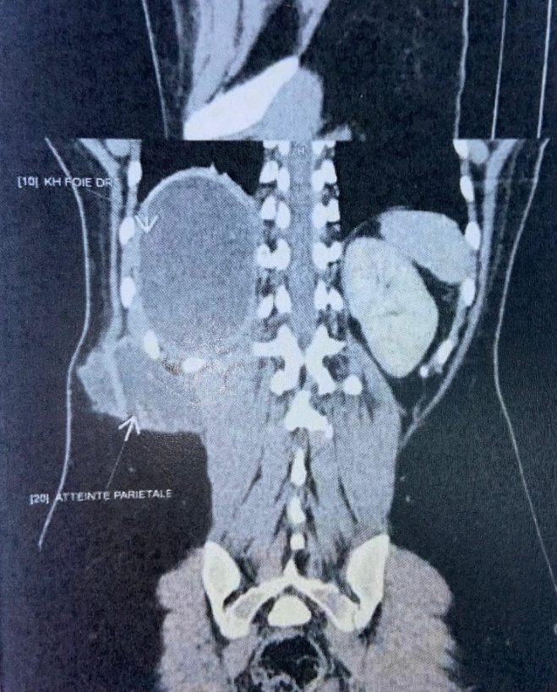

Figure 1: Abdominal CT scan showing a hepatic cystic lesion in segments V, VI and VII extending to the right chest wall, forming a collection in the intermuscular plane.

After a right subcostal incision, the surgical field was protected with drapes soaked in a scolicidal solution. Next, the cyst was punctured and around 2 liters of purulent fluid aspirated, followed by an injection of hydrogen peroxide with complete cleaning and aspiration of the fluid. Finally, resection of the protruding cyst dome was performed and a Redon drain was placed in the residual cavity after careful verification of the absence of biliary leakage. A bacteriological study of the fluid and histological examination of the cystic wall were carried out. Microscopic examination, culture and PCR for tuberculosis were negative. Histological examination of the cystic wall revealed tuberculoid granulomatous inflammation with caseous necrosis.

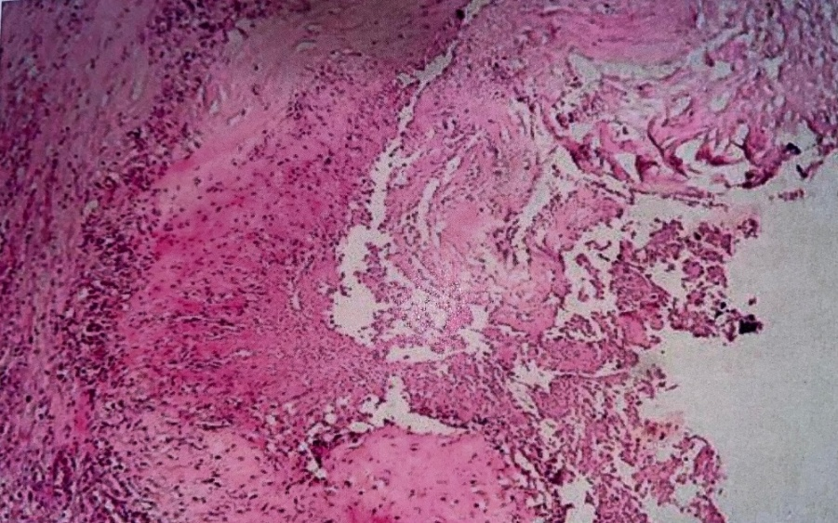

Figure 2: Histological section showing tuberculoid granulomatous inflammation with caseous necrosis.

The clinical presentation, imaging and histological findings led to the diagnosis of hepatic tuberculosis, which required 9 months of anti-tuberculosis therapy. The patient's evolution was favorable under medical treatment; a clinical and biological examination every 3 months was reassuring, and an abdominal ultrasound every 6 months for 1 year showed complete resolution of the liver abscess and chest wall swelling.

1. **DISCUSSIONS:**

Tuberculosis is a disease that mainly affects developing countries, and remains a public health problem despite the availability of effective antibiotics and control programs.[1] Two major challenges are co-infection with HIV and the emergence of drug-resistant strains. The lung is the most common site, but the disease can also affect other organs such as lymph nodes, pleura, peritoneum, bones and joints, as well as the urogenital tract.

Tuberculosis is a major health problem in Morocco, with around 36 000 new cases each year. The disease has an incidence of 103/100 000 and a mortality rate of 9.3/100 000.[2] A survey on the prevalence of drug resistance revealed a prevalence of multidrug-resistant tuberculosis of 1% in untreated patients and 8.7% in those who had already received treatment.[3] In 2017, 39 cases of hepatic tuberculosis were recorded in Morocco, representing 0.02% of extra-pulmonary localizations.[3] One study showed that the average age of patients with hepatic tuberculosis was 30,[4] with a female predominance in one case series.[5] Moreover, hepatic tuberculosis is more frequent in black people.[6] [7] [8]

Primary hepatic tuberculosis (PHT) is a rare condition,[9] characterized by the absence of splenomegaly, [9] tuberculous enteritis and visible abnormalities on chest X-ray. However, the initial site of infection often remains unknown, leaving the route of entry of bacilli into the liver unclear. A primary lesion is usually present in the lymph nodes of the portal of entry.

The diagnosis of hepatic tuberculosis is often difficult to establish, as it is often asymptomatic, or presents unspecific or even misleading symptoms. Clinical manifestations of the secondary form are usually dominated by extra-hepatic involvement, such as pulmonary, peritoneal, neuromeningeal and lymph node involvement. Several studies have shown that at least 63% of cases present with fever,[10] while abdominal pain is the most frequent reason for consultation, occurring in over 45% of cases.[11] Asthenia, anorexia, weight loss and night sweats are present in a large majority of patients.[12] Hepatomegaly is also common in sufferers,[13] and in some cases can resemble liver cancer. A study carried out at the CHU Ibn Rochd children's hospital in Casablanca revealed that in children with hepatic tuberculosis, hepatomegaly could be mistaken for a pyogenic abscess or present an image of a tuberculous abscess. Jaundice is a rare sign, often caused by compression of the bile ducts by tuberculous adenopathies.[10] It can also be caused by intrahepatic cholestasis resulting from tubercular follicles or granulation tissue. However, the presence of jaundice does not necessarily indicate a poor prognosis. Numerous studies have reported the presence of jaundice in cases of tuberculosis, with percentages ranging from 9% to 35%.[11] In hepatosplenic tuberculosis, portal hypertension is not uncommon. In hepatic autonomous tuberculosis, on the other hand, PH is considered exceptional, and some authors even deny its existence. When PH is present, it can be attributed either to compression of the portal vein by lymph nodes, or to involvement of the liver parenchyma.[13] Our patient presented with CDH pain with tender hepatomegaly without associated fever, jaundice or AEG.

Biological tests have a limited contribution to make in the diagnosis of hepatic tuberculosis. Inflammatory workup results may show elevated SV, CRP and fibrinogen.[12] [14] The blood count may reveal moderate anemia or pancytopenia in cases associated with bone marrow involvement. Liver function tests usually show elevated LAPs,[15] but the rest of the results remain normal. It is important to note that cytolysis syndrome and hepatocellular failure are rare. Intradermal tuberculin tests may be positive,[16] but a negative reaction cannot exclude the diagnosis of hepatic tuberculosis, particularly in early, disseminated cases or in immunocompromised patients.

Morphological examinations, such as abdominal ultrasound and abdominal CT, are often used for the diagnosis and monitoring of hepatic tuberculosis. Ultrasound is a safe and useful examination for excluding other causes of pseudotumoral lesions and guiding biopsies.[12] However, it is not very specific. Abdominal CT does not appear to provide any additional information compared with ultrasound. It can detect lesions in the micronodular form, whereas in the macro-nodular form, the appearance varies according to the stage of the disease.[4] [12] Lesions may initially resemble malignant tumors, then become hypodense due to caseous necrosis, and finally calcify in the form of sequellar calcifications. These complementary morphological examinations help guide liver biopsy and assess the evolution of tuberculous lesions. Abdominal CT revealed in our patient a cystic lesion in segments V, VI and VII extending to the right lateral chest wall, forming a collection in an intermuscular plane. MRI offered few suggestive elements, with the lesions presenting a variable appearance.[12] Overall, due to the lack of radiological specificity, low cost-effectiveness and high cost, the use of CT and MRI for this liver pathology is questionable. Ultrasound is therefore recommended as the examination of choice.

Diagnosis of hepatic tuberculosis is difficult and requires histological confirmation.[17] [18] Liver biopsy is performed either by transparietal biopsy, laparoscopy or laparotomy. Two types of histological lesions can currently be distinguished, specific lesions which are the EGC follicle; fibro-caseous tuberculosis; sometimes an epithelioid cluster accompanied by lymphoid cells; or a nodule which may be fibrotic and within which epithelioid cells, lymphoid cells or a necrotic cluster can be seen. Other non-specific lesions may accompany the specific lesions.[19] [20] [21] The diagnosis of hepatic tuberculosis may be erroneous due to the diversity of anatomopathological aspects. It is therefore essential to continue investigations by looking for BK on direct examination and on cultures, which remain the most reliable methods for establishing a positive diagnosis.[22]

Treatment is mainly medical, possibly supplemented by ultrasound-guided drainage or surgical treatment. Five major anti-tuberculosis drugs are currently available (rifampicin, isoniazid, ethambutol, streptomycin and pyrazinamide). Other so-called minor anti-tuberculosis drugs, less active and often poorly tolerated, are indicated in cases of multidrug resistance. The addition of a corticosteroid may be indicated in cases of cerebral or meningeal tuberculosis accompanied by signs of intracranial hypertension, and also in children in cases of stenosing bronchial tuberculosis, as well as in pericarditis.[20] Echo-guided drainage is useful for treating cold abscesses. In addition to its therapeutic role, puncture resolves certain diagnostic difficulties posed by certain abscesses and tumoral lesions. The most common surgical treatment consists of simple curettage and drainage of the abscess, or better still, partial hepatectomy.[13] [23] [24] The most frequent post-operative complications are hemorrhage, liver failure and biliary fistulas. Nanoparticles offer great potential in tuberculosis therapy, enabling optimal control and release of drugs, thus reducing dosage and compliance problems. Various nanocarriers designed for drug delivery have shown impressive results in treating the disease. Theranostic nanoparticles have been developed for various imaging and diagnostic modalities, such as nuclear, optical, ultrasound, magnetic resonance and computed tomography imaging.[25] In our case, anti-tuberculosis treatment was initiated for 09 months with a favorable clinical course. After the end of treatment, abdominal ultrasound revealed no lesions.

As a general rule, the evolution under treatment is favorable, characterized by a marked improvement in general condition, which precedes the slow regression of anatomopathological lesions.[26] Our patient thus progressed favorably under treatment.

Prevention involves detecting the disease as early as possible so that it can be treated promptly, as well as better knowledge of at-risk groups, based on current epidemiological data.[23] [27]

1. **CONCLUSION:**

Hepatic tuberculosis affects less than 1% of people with tuberculosis. In most cases, it is a secondary form, linked to an existing tuberculosis focus, and more rarely a primary form. Because the clinical, biological, radiological and histological manifestations are polymorphous and not very suggestive, diagnosis can be difficult, which is why it is important to take this diagnosis into account in the presence of any granulomatous or pseudotumoral hepatopathy, particularly in tuberculosis-endemic countries and in immunocompromised subjects. Prevention is essential, and must be integrated into the national tuberculosis control program.

Consent

As per international standards or university standards, patient(s) written consent has been collected and preserved by the author(s).

Disclaimer (Artificial intelligence)

Option 1:

Author(s) hereby declare that NO generative AI technologies such as Large Language Models (ChatGPT, COPILOT, etc.) and text-to-image generators have been used during the writing or editing of this manuscript.

Option 2:

Author(s) hereby declare that generative AI technologies such as Large Language Models, etc. have been used during the writing or editing of manuscripts. This explanation will include the name, version, model, and source of the generative AI technology and as well as all input prompts provided to the generative AI technology

Details of the AI usage are given below:

1.

2.

3.

1. **REFERENCES :**

[1] A WHO report calls for increased political commitment to end tuberculosis n.d. https://www.who.int/fr/news/item/30-10-2017-who-report-signals-urgent-need-for-greater-political-commitment-to-end-tuberculosis (accessed May 2, 2025).

[2] Piro DY. ANTITUBERCULUS FIGHT IN MOROCCO n.d. n.d.

[3] DELM n.d. https://www.sante.gov.ma/Pages/ADM_Centrale/DELM.aspx (accessed May 2, 2025).

[4] Nassar I, Errabih I, Krami I, Hammani L, Ouazzani H, Imani F. DIG-WS-36 Primary hepatic tuberculosis: about 10 cases. J Radiol 2007;88:1538. https://doi.org/10.1016/S0221-0363(07)81728-8.

[5] Hepatic tuberculosis (about 14 cases) n.d. https://toubkal.imist.ma/handle/123456789/3829?show=full (accessed May 2, 2025).

[6] BERNARD E, PELISSIER E, BIRTWISLE Y, REY JF, DELLAMONICA P. Pseudo-tumoral hepatic tuberculosis. About an observation. Tuberc Hépat À Forme Pseudo-Tumorale Propos Une Obs 1985;21:135–6.

[7] Hickey N, McNulty JG, Osborne H, Finucane J. Acute hepatobiliary tuberculosis: a report of two cases and a review of the literature. Eur Radiol 1999;9:886–9. https://doi.org/10.1007/s003300050761.

[8] Masson E. Voluminous tuberous adenopathy of the hepatic pedicle. EM-Consulte n.d. https://www.em-consulte.com/article/5044/volumineuse-adenopathie-tuberculeuse-du-pedicule-h (accessed May 2, 2025).

[9] Kok KYY, Yapp SKS. Isolated hepatic tuberculosis: report of five cases and review of the literature. J Hepatobiliary Pancreat Surg 1999;6:195–8. https://doi.org/10.1007/s005340050106.

[10] Maharaj B, Leary WP, Pudifin DJ. A prospective study of hepatic tuberculosis in 41 black patients. Q J Med 1987;63:517–22.

[11] Alvarez SZ, Carpio R. Hepatobiliary tuberculosis. Dig Dis Sci 1983;28:193–200. https://doi.org/10.1007/BF01295113.

[12] Diallo I, Mbengue A, Gning SB, Amar MA, Ndiaye B, Diop Y, et al. Hepatosplenic tuberculosis simulating secondary malignant lesions with cholangitis. BMC Res Notes 2016;9:316. https://doi.org/10.1186/s13104-016-2091-6.

[13] Ch’ng LS, Amzar H, Ghazali KC, Siam F. Imaging appearances of hepatic tuberculosis: experience with 12 patients. Clin Radiol 2018;73:321.e11-321.e16. https://doi.org/10.1016/j.crad.2017.10.016.

[14] Ai J-W, Li Y, Cheng Q, Cui P, Wu H-L, Xu B, et al. Diagnosis of local hepatic tuberculosis through next-generation sequencing: Smarter, faster and better. Clin Res Hepatol Gastroenterol 2018;42:178–81. https://doi.org/10.1016/j.clinre.2018.04.007.

[15] Wong SSM, Yuen HY, Ahuja AT. Hepatic tuberculosis: a rare cause of fluorodeoxyglucose hepatic superscan with background suppression on positron emission tomography. Singapore Med J 2014;55:e101-103. https://doi.org/10.11622/smedj.2013237.

[16] Digestive tuberculosis treatment and national prevention program Pr Jamal Eddine Bourkadi Moulay Youssef Hospital CHU IBN SINA- Rabat. - ppt download n.d. https://slideplayer.fr/slide/10230362/ (accessed May 2, 2025).

[17] Masson E. Hepatic granulomatoses. EM-Consulte n.d. https://www.em-consulte.com/article/1487/granulomatoses-hepatiques (accessed May 2, 2025).

[18] Karunanithi S, Sharma P, Jain TK, Vijay MK, Kumar R. Multiple hepatic lesions in a case of isolated hepatic tuberculosis simulating metastases on 18F-FDG PET/CT imaging. Nucl Med Rev Cent East Eur 2014;17:108–9. https://doi.org/10.5603/NMR.2014.0027.

[19] Mert A, Ozaras R, Tabak F, Ozturk R, Bilir M. Localized hepatic tuberculosis. Eur J Intern Med 2003;14:511–2. https://doi.org/10.1016/j.ejim.2003.09.007.

[20] DALLO LEFEBVRE A. Hepatic tuberculosis: about four cases. PhD thesis. Lille 2, 1992. These de doctorat. Lille 2, 1992.

[21] Kayar Y, Ekinci I, Turkdogan FT, Atay M, Soytas RB, Kayar NB. A rare case of isolated macronodular hepatic tuberculosis (Tuberculous) in an immunocompetent patient. JPMA J Pak Med Assoc 2015;65:1235–6.

[22] Alcantara-Payawal DE, Matsumura M, Shiratori Y, Okudaira T, Gonzalez R, Lopez RA, et al. Direct detection of Mycobacterium tuberculosis using polymerase chain reaction assay among patients with hepatic granuloma. J Hepatol 1997;27:620–7. https://doi.org/10.1016/s0168-8278(97)80078-5.

[23] Ibanez Martin P, Fresard A, Cuilleron M, Peoc’h M, Patouillard B, Prost B, et al. Pseudotumoral hepatic tuberculosis evolving to a multi-nodular form despite treatment. Gastroentérologie Clin Biol 2006;30:605–8. https://doi.org/10.1016/S0399-8320(06)73235-3.

[24] Gounder L, Moodley P, Drain PK, Hickey AJ, Moosa M-YS. Hepatic tuberculosis in human immunodeficiency virus co-infected adults: a case series of South African adults. BMC Infect Dis 2017;17:115. https://doi.org/10.1186/s12879-017-2222-2.

[25] Kia P, Ruman U, Pratiwi AR, Hussein MZ. Innovative Therapeutic Approaches Based on Nanotechnology for the Treatment and Management of Tuberculosis. Int J Nanomedicine 2023;18:1159–91. https://doi.org/10.2147/IJN.S364634.

[26] Husain M, Khan S, Hassan MJ. Hepatic tuberculosis mimicking metastasis in a case of carcinoma sigmoid colon. J Lab Physicians 2015;7:64–6. https://doi.org/10.4103/0974-2727.154802.

[27] Mustard RA, Mackenzie RL, Gray RG. Percutaneous drainage of a tuberculous liver abscess. Can J Surg J Can Chir 1986;29:449–50.