Case report

Mixed neuroendocrine-non-neuroendocrine carcinoma (MiNEN) in gallbladder: a rare case report with successful neoadjuvant therapy

Abstract
Introduction:
Mixed neuroendocrine–non-neuroendocrine neoplasms (MiNENs) of the gallbladder are exceptionally rare and diagnostically challenging tumors characterized by the coexistence of both neuroendocrine and non-neuroendocrine components, each comprising at least 30% of the tumor. Their clinical presentation often mimics benign gallbladder conditions, leading to delayed diagnosis and poor prognosis. This report aims to highlight a rare case of gallbladder MiNEN and review its diagnostic, therapeutic, and pathological features.
Case Report:
A 54-year-old male presented with upper abdominal discomfort and intermittent vomiting. Imaging revealed a hypodense gallbladder mass infiltrating liver segments 4B and 5. PET-CT confirmed metabolic activity consistent with malignancy. Biopsy showed a tumor composed of 20% moderately differentiated adenocarcinoma (CK7, CK19, AE1/AE3 positive) and 80% high-grade small cell neuroendocrine carcinoma (chromogranin, synaptophysin positive) with a Ki-67 index >70%. Following four cycles of neoadjuvant cisplatin and etoposide chemotherapy, imaging showed marked tumor reduction and complete metabolic response. The patient subsequently underwent radical cholecystectomy with liver wedge resection and lymphadenectomy. Final pathology revealed minimal residual adenocarcinoma and no residual neuroendocrine carcinoma. Surgical margins and lymph nodes were free of disease (ypT3N0).
Discussion:
Gallbladder MiNENs are rare, often presenting with non-specific symptoms. Accurate preoperative diagnosis remains difficult, with histopathology and immunohistochemistry being essential. The neuroendocrine component often dictates tumor aggressiveness and response to therapy. In this case, neoadjuvant chemotherapy achieved tumor downstaging and enabled complete surgical resection. The negative TTF-1 and CDX2 helped confirm the primary biliary origin. Radical resection remains the mainstay of treatment, while the role of chemotherapy and somatostatin analogues continues to evolve.
Conclusion:
This case highlights the diagnostic complexity and therapeutic potential in managing gallbladder MiNENs. Early multimodal treatment, including neoadjuvant chemotherapy and radical surgery, may offer favorable outcomes. Greater clinical awareness and reporting of such cases are essential to develop standardized diagnostic and treatment protocols.

Introduction
Mixed neuroendocrine–non-neuroendocrine neoplasms (MiNENs) are rare and complex tumors that present significant challenges in diagnosis and treatment.[1] These neoplasms are characterized by the presence of both neuroendocrine and non-neuroendocrine elements—each comprising at least 30% of the tumor volume, as per the latest WHO classification [2]. Preoperative misdiagnosis is common, with MiNENs frequently mistaken for adenocarcinoma or high-grade neuroendocrine carcinoma [3]. European epidemiological data suggests an incidence of fewer than 0.01 cases per 100,000 individuals per year [4]. MiNENs are most commonly found in the appendix (60.3%), followed by the colorectal region (14.5%), while occurrences in the biliary tract are rare (1.6%), with the gallbladder accounting for nearly two-thirds of these biliary cases [5]. Neuroendocrine carcinomas (NECs) of the gallbladder represent approximately 4% of all malignant gallbladder tumors, and over one-third of these contain an adenocarcinoma component, classifying them as MiNENs [1].
Clinically, gallbladder MiNENs often mimic benign conditions such as cholelithiasis or present as non-specific gallbladder masses. Due to their subtle onset, early detection is difficult. These tumors usually progress rapidly and are associated with a poor prognosis.[4] Given the scarcity of reported cases and limited literature, this report aims to contribute valuable insights through a case study and comprehensive literature review, thereby supporting improved diagnostic and therapeutic approaches.

Case Presentation
A 54-year-old male presented with a one-month history of upper abdominal discomfort accompanied by intermittent episodes of vomiting. On physical examination, a hard, palpable mass measuring approximately 6x6 cm was detected in the gallbladder region. Routine laboratory investigations, including tumor markers CEA and CA 19-9, were within normal ranges. Imaging with contrast-enhanced CT identified a 62x68x43 mm hypodense mass originating from the gallbladder fundus, infiltrating hepatic segments 4B and 5, and encasing the middle hepatic vein. These findings were corroborated by 18F-FDG PET-CT.
Histopathological evaluation of a CT-guided biopsy revealed features consistent with a mixed neuroendocrine-non-neuroendocrine neoplasm. The non-neuroendocrine portion, accounting for 20% of the tumor, was confirmed as adenocarcinoma, with immunohistochemistry positive for CK7, CK19, and AE1/AE3. The remaining 80%, representing the neuroendocrine component, was identified as small cell carcinoma, exhibiting positivity for synaptophysin and chromogranin.
Due to the locally advanced nature of the disease, the multidisciplinary tumor board recommended neoadjuvant chemotherapy. The patient received four cycles of cisplatin and etoposide. A follow-up CT scan performed three weeks post-treatment showed a significant reduction in tumor size to 36x36x13 mm, while PET-CT revealed a complete metabolic response in the gallbladder region.
Subsequently, the patient underwent radical surgery, including en bloc cholecystectomy and wedge resection of liver segments 4B and 5, along with complete lymphadenectomy of stations 8, 12, and 13.
Patient recovered well postoperatively, clear liquids started orally on postoperative day 1, mobilized on postoperative day 2, drain placed in right subhepatic space removed on day 5 and patient discharged on day 7.
Final histopathology report suggested 1x0.7x0.5cm residual tumour in the fundus and body of the gall bladder, residual adenocarcinoma was moderately differentiated while the neuroendocrine component had no residual disease.
The liver and the cystic duct margin were free of tumour, none of the lymph nodes are involved.
Pathological stage: ypT3N0

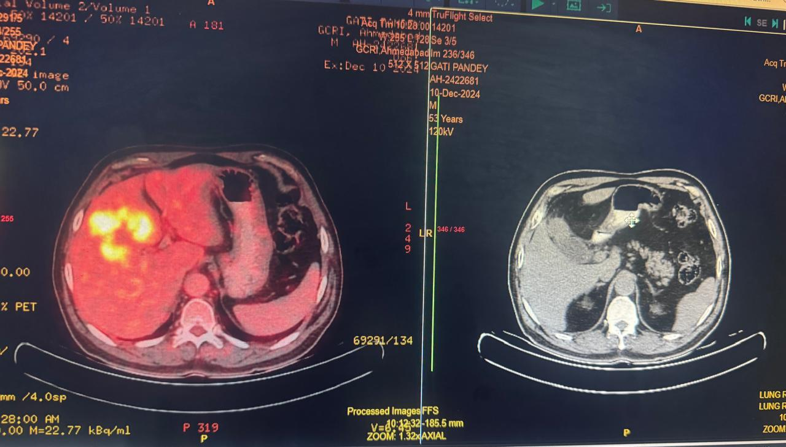
Figure 1: Pre Neoadjuvant therapy PET and CT image
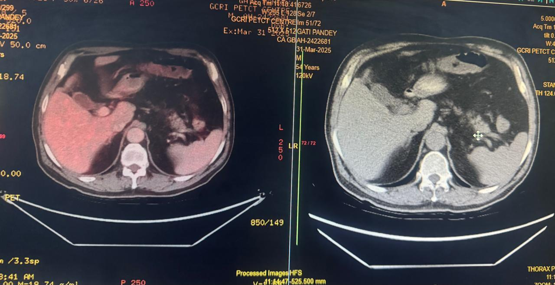
Figure 2: Post Neoadjuvant therapy PET and CT image
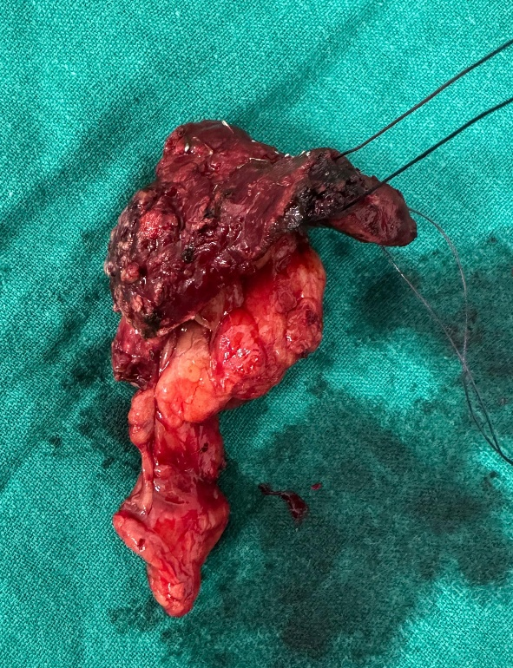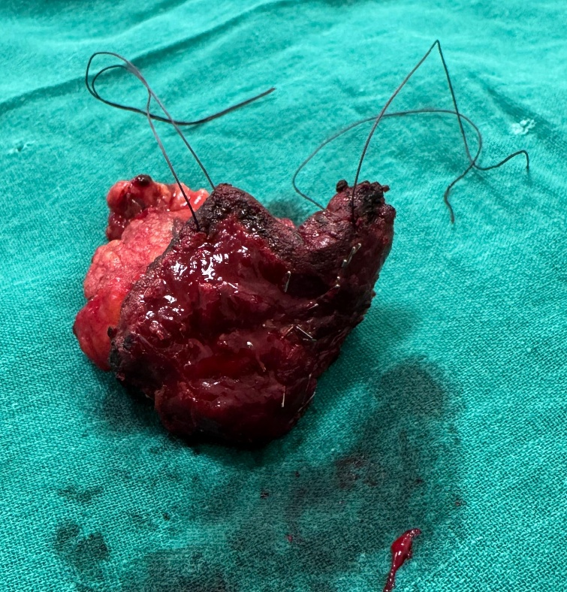
Figure 3 and 4 : specimen image – gall bladder with resected liver tissue

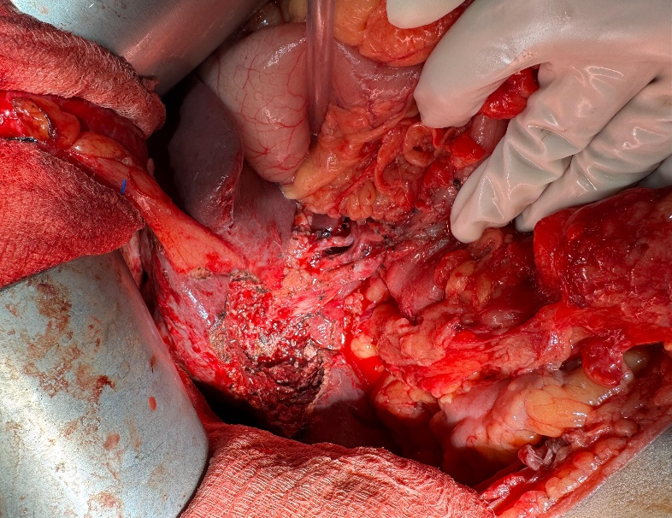
Figure 5: Post resection tumour bed

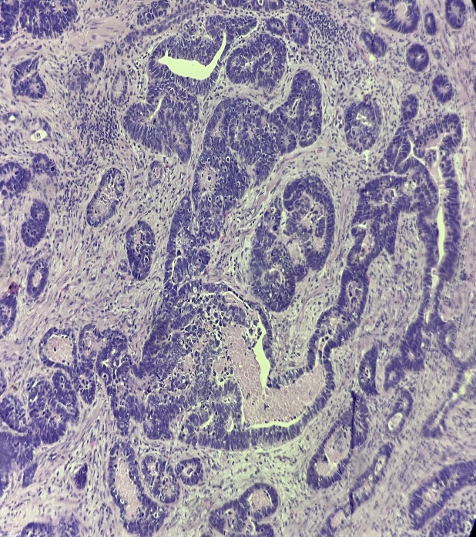
Figure 6: Histopathology image showing well-formed irregular glandular architecture consistent with adenocarcinoma and sheets and nests of small, round cells with scant cytoplasm and stippled chromatin with high mitotic activity consistent with neuroendocrine component.

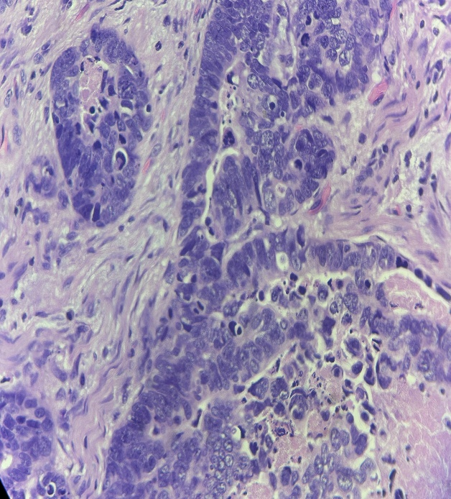
Figure 7: Histopathology image showing solid nests of tumor cells with salt pepper chromatin suggestive of neuroendocrine component. High mitotic activity and nuclear pleomorphism is consistent with high grade neuroendocrine carcinoma. Glandular structure consistent with adenocarcinoma.

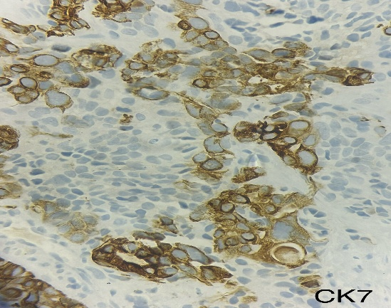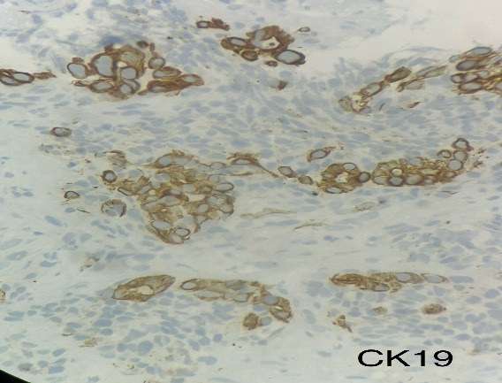
Figure 8: CK7 positive on IHC Figure 9: CK19 positive on IHC

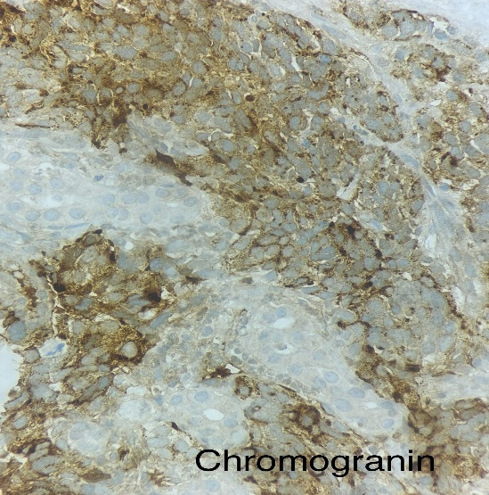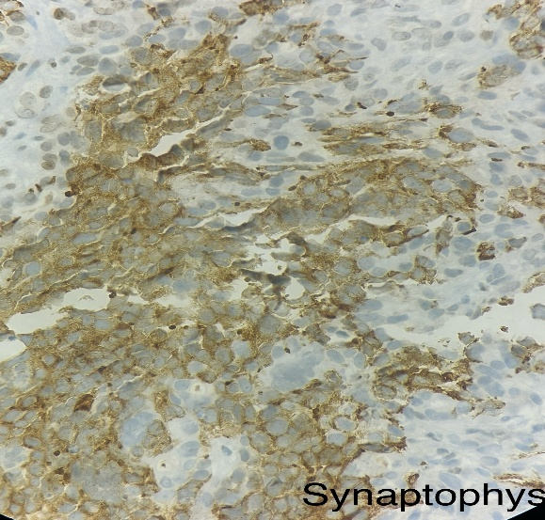
Figure 10: Chromogranin positive on IHC Figure 11: Synaptophysin positive on IHC
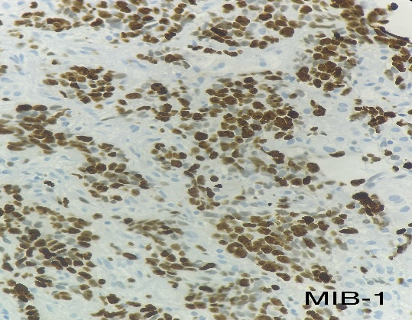
Figure 12: MIB-1 positive indicating proliferating cells

Discussion and conlusion
Gallbladder MiNENs are exceedingly rare neoplasms, with a higher incidence reported in females (male-to-female ratio of 0.22) [6]. Clinically, they often present with non-specific abdominal symptoms that mimic benign conditions such as cholelithiasis, and are typically not associated with carcinoid syndrome. This absence of hormonal symptoms is likely attributable to the localized or absent secretion of bioactive substances during the early stages of disease progression [7].
Histopathologically, MiNENs of the gallbladder frequently manifest as nodular or polypoid masses, with a propensity to invade adjacent structures, particularly the liver. In some cases, wall thickening and central necrosis are observed. A definitive diagnosis requires histological analysis, which reveals both neuroendocrine and non-neuroendocrine components, each constituting at least 30% of the tumor burden. While adenocarcinoma represents the most commonly identified non-neuroendocrine element, rare histological variants such as squamous cell carcinoma and mucinous adenocarcinoma have been reported [7,8]. Some cases may also feature coexisting small cell and large cell neuroendocrine elements alongside adenocarcinoma [9]. The pathogenesis of these tumors remains poorly understood, particularly given the general absence of neuroendocrine cells in gallbladder mucosa, except in the neck region [10].
Comparative studies indicate that gallbladder MiNENs demonstrate higher rates of lymphatic (50.7%) and hepatic (34.3%) dissemination than pure neuroendocrine carcinomas (15% and 17%, respectively) [11]. This aggressive behavior may result from a synergistic effect between the two histological components. Prognosis is frequently influenced by the grade of the neuroendocrine element [12,13]. Interestingly, these components may metastasize independently; synchronous liver metastases may correspond to a single histological subtype, whereas metachronous lesions may involve the alternate component [13,14].
Radiological imaging is integral to the evaluation of suspected MiNENs. Ultrasonography commonly demonstrates irregular, hypoechoic masses with increased vascularity. Contrast-enhanced CT and MRI often reveal strongly enhancing, irregular lesions, although distinguishing them from conventional gallbladder carcinomas remains challenging [15,16]. In cases of wall thickening, CT may show heterogeneous soft tissue masses, while MRI may highlight cystic or necrotic changes [17,18].
^18F-fluorodeoxyglucose (FDG) PET/CT exhibits high sensitivity and specificity for detecting aggressive MiNENs [19,20], although well-differentiated tumors may not be FDG-avid. Somatostatin receptor (SSR) imaging provides additional functional characterization by identifying surface receptor expression. Techniques such as ^111In-octreotide scintigraphy and ^68Ga-DOTA-NOC PET/CT have proven valuable in both localization and staging of neuroendocrine components [21].
Histopathological confirmation via tissue sampling is essential for diagnosis. CT- or ultrasound-guided fine-needle aspiration (FNA), as well as endoscopic ultrasound (EUS)-guided biopsies, significantly enhance diagnostic accuracy. Notably, EUS-FNA can achieve sensitivity rates approaching 90% [22–24]. Nonetheless, biopsy is more commonly utilized as a confirmatory diagnostic tool rather than for early detection.
The surgical approach to MiNENs parallels that for advanced gallbladder carcinoma. Radical cholecystectomy with hepatic resection and regional lymphadenectomy constitutes the standard treatment for localized disease [19]. For early-stage neuroendocrine tumors (T1N0), simple cholecystectomy may suffice, whereas more advanced disease (pT2 or pT3) typically necessitates extended resection [24,25].
Management of high-grade neuroendocrine components often involves platinum-based chemotherapy regimens, such as cisplatin combined with etoposide [26]. However, the response to adjuvant therapy is inconsistent, with many patients failing to achieve long-term survival benefits. Data from retrospective studies indicate that only a subset of patients receive postoperative systemic therapy, and its efficacy remains unclear [11,24].
Somatostatin analogues, including octreotide and lanreotide, have demonstrated efficacy in receptor-positive tumors, offering symptom control and delaying disease progression [24,27]. Furthermore, select case reports have described successful downstaging of initially unresectable MiNENs following neoadjuvant chemotherapy combined with somatostatin analogues, thereby enabling curative surgical intervention [24].

Disclaimer (Artificial intelligence)
Option 1:
Author(s) hereby declare that NO generative AI technologies such as Large Language Models (ChatGPT, COPILOT, etc.) and text-to-image generators have been used during the writing or editing of this manuscript.
Option 2:
Author(s) hereby declare that generative AI technologies such as Large Language Models, etc. have been used during the writing or editing of manuscripts. This explanation will include the name, version, model, and source of the generative AI technology and as well as all input prompts provided to the generative AI technology
Details of the AI usage are given below:
1.
2.
3.

References
- Adsay NV, La RS. Tumours of the gallbladder and extrahepatic bile duct. In: Digestive system tumours/WHO classification of tumours editorial board, 5th edition; 2019. p. 292–4.
- Klöppel G, Couvelard A, Hruban RH, Klimstra DS, Komminoth P, Osamura RY, et al. Neoplasms of the neuroendocrine pancreas. In: Lloyd RV, Osamura RY, Klöppel G, Rosai J, eds. WHO Classification of Tumours of Endocrine Organs. 4th ed. Lyon: IARC Press; 2017;210–239.
- Düzköylü Y, Aras O, Bostancı E, Keklik Temuçin T, Ulaş M. Mixed adeno-neuroendocrine carcinoma; case series of ten patients with review of the literature. Balkan Med J. 2018;35(3):263–7
- Frizziero M, Chakrabarty B, Nagy B, Lamarca A, Hubner RA, Valle JW, et al. Mixed neuroendocrine non-neuroendocrine neoplasms: a systematic review of a controversial and underestimated diagnosis. J Clin Med. 2020;9(1):273.
- Ines FMS, Anceno AL, Salamat RA, Navarro JN, Pua GL, Andal JJ, et al. Targeted sequencing of mixed neuroendocrine-non-neuroendocrine neoplasm of the gallbladder suggests a monoclonal origin: a case report. Philipp J Pathol. 2019;4:48.
- Ren, X., Jiang, H., Sun, K. et al. Mixed neuroendocrine-non-neuroendocrine neoplasm of the gallbladder: case report and literature review. Diagn Pathol 17, 51 (2022). https://doi.org/10.1186/s13000-022-01231-6
- Hashimoto M, Okuda C, Sakurai C, Seki K, Matsuda M, Nagao G, et al. Adenoendocrine cell carcinoma of the gallbladder: differentiation of the endocrine component. J Gastroenterol Hepatol. 2007;22:141–2.
- Sciarra A, Missiaglia E, Trimech M, Melloul E, Brouland JP, Sempoux C, et al. Gallbladder mixed neuroendocrine-non-neuroendocrine neoplasm (MiNEN) arising in Intracholecystic papillary neoplasm: Clinicopathologic and molecular analysis of a case and review of the literature. Endocr Pathol. 2020;31:84–93.
- Oshiro H, Matsuo K, Mawatari H, Inayama Y, Yamanaka S, Nagahama K, et al. Mucin-producing gallbladder adenocarcinoma with focal small cell and large cell neuroendocrine differentiation associated with pancreaticobiliary maljunction. Pathol Int. 2008;58:780–6.
- Chatterjee D, Wang H. Mixed adenoneuroendocrine carcinoma arising in a papillary adenoma of gallbladder. Am J Cancer Case Rep. 2014;2:37–42.
- Ayabe RI, Wach M, Ruff S, Martin S, Diggs L, Wiemken T, et al. Primary gallbladder neuroendocrine tumors: insights into a rare histology using a large national database. Ann Surg Oncol. 2019;26:3577–85.
- Shimizu T, Tajiri T, Akimaru K, Arima Y, Yoshida H, Yokomuro S, et al. Combined neuroendocrine cell carcinoma and adenocarcinoma of the gallbladder: report of a case. J Nippon Med Sch. 2006;73:101–5.
- Jung J, Chae YS, Kim CH, Lee Y, Lee JH, Kim DS, et al. Combined Adenosquamous and large cell neuroendocrine carcinoma of the gallbladder. J Pathol Transl Med. 2018;52:121–5.
- Noske A, Pahl S. Combined adenosquamous and large-cell neuroendocrine carcinoma of the gallbladder. Virchows Arch. 2006;449:135–6.
- Abe T, Kajiyama K, Harimoto N, Gion T, Shirabe K, Nagaie T. Composite adeno-endocrine carcinoma of the gallbladder with long-term survival. Int J Surg Case Rep. 2013;4:504–7.
- Oshiro H, Matsuo K, Mawatari H, Inayama Y, Yamanaka S, Nagahama K, et al. Mucin-producing gallbladder adenocarcinoma with focal small cell and large cell neuroendocrine differentiation associated with pancreaticobiliary maljunction. Pathol Int. 2008;58:780–6.
- Tsuchiya A, Endo Y, Yazawa T, Saito A, Inoue N. Adenoendocrine cell carcinoma of the gallbladder: report of a case. Surg Today. 2006;36:849–52.
- Rastogi A, Bihari C, Singh S, Deka P, Bhatia V, Sarin S. Adenoendocrine carcinoma of gallbladder in a patient with primary sclerosing cholangitis and ulcerative colitis. Trop Gastroenterol. 2012;33:158–60.
- Skalický A, Vištejnová L, Dubová M, Malkus T, Skalický T, Troup O. Mixed neuroendocrine-non-neuroendocrine carcinoma of gallbladder: case report. World J Surg Oncol. 2019;17:55.
- Okuyama Y, Fukui A, Enoki Y, Morishita H, Yoshida N, Fujimoto S. A large cell neuroendocrine carcinoma of the gall bladder: diagnosis with 18FDG-PET/ CT-guided biliary cytology and treatment with combined chemotherapy achieved a long-term stable condition. Jpn J Clin Oncol. 2013;43:571–4.
- Kamboj M, Gandhi JS, Gupta G, Sharma A, Pasricha S, Mehta A, et al. Neu roendocrine carcinoma of gall bladder: a series of 19 cases with review of literature. J Gastrointest Cancer. 2015;46:356–64.
- Muto Y, Okamoto K, Uchimura M. Composite tumor (ordinary adenocarcinoma, typical carcinoid, and goblet cell adenocarcinoid) of the gallbladder: a variety of composite tumor. Am J Gastroenterol. 1984;79:645–9.
- Moskal TL, Zhang PJ, Nava HR. Small cell carcinoma of the gallbladder. J Surg Oncol. 1999;70:54–9.
- Song W, Chen W, Zhang S, Peng J, He Y. Successful treatment of gallbladder mixed adenoneuroendocrine carcinoma with neo-adjuvant chemo therapy. Diagn Pathol. 2012;7:163.
- Shirai Y, Sakata J, Wakai T, Ohashi T, Hatakeyama K. “Extended” radical cholecystectomy for gallbladder cancer: long-term outcomes, indications and limitations. World J Gastroenterol. 2012;18:4736–43.
- Klimstra D, Klöppel G, La Rosa S, Rindi G. Classification of neuroendocrine neoplasms of the digestive system. In: WHO Classification of tumours, 5th Edition Digestive system tumours; 2019. p. 16–9.
- Azad S, Shukla D, Garg A, Negi SS, Malhotra V. Mixed adenoneuroendo crine carcinoma of the gallbladder, histopathological features. Indian J Pathol Microbiol. 2015;58:543–5.

