**Original Research Article**

**EVALUATION OF THE RENAL FUNCTION IN ANTI-OBESITY EFFECTS OF ETHANOLIC EXTRACT OF *Citrus sinensis* PEEL TREATED WISTAR RATS**

**Abstract**

Obesity is a global health concern linked to oxidative stress and kidney dysfunction. *Citrus sinensis* (sweet orange) peels, typically a waste product, are rich in bioactive compounds with antioxidant potential. This study evaluated the protective and antioxidant effects of sweet orange peel extract in obese Wistar rats. Obesity was induced using oral dexamethasone for two weeks, followed by a 21-day treatment with ethanolic peel extract at varying doses. Rats were divided into six groups (n=5), and kidney function was assessed through serum levels of urea, creatinine, sodium, bicarbonate, and chloride. Antioxidant status was evaluated using markers such as malondialdehyde (MDA), glutathione (GSH), superoxide dismutase (SOD), and catalase (CAT). Additionally, in vitro assays assessed the extract’s scavenging ability for superoxide, hydrogen peroxide, and nitric oxide radicals. Obese rats showed elevated urea, creatinine, sodium, and MDA levels, indicating kidney impairment and increased oxidative stress (p<0.05), alongside reduced antioxidant enzyme activity. Treatment with the peel extract resulted in dose-dependent improvements: reduced urea, creatinine, and sodium levels, particularly at medium (200 mg/kg) and high doses, and improved antioxidant enzyme activity. Bicarbonate levels were lowest in the medium-dose group, while chloride levels were highest in the high-dose group. In vitro, the extract demonstrated strong radical scavenging activity, confirming its antioxidant potential. These findings suggest that *C. sinensis* peel extract mitigates oxidative stress and kidney dysfunction in obesity, supporting its potential as a nutraceutical. Further studies are recommended to investigate its active components and mechanisms of action.

**Keywords:** *Citrus sinensis, obesity, antioxidant, kidney function, oxidative stress, radical scavenging, nephroprotection.*

**INTRODUCTION**

Obesity has turned into a worldwide crisis, affecting both rich and poor nations alike. It's closely linked to a higher risk of developing a range of chronic illnesses, such as metabolic syndrome, heart disease, type 2 diabetes, and kidney problems (Amber et al., 2020). The damage obesity can cause to the kidneys is especially alarming, as it can lead to issues like glomerular hyperfiltration,

changes in kidney blood flow, and progressive kidney scarring, ultimately resulting in chronic kidney disease (CKD) (Kosasih et al., 2019; Liu et al., 2021). The reasons behind kidney dysfunction related to obesity are complex, involving factors like increased oxidative stress, inflammation, fat buildup, and the activation of various molecular pathways that hinder kidney function (Huang et al., 2022). Even though we know obesity can harm the kidneys, there are still not many effective treatments available to prevent or reduce kidney damage in people who are obese. The World Health Organization (WHO) has declared obesity a global epidemic, forecasting that over 38% of individuals aged five and older will be classified as overweight or obese (Lobstein et al., 2023). This issue usually stems from an imbalance between the calories consumed and those burned, shaped by a mix of genetic, hormonal, environmental, and lifestyle factors (Safaei et al., 2021). As obesity rates continue to rise, along with the health problems that come with it, there's an increasing interest in looking into alternative treatments, especially those that utilize plant-based bioactive compounds, to help manage obesity and its related complications, including kidney dysfunction (Zayed et al., 2021).

Among the natural products being explored for their therapeutic potential is the peel of *C. sinensis*, or sweet orange. This peel has caught the eye of researchers because it’s packed with bioactive compounds like flavonoids, polyphenols, and essential oils. These compounds are celebrated for their powerful antioxidant, anti-inflammatory, and anti-hyperlipidemic effects, making them exciting candidates for tackling kidney issues related to obesity (Masdalena et al., 2020). Recent research has revealed that extracts from *C. sinensis* peel can significantly reduce oxidative stress, inflammation, and lipid buildup, all of which contribute to kidney damage in those dealing with obesity (Kosasih et al., 2019; Liu et al., 2021). The polyphenols, particularly hesperidin and naringin found in the peel, have been shown to boost insulin sensitivity, decrease oxidative stress, and help regulate appetite, which can lead to weight loss and better metabolic health (Ramalho et al., 2022; Kaur et al., 2018). In the past few years, numerous studies have looked into the positive effects of *C. sinensis* and its active ingredients on weight management and obesity. For example, a study using Moro juice extract (Morosil, 400 mg/day) found a notable decrease in body mass index (BMI) after just four weeks of treatment. Participants who received the Moro extract experienced significant changes in body weight, BMI, waist, and hip measurements compared to those on a placebo. The active compounds in Moro juice, including anthocyanins, hydroxycinnamic acids, flavone glycosides, and ascorbic acid, work together to promote fat loss in humans (Cardile et al., 2015). Additionally, extracts from citrange, a hybrid of *C. sinensis* and *Poncirus trifoliata,* showed impressive results when given to mice on a high-fat diet, leading to significant reductions in body weight, blood glucose, total cholesterol (TC), and low-density lipoprotein cholesterol (LDL-c) levels.

Researchers have linked these effects to the modulation of important metabolic pathways, particularly the down-regulation of peroxisome proliferator-activated receptor γ (PPARγ) and liver X receptors (LXRα and LXRβ). These receptors play a crucial role in lipid and glucose metabolism (Cardile et al., 2015). The findings indicate that compounds derived from citrus fruits could potentially help improve obesity and metabolic disorders by influencing gene expressions tied to lipid and glucose metabolism. Moreover, the positive effects of *C. sinensis* on oxidative stress have been highlighted in various studies. Aqueous-methanol extracts from different parts of *C. sinensis* (like the flavedo, albedo, and pulp) have been shown to effectively combat oxidative stress in human adipocytes without causing any cytotoxic effects. This further underscores the importance of citrus in alleviating complications related to obesity (Lu et al., 2013). While the anti-obesity benefits of *C. sinensis* peel are well-established, its specific impact on kidney function remains under-researched, particularly regarding obesity-related renal dysfunction. Obesity is often associated with kidney issues due to factors such as increased renal lipotoxicity, oxidative stress, and glomerular hyperfiltration (Fonseca et al., 2020). The extract’s ability to potentially reduce obesity-related kidney damage, improve lipid metabolism, and lower inflammatory markers makes it a promising subject for further study. Previous research has shown that *C. sinensis* peel extract can help normalize lipid profiles, decrease fat mass, and enhance metabolic parameters in animal models of obesity (Kumar et al., 2020; Al-Snafi et al., 2019). This study aims to investigate the protective effects of ethanolic extracts of Citrus sinensis peel in Wistar rats that have been induced with obesity. By assessing key renal biomarkers such as serum urea, creatinine, and electrolytes, the research seeks to find out if the extract can safeguard against obesity-induced kidney dysfunction.

**Materials and Methods**

# Chemicals / Reagents

The chemicals and reagents used were of analytical grade. The chemicals used in this study includes but not limited to; include but not limited to; Randox kit, ethanol, distilled water, trichloroacetic acid, thiobarbituric acid, DTNB, hydrogen peroxide.

**Sample collection**

The sweet orange peels (Citrus sinensis) were gathered from Mbieri village and left to dry at room temperature for about two weeks. Once dried, the peels were ground into a fine powder to extract their bioactive components. This plant material was verified by Prof. F. N. Mbagwu from the Department of Plant Science and Biotechnology at Imo State University, and a voucher number was recorded for reference.

**Experimental Animals**

In this study, albino Wistar rats were used, each weighing between 70-78 grams. They were kept in a controlled environment with a temperature of 24 ± 5°C and a relative humidity of 30-55%, following a 12-hour light/dark cycle. The rats had free access to water and Standard Commercial Feed from Ewu Feedmill in Edo State, Nigeria, during a two-week acclimatization period. All animal handling was in line with the Standard Principles of Laboratory Animal Care (NIH, 1978).

**Extraction of Bioactive Components**

Exactly 1300 grams of the dried orange peel powder was combined with 3250 milliliters of ethanol and allowed to soak for 72 hours. After soaking, the mixture was filtered, and the resulting extract was concentrated using a water bath set to around 40°C.

**Induction of Obesity**

After the acclimatization period, obesity induction in the rats was achieved by administering dexamethasone tablets orally, with the dosage adjusted according to the rats' body weight. This induction phase lasted for two weeks, coinciding with the treatment period. We monitored the glucose levels of the rats both before and after the induction and treatment phases (Gupta et al., 2012).

**Experimental Design**

A total of 30 Wistar rats were randomly divided into six groups, with five rats in each group. Prior to treatment, the animals were fasted for 16 hours. Over the course of 21 days, each group received specific treatments.

Group 1: normal rats that will be given only feed and water

Group 2: Induced with obesity

Group 3: Induced with obesity and given standard drugs

Group 4: Obese rats treated with orange peel extracts (200g)

Group 5: Obese rats treated with orange peel extracts (400g)

Group 6: Obese rats treated with orange peel extracts (800g)

**Laboratory Analysis**

**Determination of Serum Urea (Randox Kit)**

Urea in serum was hydrolyzed to ammonia in the presence of urease. The ammonia was then measured photometrically by Berthelot's reaction after being quantified; the absorbance (@ 580nm) was measured with a spectrophotometer (Young, 1995).

**Calculation:** Urea conc. (mmol/l) =

A sample x conc. standard (mmol/l)

A standard

**Determination of Serum Creatinine (Randox Kit)**

In an alkaline medium, creatinine reacts with picrate to create a colored complex. The absorbance was read at 520 nm and the creatinine concentration determined by comparing the sample's absorbance to a standard curve (Hall et. al., 2004).

**Calculation**:

Creatinine conc =

A sample x conc. standard (170)

A standard

**Determination of Serum Electrolyte**

* **Serum sodium concentration**

Serum sodium was determined using commercial kits. After adding the reagent and centrifuging, the absorbance was measured spectrophotometrically @ 405nm (Alatawi, and Alshubaily 2021 ).

**Calculation:**

Sodium conc. in mEq/L =

Abs. of blank – Abs. of test x Conc of standard

Abs. of blank – Abs. of standard

Where concentration of standard = 150 mEq/L

**Chloride Concentration**

Serum chloride concentration was measured using a commercial chloride reagent. The absorbance was read at 500 nm and the chloride concentration calculated based on the standard concentration (Young, 1995).

Calculation:

Cl concentration in mEq/L =

Abs of test x conc. of std.

Abs of std

Where concentration of standard = 100 mEq/L

**Bicarbonate (HCO3-) Concentration**

Serum bicarbonate concentration was determined by reconstituting the CO2 reagent and incubating it with samples. The absorbance was measured at 340 nm, and the bicarbonate concentration calculated using a standard solution.

Bicarbonate conc. in mmol/L =

Abs of blank – Abs of test x Conc. of std.

Abs of blank – Abs of std.

Where concentration of standard = 30 mmol/L

**Determining Antioxidant Parameters**

To assess oxidative stress and the antioxidant defense systems in treated Wistar rats, key biomarkers such as malondialdehyde (MDA), superoxide dismutase (SOD), reduced glutathione (GSH), and catalase (CAT) were evaluated using well-established biochemical methods.

**Malondialdehyde (MDA) Assay**

Lipid peroxidation was measured by estimating plasma MDA levels through the thiobarbituric acid reactive substances (TBARS) method, following the approach outlined by Slater and Sawyer (1971), with a few modifications. 0.5 mL of tissue homogenate was mixed with 3.0 mL of 10% trichloroacetic acid (TCA), vortexed thoroughly, and allowed to sit at room temperature for 10 minutes. The mixture was centrifuged at 4000 rpm for 15 minutes. For the assay, 2.0 mL of the supernatant was combined with 1.5 mL of 0.67% thiobarbituric acid (TBA). A blank was created using 2.0 mL of distilled water and 1.5 mL of TBA. Both mixtures were placed in a boiling water bath for 10 minutes and then cooled to room temperature. The formation of a pink chromogen spectrophotometrically was measured at 530 nm. The MDA concentration was calculated using a molar extinction coefficient of 1.5 × 10⁵ M⁻¹ cm⁻¹ and expressed as nmol MDA/100 mL of homogenate.

1.5 = 100 µmol/L (here, 100 is for conversion from ml to dl).

Then MDA = 100 × Absorbance of unknown/1.5.

**Superoxide Dismutase Assay (kakkar et al., 1984) (SOD)**

To determine SOD activity, the method developed by Kakkar et al. (1984) was used. The reaction mixture included 1.2 mL of 0.052 M sodium pyrophosphate buffer (pH 7.0), 0.1 mL of 186 μM phenazine methosulfate, and 0.3 mL of the sample supernatant. The enzymatic reaction was initiated by adding 0.2 mL of 780 μM NADH. After exactly 1 minute, the reaction was stopped with 1.0 mL of glacial acetic acid. The intensity of the resulting chromogen was measured by recording colour intensity at 560 nm. Results were expressed in units/mg of protein

**Reduced Glutathione (GSH) Assay**

The measurement of the concentration of reduced glutathione in liver homogenates, was done using the method outlined by Jollow et al. (1974). Exactly 500 μL of the supernatant was mixed with an equal volume of 4% sulfosalicylic acid to deproteinize it. This mixture was then incubated at 4°C for an hour before being centrifuged at 4000 rpm for 20 minutes. After that, 33 μL of the clear supernatant was combined with 66 μL of 100 mM 5,5′-dithiobis-(2-nitrobenzoic acid) (DTNB) and 900 μL of 0.1 M potassium phosphate buffer (pH 7.4). The yellow complex that formed from the reaction between DTNB and GSH was measured at 412 nm and expressed in terms of nmol GSH per gram of tissue.

**Catalase (CAT) Activity**

Catalase activity was assessed using the method developed by Chance and Maehly (1955), which focuses on how the enzyme breaks down hydrogen peroxide (H2O2). The reaction mixture included 625 μL of 50 mM potassium phosphate buffer (pH 5.0), 100 μL of 5.9 mM H₂O₂, and 25 μL of tissue homogenate. The decrease in absorbance due to the breakdown of H2O2 at 240 nm was monitored over the course of one minute. One unit of CAT activity was defined as the amount of enzyme needed to produce a change in absorbance of 0.01 units per minute. The results were reported in units per mg of protein.

**In Vitro Antioxidant Assays**

To assess how well the test samples can scavenge free radicals, we carried out three in vitro antioxidant assays: nitric oxide (NO) scavenging, hydrogen peroxide (H₂O₂) scavenging, and superoxide radical scavenging. Each of these assays was done in triplicate, and the results were expressed as a percentage of inhibition compared to the controls.

**Nitric Oxide (NO) Scavenging Assay**

The nitric oxide scavenging activity was determined using the method outlined by Marcocci et al. (1994), which relies on the Griess reagent reaction. Sodium nitroprusside (10 mM) in phosphate-buffered saline (PBS, pH 7.4) was used as the nitric oxide donor. 2.0 mL of the 10 mM sodium nitroprusside solution was mixed with 0.5 mL of PBS and 0.5 mL of the test sample at different concentrations (100–1000 µg/mL). This reaction mixture was then incubated at 25°C for 150 minutes. After the incubation period, 0.5 mL of the reaction mixture was combined with 0.5 mL of freshly prepared Griess reagent, which consists of equal parts of 0.33% sulfanilic acid in 20% glacial acetic acid and 0.1% (w/v) naphthylethylenediamine dichloride. It was allowed to sit at room temperature for 30 minutes, and the absorbance of the resulting chromophore at 546 nm was measured using a UV-visible spectrophotometer. The nitric oxide scavenging activity was calculated based on the following formula:

% inhibition of NO radical =

(A0 – A1)/A0 x 100

where A0 is the absorbance before the reaction and A1 is the absorbance after reaction has taken place with Griess reagent.

**Hydrogen Peroxide (H2O2) Scavenging Assay**

To evaluate the hydrogen peroxide scavenging capacity, the method described by Ruch et al. (1989) was followed. 0.1 mL of the test sample (ranging from 100–1000 µg/mL) was taken and diluted to 0.4 mL with a 50 mM phosphate buffer (pH 7.4). Then 0.6 mL of a freshly prepared H2O2 solution (40 mM) was added. The mixture was vortexed and allowed to sit at room temperature for 10 minutes. The absorbance was recorded at 230 nm using a blank for comparison, with ascorbic acid serving as the positive control. To determine the percentage inhibition of H2O2, the following formula was applied:

**H2O2**Scavenging activity percentage = [(A0-A1)/A0] x 100

where: A0 = Absorbance of control, A1 = Absorbance of sample.

**Superoxide Anion Radical Scavenging Assay**

To assess the scavenging activity of superoxide radicals, the method outlined by Robak and Gryglewski (1988) was followed. This method involves reducing nitroblue tetrazolium (NBT) in the presence of NADH and phenazine methosulfate (PMS). In this assay, the reaction mixture included 3.0 mL of Tris–HCl buffer (16 mM, pH 8.0), 0.5 mL of NBT solution (0.3 mM), 0.5 mL of NADH (0.936 mM), and 1.0 mL of the test sample. The reaction was initiated by adding 0.5 mL of PMS solution (0.12 mM) and incubating the mixture at 25°C for 5 minutes. Afterwards, the absorbance of the reduced NBT was measured at 560 nm.

The percentage inhibition of superoxide radicals was calculated using the following formula:

% Inhibition = [(A0 – AS) / A0] × 100

Where, A0 is the absorbance of the control and AS is absorbance of the sample.

**Statistical Analysis**

All values were expressed as mean and standard deviation. The data collected was analyzed by one-way analysis of variance procedure. Statistical analysis was done using SPSS, version 20.0/21. Values of *p*<0.05 were considered statistically significant (Motulsky, 2014).

# RESULTS

# Biomarkers of Kidney Function

Table 1 illustrates how *C. sinensis* peels impact kidney function in rats that have been induced with obesity. In group 11 (obesity group), significant elevated (p<0.05) levels of urea and creatinine when compared to the normal control group (Group I) were observed. Additionally, sodium ion levels in group II were notably higher (p<0.05) than in all the other groups. When *C. sinensis* peel extract at different doses (Groups IV, V, and VI) was administered alongside standard medications (Group III), improvements in most kidney function parameters were observed. Groups III, IV, V, and VI did not show any significant differences (p>0.05) in urea and creatinine levels compared to group I.

However, group IV did have significantly higher (p<0.05) creatinine levels compared to Groups III, V, and VI, suggesting a dose dependent effect. Sodium ion levels were significantly decreased (p<0.05) in groups III, IV, V, and VI compared to group II, with group V recording the lowest levels among the plant-treated groups. Bicarbonate levels were also significantly lower (p<0.05) in groups III, IV, and V compared to group I, with group V showing the lowest levels. Group VI had intermediate bicarbonate levels, which were significantly lower (p<0.05) than those in group I but did not differ significantly (p>0.05) from groups III or IV. Lastly, chloride ion levels were significantly elevated (p<0.05) in groups III, IV, V, and VI compared to group I, with group VI exhibiting the highest levels across all groups.

**Table 1: Effect of *Citrus sinensis* peels on Kidney function parameters in obesity induced**

**rats**

|  |  |  |  |  |  |  |
| --- | --- | --- | --- | --- | --- | --- |
| Group ID | Treatment groups | Urea (mg/dl) | Creatinine (mg/dl) | Na+ (mEq/L) | HCO3- (mmol/L) | Cl- (mEq/l) |
| I | **Normal control** | 23.66±0.4a | 1.73±0.2a | 133.40±2.8a | 27.75±14.0a | 49.19±1.4a |
| II | **Induction of Obesity** | 26.84±0.4b | 2.30±0.1b | 210.52±24.6b | 25.18±1.8ab | 51.31±1.0a |
| III | **Obesity + Standard drugs** | 23.85±0.7a | 1.88±0.04a | 135.90±2.6a | 17.36±1.1c | 57.87±0.3b |
| IV | **Obesity + Orange peel Extract (200g)** | 23.12±0.4a | 2.42±0.2b | 199.77±3.6b | 19.70±0.04bc | 58.59±0.4b |
| V | **Obesity + Orange peel Extract (400g)** | 22.95±0.9a | 1.91±0.1a | 177.13±3.9c | 14.81±0.2c | 59.54±1.3b |
| VI | **Obesity + Orange peel Extract (800)** | 24.03±0.1a | 1.71±0.05a | 141.74±1.9a | 17.71±0.5bc | 68.24±0.9c |

*Values are presented as mean + SD of two determinants n = 5. Superscripts in the column with different letters are statistically different (P<0.05)*

**In vivo Antioxidant parameters**

The antioxidant parameters in vivo are detailed in Table 2, which highlights the impact of *Citrus sinensis* peels on obesity-induced rats. In Group II, where obesity was induced, there were notably higher levels of

malondialdehyde (MDA/TBARS) (p<0.05) and significantly lower activities of antioxidant enzymes like GSH, SOD, and CAT compared to the normal control group (group I). When rats were treated with Citrus sinensis peel extract at different doses (groups IV, V, and VI) and standard drugs (group III), there was a noticeable reduction in oxidative stress markers and an improvement in antioxidant enzyme

Activities. The MDA levels in groups III, IV, V, and VI were significantly lower (p<0.05) than in group II, and there was no significant difference (p>0.05) between these groups and the normal control (group I), indicating the potential of these treatments to combat oxidative stress. Looking at GSH levels, group VI, which received a high dose of *Citrus sinensis* peel extract, had values that were similar to the normal control (group I) and significantly higher (p<0.05) than groups II, III, IV, and V. Group V, which received a medium dose, showed intermediate GSH levels that were significantly higher (p<0.05) than groups II and IV but lower than those in group VI. SOD activity saw a significant increase (p<0.05) in groups III, V, and VI compared to group II, with group VI showing values that were comparable to the normal control (group I). On the other hand, group IV, which received a low dose of peel extract, had significantly lower (p<0.05) SOD activity compared to Groups III, V, and VI, suggesting a dose-dependent effect. than all other groups. groups III and V had Similarly, catalase (CAT) activity followed a comparable pattern, with Group II showing significantly lower (p<0.05) levels significantly higher (p<0.05) CAT activity than groups II and IV, while group VI exhibited intermediate CAT activity that was not significantly different (p>0.05) from groups IV and V.

**Table 2: Effect of *Citrus sinensis* peels on in vivo Antioxidant parameters in obesity-induced rats**

|  |  |  |  |  |  |
| --- | --- | --- | --- | --- | --- |
| Group ID | Treatment groups | MDA/TBARS (mmol/min/mg tissue) | GSH (µmol/g tissue) | SOD (U/mg tissue) | CAT (U/min) |
| I | **Normal control** | 1.77±0.2a | 10.92±0.2a | 30.69±0.4a | 2.71 ± 0.2a |
| II | **Induction of Obesity** | 2.17±0.0b | 6.47±0.3c | 21.61±0.7c | 1.30 ± 0.1c |
| III | **Obesity + Standard drugs** | 1.88±0.1a | 8.98±0.1b | 27.47±0.3b | 2.35 ± 0.0b |
| IV | **Obesity + Orange peel Extract (200g)** | 1.86±0.1a | 6.99±0.0c | 23.56±1.4d | 1.98 ± 0.0c |
| V | **Obesity + Orange peel Extract (400g)** | 1.73±0.0a | 8.30±0.3b | 25.95±0.1bc | 2.33 ± 0.0b |
| VI | **Obesity + Orange peel Extract (800g)** | 1.67±0.0a | 10.47±0.1a | 29.75±0.7a | 2.00 ± 0.1c |

*Values are presented as mean + SD of two determinants n = 5. Superscripts in the column with different letters are statistically different (P<0.05)*

**Superoxide Radical Scavenging**

A steady decline in absorbance as the concentration of the extract went up was observed. At 100 µg/mL, the average absorbance measured 0.098, but this dropped to 0.030 at 1000 µg/mL, showing a clear dose-dependent effect. The scavenging activity, or % inhibition, rose alongside the extract concentration, pointing to a robust antioxidant capacity. At 100 µg/mL, the

inhibition was 17.93%, which jumped to 74.12% at 1000 µg/mL. Interestingly, the standard (Ascorbic acid) showed a slightly higher % inhibition of 75.91% at 500 µg/mL, compared to the extract's 57.14% at the same concentration. The calculated IC50, or half-maximal inhibitory concentration, for the extract is around 430.83 µg/mL.

**Table 3 Superoxide Radical Scavenging**

**A0 = 0.119**

|  |  |  |
| --- | --- | --- |
| **Concentration (µg/mL)** | **Absorbance (Mean ± SD)** | **% Inhibition (Mean ± SD)** |
| 100 | 0.098 ± 0.011a | 17.93 ± 8.88 a |
| 200 | 0.083 ± 0.002 a | 29.79 ± 2.02 a |
| 500 | 0.051 ± 0.002 a | 57.14 ± 1.68 a |
| 1000 | 0.030 ± 0.002 a | 74.12 ± 1.68 a |
| Standard (500) | 0.029 ± 0.006 | 75.91 ± 5.29 a |

*Values are presented as mean + SD of three determinants n = 5. Superscripts in the column with different letters are statistically different (P<0.05*

*)*

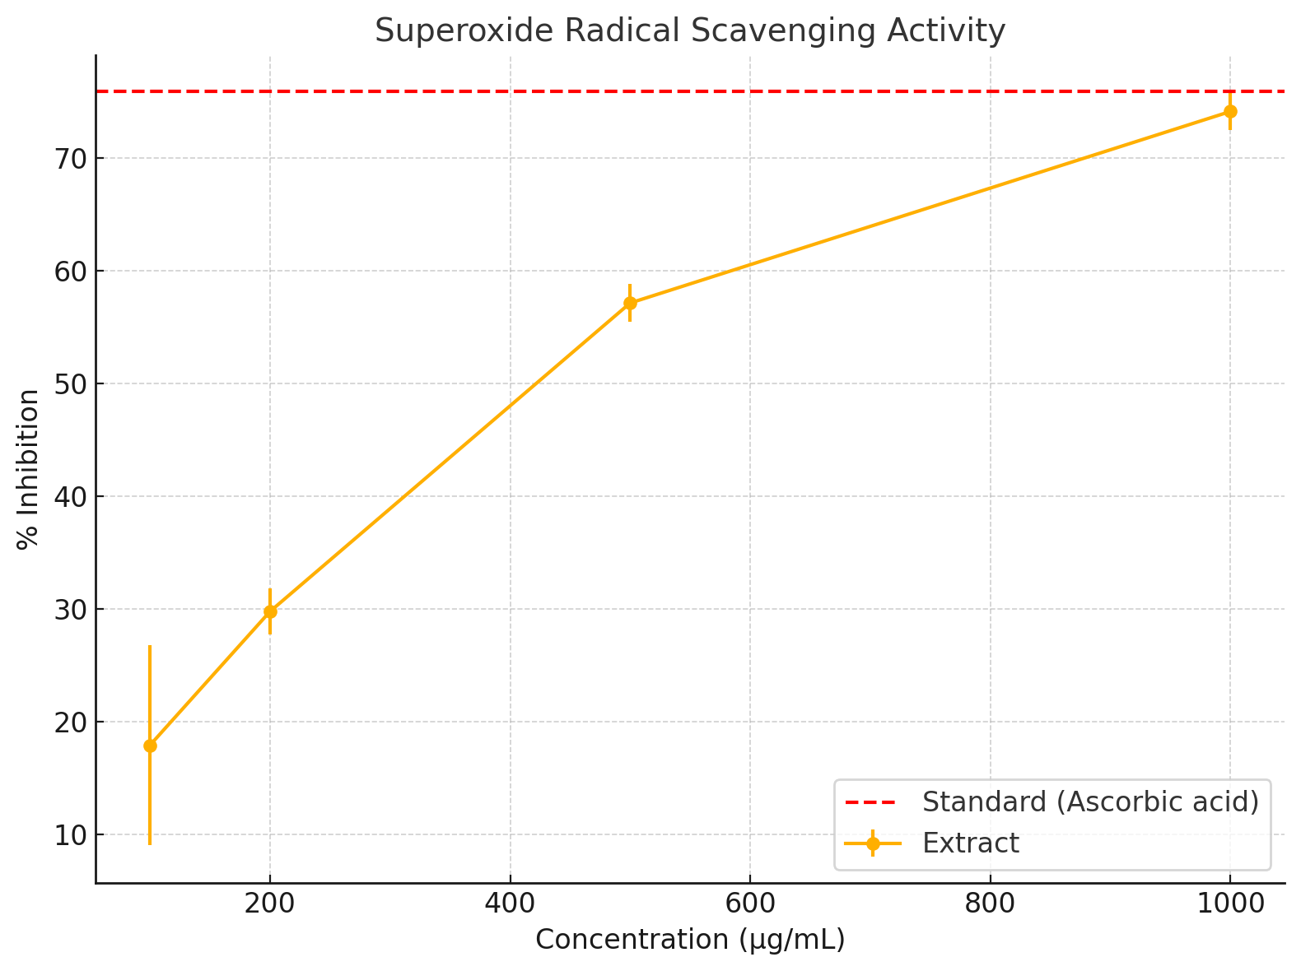

**Fig 1: Superoxide Radical Scavenging Activity**

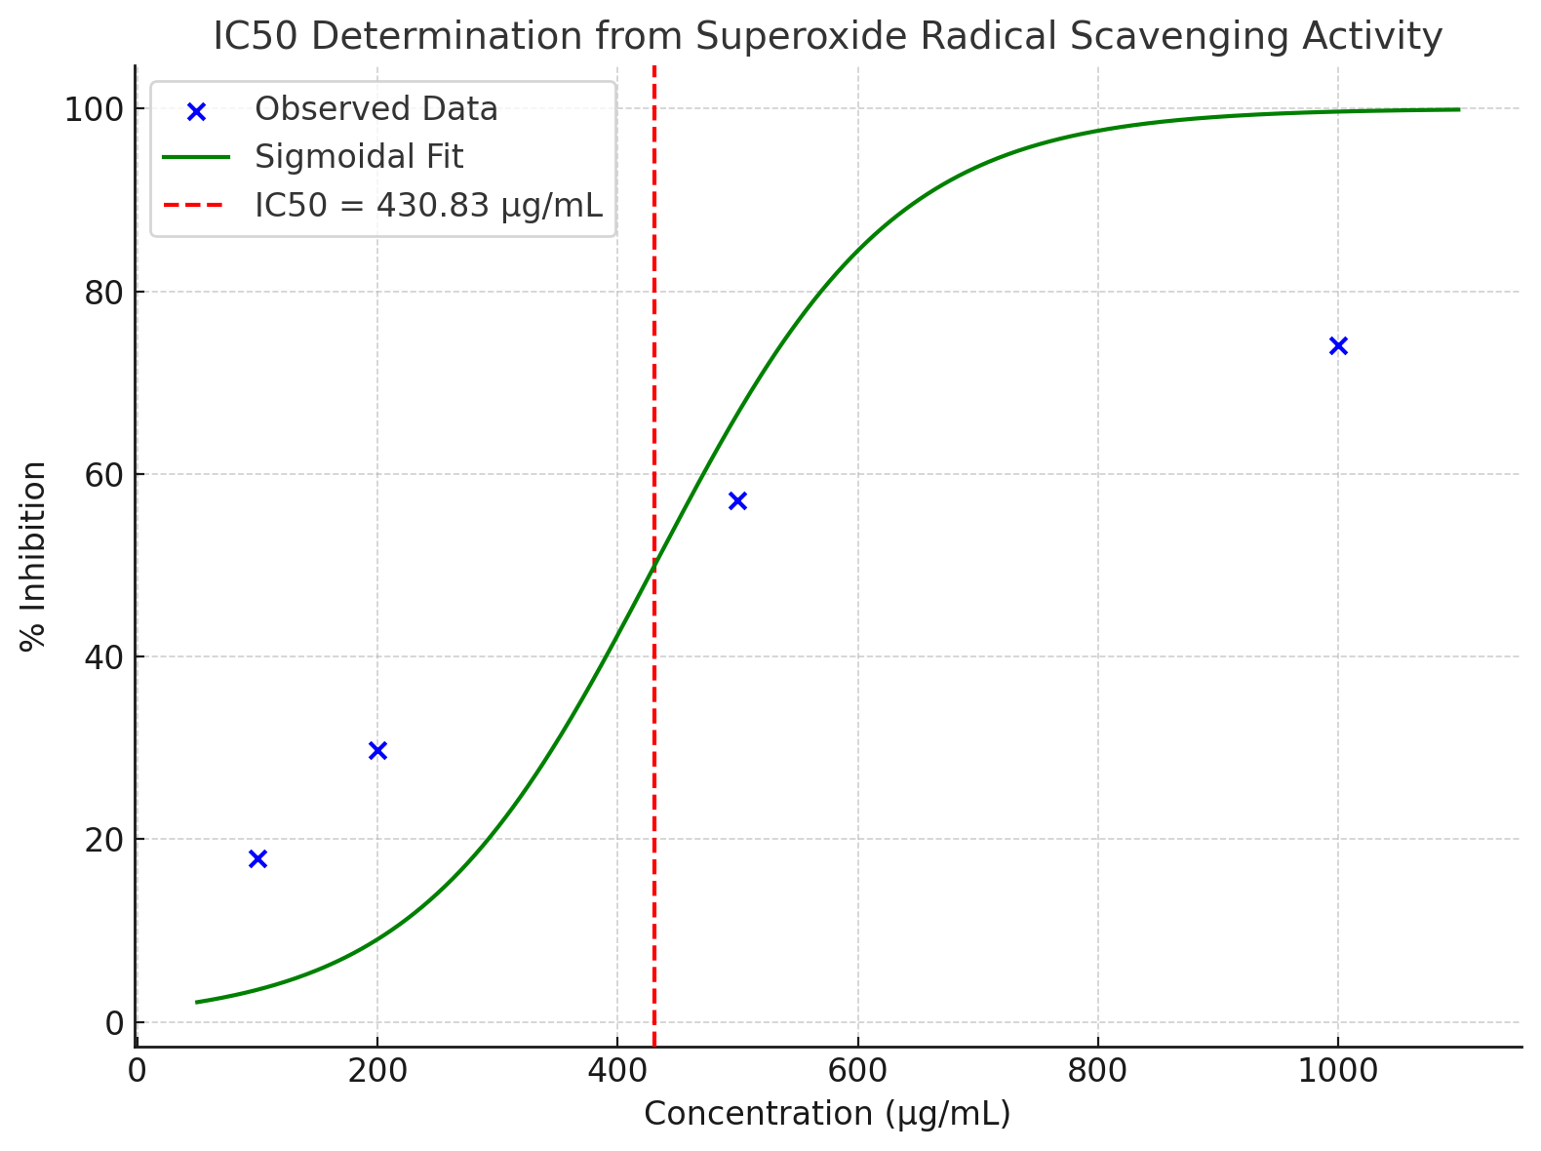

**Fig 2: IC50 Determination for Superoxide Radical Scavenging Activity**

# H2O2 Scavenging Assay

As we ramp up the extract concentration from 100 to 1000 µg/ml, we see a notable increase in the mean percentage of inhibition, which points to a better scavenging efficiency. The standard, ascorbic acid at 500 µg/ml, stands out with the highest and most reliable scavenging activity, boasting a mean inhibition of 90.59% with a standard deviation of 1.17%. This really highlights its effectiveness as an antioxidant. Interestingly, the variability in percentage inhibition is more pronounced at

the lower concentrations (like 100 µg/ml, with a standard deviation of 9.68%), but it levels out as we move to higher concentrations, showing improved consistency. At the peak concentration of 1000 µg/ml, we achieved an average inhibition of 88.50%, which is quite comparable to the standard, indicating that the extract has a robust antioxidant potential. The IC₅₀ value, derived from the fitted sigmoid curve, comes in at around 169.01 µg/ml.

**Table 4: H2O2 Scavenging Assay A0 = 0.248**

|  |  |  |
| --- | --- | --- |
| **Concentration (µg/mL)** | **Absorbance (Mean ± SD)** | **% Inhibition (Mean ± SD)** |
| 100 | 0.214 ± 0.024 a | 13.58 ± 9.68 a |
| 200 | 0.100 ± 0.016 a | 59.68 ± 6.48 a |
| 500 | 0.033 ± 0.002 a | 86.56 ± 0.62 a |
| 1000 | 0.029 ± 0.009 a | 88.50 ± 4.13 a |
| Standard (500) | 0.023 ± 0.003 a | 90.59 ± 1.17 a |

*Values are presented as mean + SD of three determinants. Superscripts in the column with different letters are statistically different (P<0.05)*

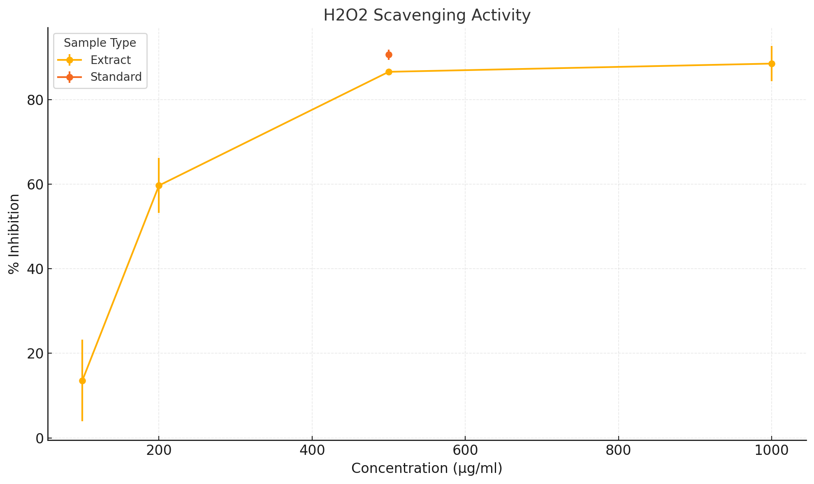

**Fig 3: H2O2 Scavenging Assay**

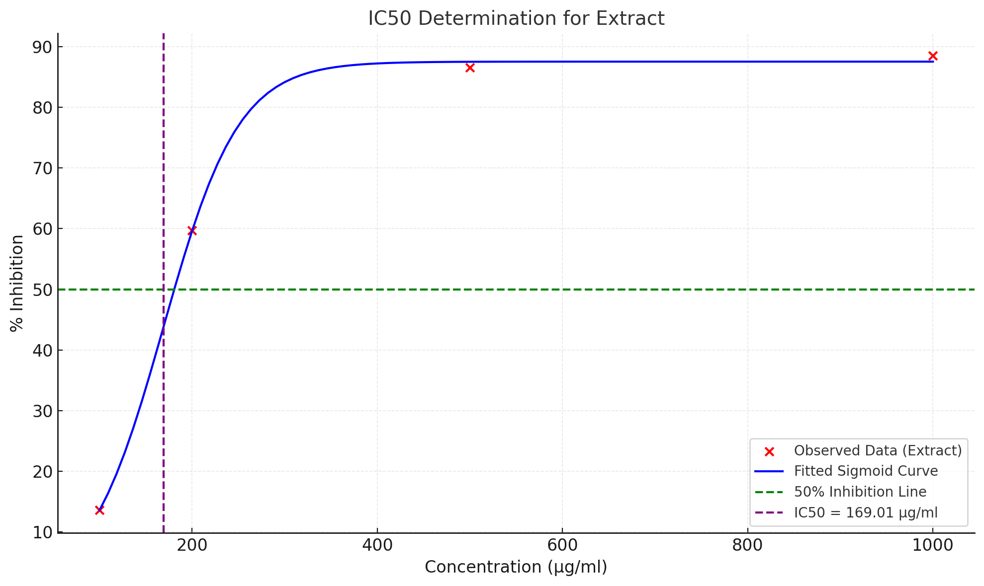

**Fig 4: IC5O Determination for the Extract**

**Nitric Oxide Scavenging Assay**

In Table 5 various concentrations ranging from 100 to 1000 µg/mL were evaluated and compared to the standard, ascorbic acid, which was set at 500 µg/mL. A clear dose-dependent increase in scavenging activity was found: the percentage of inhibition climbed from 28.48 ± 5.02% at 100 µg/mL all the way up to 67.90 ± 6.18% at 1000 µg/mL. As the concentration increased, the absorbance values dropped, which indicates that the scavenging efficiency improved. Notably, ascorbic acid stood out with the highest activity, showing a % inhibition of 72.45 ± 3.42% and a significantly lower absorbance of 0.066 ± 0.005, confirming its robust antioxidant properties. The IC₅₀ value for the nitric oxide scavenging activity was found to be around 500.64 µg/mL.

**Table 5: Nitric Oxide Scavenging Assay**

|  |  |  |
| --- | --- | --- |
| **Concentration (µg/mL)** | **Absorbance (Mean ± SD)** | **% Inhibition (Mean ± SD)** |
| 100 | 0.084 ± 0.007a | 48.55± 7.86a |
| 200 | 0.081 ± 0.006 a | 45.11± 3.61a |
| 500 | 0.101 ± 0.008a | 56.93 ± 5.49a |
| 1000 | 0.191 ± 0.015 a | 67.90 ± 6.18 a |
| Standard (500) | 0.066 ± 0.005a | N/A |

*Values are presented as mean + SD of three determinants. Superscripts in the column with different letters are statistically different (P<0.05)*

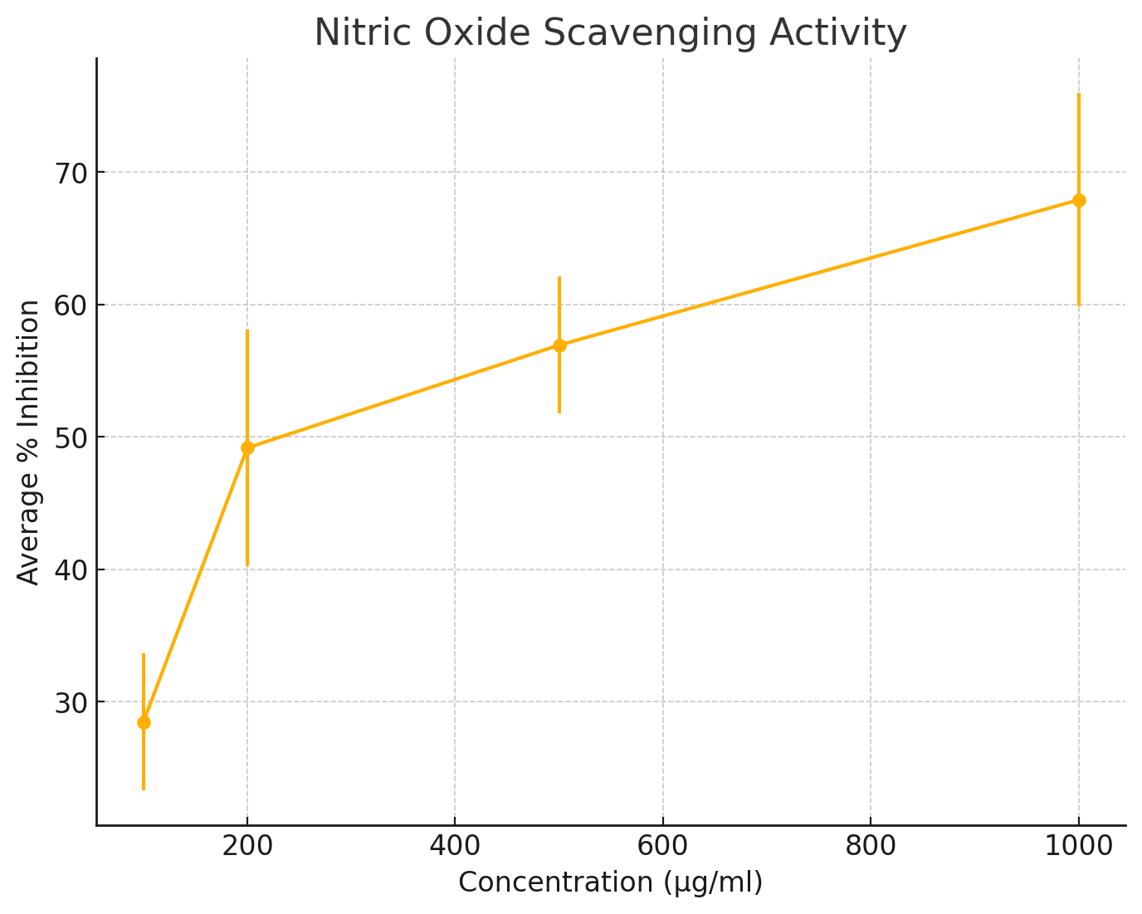

**Fig 5: Nitric Oxide Scavenging Activities**

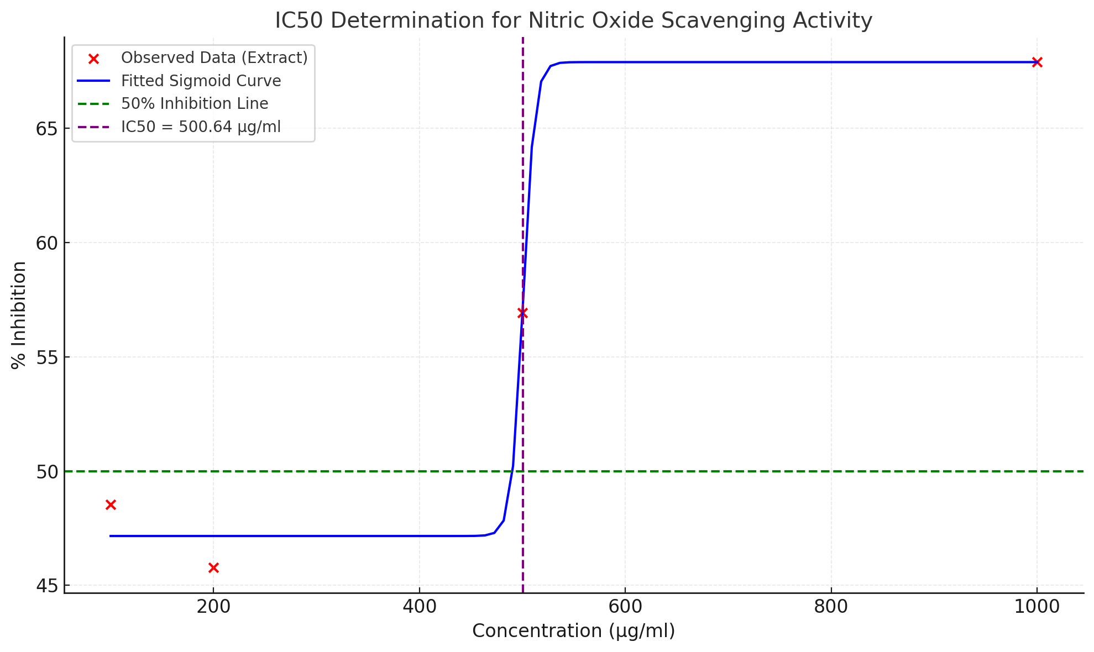

**Fig 6: IC5O Determination of Nitric Oxide Scavenging Activities**

**Discussion**

Obesity is a well-known risk factor for kidney problems, often leading to issues like glomerular hyperfiltration, electrolyte imbalances, and chronic kidney disease. In this study, obesity was induced in Wistar rats, which resulted in notable increases in serum urea, creatinine, sodium ion levels, and markers of oxidative stress-key indicators of kidney dysfunction. These results align with previous researches showing that obesity can cause kidney damage by increasing tubular reabsorption, oxidative stress, and disrupting renal blood flow (Adil et al., 2016; Dosoky & Setzer, 2018; Amber et al., 2020; Ashraf et al., 2017; Rahib et al.,2024). When the rats were given ethanolic extracts from *Citrus sinensis* (sweet orange) peels, there was a dose- dependent improvement in kidney function. The groups that received treatment showed

significantly lower levels of serum urea and creatinine, especially at medium and high doses, where their kidney markers were nearly back to normal levels. This suggests that the extract has a strong protective effect on the kidneys, supported by similar findings in other citrus fruits like *Citrus aurantifolia*, where hydroalcoholic peel extracts boosted antioxidant capacity and offered protection against toxin-induced kidney damage (Sandhiutami et al., 2024; Srivastav et al., 2021).

The improvements in kidney function are likely due to the rich array of phytochemicals found in *Citrus sinensis* peels, including flavonoids like hesperidin and naringin, polyphenols, and other antioxidants.

These compounds have powerful anti-inflammatory and antioxidant effects, which are crucial for reducing oxidative damage in kidney tissues. In the obese control group, elevated levels of malondialdehyde (MDA) and decreased activities of natural antioxidants like glutathione (GSH), superoxide dismutase (SOD), and catalase (CAT) were noted, confirming the presence of increased oxidative stress.

The treatment using orange peel extract made a remarkable difference, reversing changes and boosting antioxidant enzyme activities in a way that depended on the dosage (Durmus et al., 2024; Liu et al., 2021; Huang et al., 2022; Berroukeche et al., 2024). These antioxidant benefits are not just about enhancing kidney function; they also contribute to better metabolic health. The citrus peel extract seems to have played a role in modulating lipid metabolism, which likely helped reduce fat buildup in kidney tissues, easing the stress related to obesity. This twofold effect—fighting obesity while protecting the kidneys—aligns with earlier studies. For example, Batubara et al. (2023) found that Citrus sinensis peel extract led to significant weight loss and improved lipid profiles in obese rats. Similarly, Lee et al. (2020) and Huang et al. (2021) showed that fermented citrus peel helped combat obesity by curbing fat accumulation. Moreover, the bioactive flavonoids found in citrus peel have been shown to activate AMP-activated protein kinase (AMPK) signaling, which is vital for maintaining energy balance, reducing inflammation, and alleviating oxidative stress (Durmus et al., 2024; Li et al., 2022). This signaling pathway could explain many of the benefits observed in kidney and metabolic health. Research by Masdalena et al. (2020) supports this idea, emphasizing the protective effects of citrus peels against harmful agents in the kidneys through their antioxidant properties. Interestingly, the groups receiving medium and high doses of the extract exhibited biochemical profiles similar to those treated with standard medications, highlighting the promise of *Citrus sinensis* peel extract as a natural therapeutic option. These results are further reinforced by Berroukeche et al. (2024), who showcased significant antioxidant and metabolic health advantages of orange peel extract in obese rat models. Beyond its renoprotective and anti-obesity effects, various studies have also looked into the specific protective benefits of citrus peels for different organs.

For instance, the peel extract of *Citrus reticulata*, has been found to have protective effects on the liver against oxidative stress and damage caused by chemicals (Lee et al., 2020). This really emphasizes the wide range of benefits that come from flavonoids and phenolics found in citrus fruits. To wrap things up, this study shows that ethanolic extracts from *Citrus sinensis* peels have notable dose-dependent protective and antioxidant effects on kidney dysfunction caused by obesity in Wistar rats. These advantages come from several mechanisms, including reducing oxidative stress, restoring antioxidant defenses, influencing lipid metabolism, and possibly activating the AMPK pathway. These results are in line with recent research highlighting the therapeutic potential of citrus peels in addressing obesity and its related issues (Winda et al., 2023; Lu et al., 2023).

**Conclusion**

Considering the global challenge of obesity and its related health problems, particularly kidney disease, this study points to *Citrus sinensis* peel extract as a promising natural option for alleviating kidney dysfunction linked to obesity. Future research, including histopathological studies, molecular pathway investigations, and clinical trials, is essential to confirm and expand on these findings.

Disclaimer (Artificial intelligence)

Option 1:

Author(s) hereby declare that NO generative AI technologies such as Large Language Models (ChatGPT, COPILOT, etc.) and text-to-image generators have been used during the writing or editing of this manuscript.

Option 2:

Author(s) hereby declare that generative AI technologies such as Large Language Models, etc. have been used during the writing or editing of manuscripts. This explanation will include the name, version, model, and source of the generative AI technology and as well as all input prompts provided to the generative AI technology

Details of the AI usage are given below:

1.

2.

3.

**References**

Adil, M., Kandhare, A. D., Dalvi, G., Ghosh, P., Venkata, S., Raygude, K. S., & Bodhankar, S. L. (2016). Ameliorative effect of berberine against gentamicin-induced nephrotoxicity in rats via attenuation of oxidative stress, inflammation, apoptosis, and mitochondrial dysfunction. Renal Failure, 38, 996-1006.

Alatawi, K. A. and Alshubaily, F.A. (2021). Coconut products alleviate hyperglycaemic, hyperlipidimic and nephropathy indices in streptozotocin-induced diabetic Wistar rats. *Saudi Journal of Biological Sciences;* 28, Pp 4224-4231

Amber, W. S., Musa, S. A., Sambo, S. J., & Agbon, A. N. (2020). Nephroprotective effect of Citrus sinensis L. on mercury-exposed Wistar rats. Annals of Tropical Pathology, 11(2), 1-9.

Ashraf, H., Butt, M. S., Iqbal, M. J., & Suleria, H. A. R. (2017). Citrus peel extract and powder attenuate hypercholesterolemia and hyperglycemia using rodent experimental modeling. Asian Pacific Journal of Tropical Biomedicine, 7(10), 870–880.

Batubara, W. R. P., Susilawati, T. N., & Indarto, D. (2023). The potency of Berastagi sweet orange (Citrus sinensis) peel extract for obesity treatment: An experimental study in male rats. Journal of Obesity and Metabolic Research, 15(2).

Berroukeche, F., Malti, N., Touil, A., Didi, A., Mebarki, A., & Merzouk, H. (2024). In vitro antioxidant capacity, in silico study, and in vivo effects of orange peel on male obese rats. Waste and Biomass Valorization, 15, 5293–5310. https://doi.org/10.1007/s12649-024-02085-6

Cardile, V., Graziano, A. C., & Venditti, A. (2015). Clinical evaluation of Moro (Citrus sinensis (L.) Osbeck) orange juice supplementation for weight management. Natural Product Research, 15, 1–5.

Dosoky, N. S., & Setzer, W. N. (2018). Biological activities and safety of Citrus spp. essential oils. International Journal of Molecular Sciences, 19, 1-25. https://doi.org/10.3390/ijms19010025

Durmus, N., Gulsunoglu-Konuskan, Z., & Kilic-Akyilmaz, M. (2024). Recovery, bioactivity, and utilization of bioactive phenolic compounds in citrus peel. Food Science & Nutrition, 12(12), 9974–9997*.*

Fonseca, A. C. P. da, Marchesini, B., Zembrzuski, V. M., Voigt, D. D., Ramos, V. G., Carneiro, J. R. I., Nogueira Neto, J. F., Cabello, G. M. K., & Cabello, P. H. (2020). Genetic variants in the fat mass and obesity-associated (FTO) gene confer risk for extreme obesity and modulate adiposity in a Brazilian population. Genetics and Molecular Biology, 43(1), e20180264.

Hall, J.E., Henegar, J.R., Dwyer, T.M., (2004). Is obesity a major cause of chronic renal disease? Advances inRenal Replacement Therapy; 11(1):41-54. [[PubMed](https://www.ncbi.nlm.nih.gov/pubmed/14730537)]

Huang, C. H., Hsiao, S. Y., Lin, Y. H., & Tsai, G. J. (2022). Effects of fermented citrus peel on ameliorating obesity in rats fed with high-fat diet. Molecules, 27(24), 8966.

Huang, C.-H., Hsiao, S.-Y., Lin, Y.-H., & Tsai, G.-J. (2022). Effects of fermented citrus peel on ameliorating obesity in rats fed with a high-fat diet. Molecules, 27(24), 8966. https://doi.org/10.3390/molecules27248966

Kosasih, E., Chiuman, L., Lister, I. N. E., & Fachrial, E. (2019). Hepatoprotective effect of Citrus sinensis peel extract against isoniazid and rifampicin-induced liver injury in Wistar rats. Majalah Obat Tradisional, 24(3), 197–203.

Kumar, A., Mahajan, A., & Begum, Z. (2022). In-vitro Estimation of Phytochemicals & Flavonoids in Citrus sinensis & Study their Antimicrobial & Antioxidant Activity. Asian Journal of Advanced Research and Reports, **16**(9), 90–98. <https://doi.org/10.9734/ajarr/2022/v16i930503>

Lee, G. H., Peng, C., Park, S. A., Hoang, T. H., Lee, H. Y., Kim, J., Kang, S. I., Lee, C. H., Lee, J. S., & Chae, H. J. (2020). Citrus peel extract ameliorates high-fat diet-induced NAFLD via activation of AMPK signaling. Nutrients, 12(3), 673.

Li, P., Yao, X., Zhou, Q., Meng, X., Zhou, T., & Gu, Q. (2022). Citrus peel flavonoid extracts: Health-beneficial bioactivities and regulation of intestinal microecology in vitro*.* Frontiers in Nutrition, 9, 888745. https://doi.org/10.3389/fnut.2022.888745

Liu, K., Chen, Q., Liu, Y., Zhou, X., & Wang, X. (2012). Isolation and biological activities of decanal, linalool, valencene, and octanal from sweet orange oil. Journal of Food Science, 77(10), C1156–C1161.

Liu, N., Li, X., Zhao, P., Zhang, X., Qiao, O., Huang, L., Guo, L., & Gao, W. (2021). A review of chemical constituents and health-promoting effects of citrus peels. Food Chemistry, 365, 130585. https://doi.org/10.1016/j.foodchem.2021.130585

Lobstein, T., Jackson-Leach, R., Powis, J., Brinsden, H., & Gray, M. (2023). World Obesity Atlas 2023. World Obesity Federation, London.

Lu, K., & Yip, Y. M. (2023). Therapeutic potential of bioactive flavonoids from citrus fruit peels toward obesity and diabetes mellitus. Future Pharmacology, 3(1), 14–37. <https://doi.org/10.3390/futurepharmacol3010002>

Lu, Y., Xi, W., Ding, X., Fan, S., Zhang, Y., Jiang, D., Li, Y., Huang, C., & Zhou, Z. (2013). Citrange fruit extracts alleviate obesity-associated metabolic disorder in high-fat diet-induced obese C57BL/6 mice. International Journal of Molecular Sciences, 14(11), 23736–23750.

Masdalena, N., Chrismis, N. G., Edy, F., & I Nyoman, E. L. (2020). Potency of Sunkist orange (Citrus sinensis L. Osbeck) against kidney histology of white Wistar rats induced by gentamicin. Journal of Health Sciences and Medicine, 25(1), 42-48.

**Motulsky, H. (2014).** Intuitive Biostatistics: A Nonmathematical Guide to Statistical Thinking (3rd ed.) Oxford University Press  
**ISBN:** 978-0199946648

NIH. (2021). Prescription medications to treat overweight and obesity. National Institute of Diabetes and Digestive and Kidney Diseases. Retrieved October 19, 2021, from <https://www.niddk.nih.gov/health-information/weight-management/prescription-medications-treat-overweight-obesity>

Rahib, A., Karhib, M. M., Nasr, H. M., El-Sayed, R. A., Abdel-Daim, M. M., Jebur, A. B., & El-Demerdash, F. M. (2024). Citrus reticulata peel extract mitigates oxidative stress and liver injury induced by abamectin in rats. Tissue and Cell, 87, 102321.

Safaei, M., Sundararajan, E. A., Driss, M., Boulila, W., & Shapi'I, A. (2021). A systematic literature review on obesity: Understanding the causes & consequences of obesity and reviewing various machine learning approaches used to predict obesity. Comput Biol Med, 136, 104754.

Sandhiutami, N. M. D., Desmiaty, Y., Pitaloka, P. D. U., & Salsabila, S. (2024). The protective effect of hydroalcoholic Citrus aurantifolia peel extract against doxorubicin-induced nephrotoxicity. Research in Pharmaceutical Sciences, 19(5), 591–605.

Srivastava, B. D., Srivastava, M., Srivastav, S. K., Urata, M., Suzuki, N., & Srivastav, A. K. (2021). Protective effects of jamun (Syzygium cumini) seed and orange (Citrus sinensis) peel extracts against cypermethrin-induced nephrotoxicity in rats. Journal of Experimental Zoology, 34(1)

Winda, R. P. B., Tri, N. S & Dono, I. (n.d.). The potency of Berastagi sweet orange (Citrus sinensis) peel extract for obesity treatment: An experimental study in male rats. Nusantara Bioscience, 15(2), 251-257.

Young, D.S. (1995). Effect of Drugs on Clinical Laboratory Tests, 4th Ed. P.3

Zayed, A., Badawy, M. T., & Farag, M. A. (2021). Valorization and extraction optimization of citrus seeds for food and functional food applications. Food Chemistry, 355, 129609.