Original Research Article

Enhancing Colour Brightness in Barbir Fish (Puntius conchonius) trough Dietary Supplementation with Pumpkin (Cucurbita moschata) Flour

ABSTRACT

This study aimed to evaluate the effect of adding pumpkin (Cucurbita moschata) flour to commercial feed on the colour brightness of barbir fish (Puntius conchonius), as well as to determine the optimal supplementation dose for maximum colour enhancement. The experiment was conducted from October to December 2024 at the Hatchery Building 4, Faculty of Fisheries and Marine Science, Padjadjaran University. A completely randomized design (CRD) was used comprising four treatments with three replicates each: 0%, 15%, 30%, and 45% pumpkin flour inclusion. The parameters observed included changes in fish colour brightness using the Toca Color Finder (TCF), β-carotene content, absolute weight gain, survival rate, and water quality. The results indicated that a 15% inclusion of pumpkin flour yielded the highest colour brightness and β-carotene content (6.81 mg), compared the other treatments. There were no significant differences in absolute weight gain among the treatments. Water quality parameters remained within optimal ranges (temperature: 24.4-26.5°C; pH: 7.5-7.8; DO: 6.8-7.8 mg/L) supporting a high survival rate of 97-100%.

Keywords: Barbir Fish, Colour brightness, Pumpkin flour

1. INTRODUCTION
Freshwater ornamental fish is one of the fishery commodities that has the opportunity to increase the country's commerce. The price of consumer fish is determined by body weight and meat flavour, while ornamental fish which is determined by appearance [1]. Ornamental fish have their own appeal that can be measured in terms of their attractive colour, shape and physical completeness [2]. Barbir fish (Puntius conchonius) is one type of ornamental fish that is in great demand by the public because it has beautiful colours, quite aggressive and agile movements. In addition, when viewed in terms of cultivation, barbir fish are easy to cultivate because they do not require large land and capital. Barbir fish can also live in aquariums and can coexist with other fish, such as mollies because barbir fish are a type of fish that lives in the bottom and middle of the water [3]. One of the selling points of ornamental fish is determined by their attractive body colour. The brighter the colour, the higher the selling value. Bright colours in fish occur due to the presence of pigment cells (chromatophores) located in the epidermal layer. The level of colour brightness in fish depends on the amount and location of chromatophore movement [4]. Measures can be taken to enhance and maintain bright colours in ornamental fish by adding carotenoid pigment sources to the feed so as to improve and increase colour brightness because fish cannot synthesis colour pigments in their bodies, especially carotenoid pigment [5].

The addition of carotenoid pigments is needed to overcome the fading of fish colour when kept for a long time in ponds and aquariums which is often complained about by farmers and ornamental fish enthusiasts [2]. In addition, farmers often give synthetic colouring agents in feed such as synthetic astaxantin and lycantin which are considered relatively less safe for both fish health and the aquatic environment while pigment sources from natural ingredients are safer. Based on this, efforts are needed to maintain colour pigments in ornamental fish by using natural carotenoid pigment sources in feed. Natural carotenoid sources can be found in pumpkin flour [1].

Pumpkin (Cucurbita moschata) is a type of fruit vegetable that has high durability and a source of vitamin A because it is rich in carotene, besides other nutrients such as carbohydrates, protein, minerals and vitamins. The carotene content in pumpkin is very high at 180.00 SI [6]. High carotene content and complete nutrition, pumpkin is used as a source of natural pigments in the manufacture of fish feed or pellets that aim to increase the brightness of the colour. However, as a source of natural pigments used in commercial feed, it still needs to be biologically tested on barbir fish, this research needs to be done to determine the optimal dose of pumpkin flour addition to feed on the level of colour brightness of barbir fish.
2. material and methods

This research was carried out in October to December 2024 for 60 days. The research location was located in Hatchery Building 4, Faculty of Fisheries and Marine Science, Padjadjaran University, Jatinangor. Testing of β-carotene content in pumpkin flour was conducted at PT. Saraswanti Indo Genetech Laboratory located in Bogor.

The tools used for the research are, aquarium (40x30x20 cm³), aeration installations, Toca Color Finder, digital scales, hose, thermometer, pH meter, DO meter, zip lock plastic, stationery, scoop, and jar. The materials used are barbir fish with an average length of 4-5 cm and a weight of ±2 grams as many as 120 fish, Prima Feed (PF) 500 commercial feed, pumpkin flour, and egg white.

2.1 Research Design

The research method used is an experimental method using a completely randomised design (CRD) using four treatment and three replicates. The treatments given in the experiment are as follows: A (control, 0gr/100 pellets), B (15 gr/85 gr pellets), C (30 gr/70 gr pellets), D (45 gr/55 gr pellets). The treatment feed given as much as 5% of the total biomass and is given twice a day.
2.1.1 Implementation of Research

The research was carried out for 60 days. Measurements of water quality, fish weight and colour intensity were taken every 10 days. Colour intensity was measured using the Toca Colour Finder (TCF) by five panelists who were not colour blind. Water quality maintenance was carried out by changing the water every two days. The parameter used during the research were as follow:

- Colour Brightness Level

Brightness measurement using the assessment method by determining the colour scale of the test fish based on the TCF colour standard compared to the colour of the test fish. Colour measurement on fish included body, pectoral and caudal fins.

Table 1. TCF Colour Scale Used in the Research

Colour Scale | TCF Picture
1 | 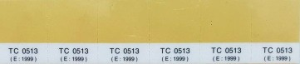
2 | 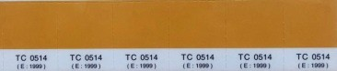
3 | 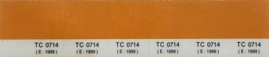
4 | 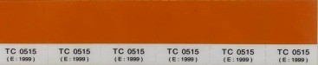
5 | 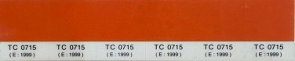
6 | 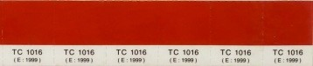
7 | 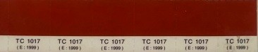

Scoring starts from the smallest score of 1 to the largest score of 7 with colour gradations from faint yellow to dark red. How to use the Toca Color Finder is to focus on colours that are close to the body colour of the test fish.

- Beta Carotene Content

Analysis of β-carotene content was conducted at Saraswanti Indo Genetech Laboratory, Bogor, referring to AOAC method 938.04 (2005). The procedure for analyzing beta carotene content follows, a standard series of β-carotene was prepared with six concentration points. Weigh the solid test portion or pipette the liquid test portion into a container, then KOH solution in methanol was added, and heated in a water bath for saponification. After cooling, the mixture is transferred to a separatory funnel and rinsed with aquabides, then extracted using non-polar solvents three times. The organic phase was collected and if required, diluted. The extraction results were evaporated to dryness, then reconstituted the residue with mobile phase solution into a volumetric flask and homogenized. The solution was filtered using a 0.45 μm syringe filter, put into a vial, and analyzed using HPLC.
- Absolute weight growth

Measurement of fish weight growth was carried out every 10 days. Measurements were made by weighing all fish in the container to obtain the total weight of barbir fish using digital scales. This absolute weight gain was calculated using the formula [7].

Wm = Wt - Wo
Information:

Wm = Absolute weight growth (g)
Wt = Final body weight (g)
Wo = Initial Body Weight (g)

- Survival Rate

Survival rate is the level of comparison of the number of fish that live from the beginning to the end of the study. Calculation of survival is done at the end of the treatment with the formula [8].
SR = $\frac{N_{t}}{N_{0}}$ x 100%

Information:

SR = Survival rate (%)
Nt = Final number of fish
N₀ = Initial number of fish

- Water Quality

Water quality parameters were observed every ten days including temperature, DO (Dissolved Oxygen) and pH measurements. The measuring instruments used were thermometer, DO-meter, and pH-meter. The analyzed water samples were taken from the fish rearing containers.

2.2 Data Analysis

Colour brightness observation data were analyzed using Kruskal-Wallis test. Fish absolute weight growth and survival rate data were analyzed with Analysis of Variance (ANOVA) using the F test with a confidence level of 95% and if there is a significant difference, the Duncan Multiple Range Test will be continued.

3. results and discussion

3.1 Color Brightness Level

Colour brightness measurements were carried out during 60 days of research with sampling every 10 days. Based on the observation results, there was an increase in the brightness of the body colour of barbir fish in all treatments after adding carotenoid sources of pumpkin flour in the feed. At the beginning of the research before being treated, barbir fish had a pale
yellow body colour with a light yellowish orange fin colour while after being treated at the end of the research the body colour was orange with a reddish fin colour (Fig.1). The results of Kruskal-Wallis Test Analysis showed that the addition of pumpkin flour for 60 days had a significant effect (P<0.05) on the increase in colour brightness of barbir fish. The highest colour improvement was obtained with the addition of 15% pumpkin flour (treatment B) with a TCF score of 4.3 on the body; 4.5 on the tail fin; and 4.6 on the pectoral fin.

A | B | C | D
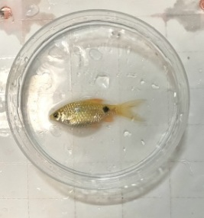 | 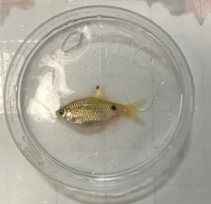 | 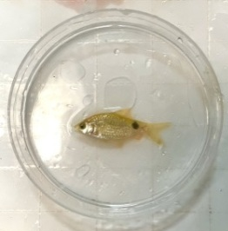 | 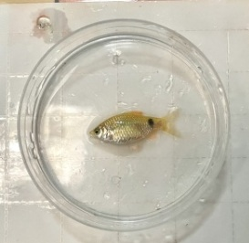
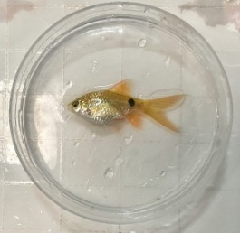 | 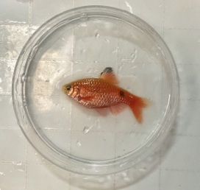 | 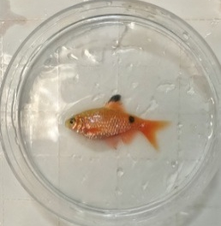 | 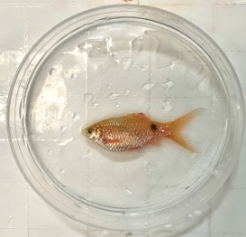
Fig.1. Visual Observation of Brightness Level of Barbir Fish; Before treatment addition pumpkin flour of Day 0 (top) and After treatment addition pumpkin flour of Day 60 (bottom).
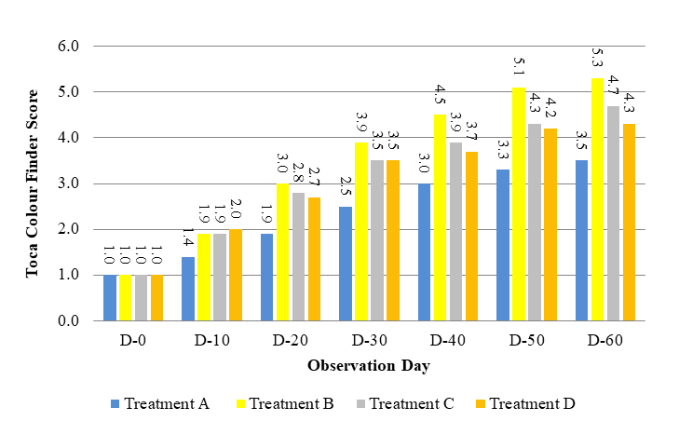
Fig. 2. Average increase in colour brightness of barbir fish body parts based on TCF score from day 0 to day 60.
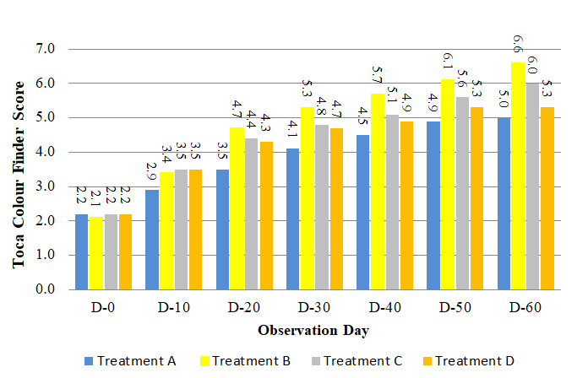
Fig. 3. Average increase in colour brightness of barbir fish caudal fin parts based on TCF score from day 0 to day 60.
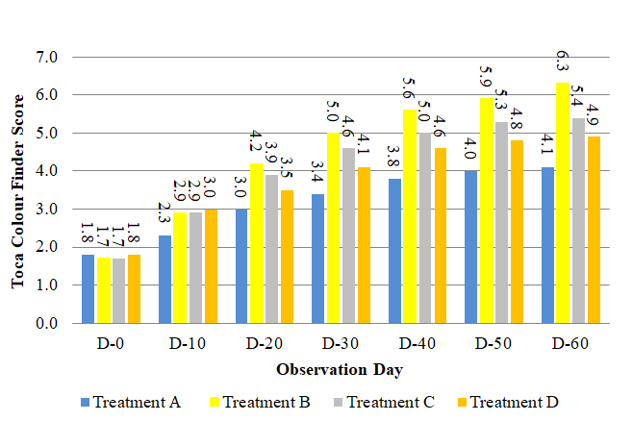
Fig. 4. Average increase in colour brightness of barbir fish body parts based on TCF score from day 0 to day 60

3.1.1 Increased Color Brightness on the Body

The observation results show that there is an increase in color brightness on the body of barbir fish. Each treatment shows a different increase in color brightness. Based on graph of change colour brightness on the body (Fig. 2), the highest and most effective colour change to increase the colour in the body of barbir fish was treatment B (15%), with an average value of 5.3 and the lowest was treatment A (0%) with an average value of 3.5 at the end of the observation. On day 10, the average test fish had already experienced a change towards a brighter colour and continued to increase until day 60 in all treatments. The increase in colour brightness in treatment B was higher than in treatments A, C, and D. The high increase in colour in treatment B is due to the dose of pumpkin flour given in accordance with the needs of colour pigmentation in barbir fish so that it is effective in producing optimal colour enhancement. According to [9] the addition of carotenoid sources in commercial feed with the right dose results in metabolic processes in the digestive system not experiencing interference, so that the pigmentation process that occurs in the body runs normally.

Pigmentation resulting from the addition of carotenoids in barbir fish expressed orange colour tends to be reddish. The fish is well adapted and the chromatophore cells on its skin are optimally expressed. The yellow and red colours on the body of barbir fish come from pigments produced by erythrophore and xanthophore cells [10]. In addition, the protein content contained in the feed in treatment b is higher than in treatment C and D, as seen from the percentage of treatment B (85% feed + 15% pumpkin flour), treatment C (70% feed + 30% pumpkin flour), and treatment D (55% feed + 45% pumpkin flour), which causes cell division activity to increase, stimulating the production of MSH (Melanocyte Stimulating Hormone). These result are in accordance with those reported by Guroy [11] high levels of protein are also able to increase cell division activity so as to stimulate the production of MSH hormones that can increase the movement of chromatophore pigment granules. The chromatophore pigment granules will be dispersed into the cell which causes the cell to absorb light perfectly, resulting in an increase in the colour of the fish scales.

The low increase in colour in treatment A was due to the absence of additional pigments contained in the feed so that the increase in colour was not very significant. This phenomenon occurs because barbir fish are unable to synthesise carotenoid pigments internally. Therefore, additional efforts are needed in the form of pumpkin flour as an external source of carotenoids to help increase colour intensity. According [5] which states that aquatic animals cannot produce their own carotenoid pigments, so these pigments must be obtained through food intake. Meanwhile, in treatments C and D due to the non-optimal amount of pumpkin flour dosage given in the feed. According to [5] the application of colour pigments must be in the right dosage to produce the best colour appearance in fish. Colour pigments are only needed in sufficient quantities, according to the ability of colour regulatory cells in fish, excessive administration of pigment substances will be removed by the fish body [12].
3.1.2 Increased Color Brightness on the Caudal Fin

The observation results show that there is an increase in color brightness on the caudal fin of barbir fish. Each treatment shows a different increase in color brightness.

Based on graph of change colour brightness on the caudal fin (Fig. 3), at the beginning of the observation until the 50th day observation, it can be seen that all treatments experienced an increase in color brightness on the tail fin of barbir fish, but on the 60th day observation, treatment D did not show an increase in color brightness, the TCF score value on the 60th day observation resulted in a value that remained the same as the observation value on the 50th day. This is thought to be due to fish have a maximum limit in digesting carotenoids. Excess carotenoids will be slowly absorbed by the fish body so that it will be excreted through feces. Giving excessive doses of carotenoids cannot be digested properly by fish and can affect hormone performance [13]. The addition of carotene to the feed has a maximum limit, meaning that if carotenoid pigments are added to the feed in excessive amounts, the saturation point will not provide better color changes and may even reduce the color value [14].

At the saturation point of pigment absorption in chromatophore cells, fish will respond physiologically to maintain the balance of homeostasis so that there will be negative feedback inhibition that lowers the hormone MSH (Melanocyte Stimulating Hormone). According to [15] hormone levels in the blood are regulated by a homeostatic mechanism called negative feedback. In conditions of continuous excessive pigment concentration, the pituitary gland will receive a signal to inhibit the production of pigmentation hormone. Hormones are generally transported in body fluids, and the amount of certain hormones circulating in the body will be adjusted [16]. The addition of excessive pigment sources can indirectly cause the performance of the hormone MSH (Melanocyte Stimulating Hormone) related to color pigmentation to decrease, so that the fish body's response to pigments also decreases. MSH (Melanocyte Stimulating Hormone) hormone functions as a trigger for the movement and distribution of pigments in chromatophores. The pigment granules will be dispersed into the chromatophore cells, which causes the cells to absorb light perfectly, resulting in an increase in the color of the fish scales [11].

3.1.3 Increased Color Brightness on the Pectoral Fin

The observation results show that there is an increase in color brightness on the pectoral fin of barbir fish. Each treatment shows a different increase in color brightness. Based on graph of change colour brightness on the pectoral fin (Fig 4), all treatments at the beginning to the end of the study experienced an increase in color brightness on the pectoral fins of barbir fish. The difference in color increase in each treatment is thought to be due to differences in the dose of pumpkin flour added to the feed. According to [17] the increase in color in each treatment is caused by differences in the level of fish absorption of the type and amount of carotenoids given. Treatment A (control) showed the lowest results, presumably because there was no addition of pumpkin flour in the feed, but the increase in color in treatment A is thought to occur because in commercial feed there is another source of carotene, namely fishmeal so that it indirectly slightly affects the color change in barbir fish. The commercial feed used as test feed contained other sources of carotenoids, namely β-carotene from fishmeal which causes fish to become appetite but has no effect on color change [18]. The addition of fishmeal indirectly slightly affects the color change in koi fish [19].

3.2 Beta Carotene Content
Beta carotene is a pro-vitamin A that is converted into vitamin A. Beta carotene is an orange/yellow pigment that is very abundant in plants and fruits [20]. Based on the analysis of β-carotene content of pumpkin flour that has been done at Saraswanti Indo Genetech laboratory, the results can be seen in Fig 5.

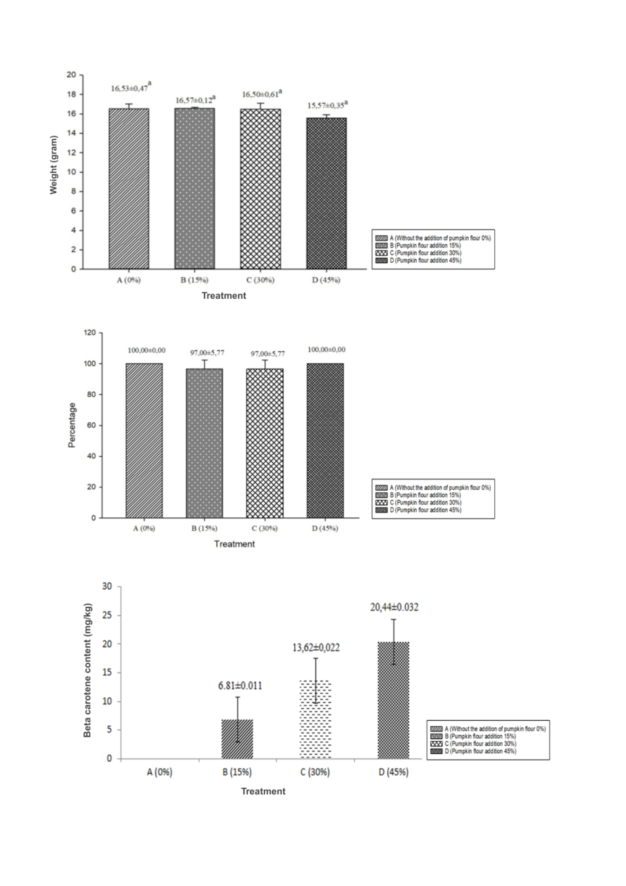
Fig. 5. Average Beta Carotene Content
Analysis of β-carotene content in pumpkin flour with the addition of 15 grams in treatment B contained β-carotene levels of 6.81 mg/kg, the addition of 30 grams in treatment C contained 13.62 mg/kg and the addition of 45 grams in treatment D had a result of 20.44 mg/kg. According to [21] carotenoids are compounds that form various colour pigments such as yellow, orange, and red. One type of carotenoid found in pumpkin flour is β-carotene, which is known to have an orange colour. This compound plays a role in colour enhancement in barbir fish, as the organism is unable to produce colour pigments independently, thus requiring additional intake of carotenoid-containing ingredients. Treatment A showed no results of β-carotene levels due to the absence of added pumpkin flour in the feed.
3.3 Absolute Weight Growth

Absolute weight growth is a supporting parameter observed to determine the effect of pumpkin flour added to artificial feed on the growth of barbir fish. The results of the ANOVA (Analysis of Variance) F test at the 95% confidence level, showed that the addition of pumpkin flour for 60 days on the absolute weight growth of barbir fish in each treatment did not significantly affect the absolute weight growth (Fig 6). According to [1] the addition of carotenoids to feed has no effect on the growth of ornamental fish fed with carotene source feed. Fish are thought to utilize the carotenoids more to improve their body color. The use of 15% pumpkin flour is the best treatment on absolute weight growth even though the results of the analysis of variance stated that the results of growth data between the control treatment, 15% pumpkin flour, 30% pumpkin flour, and 45% pumpkin flour on absolute weight growth did not show significant results (P>0.05), but the growth data on 15% carrot flour had the highest value on absolute weight growth, which was 16.57 grams.

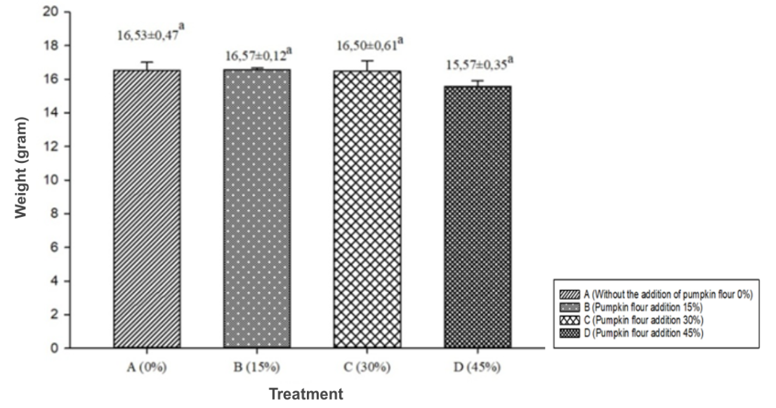

Fig. 6. Average Absolute Weight Gain of Barbir Fish

3.4 Survival Rate

Survival rate is the ratio of the number of fish at the end of the study to the number of fish at the beginning of the study. Observations were made every day by looking at the number of fish that lived until the end of the study. Based on the survival rate graph (Fig. 6), each treatment has varying survival rates. The highest survival rate during maintenance was in treatments A and D which was 100%, then the lowest survival rate was in treatments B and C which was 97%. This is because in treatments B and C there was 1 dead fish which was suspected to be stressed during sampling to become the object of panelists. The high survival rate of barbir fish in this study was due to optimal container preparation, acclimatisation process that went well, consistent feeding, and maintenance of stable water quality. Fish survival is influenced by biotic and abiotic influences [22]. One of the biotic factors that affect fish survival is human handling and abiotic factors are environmental quality.

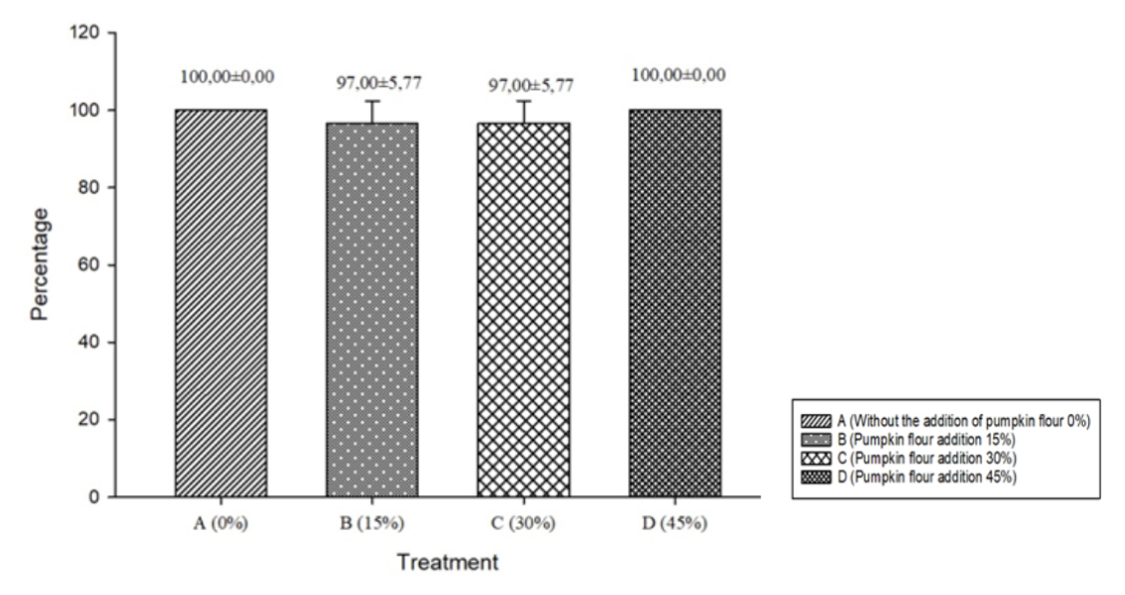
Fig. 7. Average Survival Rate of Barbir Fish
3.5 Water Quality

Water quality in ornamental fish farming is crucial. Water quality measurements are carried out to monitor the quality of fish farming feasibility and aim to determine the feasibility of the environment both physically and chemically. Water quality parameters measured in this study include temperature, dissolved oxygen, and pH. Water quality measurements were taken every 10 days during the study. The range of water quality in barbir fish rearing media for 60 days showed results that were not too fluctuating. The average value of water quality can be seen in Table 2.

Table 2. Water Quality Range During The Research

Water Quality | Oservation Result
Temperature (°C) | 24°-26°
pH | 7,5-7,8
DO (mg/L) | 6,8-7,8

The value of the water quality range of each treatment did not experience significant diffence because the four treatments were carried out in the same place and environmental conditions. Water quality in this research is still within the limits of feasibility because the maintenance media is carried out periodically so that water quality can be maintained. The water temperature in the fish rearing media obtained is in the range of 24.4-26.5°C. The temperature range is included in the optimal temperature range for survival and growth of barbir ranging from 24-30°C [23]. The pH value of the fish rearing media obtained is in the range of 7.5-7.8. The pH range that is suitable for the survival of tropical fish, including barbir fish, ranges from 7-8.5 [23]. Dissolved oxygen levels in fish rearing media obtained are in the range of 6.8-7.8 mg/L. The dissolved oxygen level is still within the tolerance limit for barbir fish rearing. Dissolved oxygen value for fish life and growth is >5 mg/L [23].

4. Conclusion

The best increase in colour brightness was found in the addition of 15% pumpkin flour (treatment B) in the feed which gave a significant increase compared to other treatments. Providing beta-carotene levels in treatment B of 6.81 mg provided the best increase in colour brightness compared to other treatments. The addition of pumpkin flour in the feed did not show a significant effect in each treatment on absolute weight growth by producing an average weight growth of 15.57-16.5 grams and producing a survival rate of 97-100%.
DISCLAIMER (ARTIFICIAL INTELLIGENCE)
Author(s) hereby declare that NO generative AI technologies such as Large Language Models (ChatGPT, COPILOT, etc) and text-to-image generators have been used during writing or editing of manuscripts

REFERENCES

1. Nazhira, S., Safrida, & Sarong, M. A. (2017). The Effect of Adding Yellow Pumpkin Flour (Cucurbita moschata D.) in Artificial Feed on the Color Quality of Goldfish (Carassius auratus). Scientific Journal of Students of the Faculty of Teacher Training and Education, Unsyiah. 2(2): 1–12
2. Lesmana, D.S. (2009). Caring for Ornamental Fish at Home. Penebar Swadaya. Jakarta
3. Susanto, H., & Lingga, P. (1989). Freshwater Ornamental Fish. Penebar Swadaya.
4. Rosid, M. M., Indah Anggraini Yusanti, and D. M. (2019). Growth Rate and Color Brightness of Comet Fish (Carassius auratus) With the Addition of Spirulina sp. Flour Concentration in Feed. Journal of Fisheries Sciences and Aquaculture. 14(1), 37–44.
5. Amin, F., Rahimi, S. A. E., & Mellisa, S. (2019). The Effect of Spirulina Addition to Feed on the Color Intensity of Mickey Mouse Platy Fish (Xiphophorus maculatus). Scientific Journal of Marine and Fisheries Students, Unsyiah. 4(3): 152–160.
6. Lestari, A. R. 2011. The Effectiveness of Glycerol Monostearate (GMS) on the Quality of Yellow Pumpkin Donuts. . Faculty of Industrial Technology, East Java Veteran National Development University. Surabaya.
7. Effendie, M.I. (1997). Fisheries biology. Nusatama Library Foundation. Yogyakarta.
8. Muchlisin, Z.A., A.A. Arisa, A.A. Muhammadar, N. Fadli, I.I Arisa and M.N. SitiAzizah. (2016). Growth performance and feed utilization of keureling (Tor tambra) fingerlings fed a formulated diet with different doses of vitamin E (alpha-tocopherol). Archives of Polish Fisheries, 23: 47–52.
9. Putri, E. N. A., Sumaryam, Muhajir, Hayati, N. (2024). Effect of Addition of Papaya (Carica Papaya L.) Fruit Flour Dose in Commercial Feed on the Brightness Level of Color of 8 Cm Koi (Cyprinus Carpio) Seeds at Candra Kirana Farm. Juvenil. 5(1): 21-26
10. Hawkes, J. W. (1974). The structure of fish skin - II. The chromatophore unit. Cell and Tissue Research, 149(2), 159–172.
11. Güroy, B., Şahin, I., Mantoǧlu, S., & Kayali, S. (2012). Spirulina as a natural carotenoid source on growth, pigmentation and reproductive performance of yellow tail cichlid Pseudotropheus acei. Aquaculture International, 20(5), 869–878.
12. Shiang, T.P. (2006). Skin Color Change in Ornamental Koi Cyprinus Carpio Fed With Different Dietary Carotenoid Source. University of Malaysia. Malaysia.
13. Kurniawati, Iskandar, Subhan U. (2012). Effect of Spirulina platensis flour addition to feed on increasing the color of red huna freshwater lobster (Cherax quadricarinatus). Journal of Fisheries and Marine Sciences 3(3): 157-161
14. Haerawati and Sambara, P. M. (2024). Effectiveness of Addition of Red Dragon Fruit Peel Carotenoids to Artificial Feed on Koi Fish Performance. Journal of Indonesian Tropical Fisheries (JOINT-FISH): Journal of Aquaculture, Capture Fisheries Technology and Management and Marine Science. 7(1):85-95
15. White, L., Duncan, G., & Baumle, W. (2013). Integrated Approach (3rd ed.). Clifton Park, USA: Delmar, Cengage Learning.
16. Smeltzer, S. C., Hinkle, J. L., Bare, B. G., & Cheever, K. H. (2010). Brunner & Suddarth’s textbook of medical-surgical nursing (12th ed., p. 1828). Philadelphia: Lippincott Williams & Wilkins.
17. Solihah, R., Buwono, I. D., and Herawati, T. (2015). Effect of Pumpkin Flour and Shrimp Head Flour on Improving the Color Quality of Goldfish (Carrasius auratus). Journal of Marine Fisheries, 2(1):107-115.
18. Widinata, E., K. Muslih, and A. Kurniawan. (2016). Effect of Giving a Combination of Marigold Flower Extract (Tagetas erecta) and Rebon Shrimp (Acetes) in Feed on the Brightness of the Color of Koi Fish (Cyprinus carpio carpio). Aquatic. Journal of Aquatic Resources, 10(2): 62 – 71.
19. Gunawan, A. (2005). Effect of Giving Spinach Leaf Extract in Artificial Feed on the Level of Color Change of Koi Fish Seeds (Cyprinus carpio) Type Kohaku. Department of Fisheries. Faculty of Agriculture. Padjadjaran University.
20. Subawati, R. (2009). Oxidation of Carotene Compounds in Oil Palm Fruit. Ma Chung University. Malang
21. Noviyanti, K., Tarsim, H.W. Maharani. (2015). Effect of Addition of Spirullina Flour to Artificial Feed on the Color Intensity of Goldfish (Carassius auratus). Journal of Aquaculture Engineering and Technology. 3(2): 411-416.
22. Herlina, S. (2016). Effect of Giving Different Types of Feed on the Growth and Survival of Snakehead Fish (Channa striata) Seeds. Faculty of Fisheries and Marine Sciences, Aquaculture Study Program, Darwan Ali University. Seruyan Regency. Journal of Tropical Animal Science. 5(2).
23. Santhosh, B. and Singh, N. P. (2007). Guidelines for water quality management for fish culture in Tripura, ICAR Research Complex for NEH Region, Tripura Centre, Publication no. 29.

