Nutritional Growth Enhancement of G4 Transgenic *Mutiara* Catfish (*Clarias gariepinus*) Broodstock Candidate Using Mixed Feed

# ABSTRACT

Transgenic mutiara catfish inserted with an additional gene (*CgGH*) exhibit faster growth compared to non-transgenic *mutiara* catfish. This potential for rapid growth also needs to be supported by proper nutrition. This study aimed to determine the optimal feed dosage using a mixture of HI-PROVITE 781 pellets and boiled tuna (*Euthynnus affinis*) flakes to evaluate growth efficiency and feed cost efficiency in sub-adult size G4 transgenic Mutiara catfish (5 months old) as they approach broodstock size. The research used a Completely Randomized Design (CRD) with 4 treatments and 3 replications. The treatments consisted of different doses of HI-PROVITE 781: treatment A (2.5%), B (2%), C (1.5%), and D (2.5% as control: non-transgenic *mutiara* catfish), based on the biomass weight of the test fish. Additionally, 10 g of boiled tuna flakes were added to each treatment for 42 days. The observed parameters included average weight gain (AWG), feed convertion ratio (FCR), and feed cost. The results showed that the best feed mixture of HI-PROVITE 781 pellets and boiled tuna flakes was found in treatment B (2% dose + 10 g), with an average weight gain of 1,515.00 g ± 422.26 g (3.35 times increase); FCR of 1.14 ± 0.11; feed cost of IDR 17,944.32 and the highest net income from feed at IDR 76,905.68

*Keywords: Broodstock*, *FCR*, *Cost*, *Growth*, *Mixed Protein*, *Transgenic Fish*

# INTRODUCTION

*Mutiara* catfish (*Clarias gariepinus*) is a superior strain of African catfish developed by the Fish Breeding Research Center in Sukamandi, Indonesia. This strain was produced through crossbreeding four African catfish strains commonly found in Indonesia—Egyptian, Paiton, Sangkuriang, and Dumbo—followed by three generations of individual selection focused on growth rate improvement. It is well known for its rapid growth (20–70% faster) and high feed efficiency compared to other local catfish strains [1]. However, the superior growth trait of *mutiara* catfish has shown instability across generations, with only slight improvements observed in advanced lines.

To improve growth stability, transgenesis technology was applied by inserting the growth hormone gene (*CgGH*) from Dumbo catfish into the sperm of male *mutiara* catfish. As a result, transgenic catfish exhibited significantly enhanced and more stable growth: G0 (2-3 times) [2], G1 (3 times) [3], G2 (3-4 times), G3 (2-3 times) [4], and G4 (2 times) faster growth than non-transgenic catfish, particularly from fry to market size under indoor hatchery conditions [5]. These findings indicate that the exogenous *CgGH* gene has been stably inherited from G0 to G4 generations. Other advantages of the transgenic *mutiara* catfish include higher feed intake, responsiveness to feeding, adaptability to both fresh and formulated feeds, and lower stress levels, which contribute to improved growth performance and feed efficiency compared to non-transgenic strains [6]. Consequently, the transgenic *mutiara* catfish exhibit a low *feed conversion ratio* (FCR < 1). However, the growth performance of G4 fish in the sub-adult phase toward broodstock size has not yet been adequately evaluated, particularly in terms of *average weight gain* (AWG) and FCR.

In the sub-adult phase toward broodstock size, catfish not only increase in weight and length but also begin to develop their reproductive organs. One of the critical factors for enhancing both growth and reproductive performance during this phase is the use of nutritionally rich feed, which supports reproductive potential, egg quality, and fry production [7]. In addition, the combination of different feed types can promote somatic and gonadal growth, improve overall feed quality, and reduce production costs during the transition to broodstock development [8]. One feed additive that has potential for use in combination with commercial pellets is boiled tuna (*E. affinis*) flakes, locally known in Indonesia as *pindang tongkol*. This fresh feed contains a high protein content (35.8%) and is well-suited for carnivorous species such as catfish [9, 10]. Optimal nutrition during sub-adult phase enhances gonad maturation and egg quality [7, 21]. In addition, the nutritional composition of fish feed, significantly affects gonad maturation leads to broodstock spawning [1, 8].

High-quality feed and proper feed management are crucial in aquaculture, as they contribute to optimal growth and reduce feeding costs. Feed should be delivered efficiently with regard to type, amount, schedule, and method—adjusted to match the fish's needs and feeding behavior [11]. However, the optimal feed dosage for G4 *mutiara* catfish during the sub-adult phase remains unclear. Therefore, determining the appropriate dosage is essential for maximizing growth at this stage [12]. Precise feed dosing improves utilization, prevents overfeeding or underfeeding, maintains water quality, promotes efficient growth, and reduces operational costs [13]. **Stable GH expression in G4 supports long-term use of transgenic broodstock**

Based on these considerations, this study aimed to evaluate the growth performance and FCR of G4 transgenic *mutiara* catfish during the sub-adult phase toward broodstock size using mixed feeds with different dosage levels.

1. **MATERIALS AND METHODS**

This research was conducted from July to September 2022 for a duration of 42 days at the Hatchery Laboratory, Building 4, Faculty of Fisheries and Marine Sciences, Universitas Padjadjaran, Jatinangor. The tools used in this study included round fiberglass tanks with a diameter of 135 cm and height of 105 cm, aeration installation, water heater (Atman), DO meter (Lutron), pH meter (Lutron), thermometer (Lutron), trash bags for covering tanks, label paper, scoop net, bucket, Camry digital scale (for weighing fish), styrofoam (as a base for measuring fish), 60 cm ruler, cloth (to limit fish movement), Scout Pro digital scale (for weighing feed), plastic plates (for feeding), refrigerator (for preserving skipjack tuna), rice cooker (for heating boiled tuna (*E. affinis*)), aerator installation, phone camera, and stationery. The materials used were transgenic mutiara catfish and nontransgenic *mutiara* catfish (5 months old), commercial feed (HI-PRO-VITE 781) and boiled tuna (*E. affinis*) flakes.

**2.1 Research Design**

This study employed an experimental method using a CRD consisting of four treatments and three replications. The aim of the study was to evaluate the effect of a mixed feed consisting of commercial feed HI-PRO-VITE 781 and an additional 10 grams of boiled tuna (*E. affinis*) flakes per day. The treatments differed in the dosage of commercial feed administered. Treatments A, B, and C involved transgenic *mutiara* catfish, with feed dosages of 2.5%, 2%, and 1.5% of total biomass, respectively. Treatment D involved non-transgenic *mutiara* catfish, receiving a commercial feed dosage of 2.5% of total biomass, and served as the control.

We hypothesized that 2% commercial feed + 10g tuna would optimize growth and cost efficiency in G4 transgenic catfish

**2.1.1 Preparation for implementation**

The study was conducted in an indoor hatchery using four round fiberglass tanks (135 cm in diameter, 105 cm in height) as treatment units. Each tank was filled with 50 cm of water and equipped with continuous aeration and a heater set at 28°C. A total of 48 five-month-old *mutiara* catfish were used, with 12 fish (6 pairs) per tank. Treatments A, B, and C contained G4 transgenic *mutiara* catfish, while treatment D consisted of non-transgenic fish as a control. Tanks were covered with black plastic to prevent fish from jumping and to maintain low-light conditions, and each was labeled according to its assigned treatment.

Fish were fed commercial HI-PRO-VITE 781 pellets supplemented with 10 g of boiled tuna (*E. affinis*) daily. Feeding of test fish 2-3% of biomass weight [1]. However, preliminary tests showed high feed waste at that range. When adjusted to 2.5%, feed waste decreased significantly; thus, 2.5% was used as the maximum feeding rate.

**2.1.2 Implementation of research**

The study was conducted for 42 days with observations every 7 days. Each tank was stocked with 12 fish per tank (mixed sex, 6 males + 6 females), individually weighed prior to stocking to determine initial biomass. Feed consisted of HI-PRO-VITE 781 pellets administered according to the treatment dose (A: 2.5%; B: 2%; C: 1.5%; D: 2.5%), with an additional 10 g of boiled skipjack tuna per day for all treatments. Feeding was carried out twice daily (at 09:00 and 13:00 WIB) and adjusted weekly based on weight gain. Fish were individually weighed weekly to adjust feed dosage

Water quality was measured twice a week, including pH, temperature, and dissolved oxygen (DO). The observed parameters included growth performance and feed efficiency.

2.1.2.1. Average Weight Gain

Growth performance evaluation can be interpreted through the parameter of average weight gain. This weight gain represents the average final total biomass weight gain of the fish at the end of the rearing period minus the average initial total biomass weight gain at the beginning of the rearing period [14].

AWG = Wt – Wo

Description:

AWG = Average Weight Gain (g)

Wt = Average Final Weight of total biomass (g)

Wo  = Average Initial Weight of total biomass (g)

2.1.2.2 Feed Convertion Ratio

FCR is a value that indicates how much feed is required to produce 1 kg of fish flesh. The feed convertion ratio is calculated using the following formula [15]:

$$FCR=\frac{F}{(Wt+D)-Wo}$$

Description:

FCR = Feed Convertion Ratio

F = Feed Consumed (g)

Wt = Final Biomass (g)

Wo = Initial Biomass (g)

D = Biomass Mortalities (g)

2.1.2.3 Feed Cost

In this study, the efficiency assessment focuses on two main aspects: the feed cost incurred and the net benefit derived from feed based on the revenue generated from fish sales. The revenue in this study is intended to measure the economic efficiency of feed utilization during the cultivation period, although it does not account for all other production costs (such as labor, electricity, and supporting equipment). Therefore, the calculated revenue is classified as partial profit, which refers to the income obtained after deducting feed costs.

2.1.2.3.1 Feed Cost

$$\text{FC = }\left(\text{Qhi × Chi}\right)\text{ + }\left(\text{Qpt × Cpt}\right)$$

Description:

FC = Feed Cost (IDR)

Qhi = Quantity of HI-PRO-VITE 781

feed used (kg)

Qpt = Quantity of pindang tongkol

(boiled tuna used (kg)

Chi = Feed Cost per kg of

HI-PRO-VITE 781

(IDR 11,533.00/kg)

Cpt = Feed Cost per kg of boiled tuna

(IDR 60,000.00/kg)

The price of HI-PRO-VITE 781 feed was based on the average market price of approximately IDR 346,000.00 per 30 kg sack (equivalent to ±IDR 11,533.00/kg). The boiled tuna flakes, priced at IDR 60,000.00/kg, were obtained from Resik market, Jatinangor.

2.1.2.3.2 Net Benefit from Feed

$$\text{NBP = }\left(\text{Awf × Pf}\right)\text{ - FC}$$

Description:

FC = Feed Cost (IDR)

NBP = Net Benefit from Feed (IDR)

Awf = Average final weight of fish (kg)

Pt = Selling price of fish per kilogram

(IDR 35,000.00/kg)

In this study, both transgenic and non-transgenic *mutiara* catfish were assumed to have a market selling price of IDR 35,000.00/kg, based on their post-consumption size and potential use as broodstock. This price was used as the basis for income calculation in the economic analysis.

2.1.2.4 Water Quality

During the maintenance period, water quality parameters such as pH, dissolved oxygen (DO), and temperature were measured twice a week to support optimal environmental conditions for catfish growth. Parameters measured twice weekly to capture diurnal fluctuations.

**2.2 Data Analysis**

The average weight gain and feed conversion ratio data were analyzed using one-way ANOVA. If significant differences were found among treatments, *Duncan’s Multiple Range Test* (DMRT) was applied at a 95% confidence level using SigmaPlot 15. Water quality parameters were analyzed descriptively.

1. **RESULTS AND DISCUSSION**

**3.1 Growth Perfomance Evaluation**

Observations on the average weight gain of the fish indicated that variations in feed dosage combined with the addition of 10 g of boiled tuna (*E. affinis)* per treatment had a significant effect on body weight increase in both G4 transgenic and non-transgenic *mutiara* catfish. The average weight gain and growth performance data are presented in Fig. 1 and 2. No mortality occurred; thus, D=0 in FCR calculations.

3.1.1 Average Weight Gain

Based on Duncan's post-hoc test, treatment A showed no significant difference from treatments B and C, but it was significantly different from treatment D. Treatment B was significantly deferens from both treatments C and D (Fig. 3). The average weight gain across all treatments ranged from 451.67 to 1515 g. The highest mean weight gain was recorded in treatment B (2% HI-PRO-VITE 781 + 10 g of boiled tuna flakes), while the lowest was observed in treatment D (2.5% HI-PRO-VITE 781 + 10 g of boiled tuna flakes, without exogenous genes).

The higher weight gain observed in treatment B is likely attributable to an appropriate feed dosage and the influence of genetic factors in the G4 transgenic *mutiara* catfish. Feed dosage also influenced the protein content of the feed mixture; higher initial biomass and feed dosage led to increased protein intake (Table 1).

Although treatment A received the highest feed dosage (2.5% of biomass) and protein content (37.91%), its weight gain was not significantly different from treatments B and C. This may be due to excess feed and protein not being entirely utilized for growth but instead stored in the liver as reserves, with the remainder excreted as metabolic waste in the form of feces and urine [16]. Treatment C, which had the lowest feed dosage, resulted in lower weight gain than treatment A. Its low protein content likely resulted in inadequate nutrient intake, thus impeding growth [17]. Optimal growth in fish carrying exogenous genes also requires sufficient nutrition, optimal environmental conditions, and good health status [18]. Fish fed low-protein diets exhibited lower growth performance than those receiving high-protein diets due to protein catabolism used for energy, thereby reducing the energy available for growth [19].

Growth in treatment D was significantly lower than that in transgenic treatments (A, B, and C), presumably due to the absence of the exogenous growth hormone gene (*CgGH*), which in transgenic fish plays a role in inducing protein synthesis from feed and increasing feed efficiency for growth [20].

Although treatments A and D were provided with the same feed dosage (2.5%), the protein content in treatment D was lower. Dietary protein levels below 20% are considered deficiency for growth catfish fed diets with protein levels ranging from 16% to 32% showed no significant differences in growth performance [21]. In the present study, fish in treatment A weighed 2.79 times more than those in treatment D. The low protein content in treatment D led to insufficient energy reserves and reduced growth. These findings underscore the necessity of pairing exogenous gene expression in transgenic fish with adequate and high-quality feed to realize optimal growth performance. In contrast, the low protein content in treatment D contributed to inefficient feed utilization, resulting in lowoptimal growth.

Most transgenic fish in treatments A, B, and C reached weights suitable for broodstock (>535 g) unlike non-transgenic fish in treatment D [22].

3.2 Feed Convertion Ratio

ANOVA results showed that feeding with different doses of HI-PRO-VITE 781 combined with 10 g of boiled tuna flakes had a significant effect on the FCR values of transgenic and non-transgenic *mutiara* catfish.

Duncan’s post-hoc test revealed that treatment A was not significantly different from treatment D, but both differed significantly from treatments B and C (Fig. 3.). The average FCR values across all treatments ranged from 1.14 to 2.03.

**Fig. 1. Average biomass weight growth during the experiment (weekly observations)**

*Feeds A, B, and C (2.5%, 2%, 1.5%) supplemented with 10 g of boiled tuna (E. affinis) were fed to G4 transgenic mutiara catfish, while feed D (2.5% + 10 g boiled tuna) was fed to nontransgenic mutiara catfish*

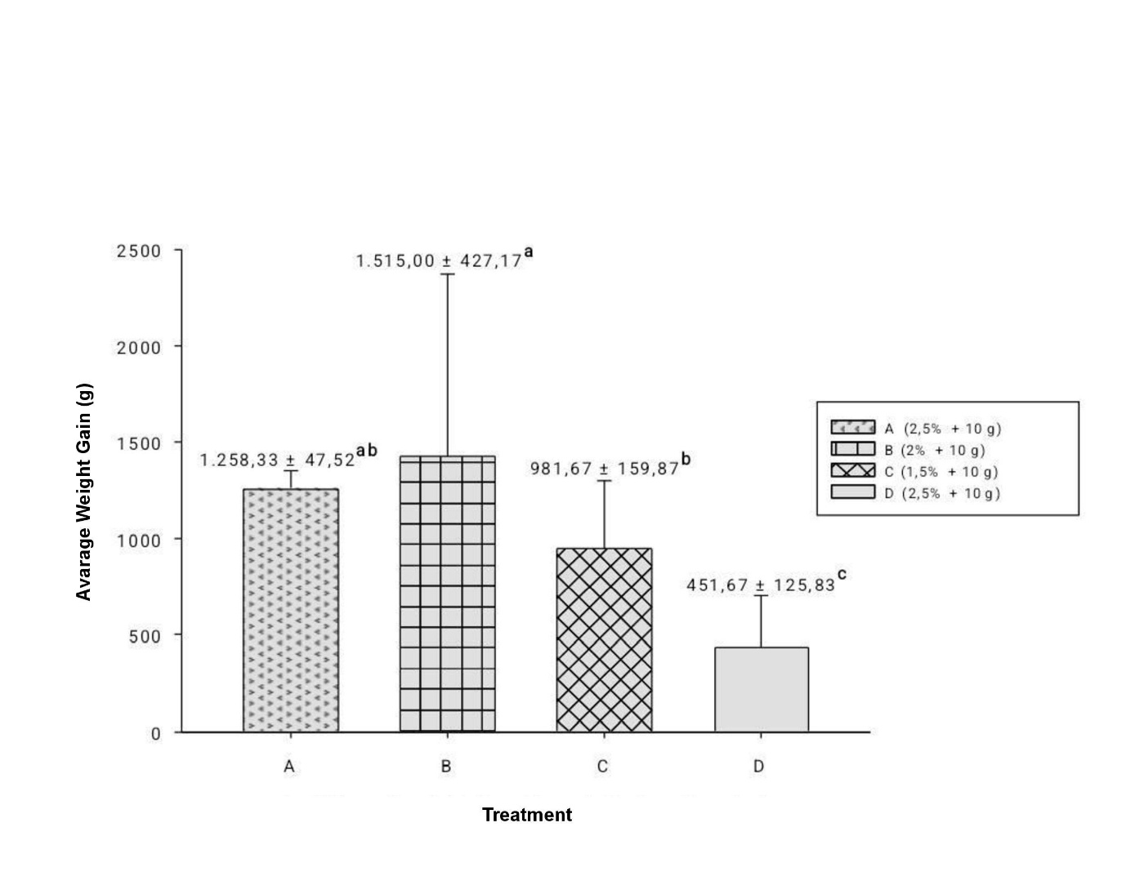

**Fig. 2. Average biomass weight gain of G4 transgenic mutiara catfish (treatments A–C) and**

**non-transgenic mutiara catfish (treatment D)**

*Data are presented as means ± SD. Means in the same row followed by the same letter* ***significantly different*** *(p ≥ 0.05). Feeds A, B, and C (2.5%, 2%, 1.5%) supplemented with 10 g of boiled tuna were fed to G4 transgenic mutiara catfish, while feed D (2.5% + 10 g) was fed to nontransgenic mutiara catfish.*

Table 1. Protein content of feed mixtures in each treatment

|  |  |  |  |  |  |
| --- | --- | --- | --- | --- | --- |
| **Treatment** | **Initial Fish Biomass (g)** | | **Feed Given (g/day)** | **Mixed Protein (%)**  **(HI-PRO-VITE 781 + boiled tuna)** | **Protein**  **From Pindang**  **Tongkol (Boiled**  **Tuna) (%)\*\*** |
| A (2,5% + 10 g) | 4.430 | 110,75 | | 37,91 | 3,58 |
| B (2% + 10 g) | 3.575 | 71,5 | | 25,75 | 3,58 |
| C (1,5% + 10 g) | 4.210 | 63,15 | | 23,16 | 3,58 |
| D (2,5% + 10 g) | 1.700 | 42,5 | | 16,76 | 3,58 |

*Feeds A, B, and C (2.5%, 2%, 1.5%) supplemented with 10 g of boiled tuna were fed to G4 transgenic mutiara catfish, while feed D (2.5% + 10 g boiled tuna) was fed to non-transgenic mutiara catfish*

*Total Dietary Protein (%) : [(pellet protein × qty) + (tuna protein × 0.01kg)] / total feed)*

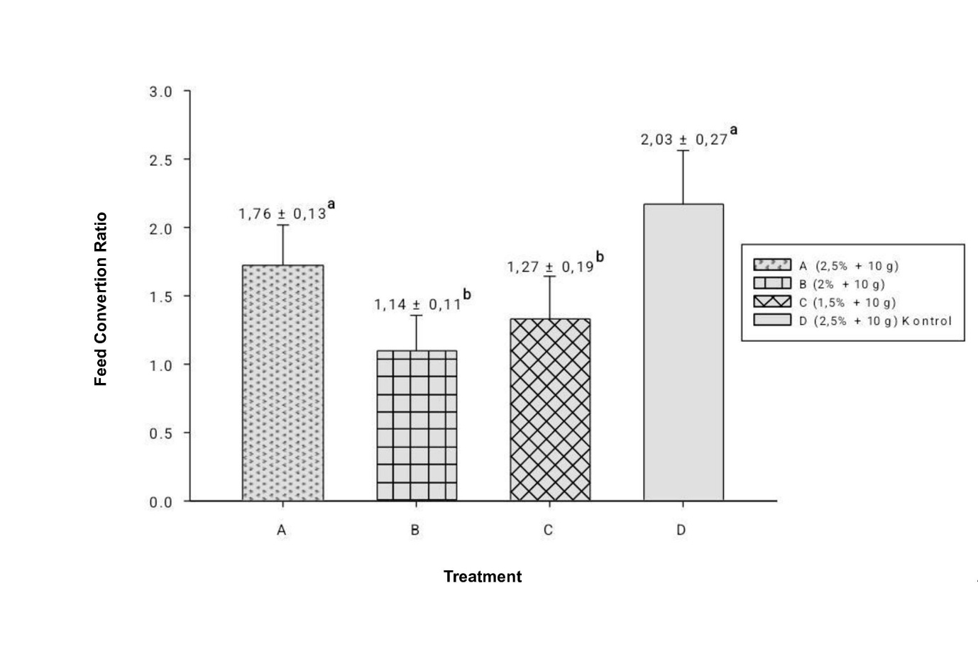

**Fig. 3. Feed convertion ratio of G4 transgenic mutiara catfish (treatments A–C) and nontransgenic mutiara catfish (treatment D)**

*Data are presented as means ± SD. Means in the same row followed by the same letter are not significantly different (p ≥ 0.05). Feeds A, B, and C (2.5%, 2%, 1.5%) supplemented with 10 g of boiled tuna were fed to G4 transgenic mutiara catfish, while feed D (2.5% + 10 g) was fed to non-transgenic mutiara catfish*

FCR is the ratio between the total feed given and the biomass weight gain during the culture period. FCR reflects feed efficiency, where a lower FCR indicates higher efficiency—meaning the feed is more effectively digested and utilized for fish growth—while a higher FCR suggests otherwise.

Treatment B (transgenic catfish with 2% feed dosage) showed the best feed efficiency (FCR 1.14), highest growth (1,515 g), and the fastest daily growth rate (36.07 g/day), supported by a feed protein content of 25.75% and a suitable feed dosage. Treatment C (1.5% feed) was also efficient (FCR 1.27), though its growth was lower and suboptimal due to a lower protein content (23.16%). This is likely influenced by the expression of the growth hormone gene (*CgGH*) in transgenic fish.

This gene functions in utilizing fat and carbohydrates as energy sources for metabolism, allowing dietary protein to be allocated more efficiently for growth [23].

In contrast, treatments A (transgenic, 2.5% feed dosage) and D (non-transgenic, 2.5% feed dosage) had the highest FCR values—1.76 and 2.04, respectively—and did not significantly differ from each other. These high FCR values indicate low feed utilization efficiency, possibly due to overfeeding, unbalanced nutrient composition (particularly protein), and excessive feed being excreted as waste. Although FCR values did not differ significantly between the two, transgenic fish in treatment A achieved 2.79 times greater weight

gain compared to non-transgenic fish in treatment D. High FCR in Treatment A suggests protein catabolism for energy, reducing growth efficiency [14, 16]

Overall, treatment B was the most efficient in converting feed into biomass. This efficiency is supported by GH gene expression, which enhances metabolism, nutrient absorption, and intestinal surface area [24]. These morphological changes improve the fish's ability to digest and absorb nutrients, allowing for optimal conversion of feed into body biomass [24]. Thus, feeding transgenic fish with 2% HI-PRO-VITE 781 plus boiled tuna flakes not only enhances growth but also reduces costs and shortens the cultivation period. Treatment B significantly outperformed others (p<0.05) in AWG and FCR.

3.3 Feed Cost

Feed cost accounts for the largest share of production expenses in aquaculture and can result in financial losses if not offset by improved productivity or market value. In this study, feed cost was calculated by multiplying the total feed administered by its unit price per kilogram. Revenue was defined as net income from feed, calculated as the difference between the total selling value of harvested fish and feed cost during a 42-day rearing period, excluding other operational costs such as labor, energy, and equipment.

Table 2. Feed Cost

|  |  |  |  |  |  |  |
| --- | --- | --- | --- | --- | --- | --- |
| **Treatment** | **Feed Cost per Kg (IDR)** | **FCR** | **Total Feed Used**  **(Kg)** | **Feed Cost**  **(IDR)** | **Average Final Weight of Fish**  **(Kg)** | **Selling Price per kg**  **(IDR 35,000.00/Kg)** |
| **A.** 2.5% HPV 781 | 11,533.00 | 1.76 | 1.64 | 18,914.12 | 2.74 | 70,385.88 |
| PT 10 g | 60,000.00 | 0.11 | 6,600.00 |
| **Total** |  |  |  | **25,514.12** |  |  |
| **B.** 2% HPV 781 | 11,533.00 | 1.14 | 1.04 | 11,944.32 | 2.71 | 76,905.68 |
| PT 10 g | 60,000.00 | 0 10 | 6,000.00 |
| **Total** |  |  |  | **17,944.32** |  |  |
| **C.** 1.5% HPV 781 | 11,533.00 | 1.27 | 1.12 | 12,916.96 | 2.39 | 61,733.04 |
| PT 10 g | 60,000.00 | 0.15 | 9,000.00 |
| **Total** |  |  |  | **21,916.96** |  |  |
| **D.** 2.5% HPV 781 | 11,533.00 | 2.03 | 1.70 | 19,606.10 | 1.02 | - 3,706.10 |
| PT 10 g | 60,000.00 | 0.33 | 19,800.00 |
| **Total** |  |  |  | **39,406.10** |  |  |

Among the treatments tested, treatment B (transgenic African catfish fed 2% HI-PRO-VITE 781 and 10 g shredded tuna residue) demonstrated the highest feed efficiency, with the lowest feed cost (IDR 17,944.32) and the highest net income (IDR 76,905.68). Conversely, treatment D (non-transgenic catfish fed 2.5% feed and tuna residue) incurred the highest feed cost (IDR 39,406.10) and a negative net income (IDR -3,706.10), indicating poor economic efficiency. Increasing feed dosage in treatment A (2.5%) did not improve economic

returns compared to treatment B (2%), while treatment C (1.5%) reduced feed costs but also resulted in lower biomass and revenue (Table 2).

These findings suggest that transgenic African catfish (G4), when fed at optimal dosages, provide superior economic performance, likely due to exogenous growth hormone (GH) enhancing feed conversion efficiency [25]. G4 transgenic catfish thus offer a promising strategy for sustainable aquaculture by improving growth rates, reducing feed costs, and shortening production cycles.

3.3 Water Quality

several water quality parameters—including temperature, pH, and dissolved oxygen (DO)—were measured to support the maintenance of optimal conditions for African catfish rearing. The results of water quality measurements throughout the cultivation period are presented in Table 3.

Table 3. Water Quality

| **Water Quality** | **Result** | **Standar** | |
| --- | --- | --- | --- |
| Temperature (°C) | 28-29 ± 0.5 | 25-30 | SNI 6484.3 (2014) |
| pH | 6.7-7.3 ± 0.3 | 6,5-8 |
| DO (mg/L) | 3.9-4.2 ± 0.25 | >3 |

Table 3 shows that the water quality during the experiment maintained a temperature range of 28-29°C, pH values between 6.7-7.3, and dissolved oxygen levels of 3.9-4.2 mg/L. These results indicate that the water quality during the study remained within the recommended ranges based on the Indonesian National Standard (SNI 6484.3:2014), which specifies ideal conditions of 25-30°C for temperature, pH between 6.5-8.0, and DO levels above 3 mg/L.

# CONCLUSION

This study demonstrated that differences in feed dosage had a significant effect on average weight gain, feed convertion ratio, and feed cost in both G4 transgenic and non-transgenic *mutiara* catfish. **Stable GH expression in G4 supports long-term use of transgenic broodstock.** The best performance was achieved with the combination of 2% body biomass of HI-PRO-VITE 781 pellets supplemented with 10 g of boiled tuna flakes (treatment B), which resulted in the highest weight gain, best feed efficiency, and most economical feed cost. This combination also generated the highest net income, and therefore can be recommended as the optimal feed dosage for the cultivation of G4 transgenic mutiara catfish.

**Disclaimer (Artificial intelligence)**

Option 1:

Author(s) hereby declare that NO generative AI technologies such as Large Language Models (ChatGPT, COPILOT, etc.) and text-to-image generators have been used during the writing or editing of this manuscript.

Option 2:

Author(s) hereby declare that generative AI technologies such as Large Language Models, etc. have been used during the writing or editing of manuscripts. This explanation will include the name, version, model, and source of the generative AI technology and as well as all input prompts provided to the generative AI technology

Details of the AI usage are given below:

1.

2.

3.

# REFERENCES

# 1. Fish Breeding Research Institute. Technical guidelines for mutiara catfish cultivation. Subang; 2014.

# 2. Buwono ID, Junianto J, Iskandar I, Alimuddin A. Growth and expression level of growth hormone in transgenic mutiara catfish second generation. Journal of Biotech Research. 2019; 10: 102-109.

# 3. Iskandar, Buwono ID and Agung MUK. The growth performance of f1 transgenic mutiara catfish. IOP Conference Series: Earth and Environmental Science. 2018; 137: 1-10.

# 4. Buwono ID, Iskandar I, Grandiosa R. Growth hormone transgenesis and feed composition influence growth and protein amino acid content in transgenic G3 mutiara catfish (*Clarias gariepinus*). Aquaculture International. 2021; 29: 431-451.

# 5. Buwono ID, Iskandar I, Grandiosa, R. **Extension outreach** of mutiara catfish cultivation at the Cileunyi catfish farmers group. Dharmakarya: Journal of Science and Technology Applications for Society. 2021; 10(4): 273–278.

# 6. Buwono, ID, Iskandar, Agung MUK, Subhan U. Development of transgenic catfish (*Clarias* sp.) using sperm electroporation technique. Journal of Biology. 2016; 20(1): 17-28.

# 7. Marnani S, Pramono TB. Alternative fish feed based on local ingredients for gourami (*Osphronemus gouramy)* broodstock. Omni-Aquatics. 2016; 12(3): 21–28.

# 8. Sidharta V, Pinandoyo, Nugroho R. Gonad maturity, fecundity, and hatching rate performance through different natural feed strategies in freshwater crayfish (*Cherax quadricarinatus*) broodstock. Journal of Tropical Aquaculture Science. 2018; 2(2): 64–74.

# 9. Ramadhan S. 2017. Alternative feed of pindang tongkol crumbs on the growth of F1 hybrid offspring of mutiara catfish (*Clarias* sp.) [The use of boiled *Euthynnus affinis* tuna crumbs as alternative feed for the growth of F1 hybrid offspring of mutiara catfish (Clarias sp.)]. Undergraduate thesis. Faculty of Fisheries and Marine Sciences, Universitas Padjadjaran.

10. Uju BR, Ibrahim B, Ramadhan W, Tanjung IS. Recovery process and concentration of drinking water protein “pindang tongkol” (*Euthynnus affinis*) through ultrafiltration. J Agroind Technol. 2017; 27:281–290.

# 11. Amalia R, Amrullah, Suriati. Feed management in Nile tilapia (Oreochromis niloticus) farming]. Proceedings of the National Seminar. 2018 April 9-10, Synergy of Multidisciplinary Science and Technology, pp. 252-257.

# 12. Zulkhasyni, Firman, Sari R. Artificial feed administration at different doses for growth and survival of white fish (Tor sp) fry. Jurnal Agroqua. 2016; 14(2): 49–55.

# 13. Karimah U, Samidjan I, Pinandoyo. Growth performance and survival rate of GIFT Nile tilapia (*Oreochromis niloticus*) fed different feed amounts. Journal of Aquaculture Management and Technology. 2018; 7(1): 128–135.

# 14. Buwono ID, Iskandar I, Grandiosa R. Growth hormone transgenesis and feed composition influence growth and protein amino acid content in transgenic G3 mutiara catfish (*Clarias gariepinus*). Aquaculture International. 2021; 29: 431-451

# 15. Rarassari MA, Dwinanti SH, Absharina FD, Gevira Z. Application of biofloc and probiotics in feed for the cultivation of mutiara catfish (*Clarias gariepinus*) [Application of biofloc and probiotics in feed for the cultivation of mutiara catfish (*Clarias gariepinus*)]. Journal of Fisheries Marine Research. 2021; 5(2): 329–334.

# 16. Buwono ID. Essential amino acid requirements in fish diets. Kanisius. Yogyakarta; 2000.

# 17. Tribina A. Utilization of dry tofu waste silage as feed for red tilapia (*Oreochromis niloticus*)]. Journal of Fisheries and Marine Technology. 2012; 3(1): 27–33.

# 18. Dewi RRSPS, Darmawan J, Nurlaela I. Transmission and phenotypic expression of the growth hormone-encoding gene in siamese catfish. Journal of Aquaculture Research. 2014; 9 (1): 31–37.

# 19. Indrawan MA, Idris M Pangerang UK. The effect of feeding with different protein levels on the growth and survival of asian swamp eel (*Monopterus albus*) in a mud-free culture system. Media Aquatika. 2016; 1 (3): 161-169.

# 20. Buwono ID, Junianto, Iskandar, Alimuddin, Yustiati A. Application of transgenesis technology for the production of transgenic catfish [Application of transgenesis technology for the production of transgenic catfish technology for the production of transgenic catfish]. Deepublish, Yogyakarta; 2019.

# 21. Robinson, Li. Low protein diets for channel catfish *Ictalurus punctatus* raised in earthen ponds at high dencity. Journal of the World Aquaculture Society. 1997; 28 (3): 224-229.

# 22.Iswanto B, Suprapto R, Marnis H, Imron. Reproductive performance of mutiara catfish (*Clarias gariepinus*). Media Akuakultur. 2016; 11 (1): 1-9.

# 23.Buwono ID, Junianto J, Iskandar I, Alimuddin A. Growth and expression level of growth hormone in transgenic mutiara catfish second generation. Journal of Biotech Research. 2019; 10: 102-109.

# 24.Walker RL, Buret AG, Jackson CL, E Scott KG, Bajwa R, Habibi HR. Effects of growth hormone on leucine absorption, intestinal morphology, and ultrastructure of the goldish intestine. Canadian Journal of Physicology and Pharmalogy. 2004; 82(11): 951-959.

# 25.Selawati, N, Yudha IG, Utomo DSC. The effect of rgh addition on artificial feed on hoven’s carp growth. e-Jurnal Rekayasa dan Teknologi Budidaya Perairan. 2019; 7(2): 823-834.