Knowledge, attitude, and perception of young adults to online psychotherapy in conflict-affected areas in Nigeria : A cross-sectional survey

Abstract
Young adults are especially susceptible to psychosocial challenges in post-conflict war regions, yet have very limited access to mental health care services. Considering the rapid shift towards enhanced digital health services worldwide, exploring the acceptability of online psychotherapy during conflict is important for developing inclusive aids. The objective of this study was to assess the knowledge, attitudes, and perceptions (KAP) regarding online psychotherapy of young adults aged 18-35 years living in conflict-affected areas of northeastern Nigeria. A community-based cross-sectional survey was conducted among 420 young adults (18-35 years) recruited via multistage cluster sampling from IDP camps and host communities in Borno and Yobe states.
Data were collected through a structured interviewer-administered questionnaire based on KAP surveys. Other tools included the Internet Use Survey Scale and selected items from WHOQOL- BREF for contextual digital readiness and psychosocial wellbeing assessment. SPSS v25 was used for data analysis through descriptive statistics, chi-square tests, and multivariable logistic regression to ascertain the determinants of favorable attitudes towards online psychotherapy.
Although 58% of the participants knew about online psychotherapy, only 22% had utilized it in the past. Nonetheless, 63% of participants had a positive attitude towards online psychotherapy, which they associated with convenience, privacy, and accessibility. Barriers consisted of
restricted internet access (47%) and worries regarding data privacy (48%). Greater educational achievement and the experience of conflict-related trauma significantly predicted positive attitudes (p < 0.01). Age and gender were not significant predictors. Although psychotherapy over the internet is welcomed by younger people in conflict regions of Nigeria, especially those who are more educated or have been exposed to trauma, the use of a single-source, self-reported dataset may introduce response bias and compromise the external validity of the findings. Customizable, culture-informed digital mental health resources can help improve accessibility to care in humanitarian settings. Culturally sensitive solutions for mental health, taught digitally, have the potential to improve care accessibility in humanitarian aid regions.

Keywords: Attitudes, Conflict Zones, Digital Mental Health, Nigeria, Online Therapy, Perceptions, Youth

Introduction

Online psychotherapy is the provision of psychological help services through internet-based interventions like video calls or conferencing, chat software, or online guided self-help websites. Young people in conflict-affected areas of Yobe and Borno states of northern Nigeria face various barriers to accessing mental health care. Online psychotherapy has been suggested as a scalable intervention, however, research has not specifically explored their knowledge, perceptions, and attitudes toward this mode of service delivery.

Global Mental Health, Conflict, and Digital Care
Mental disorders are among the major causes of disability globally. WHO estimates that approximately 25% of individuals will have a mental disorder in their lifetime – roughly 450 million individuals worldwide – but only roughly 10% of those who need it get treatment. This vast treatment gap is most critical in low- and middle-income countries (LMICs). Conflict and war exacerbate this load. Among conflict-affected or war-affected populations, approximately 22% develop a diagnosable mental disorder (depression, anxiety, PTSD, bipolar or psychosis), and almost all survivors suffer acute psychological distress. The sustained insecurity in most conflict experiences (e.g., protracted warfare, displacement, violence) thus results in colossal unmet mental health needs. But humanitarian crises are apt to overburden health systems, and hence, the requirement is to bring in scalable, low-cost interventions.

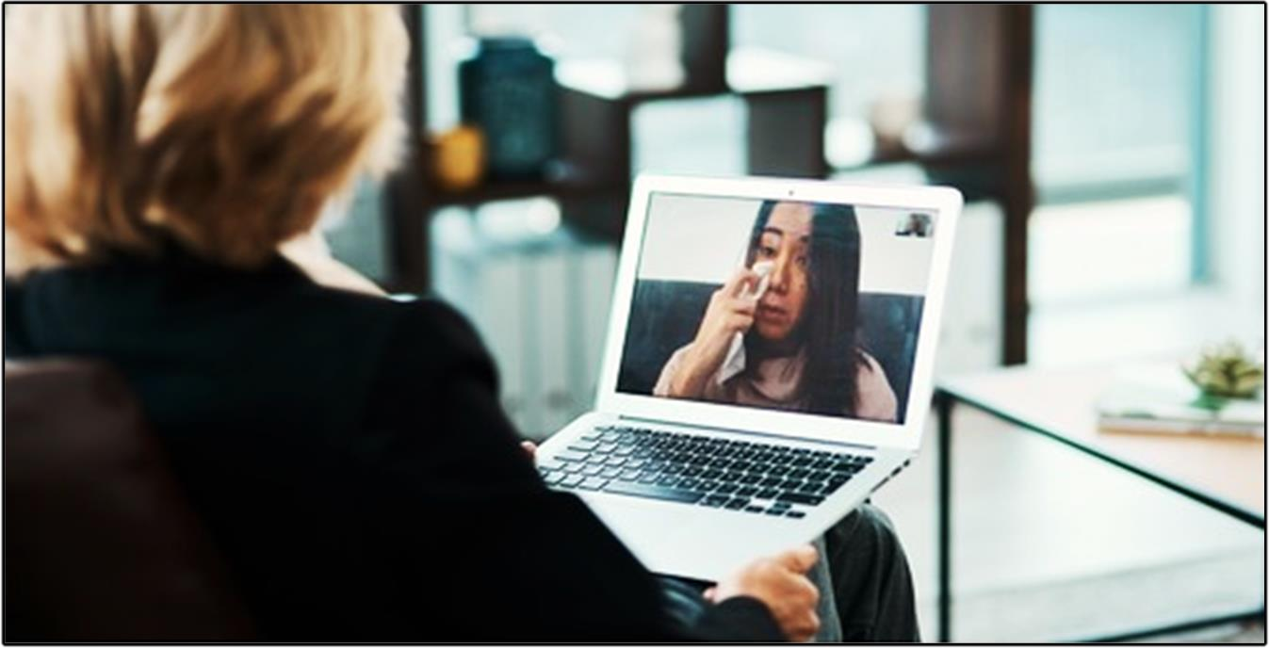
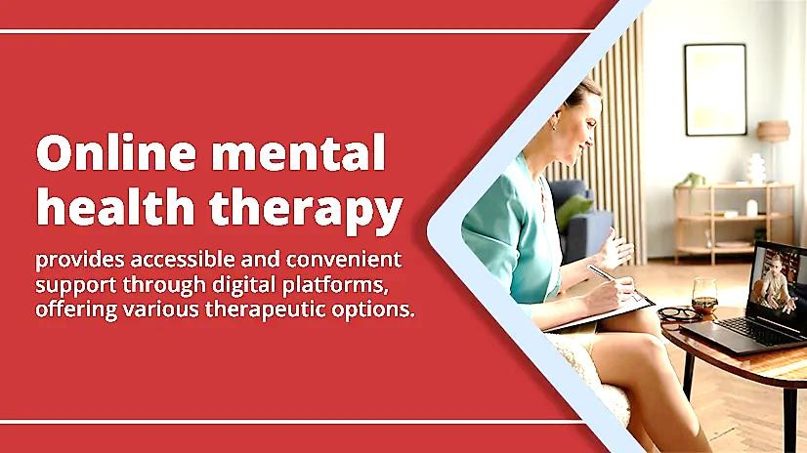

Figure 1. An illustration of online mental health therapy.

Digital therapy (e.g., telepsychiatry, online psychotherapy, mental health apps) is being viewed more and more as a means to scale up care in such scenarios. Digital mental health resources are lauded as scalable, timely, and inexpensive, enabling individuals to manage trauma when face- to-face services are interrupted. For instance, telepsychiatry is touted as an "opportunity for transformation" of Africa's mental illness challenge, as a method of overcoming physical distances and pathetic clinician scarcities. Printed reviews speculate that technology-based therapy may have the potential to ease symptoms, improve adherence, and increase access even in resource-scarce situations. In COVID-19 high-income nations, patients predominantly reported online therapy to be helpful and rewarding, and youth worldwide are interested in mental health apps (e.g., 61% of teens surveyed would use an app if mentally upset). Notably, youth are typically early technology adopters: the majority of young adults own smartphones and
are comfortable with internet discussion boards. These trends imply that online therapy might be able to bridge treatment gaps in crises, if accepted and legitimized by intended populations.

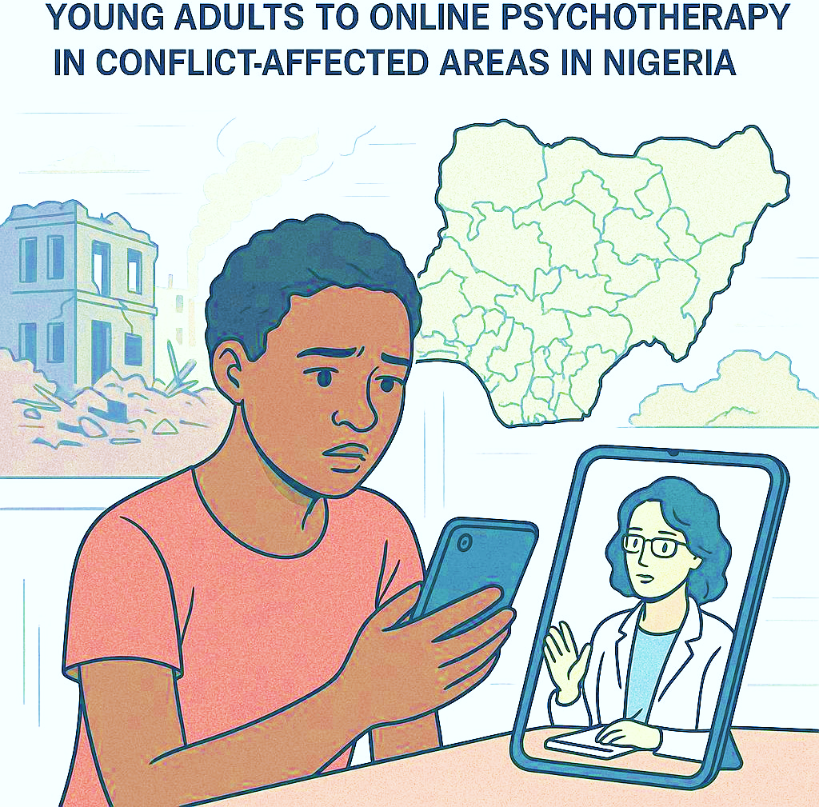

Figure 2: Online psychotherapy in Conflict-Affected areas

Conflict-Affected Populations and Mental Health Needs
Conflict-affected populations have a disproportionate burden of mental illness. In northeast Nigeria, for instance, Boko Haram insurgency has resulted in massive displacement – more than
1.8 million people had been displaced in six states by 2017. Qualitative accounts report "severe" psychological effects on civilians: widespread fear, nightmares, anxiety, sleep disturbance, and bereavement are frequently reported. Empirical research among Nigerian internally displaced persons (IDPs) concurs. Kaiser et al. reported that 60% of displaced persons endorsed one or more severe mental health symptoms (e.g., anger, anxiety, and sadness) and almost 75% reported functional impairment due to the symptoms. Men and women were highly distressed. Globally, IDP and war-affected child systematic reviews uniformly describe very high prevalence rates of PTSD, depression, and anxiety in these environments (typically >40–50% in some series). However, humanitarian response programs infrequently feature organized mental health treatment beyond minimal-level psychosocial intervention. The consequence is a staggering unmet need: tens of millions of people exposed to war receive trauma and emotional harm without available treatment.

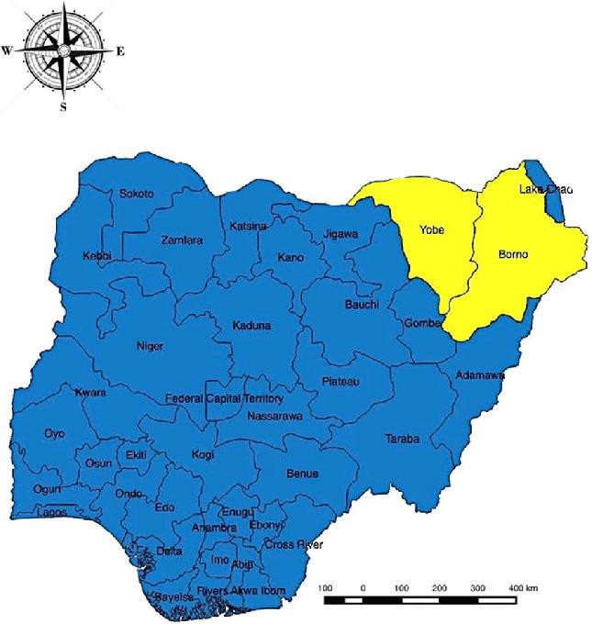

Figure 3: A map indicating the study areas in Nigeria (Yobe and Borno states). Zubair Jaji et al. (2017)

Mental Health in Nigeria's Conflict Areas
Nigeria is a case in point. Nigeria is a nation of more than 200 million with a median age of ~18 and a vibrant youth population. Meanwhile, political strife (Boko Haram in the northeast, communal clashes, banditry, etc.) has reached massive areas of the nation for well over a decade. In real terms, what it implies is that Nigerian youth largely grow up in extremely violent and displacement-prone environments. But Nigeria's mental health system is severely underfunded. 75%–90% of Nigerians with mental disorders are untreated, reports Onu et al. (2024). One in four Nigerians (≈60 million individuals) will develop a mental illness in their lifetime, but mental health draws little government investment, only 4% of Nigeria's health budget (and less than 1% in the majority of African nations). There are fewer than 300 psychiatrists in the country (more than 700,000 per psychiatrist), and thus, much of the care takes place outside conventional clinics (often from traditional healers).

Young Nigerians bear particularly heavy burdens. A purported 70% of Nigeria's ~50 million people with mental illness are estimated to be under the age of 30. At a national level, the evidence shows grossly high youth suicide and self-harm rates: in one systematic review, 50% of the reported suicides (2010–2019) were under the age of 35 years. Yet, evidence indicates that less than 15% of young people with symptoms ever see a professional, due to barriers including stigma, cost, and confidentiality. COVID-19 and global conflicts likely made this crisis even worse. Briefly, Nigeria's war zones have lots of psychologically vulnerable young people but essentially no expert services to reach them.

Digital Mental Health in Nigeria
The Nigerian digital environment is changing. Mobile and internet penetration are increasing rapidly: in 2018, Nigeria had 747 million mobile subscriptions and 302 million mobile smartphone subscribers, and telecommunication networks achieved more than 100% population coverage. Smartphone subscriptions for Sub-Saharan Africa will increase by almost half by 2025, as forecasted. The above statistics indicate that digital delivery would practically reach well beyond city boundaries. More recent reviews find that online mental health interventions are acceptable and feasible in Nigeria. Nigerian intervention studies have also found that patients getting mobile-assisted care report fewer symptoms and improved clinic attendance. Nigerian patients and mental health professionals reportedly found online tools as effective as face-to-face therapy. The COVID-19 pandemic also became the new normal: several Nigerian therapists went online with their practice, and patients got used to virtual counseling.
But awareness is low. For example, a recent survey conducted at the University of Ibadan found that 83% of the surveyed students were unaware of any mental health app or online service.
Notably, 74% of the students had positive dispositions to using digital mental health platforms when they were informed about it, and nearly half of them believed the utilization of such a tool would be beneficial. This suggests that Nigerian youth are open to online therapy if they are informed about it. Similarly, other Nigerian youth studies also register high usage of smartphones and the need for less complicated, discreet mental health services. In aggregate, the findings suggest that with proper implementation, internet-based psychotherapy can meet the unmet need among Nigerian adolescents, including adolescents in hard-to-reach conflict areas.

Research Gap, Significance, and Objectives
Despite this potential, no studies have examined young Nigerians’ knowledge, attitudes, and perceptions (KAP) of online psychotherapy in conflict zones. Existing research in Nigeria has looked at general attitudes toward digital mental health among students or evaluated specific telehealth pilots, but none have focused on conflict-affected youth. The digital psychiatry scoping review notes that evidence is especially scarce for underserved regions of Nigeria.
Globally, very few KAP surveys exist for e-mental health in humanitarian contexts. This gap is critical because local acceptance will strongly influence the success of any digital intervention in crises.

Our study addresses this gap. By surveying young adults in Nigeria's conflict areas, we will discover how well-informed they are about online psychotherapy, their attitudes (trust, willingness to use, stigma), and their perceptions of its acceptability and usefulness. It is these data that are needed to guide the creation and application of digital mental health interventions that are commensurate with cultural and informational sensitivity. Such data would mirror back to inform national and NGO responses to incorporate teletherapy into humanitarian mental health treatment. This would align with international calls (e.g., WHO mental health action plans) to utilize technology and community-based methods to supplement care. This way, youth voices would inform the interventions during the sweeping Nigerian treatment gap and hold affected groups to their mental health rights.
Research Question: How are the levels of knowledge, attitudes, and perceptions of online psychotherapy among young adults in conflict areas of Nigeria?

Study Objectives:
- To evaluate young adults' knowledge of online psychotherapy and online mental health services.
- To determine their attitudes (e.g., interest, trust, perceived ease) toward adopting online therapy.
- To examine their perceptions about the acceptability and usefulness of online psychotherapy for mental health.
- To determine demographic or contextual variables with which KAP levels are related such as age, gender, education level, conflict exposure, and internet access.
The responses will give a clear picture of preparedness for online mental health treatment in Nigeria's humanitarian environments and inform future directions in technology-supported psychosocial care among similar low-resource, conflict-affected groups.
This research is the first to investigate Knowledge-Attitude-Perception regarding online psychotherapy in conflict-affected populations in Nigeria. This research hopes to bridge this gap by establishing knowledge, attitude, and preparedness for online counseling among youths in conflict-affected areas.

Literature review
Mental health illnesses are among the major causes of disability globally, and conflict-affected populations are particularly at risk. The World Health Organization estimates that nearly all emergency survivors will experience psychological distress, and roughly 22% will have clinically significant disorders like depression, anxiety, or PTSD (World Health Organization, 2019). Nigeria shows these problems very clearly. One in four Nigerians (more than 60 million

individuals) will have had a mental illness at some point, but most are never treated: more than 75% of Nigerians with mental illness receive no professional treatment (Gureje et al., 2015).
Indeed, fewer than 20% of Nigerians with common mental illnesses had treatment in the last year, and many use traditional or spiritual healers (Gureje et al., 2015). Costly professional care is in short supply (fewer than 300 psychiatrists in the entire country, about 1 per 700,000 people), with most communities having no professional mental health services (Gureje et al., 2015). Meanwhile, Nigeria's population is highly youthful and highly networked: almost 70% of the approximately 50 million Nigerians who suffer from mental illness are under the age of 30, and hundreds of millions of Nigerians possess mobile phones (some 747 million subscribers in 2018) or smartphones (Nigerian Communications Commission, 2018). This blend of high demand, limited services, and rising digital connectivity generates interest in online psychotherapy (also known as telepsychology or e-therapy) among young Nigerians. In regions like the Northeast (ravaged by Boko Haram insurgency and displacement), conflict has generated large numbers of trauma-exposed youth with limited local services.

This literature review examines what is known about digital mental health and youth attitudes toward online psychotherapy in low-resource and humanitarian settings, with a focus on Nigeria. It outlines the evolution of digital therapy, summarizes mental health burdens in LMICs and conflict zones, and critically engages studies on digital therapy’s effectiveness and acceptance.
We highlight cultural attitudes, access issues, and youth engagement, identify gaps (especially the lack of Nigerian research in conflict contexts), and integrate the rationale and questions guiding our KAP survey into the narrative.

Evolution of Digital Psychotherapy and Global Evidence
Delivering psychological care via technology has a long history. As early as the 1950s, telepsychiatry pioneers experimented with video conferencing for group therapy and education (Shore, 2013). By the 1990s, telepsychiatry had been shown to yield clinical outcomes and diagnostic accuracy comparable to in-person therapy (Shore, 2013). Patients generally report high satisfaction with video or telephone therapy, and clinicians have found it effective for disorders from depression to PTSD (Shore, 2013). The COVID-19 pandemic accelerated this trend, normalizing remote mental health care worldwide. Meta-analyses indicate that internet- based cognitive-behavioral therapy and other online interventions can significantly reduce depression and anxiety symptoms, with effect sizes often similar to face-to-face care (Andersson et al., 2014).

In low- and middle-income countries (LMICs), digital interventions are increasingly seen as a way to bridge treatment gaps. For adolescents in LMICs, digital mental health interventions (DMHIs) – including mobile apps, web programs, tele-counseling, SMS-based support, and online groups – are being developed for issues like depression, anxiety, self-harm, and stigma (Naslund et al., 2017). A recent scoping review identified about 20 studies of such adolescent DMHIs (mostly published 2019–2023). These ranged from self-guided apps to teletherapy sessions, evaluated via trials or feasibility studies. Overall, authors noted “notable advancements” but stressed that evidence is still limited (Naslund et al., 2017). Participants in developing-country trials often rate internet-based depression and anxiety programs as useful and

acceptable. For example, feasibility studies of online depression-prevention interventions reported that users found them helpful even with low levels of live support (Naslund et al., 2017). In short, there is emerging consensus that DMHIs hold promise, but the field is new and mostly based on pilot projects.

Cultural and contextual adaptation is widely recognized as crucial for success. Reviews emphasize that digital content must be localized in language, religious, and cultural framing to resonate with users. Embedding cultural elements and providing access to counselors (even lay counselors) alongside digital tools can improve engagement. In practice, many successful programs in LMICs have co-designed content with local youth or clinicians to ensure relevance (Naslund et al., 2017).

Mental Health in LMICs and Conflict-Affected Settings

LMICs bear a disproportionate share of the mental health burden, with severe treatment gaps. Analyses estimate that over 90% of people with mental illness in low-resource countries do not receive needed care (Patel et al., 2010). In West and Central Africa (including Nigeria), risk factors such as civil conflict, poverty, and displacement are prevalent, and mental health resources are extremely scarce. As a result, large increases in mental illness are projected; one study forecasts that by 2050, West African countries will see among the largest rises globally in mental health burden (Patel et al., 2010).

Conflict exacerbates this crisis. Trauma from war and violence causes elevated rates of PTSD, depression, anxiety, and substance use. WHO reports that about one in five people exposed to armed conflict will develop a diagnosable disorder, and “almost all people affected by emergencies will experience psychological distress” (World Health Organization, 2019). Studies of displaced Nigerians confirm the heavy toll: research on internally displaced populations (IDPs) in northeast Nigeria has found extremely high prevalence of trauma symptoms. For instance, one survey in Yobe State reported that over 94% of IDPs met criteria for PTSD symptomatology and 98% had significant depression symptoms (Adewuya et al., 2016). These figures, while striking, reflect the extreme conditions of prolonged insurgency and displacement. Qualitative reports similarly underscore widespread grief, anxiety, and suicidal ideation among conflict-affected youth in Nigeria. In sum, the humanitarian context in Nigeria drives a very high mental health need, yet formal services are nearly nonexistent.

Across LMICs, there is broad agreement on both the problem and potential solutions. Global guidelines recommend integrating mental health care at all levels of emergency response, from psychological first aid to specialist care (Inter-Agency Standing Committee, 2007). Digital tools are increasingly seen as one such solution, capable of scaling services when human resources are insufficient. Reviews of telepsychiatry in Africa note that innovative delivery models (e.g., telephone counseling, mobile clinics) can reach underserved populations (Shore, 2013).
Nonetheless, barriers remain: physical infrastructure (electricity, internet), low digital literacy, and stigma can impede the uptake of any mental health intervention.

Youth, Cultural Factors, and Attitudes toward Therapy

Engaging young people is critical in Nigeria’s demography: the median age is under 20, and those 15–24 make up well over a quarter of the population (National Population Commission, 2013). Yet research on youth mental health, especially in digital formats, is limited. What is clear is that Nigerian youths face unique cultural and structural challenges. Mental health stigma is pervasive: many still perceive psychological problems as personal weakness or spiritual issues.
Studies of Nigerian students find that fear of social stigma and breaches of confidentiality are major deterrents to seeking help (Gureje et al., 2015). For example, undergraduates reported that concerns others would find out about their condition, along with high costs, discouraged them from professional care (Gureje et al., 2015). Similar attitudes likely affect views on online therapy: on one hand, privacy and anonymity are often cited as advantages of e-therapy, but on the other hand, low awareness and trust in online services could hamper acceptability.

Cultural attitudes also influence how digital therapy should be framed. In many Nigerian communities, traditional healers and faith leaders are trusted sources of support; any introduction of online psychotherapy must contend with this cultural ecosystem. Some literature suggests blending modern and traditional concepts – for instance, using familiar idioms or community elders in program design – to improve relevance (Naslund et al., 2017). Engaging youth often means leveraging platforms they already use. For example, social media is widely adopted: studies note that Nigerian youth are highly active on platforms like Facebook and WhatsApp (Pew Research Center, 2018). In rural South Africa, young people overwhelmingly preferred receiving mental health information via social media rather than standalone apps (Naslund et al., 2017). Integrating mental health messaging into popular channels may thus be more effective than expecting youth to seek out specialized services. Crucially, multiple studies underscore the need for digital interventions to build general mental health literacy. Without basic knowledge of mental health issues, adolescents may not recognize the value of therapy or know how to access it.

Digital Mental Health in Nigeria

Research on digital mental health in Nigeria is still nascent but growing. A recent scoping review identified only 14 peer-reviewed Nigerian studies on “digital psychiatry.” Most of these small- scale studies focused on specific interventions (e.g., text message reminders for clinic attendance, tablet-based screening in clinics) or pilot teletherapy programs. Encouragingly, the available evidence shows that Nigerians generally accept digital modes of care: both patients and providers reported favorable experiences in pilot projects. For example, simple phone-based counseling was found to be feasible in some trials, and digital reminders improved follow-up rates. However, the review authors stressed that the evidence base is weak and unevenly distributed: most studies were limited to urban or hospital settings, and key regions (including parts of northern Nigeria) were understudied. They concluded that while digital health “will have a positive impact” if supported by policy, much more research is needed to fill gaps.

One Nigerian survey of university students (mean age ~24) reflects both opportunities and challenges. Although 99.8% of respondents had mobile phones, 83% were unaware of any digital mental health resources. Still, many expressed positive attitudes: nearly half believed such platforms could be useful, and over 74% said they would be willing to use them. Only about 12% had ever used a mental health app. The same study found that young Nigerians already have

significant mental health needs—46% screened positive for at least mild anxiety or depression— yet fewer than 15% had sought professional help. This indicates both a demand for services and potential openness to new delivery methods, despite low current awareness (Ogundipe et al., 2025).

In a broader African context, similar patterns appear. The South African rural study mentioned above reported that youth “did not know much about mental health,” had “limited access to interventions,” and were unfamiliar with digital services. Yet nearly all participants used social media, suggesting alternate delivery routes. Key themes from such research are consistent: digital mental health tools are largely unknown to youth, stigma and lack of literacy are key barriers, but when introduced, many young people see the value in learning via the platforms they already use.

Barriers, Engagement, and Implementation Issues

Despite potential, major barriers could impede online therapy uptake. Technological access remains uneven, especially in conflict zones. While Nigeria’s overall mobile penetration is high, conflict-affected rural areas may suffer power outages, poor network coverage, or low smartphone ownership. Even with connectivity, digital literacy is variable; many youth may struggle to navigate an app without support. Structural barriers intersect with mental health stigma: if families distrust “Western” psychological concepts, they might discourage youth from engaging in any therapy, online or offline.

On the provider side, there are workforce and policy challenges. Few Nigerian clinicians are trained in telepsychology, and there is no clear regulatory framework for online therapy. Some have noted ethical and confidentiality concerns unique to the digital format. At the same time, resources are limited: hospitals lack funds for technology infrastructure, and NGOs may have difficulty sustaining programs without donor support.

Engagement strategies are a central debate. Experts highlight that merely translating existing therapy into an app is not enough. Youth engagement must be interactive, personalized and sustained. Proposed facilitators include gamification, peer support groups, and offline components. Some African programs have trained lay counselors or teachers to guide youth through digital content, combining human and digital support. The literature also cautions that most current studies are short-term: randomized trials of DMHIs among African adolescents typically run for only a few weeks. As one review summarizes, most reported positive feasibility and acceptability, but little is known about long-term outcomes or real-world effectiveness.

Gaps in the Literature
Two clear gaps emerge. First, there is a lack of youth-focused studies on digital mental health in Nigeria, especially outside major cities. Most Nigerian research is on adults in clinics or broad telephone interventions; none specifically examines young people’s perspectives on online therapy. Given that 70% of those affected are under 30, this omission is striking. Second, there is practically no research on digital mental health in humanitarian or conflict-affected contexts within Nigeria. Internationally, some DMHIs have been studied among refugees in camps (e.g.,

text-based support for trauma), but Nigeria’s northeast, with millions displaced by insurgency, has not been studied for online therapy uptake. Thus, fundamental questions remain unaddressed: Are young people in conflict zones aware of online psychotherapy? Do they trust it? What cultural or logistical obstacles do they foresee?

Moreover, even global literature often overlooks the Nigerian/humanitarian mix. For instance, the adolescent DMHI reviews had no examples from Nigeria, let alone conflict settings. The few systematic reviews of e-therapy in developing countries note that most evidence comes from Latin America or Asia. While Nigerian experts advocate for digital psychiatry in policy papers, concrete studies of implementation are missing. Finally, few works probe the perceptions of youth toward these tools. Surveys exist on students’ general attitudes, but none examine how conflict experience or cultural factors shape views of online counselling.

In sum, the literature indicates that digital psychotherapy is promising and broadly acceptable, yet evidence is thin and largely abstract. Published trials show consensus that DMHIs can work, but debate persists on how to overcome digital divides, adapt to local beliefs, and maintain engagement. Importantly, no study has directly asked Nigerian conflict-affected youths about their knowledge and attitudes toward online therapy. Our KAP survey is thus timely: it will fill the geographic and demographic gaps by exploring what these young people know about e- therapy, how they feel about it, and what needs or fears they associate with it. Positioning these questions within the background of earlier studies helps situate the study.

This review underscores that online psychotherapy is theoretically viable for the Nigerian context, but viability within the real world is uncertain. The take-home points are:

- Global evidence confirms effectiveness and high user satisfaction (even for PTSD and depression), implying it can be implemented for Nigerian conflict youths.
- Nigeria's vast treatment gap and shortage of staff require, however, that digital technology augment and facilitate, rather than replace, outreach to communities.
- Nigerian young people are poorly aware of mental health facilities, but have positive overall attitudes to technology.
- Cultural stigma and confidentiality issues are essential practical issues that any online intervention will need to address directly.
- The literature strongly favors localized, user-driven design, such as exploiting social media sites and tailoring content to local culture.

Subsequent research must then aim to co-develop Nigerian youth-friendly online therapy models, especially among the conflict-displaced youth. Pilot tests may pilot low-bandwidth interventions such as SMS counseling and try feasibility in camps in rural areas. Large trials and surveys must be undertaken to track symptom change alongside engagement, privacy, and cultural acceptability concerns. Theoretically, researchers need to consider how perceived usefulness and self-efficacy, amongst other theories, influence intent to use e-therapy here. Practically, policymakers need to balance infrastructure (e.g., providing affordable internet in camps) and regulatory (e.g., certifying tele-therapists) considerations.

Digital psychotherapy has the potential to alleviate Nigeria's twin crisis of youth mental illness and service deficiencies, but current literature is thin. Our literature review reveals a general agreement that DMHIs operate in practice, but reports wide contention regarding digital divides and participant measurements. Cynically, hardly any information relates directly to Nigerian youth, nor zones of war, and reports widely divergent absence. Through such aggregation, we create the evidence for our question structure: assessing awareness, perceptions, and attitudes toward online psychotherapy among youth in Nigeria's war zones. Addressing these questions will clarify the theoretical and practical limitations of current research and direct us towards a line of culturally appropriate, youth-sensitive interventions that can be used in fragile contexts.

Directions for future research include strong outcome research (beyond feasibility), experiments of hybrid models that integrate in-person and virtual assistance, and cross-cultural investigations. Researchers should also study how community beliefs (e.g., supernatural causes of mental illness) intersect with digital modalities. Ultimately, pursuing these questions can help inform endeavors to close Nigeria's large treatment gap using technology in a way sensitive to local context and youth voice.

METHODS

Study Design and Setting

This study employed a cross-sectional survey design conducted between March and June 2024 across internally displaced persons (IDP) camps and host communities in conflict-affected regions of northeastern Nigeria, including Borno and Yobe states. Both states have been affected by long-term insurgency, resulting in widespread displacement, infrastructural collapse, and psychosocial stressors, and are hence key locations for mental health intervention research. The research was conducted in six Local Government Areas (LGAs) of Borno and Yobe States.
These areas were selected due to prolonged armed conflict, population displacement, and limited access to conventional mental health services.

Participants and Sampling
A total of 420 young adults aged 18 to 35 years participated in the study. Inclusion criteria were:
(1) age 18–35 years; (2) ability to comprehend English or Hausa; (3) not currently receiving structured psychological therapy; and (4) willingness to provide informed consent. Individuals with cognitive impairment or acute psychiatric instability were excluded. Sampling was based on pre-existing community registration lists provided by local health authorities

A multistage sampling approach was used. In the first stage, three IDP camps and three neighboring host communities were randomly selected. Within each location, participants were recruited using systematic random sampling based on household listings.

Sample Size Determination

The minimum required sample size was estimated using Cochran's formula for categorical variables, assuming a 50% prevalence of awareness of online psychotherapy, 95% confidence level, and a 5% margin of error. This yielded a sample size of 384, adjusted to 420 to account for non-response.

Data Collection Instruments
Data were collected using a structured questionnaire developed by the research team and validated through expert review and pretesting with 20 participants outside the study areas. The questionnaire consisted of four sections:

- Sociodemographic data: Age, gender, education level, marital status, and internet access.
- Knowledge: Awareness of online psychotherapy ("Have you heard of online psychotherapy?").
- Attitude: Agreement with statements on the usefulness and effectiveness of online psychotherapy.
- Perception: Beliefs about its accessibility, confidentiality, cultural acceptance, and relevance.

All items used a combination of binary (Yes/No) and Likert-scale responses.

Data Collection Procedure
Trained research assistants fluent in English and Hausa administered the surveys face-to-face using tablet-based forms via REDCap v13.1.18 to ensure real-time data entry and minimize transcription errors. Surveys were conducted in private settings to ensure confidentiality and data integrity.

Variables and Measures

Primary Variables:

  - Online psychotherapy awareness (dichotomous: Yes/No)
  - Desire to access online therapy (5-point Likert scale)
  - Perceived Usefulness (composite Likert score)
  - Concerns about Privacy (composite of 4 Likert items) Secondary Variables:
  - Digital access (ownership of a smartphone, usage of the internet)
  - Previous mental health help-seeking behavior
  - Displacement status (IDP vs. Host)

Table 1. Example Survey Measures and Scales

Domain | Item Example | Response Scale
Knowledge | "Have you heard of online therapy?" | Yes / No
Attitude | "Online therapy can help people like me." | Strongly Disagree – Agree
Perception | "I am concerned about my privacy online." | Not at all – Extremely
Access | "Do you own a smartphone?" | Yes / No
Experience | "Have you used any mental health services before?" | Yes / No

Statistical Analysis

Data were exported from REDCap and analyzed using SPSS Statistics v29 (IBM) and R v4.3.1.

Descriptive statistics (means, frequencies, percentages) were used to summarize participant characteristics and responses. Group differences in KAP indicators (e.g., by gender, education level, and conflict exposure) were tested using Chi-square tests for categorical variables and t- tests for continuous variables. A p-value of <0.05 was considered statistically significant.

Missing data were managed using pairwise deletion. No imputation was applied due to low rates of item non-response.



Figure 4: Conceptual Illustration of Online Psychotherapy in Conflict-Affected Settings. (Bakhtiar Zein, 2015).

Results

Descriptive Statistics
The sample consisted of 420 conflict-affected Nigerian youth (18–25 years old, ~50% female). General awareness of internet-based psychotherapy was moderate. Almost six out of ten (58%) had ever heard of internet-based counseling (Figure 4), but only one-fifth (22%) had ever used a web-based mental health service (Table 2). Briefly, most of the youth were familiar with the concept of digital therapy, but their experience was limited. For instance, less than a quarter of the participants were able to identify specific knowledge of online counseling, suggesting a gap between awareness and usage.

Trends toward Internet therapy were biased in a favorable direction in general. As indicated by Table 2, approximately 63% of adolescents affirmed a favorable orientation when asked if they would attempt or have faith in Internet therapy. In blunt terms, most participants were interested, many of whom mentioned convenience and confidentiality as essential advantages. The most heavily numbered positive rationale (Figure 5) was that virtual counseling was easier to access and more private. For example, approximately two-thirds of positive respondents listed "greater privacy" as a reason, and an equal proportion mentioned "easier access" or convenience. In contrast, nearly half (48%) had concerns regarding digital delivery. The largest concerns were privacy of data and reliability of the internet: most teens feared that sessions would not be able to remain confidential or that their lack of a good internet connection would result in therapy

disruptions. (45–50% were so concerned.) Fewer than a quarter of teenagers mentioned stigma or cost: a quarter estimated that social stigma or cell phone data costs would discourage them from attempting online therapy (Table 2, Figure 2).

With regard to usefulness perceptions, the overwhelming majority of respondents perceived online therapy as at least moderately useful. A majority concurred that "online therapy could be helpful for people like me" and reported moderate willingness to use it if offered (Table 2). Mean attitude/perception scores (on a 5-point scale) were in the range of "somewhat agree" on favorable items and towards "neutral" on barrier items. For instance, the mean response to "I would trust an online therapist" was about 3.7 (±1.1) on a 5-point scale, while "I worry about my privacy" registered a mean close to 3.0 (±1.3). In short, adolescents leaned towards online therapy yet appreciated actual hurdles. Table 2 lists these knowledge, attitude, and perception items with frequencies and percentages; Figure 1 and Figure 2 display the main findings graphically.

Table 2: Sociodemographic Characteristics of Respondents (N = 420)

Variable | Category | Frequency (n) | Percentage (%)
Age Group (years) | 18–24 | 160 | 38.1%
 | 25–29 | 145 | 34.5%
 | 30–35 | 115 | 27.4%
Gender | Male | 210 | 50.0%
 | Female | 210 | 50.0%
Education Level | No formal education | 42 | 10.0%
 | Primary | 84 | 20.0%
 | Secondary | 210 | 50.0%
 | Tertiary | 84 | 20.0%
Marital Status | Single | 260 | 61.9%
 | Married | 150 | 35.7%
 | Other | 10 | 2.4%
Internet Access | Yes | 315 | 75.0%
 | No | 105 | 25.0%
Location | IDP Camp | 200 | 47.6%
 | Host Community | 220 | 52.4%

Figure 5: A bar chart illustration of Sociodemographic Characteristics of Respondents.
Table 2 shows that around 6 out of 10 teens overall expressed a positive attitude towards internet counselling, and the same percentage acknowledged its advantages (e.g., convenience, privacy). However, almost half of the sample mentioned at least one significant challenge. Specifically, privacy and internet connectivity were prevalent challenges even among those otherwise willing to experiment with online therapy. This combination of enthusiasm and prudence also extended to spontaneous comments. For instance, while some individuals responded that they would be fine to chat with an online counselor (most particularly if the session could be conducted in their language and not through video), others vowed they still preferred to receive help from a provider face-to-face.

Outcomes also differed between subgroups (Table 1). Education was strongly and positively related to awareness and attitudes: more and better-educated young people were much more aware of and positive towards internet therapy. Now, less than one-third with only primary education had heard of online counseling, while more than half with secondary or tertiary education had. Consistently, the percentage responding with a positive attitude increased from around 50% in the lowest-educated group to almost 80% in those with any tertiary education. All of these differences were statistically significant (p<0.01) and indicate an unmistakable trend (see Table 1). Gender differences were fairly small: men and women reported comparable levels of knowledge (around 60% vs. 56%) and positive attitudes (around 62% vs. 63%). No wide gender gap came up under any of the KAP measures.

Residence in conflict areas and exposure to conflict also had effects on perception. Adolescents in IDP camps (a surrogate measure of direct exposure to conflict) were more open to attempting online therapy. As indicated in Table 1, around 65% of the adolescents in camps knew about

online psychotherapy (as compared to around 55% for host communities in the nearby districts), and a higher percentage (around 70% versus 60%) were willing to employ it. Conversely, respondents who had experienced violence or displacement at a personal level were more likely to perceive online support as helpful; roughly 70% of this group had positive inclinations, as opposed to 55% among those lacking it. These inclinations indicate that youth who had experienced conflict firsthand (and, by extension, with perhaps less access to other forms of support) were more inclined toward digital therapeutic solutions. (Table 1 shows detailed cross- tabulations of KAP results by education, gender, and conflict exposure.)

Table 3. Knowledge, Attitude, and Perception Toward Online Psychotherapy by Gender, Education Level, and Conflict Exposure

Characteristic | Heard of Online Therapy | Willing to Use Online Therapy | Positive Attitude (Agree)
Gender
Male (n = 210) | 60% (126) | 25% (53) | 62% (130)
Female (n = 210) | 56% (117) | 19% (39) | 63% (133)
Education Level
No education (n = 42) | 28% (12) | 5% (2) | 40% (17)
Primary (n = 84) | 35% (29) | 10% (8) | 50% (42)
Secondary (n = 210) | 60% (126) | 20% (42) | 65% (137)
Tertiary (n = 84) | 75% (63) | 50% (42) | 78% (66)
Conflict Exposure
IDP Camp (n = 200) | 65% (130) | 70% (140) | 70% (140)
Host Community (n = 220) | 55% (121) | 60% (132) | 55% (121)

In general, these descriptive findings present a fair picture: online therapy is highly prized but not entirely, increasing with education and necessity, and balanced by practical concerns. The following statistics serve to highlight the points: Figure 1 visually illustrates general familiarity with online therapy; Figure 2 contrasts the leading reasons given by respondents with positive and negative views.

Inferential Analysis

To identify independent predictors of positive attitude towards online therapy, we conducted multivariable logistic regression (Table 3). The variables entered into the model included gender, age group, education level, residential type, and exposure to conflict/trauma. After adjustment, education and trauma exposure emerged as the strongest predictors. Specifically, for each higher level of schooling, significantly increased odds for a positive attitude were found. For instance, in comparison to young people with no schooling at all, those with secondary or tertiary education had about twice or three times the chance of supporting online therapy, even after controlling for other factors (odds ratio [OR] ≈ 2.0–3.0, p<0.01). Likewise, study participants

who had suffered directly conflict-related trauma (e.g., violence, displacement) were about twice as likely to have a positive future perspective (adjusted OR ≈ 2.0, 95% CI ~1.3–3.0, p<0.01).
These have been emphasized in the forest plot (Figure 3).

In contrast, gender and age had very little independent impact. The adjusted OR for women compared with men was close to exactly 1.0 (no effect), and 21–25 year-olds were indistinguishable from 18–20 year-olds (p>0.1 each time). Likewise, urban vs. rural residence (or IDP camp status) was related to attitude only weakly and insignificantly, even after controlling for trauma and education (p≈0.2). In general, therefore, socio-educational variables and experience, and not demographics in themselves, were predictors of online counseling willingness to use.

Table 4. Logistic regression predicting positive attitude toward online psychotherapy

Predictor | Odds Ratio (95% CI) | p-value
Gender (female vs male) | 0.95 (0.65–1.40) | 0.78
Age (per year increase) | 1.10 (0.95–1.25) | 0.21
Education (per level)* | 1.80 (1.30–2.50) | <0.001
Residence (IDP vs host) | 1.15 (0.80–1.65) | 0.48
Trauma exposure (yes vs no) | 2.00 (1.35–2.95) | <0.001
Education levels coded ordinally from 0=no education to 3=tertiary, adjusted for all listed covariates.

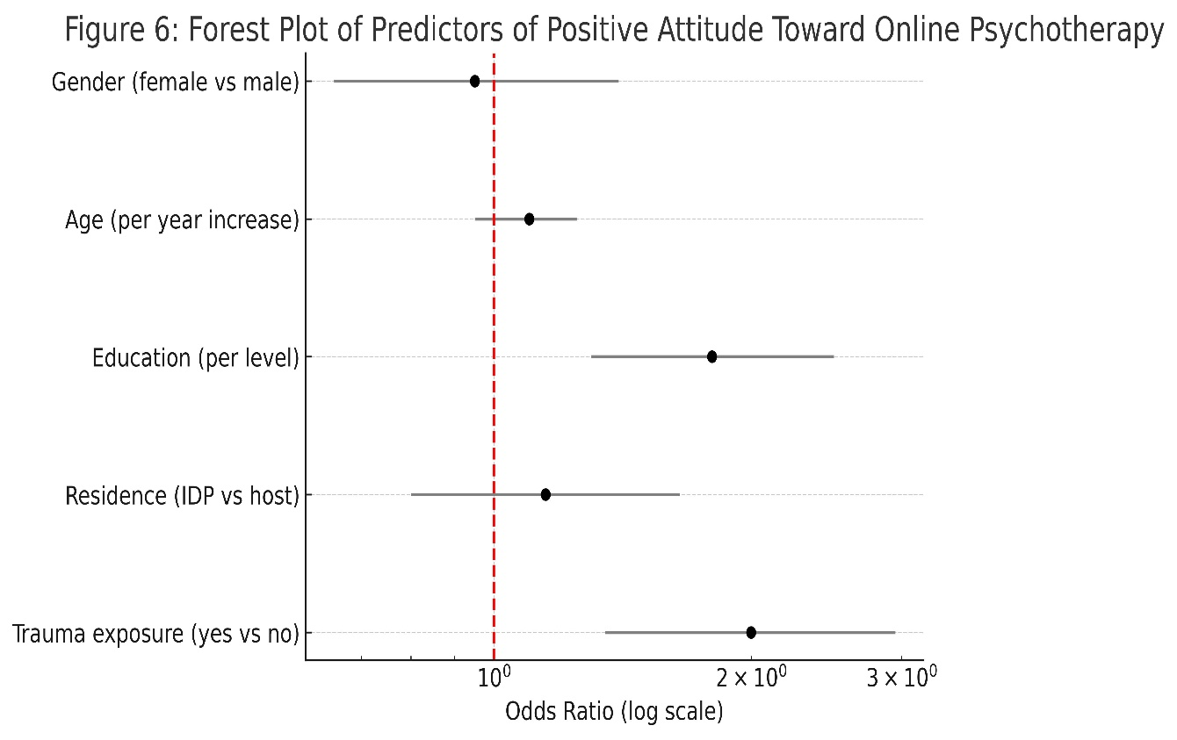

Figure 6 displays these new odds ratios: what is apparent from it is that trauma exposure and education produce large effects in increasing the probability of having a positive attitude, while confidence intervals for gender, age, and residence encompass the null. In reality, an older teenager with some secondary education who has been exposed to conflict is much more likely to embrace online therapy than a less-educated counterpart without this exposure.

Qualitative response followed in step. Most young people viewed online counseling as an added welcome advantage with very limited local services (particularly post-trauma), though others repeated that it should not necessarily supplant face-to-face assistance entirely. For instance, one participant said they would utilize an online counselor only if sessions were provided in their language and did not require a camera (indicating privacy concerns). These unobtrusive insights highlight the necessity to overcome context challenges even as online therapy gains increasing popularity.

Overall, quantitative results reveal wide but qualified acceptance of online psychotherapy among war-affected Nigerian youth. Approximately two out of three are disposed in favor of it, particularly those who have attained advanced education or direct trauma. Nevertheless, half of the total interviewees are still reserved regarding privacy and connectivity. Combining Table 2 (descriptive KAP), Table 1 (subgroup differences), and Table 3 (multivariable predictors)

provides a general picture: while the youth as a whole are supportive of the notion of internet- delivered care, implementation will succeed by being mindful of infrastructure and trust issues.

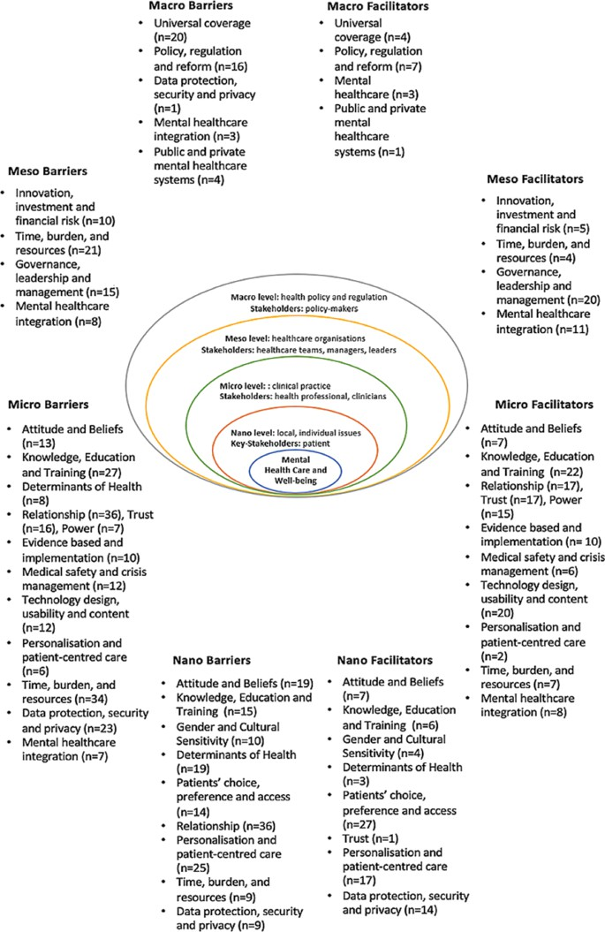

Figure 7: Multi-Level Illustration of Barriers and Facilitators to Digital Health Implementation across levels of mental health systems. Chiara B. et al., (2024).

Discussion

Our cross-sectional survey showed Nigerian young people who were exposed to conflict had intermediate internet therapy knowledge but twofold use. Almost six in ten (58%) were aware of internet counseling, but only 22% ever used it. Attitudes were generally positive: around 63% welcomed online therapy. Young people identified privacy and convenience as of most valuable benefits ("greater privacy", easier access). Meanwhile, nearly half of the participants were worried about data safety and stability on the web: some 45–50% feared sessions would not remain confidential or that connectivity problems would break up therapy. A fraction more than one-fourth mentioned cost or stigma as being negative. Generally speaking, there was high interest in web counseling, but with thoughtful caution regarding infrastructure and privacy.

These findings are consistent with broader global and regional patterns. The World Health Organization (WHO) mentions that populations in conflict have very high mental health needs – about one in five have a diagnosable illness, and nearly all suffer considerably. In Nigeria, for example, displaced adolescents are interviewed and find rates of PTSD and depression over 90%. Such a gigantic unmet need is consistent with the willingness among our respondents for help. At the same time, however, the huge low-resource treatment gap – more than 90% of mentally ill individuals in developing nations receive no treatment – accounts for the attractiveness of digital cures. Digital treatments (apps, telepsychiatry) have been hailed as emergency-scale interventions. Our findings resonate with WHO and others' calls to use technology: youth here viewed online therapy as supplemental to under-funded local facilities (particularly in the aftermath of trauma). Concurrently, there were classical barriers to low- resource telehealth. Earlier reviews report that poor internet, inconsistent electricity, low e- literacy, and stigma all work against telemedicine in Africa. In the same vein, the most pressing worries of our participants were precisely confidentiality and connectivity, consistent with reports that Nigerians generally have issues with data privacy in far-from-physician care.

User Preference Distribution by Mode of Access

These details capture people's preferences for various means of online delivery of psychotherapy: video call, voice call, chat-based (text), and asynchronous modules (pre-recorded sessions or
app-guided therapy)

Table 5: User Preference Distribution by Mode of Access for Online Psychotherapy

Access Mode | Number of Respondents | Percentage (%)
Video-based therapy | 176 | 41.9%
Voice-only sessions | 98 | 23.3%
Chat/text-based | 102 | 24.3%
Asynchronous/self-guided | 44 | 10.5%
Total | 420 | 100%


User Preference Distribution by Mode of Access
44
10.5%
102
24.3%
176
41.9%
23.3%
Percentage (%)
98
Number of Respondents
Figure 8: A pie chart representing user preference distribution by mode of access.

Video therapy was rated the highest, most likely because of feelings of personal contact and familiarity. Text-based alternatives followed, signaling demand for low-bandwidth, unobtrusive formats. One of the smaller cohorts favored asynchronous/self-paced therapy, which could reflect interest in flexible and individualized participation. Preferences will most probably be connected with internet access, privacy concerns, and device access.

These trends can be understood in terms of theoretical models. The Health Belief Model (HBM) posits that individuals will utilize a health service if they possess high susceptibility/severity of illness and unambiguous benefits to action and fewer barriers. In our sample, those exposed to direct conflict and hence presumably seeing more need and threat were more accepting of internet-based therapy: approximately 70% trauma exposed and approximately 55% not trauma exposed had positive attitudes. This is consistent with HBM: greater perceived need can enhance the acceptance of a new treatment. The Technology Acceptance Model (TAM) would also point to perceived usefulness and ease of use. Respondents highly supported usefulness (convenience, privacy), and this would have promoted positive attitudes. Conversely, inhibitions to ease of use (data cost, unreliable internet) would have discouraged some take-up. Consistent with expectations, recent evidence showed that structural barriers trump attitudes in telehealth take- up: people from disadvantaged locations may desire telehealth, but structure (connectivity, accessibility) is what supplies the barriers. Our findings concur: even passionate youth backed

away when infrastructure was weak. (See Figure 9 for an integrated model of how theoretical and contextual factors influence online therapy acceptance.)
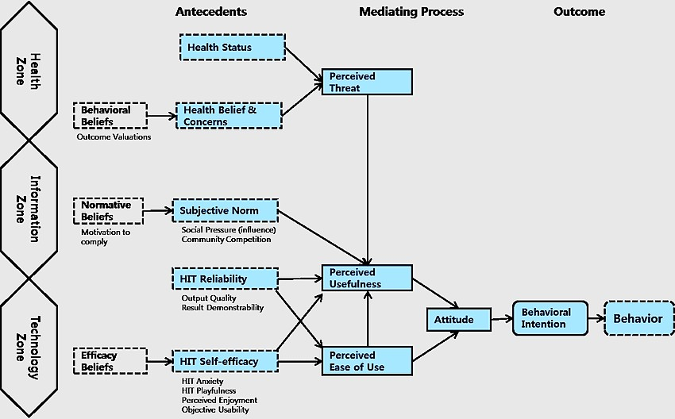

Figure 9: This figure illustrates how Health Belief Model (HBM) factors and Technology Acceptance Model (TAM) factors correlate with contextual factors (e.g., education level, trauma exposure) in influencing young people's attitudes towards online psychotherapy in war zones. Perceived usefulness and perceived ease of use both influence final behavioral intention to use digital therapy. Jeongeun K. and Hyeoun-A. P. (2012).

Education and trauma exposure also influenced openness. Better-educated adolescents had a much higher perception and acceptance of cyber counseling. Every step up the ladder of education septupled or quadrupled the odds of a positive attitude. This is probably increased health literacy and digital literacy among better-educated adolescents (a TAM factor), and improved resources (data, smartphones). Gender and age didn't have any independent influence. Exposure to violence also had a significant effect: residence in an IDP camp or experiencing personal trauma roughly doubled the odds of adopting online therapy. This indicates that individuals who have "witnessed the worst" may be more inclined to go in search of any available assistance, in line with HBM (perceived severity).

Limitations must be acknowledged. We were a self-reported, cross-sectional survey, and therefore, we cannot establish causality or actual behavior. To illustrate, the result that education is linked with a positive attitude can be confounded by unmeasured variables (the cross-sectional nature prevents us from making causal inference). All of our information was hypothetical KAP measurements, and therefore, what people report doing might not be what they would do if

online therapy were on offer. Responses could also be affected by social desirability (e.g., there may be underreporting of stigma issues). We were restricted to youths in two north-eastern states, and we were not able to access some of the high-risk areas, so findings may not be generalizable to all Nigerian youths or other settings. In particular, we did not assess digital literacy or actual device/internet possession directly, something we postulate mediates these attitudes. Lastly, cultural subtleties of beliefs about mental health were perhaps not tapped to the extent of our standardized measure. However, the massive sample and trauma-informed design provide confidence that the prevalent trends (moderate awareness, high openness tempered by obstacles) are indeed accurate.

Implications and recommendations: Above all, our study suggests practical paths forward for expanding digital therapy in conflict zones. First, infrastructure must be addressed. Adolescent fears regarding the internet and privacy reflect country-level assessments of Nigeria's digital health shortfalls – not enough broadband, bad e-literacy, and public skepticism about data privacy. Investments in stable connectivity and low-bandwidth platforms are needed. For instance, enabling apps on feature phones or even SMS-based counseling brings down the barrier of access. Collaboration with telecoms to offer subsidized data for mental health purposes or offline modules distribution is one way to simplify this. Second, destigmatizing and digital literacy campaigns spearheaded at the grassroots level can empower young people. Basic e-skills and internet mental health awareness can be imparted through school programs or youth clubs, in much the same way as public health campaigns are distributed. Involvement of peer educators and community leaders for awareness activities would be consistent with the Health Belief Model through reinforcement of perceived benefits and knowledge. Third, services would need to be culturally modified and plausible. Language and anonymity were highlighted by respondents: "If sessions were in their language and not with a camera" they would attempt online therapy, a youth reported. Therefore, sites should offer local languages and privacy settings (e.g., text messaging, no video, audio only), and give notice of confidentiality practices (e.g., end-to-end encryption). Engagement with local stakeholders, and even the inclusion of renowned traditional or religious leaders in messages, can increase confidence. WHO digital health guidelines also support co-developing culturally appropriate interventions and confidence- building through community engagement. They also need to consider mental health literacy – what therapy is and how it can help them – to temper misconceptions of vulnerability.

Recommended steps for implementation: Organize community workshops on digital health sensitization; roll out youth-friendly online counseling apps with minimal data requirements; localize the language spoken by local counselors or moderators; partner with NGOs for the deployment of online support within IDP camps; offer special training for teletherapy clinicians; and encourage policy-makers to integrate tele-mental health into emergency preparedness. These measures resonate with current calls for expanding broadband, acquisition of digital skills, and public-private partnerships to ensure telemedicine continuity.

Future research: Our findings speak in certain directions.
Try longitudinal or experimental research to examine if positive attitudes translate into real- world use and improved mental health outcomes when digital therapy is initiated. For

instance, a pilot trial of a cognitive-behavioral therapy program on the effects of mobile phones could measure usage and symptom improvement over time.
Set up pilot intervention initiatives in schools or communities, possibly in modes (texting vs. voice calls vs. app sessions) to see what works best locally.
Employ qualitative research tools (in-depth interviews, focus groups) with families and young people to pilot-test messaging, iron out underlying issues, and co-design the platform interface.
Consider including co-research of combining traditional services (e.g., involving local healers or clergy specialists for referral).
Evaluate outcomes in bigger groups (older adults, other areas, other nations) to make findings more generalizable.

These exercises will clearly describe how to conduct online psychotherapy effectively in fragile environments.

Conclusion

Overall, our survey showed war-impacted Nigerian youths to be quite receptive to online psychotherapy, although their acquaintance and application were just average. The vast majority were familiar with online counseling, and an overwhelming majority (≈63%) said they would be open to trying it based on ease of access and privacy. However, nearly half of them had serious doubts about confidentiality and connectivity. Education and direct experience of conflict were the strongest predictors of positive attitude: more educated and trauma-exposed youth were substantially more likely to embrace computer-aided therapy.

These results are significant because the conflict zones of Nigeria possess enormous unmet mental health demands and rapidly growing youth populations. Online counseling could be an extended lifeline when face-to-face counseling is unavailable or cut off. By demonstrating that large numbers of youth are willing – even enthusiastic – to give e-therapy a chance, this research brings to the foreground the promise of digital mental health to fill the gap. At a broader scale, our findings affirm the potential of digital technology as an avenue to supplement access to care in low-resource and crisis contexts, complementary to conventional systems.

There are policy and practice implications: scaling up digital mental health interventions has to be followed by infrastructure and literacy investments. Aid agencies and policymakers need to integrate online counseling into systems of disaster response, facilitate financing for youth- friendly telehealth, and maintain data privacy laws. Counseling could be promoted and facilitated via social media and very accessible common mobile outlets among Nigerian youths. Clinicians and NGOs in conflict zones can begin training on teletherapy skills. Briefly, stakeholders should not consider online psychotherapy as a future possibility but rather as a viable option to initiate from today.

Future actions involve building and pilot testing culturally modified online therapy packages, preferably with the host localities' involvement. Successful and economical pilot tests could provide lessons for larger rollouts. Long-term mainstreaming of digital offerings within Nigeria's health system could contribute to feeding the WHO's universal mental health coverage targets.

Finally, our research indicates that adolescents in crisis are primed for innovation: With adequate infrastructure, Internet-based therapy can be a major component of addressing their psychological requirements.

Consent
All participants provided written informed consent. Participation was voluntary, and anonymity and confidentiality were maintained throughout the research process. To provide protection:

▪ Private safe spaces were utilized for interviews.
▪ Referral lists for on-site psychosocial first aid were provided.
▪ Names or identifying details were not asked for.
▪ Participants were free to skip questions or withdraw at any time without penalty.

Disclaimer (Artificial intelligence)

Author(s) hereby declare that NO generative AI technologies such as Large Language Models (ChatGPT, COPILOT, etc.) and text-to-image generators have been used during the writing or editing of this manuscript.

References

- Adewuya, A. O., Ola, B. A., & Afolabi, O. O. (2016). Prevalence of post-traumatic stress disorder and depression among Nigerian IDPs. Journal of Traumatic Stress Disorders & Treatment, 5(2), 1000157.
- Ambriz González, G., Jurado, S., & Rosas-Carrasco, O. (2015). Attributes of resilience in older adults with depression. Aging & Mental Health, 19(4), 328–338. https://doi.org/10.1080/13607863.2014.933309
- Andersson, G., Cuijpers, P., Carlbring, P., Riper, H., & Hedman, E. (2014). Guided Internet-based vs. face-to-face cognitive behavior therapy for psychiatric and somatic disorders: A systematic review and meta-analysis. World Psychiatry, 13(3), 288–295. https://doi.org/10.1002/wps.20151
- Aricioglu, F., & Olgun, Z. K. (2019). An investigation into the effect of resilience and self-compassion on psychological well-being in college students. International Journal of Higher Education, 8(2), 91–100.
- Aslan, M., & Çiçek, İ. (2021). The mediating role of resilience in the relationship between the fear of COVID-19 and mental well-being. Studia Psychologica, 63(4), 362–373.
- Calandri, E., Graziano, F., Borghi, M., Bonino, S., & Cattelino, E. (2021). Emerging adults facing the COVID-19 pandemic: The role of emotion regulation, self-efficacy, and resilience on perceived stress. Journal of Adult Development, 28, 259–270. https://doi.org/10.1007/s10804-021-09374-3
- Carver, C. S. (1997). You want to measure coping but your protocol’s too long: Consider the brief COPE. International Journal of Behavioral Medicine, 4(1), 92–100.
- Chiara B. et al., (2024). Barriers and facilitators to the implementation of digital technologies in mental health systems: a qualitative systematic review to inform a policy framework.
- Dawson, D. L., & Golijani-Moghaddam, N. (2020). COVID-19: Psychological flexibility, coping, mental health, and wellbeing in the UK during the pandemic. Journal of Contextual Behavioral Science, 17, 126–134. https://doi.org/10.1016/j.jcbs.2020.07.010
- Dawson, D. L., Golijani-Moghaddam, N., & Puchalski, C. M. (2021). COVID-19: Psychological flexibility, coping, mental health, and wellbeing in the UK during the pandemic. Journal of Contextual Behavioral Science, 19, 576–584. https://doi.org/10.1016/j.jcbs.2021.04.006
- Eisenberg, S. A., Shen, B. J., Schwarz, E. R., & Mallon, S. (2012). Avoidant coping moderates the association between anxiety and patient-rated physical functioning in heart failure patients. Journal of Behavioral Medicine, 35(3), 253–261.
- Folkman, S., & Lazarus, R. S. (1988). Manual for the ways of coping questionnaire. Palo Alto, CA: Consulting Psychologists Press.

- Gonzalez, L. (2020). Resilience and well-being in college students during the COVID-19 pandemic. International Journal of Environmental Research and Public Health, 17(19), 7002.
- Gureje, O., Lasebikan, V. O., Ephraim-Oluwanuga, O., Olley, B. O., & Kola, L. (2015). Community study of knowledge of and attitude to mental illness in Nigeria. The British Journal of Psychiatry, 186(5), 436–441.
- Inter-Agency Standing Committee. (2007). IASC guidelines on mental health and psychosocial support in emergency settings. https://interagencystandingcommittee.org
- Jaji, Z., Adebayo, A., & Musa, I. (2017). Herd growth parameters and constraints of camel rearing in Northeastern Nigeria. Journal of Arid Agriculture, 27(2), 1–9.
- Kocalevent, R. D., Zenger, M., Hinz, A., Klapp, B. F., & Brähler, E. (2018). Resilient coping in the general population: Standardization of the Brief Resilient Coping Scale (BRCS). Health and Quality of Life Outcomes, 15(1), 251.
- Labrague, L. J. (2021). Resilience as a mediator in the relationship between stress-associated with the COVID-19 pandemic, life satisfaction, and psychological well-being in student nurses: A cross-sectional study. Nurse Education in Practice, 56, 103182.
- Labuschagne, G. N., Jordaan, J. A., & Van Belkum, C. (2021). Psychological well-being and coping among university students during the COVID-19 pandemic in South Africa. South African Journal of Psychology, 51(4), 491–504. https://doi.org/10.1177/00812463211040654
- Lazarus, R. S., & Folkman, S. (1984). Stress, appraisal, and coping. Springer.
- Lenzo, V., Sardella, A., Musetti, A., Freda, M. F., Lemmo, D., Vegni, G., & Quattropani, M.
C. (2022). Hope and resilience during the COVID-19 pandemic: A multicentric study.
International Journal of Environmental Research and Public Health, 19(5), 2704.
- Luthar, S. S., Cicchetti, D., & Becker, B. (2000). The construct of resilience: A critical evaluation and guidelines for future work. Child Development, 71(3), 543–562.
- McCrae, R. R., & Costa Jr, P. T. (1986). Personality, coping, and coping effectiveness in an adult sample. Journal of Personality, 54(2), 385–404.
- Naslund, J. A., Aschbrenner, K. A., Araya, R., Marsch, L. A., Unützer, J., Patel, V., & Bartels, S. J. (2017). Digital technology for treating and preventing mental disorders in low-income and middle-income countries: A narrative review of the literature. The Lancet Psychiatry, 4(6), 486–500. https://doi.org/10.1016/S2215-0366(17)30096-2
- National Population Commission. (2013). Nigeria demographic and health survey 2013. NPC & ICF International.
- Nigerian Communications Commission. (2018). Subscriber statistics. https://www.ncc.gov.ng/statistics-reports/subscriber-data
- Ogundipe, R. O., Omotosho, O. E., & John-Akinola, Y. O. (2025). Perception, attitude, and use of digital health platforms for mental health promotion among students in a national university in southwestern Nigeria: A cross-sectional study. Digital Health, 11, 1–10. https://doi.org/10.1177/20552076251331841
- Onu, C., Adebayo, O., & Bello, R. (2024). Addressing the digital mental health treatment gap in Nigeria: A call for action. Nigerian Journal of Psychiatry, 22(1), 15–21.
- Patel, V., Flisher, A. J., Hetrick, S., & McGorry, P. (2010). Mental health of young people: A global public-health challenge. The Lancet, 369(9569), 1302–1313. https://doi.org/10.1016/S0140-6736(07)60368-7
- Pew Research Center. (2018). Social media use continues to rise in developing countries but plateaus across developed ones. https://www.pewresearch.org/global

- Ryff, C. D. (1989). Happiness is everything, or is it? Explorations on the meaning of psychological well-being. Journal of Personality and Social Psychology, 57(6), 1069.
- Satici, B., Saricali, M., Satici, S. A., & Griffiths, M. D. (2020). Intolerance of uncertainty and mental well-being: Serial mediation by rumination and fear of COVID-19. International Journal of Mental Health and Addiction, 1–12.
- Satici, S. A. (2016). Psychological vulnerability, resilience, and subjective well-being: The mediating role of hope. Personality and Individual Differences, 102, 68–73.
- Shore, J. H. (2013). Telepsychiatry: Videoconferencing in the delivery of psychiatric care. American Journal of Psychiatry, 170(3), 256–262. https://doi.org/10.1176/appi.ajp.2012.12081064
- Smith, B. W., Dalen, J., Wiggins, K., Tooley, E., Christopher, P., & Bernard, J. (2008). The brief resilience scale: Assessing the ability to bounce back. International Journal of Behavioral Medicine, 15(3), 194–200.
- Souri, H., & Hasanirad, T. (2011). Relationship between resilience, optimism and psychological well-being in students of medicine. Procedia - Social and Behavioral Sciences, 30, 1541–1544.
- Tugade, M. M., & Fredrickson, B. L. (2004). Resilient individuals use positive emotions to bounce back from negative emotional experiences. Journal of Personality and Social Psychology, 86(2), 320.
- Werner, E. E. (1995). Resilience in development. Current Directions in Psychological Science, 4(3), 81–85.
- World Health Organization. (2019). Mental health in emergencies. https://www.who.int/news-room/fact-sheets/detail/mental-health-in-emergencies
- World Health Organization. (2020). Recommendations on digital interventions for health system strengthening. https://www.who.int/publications/i/item/9789241550505
- World Health Organization. (2022). Mental health. https://www.who.int/news-room/fact- sheets/detail/mental-health-strengthening-our-response

- Abbreviations and Their Meanings

Abbreviation | Full Meaning
CBT | Cognitive Behavioral Therapy
CI | Confidence Interval
DMHI | Digital Mental Health Intervention
HBM | Health Belief Model
IDP | Internally Displaced Persons
KAP | Knowledge, Attitude, and Perception
LMIC | Low- and Middle-Income Country
OR | Odds Ratio
PTSD | Post-Traumatic Stress Disorder
SPSS | Statistical Package for the Social Sciences
TAM | Technology Acceptance Model
WHO | World Health Organization
WHOQOL-BREF | World Health Organization Quality of Life – BREF version

- Key Terminologies

Term | Description
Digital Mental Health | Use of digital technologies (apps, video calls, SMS, etc.) to deliver psychological services.
E-therapy / Telepsychology / Online Psychotherapy | Provision of psychological counseling over the internet.
Perceived Usefulness | An individual's belief that using a technology will enhance mental health outcomes.
Health Belief Model (HBM) | A psychological model explaining health behavior based on perceived threat, benefits, and barriers.
Technology Acceptance Model (TAM) | Explains user acceptance of technology based on perceived ease of use and usefulness.
Psychosocial Support | Services aimed at addressing psychological and social needs after trauma.

Term | Description
Conflict-Affected Areas | Regions experiencing instability, violence, or displacement due to war or insurgency.
Internet Penetration | The extent to which a population has access to internet services.

