Clinical presentation of IgG4-related disease: A rare case report and literature review

Abstract

IgG4-related disease (IgG4-RD) is a new growing entity of immune-mediated origin, characterized by a mass-forming lesion, the infiltration of IgG4-positive plasma cells and occasionally elevated serum IgG4. It is considered to be both a systemic inflammation and sclerosing disease.
The clinical presentation varies widely, as one or more organs may be affected, either synchronously or metachronously.
Glucocorticoid therapy is the most effective traitement but may be followed by relapses.

It is important to highlight this case and those of the literature, as many gastro-enterologist may have never seen a case of IgG4-RD.

This manuscript provides a better understanding of certain aspects of IgG4-related disease. It will be useful for researchers with a passion for immunology. New research projects may arise from this manuscript such as estimating the incidence and prevalence of IgG4-RD, the raisons that men are more prone to the classic form of IgG4-RD than women in different parts of the world and also why the elderly are often the target.

Through the column of this article, we describe 24-years-old women to whom the clinical presentation, radiological and biological findings were that of IgG4-RD presented as acute hepatitis.

Keywords: IgG4-related disease, severe acute hepatitis, cholangitis.

Introduction

“IgG4-related disease (IgG4-RD) is a clinicopathological entity first described by Professor Sarles in 1961 as a distinctive presentation of pancreatitis combined with hypergammaglobulinemia. The association with IgG4 was reported in 2001 in Japan”. (1)
“Previously, this disorder was known as IgG4 multi-organ lymphoproliferative syndrome (IgG4 MOSLP), IgG4 sclerosing disease, or IgG4-related systemic plasmocytic syndrome (SIPS). Recently, it is simply recognized as IgG4-RD”. (2)

IgG4-RD chiefly affects men older than 50 years of age. (3)
“The diagnosis relies on the following clinical, laboratory, and pathological criteria
swelling or mass in one or more organs; serum IgG4 greater than 1.35 g/L, histopathological features: marked infiltration by lymphocytes and plasma cells, more than ten IgG4-positive plasma cells per high-power field with an IgG4/IgG ratio greater than 40%, storiform fibrosis.
The presence of all three criteria indicates a definitive diagnosis of IgG4-RD”. (4)
The manuscript helps the practitioners to think beyond the common etiologies of acute hepatitis and to think of IgG-4-related disease as a differential for Acute hepatitis which is rare. It also enforces that proper history taking guides us to investigate patients in a better way, so that nothing is missed. One should not shy away till a proper diagnosis is reached.

Below we present a case of a 24 years old patient presented with IgG4-RD.

Case Presentation

The study reports a case that goes back to 27/02/25 of a 24-year-old woman with medical history of self-medication (paracetamol) and one-month history of jaundice without any other symptom, followed by consciousness trouble which motivated a consultation to our emergency department.

The admission examination revealed a conscious patient with jaundice, positif flapping tremor, a blood pressure of 110/80 mmHg and a heart rate of 68 beats per minute. Her respiratory rate was at 23c /min and arterial oxygen saturation at 98% at room air without fever (body temperature at 36.7°C).

The patient's biological assessment revealed a liver function (BT: 265mg/dL, BC:114 mg/dL, BL:151 mg/dL, GGT:180 UI/L, PAL: 140UI/L, ASAT: 808 IU/L and ALT: 513 IU/L),
Prothrombin time and partial thromboplastin time (TP at 68% and TCA at 26s for a witness of 23s),
white blood cell counts of 6,090 cells / mm 3 (Neutrophils 3540, lymphocytes 1810), a haemoglobin level of 12.5 g /dl, thrombocytes at 146,000 cells /mm3.
Natremia:144 mmol / l, kalemia: 3.7mmol /l, correct renal function (urea: 6.6 mmol/L and creatinine: 7.8 mg /dl), fasting blood sugar at 1.03 g/l (5.72 mmol/L), C-reactive protein at 1mg/l, albumin 45 g/L.
Viral hepatitis and autoimmune serologies were negative,
Elevated value of Igg4 = 1.023 mg/dl.

Therapeutic management included lactulose for hepatic encephalopathy and to raise awareness of the importance of forbidding all the treatment that can be hepatotoxic (paracetamol).

Magnetic resonance imaging (RMI) that finds on of its good indication in this case showed:
- Homogeneous hepatomegaly
- Swelling of the body-tail portion of the pancreas
- Dilation of intrahepatic bile duct with biliary cholangitis
Aspect that can be related to Igg4-RD

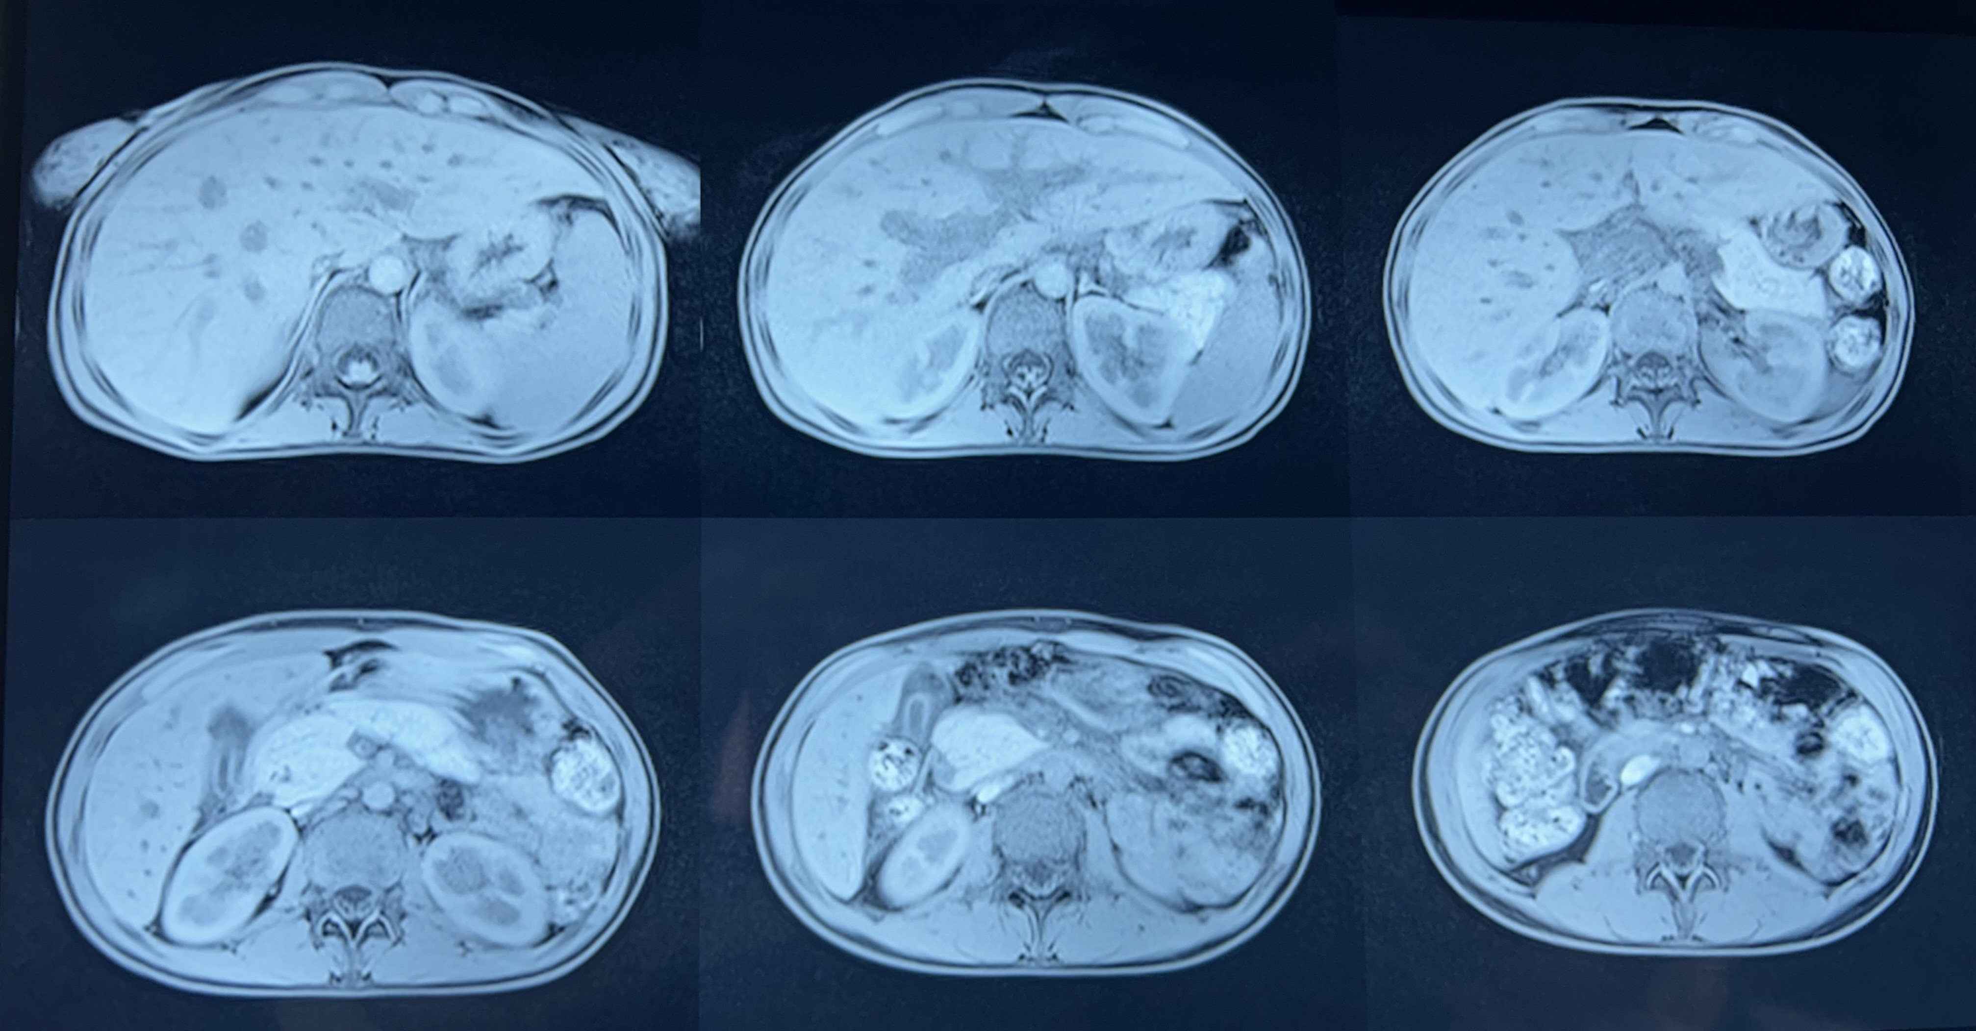

Figure 1: Magnetic resonance imaging showing aspect that can be related to igg4-related disease.

The course of the disease was marked by disappearance of flapping tremor, Jaundice showed signs of improvement and biologically: liver function tests performed every 48 hours, showing good improvement of liver enzymes.
(BT: 92mg/dL, BC: 31mg/dL, BL: 61mg/dL, GGT: 140UI/L, PAL: 56 UI/L, ASAT: 241IU/L and ALT: 88 IU/L)

Discussion:

“IgG4-related disease (IgG4-RD) is a systemic autoimmune disorder characterized by a fibrous-inflammatory process that can affect nearly any organ. Its pathogenesis remains poorly understood”. (16)
Key immune cell subsets contributing to the pathogenesis of IgG4-RD include T follicular helper 2 cells (Tfh2), Tfh1, CX3CR1 + cytotoxic T cells (CX3CR1 + CTLs), Tregs and IgG4 + B cells. (14)
“Common manifestations include dacryoadenitis (lacrimal gland inflammation), sclerosing sialoadenitis of the major salivary glands (submandibular, parotid, and sublingual),
autoimmune pancreatitis, sclerosing cholangitis, and retroperitoneal fibrosis”. (5)

Because of its relatively recent recognition, the incidence and prevalence of IgG4-RD are difficult to estimate. Knowledge of IgG4-RD and recognition of its manifestations has improved in recent years but persistent delays in diagnosis underscore the problem of under-recognition of this disease. (6)

Across cohorts, males tend to be affected more often than females and patients typically present in their 5th, 6th, and 7thdecades of life. However, patients of all ages, including children, have been diagnosed with IgG4-RD. (6)
“Risk factors for IgG4-RD are poorly understood. Tobacco and asbestos exposure have been found to be risk factors for idiopathic retroperitoneal fibrosis in multiple studies conducted before IgG4-RD”. (8)
“Antecedent malignancy has been identified as a risk factor for the subsequent development of IgG4-RD but this observation requires further study”. (9)
Multiorgan disease may be evident at diagnosis but can also evolve metachronously, over months to years. Spontaneous improvement, sometimes leading to clinical resolution of certain organ-system manifestations, is reported.
Manifestation of IgG-4 related disease: hypophysitis, hypertrophic pachymeningitis, hypophysitis, sinusitis, Fibrosing thyroiditis, Tracheobronchial stenosis, Pleural thickening and nodules, pleural effusion, Fibrosing pericarditis and/or mediastinitis, Autoimmune pancreatitis (Type 1), Sclerosing cholangitis, pancreatitis, prostatitis, Tubulointerstitial nephritis (10)

“The appearance in images varies considerably, particularly in the lung and kidney.
The imaging features are generally nonspecific and do not permit reliable distinctions between IgG4-related disease and cancer. In the pancreas, the presence of a peripancreatic halo and diffuse narrowing of the pancreatic duct correspond, respectively, to a fibroinflammatory process extending into peripancreatic adipose tissue and to nonocclusive periductal inflammation”.(7)

“The majority of patients with IgG4-related disease have elevated serum IgG4 concentrations, but the range varies widely. Approximately 30% of patients have normal serum IgG4 concentrations, despite classic histopathological and immunohistochemical findings”. (11)

“A multinational, multidisciplinary group of experts defined criteria for the diagnosis of IgG4-RD. The three major histopathological features associated with IgG4-related disease are as follows: Dense lymphoplasmacytic infiltrate, focally arranged fibrosis in a storiform pattern, obliterative phlebitis”. (13)
“Although no randomized treatment trials have been conducted, several points about treatment are clear. When vital organs are involved, aggressive treatment is needed because IgG4-related disease can lead to serious organ dysfunction and failure. Inebilizumab can reduce the risk of flares of IgG4-related disease”. (15)
“However, not all manifestations of the disease require immediate treatment. For example, IgG4-related lymphadenopathy is often asymptomatic; indolent cases of lymphadenopathy persisting for decades have been reported. Watchful waiting is therefore prudent in some cases”. (12)

Conclusion:

IgG4-related disease is a recently recognized condition with pathological features that are consistent across a wide range of organ systems. This condition unifies a large number of medical disorders previously regarded as confined to single organ systems.

Competing interests:

The authors declare no competing interests.

Authors’ contribution:

All the authors contributed equally in drafting of the manuscript. All the authors read and agreed to the final manuscript
Ethical Approval:
As per international standards or university standards written ethical approval has been collected and preserved by the author(s).
Consent
As per international standards or university standards, patient(s) written consent has been collected and preserved by the author(s).

DISCLAIMER (ARTIFICIAL INTELLIGENCE)
Authors hereby declare that NO generative AI technologies such as Large Language Models (ChatGPT, COPILOT, etc) and text-to-image generators have been used during writing or editing of this manuscript.

References

1. M. Guma et al. Igg-4 related desease.Best Pract Res Clin Rheumatol (2012)

2. Zen Y, Nakanuma Y (2010) IgG4-related disease: a cross-sectional study of 114 cases. Am J Surg Pathol

3. J.H. Stone

IgG4-related disease: nomenclature, clinical features, and treatment

Semin Diagn Pathol
(2012)

4. V. Deshpande et al.

Consensus statement on the pathology of IgG4-related disease

Mod Pathol
(2012)

5. Kamisawa T, Zen Y, Pillai S, Stone JH. IgG4-related disease. Lancet 2015;385(9976):1460–1471.

6. Wallace ZS, Zhang Y, Perugino CA, et al. Clinical phenotypes of IgG4-related disease: an analysis of two international cross-sectional cohorts. Ann Rheum Dis 2019

7. Sahani, DV, Kalva, SP, Farrell, J, et al. Autoimmune pancreatitis: imaging features. Radiology 2004.

8. Goldoni M, Bonini S, Urban ML, et al. Asbestos and smoking as risk factors for idiopathic retroperitoneal fibrosis: a case-control study. Ann Intern Med 2014

9. Wallace ZS, Wallace CJ, Lu N, Choi HK, Stone JH. Association of IgG4-Related Disease With History of Malignancy. Arthritis Rheumatol 2016.

10. national library of medecine IgG-4 related desease Zachary S Wallace and al

11. Sah, RP, Chari, ST. Serologic issues in IgG4-related systemic disease and autoimmune pancreatitis. Curr Opin Rheumatol 2011

12. Cheuk, W, Yuen, HK, Chu, SY, Chiu, EK, Lam, LK, Chan, JK. Lymphadenopathy of IgG4-related sclerosing disease. Am J Surg Pathol 2008

13. Deshpande V, Zen Y, Chan JK et al (2012) Consensus statement on the pathology of IgG4-related disease.

14. Akiyama, M., Alshehri, W., Ishigaki, S., Saito, K., & Kaneko, Y. (2025). The immunological pathogenesis of IgG4-related disease categorized by clinical characteristics. Immunological Medicine, 48(1), 11-23. https://www.tandfonline.com/doi/abs/10.1080/25785826.2024.2407224

15. Stone, J. H., Khosroshahi, A., Zhang, W., Della Torre, E., Okazaki, K., Tanaka, Y., ... & Culver, E. L. (2025). Inebilizumab for treatment of IgG4-related disease. New England Journal of Medicine, 392(12), 1168-1177.https://www.nejm.org/doi/abs/10.1056/NEJMoa2409712

16. Li, J., Wang, M., Zhou, J., Fei, Y., Li, M., Zhao, Y., ... & Zhang, W. (2025). Polarization of Vδ2 T cells to a Th2-like phenotype promotes plasmablast differentiation and possesses pro-fibrotic properties in IgG4-related disease. Frontiers in Immunology, 16, 1550405.https://www.frontiersin.org/journals/immunology/articles/10.3389/fimmu.2025.1550405/full

