PERFORMANCE ANALYSIS OF A SOLAR-POWERED ABSORPTION REFRIGERATION SYSTEM FOR SMALL-SCALE FARMERS IN THE GLOBAL SOUTH

-----------------------------------------------------------------------------------------------------------------------------------------------------------------------------------------------------------------------------------------------------------------------------------------
Abstract
A solar absorption refrigeration system powered by a solar Photovoltaic (PV) module has been successfully built and tested for its performance. The solar panels selected for the absorption refrigeration system are rated at 150 W. From the experiment conducted on the solar-powered absorption refrigeration system, results show that the lowest evaporating temperature of 10.1 °C was achieved after 12 hours of operation from the initial conditions. It was found that a heat input of 785 W, with a coefficient of performance (COP) of 0.65, yields a cooling capacity of 510 W. Another observation was that the system operated at an evaporating temperature ranging between 10.8 °C and 10.1 °C. The overall performance (COP) of the solar-powered absorption refrigeration system is 0.65. Further analysis indicated that the inclusion of energy storage not only enhances cooling but also increases the system’s throughput, allowing it to be used during nighttime hours.
-----------------------------------------------------------------------------------------------------------------------------------------------------------------------------------------------------------------------------------------------------------------------------------------

Keywords: Absorption refrigeration system; Energy storage, Energy-food nexus; Small-scale farmers; Solar PV system

1. Introduction
Solar-powered absorption refrigeration systems are gaining public interest as eco-friendly and sustainable cooling alternatives, as global concern increases over climate change and the depletion of non-renewable energy resources [1]. It is technically feasible to utilize solar energy in a wide range of applications, including food preservation and vaccine storage for medical use. This makes it a desirable option in many developing nations in Africa, especially in remote areas without access to electricity.
The absorption refrigeration system is an older technology. In such systems, the refrigerant is not subjected to mechanical force via an electric compressor. Instead, the cooling effect is produced by heat from a thermal generator, eliminating the need for extensive rotating machinery [2]. The absorption system uses thermal energy to separate the pressurized refrigerant from an absorbent/refrigerant mixture through evaporation.
In an absorption refrigeration system, there is a refrigerant-absorbent pair. Thus, there are two working fluids: one is the refrigerant, and the other is the absorbent. For example, the ammonia-water combination is used to achieve sub-cooling (freezing), while the water-lithium bromide combination is used for temperatures above 0 °C [3]. Several studies in the literature have focused on absorption refrigeration systems. In the work of [4], a theoretical and experimental analysis of a vapor absorption refrigeration system was conducted, achieving a temperature drop of 3.5 °C below ambient temperature over 325 minutes for a system with a 0.25-tonne refrigeration (TOR) capacity.
Another study on solar absorption refrigeration systems found that high fluid viscosity and vacuum conditions negatively affected spray quality and the overall coefficient of performance (COP) [5]. The impact of ambient temperature on the performance of solar absorption refrigeration systems for air-conditioning applications was also analyzed [6]. The study revealed that ambient temperature significantly influences the system’s operational characteristics. When the ambient temperature increases from 35 °C to 40 °C, the COP decreases sharply from 14.85 to 3.95. Conversely, when the ambient temperature drops from 35 °C to 30 °C, the generator load ratio decreases from 100% to 89.9%.
In the study by [7], a 3.6% improvement in energetic efficiency and a slight 0.6% improvement in energetic efficiency were achieved by lowering the generator’s mean temperature by about 6.2 °C and increasing the evaporator’s mean temperature by about 1.6 °C. Additionally, [8] analyzed the COP of an ammonia-water vapor absorption refrigeration system and found it to be 0.598.
From the available literature, one key challenge of solar absorption refrigeration systems is maintaining a constant heat source at night when solar energy is unavailable.
In this research study, a solar-powered absorption refrigeration system incorporating thermal energy storage is built and tested. In the thermal generator section, an electric heater connected to a solar panel is embedded in a Phase Change Material (PCM), serving as a thermal energy storage medium. During the daytime, the PCM is heated by the solar panel and electric heater, storing the thermal energy to sustain system operation throughout the night. This study’s innovation demonstrates that a solar panel connected to a resistive heating element can effectively generate heat and store it in PCM for night-time operation of a solar absorption refrigeration system. The methodological approach of this study is presented in the following sections.
2. Materials and Methods
2.1. Description of the Solar-Powered Absorption Refrigeration System
The solar-powered absorption refrigeration system designed and built for this research study is illustrated in Fig. 1. The system comprises the condenser, evaporator, heating coil, absorber, expansion valves, and solar panel. In the absorption system, the working pair consists of a refrigerant (ammonia) and an absorbent. In the generator section (point 2) of the system, electric resistive heaters are integrated and connected to the solar panel (point 1) [9]. The photovoltaic (PV) system is designed to supply the necessary power to operate the system. Additionally, an electric battery energy storage unit is included to provide electricity solely for operating the solution pump (point 7). The refrigerant vapor escaping from the generator flows into the condenser (point 3), where the condensation heat​ is removed. The resulting liquid refrigerant is then throttled to low pressure (point 4) and directed to the evaporator (point 5) to produce the cooling effect.
In the absorber (point 6), the refrigerant is absorbed into the weak solution that exits the generator and has been throttled to a lower pressure. This refrigerant-absorbent mixture then enters the solution pump (point 7). The strong solution is subsequently pumped back to the generator (point 2), where heat from the solar-powered heating coils separates the refrigerant from the absorbent.
This thermodynamic cycle is continuously repeated, with the refrigerant and absorbent reuniting in the absorber to sustain the refrigeration process.
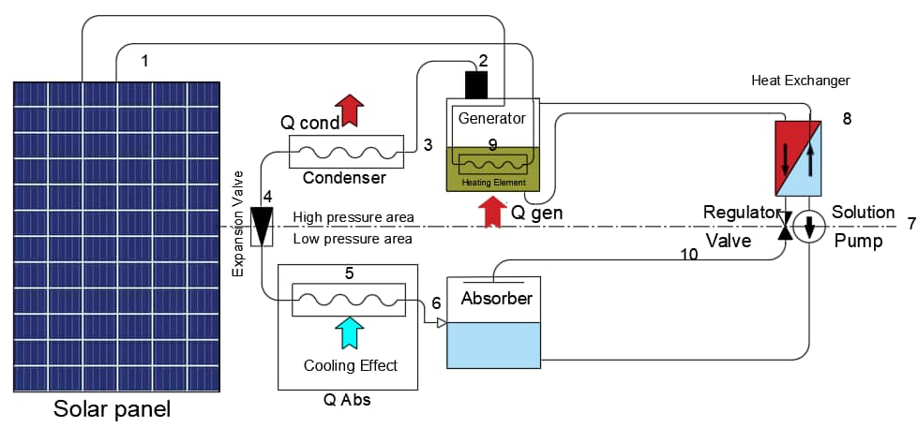
Fig. 1 Schematic drawing of the solar-powered absorption refrigeration system
2.2. Thermodynamic analysis
The heat rejected in the condenser and absorber must equal the energy absorbed in the evaporator and generator, based on the principle of energy conservation, as shown in Equation 1 [10]:
$$Q_{E}+Q_{G}=Q_{A}+Q_{C} (1)$$
Where:
$$Q_{E}=Evaporator heat$$
$$Q_{G}=Generator heat$$
$$Q_{A}=Absorber heat$$
$$Q_{C}=Condenser heat$$
According to the second law of thermodynamics, entropy must remain constant in an ideal reversible process [11]. The increase in entropy in the evaporator corresponds to a decrease in entropy in the condenser, and similarly, the increase in entropy in the generator corresponds to a decrease in entropy in the absorber.
Equations (2) and (3) are used to express this entropy relationship when power equilibrium is assumed instead of energy balance, and when mass flow is linked to the power of the circulating refrigerant [10]:
$$\frac{\dot{Q_{e}}/\dot{m_{v}}}{T_{e}}=\frac{\dot{Q_{c}}/\dot{m_{v}}}{T_{c}} (2)$$
$$\frac{\dot{Q_{a}}/\dot{m_{v}}}{T_{a}}=\frac{\dot{Q_{g}}/\dot{m_{v}}}{T_{g}} (3)$$
Where:
$$\dot{Q_{a}}=Absorber flow heat$$
$$\dot{m_{v}}=circulating refrigerant mass flow$$
$$T_{a}=Absorber temperature$$
$$T_{g}=generator temperature$$
Equation (4) is derived by reformulating the above relationships to determine the coefficient of performance (COP) of the absorption refrigeration system. COP is defined as the ratio of heat absorbed in the evaporator to the heat supplied to the generator [12]:
$$COP=\frac{\dot{Q_{E}}}{\dot{Q_{G}}}=\frac{T_{G}-T_{a}}{T_{G}}×\frac{T_{E}}{T_{C}-T_{E}} (4)$$
Where:
$$\dot{Q_{E}}=Evaporator flow heat$$
$$\dot{Q_{G}}=Generator heat flow$$
$$T_{a}=Absorber temperature$$
$$T_{G}=Generator temperature$$
$$T_{E}=Evaporator temperature$$
$$T_{C}=Condenser temperature$$
2.2.1 Evaporator Analysis
The evaporator is the component of the refrigeration system where the refrigerant vaporizes and absorbs heat [13]. The refrigerant must reach a low pressure before it can enter the evaporator in a condensed state. The evaporator is designed to receive low-temperature fluid from the throttle valve on the low-pressure side, bring it into close thermal contact with the load, and release the refrigerant as dry gas [14].
By applying energy balance principles, the heat absorbed in the evaporator can be calculated using Equations (5) and (6), as reported in [10]:
$$\dot{m_{5}}=\dot{m_{6}} (5)$$
$$Q_{E}=\dot{m_{6}}h_{6}-\dot{m_{5}}h_{5} (6)$$
Where:
$$\dot{m}=mass flow rate of the evaporator$$
$$h=enthalpy of the evaporator$$
2.2.2 Condenser analysis
The condenser is responsible for transferring energy from the refrigeration system to an external medium, which can then dispose of it [15]. Heat rejection in the condenser can be facilitated via liquid cooling circuits or air. High-pressure, high-temperature refrigerant vapor enters the condenser, where it first loses sensible heat, lowering its temperature to the condensation point. It then releases latent heat, condensing into a liquid state [16].
The mass flow and heat rejection in the condenser are expressed by Equations (7) and (8) [5]:

$$\dot{m_{3}}=\dot{m_{4}} (7)$$
$$Q_{C}=\dot{m_{4}}h_{4}-\dot{m_{3}}h_{3} (8)$$

Where:
$$Q_{C}=Condenser heat$$
$$\dot{m}=mass flow rate of the condenser$$
$$h=enthalpy of the condenser$$

2.3 Experimental setup and measurement
Figure 2 shows the complete experimental setup used for the study. The system comprises solar panels and an absorption refrigeration system with the generator embedded in a phase change material (PCM). The specifications of each component in the system are summarized in Table 1.
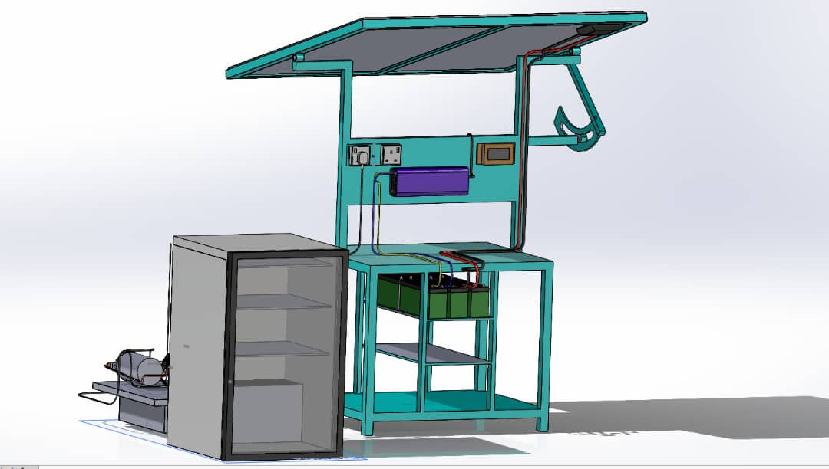
Fig. 2 The complete experimental setup used for the study
Table 1: The specifications of the system component
Name of component | Quantity /Unit | System size & specification
Solar panel capacity | 4 panels | 150 W each (600 W total)  Rated voltage per panel: 18.0 V  Rated current per panel: 8.33 A
Heating coil capacity | 1 | 100 W
Evaporator capacity | 1 | Cooling capacity: 48 W
Condenser capacity | 1 | Condenser capacity: 151 W
Absorber capacity | 1 | Absorber capacity ranges between 500 - 1000 W
Pump capacity | 1 | Volt: 24 volts  Current/Amps: 1.0 A – 1.2 A  Open flow: 72 L/H  Working Pressure: 0.70 MPa  Working flow: 43 L/H  Max Pressure: 1.0 MPa
Generator capacity | 1 | Generator capacity: 1000 W
PCM material used in the generator | 1 | The type of PCM used is Eutectic Salts and water.
To gain a clear understanding of the system, each component was tested for its electrical and/or mechanical characteristics. The following sections present the step-by-step testing of each system component.
2.3.1. Testing of Solar Panel
Under bright sunlight, the solar panel achieved a voltage of approximately 19.9 V, as shown in Fig. 3. This value is very close to the design specification listed in Table 1, as reported by [17].
Fig. 3 Open-circuit voltage of a solar panel
2.4 Testing of Charge Controller
To charge the 12V battery, a voltage of approximately 14.6V is required, as reported by [18], since a potential higher than 12V is necessary for effective charging. Testing with a multimeter on the charge controller confirmed a voltage of 14.6V, as shown in Fig. 4. According to [19], the selected charge controller is rated at 20A for 12V/24V systems. It can therefore be concluded that the solar charge controller is well-suited for the system module.
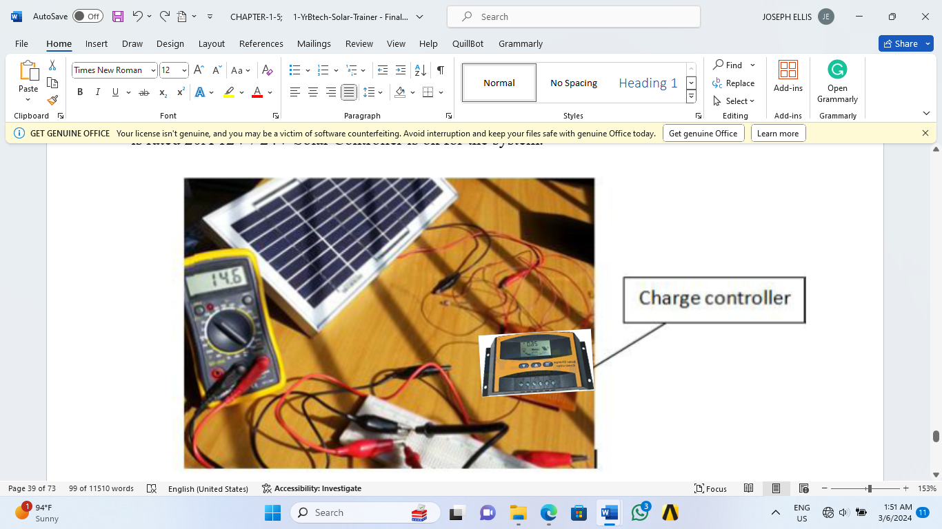
Fig. 4 Testing of the charge controller
After sunlight was intentionally blocked, the output voltage dropped to 12.3V, as shown in Fig. 5, indicating that the output voltage depends on the amount of available sunlight, as reported by [20]. For the charge controller to function properly, sunlight must be directed onto the solar panel without obstruction.
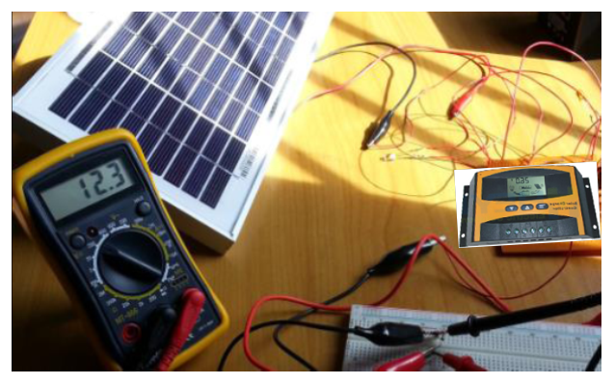
Fig. 5 Calibration of the charge controller
2.5 Performance testing of the system
The solar absorption refrigeration system was tested at the Air-Conditioning and Refrigeration Laboratory (ACRU Lab) of Kwame Nkrumah University of Science and Technology. An average sun irradiance of 420 W/m² was measured on the panel surface, and a system voltage of 39.5 volts was recorded using a multimeter.
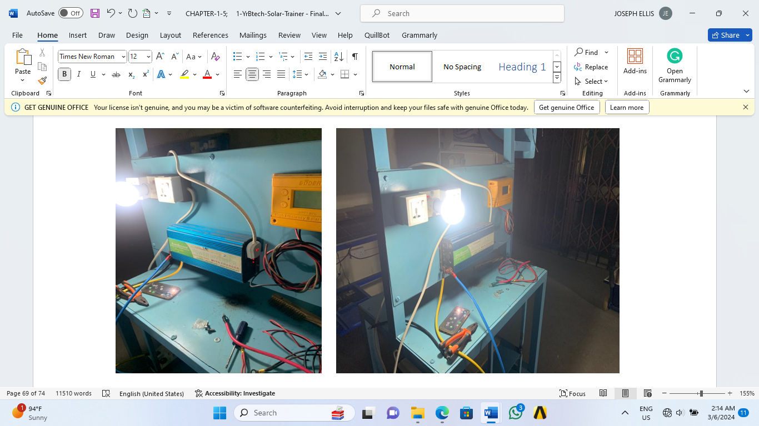
Fig. 6 Inverter operating a fluorescent light.
3. Results and Discussion
3.1 Temperature of the solar absorption refrigeration system
As already pointed out, the focus of this study is to test the performance of the system based on the PCM thermal energy storage medium. The variation of temperature inside the evaporator of the absorption refrigeration system over time during the test is shown in Figures 7 and 8.

Fig. 7 The cooling temperature of the solar absorption refrigeration system is observed from 8 pm to 9 am.
The initial evaporating temperature of the evaporator was recorded at 27.0 °C, with an ambient temperature of 28.0 °C at exactly 20:00 GMT (8:00 pm). The lowest evaporating temperature of 10.1 °C was observed at 9:00 GMT (9:00 am). During the first 30 minutes of system operation, the temperature decreased from 27.0 °C to 26.0 °C. In the subsequent 30 minutes, it further dropped from 26.0 °C to 24.3 °C. On average, the temperature declined by 1.7 °C every 30 minutes. The system demonstrated a cooling rate of 0.0567 °C/min. Additionally, under steady-state conditions, the system operated within an evaporating temperature range of 10.8 °C to 10.1 °C.

Fig. 8 The cooling temperature of the solar absorption refrigeration system as observed from 9 am to 8 pm
3.2 Temperature of the Generator and the Condenser
The temperature variation of the generator and the condenser over time in the solar absorption refrigeration cycle is presented in Fig. 9.

Fig. 9 Temperature variation with time of the Generator and Condenser
From Fig. 9, the following observations were made:
The initial generator temperature was recorded at 34.9 °C at 20:00 GMT (8:00 pm). It was observed that the generator temperature increases only during the daytime, when solar radiation is available, and the heating element actively charges the generator from morning until evening. The generator temperature rises in tandem with the condensing temperature, at an average rate of 0.2 °C per minute. Both the generator and condenser maintained constant temperatures starting from 6:00 GMT. The generator stabilized at a temperature of 82.5 °C, regulated by a temperature-control device known as a heating thermostat. Between 5:30 GMT and 6:00 GMT, the generator temperature fluctuated between 80.2 °C and 82.5 °C.
The generator’s maximum operating temperature of 82.5 °C corresponded to a condensing temperature of 40.4 °C at 6:00 GMT. This value also marked the maximum condensing temperature observed at the inlet of the condensing unit.
At the exit of the condenser and the inlet of the capillary tube, a constant temperature of 40 °C was recorded at 22:00 GMT, while the evaporator temperature decreased from 27 °C to 26 °C at 20:30 GMT. This cycle was continuously repeated in the absorption refrigeration system.
The Phase Change Material (PCM) is housed in a small container located inside the cooling compartment, near the evaporator. It provides high thermal storage capacity and helps maintain stable internal temperatures. The PCM used in this study is Eutectic Solution, typically a mixture of salts and water. During power outages, the PCM melts and releases stored thermal energy, thereby maintaining the refrigeration temperature.
3.3 Performance of the solar-powered absorption refrigeration system
The mathematical and heat transfer calculations for each component were conducted to determine the overall performance, specifically, the coefficient of performance (COP) of the solar-powered absorption refrigeration system.
Using Equation (4), the COP is calculated based on the ratio between the heat absorbed in the evaporator and the heat supplied by the generator, as proposed by [12]:
$$COP=\frac{\dot{Q_{E}}}{\dot{Q_{G}}}=\frac{T_{G}-T_{a}}{T_{G}}×\frac{T_{E}}{T_{C}-T_{E}} (4)$$
$$COP=\frac{T_{G}-T_{a}}{T_{G}}×\frac{T_{E}}{T_{C}-T_{E}}$$

Where:
$T_{G}=Generator temperature$
$$T_{a}=Absorber temperature$$
$$T_{E}=Evaporator temperature$$
$$T_{C}=Condenser temperature$$
According to [21], the most favorable working temperature ranges for ammonia-water refrigeration systems that yield a COP between 0.6 and 0.8 are as follows:
- Generator Temperature, T_{G}: 60 – 99 °C
- Condenser Temperature, T_{C}: 21 – 60 °C
- Absorber Temperature, T_{A}: 16 – 32 °C
- Evaporator Temperature, T_{E}: 2.5 – 10 °C
The operating temperatures selected for this study are as follows:
- Generator temperature is taken as the maximum achievable value in the system, per [22]:
T_{G} = 82.5 °C
- The condenser temperature is selected as the lowest theoretical value per [22]:
T_{C} = 21 °C
- Evaporator temperature is also chosen as the lowest theoretical value, per [22]:
T_{E} = 4 °C
- Absorber temperature is taken as: T_{A} = 20 °C
However, the actual operating temperatures observed for the system's performance evaluation are:
- Generator Temperature, T_{G} = 82.5 °C
- Condenser Temperature, T_{C} = 21 °C
- Absorber Temperature, T_{A} = 25 °C
- Evaporator Temperature, T_{E} ​= 10.1 °C
Substituting these values into Equation (4):
$$COP=\frac{T_{G}-T_{a}}{T_{G}}×\frac{T_{E}}{T_{C}-T_{E}}$$
$$COP=\left(\frac{82.5-25}{82.5}\right)×\left(\frac{10.1}{21-10.1}\right)$$
COP = 0.65
The overall coefficient of performance (COP) of the solar-powered absorption refrigeration system is 0.65. This value falls within the typical range of 0.6 to 0.8, as reported in [19].
4. Conclusions
Based on the study, the following conclusions are drawn:
- A solar absorption refrigeration system powered by a solar Photovoltaic (PV) module was successfully built and tested to evaluate its cooling capacity and overall performance. The solar panels used for the system were rated at 150 W, with a maximum power voltage (Vmp) of 18.0 V and a maximum power current (Imp) of 6.67 A.
- The initial evaporating temperature of the evaporator was recorded at 27.0 °C, with an ambient temperature of 28.0 °C at exactly 20:00 GMT. The lowest evaporating temperature achieved was 10.1°C, recorded at 9:00 GMT.
- During the first 30 minutes of system operation, the temperature decreased from 27.0 °C to 26.0 °C. With a heat input of 785 W and a coefficient of performance (COP) of 0.65, the system delivered a cooling capacity of 510 W.
- It was further observed that the solar-powered absorption refrigeration system operated at an evaporating temperature range between 10.8 °C and 10.1°C.
- The overall performance of the system, as indicated by the coefficient of performance, was 0.65. Further analysis showed that the integration of thermal energy storage not only enhanced cooling efficiency but also increased the system’s usability during nighttime hours.
- A solar absorption refrigeration system powered by a solar Photovoltaic (PV) module is technically feasible to utilize solar energy in a wide range of applications, including food preservation and vaccine storage for medical use. This makes it a desirable option in many developing nations in Africa, especially in remote areas without access to electricity.

Declarations
Conflict of Interest
The authors declare that they have no known competing financial interests or personal relationships that could have appeared to influence the work reported in this paper.

Disclaimer (Artificial intelligence)
Author(s) hereby declares that NO generative AI technologies such as Large Language Models (ChatGPT, COPILOT, etc.) and text-to-image generators have been used during the writing or editing of this manuscript.

References

[1] A. G. Olabi et al., “Progress in Solar Thermal Systems and Their Role in Achieving the Sustainable Development Goals,” Energies, vol. 15, no. 24, 2022, doi: 10.3390/en15249501.
[2] R. Z. Wang and R. G. Oliveira, “Adsorption refrigeration-An efficient way to make good use of waste heat and solar energy,” Prog. Energy Combust. Sci., vol. 32, no. 4, pp. 424–458, 2006, doi: 10.1016/j.pecs.2006.01.002.
[3] M. U. Ahrens et al., “Applied Sciences Identification of Existing Challenges and Future Trends for the Utilization of Ammonia-Water Absorption – Compression Heat Pumps at High-Temperature Operation,” 2021.
[4] V. D. Patel, a J. Chaudhari, and R. D. Jilte, “Theoretical and Experimental Evaluation of Vapour Absorption Refrigeration System,” Natl. Conf. Emerg. Trends Eng. Technol., no. November, pp. 128–131, 2012, [Online]. Available: http://www.ijera.com/special_issue/VNCET_Mar_2012/23.pdf
[5] M. A. J. A. Juma, “Solar Absorption Cycle for Cooling / Refrigeration,” PhD Thesis, no. March, pp. 1–172, 2014.
[6] J. Sarkar and S. Bhattacharyya, “Application of graphene and graphene-based materials in clean energy-related devices,” Arch. Thermodyn., vol. 33, no. 4, pp. 23–40, 2012, doi: 10.1002/er.
[7] S. Sharifi, F. Nozad Heravi, R. Shirmohammadi, R. Ghasempour, F. Petrakopoulou, and L. M. Romeo, “Comprehensive thermodynamic and operational optimization of a solar-assisted LiBr/water absorption refrigeration system,” Energy Reports, vol. 6, pp. 2309–2323, 2020, doi: 10.1016/j.egyr.2020.08.013.
[8] K. Shukla, A., Mishra, A., Shukla, D., & Chauhan, “I A E M E C . O . P Derivation and Thermodynamic Calculation of Ammonia Water Vapor Absorption Refrigeration System,” vol. 6, no. 5, pp. 72–81, 2015.
[9] R. Opoku, E. A. Adjei, G. Y. Obeng, L. Severi, and A.-R. Bawa, “Electricity Access, Community Healthcare Service Delivery, and Rural Development Nexus: Analysis of 3 Solar Electrified CHPS in Off-Grid Communities in Ghana,” J. Energy, vol. 2020, pp. 1–10, 2020, doi: 10.1155/2020/9702505.
[10] M. Zaki, “Design and Construction of a Continuous Solar Absorption Refrigeration Unit,” no. 1993, pp. 1–137, 1999.
[11] H. Struchtrup, “Entropy and the second law of thermodynamics, nonequilibrium perspective,” Entropy, vol. 22, no. 7, 2020, doi: 10.3390/e22070793.
[12] H. Rostamnejad Takleh and V. Zare, “Employing thermoelectric generator and booster compressor for performance improvement of a geothermal driven combined power and ejector-refrigeration cycle,” Energy Convers. Manag., vol. 186, no. November 2018, pp. 120–130, 2019, doi: 10.1016/j.enconman.2019.02.047.
[13] J. Aman, P. Henshaw, and D. S. K. Ting, “Caractérisation des performances d’une pompe à bulles pour les machines frigorifiques à absorption de vapeur,” Int. J. Refrig., vol. 85, no. September 2020, pp. 58–69, 2018, doi: 10.1016/j.ijrefrig.2017.09.011.
[14] M. M. Islam, S. Bhowmick, and J. Ishtiaque, “Design and Fabrication of a Vapor Absorption Refrigeration System for Vehicle Cabin Cooling Utilizing Exhaust heat, BSc,” no. January 2017, pp. 1–92, 2017.
[15] R. Nikbakhti, X. Wang, A. K. Hussein, and A. Iranmanesh, “Absorption cooling systems – Review of various techniques for energy performance enhancement,” Alexandria Eng. J., vol. 59, no. 2, pp. 707–738, 2020, doi: 10.1016/j.aej.2020.01.036.
[16] V. S. Chakravarthy, R. K. Shah, and G. Venkatarathnam, “A review of refrigeration methods in the temperature range 4-300 K,” J. Therm. Sci. Eng. Appl., vol. 3, no. 2, pp. 1–19, 2011, doi: 10.1115/1.4003701.
[17] M. Karabulut, H. Kusetogullari, and S. Kivrak, “Outdoor Performance Assessment of New and Old Photovoltaic Panel Technologies Using a Designed Multi-Photovoltaic Panel Power Measurement System,” Int. J. Photoenergy, vol. 2020, 2020, doi: 10.1155/2020/8866412.
[18] S. Lavety, R. K. Keshri, and M. A. Chaudhari, “Multistep Constant Current-Constant Voltage Charging Strategy for a Valve Regulated Lead-Acid Battery,” IEEE Trans. Ind. Appl., vol. 57, no. 6, pp. 6494–6503, 2021, doi: 10.1109/TIA.2021.3113268.
[19] K. Sayed, “Zero-voltage soft-switching DC-DC converter-based charger for LV battery in hybrid electric vehicles,” IET Power Electron., vol. 12, no. 13, pp. 3389–3396, 2019, doi: 10.1049/iet-pel.2019.0147.
[20] M. Arias, M. Fernández Diaz, D. G. Lamar, D. Balocco, A. Aguissa Diallo, and J. Sebastián, “High-efficiency asymmetrical half-bridge converter without electrolytic capacitor for low-output-voltage AC-DC LED drivers,” IEEE Trans. Power Electron., vol. 28, no. 5, pp. 2539–2550, 2013, doi: 10.1109/TPEL.2012.2213613.
[21] Y. Gong, L. Yang, Z. Lu, L. Wang, and H. Li, “Thermodynamic performance assessment of ammonia/ionic liquid based half-effect absorption refrigeration cycle,” Case Stud. Therm. Eng., vol. 25, no. November 2020, p. 100924, 2021, doi: 10.1016/j.csite.2021.100924.
[22] A. Shukla, A. Mishra, D. Shukla, and K. Chauhan, “C.O.P Derivation and Thermodynamic Calculation of Ammonia-Water Vapor Absorption Refrigeration System,” Int. J. Mech. Eng. Technol., vol. 6, no. 5, pp. 72–81, 2015.

