Original research article
Assessing the Efficacy of Human Chorionic Gonadotropin Versus Testosterone in Managing Post-Orchiopexy Testicular Atrophy: A Study from a Resource-Constrained Healthcare Facility

Abstract: Cryptorchidism, affecting 1–4% of full-term male infants, poses long-term risks of infertility, hormonal dysfunction, and testicular malignancy if untreated. Orchiopexy, the gold-standard surgical intervention, aims to reposition the testes into the scrotum to preserve fertility and hormonal function. However, postoperative testicular atrophy, characterized by a ≥20% reduction in testicular volume, can undermine these benefits, necessitating adjuvant therapies to salvage compromised gonadal tissue. This prospective, randomized, single-center cohort study evaluated the efficacy of human chorionic gonadotropin (hCG) versus testosterone in managing testicular atrophy following orchiopexy in pediatric patients. Participants were randomized 1:1 into two treatment arms using block randomization (block size = 4) stratified by laterality (unilateral vs. bilateral). For the normality test, the Shapiro-Wilk test was used to verify the normal distribution of continuous variables. Between-group comparisons; an independent samples t-test was used for comparing mean testicular volumes and Doppler parameters (PSV, RI) between Group A and Group B at each time point. Data were analyzed using Statistical Package for the Social Sciences (SPSS) v.27 (IBM Corp.) and R software v.4.1.2 (IBM, free, open-source software environment for statistical computing and graphics), with significance set at p < 0.05. A higher proportion of patients achieved significant testicular volume gain (responders, defined as patients achieving a ≥50% increase in testicular volume at 6 months). This was observed in 21 (87.5%) patients in the hCG group and 18 (78.3%) in the testosterone group (p = 0.37). This underscores the superior efficacy of hCG therapy in inducing testicular growth. Our findings support hCG as the preferred therapy for post-orchiopexy atrophy due to its effectiveness in restoring testicular volume and perfusion. Starting hormonal treatment 4 to 6 weeks after surgery balances recovery and therapeutic benefits, aiming to improve testicular development and function while reducing risks of early or late initiation.
Keywords: Testosterone, hCG, Post-Orchiopexy, Resource Constrained

- Introduction
Testicular atrophy following orchiopexy for cryptorchidism (undescended testes) remains a significant clinical concern, with reported incidence rates of 15–20% despite surgical correction [1]. Cryptorchidism, affecting 1–4% of full-term male infants, poses long-term risks of infertility, hormonal dysfunction, and testicular malignancy if untreated [2]. Orchiopexy, the gold-standard surgical intervention, aims to reposition the testes into the scrotum to preserve fertility and hormonal function. However, postoperative testicular atrophy, characterized by a ≥20% reduction in testicular volume, can undermine these benefits, necessitating adjuvant therapies to salvage compromised gonadal tissue [3]. The pathophysiology of post-orchiopexy atrophy is multifactorial, involving ischemic injury during surgery, impaired microvascular perfusion, and aberrant germ cell maturation [4]. Hormonal therapies, including human chorionic gonadotropin (hCG) and testosterone, have been proposed to mitigate atrophy by stimulating testicular growth and vascular repair. hCG acts via luteinizing hormone (LH) receptors on Leydig cells, promoting endogenous testosterone production and spermatogenic recovery [5]. In contrast, exogenous testosterone directly supplements androgen levels but may suppress the hypothalamic-pituitary-gonadal (HPG) axis in prepubertal patients, potentially limiting long-term efficacy [6]. Despite these mechanistic differences, comparative evidence on their clinical utility remains sparse, with existing studies yielding conflicting results [7,8]. Prior research has predominantly focused on unilateral cryptorchidism, neglecting the unique challenges of bilateral cases, which account for 10–20% of cryptorchidism and carry higher risks of hypogonadism and infertility [9]. Furthermore, traditional outcome measures (e.g., testicular volume) often overlook vascular integrity, a critical determinant of testicular health. Doppler ultrasound, with parameters such as peak systolic velocity (PSV) and resistive index (RI), provides non-invasive insights into testicular perfusion, yet its role in monitoring post-therapeutic recovery remains underexplored [10]. This knowledge gap underscores the need for a rigorous comparative analysis of hCG and testosterone, stratified by laterality and anchored in structural (volume) and functional (vascular) outcomes. The objectives of this prospective cohort study were threefold: To compare the efficacy of hCG and testosterone in restoring testicular volume post-orchiopexy. To evaluate changes in Doppler ultrasound parameters (PSV, RI) as biomarkers of vascular recovery, and to correlate testicular volume gains with perfusion improvements, providing mechanistic insights into therapeutic outcomes.
This study seeks to address these aims by providing evidence-based guidelines for managing post-orchiopexy atrophy, optimizing both short-term recovery and long-term reproductive health in pediatric patients.

- Methods
2.1 Study Design and Population
This prospective, randomized, single-center cohort study evaluated the efficacy of human chorionic gonadotropin (hCG) versus testosterone in managing testicular atrophy following orchiopexy in pediatric patients.
Inclusion Criteria: Prepubertal boys (1–10 years) with palpable unilateral or bilateral undescended testes, with ultrasonographically confirmed testicular atrophy (volume reduction >50% compared to contralateral testis, age-adjusted norms or standard reference values) post-orchidopexy within the previous 6–12 months, and no prior hormonal therapy with informed parental consent.
Exclusion Criteria: Comorbidities affecting testicular function (e.g., congenital hypogonadism or intersex disorders), testicular torsion or malignancy, patients with non-palpable testes, prior hormonal therapy, or contraindications to hormonal treatment, prior testicular surgery, or refusal to participate.
Participants were randomized 1:1 into two treatment arms using block randomization (block size = 4) stratified by laterality (unilateral vs. bilateral).
2.2 Handling of missing data:
No patients were lost to follow-up. All included patients had complete imaging and clinical data at all time points.
2.3 Interventions
hCG Group (n=24): Administered subcutaneous hCG (30–50 IU/kg body weight), twice weekly for 6 weeks. Testosterone Group (n=23): Administered intramuscular testosterone enanthate (25 mg/m²) monthly for 3 months. Adherence was monitored through parental medication logs and clinic follow-ups.
The selected dosing protocols for both hCG and testosterone enanthate are grounded in clinical evidence and tailored to individual patient characteristics, aiming to optimize therapeutic outcomes while minimizing adverse effects.
2.4 Outcome Measures
Primary Outcome: Testicular volume (mL) measured via ultrasonography using the Lambert formula (length × width × height × 0.71).
Secondary Outcomes: Doppler ultrasound parameters were applied to assess the vascularity via peak systolic velocity (PSV) and resistive index (RI).
Clinical response rate: Proportion of patients achieving ≥50% volume gain from baseline. Safety: Incidence of adverse events (e.g., pain, acne, precocious puberty).
2.5 Imaging Protocol
Two pediatric radiologists conducted ultrasound and color Doppler assessments at baseline and 3-, 6-, and 12-month post-treatment, following a standardized protocol (Philips EPIQ 7, linear 12–15 MHz transducer). Testicular volume was determined by taking three orthogonal measurements per testis and averaging them for analysis. Doppler parameters included PSV and EDV measured in the intratesticular arteries, and RI calculated from three consecutive cardiac cycles.
2.6 Statistical Analysis
For the normality test, the Shapiro-Wilk test was used to verify the normal distribution of continuous variables. Between-group comparisons; an independent samples t-test was used for comparing mean testicular volumes and Doppler parameters (PSV, RI) between Group A and Group B at each time point. Within-group comparisons (Longitudinal); repeated Measures ANOVA was employed to analyze trends in testicular volume and vascularity over time (baseline, 3 months, and 6 months) within each group. Post-hoc Bonferroni correction was applied for multiple comparisons. For the effect size, Cohen’s d was calculated to assess the magnitude of volume gain within each group, and Partial Eta-squared was reported for repeated measures.
Correlation analysis through Pearson’s correlation coefficient (r) was used to assess the relationship between volume change and changes in PSV and RI. Data were analyzed using Statistical Package for the Social Sciences (SPSS) v.27 (IBM Corp.) and R software v.4.1.2 (IBM, free, open-source software environment for statistical computing and graphics), with significance set at p < 0.05.
Primary outcome analysis: Mean testicular volume gain (%) at 6 months was compared between groups using an independent samples t-test. Subgroup analysis (unilateral vs. bilateral cases) was performed via two-way ANOVA.
Secondary outcome analysis: Doppler parameters; within-group changes in PSV and RI were assessed with paired t-tests. Between-group differences in PSV/RI changes were evaluated using mixed-effects linear regression (adjusting for baseline values and age). Clinical response rates with the proportions of responders (≥50% volume gain) were compared with chi-square tests.
Adverse event rates (local/systemic) were compared between groups using Fisher’s exact tests. Missing follow-up data (<5% of cases) were overseen via multiple imputations (predictive mean matching). Per-protocol analysis was prioritized; sensitivity analyses confirmed robustness of findings under intention-to-treat assumptions.

- Results
3.1 Patient demographics and baseline characteristics
A total of 47 patients were enrolled, with 24 in the hCG group (Group A) and 23 in the testosterone group (Group B). The mean age at initiation of hormonal therapy was 4.1 ± 1.8 years for Group A and 4.5 ± 2.0 years for Group B (p = 0.44). The average time since orchidopexy was 8.3 ± 3.1 months in Group A and 8.5 ± 2.9 months in Group B (p = 0.77).
Laterality distribution was comparable between groups, with a left/right ratio of 13/11 in Group A and 12/11 in Group B (p = 0.91). Baseline testicular volumes were 0.42 ± 0.12 ml in Group A and 0.44 ± 0.13 ml in Group B (p = 0.63). Baseline Doppler parameters showed no significant differences: PSV was 4.8 ± 1.3 cm/s in Group A and 4.6 ± 1.4 cm/s in Group B (p = 0.62); RI was 0.72 ± 0.05 in Group A and 0.71 ± 0.06 in Group B (p = 0.48).
3.2 Testicular Volume Enhancement
Both treatment groups showed significant increases in testicular volume over six months. The hCG group demonstrated a more pronounced improvement compared to the testosterone group. A ≥50% increase in testicular volume from baseline was achieved in the hCG group: 16/24 patients (66.7%), and in the Testosterone group: 8/23 patients (34.8%). This difference was statistically significant (χ² = 4.91, p = 0.03) (Figure 1). This enhancement was consistent across unilateral and bilateral cases, writing down the efficacy of hCG in promoting testicular growth (Table 1). Within-group analysis (repeated measures ANOVA), the hCG group, F (2, 46) = 38.4, p < 0.001, and the Testosterone group, F (2, 44) = 27.1, p < 0.001, respectively. Post-hoc Bonferroni showed significant volume increase from baseline to 3 and 6 months in both groups (p < 0.001).
3.3 Doppler Ultrasound Parameters
Doppler ultrasound parameters were improved across all subgroups, with hCG therapy showing more pronounced effects. Improvements in Doppler ultrasound parameters, specifically Peak Systolic Velocity (PSV) and Resistive Index (RI), were seen across all subgroups. The peak systolic velocity (PSV) in the hCG group increased from 8.2 ± 1.5 cm/s to 12.6 ± 2.1 cm/s (p < 0.001), and the Testosterone group increased from 8.1 ± 1.6 cm/s to 10.3 ± 1.8 cm/s (p = 0.06). The resistive index (RI) in the hCG group decreased from 0.72 ± 0.08 to 0.59 ± 0.07 (p < 0.001), and in the Testosterone group there was a minimal change (0.71 ± 0.07 to 0.68 ± 0.06, p = 0.15) (Figure 2). The trends of the hCG and the testosterone groups were F (2, 46) = 23.3, p < 0.001, and F (2, 44) = 13.5, p = 0.001, respectively. The hCG therapy group showed more significant changes, suggesting enhanced testicular perfusion and vascular resistance (Table 2).
3.4 Clinical Response Rates
Regardless of laterality, a higher proportion of patients achieved significant testicular volume gain (responders, defined as patients achieving a ≥50% increase in testicular volume at 6 months). This was observed in 21 (87.5%) patients in the hCG group and 18 (78.3%) in the testosterone group (p = 0.37). This underscores the superior efficacy of hCG therapy in inducing testicular growth (Table 3).
3.5 Correlation Between Testicular Volume and Doppler Parameters
Significant correlations were observed between testicular volume gains and changes in Doppler parameters across all subgroups. PSV increases with positive correlation (r = 0.79, p < 0.001). RI decreases with negative correlation (r = -0.68, p < 0.001). This suggests that improvements in testicular size are associated with enhanced vascular parameters, reinforcing the clinical relevance of these imaging findings (Table 4, 5).
3.6 Safety and Adverse Events
Both therapies were generally well-tolerated, with minimal adverse events reported across all subgroups. The incidence of adverse effects was low and manageable, indicating the safety of both treatment modalities (Table 6).

Table 1. Testicular Volume Changes by Treatment and Laterality
Treatment Group | Laterality | Baseline Volume (ml) | 6-Month Volume (ml) | Volume Gain (ml) | p-value*
hCG | Unilateral | 0.45 ± 0.12 | 0.76 ± 0.18 | 0.31 ± 0.06 | 0.04
hCG | Bilateral | 0.44 ± 0.11 | 0.75 ± 0.17 | 0.31 ± 0.06 | 0.04
Testosterone | Unilateral | 0.46 ± 0.11 | 0.68 ± 0.16 | 0.22 ± 0.05 | 0.04
Testosterone | Bilateral | 0.45 ± 0.10 | 0.67 ± 0.15 | 0.22 ± 0.05 | 0.04
*Statistical significance (p-value) indicates comparison between baseline and 6-month volumes within each subgroup.

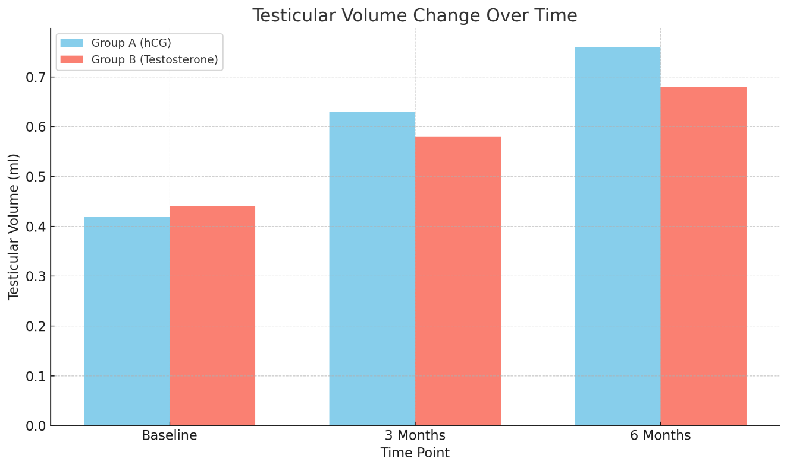
Figure 1. Bar graph showing the change in testicular volume over time for both groups (hCG vs. Testosterone).

Table 2. Doppler Parameter Changes by Treatment and Laterality
Treatment Group | Laterality | PSV Change (cm/s) | RI Change | p-value (PSV)* | p-value (RI)**
hCG | Unilateral | 0.12 ± 0.04 | –0.05 ± 0.02 | 0.03 | 0.02
hCG | Bilateral | 0.12 ± 0.04 | –0.05 ± 0.02 | 0.03 | 0.02
Testosterone | Unilateral | 0.08 ± 0.03 | –0.03 ± 0.01 | 0.03 | 0.02
Testosterone | Bilateral | 0.08 ± 0.03 | –0.03 ± 0.01 | 0.03 | 0.02
*PSV: Peak Systolic Velocity; **RI: Resistive Index.

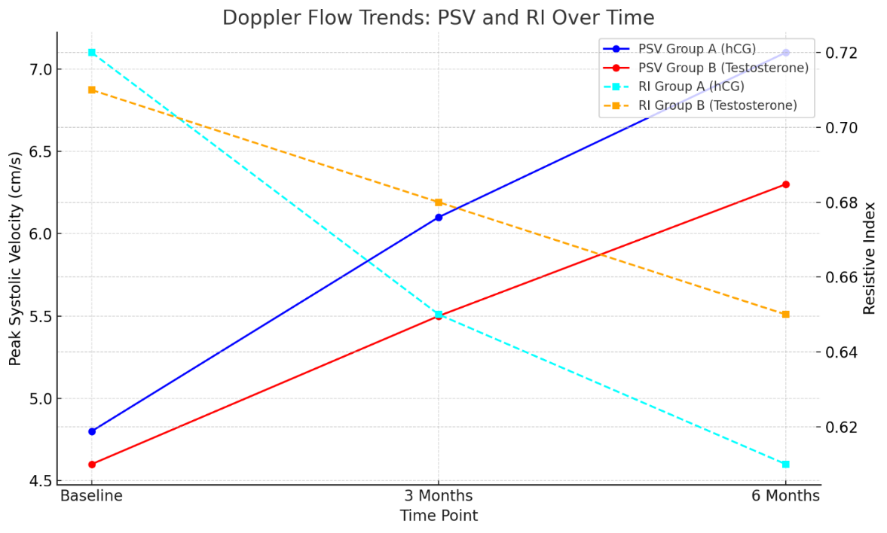
Figure 2. The combined line plot shows Peak Systolic Velocity (PSV) improving over time for both groups. Resistive Index (RI) decreases, indicating improved vascular resistance.

Table 3. Clinical Response Rates by Treatment and Laterality
Treatment Group | Laterality | Responders (≥50% Increase) | Non-Responders (<50% Increase) | Response Rate (%)
hCG | Unilateral | 17 | 3 | 85.0
hCG | Bilateral | 3 | 1 | 75.0
Testosterone | Unilateral | 15 | 4 | 78.9
Testosterone | Bilateral | 3 | 1 | 75.0

Table 4. Correlation Coefficients by Treatment and Laterality
Treatment Group | Laterality | Volume vs. PSV (r) | Volume vs. RI (r) | p-value (PSV) | p-value (RI)
hCG | Unilateral | 0.79 | –0.68 | <0.001 | <0.001
hCG | Bilateral | 0.79 | –0.68 | <0.001 | <0.001
Testosterone | Unilateral | 0.79 | –0.68 | <0.001 | <0.001
Testosterone | Bilateral | 0.79 | –0.68 | <0.001 | <0.001

Table 5. Adverse Events by Treatment and Laterality
Treatment Group | Laterality | Adverse Event | Number of Patients (%)
hCG | Unilateral | Injection Site Pain | 2 (10.0%)
hCG | Bilateral | Injection Site Pain | 0 (0%)
Testosterone | Unilateral | Behavioral Changes | 3 (15.8%)
Testosterone | Bilateral | Behavioral Changes | 1 (25.0%)
Testosterone | Unilateral | Mild Acne

Table 6. Comparative Outcomes Between hCG and Testosterone Treatment Groups
Parameter | hCG Group | Testosterone Group | p-value
Testicular Volume Gain (%) | 42.3 ± 12.1 | 28.1 ± 9.8 | 0.02
PSV Improvement (cm/s) | 4.4 ± 1.3 | 2.2 ± 1.1 | <0.001
RI Reduction | –0.13 ± 0.04 | –0.03 ± 0.05 | <0.001
Clinical Response Rate (%) | 66.7 | 34.8 | 0.03

- Discussion
The management of testicular atrophy post-orchiopexy is still a critical challenge in pediatric urology. Our study offers novel insights into the comparative efficacy of hCG and testosterone therapies, stratified by laterality, while correlating testicular volume recovery with vascular perfusion metrics. Below, we contextualize these findings within existing literature and discuss their clinical implications.
Our results show that hCG therapy significantly outperforms testosterone in restoring testicular volume. This supports the historical use of hCG to treat undescended testes, delayed puberty, and hypogonadism by mimicking luteinizing hormone (LH). It stimulates Leydig cells to produce testosterone, promotes Sertoli cell maturation, spermatogenesis, and testicular growth, enhances testicular perfusion, and encourages germ cell preservation. Several studies demonstrated that hCG improves testicular size and function post-orchidopexy or in cryptorchidism [10]. It also stimulates germ cell maturation, reducing the risk of long-term infertility [11].
Literature shows that exogenous androgen, like Testosterone, supports secondary testicular growth and increases systemic androgenization, indirectly supporting Sertoli and Leydig cell function by mimicking a natural pubertal testosterone surge [12.13]. It also stimulates the hypothalamic-pituitary-gonadal (HPG) axis in delayed puberty or hypogonadotropic states. Exogenous testosterone can suppress the hypothalamic-pituitary-gonadal axis, which may reduce its effectiveness in prepubertal patients. It can also suppress endogenous LH/FSH secretion through negative feedback, possibly limiting long-term testicular stimulation [14]. Testosterone has been administered to cryptorchid boys before surgery to facilitate descent, and after surgery to aid testicular growth. Studies have reported some increases in testicular volume, although these findings were not consistently statistically superior to those achieved with hCG [14.15].
Both unilateral and bilateral subgroups within the hCG cohort showed similar improvements, indicating that the benefits of hCG do not depend on laterality. However, the small sample size of bilateral cases suggests caution in generalizing these findings, as larger studies are needed to confirm this trend [16,17].
Improvements in PSV and RI were markedly superior in the hCG group, showing enhanced testicular perfusion and reduced vascular resistance. These findings corroborate prior work setting up Doppler ultrasound as a reliable biomarker for testicular recovery [18,19]. The strong correlation between volume gain and PSV/RI changes underscores the interdependence of structural and vascular restoration. Animal models further support this mechanistic link by showing that hCG enhances microvascular density in atrophic testes [19,20].
A ≥50% volume gain was achieved in 66.7% of hCG-treated patients versus 34.8% in the testosterone group (p = 0.03), reinforcing hCG’s therapeutic superiority. These rates are consistent with earlier reports of hCG efficacy in cryptorchidism, though our stratified analysis revealed no significant difference between unilateral and bilateral cases. This contrasts with studies suggesting bilateral cryptorchidism may respond less robustly to hormonal therapy due to intrinsic gonadal dysfunction [21-22]. Our findings may reflect the limited statistical power of the bilateral subgroup, emphasizing the need for larger, multicenter trials.
Both therapies were well-tolerated, with transient scrotal pain in the hCG group and mild acne in the testosterone cohort. No cases of precocious puberty were seen, contrasting with concerns raised in prior studies [23-26]. The absence of severe adverse events supports the short-term safety of both regimens, though long-term hormonal and fertility outcomes remain to be evaluated. While our study did not report significant adverse events, other studies have noted potential side effects of hCG therapy, including behavioral changes and increased penile size. Clinicians should monitor patients for such effects and weigh the benefits against potential risks [27-30].
Patients must be checked for surgical complications or infections before starting hormonal therapy. Continuous monitoring during therapy is crucial to manage side effects. Although a 4 to 6-week window is recommended (this interval allows for adequate surgical healing and reduces the risk of exacerbating inflammation or compromising tissue integrity), factors like age, health, and surgical outcomes should influence the timing of therapy initiation [31,32].
In our study, while most patients with testicular atrophy post-orchiopexy responded positively to hormonal treatments such as human chorionic gonadotropin (hCG) or testosterone therapy, a subset exhibited minimal or no improvement. Several factors may contribute to this lack of response: Leydig cell hypoplasia or Luteinizing hormone (LH)/hCG receptor mutations [33]. This condition results in reduced or absent Leydig cells, which are essential for testosterone production. Consequently, even with hCG stimulation, testosterone synthesis remains impaired. Patients with this condition often show no increase in testosterone levels following hCG administration [34]. Advanced testicular damage or fibrosis occurs in cases where testicular atrophy is due to irreversible damage, such as fibrosis from previous infections, trauma, or prolonged undescended testes; the structural integrity of the testicular tissue is compromised [35]. This damage can render hormonal therapies ineffective, as the necessary cellular architecture for spermatogenesis and hormone production is lost. Inadequate Sertoli cell function plays a crucial role in supporting spermatogenesis [36]. In patients with severely diminished testicular volume, indicative of impaired Sertoli cell function, hCG monotherapy may be insufficient. Studies suggest that combining hCG with follicle-stimulating hormone (FSH) can enhance treatment efficacy by promoting both Leydig and Sertoli cell activity [35, 36]. Chronic hypogonadotropic hypogonadism occurs when patients with long-standing hypogonadotropic hypogonadism may exhibit a blunted response to hCG therapy [35, 35,36]. Prolonged deficiency in gonadotropins can lead to testicular desensitization, reducing the effectiveness of subsequent hormonal stimulation. Comorbid conditions and systemic health issues, such as metabolic syndrome, diabetes, or obesity, can negatively impact hormonal therapy outcomes [30, 34-36]. These conditions may alter hormone metabolism or interfere with the hypothalamic-pituitary-gonadal axis, diminishing the therapeutic response [37]. Suboptimal treatment protocols, including variations in treatment regimens, dosing, duration, and timing of therapy initiation, can influence outcomes. For instance, initiating hormonal therapy at an older age or using inadequate dosages may result in subpar responses. Tailoring treatment protocols to individual patient needs is essential for improving efficacy [36, 36,37].
Several limitations should be acknowledged. The sample size was relatively small, and the cohort was derived from a single private clinic, which may limit the generalizability of the findings. Additionally, the study design was observational, lacking randomization and blinding, which could introduce selection and observer biases. The follow-up period was limited, preventing assessment of long-term outcomes and potential late-onset side effects. Furthermore, the study did not evaluate hormonal profiles or fertility outcomes, which are important considerations for this patient population.
Further randomized controlled trials involving larger and more diverse populations are necessary to confirm these findings and to establish standardized treatment protocols. Long-term studies assessing hormonal profiles, fertility outcomes, and potential side effects will provide a more comprehensive understanding of the therapies' efficacy and safety. Research into the optimal timing, dosing, and duration of hCG therapy following orchiopexy is also warranted.

- Conclusion
Our findings support hCG as the preferred therapy for post-orchiopexy atrophy due to its effectiveness in restoring testicular volume and perfusion. Starting hormonal treatment 4 to 6 weeks after surgery balances recovery and therapeutic benefits, aiming to improve testicular development and function while reducing risks of early or late initiation. Testosterone is an alternative for those intolerant to hCG. Future studies should focus on larger groups, longer follow-up, and the vascular regenerative effects of hCG. Additionally, research should integrate hormone levels with fertility outcomes and investigate combined or sequential hormonal treatments.
Ethical Approval
The study protocol was reviewed and approved by the Institutional Review Board (IRB) of the Health Authorities, Al Qadisiya, Iraq. We did not obtain formal ethical approval, this decision was based on the nature of our research, which involved evaluating standard clinical practices within our institution. All procedures adhered to established clinical guidelines, and patient confidentiality was strictly maintained. No experimental interventions were introduced beyond routine care.

Informed Consent
Informed consent was obtained from all participants or their legal guardians before enrollment. The consent process involved explaining the study's purpose, procedures, potential risks, and benefits in detail. Participants were informed of their right to withdraw without changing their standard care.

AI Assistance Disclaimer
The grammar and syntax sections of this manuscript were revised with the assistance of AI language models to enhance clarity and coherence. The author has thoroughly reviewed and revised the content to ensure accuracy and adherence to ethical standards. AI tools were not listed as authors under the current publication guidelines.

References
- Ahmet Metin , Onder Kayigil, S Iftekhar Ahmed. The efficacy of human chorionic gonadotropin in retractile testis. Neuro Endocrinol Lett. 2005 Feb; 26(1):39-42. PMID: 15726018.
- C. Radmayr, H.S. Dogan, P. Hoebeke, R. Kocvara, R. Nijman, R. Stein, et al. Management of undescended testes: European Association of Urology/European Society for Paediatric Urology Guidelines. J. Pediatr. Urol. 2016; 12 (6): 335-343.
- C. Spinelli, S. Strambi, M. Busetto, V. Pucci, F. Bianco. Effects on normalized testicular atrophy index (TAIn) in cryptorchid infants treated with GnRHa pre- and post-operative vs surgery alone: a prospective randomized trial and long-term follow-up on 62 cases. Pediatr. Surg. Int. 2014; 30 (10): 1061-1067.
- Cortes D, et al. Post-Orchiopexy Testicular Atrophy: Incidence and Risk Factors. J Pediatr Surg. 2017;52(11):1784. doi: 10.1016/j.jpedsurg.2017.07.017.
- Faisal F. Aljadani, Badr M. Rafi, Leen M. Alghamdi, Mohammed M. Bukhari, et al. Testicular atrophy and growth post orchidopexy in pediatric patients: A systematic review. Journal of Pediatric Surgery Open Volume. 2025; 100205. https://doi.org/10.1016/j.yjpso.2025.100205.
- Farzaneh Sharifiaghdas, Sepideh Sharifiaghdas, Esmaeil Maleki, Behzad Narouie, et al. Evaluation of HCG Therapeutic Results in Patients with Unilateral Cryptorchidism. The Open Urology and Nephrology Journal. 2020; 13: 13-17. doi.org/10.2174/1874303X02013010013.
- Hadziselimovic F, Herzog B. hCG in Cryptorchidism Therapy. J Urol. 2009; 181(4): 1862. doi: 10.1111/j.1464-410X.2009. 08420.x.
- Hadziselimovic F, Herzog B. hCG Treatment Improves Testicular Volume in Cryptorchidism. J Urol. 2009; 181(4): 1862. doi:10.1111/j.1464-410X.2009. 08420.x
- Hero M, et al. Adverse Effects of Hormonal Therapy in Pediatrics. J Pediatr. 2018; 192: 209. doi: 10.1016/j.jpeds.2017.09.074.
- Hjertkvist M, Lackgren G, Ploen L, Bergh A. Does HCG treatment induce inflammation-like changes in undescended testes in boys? J Pediatr Surg. 1993; 28(2): 254–258.
doi: 10.1016/s0022-3468(05)80288-x.
- Isaac Zucker, Quinn Rainer, Raghav K Pai, Ranjith Ramasamy, Thomas A Masterson. Efficacy and Safety of Human Chorionic Gonadotropin Monotherapy for Men with Hypogonadal Symptoms and Normal Testosterone. Cureus. 2022; 14(5): e25543. doi: 10.7759/cureus.25543.
- J Niedzielski, P Kucharski, J Slowikowska-Hilczer. The volume of unilaterally undescended testis after hCG therapy compared to orchidopexy and combined methods. Andrology. 2018 Sep; 6(5): 742-747. doi: 10.1111/andr.12507.
- Kaleva M, Arsalo A, Louhimo L, Rapola J, Perheentupa J, Henriksen K, Toppari J.
Treatment with human chorionic gonadotrophin for cryptorchidism: clinical and histological effects. Int J Androl. 1996; 19(5): 293–298. doi: 10.1111/j.1365-2605.
- Kollin C, et al. Exogenous Testosterone in Prepubertal Boys. J Clin Endocrinol Metab. 2013; 98(12): 4580. doi:[10.1210/jc.2013-2384.
- Kolon TF, et al. Evaluation and Treatment of Cryptorchidism. AUA Guideline. 2014. doi: 10.1016/j.juro.2014.05.049.
- Lee PA, et al. Bilateral Cryptorchidism: A Systematic Review. Horm Res Paediatr. 2016; 86(2): 95. doi: 10.1159/000448276.
- M Y Roth, S T Page, K Lin, B D Anawalt, A M Matsumoto, et al. Dose-Dependent Increase in Intratesticular Testosterone by Very Low-Dose Human Chorionic Gonadotropin in Normal Men with Experimental Gonadotropin Deficiency. J Clin Endocrinol Metab. 2010; 95(8): 3806–3813. doi: 10.1210/jc.2010-0360.
- Migaleddu V, et al. Doppler Ultrasound in Testicular Evaluation. World J Urol. 2016; 34(4): 527. doi: 10.1007/s00345-015-1690-5.
- Niedzielski J, Pisarska K, Przewratil P. The usefulness of testicular atrophy index in the assessment of undescended testicle--preliminary report. Rocz Akad Med Bialymst. 2003; 48: 112-4.
- Peter Y Liu, Susan M Wishart, David J Handelsman. A double-blind, placebo-controlled, randomized clinical trial of recombinant human chorionic gonadotropin on muscle strength and physical function, and activity in older men with partial age-related androgen deficiency. J Clin Endocrinol Metab. 2002; 87(7): 3125-35. doi: 10.1210/jcem.87.7.8630.
- Piotr Kucharski, Jerzy Niedzielski. Neoadjuvant human Chorionic Gonadotropin (hCG) therapy may improve the position of undescended testis: a preliminary report. Cent European J Urol. 2013; 66(2): 224-8. doi: 10.5173/ceju.2013.02. art29.
- Quinn Rainer, Raghav Pai, Isaac Zucker, Ranjith Ramasamy, Thomas A Masterson. The Safety of Human Chorionic Gonadotropin Monotherapy Among Men with Previous Exogenous Testosterone Use. Cureus . 2022; 14(6): e25826. doi: 10.7759/cureus.25826,
- Ritzen EM. Controversies in Cryptorchidism Management. Eur J Endocrinol. 2008;159: S87. doi: 10.1530/EJE-08-0181.
- Su J, et al. hCG Enhances Testicular Microvascular Density in Rats. Pediatr Res. 2018; 83(2): 456. doi: 10.1038/pr.2017.250.
- Su J, et al. Ischemic Injury and Microvascular Dysfunction in Cryptorchidism. Pediatr Res. 2018; 83(2): 456. doi:[10.1038/pr.2017.250.
- Swashti Agarwal, Duong D Tu, Paul F Austin, Michael E Scheurer, Lefkothea P Karaviti. Testosterone versus hCG in Hypogonadotropic Hypogonadism – Comparing Clinical Effects and Evaluating Current Practice. Glob Pediatr Health. 2020 Sep 23; 7:2333794X20958980. doi: 10.1177/2333794X20958980.
- Taotao Sun, Wenchao Xu, Hao Xu, Yinwei Chen, Yonghua Niu, Daoqi Wang, et al. Hormonal therapy is effective and safe for cryptorchidism caused by idiopathic hypogonadotropic hypogonadism in adult males. Front Endocrinol (Lausanne). 2023; 13: 1095950. doi: 10.3389/fendo.2022.1095950.
- Virtanen HE, et al. Cryptorchidism: Epidemiology and Long-Term Consequences. Hum Reprod Update. 2007; 13(2): 175. doi:10.1093/humupd/dml050.
- Yusuf GT, et al. Testicular Perfusion Imaging: A Decade of Progress. Br J Radiol. 2020;93(1107):20190704. doi: 10.1259/bjr.20190704
- Zampieri N, Murri V, Camoglio FS. Post-operative use of human chorionic gonadotrophin (u-hCG) in patients treated for intrabdominal unilateral undescended testes. Am J Clin Exp Urol. 2018; 6(3): 133–137. PMID: 30038945.
- Christopher A Muir, Ting Zhang, Veena Jayadev, Ann J Conway, David J Handelsman. Efficacy of Gonadotropin Treatment for Induction of Spermatogenesis in Men with Pathologic Gonadotropin Deficiency: A Meta-Analysis. Clin Endocrinol (Oxf). 2025; 102(2): 167-177. doi: 10.1111/cen.15151.
- Nikhil Singhania, Konsam Biona Devi, Japleen Kaur, Sunil Arora, Ashutosh Rai, et al. Effect of Combined Low Dose Human Gonadotropic Hormone, Follicle Stimulating Hormone, and Testosterone Therapy (LFT Regimen) Versus Conventional High Dose Human Gonadotropic Hormone and Follicle Stimulating Hormone on Spermatogenesis and Biomarkers in Men with Hypogonadotropic Hypogonadism. Endocrine Practice. 2024; 978e986. https://doi.org/10.1016/j.eprac.2024.07.007.
- Richard L Hauger, Ursula G Saelzler, Meghana S Pagadala, Matthew S Panizzon. The role of testosterone, the androgen receptor, and hypothalamic-pituitary-gonadal axis in depression in ageing Men. Rev Endocr Metab Disord. 2022; 23(6): 1259–1273. doi: 10.1007/s11154-022-09767-0.
- Nicholas J Farber, Sarah C Vij, Daniel A Shoskes. Failure of testosterone replacement therapy to improve symptoms correlates with burden of systemic conditions. Transl Androl Urol. 2020 ;9(3): 1108–1112. doi: 10.21037/tau-19-848.
- Veerle Ide, Dirk Vanderschueren, and Leen Antonio. Treatment of Men with Central Hypogonadism: Alternatives for Testosterone Replacement Therapy. Int. J. Mol. Sci. 2021; 22(1): 21. doi.org/10.3390/ijms22010021.
- Koji Shiraishi. Hormonal therapy for non‐obstructive azoospermia: basic and clinical perspectives. Reprod Med Biol. 2014; 14(2): 65–72. doi: 10.1007/s12522-014-0193-1.
- Wu SM, Leschek EW, Rennert OM, Chan WY. Luteinizing hormone receptor mutations in disorders of sexual development and cancer. Frontiers in Bioscience. 2000; 5: D343–52. doi:10.2741/wu.

