Original Research Article

A Novel Phytogenic Solution for Sustainable Poultry Farming: Exploring the Growth-Promoting and Antimicrobial Potential of *Sesamum radiatum*

.

ABSTRACT

|  |
| --- |
| **Aims:** This study evaluates the nutritional composition, antioxidant capacity, and antimicrobial potential of *Sesamum radiatum* extracts, with a focus on its suitability as a functional ingredient in poultry feed.  **Study Design:** Laboratory-based experimental research.  **Place and Duration of Study:** Conducted at the Integrated Bio Chemical Laboratory, Agro Bio Tech Research Centre Ltd (ABTEC), Poovanthuruth, Kottayam, Kerala, India, in April 2024.  **Methodology:** Proximate analysis was performed to determine the macronutrient composition of *Sesamum radiatum*. The antioxidant activity was assessed using the Ferric Reducing Antioxidant Power (FRAP) assay. Soxhlet extraction was used to obtain plant extracts in hexane, chloroform, and methanol. Antimicrobial activity against *Staphylococcus aureus* and *Pseudomonas aeruginosa* was evaluated using the agar well diffusion method. The most effective extract was incorporated into a formulated poultry feed.  **Results:** *Sesamum radiatum* exhibited a rich nutritional profile, containing high levels of protein, fiber, and essential micronutrients. The FRAP assay confirmed strong antioxidant capacity. The methanolic extract demonstrated significant antimicrobial activity against *Staphylococcus aureus* and *Pseudomonas aeruginosa*. Incorporation into poultry feed enhanced its bioactive potential.  **Conclusion:** *Sesamum radiatum* presents promising nutritional, antioxidant, and antimicrobial properties, supporting its use as a natural supplement in poultry feed. Its bioactive potential suggests a sustainable alternative to synthetic additives, warranting further in vivo studies for validation. |

*Keywords:* Sesamum radiatum, poultry nutrition, antioxidants, antimicrobial activity

1. INTRODUCTION

The growing demand for sustainable and high-quality poultry feed has intensified research into plant-based substitutes with bioactive properties (Singh *et al*., 2023). As a critical contributor to global food security, the poultry sector has long relied on synthetic feed additives to enhance immunity, growth performance, and overall health (Upadhayay & Vishwa, 2014). However, concerns about antibiotic resistance, residual toxicity, and environmental impact have driven a shift toward natural feed supplements (AlSheikh *et al*., 2020). In this context, *Sesamum radiatum* a lesser-known but highly nutritious plant has emerged as a promising candidate due to its antibacterial and antioxidant properties. However, despite its known medicinal value, its efficacy in live poultry feeding trials remains underexplored, creating a knowledge gap that this study aims to address (Wacal *et al*., 2024).

Oxidative stress is a significant problem in poultry production, frequently resulting in slowed growth, decreased feed efficiency, and heightened susceptibility to illness (Oke *et al*., 2024). In order to stop oxidative damage to cells, antioxidants are essential for neutralizing reactive oxygen species (ROS). Despite their widespread use, synthetic antioxidants like butylated hydroxytoluene (BHT) and butylated hydroxyanisole (BHA) continue to raise questions about their long-term safety (Yehye *et al*., 2015) this has increased interest in antioxidants derived from natural plants, which may provide safer and more efficient substitutes. Sesamum radiatum, which is high in flavonoids and phenolic compounds, offers a good way to boost poultry's antioxidant defences (Oduntan, Olaleye, & Akinwande, 2012).

In addition to oxidative stress, bacterial infections are a serious risk to poultry production, requiring the widespread use of antibiotics to prevent and control disease (Mishra & Jha, 2019). Multidrug-resistant bacteria have emerged as a result of an over-reliance on antibiotics, posing a major threat to human and animal health (Fatima *et al*., 2023). Natural antibacterial substitutes are the subject of more and more research in an effort to lessen this. According to preliminary research, *Sesamum radiatum* has potent antibacterial action against important poultry pathogens, such as *Staphylococcus aureus* and *Pseudomonas aeruginosa* (Shittu *et al*., 2007). Reliance on synthetic antibiotics can be decreased by adding natural antimicrobial agents to poultry feed, which could lessen worries about antibiotic resistance in the poultry sector.

Although Sesamum radiatum is known for its medicinal and therapeutic properties, its application as a functional ingredient in poultry nutrition remains largely unexplored. This study aims to address that gap by evaluating its proximate composition, antioxidant and antimicrobial activities, and potential benefits when incorporated into poultry feed (Dossou *et al*., 2023).

*Sesamum radiatum* has a distinct bioactive content that sets it apart from other sesame species and makes it ideal for use in poultry feed. According to new research, Sesamum radiatum contains a greater profile of phenolic compounds and flavonoids, which play a crucial role in antioxidant defense, while Sesamum indicum is recognized for its abundant oil content and lignans, including sesamin and sesamolin. (Kamal-Eldin, 2010; Kancharla et al., 2020). Additionally, although *Sesamum indicum* has been associated with enhanced immunity and growth in chicken, its antibacterial qualities pale compared to those of other therapeutic herbs (Wei *et al*., 2022). *Sesamum radiatum*, on the other hand, has strong antibacterial properties that make it a potentially better option for preventing poultry diseases.

Other plant-based feed additives with antibacterial and immunomodulatory properties have been investigated, including oregano (*Origanum vulgare*), garlic (*Allium sativum*), and turmeric *(Curcuma longa*) (Ivanova *et al*., 2024). Curcumin, the active ingredient in turmeric, for instance, has well-established anti-inflammatory and antioxidant properties; nevertheless, its bioavailability in poultry is comparatively poor unless piperine or other boosters are added (Menon & Sudheer, 2007) Similar to this, although extracts of garlic and oregano have been used extensively as antibiotic substitutes, their potent taste and smell frequently make feed less palatable, which restricts their widespread use. However, *Sesamum radiatum* is a more sensible option for commercial poultry feed since it provides a neutral-tasting substitute with equivalent or even better antimicrobial advantages (Florou-Paneri, Christaki, & Giannenas, 2019)

From both an animal health and sustainable agriculture perspective, this research is of critical importance. The use of natural feed additives aligns with global initiatives promoting eco-friendly and organic farming practices. By providing scientific validation of nutritional and functional properties of *Sesamum radiatum's*, this study contributes to the development of safer and more sustainable poultry feed solutions. The findings could have significant implications for both commercial and small-scale poultry farming, offering an innovative and practical solution to current industry challenges.

1. materialS and methods

#### **Plant Collection & Extraction**

Fresh and disease-free *Sesamum radiatum* leaves were collected from Poovanthuruth, Kottayam district, Kerala, India in April 2024. The plant species were identified and authenticated by experts at the Department of Biochemistry, IBCL, Poovanthuruth, Kottayam. Fig.1 shows the processing of *Sesamum radiatum* leaves.

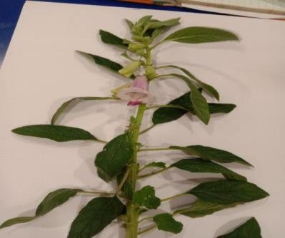 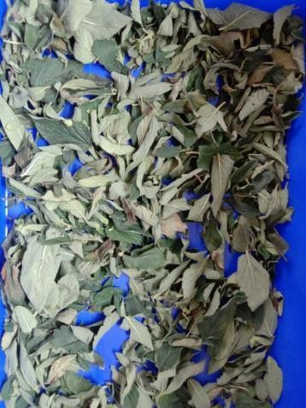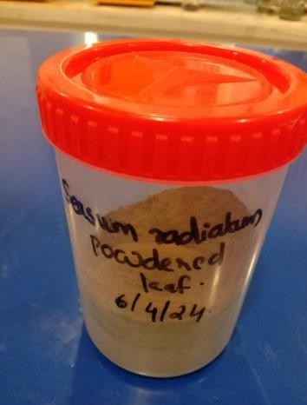

**Processing Stages of *Sesamum radiatum* Leaves *(Fig. 1. Fresh Leaf (A), Dried Leaf (B), Dried Leaf Powder (C), respectively.)***

### **2.1.1 Preparation of Plant Materials and Extraction Process**

Fresh leaves of Sesamum radiatum were thoroughly washed under running tap water to remove dirt and other adhering particles. The cleaned leaves were coarsely chopped and air-dried under shade for three days, followed by further drying in a hot air oven at 60°C. Once dried, the plant material was ground into a fine powder using an electric grinder. The powdered material was sieved through a kitchen strainer to enhance solvent interaction during extraction. A total of 92.17 g of fine powder was collected and stored in a plastic container at room temperature with proper labeling.

For extraction, three different solvent systems hexane, chloroform, and methanol were used to target a range of polar and non-polar compounds. Soxhlet extraction was carried out by placing 50 g of powdered leaves in the apparatus with 300 ml of each solvent. The temperature for hexane extraction was maintained between 42–52°C, while chloroform and methanol extractions were conducted at 50°C. After extraction, the solvents were evaporated using a china dish, and the resulting crude extracts were stored at 4°C for future analysis. (Oreopoulou, Tsimogiannis, & Oreopoulou, 2019)

**2.2. Phytochemical Screening & Antioxidant Assay**

#### **2.2.1 Preliminary Qualitative Screening**

The methanol, chloroform, and hexane extracts of Sesamum radiatum leaves were subjected to qualitative phytochemical analyses to identify the presence of various bioactive compounds. The following standard tests were conducted. Table 1 presents the results of the preliminary phytochemical screening of *Sesamum radiatum* extracts.

**Table 1: Preliminary phytochemical screening**

|  |  |  |  |  |
| --- | --- | --- | --- | --- |
| SL.NO | Phytochemical | Test Method | Observation | Reference |
| 1 | Flavonoids | Alkaline Reagent Test | Yellow coloration indicates presence | **(Sawant & Godghate, 2013)** |
| 2 | Alkaloids | Wagner’s Test | Reddish brown precipitate indicates presence | **(Sawant & Godghate, 2013)** |
|  |  | Mayer’s Test | White precipitate indicates presence | **(Sawant & Godghate, 2013)** |
|  |  | Dragendorff’s Test | Red precipitate indicates presence | **(Sawant & Godghate, 2013)** |
| 3 | Phenols | Ferric Chloride Test | Intense blue color indicates presence | **(Sawant & Godghate, 2013)** |
|  |  | Lead Acetate Test | Bulky white precipitate indicates presence | **(Rashid, Wani & Devi, n.d.)** |
| 4 | Tannins | Ferric Chloride Test | Dark green color indicates presence | **(Sawant & Godghate, 2013)** |
| 5 | Glycosides | Anthrone Test | Dark green coloration indicates presence | **(Rashid, Wani & Devi, n.d.)** |
| 6 | Protein | Biuret Test | Bluish-violet color indicates presence | **(Rashid, Wani & Devi, n.d.)** |
| 7 | Saponins | Frothing Test | Froth formation indicates presence | **(Sawant & Godghate, 2013)** |
| 8 | Coumarins | NaOH Test | No dark yellow colour  absence | **(Sawant & Godghate, 2013)** |

#### **2.2.2 Quantitative Analysis**

#### **2.2.2.1 Estimation of Flavonoids**

Flavonoid content was estimated using a colorimetric method. Standard flavonoid solutions (50–250 µg) were prepared by pipetting 0.5–2.5 ml of the standard solution into a series of test tubes. A 0.1 ml aliquot of the sample was added, and the volume was adjusted to 2.5 ml with distilled water. Subsequently, 75 µl of 5% NaNO₂ was added, followed by incubation at room temperature for 5 minutes. Then, 150 µl of 10% AlCl₃ was introduced, and the mixture was incubated for another 6 minutes. Finally, 0.5 ml of 1 M NaOH was added, and the resulting pink color was measured spectrophotometrically at 415 nm. (Agbo *et al*., 2015)

#### **2.2.2.2 Estimation of Carbohydrates**

Carbohydrate content was estimated using the anthrone reagent method. A series of test tubes was prepared containing varying glucose concentrations, with tube 1 serving as the blank and tubes 2–7 used for constructing a standard curve. Each tube received 5 ml of anthrone reagent, and the mixtures were vortexed thoroughly. After cooling, the tubes were covered and incubated in a boiling water bath for 10 minutes. The absorbance was then recorded at 620 nm against the blank. (Patel *et al*., 2022)

#### **2.2.2.3 Estimation of Crude Fiber**

The crude fiber content was determined by hydrolyzing non-fibrous components. A fat-free sample was treated with 200 ml of H₂SO₄, heated under reflux for 30 minutes, filtered, and washed until neutral. The residue was then digested with 200 ml of boiling NaOH, followed by further filtration and washing. The residue was dried at 130°C for 1 hour, and its dry weight was recorded. Ashing was performed by placing the sample in a furnace at 600°C for 2 hours, after which the weight of the remaining residue was recorded. (Madhu *et al*., 2017)

#### **2.2.2.4 Estimation of Phenols**

Total phenolic content was estimated using the Folin-Ciocalteu method. A 1 ml aliquot of the sample or standard gallic acid (10–100 µg/ml) was added to a test tube, followed by 5 ml of distilled water and 0.5 ml of Folin-Ciocalteu reagent. After 5 minutes, 1.5 ml of 20% sodium carbonate was added, and the volume was adjusted to 10 ml with distilled water. The solution was incubated for 2 hours at room temperature, allowing an intense blue color to develop. Absorbance was then measured at 750 nm. (Lamuela‐Raventós, 2018)

**2.2.2.5 Estimation of Vitamin C**

Vitamin C content was determined using an iodine-based titration method. A **5 g methanolic extract** was taken in a **250 ml conical flask,** to which **10 ml of 30% potassium iodide (KI)** solution was added and mixed thoroughly. **5 ml of 1 M sulfuric acid (H₂SO₄)** was then added to maintain an acidic medium. Four drops of **1% starch solution** were introduced as an indicator. The mixture was titrated against **0.005 M iodine (I₂) solution** until a **stable blue-black color** appeared, indicating the endpoint. The amount of Vitamin C was calculated based on the volume of iodine consumed in the titration. (Dioha *et al*., 2011)

**2.2.2.6 Estimation of Protein (Kjeldahl Method)**

Protein content was determined using the Kjeldahl method. Four Kjeldahl digestion tubes were used two for the samples and two as blanks. Sample 1 contained 0.250 g of the test material, and Sample 2 contained 0.252 g. A catalyst mixture consisting of potassium sulfate and copper sulfate in a 5:1 ratio was added to each tube (approximately one spoonful). Then, 5 ml of concentrated sulfuric acid (H₂SO₄) was added to each tube to facilitate the conversion of organic nitrogen to ammonium sulfate. The tubes were heated to ensure complete digestion of the protein content. For the blank samples, only the catalyst mixture and sulfuric acid were added. After digestion, a mixed indicator was introduced to aid in visual endpoint detection. The digested solution was then titrated against 0.02 N hydrochloric acid (HCl) until a green color endpoint was observed, indicating the completion of the reaction. (Baker & Thompson, 1992)

### **2.2.3 Bioactivity Assays**

#### **2.2.3.1 Antioxidant Assay**

**Ferric Reducing Antioxidant Power (FRAP) Test**

FRAP solution (3.6 ml) add to distilled water (0.4 ml) and incubated at 37˚C for 5 min. Then this solution mixed with certain concentration of the plant extract (80 ml) and incubated at 37˚C for 10 min. The absorbance of the reaction mixture was measured at 593 nm. For construction of the calibration curve, five concentrations of FeSO4, 7H2O (0.1, 0.4, 0.8, 1, 1.12, 1.5 mM) were used and the absorbance values were measured as for sample solutions (Gohari *et al*., 2011)

#### **2.2.3.2 Antimicrobial Assay**

**Isolation and Identification of Target Organisms**

For the isolation of Staphylococcus aureus, Mannitol Salt Agar (MSA) was prepared by dissolving 2.22 g of MSA medium and 0.52 g of agar in 20 ml of sterile water, followed by sterilization at 21°C for 12–20 minutes. The prepared medium was poured into sterile Petri plates. The bacterial strain was streaked using the quadrant streak method and incubated for 24 hours, after which pure colonies were subcultured for further experiments. (Kateete *et al*., 2010)

For the isolation of Escherichia coli, MacConkey Agar was prepared by dissolving 2.5 g of MacConkey medium and 1.3 g of agar in 50 ml of distilled water, followed by sterilization at 21°C for 12–21 minutes. The bacterial strain was streaked using the quadrant streak method and incubated. Pure cultures were subcultured for further analysis. (Bozaslan *et al*., 2016)

Pseudomonas aeruginosa was cultured on Nutrient Agar, as it is an obligate aerobe capable of anaerobic growth in the presence of nitrates. The organism was incubated at 37°C, its optimal growth temperature. Fig. 2 display bacterial strains cultured on selective media: *Escherichia coli*, *Staphylococcus aureus*, and *Pseudomonas aeruginosa*.

**2.2.3.3 Agar Disc Diffusion Method for Antimicrobial Susceptibility Testing**

The disc diffusion method is based on the diffusion of an antimicrobial agent from an impregnated disc placed on an agar plate pre-inoculated with the test bacterium. The antibiotic diffuses radially, creating a concentration gradient. If the antimicrobial agent is effective, a clear zone of inhibition appears around the disc.

Mueller-Hinton Agar (MHA) was prepared according to the manufacturer’s instructions using distilled or deionized water. The medium was boiled, autoclaved at 121°C for 15 minutes, and cooled to 40–50°C before being poured into sterile Petri plates to a uniform depth of 4 mm. The plates were dried at 30–37°C in an incubator with lids partially open to remove excess moisture, preventing bacterial swarming and ensuring accurate results. (Jorgensen & Turnidge, 2015)

For inoculum preparation, bacterial suspensions were prepared from pure cultures not older than 48 hours. Four to five colonies were transferred using a sterile wire loop into 5 ml of Trypticase soy broth or 0.9% saline.

For plate inoculation, a sterile cotton swab was dipped into the bacterial suspension and used to evenly spread the inoculum over the MHA plate. The plate was rotated 60° and streaking was repeated to ensure uniform bacterial distribution. The inoculated plates were allowed to dry for 3–5 minutes before applying antimicrobial discs. Three different concentrations of the plant extract were introduced as antimicrobial agents, and the plates were incubated under optimal conditions for the test organism. The zones of inhibition were measured to assess antimicrobial efficacy.

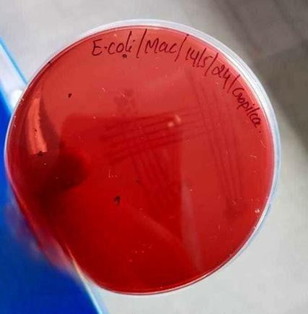 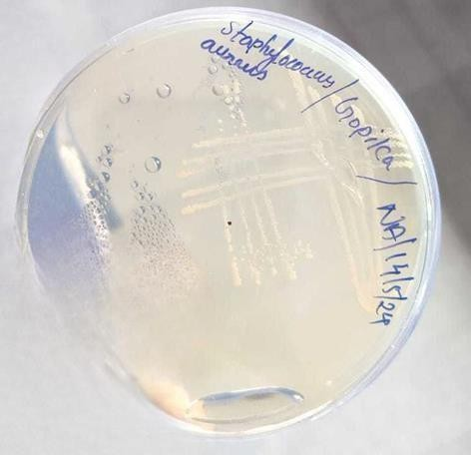 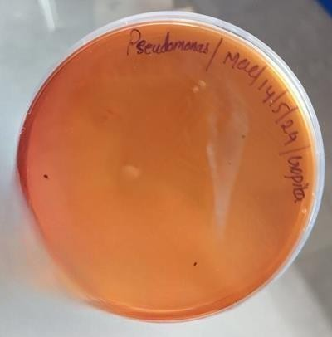

**Streak Plate Cultures of Bacterial Strains on Selective Media: (Fig. 2. *Escherichia coli* on *MacConkey* Medium (A), *Staphylococcus aureus* on Nutrient Agar (B), *Pseudomonas aeruginosa* on MacConkey Medium (C), respectively.)**

#### **2.3 Formulation of Nutritional Feed Mix**

#### A nutritional feed mix was formulated using **400 g of wheat, 30 g of starch, 50 g of turmeric and ginger, 10 g of Sesamum radiatum powder, and 10 ml of distilled water.** The ingredients were thoroughly mixed and then dried at **50°C for 1 hour** before use. Fig. 3 illustrates the formulated poultry feed containing Sesamum radiatum powder.

#### 

**Fig .3. *Sesamum radiatum* Feed for poultry**

**3. RESULTS**

### **3.1 Phytochemical Screening**

### **3.1.1 Preliminary Phytochemical Tests**

**Table 2. Preliminary phytochemical screening of Sesamum radiatum extract**

|  |  |  |  |
| --- | --- | --- | --- |
| Preliminary analysis of *Sesamum radiatum* | Hexane | Chloroform | Methanol |
| Flavanoid | + | - | + |
| Terpenoid | - | - | - |
| Phenol | - | - | + |
| Tannin | - | - | + |
| Resin | - | - | - |
| Glycoside | - | + | + |
| Protein | + | + | + |
| Reducing sugar | - | - | - |
| Saponin | - | - | - |
| Coumarin | + | - | + |
|  |  |  |  |

**(+: Presence, -: Absence)**

These results indicate that methanolic extracts contain the highest number of phytochemicals, including flavonoids, phenols, tannins, glycosides, proteins, and coumarin. Table 2 summarizes the presence (+) or absence (–) of key phytochemicals across different solvent extracts.

The presence of individual phytochemicals was further confirmed through qualitative tests. The characteristic color changes were observed

## **3.2 Quantitative Analysis of Bioactive Compounds**

The total carbohydrate, phenol, and flavonoid content of Sesamum radiatum extracts were estimated using spectrophotometric methods. The results are shown in **Tables 3–4**.

### **3.2.1 Estimation of Carbohydrates**

Carbohydrate content was determined by measuring optical density (OD) at 620 nm.

**Table 3. Total carbohydrate estimation**.

|  |  |
| --- | --- |
| Concentration (**µ**g/ml) | OD Values |
| 10 | 0.051 |
| 20 | 0.103 |
| 40 | 0.166 |
| 60 | 0.251 |
| 80 | 0.351 |
| 100 | 0.406 |
| 150  200 | 0.654  0.864 |

**Fig .3. Estimation of total carbohydrate**

From the calibration curve, the carbohydrate content was estimated as **59.5 µg/ml**

### **3.2.2 Estimation of Phenol Content**

Phenol content was determined using OD measurements at 765 nm.

**Table 4. Total phenol estimation.**

|  |  |
| --- | --- |
| Concentration (**µ**g/ml) | OD Values |
| 10 | 0.241 |
| 20 | 0.406 |
| 40 | 0.651 |
| 60 | 0.924 |
| 80 | 1.221 |
| 100 | 1.462 |

**Fig .4. Estimation of Phenol content**

The estimated phenol content was **28 µg/ml**

### **3.2.3 Estimation of Flavonoid Content**

Flavonoid concentration was analyzed using OD readings at 415 nm.

**Table 5. Total flavonoid estimation.**

|  |  |
| --- | --- |
| Concentration (µg/ml) | OD Values |
| 50 | 0.060 |
| 100 | 0.128 |
| 150 | 0.182 |
| 200 | 0.232 |
| 250 | 0.300 |

**Fig .5. Estimation of Flavonoid content**

The flavonoid content was estimated to be **449 µg/ml**

**Table 6. Proximate Composition of Sample**

|  |  |
| --- | --- |
| Component | Percentage (%) |
| Crude Fibre | 4.6 |
| Protein | 22.4 |
| Lipid | 3.68 |

## **3.3 Antioxidant Activity by FRAP Assay**

The antioxidant potential of Sesamum radiatum was evaluated using the Ferric Reducing Antioxidant Power (FRAP) assay. Fig: 6 shows the antioxidant activity of *Sesamum radiatum* extracts using the FRAP assay. The results (**Table.7**) show a concentration-dependent increase in reducing power.

**Table 7.** **Antioxidant activity of Sesamum radiatum extracts.**

|  |  |  |
| --- | --- | --- |
| Concentration of standard and test (μg/ml) | O.D of standard ascorbic acid | Methanol extract of *Sesamum radiatum* |
| Blank | 0.021 | 0.039 |
| 0.2 | 0.286 | 0.224 |
| 0.4 | 0.344 | 0.265 |
| 0.6 | 0.391 | 0.323 |
| 0.8 | 0.452 | 0.331 |
| 1 | 0.476 | 0.375 |
| 1.2 | 0.561 | 0.401 |
| 1.4 | 0.6 | 0.454 |
| 1.6 | 0.68 | 0.506 |



**Fig.6. Ferric Reducing Antioxidant Power (FRAP) Assay of Sesamum radiatum Extracts**

The methanolic extract exhibited the highest antioxidant activity, correlating with its high phytochemical content.

## **3.4 Antimicrobial Activity**

### **3.4.1 Isolation and Identification of Target Organisms**

The selected bacterial strains were isolated and cultured on respective agar media.

### **3.4.2 Agar Disc Diffusion Assay**

The antibacterial activity of different extracts was evaluated using the disc diffusion method (**Fig. 7 - 9**)**.** The results are summarized in **Table 8.**

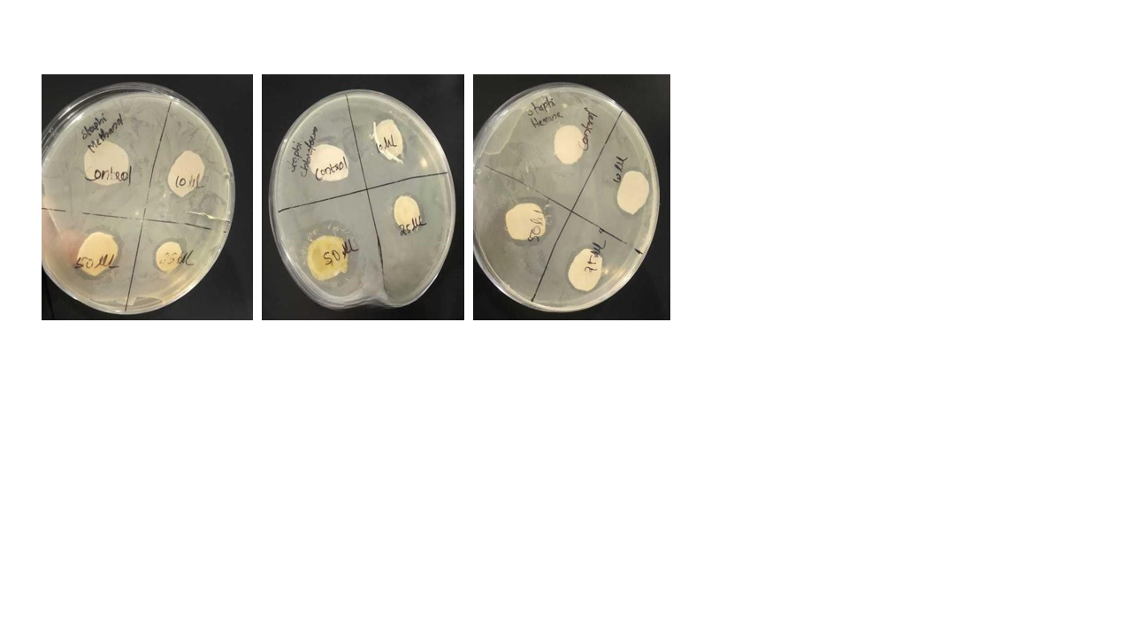

**Fig.7. Antibacterial Activity of Sesamum radiatum Extracts (Methanol (A), Chloroform (B), and Hexane(C)) Against *Staphylococcus aureus***

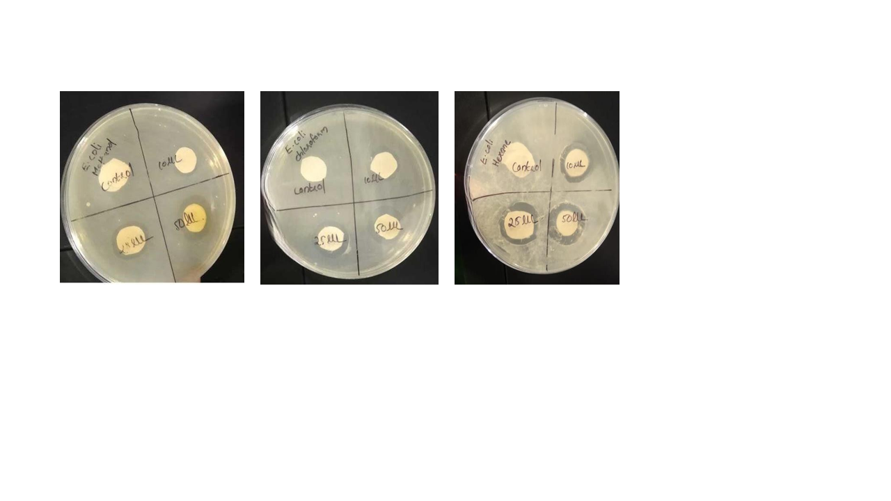

**Fig. 8. Antibacterial Activity of Sesamum radiatum Extracts (Methanol (A), Chloroform (B), and Hexane (C)) Against *Escherichia coli***

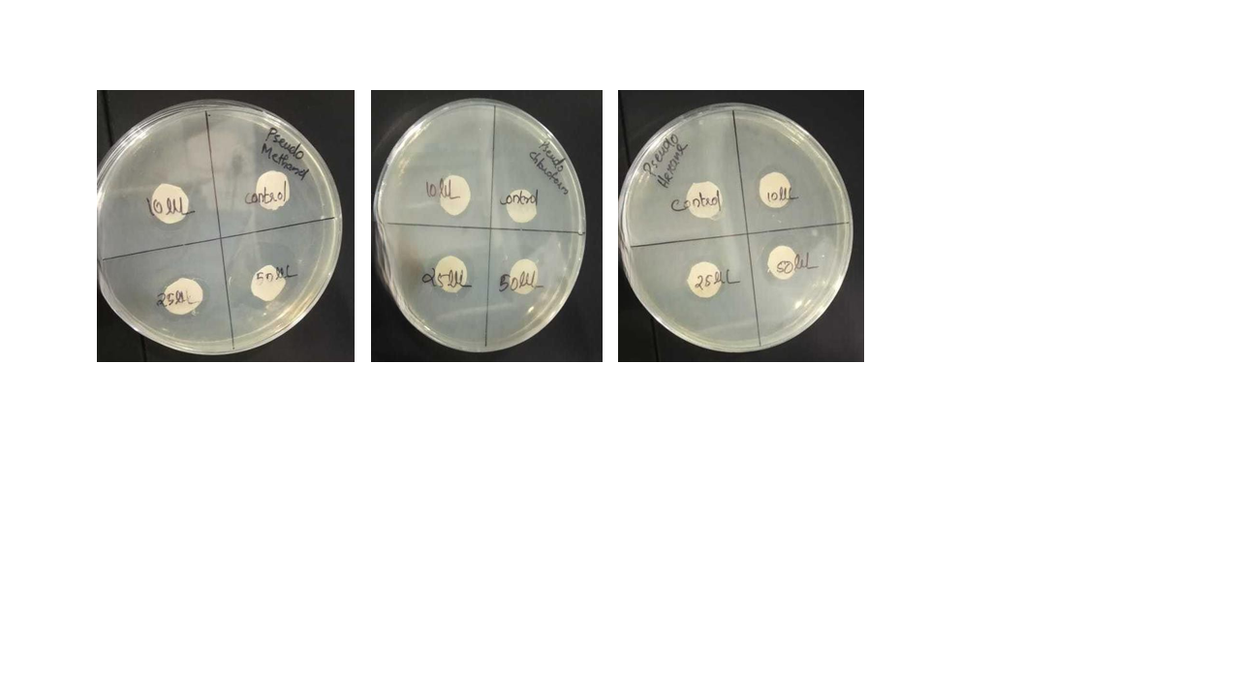

**Fig. 9. Antibacterial Activity of Sesamum radiatum Extracts (Methanol (A), Chloroform (B), and Hexane (C)) Against *Pseudomonas aeruginosa***

**Table 8. Antimicrobial activity of Sesamum radiatum extracts.**

|  |  |  |  |  |  |
| --- | --- | --- | --- | --- | --- |
| Plant extract | | | Microorganism | | |
| Hexane | Chloroform | Methanol | *Staphylococcus aureus* | *Escherichia coli* | *Pseudomonas aeruginosa* |
| 10 µL | 10 µL | 10 µL | Resistant | Resistant | Resistant |
| 25 µL | 25 µL | 25 µL | Resistant | Resistant | Resistant |
| 50 µL | 50 µL | 50 µL | Resistant | Resistant | Resistant |

## **3.5 Evaluation of Poultry Feed**

The Sesamum radiatum feed formulation and field trials are shown in **Fig.** 10 -11 .The test group showed **15.25% weight gain**, compared to **10.41% in the control group**, indicating its potential as a poultry feed supplement.

**Table 9.** **Field trial for feed in Poultry farm**

|  |  |  |  |
| --- | --- | --- | --- |
| Test | | Control | |
| Initial weight | **Final weight** | **Initial weight** | Final weight |
| 590 g | 680 g | 480 g | 530 g |

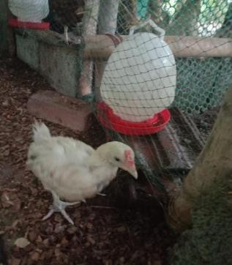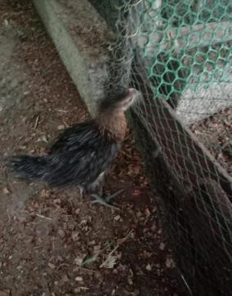

**Fig. 10. Field Trial for Feed in Poultry Farm: Field trial before feed (Test and control)**

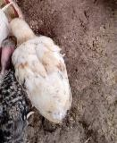 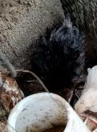;

**Fig. 11. Field Trial For Feed In Poultry Farm: Field trial after feed (Test and control)**

**4. DISCUSSION**

A rich phytochemical profile comprising flavonoids, phenols, tannins, glycosides, proteins, and coumarins was found in the methanolic extract of *Sesamum radiatum*. These molecules are present in diverse solvent extracts, most likely as a result of variations in the solvent's polarity and capacity to dissolve particular phytochemicals. Hexane extracts, for instance, contained proteins, coumarins, and flavonoids, whereas chloroform extracts produced proteins and glycosides. But the best solvent for extracting a wider variety of bioactive substances was methanol.

The methanolic extract contains flavonoids and tannins, which are known to have antibacterial and anti-inflammatory qualities. Plants produce flavonoids in reaction to microbial infection, which combine with bacterial cell walls and proteins to produce antimicrobial effects (Rice-Evans et al., 1997). Conversely, tannins have the ability to attach to proteins that are high in proline, which can interfere with protein synthesis and have the ability to repair wounds (Jorgensen et al., 1991).

The disc diffusion method was used to assess the antibacterial activity of *Sesamum radiatum* extracts against *Pseudomonas aeruginosa, Escherichia coli,* and *Staphylococcus aureus.* The rich phytochemical makeup indicates potential efficacy at larger dosages, despite the weak antibacterial impact at the studied concentrations.  
  
The extract's ability to neutralize free radicals was further supported by antioxidant activity measured using the Ferric Reducing Antioxidant Power (FRAP) assay, which further supports its usage as a natural medicinal agent.

Results from a field trial with 30-day-old chicks during a 30-day period were encouraging. The methanolic extract-fed chickens showed improved immunological response and increased body weight by 15.25%, suggesting greater metabolic efficiency and food absorption. These results highlight the potential in poultry production of *Sesamum radiatum* as a natural immune-boosting and growth-promoting agent.  
  
In summary, the findings support the traditional application of *Sesamum radiatum* and offer a rationale for its inclusion in organic poultry feed. To fully realize its potential as a sustainable substitute for synthetic chemicals, future research should examine the precise mechanisms of action, ideal doses, and long-term safety.

5. Conclusion

This study evaluated the nutritional composition, antioxidant capacity, and antimicrobial activity of *Sesamum radiatum* leaf extracts for potential application in poultry feed. The methanolic extract, in particular, exhibited a high concentration of bioactive compounds such as flavonoids, phenols, and proteins, contributing to its strong antioxidant performance as evidenced by the FRAP assay.Although no zones of inhibition were observed in the disc diffusion assayindicating resistance of the tested bacterial strains to the crude extracts at the applied concentrations the phytochemical profile suggests that antimicrobial potential may still exist at higher doses or in purified fractions.Notably, the in vivo poultry feed trial demonstrated a significant improvement in weight gain among birds supplemented with *Sesamum radiatum*-enriched feed, highlighting its promise as a natural growth-promoting additive. These findings support the incorporation of *Sesamum radiatum* as a functional ingredient in sustainable poultry nutrition, particularly for its nutritional and antioxidant benefits. Further research should focus on optimized extraction protocols, the isolation of active constituents, and expanded in vivo antimicrobial testing to better understand its potential as a phytogenic alternative to synthetic additives.

Disclaimer (Artificial intelligence)

Option 2:

Author(s) hereby declare that generative AI technologies such as Large Language Models, etc. have been used during the writing or editing of manuscripts. This explanation will include the name, version, model, and source of the generative AI technology and as well as all input prompts provided to the generative AI technology

Details of the AI usage are given below:

1.Paraphrasing tool

During the preparation of this work, the authors used Chat gpt and quillbot to assist with summarizing and refining data and for finding research papers. After using this tool/service, the authors reviewed and edited the content as needed and take full responsibility for the content of the publication.

References

1. Singh, B. P., Bangar, S. P., Alblooshi, M., Ajayi, F. F., Mudgil, P., & Maqsood, S. (2023). Plant-derived proteins as a sustainable source of bioactive peptides: recent research updates on emerging production methods, bioactivities, and potential application. Crit. Rev. Food Sci. Nutr., 63(28), 9539-9560. <https://doi.org/10.1080/10408398.2022.2145678>
2. Upadhayay, U. P. P. D. D., & Vishwa, P. C. V. (2014). Growth promoters and novel feed additives improving poultry production and health, bioactive principles and beneficial applications: the trends and advances-a review. Int. J. Pharmacol., 10(3), 129-159.
3. AlSheikh, H. M. A., Sultan, I., Kumar, V., Rather, I. A., Al-Sheikh, H., Tasleem Jan, A., & Haq, Q. M. R. (2020). Plant-based phytochemicals as possible alternative to antibiotics in combating bacterial drug resistance. Antibiotics, 9(8), 480. <https://doi.org/10.3390/antibiotics9080480>
4. Wacal, C., Musinguzi, S. P., Ewaju, E., Atibo, C., Alowo, D., Alipa, J., & Basalirwa, D. (2024). Unravelling the potential benefits of sesame (Sesamum indicum L.) in cropping systems, nutritional, health, and industrial uses of its seeds–a review. Cogent Food Agric., 10(1), 2360766. <https://doi.org/10.1080/23311932.2024.2360766>
5. Oke, O. E., Akosile, O. A., Oni, A. I., Opowoye, I. O., Ishola, C. A., Adebiyi, J. O., et al. (2024). Oxidative stress in poultry production. Poult. Sci., 104003. <https://doi.org/10.1016/j.psj.2024.104003>
6. Yehye, W. A., Rahman, N. A., Ariffin, A., Abd Hamid, S. B., Alhadi, A. A., Kadir, F. A., & Yaeghoobi, M. (2015). Understanding the chemistry behind the antioxidant activities of butylated hydroxytoluene (BHT): A review. Eur. J. Med. Chem., 101, 295-312. <https://doi.org/10.1016/j.ejmech.2015.06.026>
7. Oduntan, A. O., Olaleye, O., & Akinwande, B. A. (2012). Effect of plant maturity on the proximate composition of *Sesamum radiatum* Schum leaves. J. Food Stud., 1(1), 69-76. <http://dx.doi.org/10.5296/jfs.v1i1.1806>
8. Mishra, B., & Jha, R. (2019). Oxidative stress in the poultry gut: potential challenges and interventions. Front. Vet. Sci., 6, 60. <https://doi.org/10.3389/fvets.2019.00060>
9. Fatima, Z., Purkait, D., Rehman, S., Rai, S., & Hameed, S. (2023). Multidrug resistance: a threat to the antibiotic era. In Biological and Environmental Hazards, Risks, and Disasters (pp. 197-220). Elsevier. <https://doi.org/10.1016/B978-0-12-818732-6.00023-6>
10. Shittu, L. A. J., Bankole, M. A., Ahmed, T., Bankole, M. N., Shittu, R. K., Saalu, C. L., & Ashiru, O. A. (2007). Antibacterial and antifungal activities of essential oils of crude extracts of *Sesamum radiatum* against some common pathogenic micro-organisms. J. Med. Plants Res.
11. Dossou, S. S. K., Xu, F. T., Dossa, K., Rong, Z., Zhao, Y. Z., & Wang, L. H. (2023). Antioxidant lignans sesamin and sesamolin in sesame (*Sesamum indicum L*.): A comprehensive review and future prospects. J. Integr. Agric., 22(1), 14-30. <https://doi.org/10.1016/S2095-3119(22)63874-3>
12. Kamal-Eldin, A. (2010). Lignans of sesame: Purification methods, biological activities and biosynthesis—a review. In D. Bedigian (Ed.), Sesame—The genus Sesamum (pp. 560–580). CRC Press.
13. Kancharla, P. K., Arumugam, N., & Arumugam, N. (2020). Variation of oil, sesamin, and sesamolin content in the germplasm of the ancient oilseed crop Sesamum indicum L. Journal of the American Oil Chemists' Society, 97(5), 475–483. <https://doi.org/10.1002/aocs.12346>
14. Wei, P., Zhao, F., Wang, Z., Wang, Q., Chai, X., Hou, G., & Meng, Q. (2022). Sesame *(Sesamum indicum L*.): A comprehensive review of nutritional value, phytochemical composition, health benefits, development of food, and industrial applications. Nutrients, 14(19), 4079. <https://doi.org/10.3390/nu14194079>
15. Ivanova, S., Sukhikh, S., Popov, A., Shishko, O., Nikonov, I., Kapitonova, E., et al. (2024). Medicinal plants: a source of phytobiotics for the feed additives. J. Agric. Food Res., 101172. <https://doi.org/10.1016/j.jafr.2024.101172>
16. Menon, V. P., & Sudheer, A. R. (2007). Antioxidant and anti-inflammatory properties of curcumin. In The molecular targets and therapeutic uses of curcumin in health and disease (pp. 105-125). Springer. <https://doi.org/10.1007/978-0-387-46401-5_4>
17. Florou-Paneri, P., Christaki, E., & Giannenas, I. (Eds.). (2019). Feed Additives: Aromatic Plants and Herbs in Animal Nutrition and Health. Academic Press. <https://doi.org/10.1016/C2017-0-02983-8>
18. Oreopoulou, A., Tsimogiannis, D., & Oreopoulou, V. (2019). Extraction of polyphenols from aromatic and medicinal plants: An overview of the methods and the effect of extraction parameters. In Polyphenols in Plants (pp. 243–259). Academic Press. <https://doi.org/10.1016/B978-0-12-813768-0.00025-6>
19. Rashid, R., Wani, M. H., & Devi, S. (2017). Phytochemical Investigation of the Plant Solanum nigrum L. used in Traditional Medicine from the Local Area of Bhopal. International Journal of Science and Research (IJSR), 6(6), 1206–1209.
20. Sawant, R. S., & Godghate, A. G. (2013). Qualitative phytochemical screening of rhizomes of Curcuma longa Linn. International Journal of Science, Environment and Technology, 2(4), 634–641.
21. Ahmed, M. H., & Majaz, Q. (2022). Qualitative and quantitative phytochemical analysis of some edible fruits. NeuroQuantology, 20(22), 2036–2047. <https://doi.org/10.48047/nq.2022.20.22.NQ10192>
22. Agbo, M. O., Uzor, P. F., Nneji, U. N. A., Odurukwe, C. U. E., Ogbatue, U. B., & Mbaoji, E. C. (2015). Antioxidant, total phenolic and flavonoid content of selected Nigerian medicinal plants. Dhaka University Journal of Pharmaceutical Sciences, 14(1), 35–41. <https://doi.org/10.3329/dujps.v14i1.23733>
23. Patel, M. K., Bhatnagar, M. M., Thakor, M. N., & Dodia, M. R. V. (2022). Evaluation of protein and carbohydrate content of some anti-diabetic medicinal plants. International Journal of Advanced Medical Sciences and Technology, 2(3), 1–6. <https://doi.org/10.54105/ijamst.C3027.042322>
24. Madhu, C., Krishna, K. M., Reddy, K. R., Lakshmi, P. J., & Kelari, E. K. (2017). Estimation of crude fibre content from natural foodstuffs and its laxative activity induced in rats. International Journal of Pharma Research and Health Sciences, 5(3), 1703–1706. <https://doi.org/10.21276/ijprhs.2017.03.04>
25. Lamuela-Raventós, R. M. (2018). Folin–Ciocalteu method for the measurement of total phenolic content and antioxidant capacity. In Measurement of Antioxidant Activity & Capacity: Recent Trends and Applications (pp. 107–115). Wiley. <https://doi.org/10.1002/9781119135388.ch6>
26. Dioha, I. J., Olugbemi, O., Onuegbu, T. U., & Shahru, Z. (2011). Determination of ascorbic acid content of some tropical fruits by iodometric titration. International Journal of Biological and Chemical Sciences, 5(5), 2180–2184. <https://doi.org/10.4314/ijbcs.v5i5.40>
27. Baker, W. H., & Thompson, T. L. (1992). Determination of total nitrogen in plant samples by Kjeldahl. *Plant analysis reference procedures for the southern region of the United States*, *368*, 13-16.
28. Gohari, A. R., Hajimehdipoor, H., Saeidnia, S., Ajani, Y., & Hadjiakhoondi, A. (2011). Antioxidant activity of some medicinal species using FRAP assay. Journal of Medicinal Plants, 10(37), 1–7.
29. Kateete, D. P., Kimani, C. N., Katabazi, F. A., Okeng, A., Okee, M. S., Nanteza, A., ... & Najjuka, F. C. (2010). Identification of Staphylococcus aureus: DNase and mannitol salt agar improve the efficiency of the tube coagulase test. Annals of Clinical Microbiology and Antimicrobials, 9, 23. <https://doi.org/10.1186/1476-0711-9-23>
30. Bozaslan, B. S., Cakan, H., Ates, P. S., Alturfan, A. A., & Cengiz, S. (2016). The examination of the growth of Escherichia coli (E. coli) strain on MacConkey agar prepared with wastewater. International Journal of Environmental Science and Development, 7(11), 793–796. <https://doi.org/10.18178/ijesd.2016.7.11.880>
31. Jorgensen, J. H., & Turnidge, J. D. (2015). Susceptibility test methods: Dilution and disk diffusion methods. In Manual of Clinical Microbiology (11th ed., pp. 1253–1273). ASM Press. <https://doi.org/10.1128/9781555817381.ch71>
32. Rice-Evans, C., Miller, N., & Paganga, G. (1997). Antioxidant properties of phenolic compounds. Trends in plant science, 2(4), 152-159.
33. Jorgensen, W. L. (1991). Rusting of the lock and key model for protein-ligand binding. Science, 254(5034), 954-955.