# **Innovative and Cost-Effective Vertical Movement in Multistory Construction in Lagos, Nigeria**

**Abstract**

In Nigeria, Lagos, the city, becomes a bustling megacity, and multistory buildings serve as crucial solutions for housing shortages and the need for commercial infrastructure. The city has led to a surge in the demand for multistory buildings due to rapid population growth, economic development, and the need to optimise limited land space. This study investigates innovative and cost-effective approaches to the vertical movement of personnel and materials in multistory building construction in Lagos, Nigeria. As urbanisation accelerates and the demand for high-rise buildings grows, effective vertical transportation systems are essential for improving construction efficiency and reducing operational costs. The research employs a qualitative methodology, incorporating interviews with 20 construction professionals, including construction managers, architects, engineers, and logistics managers, along with site observations and case studies from active construction projects in Lagos. The findings reveal that traditional systems such as cranes and lifts dominate the industry. However, emerging alternatives like modular hoists, automated lifts, and even drones are gaining traction due to their potential for cost savings and increased efficiency. However, the adoption of these innovative systems is hindered by challenges such as high initial investment costs, safety concerns, limited technical knowledge, and a lack of infrastructure for maintenance. The study highlights the need to shift towards more sustainable and affordable vertical transport solutions. It also recommends strategies to improve safety standards, increase awareness, and provide targeted training to ensure these innovative approaches can be more widely adopted and successfully implemented in Lagos' construction sector. To meet Lagos’ vertical building demands, construction firms must adopt smarter, more sustainable vertical movement systems.

Key words: multistory buildings, Construction, Innovative, Cost-Effective, metropolitan area

**1.0 Introduction**

Lagos, the economic and industrial hub of Nigeria, is the third-largest metropolitan area in Africa and one of the fastest-growing megacities in the world (Oyewo & Oyewale,2023). Urbanisation in Lagos, Nigeria, has led to a surge in the demand for multistory buildings due to rapid population growth, economic development, and the need to optimise limited land space. Urban spatial evolution is shaped by a complex interplay of anthropogenic activities and environmental dynamics, influenced by physical, socioeconomic, and regulatory factors. This study focuses on understanding the driving forces behind urban spatial evolution in Lagos, Nigeria (Gilbert & Shi,2024; Chidi & Badejo,2024).

As the city becomes a bustling megacity, multistory buildings serve as crucial solutions for housing shortages and the need for commercial infrastructure (Gilbert & Shi, 2023; Afolabi et al., 2019). However, constructing these buildings presents challenges, particularly in the efficient vertical movement of personnel and materials. Traditional methods like ladders, pulleys, and ropes are often inefficient, unsafe, and inadequate for large-scale projects. These methods lead to frequent accidents, delays, and increased costs, driving more advanced technologies such as cranes, construction elevators, and material hoists (Oladimeji & Ojo, 2021; Afolabi et al., 2022). While these advanced systems improve efficiency and safety, their high cost remains a financial barrier for many construction firms, tiny and medium-sized enterprises (SMES) (Afolabi et al., 2022).

The urban environment of Lagos exacerbates the challenges related to vertical movement during construction. Urban resilience against environmental disasters is a critical aspect of sustainable urban development, particularly in megacities like Lagos, which face diverse environmental challenges (Eneh et al.,2024). High population density, heavy traffic congestion, and limited construction site sizes create logistical difficulties that hinder the transportation and deployment of vertical movement equipment (Adebayo, 2021; Mustard Insights, 2022; Salau, 2023). Additionally, unreliable infrastructure, such as inconsistent electricity supply and high fuel costs, further complicates the operation of advanced systems (Afolabi et al., 2019). Innovative and cost-effective approaches, such as modular scaffolding, prefabricated lifts, and drone technology, offer potential solutions to address these challenges. As urbanisation and high-rise living increase, frequent delivery of goods in the building to higher floors from the ground level is becoming a pressing issue. A drone-based vertical delivery system is aimed at enhancing the efficiency of high-rise building logistics (Ezaki et al.,2024). These technologies can improve efficiency, reduce costs, and enhance safety while adapting to Lagos's unique constraints. Local fabrication of systems and using sustainable practices, such as solar-powered equipment, can further reduce costs and align with global sustainability trends. Effective vertical movement systems are critical for improving construction timelines, labour productivity, and overall project budgets, ultimately supporting Lagos’ broader development goals and addressing the city's growing infrastructure demands.

## **1.2 Research Questions**

This research seeks to answer the following questions:

1. What are the challenges of vertical movement in multistory building construction in Lagos?

2. What innovative approaches can enhance the efficiency and cost-effectiveness of vertical movement systems?

## **1.3 Aim**

The study aims to explore innovative and cost-effective approaches to vertical movement of personnel and materials in multistory building construction in Lagos, Nigeria.

## **1.4 Objectives**

The objectives of this study are to:

1. Identify the key challenges of vertical movement in Lagos' construction projects.

2. Explore innovative and cost-effective solutions for vertical movement systems.

## **1.5 Problem Statement**

Vertical movement systems for personnel and materials in Lagos' multistory building construction face inefficiencies, high costs, and inadequate infrastructure. These systems are crucial to construction activities but encounter numerous challenges that significantly impede project progress and success. Traditional methods, such as manual labour and basic scaffolding, are increasingly outdated and insufficient for modern construction demands. While cost-effective, they lack the efficiency, safety, and reliability required for large-scale projects, leading to delays, labour fatigue, and higher workplace accidents (Afolabi et al., 2019).

## **2.0 Literature review**

Vertical movement systems, encompassing elevators, lifts, and cranes, are integral to the construction and functionality of multistory buildings. These systems ensure the efficient transportation of personnel and materials, which is critical for maintaining productivity and meeting construction timelines. In Nigeria, the rapid pace of urbanisation, particularly in cities like Lagos, has increased demand for high-rise buildings, intensifying the need for efficient and cost-effective vertical transportation solutions (Aliyu & Abdullahi, 2017).

**2.1 Evolution of Vertical Movement in Building Construction**

**Early Methods of Vertical Movement:**

The need for vertical movement in construction dates back to ancient civilisations. In Ancient Egypt, the construction of pyramids involved inclined planes and human labour to transport large stones upward, a technique that allowed workers to stack massive blocks with precision (Levy, 1992; Arnold, 2003). On the other hand, the Romans developed cranes powered by human or animal force, which were used extensively in constructing aqueducts, temples, and amphitheatres. These early cranes enabled builders to lift heavier materials to greater heights, improving construction efficiency (Lancaster, 1999). During the medieval period in Europe, the invention of treadwheel cranes revolutionised building practices, particularly in cathedral construction. These devices, operated by workers walking inside a large wheel, significantly improved hoisting materials' lifting capacity and precision (Adams, 2007).

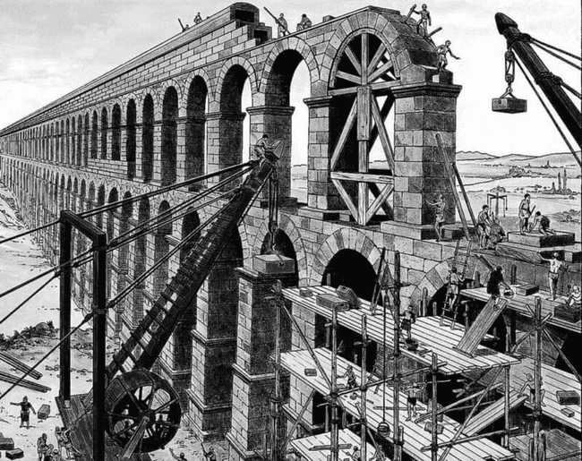

**Fig. 1.** Crane and Hoist in Ancient Rome. Travelling Cook,<https://traveling-cook.com/evolution-cranehoist-ancient-rome/>.

**The Industrial Revolution and the Advent of Mechanical Lifting Systems:**

The Industrial Revolution (18th–19th century) marked a turning point in vertical movement technology. The introduction of steam-powered and hydraulic lifting devices allowed for more efficient material handling in factories and warehouses (Strakosch & Caporale, 2010). In 1853, Elisha Otis invented the first safety elevator equipped with an automatic brake system, allowing elevators to be used in buildings without fear of sudden falls (DuMont, 1978). This innovation paved the way for taller structures, as developers could now rely on safer vertical transportation systems. By the late 19th century, advancements in steel construction facilitated the development of skyscrapers, increasing the necessity for elevators as a standard feature in high-rise buildings (Willis, 1995).

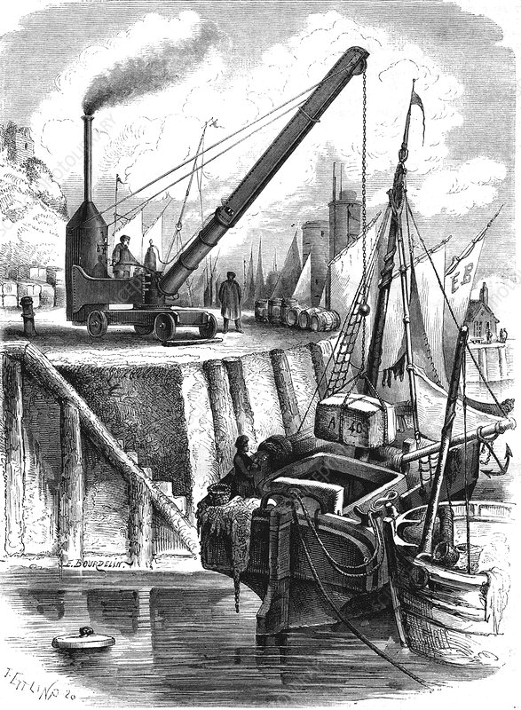

**Fig. 2.** "19th-Century Steam Crane Illustration." Science Photo Library,<https://www.sciencephoto.com/media/717604/view/19th-century-steam-crane-illustration>.

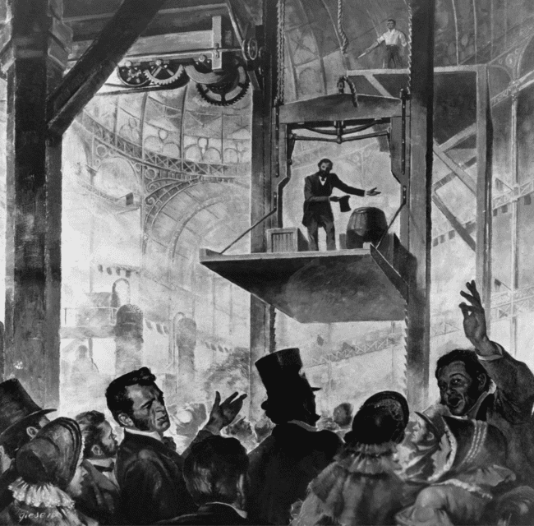

Fig. 3: Elisha Otis Demonstrating His Safety Elevator at the Crystal Palace, 1854. Source: <https://commons.wikimedia.org/wiki/File:Elisha_OTIS_1854.jpg>.

**The 20th Century:**

Electrification and Automation. The 20th century saw rapid improvements in elevator technology. The early 1900s introduced electrically powered elevators, which replaced hydraulic and steam-driven systems, making vertical movement faster and more reliable (Friedman, 2002). By the mid-20th century, push-button controls became standard, eliminating the need for elevator operators and increasing efficiency in high-rise structures (Otis Elevator Co., 1952). During the late 20th century, the global expansion of skyscrapers spurred innovations such as express elevators, double-deck systems, and computerised scheduling, all of which improved the speed and efficiency of vertical transportation (Wood & Oldfield, 2007).

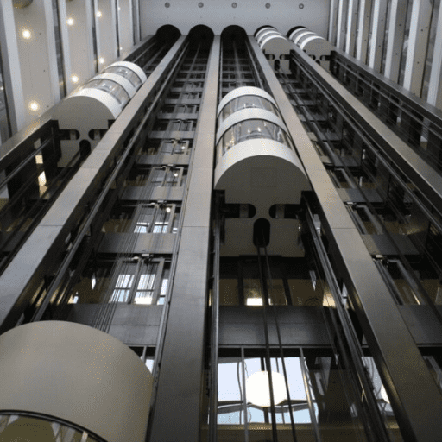

Fig. 4: High Rise Elevator Solutions. Gold Supplier Blog,<https://blog.goldsupplier.com/elevator-high-rise/>.

**The 21st Century:**

Innovative and Sustainable Vertical Movement. In the 21st century, advancements in technology and sustainability have significantly transformed vertical transportation. Smart elevators, equipped with Internet of Things (IoT) capabilities, optimise movement patterns, reduce wait times, and enhance energy efficiency (Sharma & Seth, 2011). Additionally, regenerative braking systems have been introduced, allowing elevators to generate electricity while descending, thereby reducing overall energy consumption (Siemens, 2019). The emergence of pneumatic and magnetic levitation (Maglev) elevators, such as the ThyssenKrupp MULTI system, eliminates the need for cables and enables multidirectional movement within buildings, increasing efficiency and design flexibility (Smith & Randell, 2016). Furthermore, some construction sites now experiment with drones for material transport and robotic systems for automated hoisting, improving safety and efficiency in high-rise projects (Ganesan, 2021).

By examining the historical evolution of vertical movement systems, it is evident that technological advancements have played a crucial role in enabling efficient and safe transportation in multistory buildings. These innovations provide a foundation for addressing contemporary challenges in Lagos' construction industry.

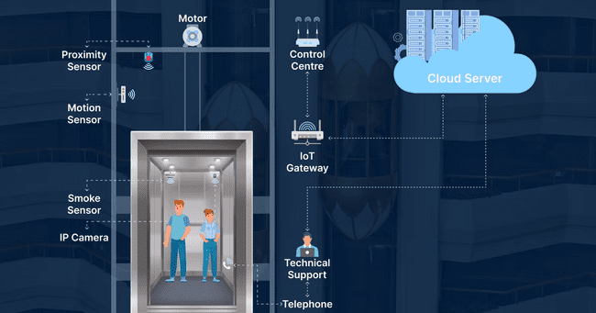

Fig. 5: IoT Solutions for Smart Elevator Management. Intuz Blog,<https://www.intuz.com/blog/guide-iot-solutions-for-smart-elevator-management>.

## **2.2 Challenges in Vertical Movement**

**Economic Constraints**  
High acquisition, installation, and maintenance costs of modern vertical transport systems hinder adoption in Nigeria. Imported equipment and components are expensive, and local manufacturing remains limited. Frequent equipment breakdowns, mainly due to poor maintenance, further increase operating costs. The absence of government financial support exacerbates these issues (Ogunbayo & Adebayo, 2020; Onuoha & Opara, 2022).

**Technological Gaps**  
The Nigerian industry is slow to adopt advanced systems such as smart elevators and Building Information Modelling (BIM). Instead, it often relies on outdated manual methods that are inefficient and hazardous. Limited technical know-how and high implementation costs deter digital transformation in construction logistics (Afolabi et al., 2019; Hassan et al., 2022).

**Infrastructural Challenges**  
Urban conditions—narrow roads, traffic congestion, and small construction sites—complicate the setup and operation of cranes and lifts. Additionally, the national grid’s instability forces reliance on diesel generators, increasing costs and environmental impact (Onuoha & Opara, 2022).

**Maintenance and Operational Inefficiencies**  
There is a chronic shortage of trained personnel for maintaining vertical movement systems. Imported expertise is costly and unsustainable. Poor maintenance culture contributes to frequent breakdowns and delays, especially in public sector projects (Ogunbayo & Adebayo, 2020).

**Safety Concerns**  
Lack of regulatory enforcement leads to unsafe practices, including non-compliant scaffolding and lift usage, causing injuries and delays. Many construction sites disregard international safety standards, leading to frequent inspections and project disruptions (Mehta & Gupta, 2018).

**Environmental Impact**  
Widespread reliance on diesel-powered systems contributes to pollution. Although sustainable alternatives exist (e.g., solar-powered lifts), high upfront costs and inadequate policy support hinder their implementation (Oke et al., 2017; Okoye et al., 2021).

Evolution of Vertical Movement in Building Construction

## **3.0 Innovative Approaches**

* Modular Scaffolding & Temporary Lifts:  
   Prefabricated systems reduce setup time and labour, with local firms beginning production.

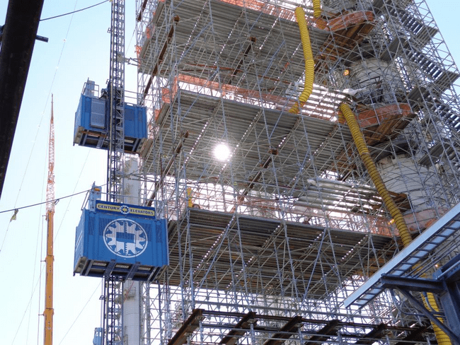

Fig. 6: Modular Scaffolding System in Use. Lift and Access,<https://www.liftandaccess.com/article/tall-orders-century-elevators-excel-modular-scaffold-scale-262-feet>.

* Pneumatic & Energy-Efficient Elevators:  
   Using air pressure and low power, these elevators are environmentally friendly and suitable for sites with limited space.

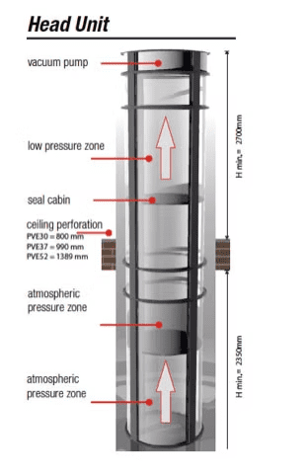

Fig. 7: Pneumatic and Energy-Efficient Elevator. Roohki,<https://www.roohki.com/pneumatic-vacuum-elevator>.

* Drone Technology:  
   Promising for lightweight material transport in dense urban areas.

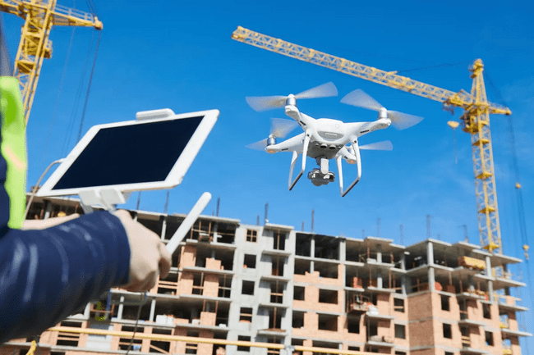

Fig. 8: Drone-Assisted Material Delivery. Remote Flyer,<https://www.remoteflyer.com/how-drone-technology-helps-in-construction/>.

Local Fabrication & Sustainable Practices:  
Bamboo scaffolding and solar-powered lifts use local materials and reduce the carbon footprint.

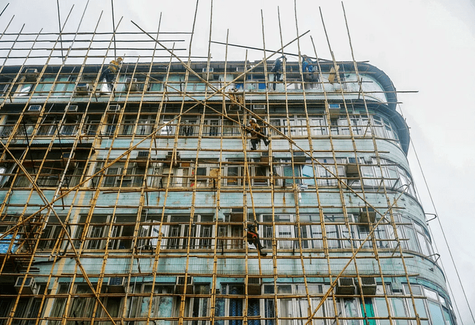

Fig. 9: Bamboo Scaffolding in a Local Project. Hong Kong Free Press,<https://hongkongfp.com/2025/03/19/hong-kongs-iconic-bamboo-scaffolds-on-their-way-out/>.

* Kinetic Lifts Using Regenerative Energy:  
   Systems that harvest energy on descent to power ascent.

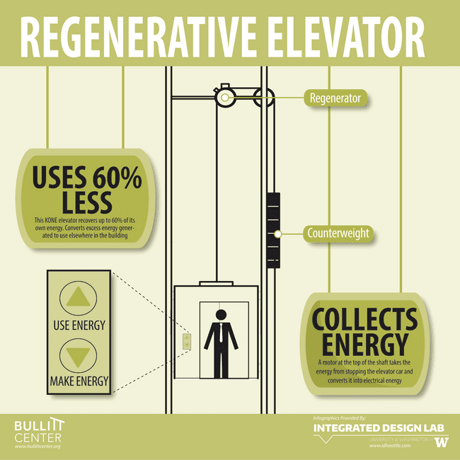

Fig. 10: Kinetic energy lift mechanism <https://bullittcenter.org/building/building-features/a-powerful-plunge/>

* Telescopic Mobile Work Platforms:  
   Hydraulic platforms that extend vertically, reducing the need for ladders or scaffolds.

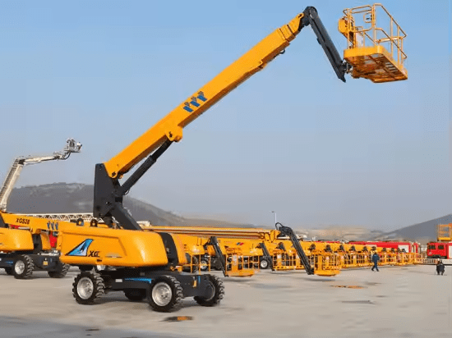

Fig. 11: Mobile Telescopic Platform in Operation. Made-in-China,<https://sinomada.en.made-in-china.com/product/mEjRwgLxgHWd/China-Official-40m-Mobile-Aerial-Work-Platform-Xgs40K-Telescopic-Platform.html>.

* Electric Hydraulic Lift:

It is a type of elevator that combines electric and hydraulic systems, utilises lightweight aluminium materials, and is designed for specific applications like aerial work or in buildings. These lifts often feature an electric motor that powers a hydraulic pump, which uses pressurised fluid to lift a platform or carriage. The aluminium construction makes them lighter and easier to transport

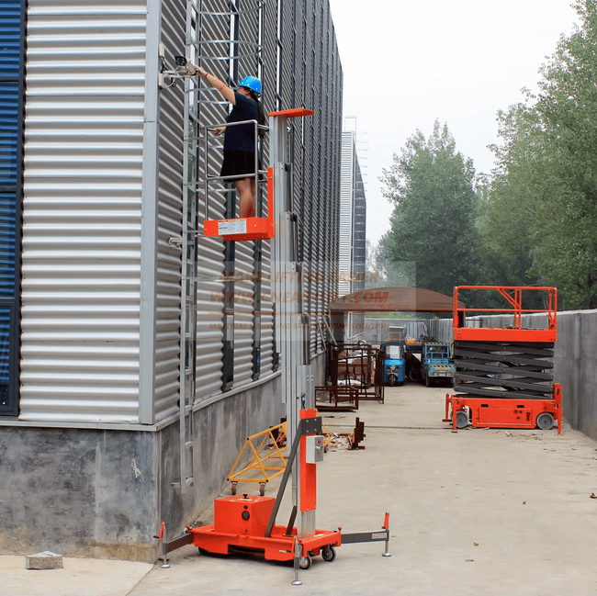

Fig. 12: Lightweight Aluminium Hydraulic Lift Elevator in Operation. Alibaba,<https://www.alibaba.com/product-detail/mobile-man-lift-electric-hydraulic-lift_62007505214.html>.

* Telescopic Excavator:

A telescopic excavator is a specialised excavator equipped with a telescopic arm, allowing it to reach and dig at greater depths than standard excavators. These machines are designed for underground construction projects, enabling them to remove soil from depths up to 30 meters below ground level. The telescopic arm can extend and retract quickly, facilitating efficient loading of trucks and safe operation.

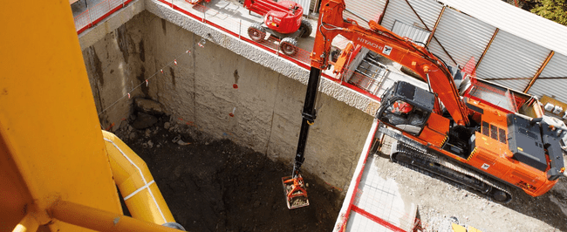

Fig. 13: Telescopic Excavator in Operation. Hitachi Construction Machinery,<https://www.hitachicm.com/eu/en/machinery/excavators/special-applications/clamshell-telescopic-arm-excavators/>.

## **Methodology**

A qualitative case study approach was adopted, featuring interviews with 20 construction professionals, including engineers, project managers, and architects. Field visits were conducted to active multistory sites such as The Ark Legacy Project, Piper Furniture Ltd., and Luxurious Apartments by CCECC. Data was gathered via semi-structured interviews and site observation.

**5.0 RESULT and discussion:** Common Practices:  
 Tower cranes and hoists are used alongside manual labour. Manual lifting is still prevalent on smaller sites.

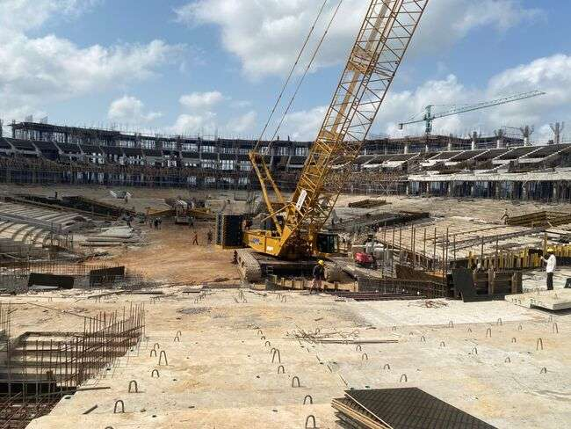 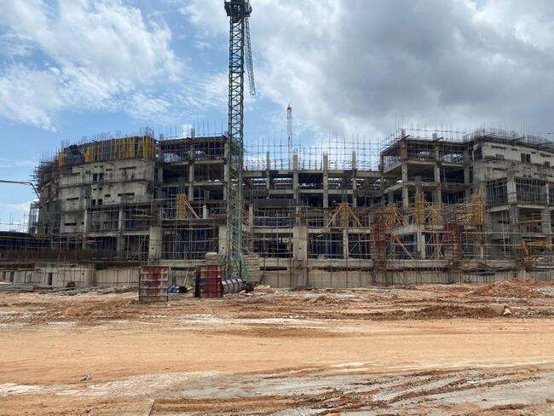

Fig. 14: Site visit at The Ark Legacy Project

During our site visit to the Ark Legacy Project, we observed the use of tower and mobile cranes strictly for the vertical and horizontal movement of materials such as steel, formwork, and blocks.

The tower crane was centrally positioned and used to lift materials to various floors efficiently due to its height and broad reach. The mobile crane handled ground-level lifting and offloading tasks, offering flexibility in tighter areas.

While tower cranes are expensive to install, they are cost-effective for high-rise projects due to their continuous use. Mobile cranes are more flexible but can become costly with long-term use.

In conclusion, both cranes were appropriately used on-site, balancing efficiency and cost based on their strengths.

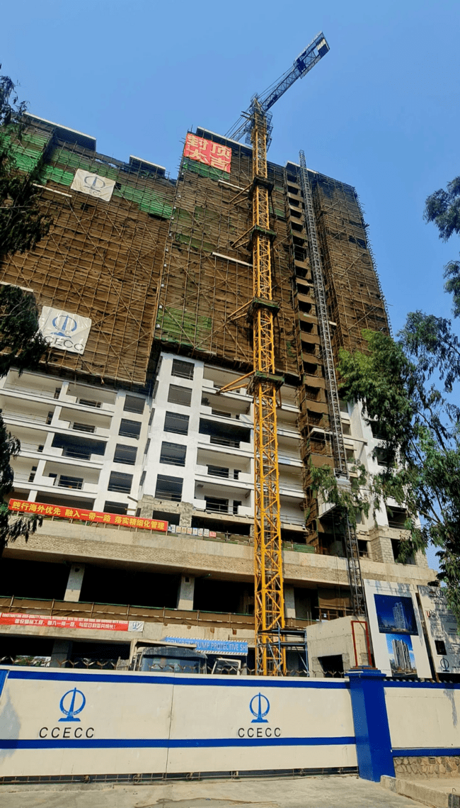 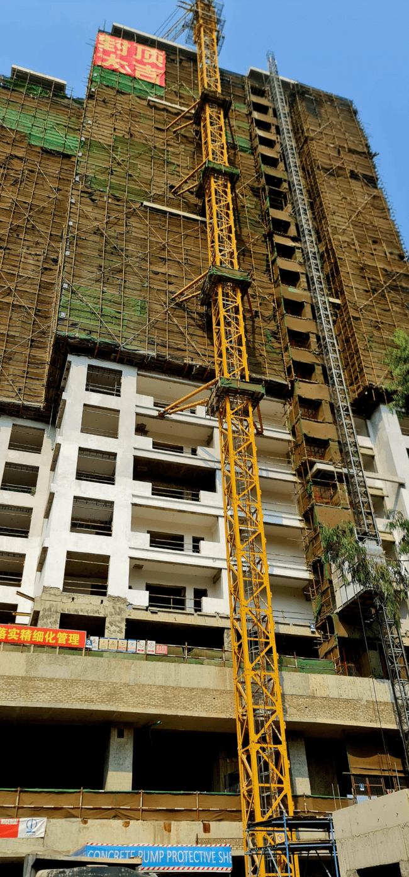

Fig. 15: Construction progress at Luxurious Apartments by CCECC

During our site visit to the Luxurious Apartments project by CCECC, we observed the use of tower cranes and temporary lifts (hoists). The tower crane was used strictly to move materials vertically and horizontally across the site. It was positioned to cover a wide area and efficiently handle heavy items like steel bars and precast elements.

The temporary lift (hoist) was used for vertical movement of materials and personnel, especially for accessing upper floors during construction.

In conclusion, using the tower crane and hoist was appropriate. While costly to set up, the tower crane is efficient for large-scale lifting. Though more limited in range, the hoist is cost-effective for moving materials quickly between floors.

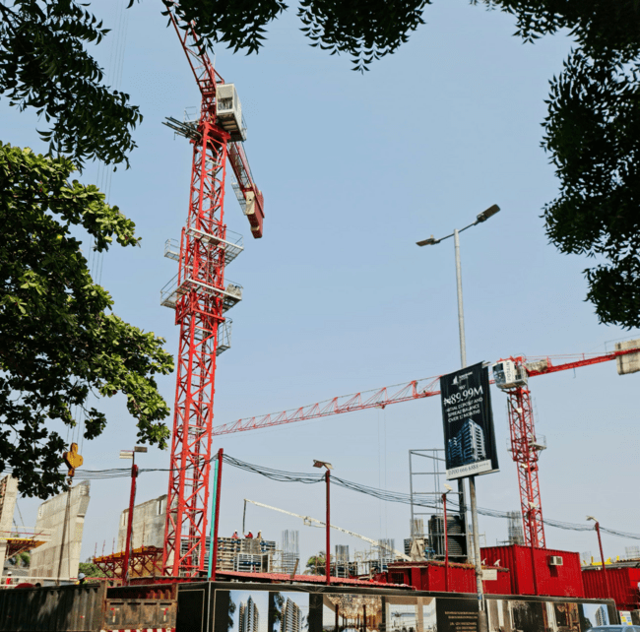 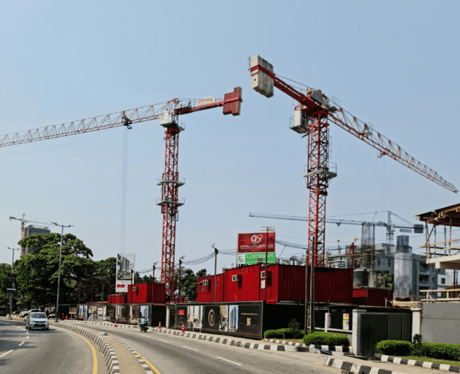

Fig. 16: Pictures from site visit at Luxurious residential apartments by Cappa

During our site visit to the luxurious residential apartments by Cappa, we observed two tower cranes on-site. These cranes were being used for the vertical transportation of materials, but at this particular moment, the cranes were not actively lifting any materials. Instead, they were being prepared for the upcoming stages of construction.

As the project is in its early phases and an elevator has not been installed yet, the tower cranes are essential for moving workers, small tools, and light materials to higher levels. Their strategic positioning allows them to cover the entire site, ensuring that future material handling will be more efficient.

In conclusion, while tower cranes come with significant setup and operational costs, they are invaluable for projects of this scale and phase. They will become even more cost-effective as the project progresses and material lifting demands increase.

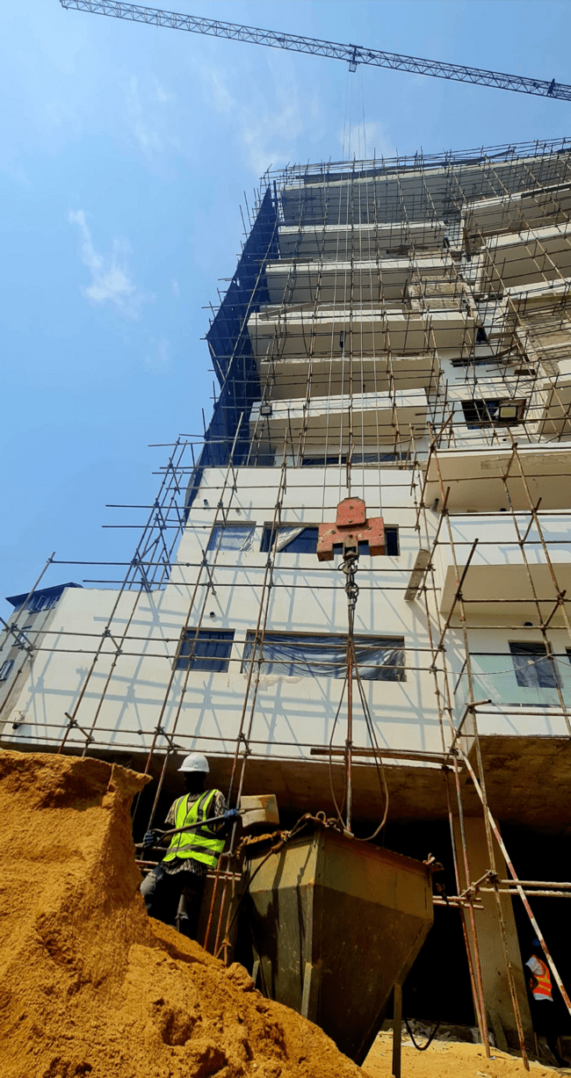 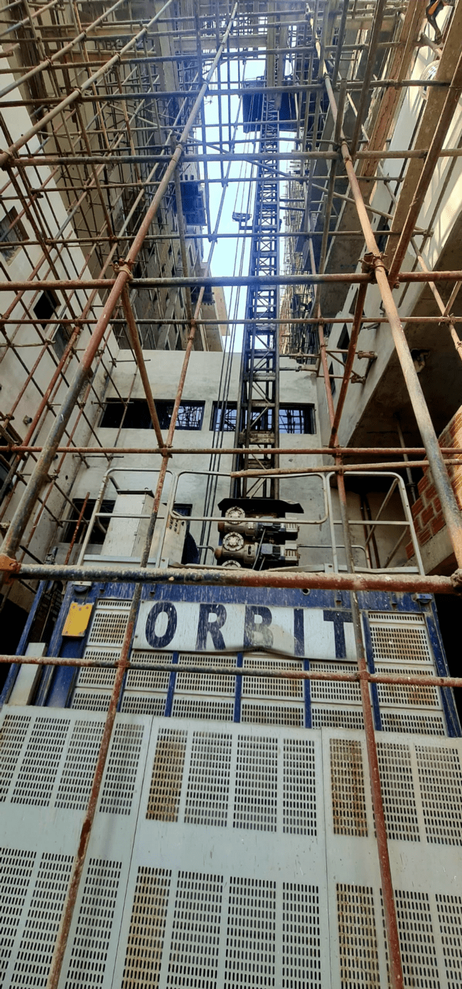 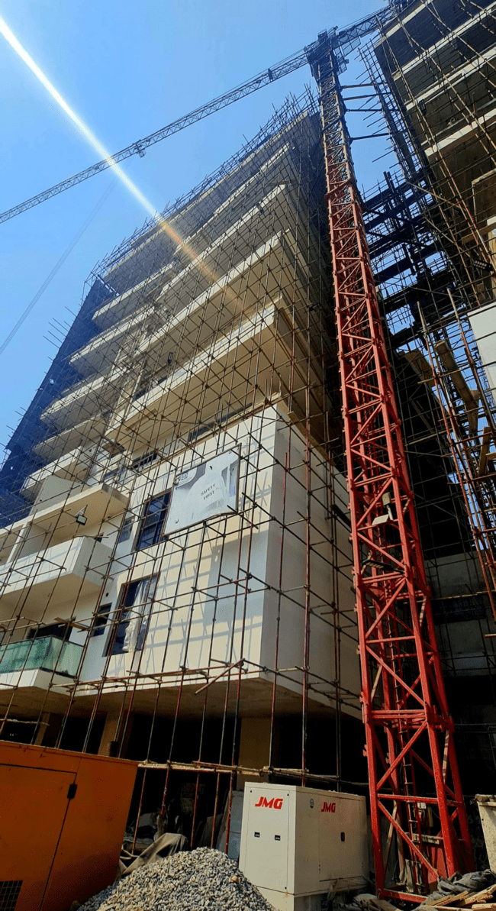

#### Fig. 17: The use of vertical movement equipment at the Luxurious apartment site by black diamond

During our site visit to the Luxurious Apartments by Black Diamond, we observed that tower cranes were actively used for materials' vertical and horizontal movement. In the moment captured in the photo, the tower crane was lifting reinforced concrete elements and other construction materials to the upper floors.

A temporary lift (hoist) was also used, primarily for transporting workers and lighter materials vertically within the building.

In conclusion, combining tower cranes and hoists is an efficient and cost-effective approach for a project of this scale. While tower cranes are expensive, their ability to handle heavy materials across wide areas speeds up construction. The hoist complements this by safely moving personnel and small items, reducing delays and improving productivity.

* Innovative Practices Observed:  
  + BIM helped optimise material flow
  + Smart hoists improved safety and monitoring
  + Prefabrication minimised vertical movement demand
  + Drones were tested for aerial monitoring and small item transport

## **6.0 Cost-Effectiveness Analysis**

While initial costs of smart and automated systems are high, long-term benefits include reduced labour costs, fewer project delays, and increased safety. Companies using smart systems reported shorter timelines and improved efficiency.

## **7.0 Implementation Barriers**

* High Capital Investment, especially for SMEs
* Skills Gap in operating and maintaining advanced systems
* Inconsistent Power Supply affecting the performance of electric equipment
* Cultural Preference for familiar, manual methods

## **8.0 Role of Skilled Labour**

The success of modern vertical systems hinges on the availability of trained personnel. Workforce shortages lead to misuse or underuse of equipment, compromising efficiency and safety. Workforce training is essential to long-term adoption.

## **9.0 Recommendations**

* The Nigerian government should provide tax incentives for green and innovative vertical equipment manufacturing
* The private sector should be encouraged to invest in vocational training on vertical movement equipment maintenance and operation
* The Nigerian government should promote the local manufacturing of vertical transport tools
* The Manufacturers Association of Nigeria (MAN) should encourage public-private partnerships and pilot programs for new systems for vertical transport
* Fund research to generate data-driven strategies

## **10.0 Conclusion**

To meet Lagos’ vertical building demands, construction firms must adopt smarter, more sustainable vertical movement systems. This calls for combined efforts—policy support, local innovation, stakeholder training, and investment in clean, adaptable technologies—to create a safe, cost-efficient, and future-ready construction industry.

COMPETING INTERESTS

Authors have declared that they have no known competing financial interests OR non-financial interests OR personal relationships that could have appeared to influence the work reported in this paper.

Disclaimer (Artificial intelligence)

Option 1:

Author(s) hereby declare that NO generative AI technologies such as Large Language Models (ChatGPT, COPILOT, etc.) and text-to-image generators have been used during the writing or editing of this manuscript.

Option 2:

Author(s) hereby declare that generative AI technologies such as Large Language Models, etc. have been used during the writing or editing of manuscripts. This explanation will include the name, version, model, and source of the generative AI technology and as well as all input prompts provided to the generative AI technology

Details of the AI usage are given below:

1.

2.

3.

**References**

1. Afolabi, A. O., Akinbo, F. T., & Akinola, A. (2019). Vertical architecture construction: Prospects and barriers in solving Lagos’ housing deficit. *Journal of Physics: Conference Series, 1378*(4), 042032. https://doi.org/10.1088/1742-6596/1378/4/042032
2. Afolabi, A. O., Ojelabi, R. A., & Oyeyipo, O. O. (2022). Evaluation of drivers and barriers to vertical architecture construction for public housing delivery in Lagos megacity. *Journal of Construction and Building Materials*, 45(2), 115-132.
3. Gilbert, K. M., & Shi, Y. (2023). Land use/land cover changes detection in Lagos City of Nigeria using remote sensing and GIS. *Advances in Remote Sensing, 12*, 145-165. <https://doi.org/10.4236/ars.2023.124008>
4. Eze, C. A., & Umeh, K. C. (2020). The adoption of mechanized lifting equipment in Nigerian construction sites: Challenges and prospects. *Journal of Construction Engineering and Management, 12*(3), 88-102.
5. Oladimeji, T. A., & Ojo, S. O. (2021). Analyzing safety hazards associated with traditional vertical transportation methods in Lagos construction sites. *Nigerian Journal of Building Research, 8*(1), 45-61.
6. Adebayo, S. (2021). *Urban population growth and land constraints in Lagos: Challenges for sustainable development*. Journal of Urban Studies, 15(2), 112-130.
7. Mustard Insights. (2022). *Lagos ranks as the most congested city in the world in 2022*. Retrieved from https://blog.mustardinsights.com
8. Salau, T. (2023). *Impact of urbanization on land availability and construction site sizes in Lagos*. Buildings & Cities Journal, 4(1), 56-78. https://doi.org/10.5334/bc.243
9. Aniekwu, N. (2005). Constraints in the procurement of plants and equipment in the Nigerian construction industry. *Journal of Construction Engineering and Management, 131*(8), 857-864. https://doi.org/10.1061/(ASCE)0733-9364(2005)131:8(857)
10. Le Monde. (2024, November 21). Au Nigeria, à bord du RER de Lagos, un luxe rare en Afrique subsaharienne. *Le Monde Afrique*. https://www.lemonde.fr/afrique/article/2024/11/21/au-nigeria-a-bord-du-rer-de-lagos-un-luxe-rare-en-afrique-subsaharienne_6406066_3212.html
11. Kukoyi, P. O., & Smallwood, J. J. (2017). A qualitative study of health and safety (H&S) construction practices in Lagos. *Journal of Construction Business and Management, 1*(1), 1-7. <https://doi.org/10.15641/jcbm.1.1.17>
12. Alarcon, L. F., Grillo, A., Freire, J., & Diethelm, S. (2016). Lean management practices in construction: Methodology and case study. *Journal of Construction Engineering and Management*, *124*(4), 263–273.
13. Ashuri, B., & Lu, J. (2020). Advanced construction technologies: An overview of current advancements. *Automation in Construction*, *118*, 103275.
14. Atkinson, R. (1999). Project management: Cost, time, and quality, two best guesses and a phenomenon. *International Journal of Project Management*, *17*(6), 337–342.
15. Aye, L., Ngo, T., Crawford, R. H., Gammampila, R., & Mendis, P. (2012). Life cycle greenhouse gas emissions and energy analysis of prefabricated reusable building modules. *Energy and Buildings*, *47*, 159–168.
16. Bryde, D., Broquetas, M., & Volm, J. M. (2013). The project benefits of Building Information Modelling (BIM). *International Journal of Project Management*, *31*(7), 971–980.
17. Costello, G., & Wallace, R. (2017). Innovations in construction: The role of prefabrication in modern building practices. *Construction Innovation*, *17*(2), 101–118.
18. Feng, Y., Zhao, Z., & Jiang, L. (2019). Sustainable vertical mobility solutions in urban high-rise developments. *Journal of Urban Technology*, *26*(3), 45–61.
19. Lagos Bureau of Statistics (2023). Urban development and construction trends in Lagos.
20. Olusanya, O. O., & Ogungbemi, O. D. (2020). Challenges and opportunities in high-rise construction in Nigeria. *Journal of Nigerian Construction Management*, *35*(2), 87–104.
21. Ruwanpura, J. Y., & Mohamed, Y. (2021). Enhancing construction efficiency through lean principles and automation. *Engineering, Construction, and Architectural Management*, *28*(6), 1631–1650.
22. Talebi, S., & Rahimian, F. P. (2016). Integration of sustainable practices in vertical transportation systems for high-rise buildings. *Sustainable Cities and Society*, *24*, 47–57.
23. Ugochukwu, S. C., & Onyekwena, C. E. (2021). Urbanization and the role of sustainable construction practices in Nigeria. *African Journal of Sustainable Development*, *15*(3), 123–138.
24. Usman, N., & Oyediran, O. (2022). The application of cost-effective solutions in high-rise construction in Lagos, Nigeria. *West African Journal of Building Technology*, *12*(1), 67–81.
25. World Bank (2022). The urbanization process in Nigeria: Opportunities and challenges.
26. Abolore, A. A. (2012). Comparative study of housing delivery systems in Nigeria and South Africa. *Journal of Building Performance*, *3*(1), 1–11.
27. Adegbite, I., & Lawal, A. K. (2020). Leveraging modern construction techniques in urban high-rise development: Case studies from Lagos, Nigeria. *Nigerian Journal of Construction and Architecture*, *8*(2), 14–29.
28. Ajibola, O. M., & Oladosun, T. F. (2021). Application of smart technology in building construction: The Lagos experience. *Journal of Sustainable Construction Practices in Africa*, *9*(1), 45–57.
29. El-Zeiny, R. M. A. (2012). Sustainable applications in interior design: Design and nature theories, principles, and practices. *Procedia - Social and Behavioral Sciences*, *50*, 502–512.
30. Gbadamosi, A., & Olowu, T. S. (2018). A study on the integration of prefabricated building components in Nigerian construction projects. *Journal of Civil Engineering and Management*, *24*(3), 271–280.
31. Ilesanmi, F. F., & Ogunleye, A. S. (2020). Vertical movement systems in Lagos high-rise construction: Balancing efficiency and cost. *Journal of Urban Construction Technology*, *7*(4), 89–104.
32. KPMG (2023). Nigeria construction industry report: Opportunities, challenges, and innovations.
33. Okonkwo, J. U., & Okafor, I. J. (2016). Structural considerations for high-rise buildings in Nigeria: Challenges and prospects. *Journal of Structural Engineering in Africa*, *15*(2), 102–116.
34. Oyewole, O., & Adebayo, T. (2019). Enhancing construction project delivery in Nigeria through the adoption of innovative technologies. *International Journal of Building Technology and Construction Management*, *12*(1), 87–103.
35. PwC (2023). Cities of the future: Urbanization trends and infrastructure development in Nigeria.
36. Sun, Y., & Shang, X. (2019). Adoption of renewable energy-powered elevator systems in urban high-rise buildings. *Journal of Cleaner Production*, *234*, 1193–1202.
37. Usman, A. A., & Ahmed, O. B. (2018). Challenges of sustainable construction in Nigeria: Focus on high-rise buildings. *Journal of Nigerian Urban Planning and Development*, *15*(1), 45–58.
38. Zakaria, S., Hamid, Z. A., & Awang, H. (2014). Modern construction methods in high-rise buildings: A review of practices. *Engineering Journal of Sustainability*, *23*(3), 195–208.
39. Oyewo, O., & Oyewale, O. O. (2023). Population growth and economic Wellbeing in Lagos, Nigeria. *Nigerian Journal of Horticultural Science*, *27*(2), 95-106.
40. Gilbert, K. M., & Shi, Y. (2024). Quantitatively Analysing the Driving Factors of Urban Spatial Evolution in Lagos (2000-2020). *Open Access Library Journal*, *11*(3), 1-22.
41. Chidi, O. C., & Badejo, A. E. (2024). EMERGING ISSUES IN THE DEVELOPMENT OF LAGOS AS A MEGA-CITY. *UDS International Journal of Development*, *11*(1), 1092-1104.
42. Eneh, N. E., Adeniyi, A. O., Akpuokwe, C. U., Bakare, S. S., & Titor-Addingi, M. C. (2024). Urban resilience against environmental disasters: Comparing Lagos and New York. *World Journal of Advanced Research and Reviews*, *21*(2), 1909-1917.
43. Ezaki, T., Fujitsuka, K., Imura, N., & Nishinari, K. (2024). Drone-based vertical delivery system for high-rise buildings: Multiple drones vs. a single elevator. *Communications in Transportation Research*, *4*, 100130.