**Impediments Faced by Farmers apropos ICT-based Agro-met Advisory Services**

**ABSTRACT**

Information related to weather becomes very crucial to farmer attributed to its highly variable nature. ICT based Agro-met advisory services hold the capacity to reduce the vulnerability of farmers to extreme weather and climatic fluctuations by providing need based timely information to farmers. Although there exist a number of ICT based initiatives to provide the farmers with needed information, several constraints pose threat in bridging this information gap. This study was conducted during the year 2021 in Darrang District of Assam to study the impediments faced by farmers in effective use of agro-met advisory services provided by various stakeholders. Data to study constraints were collected from 100 beneficiaries of agro-met advisory services using semi-structured schedule. To rank the constraints indicated by the respondents, Garret ranking technique was used. Result of the study reveals that inability to update ICT expertise regularly, lack of updated information and lack of skills to use the ICT were some of the major constraints as indicated by the beneficiary farmers. The study concluded there is a need to provide training to enhance skills in using ICT tools. Location specific updated information should be made accessible to farmers via various ICT based platforms.

***KEYWORDS****:* *agro-met advisory service, impediments, ICT, information, weather*

**INTRODUCTION**

Climate change poses a serious global threat with significant consequences for human societies, economies, and ecosystems, especially impacting agriculture. Its effects—such as shifts in temperature, rainfall patterns, and extreme weather—are particularly concerning for developing countries, where agriculture is vital for economic growth and food security (Saleem et al., 2024). Although the farmers, over the years, have accumulated much experience and has considerably mastered the ability to predict variations in weather and its relation to their crop, with present rate of climate change and new technologies being emerging every single day, advisory services related to weather has become vital for farmers to cope up with the risk associated with uncertain conditions. The variations in the weather parameters and its interaction with various agricultural operations have profound effect on farming. The increasing impact of nature and human induced climate change calls for the attention to furnish new information and assessment in this regard. Information in today’s era acts as the driver of development in all the sectors. Agriculture too relies on information by latest technological intervention. Soylu *et al. (2016)* observed in their study that quality seeds, weather forecast, and soil type are among the key information demands of farmers which was followed by information on cutting-edge agricultural practices, current market conditions, and plant protection. Information and Communication Technology based advisories bridges the gap between the information generated by technology and farmers, who are in utmost need of information in timely and economical way. Kumari *et al. (2022)* emphasized that farmers used ICT tools to gain information on different agricultural practices till post-harvest stages. Weather related information, which is one of the most important aspects of crop development, is required to be communicated to farming community accurately and timely. Kaur *(2020)* reveals in her study that around 94% of the farmers' information requirements in the Gurdaspur area of Punjab were connected to weather forecasting. To improved crop yield, farmers need both weather and climatic services. Agro-met Advisory Services, which provide reliable and locally relevant climate and meteorological information, are critical for agricultural risk reduction (Chaubey *et al., 2018*).

A number of initiatives to provide accurate, timely and relevant information is escalating but several constraints pose threat in bridging the information gap of farmers. Considerable personal, technological, cultural and infrastructural constraints manacle the effective use of such advisory services. Singh *et al.* (2015) revealed in their study that according to farmers, the most serious impediment in successful operation of mKRISHI® was a lack of updated information. Kumar *et al.* (2020)in their study found that despite the fact that mobile phone use is prevalent in their area of study, access to information appertain to agriculture through mobile phones is limited. Das and Sangma(2021) stated according to the study in Meghalaya, 100% of the respondents have issues with lack of awareness about ICTs, erratic power supply, lack of knowledge on operating ICTs, lack of training on using ICTs, technical illiteracy etc. Hence, this study is an attempt to discern various constraints that act as blockade in achieving the effective use of the ICT based agro-met advisory services.

**OBJECTIVE**

To study the impediments confronted by the respondents in using ICT based agro-met advisory services in Darrang District of Assam.

**METHODOLOGY**

The study was conducted in Darrang District of Assam where various stakeholders like KVK, state agriculture department and NGOs provide agro-met advisory services through e-bulletin, SMS, mobile application, websites etc. Based on the highest number of beneficiaries of the ICT based agro-met advisory services, 2 blocks of Darrang district, namely Sipajhar and Pachim Mangaldai were selected purposively for collection of data. 50 farmers from each block were selected randomly and the total sample size was 100. *Ex-post facto* research design was used for the study, as had been used by Srivastava *et al*. (2022) in their study. Data was collected using semi-structure schedule.

For this study, Garret methodology was used, as was used by Goyal *et al.* (2014), Lal *et al.* (2016), Sinha *et al.* (2018)andBandhavya *et al*. (2022) in their respective studies on constraints. Constraints for effective use of agro-met advisory services were enlisted under categories- Personal, Technological, Infrastructural and Cultural constraints. The agro-met beneficiaries considered for study were asked to rank the constraints under each category as per the perceived degree of arduous. The responses against these constraints were recorded on a 3-point continuum of most severe, severe and not severe.

The constraints listed in the questionnaire were not ranked same by all the respondents. A particular constraint was ranked by the respondent .To standardize and quantify the relative importance of ranked constraints, researcher employed a formula to transform raw ordinal ranks into a percentage-based 'position' score by Garret (1979). Using the below formula mentioned below, the percent position for each constraint is calculated in order of rank given by the respondents.

* Nj % position =100 (Rij – 0.50)
* Rij refers to rank given for the ith constraints by jth individual and Nj refers to number of constraints ranked by the jth individual.

In the next step, the percent position for each rank was converted into scores by referring to the table given by Garrett (1979). Later, the Garret scores given by all respondents are aggregated for each constraint and appropriate rank was ascribed accordingly by calculating the garret value for each constraint. Thus the various constraints such as personal, technological, infrastructural and cultural were ranked, with “Inability to update ICT expertise” and “Lack of updated information” scoring the I and II ranks respectively.

**RESULTS AND DISCUSSION**

The garret value and the corresponding ranks obtained by each constraint were presented in the Table 1.

**Table 1: Response of farmers regarding various constraints in Effective use of ICT based advisory services**

|  |  |  |  |  |
| --- | --- | --- | --- | --- |
| **S. No.** | **Personal Constraints** | **Garret Value** | **Rank** | **Overall Rank** |
| 1. | Inability to update ICT expertise regularly | 67.59 | I | I |
| 2. | Lack of skills to use ICT | 60.84 | II | III |
| 3. | Lack of expertise | 56.6 | III | V |
| 4. | Lack of time to utilize ICT | 51.21 | IV | VII |
| 5. | Lack of confidence | 39.78 | V | XIII |
| 6. | Fear of technology | 37.11 | VI | XV |
| 7. | High cost of advisory services | 35.55 | VII | XVI |
|  | **Technological Constraints** |  |  |  |
| 1. | Lack of updated information | 61.81 | I | II |
| 2. | Complex nature of ICT | 49.54 | II | IX |
| 3. | Irrelevancy of content to the needs of farmers | 49.08 | III | X |
| 4. | Language problem to use dvisory services | 39.57 | IV | XIV |
|  | **Infrastructural Constraints** |  |  |  |
| 1. | Poor network connectivity | 59.5 | I | IV |
| 2. | Lack of proper electricity supply | 50.19 | II | VIII |
| 3. | Lack of access to internet | 40.31 | III | XII |
|  | **Cultural Constraints** |  |  |  |
| 1. | Lack of faith | 53.38 | I | VI |
| 2. | Preference of traditional belief over ICT | 46.62 | II | XI |

In the category of personal barrier, inability to update ICT expertise regularly with garret value 67.59 was ranked first. Lack of skills to use ICT (60.84) was ranked second, which is in pursuant with the study conducted by Naik *et al*. (2022), Naveenkumar and Philip (2019) and Boniface *et al.* (2019). It was by followed lack of expertise (56.6), lack of time to utilize ICT (51.21) and lack of confidence (39.78). Fear of technology with garret value 37.11 and high cost of advisory services with garret value 35.55 were ranked sixth and seventh respectively. In case of Technological constraints, lack of updated information (61.81) was ranked first, followed by complex nature of ICT (49.54). Irrelevancy of content to the needs of farmers (49.08) was ranked third, which is in line with the findings of Mishra *et al.* (2020) and Sandhiya and Balakrishnan (2022). Regarding infrastructural constraints, poor network connectivity with garret value 59.5 was ranked first which is supported by the findings of Sandhiya and Balakrishnan (2022), Anand *et al.* (2020), Navinkumar *et al.* (2018) and Naveenkumar and Philip (2019). Lack of faith (53.38) and preference of traditional belief over ICT (46.62) was ranked as first and second respectively.

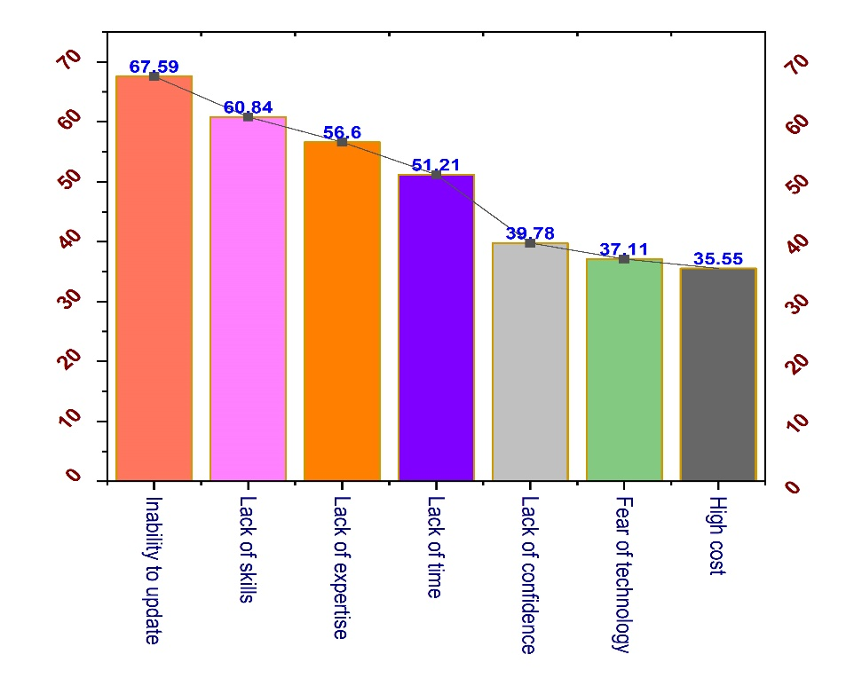

**Fig. 1. Graph depicting Personal constraints faced by farmers in effective use of ICT based agro-met advisory services**

Based on the overall ranking, inability to update ICT expertise regularly, lack of updated information, lack of skills to use ICT, poor network connectivity and lack of expertise were the major constraints.

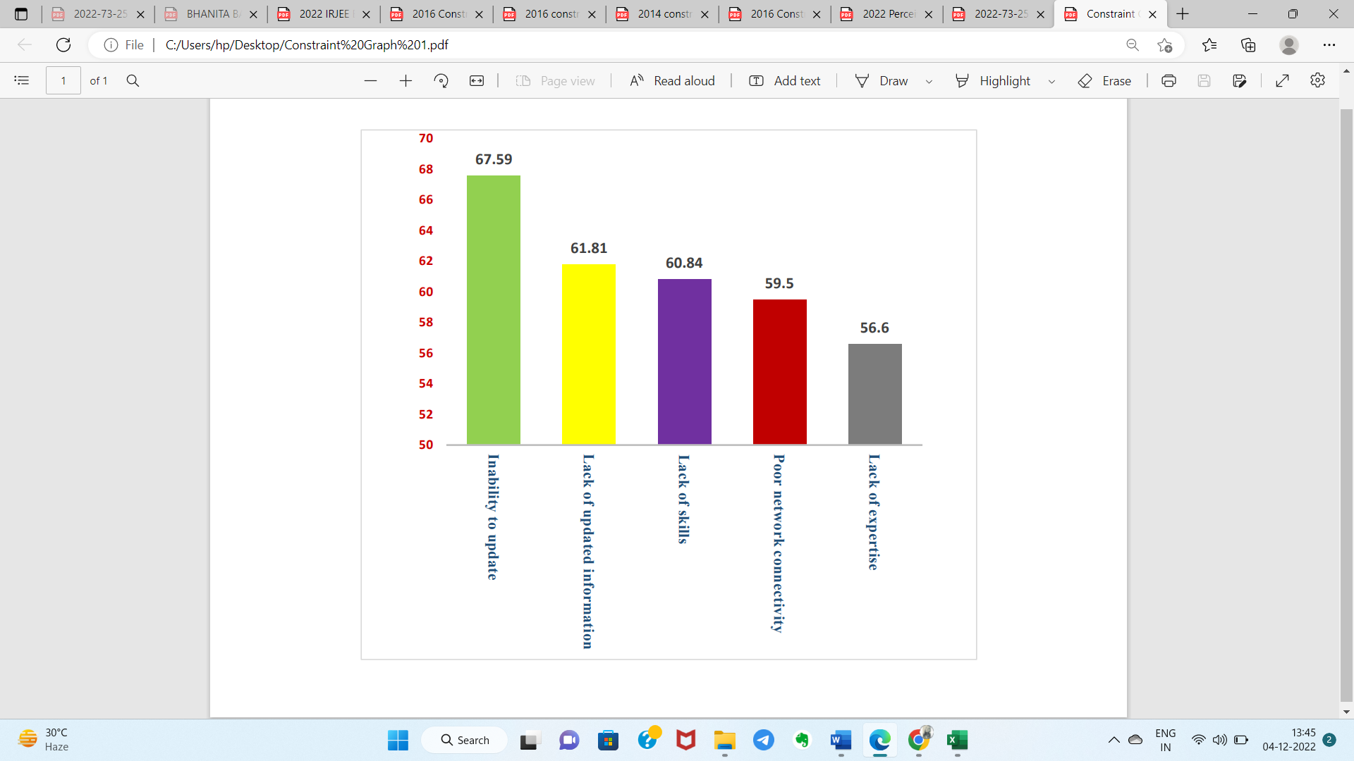

**Fig.2. Graph represents major constraints in effective use of ICT based agro-met advisory services**

**CONCLUSION**

The study was conducted to study the impediments faces by the beneficiaries of ICT based agro-met advisory services in Assam. The findings accentuate perceived constraints under four categories- Personal, Technological, Infrastructural and Cultural constraints. Using Garret ranking methodology it was found that inability to update ICT expertise regularly, lack of updated information, lack of skills to use ICT, poor network connectivity and lack of expertise were the major constraints. Contemplating the impediments, the study indicates that there is a need to provide of skill enhancing training in using ICT based tools to farmers. Diverse ICT platforms providing agro-met information services should provide location specific and timely information to enhance its effectiveness.

**RECOMMENDATIONS**

In pursuance of the findings of present study, the following strategies can be incorporated to increase the effectiveness in using agro-met advisory services.

* There exist need for training to enhance the skills and capacity of farmers in using ICT tools. With enhanced skills and capacity, the farmers will be able to use these advisory services more effectively.
* To obtain greater output of ICT based agro-met advisory services, policy inclination should be towards increasing the general awareness and access of these advisory services to the rural areas.
* Information specific to location and problem should be supplied as early as possible. Regular update of information on various ICT platforms should be maintained and feedback mechanism may be incorporated.

Disclaimer (Artificial intelligence)

Author(s) hereby declares that NO generative AI technologies such as Large Language Models (ChatGPT, COPILOT, etc.) and text-to-image generators have been used during the writing or editing of this manuscript.

**REFERENCES**

Anand, S., Prakash, S., Yedida, S. and Singh, A. K. (2020). Constraints faced by farmers in access and use of information and communication technologies (ICTs) in Bihar. *J***.** pharmacogn. phytochem., *9*(2); 80-85.

Bandhavya, M., Singh, A. K. and Lal, S. P. (2022). Procedural impediments in e-NAM system faced by stakeholders in Guntur Mandi of Andhra Pradesh. *Indian Res. J. Ext. Edu*., 22(4): 106-111.

Boniface, P. J., Jose, A. M. and Husain, A. S. (2019). Constraints Faced by Farmers and Agricultural Extensionists in Using Selected Information Technology Enabled Systems for Agriculture. *J. Soc. Sci*, *58*(1-3); 7-12.

Chaubey, D., Prakash, V., Patel, A.B. and Yadav, T.C. (2018). Role of Agro-Meteorological Advisory Services on Risk Mitigation in Agriculture. *Int. J. Pure App. Biosci., 6* (1): 27-32.

Das P. and Sangma N.C. (2021). A Comparison Study on Knowledge and Use of Different ICT Tools of Farm Women of State Meghalaya.Int. J. Curr. Microbiol. Appl. Sci., 10(1): 2663-2671.

Garrett, H.E. (1979). Statistics in psychology and education. 6th edition, Vakils, Feffer and Simons Ltd., Mumbai, India.

Goyal, J., Singh, K., Tiwari, M., Datt, R. and Lal, S. (2014). Constraints perceived by Veterinary Surgeons of Haryana. *Interaction*, 32(3): 92-96.

Kaur, H. (2020). Information needs and information seeking behavior of rural farmers of Gurdaspur District in Punjab: A study.J. Emerg. Technol. Innov. Res., **7**(2): 225-229.

Kumar, U., Werners, S., Paparrizos, S., Datta, D. K. and Ludwig, F. (2020). Hydroclimatic information needs of smallholder farmers in the lower Bengal delta, Bangladesh. *Atmosphere*, 11(9): 1009.

Kumari R., Kumari, A. and Lal, S.P. (2022). Progressive and Non-progressive Farmers Apropos Utilizing ICT to Advance Agriculture in Samastipur District of Bihar. *Indian Res. J. Ext. Edu*., 22 (5): 251-255.

Lal, S. P., Kadian, K. S. and Wodajo, W. A. (2016). Is That Environmental Factor Affected the Distressed Farmers’ Most!?-An Exploratory Factor Analysis of Constraint and Amelioration Strategies in National Calamity Hit Region of India. *Curr. World Environ.*, 11(3): 859.

Mishra, A., Yadav, O., Yadav, V. and Pratap, S. (2020). Constraints faced by farmers and suggestions for effective utilization of ICT services in agriculture in central UP. *J. Pharm. Innov*., *9*(2); 121-124.

Naik, B. J., Rao, B. M., Rambabu, P. and Rekha, M. S. (2022). Constraints Faced in the Usage of ICT Tools by Farmers in Anantapur District of Andhra Pradesh, India. *Asian J. Agric. Ext.*, 40 (10): 1073-1078.

Naveenkumar, M. R. and Philip, H. (2019). Constraints Faced in the Usage of Contemporary ICT Tools. *J. Ext. Educ.*, *31*(3): 6320-6326.

Navinkumar, B., Dhananjaya, H. M. and Ranjeeth, T. H. (2018). Constraints faced by the farmers in using mobile agro-advisory services. Int. J. Curr. Microbiol. Appl. Sci., 2885-2890.

Saleem, A., Anwar, S., Nawaz, T., Fahad, S., Saud, S., Ur Rahman, T., et al. (2024). Securing a sustainable future: the climate change threat to agriculture, food security, and sustainable development goals. *Journal of Umm Al-Qura University for Applied Sciences*, 1-17.

Sandhiya, V. and Balakrishnan, T. (2022). Constraints Faced by the Farmers in Extent of Utilization of ICT Advisory Services in Dindigul District of Tamil Nadu. *Eur. Online J. Nat. Soc.*, *11*(4): 7-12.

Singh, M. and Burman, R. R. (2015). Constraints Faced in Mobile Based Agro-Advisory Services and Strategy for Enhancing the Effectiveness of mKRISHI®. *Indian Res. J. Ext. Edu*., 15(2): 119-122.

Sinha, S. Sankhala, G. and Lal, S. P. (2018). Profile Characteristics and Analysis of the Constraints Faced by the Dairy Farmers of Urban and Peri-Urban Areas of Indian National Capital Region vis-a-vis Using Mobile Android Application “Eco-Dairy”. Int. J. Curr. Microbiol. Appl. Sci., *7*(3): 2335-2342.

Soylu, D., Cevher N., Schirone M. and Medeni T. (2016). A comparative study of information-seeking behavior and digital information needs of farmers in Turkey and Sweden. *Int. J eBusiness and eGovernment Stu.,* 8(2): 18-33.

Srivastava D., Kumari A. and Lal S.P. (2022). Factors Influencing Adoption of Climate-Friendly Oxo-Biodegradable Jan Ausadhi Suvidha Sanitary Napkins among Women in India*.  Int. J. Environ. Clim.,* 12 (12): 1754-1760.