In Vitro Study on the Synthesis of Seaweed Ulva fasciata Generated Nanoparticles and its Cytotoxicity Effect on Selected Continuous Cell Lines

ABSTRACT

Aim:To examine the effect of gold nanoparticles on normal Vero cell lines as well as on three different cancer cell lines (HepG2, HeLa, and MCF7) to evaluate their safety and toxicity. The study aims to assess the biocompatibility and potential cytotoxicity of gold nanoparticles, considering the ongoing debate about their effects on human health.

Study design: Experimental in vitro study.

Place and Duration of Study:This study was conducted at P.G. and Research Department of Biotechnology, Marudupandiyar college, Thanjavur

Methodology:In this study, Ulva fasciata seaweed was collected from coastal regions of Kerala and Tamil Nadu, cleaned, shade-dried, and powdered for methanolic extraction using Soxhlet apparatus. The resulting extract was used for the phytosynthesis of gold nanoparticles (Au NPs) by reacting with 1 mMHAuCl₄ under dark, static conditions at room temperature. Phytochemical screening identified various bioactive compounds in the extract. Optimization of nanoparticle synthesis was carried out by varying pH, temperature, extract and metal salt concentrations, and incubation time, with stability assessed over 12 months. The Au NPs were characterized using techniques such as UV–vis spectroscopy, HRTEM, EDX, XRD, DLS, zeta potential, AFM, and ICP-OES. Cytotoxic effects of the Au NPs were evaluated via MTT assay against normal (Vero) and cancer (HepG2, HeLa, MCF7) cell lines to determine IC50 values, and apoptosis in HepG2 cells was confirmed using PI and AO/EB staining under fluorescence microscopy..

Results: Phytosynthesized gold nanoparticles (Au NPs) using Ulva fasciata extract exhibited a characteristic UV-Vis absorbance peak at 545 nm, confirming their formation. Phytochemical analysis of the extract revealed the presence of various bioactive compounds such as alkaloids, phenolics, flavonoids, and terpenoids, which likely mediated the nanoparticle synthesis. Optimal synthesis conditions were determined as pH 7, 1.0 mM HAuCl₄, 1.0 mL extract, 37 °C, and 24-hour incubation. Characterization revealed predominantly spherical, crystalline Au NPs with a size range of 25–35 nm by HR-TEM, a maximum hydrodynamic diameter of 50 nm (DLS), and a zeta potential of -16.0 mV, indicating good stability. XRD confirmed face-centered cubic structures, and EDX and SAED affirmed elemental purity and crystallinity. AFM showed smooth, spherical particles (~60–90 nm), and ICP-OES quantified Au NP concentration at 258.0 mg/L. In vitro cytotoxicity tests demonstrated higher biocompatibility of Au NPs (IC₅₀: 75 µg/mL) compared to gold chloride (IC₅₀: 10 µg/mL) in Vero cells. Au NPs showed dose-dependent anticancer activity, with IC₅₀ values of 30 µg/mL (HepG2) and 50 µg/mL (HeLa and MCF7). Fluorescent staining of HepG2 cells revealed apoptotic features, including chromatin condensation and nuclear fragmentation, confirming the pro-apoptotic effects of the Au NPs.
Conclusion:Gold nanoparticles show promise as a non-toxic drug delivery vehicle in normal cells while exhibiting cytotoxic effects in cancer cell lines. These findings suggest potential for selective therapeutic applications, though further studies are needed to confirm long-term safety and efficacy.

Keywords:Gold nanoparticles, Ulva fasciata, phytosynthesis, cytotoxicity, anticancer activity, characterization

1. INTRODUCTION

Nanotechnology has greatly influenced modern biomedical science, mainly in the realms of using drugs, cancer treatments, and diagnosing diseases. In this area, metal nanoparticles, mostly gold and silver ones, are highly valued because of their different optical, chemical, and biological qualities. Often, creating these nanoparticles is done through methods that make use of highly toxic chemicals, advanced devices, or a lot of energy, and this causes threats to the environment and health. Since these limitations exist, one answer is to use green synthesis with plants, microbes, and algae as environmentally friendly solutions. Marine macroalgae (seaweeds) have gotten a lot of interest because they are rich in valuable chemicals and are environmentally friendly. The green macroalga Ulva fasciata that grows in many parts of the world is known to have polysaccharides, flavonoids, alkaloids, terpenoids, and phenolic compounds in it. They help reduce the metal ions and also keep the size of the nanoparticles under control. Various studies conducted recently have proved that nanoparticles of silver, gold, zinc oxide, and selenium were made possible using extracts from Ulva fasciata, and these nanostructures are promising in battling bacteria, protecting cells from oxidative damage, and preventing cancer (Kumar et al, 2024; Zangeneh et al., 2022). Making the nanoparticles is easy, they are stable, and there is no use of harmful substances, so this approach is better than others.

Cancer is responsible for a large number of deaths globally, so research efforts are needed to find safer and more effective ways to treat it. Normal and cancerous cells can be impacted by conventional chemotherapy since it is not very selective in its actions and often leads to unpleasant side effects. However, when nanoparticles are created using eco-friendly processes, they are able to target and kill cancer cells by releasing reactive oxygen species (ROS), breaking down their DNA, and causing apoptosis without doing much harm to normal cells (Nisha et al., 2024; Pan et al., 2012). Gold nanoparticles synthesized from plant or algal extracts possess the ability to enter cancer cells easily because of their nanoscale size and their surface coating with bioactive substances. Once present in the body, these components may start oxidative stress and consequently harm DNA, cause cell division to stop, and kill certain cells. In addition, biomolecules from Ulva fasciata like phenolic compounds and polysaccharides stabilize the nanoparticles and could make them cytotoxic to cancer cells, without causing significant problems for normal cells (Sriram et al., 2010; Singh et al., 2014).

The primary aim of this study is to make gold nanoparticles (AuNPs) with aqueous extracts from Ulva fasciata and check their cytotoxicity in vitro. Through the use of UV–Vis spectroscopy, FTIR, SEM, and TEM, it is possible to check if nanoparticles have formed and to analyze their appearance and stability. Then, the toxicity of the manufactured nanoparticles is analyzed by MTT assay in selected cell lines: HeLa (cervical cancer), HepG2 (liver cancer), MCF-7 (breast cancer), and Vero (non-cancerous African green monkey kidney epithelial cells). Such analysis helps us evaluate how safe and effective the nanoparticles are once they enter the body. The use of a sustainable process and the analysis of selectivity in toxicity provides key discoveries for biomedical use of Ulva fasciata-made nanoparticles. The research supports the goal of using green nanotechnology in standard cancer therapy, which is meant to be safer, less costly, and more environmentally friendly.

2. MATERIAL AND METHODS

2.1. Collection of Seaweed Ulva fasciata

For the present study, the green macroalgae Ulva fasciata was collected from coastal regions of Kerala and Tamil Nadu, specifically from Kovalam, Mulloor, and Muttom, along the Indian shoreline. Immediately after collection, the samples were thoroughly rinsed with fresh seawater to eliminate surface-adhering contaminants such as sand particles, epiphytic organisms, and other debris. Following this initial cleaning, the seaweed was air-dried in the shade to preserve its bioactive constituents, with excess moisture removed using blotting paper. Once partially dried, the material was further subjected to controlled drying in a laboratory incubator at 37 °C to ensure complete dehydration. The dried seaweed was then finely powdered using a mechanical grinder, ensuring homogeneity for subsequent nanoparticle synthesis experiments. This preparation method, widely employed in algal nanobiotechnology studies, helps retain the biochemical integrity of the algal material while producing consistent particle sizes for reproducible synthesis (AlNadhari et al., 2021).
2.2. Isolation of secondary metabolites from the seaweed

To obtain the crude extract using methanol as the solvent, 10 g of finely powdered Ulva fasciata alga were packed in Whatman No. 1 filter paper and fed into the Soxhlet equipment. The solvent was extracted thrice with distilled methanol while being refluxed at the proper boiling point (65ºC). Finally, the packed substance was taken out and concentrated to a volume of 5 to 10 mL. Consequently, obtained extract was stored in the refrigerator for future employment in consecutive research (Cikoš et al., 2018).

2.3. Phytosynthesis of gold nanoparticles (Mubarak Ali et al., 2011)

One millilitre of the extract was collected, and then 9.0 millilitres each of 1.0 mM HAuCl₄ were added. The reaction was carried out for 24 hours under static conditions in the dark at room temperature, and any changes in colour were noted. Gold nanoparticles that were created from Ulva fasciata seaweed were further examined and confirmed between 300 and 700 nm using a UV-vis spectrophotometer (HITACHI U-2900).
2.4. Qualitative phytochemical screening of Ulva fasciata seaweed extract
To find various phytoconstituents in the seaweed extract, the following assays were run according to the following procedures mentioned below. Detection of Alkaloids (Evans, 1997)- Mayer’s test (Evans, 1997), Wagner’s test (Wagner, 1993), Hager’s test (Wagner et al.,1996); Detection of Carbohydrates (Ramakrishnan et al., 1994)- Benedict’s test; Detection of Glycosides- Modified Borntrager’s test (Evans, 1997); Detection of Phenolic compounds- Ferric chloride test (Mace, 1963), Gelatin test (Evans, 1997); Detection of Tannins- Gelatin test; Detection of Flavonoids- Alkaline reagent test, Lead acetate test; Detection of Terpenoids- Salkowski test; Detection of Proteins and Amino acids- Biuret test (Gahan, 1984), Ninhydrin test (Yasuma and Ichikawa, 1953); Detection of Diterpenes- Copper acetate test; Detection of Saponins- Foam test (Kokate, 1999) etc.

2.5. Optimization of the Phytosynthesized of gold nanoparticles

In the test tubes followed by 9 mL each of HAuCl₄ were added to 1.0 mL of seaweed extract to create gold bio nanoparticles, respectively, thereafter test tubes were subjected to under various external parameters and conditions. Consequently, their stability was measured using an HITACHI U-2900 spectrophotometer between 300 and 700 nm. The various external parameters were applied and noted which includes Effect of different pH value ( pH 4, 5, 6, 7, 8, 9 and 10) ; Effect of different concentrations of gold chloride- 9.0 mL of HAuCl₄ were added separately to 1.0 mL of the selected extracts at concentrations of 0.5 mM, 1 mM, 1.5 mM, 2 mM, 2.5 mM, and 3 mM; Effect of different concentrations of extracts for the synthesis of Au NPs, various extract amounts of 0.5 mL, 1 mL, 1.5 mL, 2 mL, 2.5 mL, and 3 mL were taken and produced up to 10 mL using 1.0 mM HAuCl₄, respectively; Effect of different Temperatures-At several temperatures, including 22°C, 27°C, 32°C, 37°C, 42°C, 47°C, and 52°C, gold nanoparticles were phytosynthesized; Effect of different durations on phytosynthesis of gold nanoparticles- Phytosynthesis of gold nanoparticles tested across time periods of 0 hours, 6 hours, 12 hours, 18 hours, and 24 hours; Stability of phytosynthesized gold nanoparticles- The samples of phytosynthesized Au NPs were stored at room temperature in the dark for a full year. Using the HITACHI U-2900, the stability of the samples was measured between 300 and 700 nm on the fifth, fifteenth day, first, second, sixth, and twelfth months.

2.6. Characterization of the gold nanoparticles (González Ballesteros, 2020)
AuNPs of the newly selected Ulva fasciata test tube were subjected to characterization procedure for morphological and further studies for example, UV-visible spectroscopy, High Resolution Transmission Electron Microscopy (HRTEM), Energy Dispersive X-ray analysis (EDX), Selected area electron diffraction (SAED), X-ray Diffraction Studies (XRD), Dynamic Light Scattering (DLS), Zeta Potential measurement, Atomic force microscopy (AFM), Inductively Coupled Plasma Optical Emission Spectroscopy (ICP-OES) instrumentation etc.

2.7. Chemicals and reagents
The Gibco (Grand Island, NY, USA) provided the Cell culture Dulbecco's Modified Eagle Medium (DMEM) and Fetal Bovine Serum (FBS), 0.25% Trypsin-EDTA. From Sigma-Aldrich (St Louis, MO, USA)., we obtained streptomycin, penicillin, dimethyl sulfoxide (DMSO), 3-(4,5-dimethylthiazol-2-yl)-2,5-diphenyltetrazolium bromide (MTT), phosphate buffer, and fluorescent dyes such as acridine orange and ethidium bromide (AO/EB) with higher than 98% purity. From the Himedia Lab Pvt. Ltd. (Mumbai, India) chloroauric acid/gold chloride (HAuCl₄) were purchased.

2.8. Cell culture maintenance
The National Centre for Cell Sciences (NCCS), Pune, India, provided the Vero African green monkey kidney normal cell line, HepG2 hepatocellular carcinoma, HeLa cervical cancer, and MCF7 breast epithelial adenocarcinoma cancer cell line. In DMEM media supplemented with 10% (v/v) heat inactivated foetal bovine serum, 100 U/mL penicillin, and 100 g/mL streptomycin, cells were kept in the logarithmic phase of growth. They were kept at 37 °C in an incubator with 5% CO₂ and 95% humidified air.
2.9. Effect of phytosynthesized gold nanoparticles on cytotoxicity of cell lines – MTT assay. (Mossman, 1983)
Phytosynthesized Au NPs were tested by MTT (3-(4,5-dimethylthiazol-2-yl)-2,5- diphenyl tetrazolium bromide assay) against both normal cell line Vero and cancer cell lines such as HepG2, HeLa, and MCF7.
2.9.1. Cytotoxicity analysis against Vero (Normal) cell line. (Asra Parveen and Srinath Rao, 2015)
Prior to researching the anti-proliferative effect against cancer cell lines, it is critical to determine the drug and metal nanoparticle compatibility and dosage on normal cell lines. In the current work, the cytotoxic effects of various doses of gold chloride and gold nanoparticles (Au NPs) were investigated against the Vero cell line.The individual, viable Vero cells were planted at 1x10⁶ cells/mL in 96-well microplates and cultured at 37°C for 24 hours in a 5% CO₂ incubator. This allowed the cells to swell to 90% confluence. At the conclusion of the incubation, the medium was changed, and the Vero cells were treated with gold chloride and Au NPs at concentrations of 5, 10, 30, 50, 75, and 100 µg/mL. Incubation of the samples followed for 24 hours. The cells were then washed with phosphate-buffered saline (PBS, pH-7.4) and added 20μL of (MTT) solution (5 mg/mL) to each well and allowed to stand at 37ºC in the dark for additional 4 h then added 100μL DMSO and dissolved the formazan crystals and it absorbance was read spectrometrically at 570 nm using ELISA plate reader. The fraction of viable cells was calculated.
2.9.2. Cytotoxicity analysis against cancer cell lines
Separately planted in 96-well microplates with 1x10⁶ cells per well, HepG2, HeLa, and MCF7 cell lines were cultured at 37°C for 24 hours in a 5% CO₂ incubator and allowed to reach 90% confluence. After changing the media, the cells were exposed to Au NPs at various concentrations, including 5, 10, 30, 50, 75, and 100 µg/mL, and incubated for 24 hours. After using phosphate-buffer saline (PBS, pH 7.4) to wash the cells, 20 µL of the MTT solution (5 mg/mL) was added to each well. After that, the plates were left at 37 °C in the dark for an additional 4 hours. The absorbance was measured spectrophotometrically at 570 nm after the formazan crystals were dissolved in 100 µL of DMSO. The formula above was used to express the fraction of viable cells.
The IC₅₀ value, a measure for cytotoxicity studies, was defined as the concentration that inhibited 50% of cell growth. After 24 hours, the morphological alterations of untreated (control) and IC₅₀-treated cells were examined under a bright field microscope and documented. HepG2 cells treated with phytosynthesized Au NPs demonstrated an IC₅₀ valueof 30 µg/mL, whilst HeLa and MCF7 cells were each at 50 µg/mL after 24 hours. As the HepG2 cell line displayed a lower IC₅₀ value than the others, it was chosen for further research.
2.10. Assessment of Apoptosis
2.10.1. Propidium iodide (PI) nucleic acid stain (Hirak et al., 2007)
HepG2 cells were plated in a six-well chamber plate at a density of 5 x 10⁴ cells per well. The cells were exposed to phytosynthesized Au NPs for 24 hours after reaching > 90% confluence. The cells were then stained with 50 µg/mL propidium iodide (PI) for 20 minutes after being rinsed with PBS and fixed in a 3:1 mixture of methanol and acetic acid for 10 minutes. Fluorescent microscopy called FLoid Cell Imaging was used to analyse the nuclear morphology of apoptotic cells.
2.10.2. Determination of mode of cell death by acridine orange (AO) / ethidium bromide (EB) dual staining (Jeyaraj et al., 2013)
HepG2 cells were plated in 6-well plates and exposed to Au NPs at the IC₅₀ concentration for 24 hours. The monolayer of cells was rinsed with PBS before being stained with 5 µl of acridine orange (100 µg/mL) and 5 µl of ethidium bromide (100 µg/mL) for the nuclear examination. FLoid Cell Imaging fluorescent microscopy was used to detect the morphological changes in the stained cells and the apoptotic nuclei (intensely stained, fragmented nuclei, and condensed chromatin).
3. RESULTS
3.1. Phytosynthesis of gold nanoparticles
The reduction of Au NPs (545 nm) in the solution of gold complex during the reaction with the seaweed extracts of Ulva fasciata was confirmed by the UV-vis spectra.
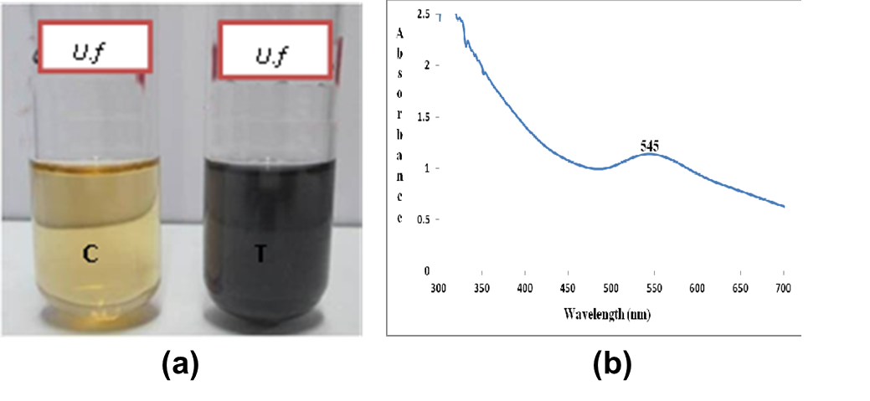
Fig. 1. Synthesis and UV Characterization of the Phytosynthesized Gold nanoparticle
(a) Color change in phytosynthesized Au NP (b) UV-visible spectroscopy of Au NP
3.2. Qualitative phytochemical analysis of crude seaweed extract of Ulva fasciata
The seaweed extracts of Ulva fasciata showed the presence of alkaloids (positive for Mayer’s test, Wagner’s test, Hager’s test), carbohydrates (positive for Benedict's test), glycosides (positive for Modified Borntrager's test), phenolic compounds (positive for Ferric chloride test, Gelatin test), proteins, amino acids (positive for Biuret reagent, Ninhydrin reagent), flavonoids (positive for Alkaline reagent test, Lead acetate test), terpenoids (positive for Salkowski test) and Saponins (negative for foam test).
3.3. Optimization of the phytosynthesized gold nanoparticles from Ulva fasciata
The stability of phytosynthesized gold nanoparticles were high and at the peak when the selected solution test tube consists of optimum external parameters such as pH 7 (530 nm); 1.0 mM HAuCl₄ concentration (530 nm); 1.0 mL of Ulva fasciata extract (530 nm); 37ºC temperature (545 nm) and stability up to 24-hour timing (530 nm).
3.4. Characterization of Gold Nanoparticles
3.4.1. High resolution transmission electron microscopy
The particles size, distribution, shape and morphology of Au NPs were characterized using HR-TEM showed Au NPs were predominantly spherical in shape with an average particle size of 25 - 35 nm.
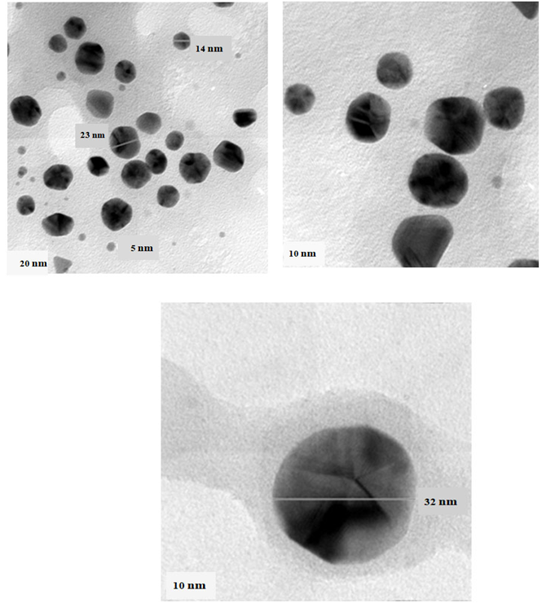
Fig. 2.High resolution transmission electron microscope of Au NPs synthesized from Ulva fasciata
3.4.2. Energy dispersive X-ray analysis
The EDX spectra displayed a single signal for gold nanoparticles indicating that the synthesized NPs were free from impurities; The presence of O and C peaks over the Au signals indicates that phytoconstitutents used oxygen atoms to cap the Au NPs.
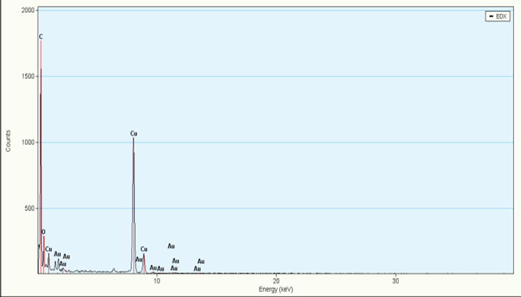
Fig.3. Energy dispersive X-ray analysis of phytosynthesized Au NPs
3.4.3. Selected area electron diffraction (SAED)
The selected area electron diffraction (SAED) spectra confirmed that the Au NPs synthesized are crystalline in nature;
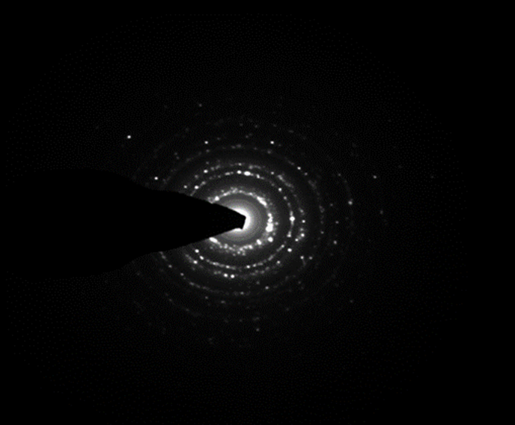
Fig.4. Selected area electron diffraction of phytosynthesized Au NPs

3.4.4. X-ray Diffraction pattern analysis
In XRD pattern, the peaks of gold recorded at 2θ = 38.0°, 44.2°, 64.4° confirmed the purity of the samples. The sharp peak displays the crystalline nature of Au NPs and corresponding hkl planes are (111), (200), (220). This plane represents the face-centered cubic (fcc) structure of the Au NPs in comparison with standard JCPDS file number 65-2870. The crystallite size of Au NPs was calculated using Scherrer formula confirmed the presence of Nano crystalline Au.
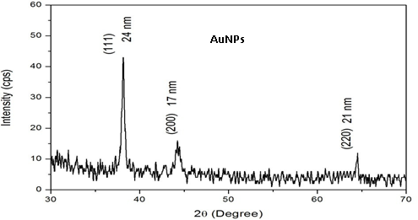
Fig.5. X-ray diffraction analysis of Au NPs synthesized from Ulva fasciata
3.4.5. Dynamic light scattering (DLS)
DLS analysis shows the hydrodynamic diameter using the auto correlation function and the diffusion coefficient of the mono-dispersive colloids containing Au NPs. They showed maximum size of 50 nm for Au NPs, respectively.
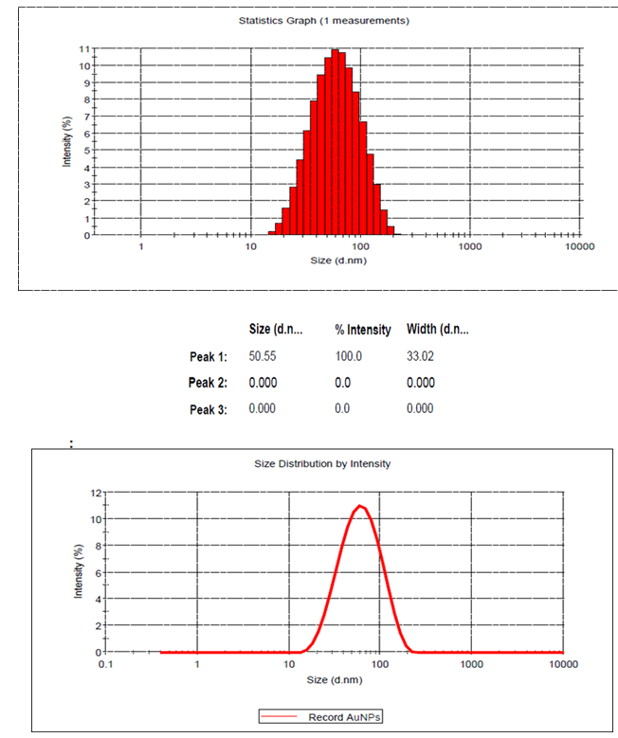
Fig.6. Dynamic light scattering of Au NPs synthesized from Ulvafasciata
3.4.6. Zeta potential analysis
The zeta potential is found to be -16.0 mV for Au NPs, respectively. The negative value in specific may be due to the bio-organic compounds capped on the nanoparticles. The negative charge intensity indicates that the Au NPs are found stable.
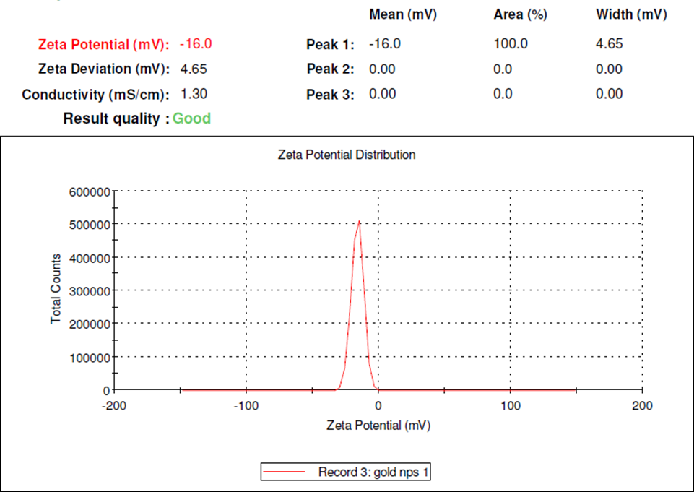
Fig.7. Zeta potential of Au NPs synthesized from Ulvafasciata
3.4.7. Atomic force microscopy (AFM) &Inductively plasma optical emission spectroscopy (ICP-OES)
Surface morphology of the metal nanoparticles was studied under AFM as for Au NPs, respectively. The size of the particles was in the range of ~60-90 nm for Au NPs, respectively. Gold were displaying spherical shape of nanoparticles with smooth surface, without any pinholes or cracks. The phytosynthesized Au NPs were quantitatively determined by ICP- OES analysis which showed that the concentration of AuNPs were and 258.0 mg/L, respectively. The elemental wavelength of Au NPs was 267.595, respectively.
3.5. Cytotoxicity analysis against Vero (Normal) cell line-MTT assay
The MTT assay was used to test the cytotoxicity of different concentrations of gold chloride, phytosynthesized Au NPs on Vero cells (a normal cell line) in vitro. Au NPs among them demonstrated a maximum with IC₅₀ value of 75 µg/mL, next was gold chloride, and with IC₅₀ values of 10 µg/mL, respectively. The salts of HAuCl₄ were less biocompatible than the Au NPs tested in Vero cells. Lower cell viability was seen in treated concentrations when compared to control (p< 0.05) in a significant manner.

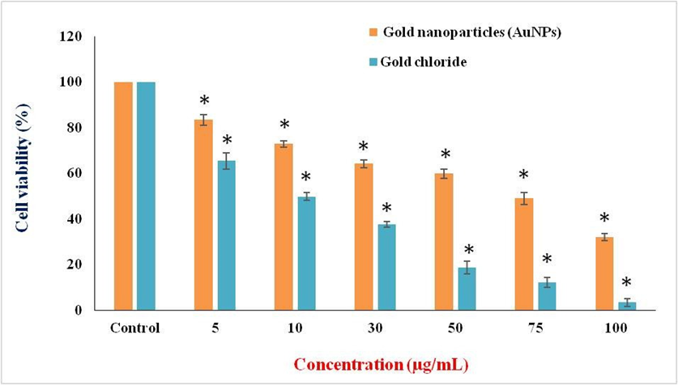
Fig.8. Effect of different concentration of HAuCl₄ and phytosynthesized Au NPs on Vero cell line at 24 h. Values are given as mean ± S.D for each concentration. The treated concentrations statistically significant (p<0.05) when compared to control.
Vero cell line- non-cancerous African green monkey kidney epithelial cells
3.5.1. Morphological observation of Vero cells
The Vero cells were exposed for 24 hours to the IC₅₀ concentrations of gold chloride, and gold nanoparticles, and the results showed that the cells rounded, shrank, and lost contact with surrounding cells. The materials' harmful effects on Vero cells were confirmed by the images.
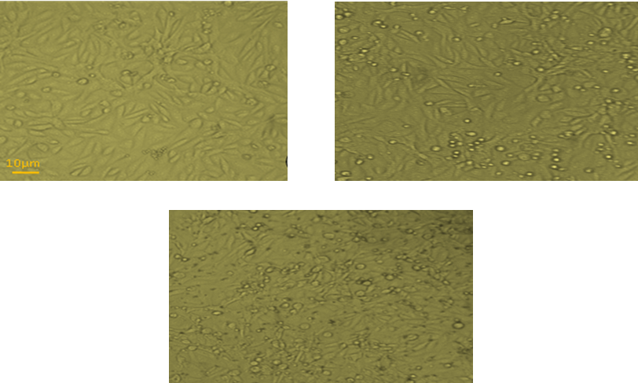
Fig.9. Effect of HAuCl₄ and Au NPs on Vero cell line at 24 h
(a) Control (b) Au NPs treated (75µg/mL) (c) HAuCl₄ treated (10µg/mL).
3.6. Cytotoxicity for phytosynthesized AuNPs against cancer cell lines
The MTT assay was used to evaluate the anti-proliferative effects of Au NPs on three different cell lines, including HepG2, HeLa, and MCF7 cells. Au NPs antagonistic procedures were dose-dependent mechanisms on HepG2, HeLa, and MCF7 cells at doses of 5, 10, 30, 50, 75, and 100 µg/mL. HepG2 cells had an inhibitory concentration of IC₅₀ of 30 µg/mL, but HeLa and MCF7 cells had an inhibitory concentration of 50 µg/mL each after 24 hours. Lower cell viability was seen in treated concentrations when compared to control (p <0.05) in a significant manner.
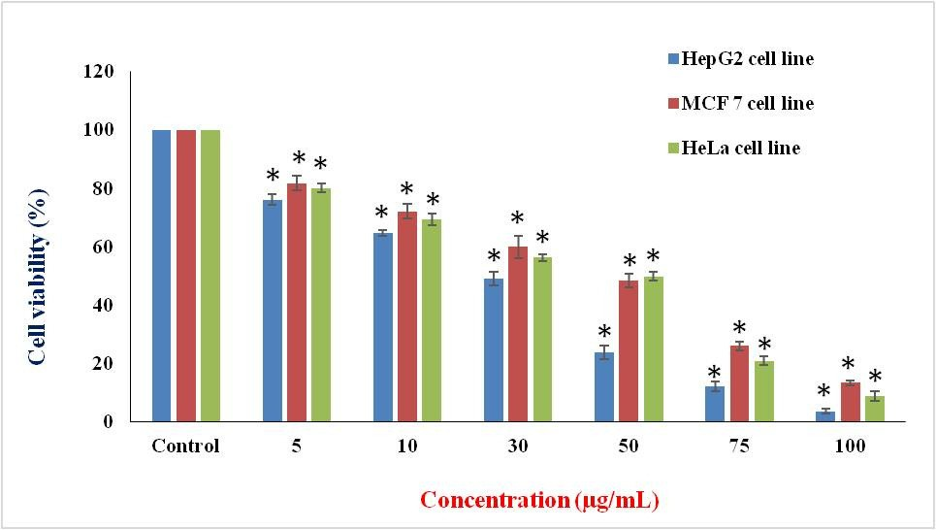
Fig.10. Effect of different concentration of Au NPs on HepG2, MCF7 and HeLa cell lines at 24 h. Values are given as mean ± S.D for each concentration. The treated concentrations statistically significant (p<0.05) when compared to control.
Control- Untreated Cell lines
3.6.1. Morphological observations
HepG2 cells were discovered in irregular confluent aggregates that were rounded and polygonal after being exposed to AuNPs at an IC₅₀of 30 µg/mL for 24 hours. The cells had a lot of protrusions on their surfaces. Condensed plasma membrane was discovered. Under the nuclear membrane, a substantial quantity of nuclear chromatin aggregation was seen.
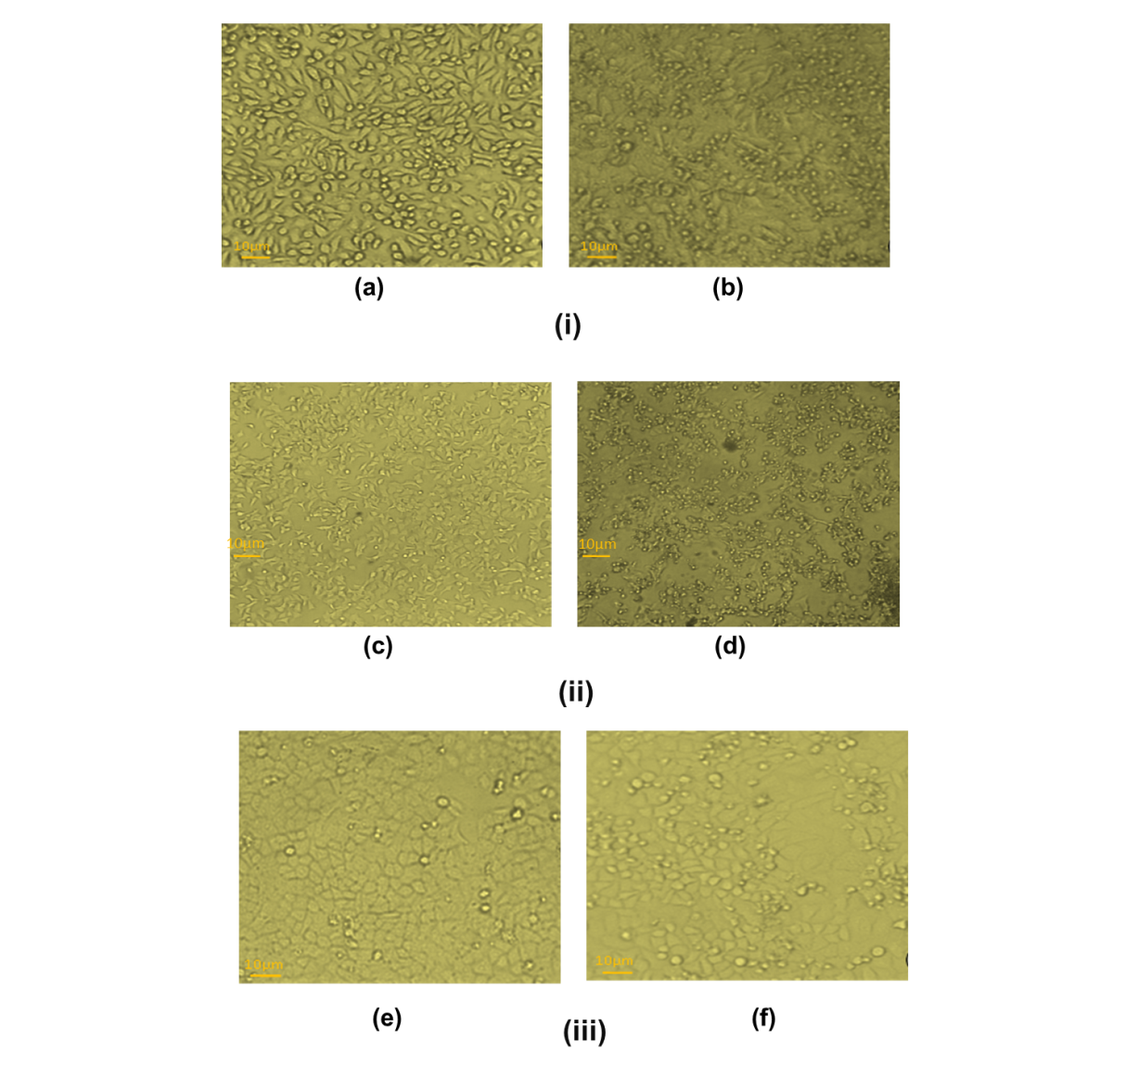
Fig 11. Cytotoxicity effect of AuNP against different cancer cell line
(i) Effect of AuNPs on HepG2 cells at 24h; (a) Control (b) Au NPs treated (30µg/mL); (ii) Effect of AuNPs on MCF7 cells at 24h; (a) Control (b) Au NPs treated (50µg/mL); (iii) Effect of AuNPs on HeLa cells at 24h; (a) Control (b) Au NPs treated (50µg/mL)
3.6.2. Morphological features of HepG2 cells stained with propidium iodide under fluorescence microscope
After 24 hours, the morphological characteristics of HepG2 treated with IC₅₀ concentrations of Au NPs revealed condensation and fragmentation of dead cells.
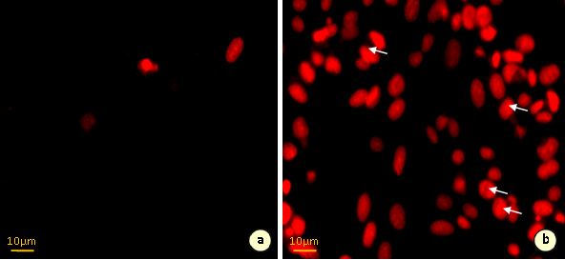
Fig.12. Morphological features of HepG2 cells stained with propidium iodide under fluorescence microscope
(a.) HepG2 control cells (b.) Au NPs treated cells.
3.6.3. Morphological features of HepG2 cells double stained with acridine orange / ethidium bromide under fluorescence microscopy
In comparison to untreated control cells, HepG2 cells treated with IC₅₀ concentrations of Au NPs displayed morphological apoptotic alterations when stained with acridine orange/ethidium bromide (AO/EB) fluorescence staining after 24 hours. The cytoplasm and nuclei of the control cells had been uniformly brilliant green. However, the Au NP-treated cells displayed the telltale signs of death, including cell shrinkage, nuclear condensation and fragmentation, and the development of apoptotic bodies.
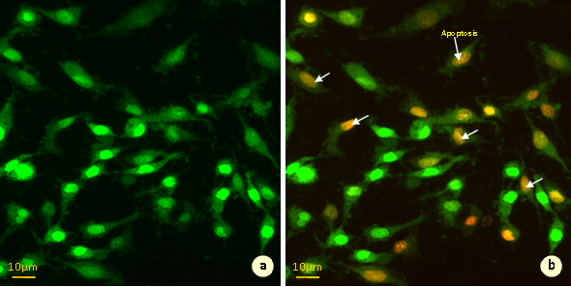
Fig.13. Effect of Au NPs at 30µg/mL on nuclei of HepG2 cells at 24h-stained with acridine orange and ethidium bromide.
(a.) HepG2 control cells (b.) Au NPs treated cells
4. DISCUSSION
The goal of this study was to examine in detail the physical and chemical characteristics of gold nanoparticles produced from Ulva fasciata and measure their impact on both healthy and cancer cells. The AuNP formation was clear from the emergence of a SPR band at ~545 nm in UV–Vis spectroscopy, as it is mentioned in Ramakrishna et al., 2016 . When gold changes color from pale yellow to ruby red, this supports the formation of nanoparticles due to the reduction of Au³⁺ to Au⁰ agents from the plant. Phytochemical screening revealed there are different bioactive molecules like alkaloids, carbohydrates, glycosides, phenolics, proteins, flavonoids, and terpenoids, and they helped to prevent AuNPs from oxidation. This study supports the idea that seaweed phytochemicals play a key role in both making and stabilizing nanoparticles, which is widely accepted in other studies (Choudhary et al., 2020). The lack of foam in the saponin testing demonstrates fewer compounds that cause foaming, which may be favorable for creating stable nanoparticles that are not grouped together.
Optimization of the process indicated that AuNPs were synthesized best and most stably at pH 7, 1 mM HAuCl₄, 1 mL extract, 37 °C, and 24 h incubation, as shown by the steady SPR peak at about 530–545 nm. Controlling the synthesis and reaction well-aligned with earlier studies proving that it greatly influences the dispersion and stability of nanoparticles (Boisselier and Astruc, 2009). Morphological characterization using HRTEM confirmed spherical AuNPs with diameters between 25–35 nm. The spherical morphology and size range are characteristic of biosynthesized AuNPs from Ulva species further validating the efficacy of U. fasciata extracts (Ramakrishna et al., 2016). The monodispersity of the nanoparticle population was reflected in the dynamic light scattering data, which showed an average hydrodynamic size of ~50 nm—only slightly larger than the TEM measurements due to surface-bound capping agents. A zeta potential of −16.0 mV suggests moderate colloidal stability, comparable to values reported in literature for biosynthesized AuNPs (Kumar et al., 2023) . Elemental purity was validated by EDX analysis, which showed gold signals devoid of metallic impurities, and the presence of oxygen and carbon signals indicative of phytochemical capping. Crystallinity was confirmed via SAED and XRD, with characteristic peaks at 2θ = 38.0°, 44.2°, and 64.4° corresponding to the (111), (200), and (220) planes of face-centered cubic gold. These observations align with standard JCPDS reference for nanocrystalline gold and with prior reports of seaweed-extracted AuNPs showing similar crystalline signatures (Ramakrishna et al., 2016) . Atomic Force Microscopy corroborated the spherical morphology, though it revealed slightly larger sizes (60–90 nm), a likely artifact of tip-broadening. Quantitative analysis via ICP-OES revealed a gold concentration of ~258 mg/L, confirming efficient metal recovery during synthesis.
The study received insightful data from cytotoxicity tests on human cells. In normal Vero cells, the AuNPs that had undergone phytosynthesis produced fewer toxic effects (IC₅₀ = 75 µg/mL) than free gold chloride (IC₅₀ = 10 µg/mL). This difference clarifies that using biosynthetic capping agents when making nanomaterials lowers their toxicity and improves how selective they are, which supports the findings of other studies with nanoparticles made from photosynthetic algae. The same pattern was found in cell lines derived from cancer. The AuNPs synthesized by the method were found to decrease the viability of HepG2, HeLa, and MCF7 cells in a dose-dependent manner with IC₅₀ values of 30 µg/mL (HepG2) and 50 µg/mL (HeLa, MCF7). Such findings illustrate that the green synthesis of AuNPs tends to favour killing cancer cells since they accumulate differently and are more likely to be affected by reactive oxygen species—according to multiple previous studies (Pan et al., 2012; Nisha et al., 2024). Using the fluorescent dyes PI and AO/EB, the study confirmed mechanisms of apoptosis including chromatin condensation, membrane blebbing, and fragmentation, which are aligned with previous results on oxidative stress- and apoptosis-mediated mechanisms Ramakrishna et al., 2016 Gold NPs–induced apoptosis in various cell lines).
From the results, it is clear that algae-formed AuNPs are promising for nanomedicine as they are uniform, stable, kill cancer cells selectively, and leave normal cells safe. This highlights green nanotechnology as a suitable way to produce nanoparticles, since it reduces toxicity and makes integration with biology more straightforward. While in vitro evaluations provide valuable preliminary insight, in vivo assessments are essential to fully understand bio distribution, pharmacokinetics, immune response, and systemic toxicity. Future studies should explore targeted delivery capabilities, perhaps through conjugation with tumor-specific ligands, and extended biocompatibility studies in animal models. Additionally, deciphering the precise molecular signaling pathways underlying the apoptotic response particularly the role of ROS and mitochondrial pathways will enhance mechanistic clarity and optimize therapeutic applications. This work confirms that Ulva fasciata-derived AuNPs exhibit robust physicochemical attributes and promising selective anticancer effects. They embody green, scalable, and biocompatible nanomaterials with potential utility in targeted cancer therapy, diagnostics, and regenerative medicine.
5. CONCLUSION
The present study demonstrates the potential of Ulva fasciata as a sustainable and eco-friendly biological system for the green synthesis of gold nanoparticles. Utilizing naturally occurring phytochemicals within the seaweed extract, the synthesis process avoids the need for harmful chemicals or high-energy inputs, aligning with the principles of green chemistry. The biological molecules within the extract act both as reducing and stabilizing agents, enabling the formation of nanoparticles with desirable physicochemical characteristics. Furthermore, the study supports the growing interest in marine resources as a valuable and renewable source for nanomaterial production. Given their biogenic origin, such nanoparticles are particularly promising for applications in biomedicine, especially in the development of safer therapeutic agents. This approach underscores the integration of natural resources and nanotechnology for innovative, environmentally responsible applications in science and healthcare.

Disclaimer (Artificial intelligence)
Author(s) hereby declare that NO generative AI technologies such as Large Language Models (ChatGPT, COPILOT, etc.) and text-to-image generators have been used during the writing or editing of this manuscript.

References

AlNadhari, S., Al-Enazi, N. M., Alshehrei, F., & Ameen, F. (2021). A review on biogenic synthesis of metal nanoparticles using marine algae and its applications. Environmental Research, 194, 110672. https://doi.org/10.1016/j.envres.2020.110672
Ashokkumar, T., Prabhu, D., Geethaa, R., Govindaraju, K., Manikandan, R., Arulvasu, C., et al. (2014). Apoptosis in liver cancer (HepG2) cells induced by functionalized gold nanoparticles. Colloids and Surfaces B: Biointerfaces, 123, 549–556.
https://doi.org/10.1016/j.colsurfb.2014.09.051
AshaRani, P. V., Hande, M. P., & Valiyaveettil, S. (2009). Anti-proliferative activity of silver nanoparticles. BMC Cell Biology, 10, 65.
https://doi.org/10.1186/1471-2121-10-65
Banerjee, K., RavishankarRai, V., & Umashankar, M. (2019). Effect of peptide-conjugated nanoparticles on cell lines. Progress in Biomaterials, 8(1), 11–21.
https://doi.org/10.1007/s40204-019-0106-9
Bhattacharyya, S. S., Mandal, S. K., Biswas, R., Paul, S., Pathak, S., Boujedaini, N., et al. (2008). In vitro studies demonstrate anticancer activity of an alkaloid of the plant Gelsemium sempervirens. Experimental Biology and Medicine, 233(12), 1591–1601.
https://doi.org/10.1177/1535370208330269
Boisselier, E., & Astruc, D. (2009). Gold nanoparticles in nanomedicine: Preparations, imaging, diagnostics, therapies and toxicity. Chemical Society Reviews, 38(6), 1759–1782. https://doi.org/10.1039/B806051G
Chaudhary, R., Nawaz, K., Khan, A. K., Hano, C., Abbasi, B. H., & Anjum, S. (2020). An overview of the algae-mediated biosynthesis of nanoparticles and their biomedical applications. Biomolecules, 10(11), 1498.
https://doi.org/10.3390/biom10111498
Cikoš, A. M., Jokić, S., Šubarić, D., & Jerković, I. (2018). Overview on the application of modern methods for the extraction of bioactive compounds from marine macroalgae. Marine Drugs, 16(10), 348.
https://doi.org/10.3390/md16100348
González Ballesteros, N. (2020). Macroalgae to gold and silver nanoparticles: Biosynthesis, characterization and biological applications (Doctoral dissertation, Universidade de Vigo).
Hirak, K., Patra, S., Banerjee, S., Chaudhuri, U., Lahiri, P., Anjan, K. R., & Dasgupta, S. (2007). Cell selective response to gold nanoparticles. Nanomedicine: Nanotechnology, Biology and Medicine, 3(2), 111–119.
https://doi.org/10.1016/j.nano.2007.02.005
Jeyaraj, M., Rajesh, M., Arun, R., Ali, M., Sathishkumar, G., Sivanandhan, G., et al. (2013). An investigation on the cytotoxicity and caspase-mediated apoptotic effect of biologically synthesized silver nanoparticles using Podophyllum hexandrum on human cervical carcinoma cells. Colloids and Surfaces B: Biointerfaces, 102, 708–717.
https://doi.org/10.1016/j.colsurfb.2012.09.044
Kokate, C. K. (1999). Practical pharmacognosy (4th ed.). New Delhi, India: Vallabhprakashan Publications.
Mosmann, T. (1983). Rapid colorimetric assay for cellular growth and survival: application to proliferation and cytotoxicity assays. Journal of Immunological Methods, 65(1–2), 55–63. https://doi.org/10.1016/0022-1759(83)90303-4
Mubarak Ali, D., Thajuddin, N., Jeganathan, K., & Gunasekaran, M. (2011). Plant extract mediated synthesis of silver and gold nanoparticles and its antibacterial activity against clinically isolated pathogens. Colloids and Surfaces B: Biointerfaces, 85(2), 360–365. https://doi.org/10.1016/j.colsurfb.2011.06.007
Nisha, Sachan, R. S. K., Singh, A., Karnwal, A., Shidiki, A., & Kumar, G. (2024). Plant-mediated gold nanoparticles in cancer therapy: exploring anti-cancer mechanisms, drug delivery applications, and future prospects. Frontiers in Nanotechnology, 6, 1490980. https://doi.org/10.3389/fnano.2024.1490980
Pan, Y., Bartneck, M., & Jahnen-Dechent, W. (2012). Cytotoxicity of gold nanoparticles. In Methods in Enzymology (Vol. 509, pp. 225–242). Academic Press.
https://doi.org/10.1016/B978-0-12-391858-1.00012-5
Parveen, A., & Rao, S. (2015). Cytotoxicity and genotoxicity of biosynthesized gold and silver nanoparticles on human cancer cell lines. Journal of Cluster Science, 26(3), 775–788. https://doi.org/10.1007/s10876-014-0810-6
Singh, S., Singh, P. P., Murad, M. H., Singh, H., & Samadder, J. N. (2014). Prevalence, risk factors, and outcomes of interval colorectal cancers: a systematic review and meta-analysis. The American Journal of Gastroenterology, 109(9), 1375–1389.
https://doi.org/10.1038/ajg.2014.171
Sriram, G., & Birge, R. B. (2010). Emerging roles for crk in human cancer. Genes & Cancer, 1(11), 1132–1139.
https://doi.org/10.1177/1947601910397188
Zangeneh, M. M. (2020). Green synthesis and formulation a modern chemotherapeutic drug of Spinacia oleracea L. leaf aqueous extract conjugated silver nanoparticles; chemical characterization and analysis of their cytotoxicity, antioxidant, and anti‐acute myeloid leukemia properties in comparison to doxorubicin in a leukemic mouse model. Applied Organometallic Chemistry, 34(1), e5295.
https://doi.org/10.1002/aoc.5295

