Original Research Article
Phytochemical Screening, proximate analysis, and Phyto-synthesis of Zinc Oxide metallic nanoparticles from the leaf of Abutilon persicum (Burm. f.) Merr. And their biological applications

Abstract
Aims: The Study highlights that Plant-mediated Zinc oxide nanoparticles provide an eco-conscious method for the biosynthesis of Zinc oxide nanoparticles from the aqueous leaf extract of Abutilon persicum (Malvaceae). These NPs show their relevance for future drug delivery systems, biomedical research, and disease treatment strategies.
Study design: Green synthesis of Zinc oxide nanoparticles (ZnO NPs) was done from the plant Abutilon persicum leaf extracts by a bottom-up approach.
Place and Duration of study: Sample collected from Jambooti village near Belgavi, research work carried out in the Department of Studies in Botany, Davangere University, Davangere- 577007. Characterization was carried out in USIC, Karnataka University, Dharwad, duration of work is November 2023 to December 2024.
Methodology: The proximate composition determines the nutritional value, and GC-MS analysis of volatile compounds was reported. The ZnO NPs were characterized by using UV, FTIR, EDX, XRD, ZETA potential, SEM, DLS, TEM, respectively, and to determine the biological applications like Anti-oxidant activity DPPH, anti-microbial activities against pathogenic strains Staphylococcus aureus & Pseudomonas aeruginosa, and Anti-fungal strains were Aspergillus flavus & Pichia anomala, and for anti-diabetic activity (alpha glucosidase), in case of Anti-cancer activity, MTT assay was performed.
Results: UV-visible spectroscopy, FTIR, EDX, XRD, SEM, DLS, and TEM confirm the stability, structural integrity, and functional properties. The UV-visible spectroscopic analysis reveals a surface plasmon resonance at 300 nm, indicating successful nanoparticle formation. FTIR analysis identifies functional groups such as alcohols, carboxylic acids, amine salts, isothiocyanates, aromatic compounds, conjugated alkenes, aldehydes, and halo compounds, which contribute to the nanoparticle’s physicochemical properties. XRD analysis confirms their crystalline nature, with 2θ values ranging from 26.2° to 84.0°, validating their phase purity and morphology. Additionally, EDX elemental analysis quantifies the composition as Zinc (27%), Carbon (16.1%), and Oxygen (34.6%). SEM analysis reveals a spherical morphology with an average nanoparticle size of 8.8 nm, while Zeta potential analysis records a value of +40 mV, indicating strong colloidal stability. DLS and TEM further establish the nanoparticles' size distribution and structural uniformity. The biological applications of ZnO NPs are extensive, demonstrating antioxidant, antimicrobial, antidiabetic, and anticancer activities. Their DPPH assay (106.65 ± 7.24 µg/ml) confirms robust antioxidant activity, supporting their application in oxidative stress management. Their antimicrobial effectiveness is demonstrated against Staphylococcus aureus and Pseudomonas aeruginosa (bacterial strains) and Aspergillus flavus and Pichia anomala (fungal strains), suggesting a broad-spectrum defense mechanism. Additionally, ZnO NPs exhibit significant antidiabetic activity (62.14 ± 3.04 µg/ml), making them promising agents for metabolic disorder management. Their anticancer properties have been validated in MCF-7 breast cancer (72.83 µg/ml) and HeLa cervical cancer (29.67 µg/ml) cell lines, highlighting their potential in nanomedicine. This study reinforces plant-mediated ZnO NPs as a viable alternative therapeutic platform for biomedical applications. The combination of green synthesis, strong physicochemical characterization, and potent bioactivities
Conclusion: It is concluded that the Abutilon persicum plant mediated ZnO NPs offers a possible therapeutic avenue for biomedical applications, by emphasizing their potential in biological activity, and their significant results, so ZnO NPs are an alternative therapeutic for Nanomedicines.

Keywords: Abutilon; Anti-cancer; Anti-diabetic; Anti-microbial; Green synthesis; Zinc Oxide nanoparticles

1. INTRODUCTION:
The Malvaceae, commonly known as mallows, belong to the order Malvales. .10 families, 338 genera, and 6005 species of herbs, shrubs, and trees. Collectively distributed across temperate and tropical regions. (Jian-Hua Wang et al., 2021). Abutilon comprises about 200 recognized species spread in tropical and subtropical areas of the world. (Sivarajan V V et al., 1996). And 18 species in India. (Sharma et al., 1979). Abutilon indicum leaf treats asthma, gonorrhoea, and toothache as a mouthwash. (A.H. Memon et al., 2008), In India, seeds are utilized for treating coughs, fever, bronchitis, dysuria, diabetes, dysmenorrhea, diarrhoea, boils, and skin ulcers. (Patel M K et al., 2013). Abutilon persicum has been traditionally used by tribal communities for various medicinal purposes. Studies indicate its abortifacient, antioxidant, and antimicrobial properties (Murugesan et al.,2024). Nanomaterials are defined with around 1–100 nm lengths and diameter. Nanoparticles and nanomaterials have had prominent advancements in their adjustable physicochemical properties, including wettability, light absorption, melting point, electrical and thermal conductivity, catalytic dye activity, and scattering, which have led to improved performance compared to their bulk forms. (Jeevanadam et al., 2018). Nanoparticles are essential in developing technology for the future, life, and the environment. Green-synthesized nanoparticles using a green chemistry approach that inter-joins nanotechnology and plant biotechnology. Zinc oxide can be called numerous functional materials because of its unique and countless physicochemical properties. ZnO can be divided by its metallurgical and chemical methods (Agnieszka Kołodziejczak-Radzimska et al., 2014). ZnO NPs species are reactive to oxygen, like superoxide, Hydroxyl radicals, and hydrogen peroxide. This helps protect cells and tissues from oxidative stress and damage, also interacts with microbial cell membranes, by interfering with cellular processes like replication, synthesis of protein, and division of cells, leading to the death of a cell and growth inhibition. (Fallah et al.,2024) It inhibits the concentration of ZnO NPs on the microbial cytological profile (Mendes et al., 2022). The synthesis of zinc oxide nanoparticles (ZnO NPs) using plant extracts has drawn considerable interest due to their potential in biomedical applications. This method offers an environmentally friendly alternative, avoiding harmful chemicals while improving nanoparticle stability and compatibility with biological systems. Studies indicate that ZnO NPs derived from plant-based sources exhibit strong antioxidant properties, effectively neutralizing free radicals and reducing oxidative stress. zinc oxide nanoparticles (ZnO NPs) derived from Vicoa indica leaf extract exhibit effective radical scavenging activity, as assessed through DPPH, ABTS, and SOD assays. These evaluations confirm their ability to neutralize free radicals, highlighting their potential in antioxidant applications. The presence of bioactive compounds in the plant extract contributes to the nanoparticles (Shanmugarathinam et al.,2025). Diabetes is a major global health concern. This chronic metabolic disorder is characterized by several prominent symptoms and conditions. Obesity frequently plays a crucial role, as excessive body fat can hinder the body's ability to utilize insulin efficiently. Elevated blood sugar levels (hyperglycemia) result from the body's inability to regulate glucose appropriately. Insulin resistance complicates matters further, as the body's cells become less responsive to insulin, causing an increase in blood sugar levels. Additionally, the disease involves progressive damage to the pancreatic β-cells, which are vital for insulin production. This deterioration impairs the body's capacity to produce adequate insulin, leading to further disturbances in blood sugar regulation. (Guariguata et al., 2014) Type II diabetes mellitus is a progressive and complicated disorder that is strenuous to treat effectively in the long term. Many patients are obsessed with their diagnosis and will be unable to achieve or sustain a normal sugar content in the blood without oral antidiabetic agents. However, more intensive lifestyle interventions can be more effective than drug therapies, at least in clinical trials. No antidiabetic drug evaluation is presently licensed for use in pre-diabetic individuals. (Krentz et al., 2005). Cancer is characterized by the relentless and unchecked growth of cancer cells. Unlike normal cells, which respond to signals that regulate their behavior, cancer cells grow uncontrollably. Cancer cells invade healthy tissues and organs, eventually spreading throughout the body. This deregulation of growth is due to accumulating abnormalities in multiple cellular regulatory systems, which manifest in various cellular functions. Behavior that sets cancer cells apart from their normal counterparts (Gm et al.,2000). The MCF-7 cell line is propagated in multiple age groups, it has an invasive cell line, and it is well-suited for anti-hormonal therapy resistance studies (Comsa et al., 2015). whereas ZnO NPs have a strong toxicity effect against the MCF-7 cell line, which is examined through the cell cycle profile, the status of cell death, which is determined through MTT assay of ZnO NPs, can be induced through signaling pathways (Boroumand Moghaddam et al., 2017). In Shilajit extract from rocks through ZnO NPs from in vitro studies show that it has a Strong cytotoxic impact on human cervical cancer (Perumal et al., 2024). The green synthesis of zinc oxide nanoparticles (ZnO NPs) utilizes plant extracts as natural reducing and stabilizing agents, avoiding the use of harmful chemicals. Research indicates that ZnO NPs produced through plant-mediated methods exhibit improved biocompatibility, stability, and biological activity, making them valuable for biomedical applications. These Zinc oxide nanoparticles show high inhibition rates against HeLa cells, with cytotoxicity reaching 93.6% at a concentration of 200 µg/ml. (Alzubaidy et al.,2023) For instance, extracts from Vitex agnus-castus have been found to support the formation of ZnO NPs with a spherical shape, ranging in size from 20 to 61 nm. (Hussain et al.,2022).
In this study, we synthesized ZnO NPs using A. persicum leaf extracts (Ab.P ZnO NPs). The physical and chemical properties of Ab.P ZnO NPs including size, shape, morphology, stability, and structure, were determined through X-ray diffraction (XRD), UV–visible spectroscopy, Fourier-transform infrared (FTIR), dynamic light scattering (DLS), zeta potential, scanning electron microscopy (SEM) coupled with energy-dispersive X-ray (EDX), transmission electron microscopy (TEM), DPPH determined the antioxidant activity of the Ab. P ZnO NPs. The anti-microbial activity of the Ab. P ZnO NPs were evaluated by the disc diffusion method, Anti-diabetic by α-Glucosidase inhibition activity, and Anti-cancer activity by MTT assay (MCF-7 & HeLa) were evaluated.

2. MATERIALS AND METHODS:

2.1 Collection of A. persicum Plant Material:

Abutilon persicum (Burm. f.) Merr leaves (Figure 01) were collected from the Jambooti Forest in the Kanapur district of Karnataka, India. The collected leaves were thoroughly washed out under running water to eliminate any particulate matter and contaminants. After washing, the leaves were finely chopped into smaller pieces, and 25 grams of A. persicum was finely grinded. These grinded plant leaves were then added to a Soxhlet for extraction with distilled water. Once the extraction was complete (Figure 02) the aqueous leaf extract was cooled and filtered using Whatman No.1 filter paper. The filtered extracts were kept in a refrigerator at 4°C for further activities.

2.2 Proximate compositions:

Compositions of plant dried leaf powder were determined by (AOAC, 1995). Moisture content was analyzed by drying the A. persicum leaf plant sample at 100 °C for 10 h, content in the lipid was estimated by the Soxhlet method, estimation of total carbohydrates were assessed by carbohydrate content was estimated using the phenol-sulfuric acid method, protein content was estimated by the Kjeldahl method, and ash content was evaluated in a muffle furnace at 550 °C.

2.3 Qualitative Phytochemical Analysis:

Analysis/Activity | Methods
Phytochemical Analysis | (Harborne 1973)
Nutritive value | (Indrayana et al., 2005).

2.4 GC–MS analysis of Abutilon persicum Aqueous extract:

Gas chromatography (GC) facilitated the detection and characterization of compounds in A. persicum aqueous leaf extract using mass spectrometry (MS) (QP2010S, Shimadzu, Japan) in electrospray ionization (ESI) mode. The system was equipped with an ELITE-5MS column (0.25 µL, 30 m, 0.25 mm). The column oven temperature was initially set at 80°C, then progressively increased to 450°C at a rate of 20°C per minute. A 2 mm injector introduced all specimens directly into the capillary column. The chromatographic peaks were identified based on their relative retention times, and the mass spectrometric analysis was conducted by comparing spectral data with the National Institute of Standards and Technology (NIST) library for precise compound identification. (Chakraborty et al., 2022).

2.5 Formulation of ZnO NPs from the extract of Abutilon persicum:

Zinc oxide nanoparticles (ZnO NPs) were fabricated using Abutilon persicum leaf extract and a 0.01 M zinc nitrate hexahydrate solution. The 98% reagent-grade zinc nitrate hexahydrate was procured from SDFC Chemicals, Karnataka, India. Initially, 5 mL of aqueous leaf extract was blended with 95 mL of 0.01 M zinc nitrate solution. The mixture underwent continuous agitation using a magnetic stirrer for one hour at 75°C (150 rpm). The emergence of reduced precipitates signified the biosynthesis of ZnO NPs. The trace precipitates were subsequently isolated via centrifugation for 25 minutes at 5000 rpm. Following the removal of supernatants, the precipitates were triturated in distilled water and pulverized using a mortar and pestle to attain a uniform texture for characterization and further evaluation. (Yassin MT et al., 2022)

2.6 Characterization of A. persicum Zinc Oxide Nanoparticles (ZnO NPs):

2.6.1 UV-visible spectroscopy analysis of Abutilon persicum (ZnO NPs):

The ultraviolet-visible (UV-Vis) spectral analysis of the biosynthesized A. persicum nanoparticles was conducted using a dual-beam UV-9600 A spectrophotometer (Shanghai, China). The ZnO nanostructures derived from the leaf extract were introduced into a cuvette, and their optical absorbance was measured across a wavelength range of 200 to 600 nm. The obtained spectral data were then graphically represented, with wavelength values plotted along the X-axis and absorbance intensity mapped on the Y-axis, facilitating a comprehensive evaluation of the nanoparticles (Lahoti et al., 2025).

2.6.2 FTIR analysis of synthesized Abutilon persicum (ZnO NPs):

Fourier Transform Infrared Spectroscopy (FTIR) was employed to analyze bioactive constituents in A. persicum leaf-derived ZnO nanoparticles. A Thermo Fisher Scientific FTIR spectrophotometer (Waltham, MA, USA) was utilized for the assessment. The dried powder of biosynthesized nanoparticles was blended with potassium bromide (KBr) to form a compressed pellet. The KBr pellets were evaluated within the spectral range of 400 to 4000 cm¹, enabling the identification of infrared absorption bands. The presence of functional biomolecules in the sample was documented through spectral data analysis within the 400–4000 cm¹ range, facilitating a comprehensive characterization of the nanoparticles' chemical composition. (RC D et al., 2024).

2.6.3 Analysis of X-ray diffractometer of Abutilon persicum (ZnO NPs):

The dried powder of synthesized A. persicum leaves material was analyzed for XRD patterns by placing it in a sample holder, followed by an X-ray diffractometer (Rigaku Miniflex 600, Smart-Lab SE, Tokyo, Japan) to record the spectral patterns. The patterns were captured using a current of 30 mA with Cu Kα radiation at angles of 2θ ranging from 20° to 80°, operating at 40 kV (Daphedar et al., 2021).

2.6.4 Scanning electron microscopic analysis and energy dispersive EDX analysis of Abutilon persicum (ZnO NPs):

The topology and elemental compositions of A. persicum ZnO NPs were calculated using scanning electron microscopy (SEM) coupled with an EDX instrument (JEOL, JSM IT 500 LA, Peabody, MA, USA). Briefly, the A. persicum ZnO NPs were placed on the stub with carbon tape, then fixed and coated with gold using sputtering. The prepared stub was then placed in the instrument chamber for analysis. (Akhter et al., 2024).

2.6.5 Zeta Potential and Dynamic Light Scattering Analysis of Abutilon persicum (ZnO NPs):

The electrostatic charge of Abutilon persicum-derived ZnO nanoparticles was assessed through zeta potential evaluation within a colloidal medium. A homogeneous dispersion of ZnO NPs was formulated via ultrasonic agitation and subsequently subjected to centrifugation at 6000 rpm for 20 minutes. The resultant suspension was analyzed using a Nano analyzer (Horiba Scientific nanoparticle analyzer SZ-100, Kyoto, Japan) at 3.4 eV. The distribution pattern and mean particle size of A. persicum ZnO NPs were determined through dynamic light scattering (DLS) analysis, ensuring precise characterization of their physicochemical properties. (Ullah et al.,2024).

2.6.6 Transmission Electron Microscopy

To analyze the morphology, dimensions, and structural attributes of A. persicum-derived ZnO nanoparticles, Transmission Electron Microscopy (TEM) was conducted using an FEI TECNAI G2 F30 system (Beijing, China). A 5-microliter aliquot of the ZnO nanoparticle suspension was deposited onto a copper grid and subjected to desiccation for 48 hours to ensure proper sample preparation. The nanoparticles were subsequently examined at an accelerating voltage of 300 keV, and high-resolution images were acquired at a magnification range of 7000× to 8000, facilitating precise characterization of their structural and morphological properties. (Sreenivasa, N et al.,2020).

2.7 Antimicrobial activity of A. persicum ZnO NPs by agar well diffusion method:

Based on Ranjitha et al. (2023, the antimicrobial efficacy of Abutilon persicum-derived ZnO nanoparticles was evaluated against Gram-positive Staphylococcus aureus (MTCC–7443) and Gram-negative Pseudomonas aeruginosa (MTCC–1034) bacterial strains, along with Aspergillus flavus (MTCC-9606) and Pichia anomala (MTCC–237) fungal species. The inoculum density was standardized to approximately 5 × 10⁵ CFU/mL using a sterile saline solution.A stock solution of A. persicum ZnO NPs was prepared by dissolving 20 mg/mL in dimethyl sulfoxide (DMSO), with varying concentrations ranging from 100 µg to 400 µg introduced into separate well plates. Muller-Hinton agar was utilized for bacterial cultures, while Czapek-Dox agar was employed for fungal growth. The culture plates were incubated at 37°C for bacterial strains and 28°C for fungal species for over 72 hours. Following incubation, the diameter of the inhibition zones (mm) was measured to assess the antimicrobial potency of the synthesized nanoparticles

2.8 DPPH free radical scavenging assay of A. persicum ZnONPs

The radical-scavenging activities of the A. persicum ZnO NPs were assessed using the stable DPPH radical, as outlined by Blois (1958). Different kinds of concentrations (0 to 250 µg/mL) of A. persicum ZnO NPs and 2 mL of DPPH (100 µM) were combined, with the volume adjusted to 3 mL using methanol. The reacted mixture was incubated in the dark chamber for 45 minutes at room temperature. After the incubation period, absorbance readings were taken at a wavelength of 517 nm. A spectrophotometer (Shimadzu UV-1800, Kyoto, Japan) was used, with a blank (without sample/standard) serving as a control. The free radical scavenging capacity of the samples was calculated and expressed as IC₅₀ values, using vitamin C as the standard antioxidant.

2.9 Inhibitory activity against α-Glucosidase from A. persicum ZnO NPs

The α-glucosidase activity of α-Glucosidase from A. persicum ZnO NPs was evaluated using the method described by Poovitha et al. (2016). In summary, 50 µL of α-glucosidase (1U/mL) from yeast (SRL, Bangalore, India) was mixed in phosphate buffer (50 mM, pH 6.9) and exposed to various concentrations. Of A. persicum ZnO NPs (0 – 125 µg/mL) for 10 mins at 37 °C. The reaction was started by adding 50 µL of 5 mM p-nitrophenyl-D-glucopyranoside in phosphate buffer. The enzymatic reaction was conducted at a temperature of 37 °C for 30 minutes and then terminated by adding 1M Na₂CO₃. Absorbance was read at 405 nm. The percentage of inhibition was calculated and expressed as IC₅₀ values, with Acarbose serving as a positive control.

2.10 Cytotoxicity property of A. persicum ZnO NPs:

2.10.1 Cell culture technique:

The MCF7 and HeLa cancer cell lines were procured from the National Centre for Cell Sciences, Pune, India. These cells were maintained in Dulbecco’s Modified Eagle Medium (DMEM), supplemented with 2 mM L-glutamine, a balanced salt solution (BSS) containing 1.5 g/L sodium carbonate (Na₂CO₃), 0.1 mM non-essential amino acids, 1 mM sodium pyruvate, 1.5 g/L glucose, and 10 mM HEPES (4-(2-hydroxyethyl)-1-piperazineethanesulfonic acid). Additionally, 10% fetal bovine serum (GIBCO, USA) was incorporated to support cell growth. Penicillin and streptomycin were added at a concentration of 100 IU/100 µg per mL to prevent microbial contamination. The cells were preserved at 37°C in a humidified incubator with 5% carbon dioxide (CO₂) to ensure optimal physiological conditions for proliferation and viability.

.2.10.2 Evaluation of cytotoxicity:

The half-maximal inhibitory concentration (IC50) value was assessed using the MTT assay to evaluate cytotoxicity. Cultured cells (1×10⁵) were seeded into a 96-well microplate and incubated for 48 hours at 37°C in a humidified 5% CO₂ incubator. Following incubation, the monolayer was rinsed with fresh medium, and 100 µL of varying concentrations (0–160 µg/mL) of A. persicum-derived ZnO nanoparticles was introduced into the wells. The cells were maintained under identical conditions for further exposure. Subsequently, the culture medium was discarded, and 100 µL of MTT reagent was added to each well, followed by an additional 4-hour incubation at 37°C. After removing the supernatant, 100 µL of dimethyl sulfoxide (DMSO) was introduced to dissolve the formazan crystals, ensuring accurate measurement. The optical absorbance was recorded at 590 nm, and the cell viability percentage was calculated. The results were analyzed using a dose-response curve, determining the IC50 value, which reflects the concentration required to inhibit 50% of cell proliferation (Tolosa et al., 2015).

3. RESULTS AND DISCUSSION:

3.1 Preliminary qualitative phytochemical analysis of Abutilon persicum extracts:

Table 01: Qualitative phytochemicals estimation of extract solvents

Sl No | Phytochemical tests | ABPLFM | ABPLFDW | ABPLFPE
1 | Phenols | + | + | +
2 | Alkaloids | + | + | +
3 | Flavonoids | + | + | +
4 | Tannins | + | + | +
5 | Terpenoids | + | + | +
6 | Saponins | + | + | -
7 | Glycosides | + | + | -
8 | Steroids | + | - | +
9 | Proteins | + | + | +
10 | Carbohydrates | + | + | +
NOTE: + = Present and - = Absent. M= Methanol, DW= Distilled water, PE= Petroleum ether ABPLF-Abutilon persicum)

The phytochemical analysis of A. persicum leaf extracts highlight the impact of solvent choice on bioactive compound extraction. The methanolic leaf extract contains alkaloids, flavonoids, tannins, phenols, glycosides, carbohydrates, and proteins, indicating its medicinal potential due to their antimicrobial, antioxidant, and anti-inflammatory properties. (Nag et al., 2013) The absence of steroids in the distilled water (Aqueous) extract suggests that they rely on organic solvents for extraction. Petroleum ether extracts retain the most phytochemicals but lack saponins and glycosides, reflecting their preference for polar solvents. These findings show the significance of solvent selection in phytochemical studies, which in turn influences the therapeutic applications of A. persicum. Further applications in research can provide deeper insights into its pharmacological benefits (Table 1)

3.2 Proximate composition:

Table 02: Proximate chemical composition of dried plant powder

Parameter | AbP Values in percentage (%)
Total protein | 28.25 ± 1.86
Total carbohydrates | 09.84 ± 1.25
Total lipids | 12.63 ± 0.57
Total ash content | 14.83 ± 1.16
Moisture | 1.64 ± 0.27
Nutritive value | 266.03 Kcal

The total Moisture content of plant-dried powder of A. persicum is (1.64 ± 0.27%), Fat 12.63 ± 0.57%), Carbohydrate (09.84 ± 1.25%), Protein (28.25 ± 1.86%), Ash (14.83 ± 1.16%) and Nutritive value is 266.03 Kcal were shown in (Table no.2). These findings align with previous literature on medicinal plants, such as Bunium persicum, which has been reported to contain high protein and mineral content, supporting its therapeutic applications (Yazdinezhad et al.,2016). Additionally, research on Cyclamen persicum has demonstrated its antioxidant properties, reinforcing the significance of its nutritional components in health and disease prevention (Jaradat et al.,2015).

3.3 GC-MS Analysis of A. persicum leaf extract:

The detection of compounds was conducted using GC–MS analysis on the intracellular metabolites from A. persicum. The chromatogram in Figure 03 revealed the presence of 17 compounds. Among these, the major compounds identified were Torulosol with the highest area percentage of 39.43 % in the case of plant Shorea longisperma Torulosol having 13.11%, (Roszaini et al.,2020) Stigmasterol at 38.5 %, in the plant leaves Squalene at 32.88 %, the Neophytadiene at 21.87 %, In Crataeva nurvala through methanolic extract it shows a good neuropharmacological effects (Gonzalez et al.,2023) Isopulegol at 20.90 %, in the plant Melissa officinalis it shows an effective treatment of inflammatory disorders (Ramos et al.,2020) Croweacin at 19.8%, from the leaves of Myristica fragrans it shows a good larvicidal activity (Carolina et al., 2016)and Loliolide at 16.63 %. The loliolide compound, which is extracted from Codium tomentosum, shows an excellent potential therapeutic option for nervous system-related diseases (Silva et al., 2021). The compound structure is shown in Figure 05. These compounds were identified as possessing significant biological properties. The peak report is shown in Table 03.

Table 03: showing a Peak report of A. persicum Leaf extract through GC-MS analysis

Peak# | R. Time | Area | Area% | Similarity | Base m/z | CAS# | Name
1 | 3.299 | 326689 | 2.69 | 83 | 73.05 | 109-73-9 | n-Butylamine
2 | 9.595 | 503583 | 4.15 | 84 | 120.05 | 620-23-5 | Tolualdehyde <meta->
3 | 13.320 | 298586 | 2.46 | 66 | 141.05 | 111-14-8 | Heptanoic acid <n->
4 | 16.202 | 662422 | 5.45 | 79 | 137.10 | 32811-40-8 | Coniferyl alcohol<E->
5 | 16.639 | 282542 | 2.33 | 73 | 43.05 | 37172-02-4 | Vinyl cyclohexane <1-acetoxy-, 2-sec-butyl->
6 | 18.800 | 388213 | 3.20 | 94 | 74.05 | 112-39-0 | Hex decanoate <methyl->
7 | 19.353 | 2097815 | 17.27 | 94 | 73.00 | 57-10-3 | Hexadecenoic acid <n->
8 | 19.827 | 418622 | 3.45 | 66 | 149.10 | 484-34-4 | Croweacin
9 | 20.905 | 309085 | 2.54 | 77 | 97.05 | 59905-54-3 | Isopulegol <iso>
10 | 21.684 | 486954 | 4.01 | 90 | 79.05 | 301-00-8 | Linolenate <methyl->
11 | 21.877 | 1933085 | 15.91 | 92 | 71.05 | 504-96-1 | Neophytadiene
12 | 22.315 | 1632757 | 13.44 | 91 | 79.05 | 301-00-8 | Linolenate <methyl->
13 | 25.988 | 267312 | 2.20 | 77 | 59.05 | 58567-11-6 | Boisambrene forte
14 | 32.885 | 536203 | 4.41 | 96 | 69.05 | 111-02-4 | Squalene
15 | 37.023 | 572535 | 4.71 | 48 | 165.10 | 210482-76- | Nopsan-4-ol
16 | 38.584 | 454003 | 3.74 | 67 | 83.10 | 1908-44-7 | Torulosol
17 | 39.436 | 705993 | 5.81 | 64 | 145.10 | 1908-44-7 | Torulosol

3.4 Characterization A. persicum ZnONPs results:

3.4.1 UV – vis absorption

In this study, the synthesized ZnO NPs were used in an aqueous extract of A. persicum leaves. The synthesis was confirmed by a color change in the extract after the addition of Zn and 24 hours of incubation at ambient temperature (27 °C) and pH 8.0. The optical property of ZnONps. The suspension transitioned from. Brownish red to pale yellow. This transformation indicates the formation of ZnO NPs, as observed in similar studies (Satdev et al.,2020). In the range of 200 to 800 nm (Sasani Ghamsari M et al., 2017). The biosynthesized particle characteristic SPR absorption spectrum was spotted at 300 nm. The results are due to quantum capativity effect, reported from (Abel et al., 2021), shown in (Figure. 06), confirming the biosynthesis of A. persicum ZnO NPs. The intensity seen in the UV-visible spectrum has been linked to the particle size of the nanoparticle. Due presence of secondary metabolites in plants reduces zinc ions in the solution to zinc oxide, which acts as a reducing agent as well. (Shamhari et al.,2018).

3.4.2 FTIR analysis

The zinc nanoparticles are synthesized through biomimetic methods involving molecular-level interactions with metallic surfaces. FTIR analysis was used to evaluate the interactions between the functional groups in the synthesized materials. The width of A. persicum Leaf ZnO NPs extract exhibited peaks shown in (Figure. 07) at 3859 cm⁻¹ appearances of Strong-broad which is an O-H bond group having compound class Alcohol, 3673 cm⁻¹ Medium, sharp appearance group of O-H Stretching having compound class Aldehyde, 3455 cm⁻¹ showing Strong, broad appearance & group of O-H stretching compound class alcohol, 2927 cm⁻¹ showing a Strong appearance with a group O-H stretching compound class were carboxylic acid, 2852 cm⁻¹ which is a strong and broad, appearance, and group of N-H Stretching showing the compound class of amine salt, 2764 cm⁻¹ appearance of weak, broad the group is O-H Stretching having a compound class of alcohol, 2093 cm⁻¹ showing a strong appearance and group of N- = C= Stretching of Isothiocyanate, 1788 cm⁻¹ weak appearance having a group of C – H Bending compound present is an aromatic compound, 1769 cm⁻¹ weak appearance with a group of C – H Bending which is an aromatic compound, 1635 cm⁻¹ similar report seen in (Karthik, L et al., 2014) medium appearance with a group of C=C stretching compound is conjugated alkene group,1382 cm⁻¹ similar peak observed in (Karthik, L et al., 2014)is medium appearance with a group of C – H bending compound present is aldehyde, 836 cm⁻¹ with the strong appearance of C-Cl stretching compound class is halo compound of whereas the showed major peaks as a result of biotransformation. A. persicum ZnO NPs exhibited slight changes in shifts of peak positions; these results were confirmed by Dutta A. 2017). Table 04 shows the functional compounds.

Table 04. FTIR analysis revealed the functional groups present in the Ab. P ZnO NPs.
Wave Numbers | Group | Compound Class | Peak details | References
3859 | O-H Bonding | alcohol | strong | Dutta, A. (2017).
3673 | O-H stretching | alcohol | Medium, sharp
3619 | O-H stretching | alcohol | Medium, sharp
3455 | O-H stretching | alcohol | strong, broad
2927 | O-H stretching | carboxylic acid | strong, broad
2852 | N-H stretching | amine salt | strong, broad
2764 | O-H stretching | alcohol | weak, broad
2093 | N=C=S stretching | isothiocyanate | strong
1788 | C-H bending | aromatic compound | weak
1768 | C-H bending | aromatic compound | weak
1635 | C=C stretching | conjugated alkene | medium
1382 | C-H bending | aldehyde | medium
836 | C-Cl stretching | halo compound | strong
.
3.4.3 SEM analysis of A.Perisum ZnO NPs

SEM analysis morphology of zinc oxide nanoparticles, displaying agglomerations of individual ZnO nanoparticles. A detailed examination of the aggregates showed notable clusters of nanoparticles. Upon further inspection of the agglomerated masses, distinct nanoparticle aggregates were observed. Some nanoparticles appeared individually, while others formed clusters, some nanoparticles were seen as spherical shape of an average size of 8.8mm seen in (Figure 08) as that of similar spherical-shaped ZnO NPs reported in the literature (Khan, S. B et al., 2022) as that aspect ratio of the spherical shaped structure of ZnO nanoparticles maximum at lower temperature and decreases towards high temperature were seen. (Mahanthe et al.,2025)

3.4.4 EDX analysis

Further examination of the A. persicum zinc oxide nanoparticles using the EDX spectrum (Figure 09) identified signals characteristic of zinc and oxygen only. This confirmed the existence of zinc oxide nanoparticles. The Absence of additional signals among the peaks indicated the purity of the green synthesized zinc oxide nanoparticles. The stoichiometric mass percentages of Zn and O are 27.2 % and 34.6%, respectively, aligning with previous studies, reinforcing the consistency of the fabrication process (Sarma et al.,2014). As reported, the peaks are comparable to those described earlier for synthesizing Zinc oxide nanoparticles (Negi et al., 2024). The analysis of uncertainty is 15.48 %. The uncertainty analysis ensures precision in elemental quantification, enhancing reliability in characterization. Studies on ZnO nanoparticles have emphasized their wurtzite crystalline structure, which contributes to their stability and functional properties. EDX spectroscopy plays an important role in confirming nanoparticle composition and purity, ensuring their effectiveness in applications such as antimicrobial treatments and photocatalysis. (Deekala et al.,2019) Further refinement in synthesis methods can enhance purity and optimize functional properties for advanced technological applications.

3.4.5 XRD analysis

The powdered ZnO NP samples were used by Cu KαX-ray diffraction (XRD) to confirm the presence of Zn and examination of the structure. The peak appeared at 2θ values ranging from values 29º to 84correspondingttto o o g lattice planes (101), (202), (103), (200), (201), (202), corresponding to pure Zn shown in (Figure 10). These graph peaks are consistent with the literature of zinc oxide nanoparticles using Sea lavender extracts (Naiel, B. et al., 2022).

3.4.6 ZETA AND DLS analysis

The synthesized A. persicum ZnO NPs were dispersed in an aqueous colloidal medium at ambient temperature. The resulting zeta potential was calculated, with values in the range of 25–40 mV generally considered stable, while values exceeding 60 mV (Mohamed et al., 2014) indicate high stability for nanoparticles in solution (Mutukwa et al., 2022). A. persicum mediated ZnO NPs. The value of +40 mV shown in Figure 10A) shows that Plant-mediated ZnO NPs were highly stable (Figure 11A). The A. persicum ZnO NPs synthesized through the biosynthesized zinc nanoparticles exhibited a positive zeta potential, indicating repulsive forces among the particles, which enhance their stability. The high positive zeta potential implies that the nanoparticles possess a strong positive surface charge in solution, contributing to their stability. Electrostatic repulsion between the nanoparticles prevents agglomeration, thereby promoting long-term stability. The dimensions and dispersion characteristics of Nanoparticles were determined using dynamic light scattering. The mean size of the synthesized nanoparticles ranged between 20 and 130 nm (Gu et al., 2022), with the mean size of A. persicum ZnO NPs being approximately 145.2 nm, these findings align with previous studies in article on ZnO nanoparticle stability, emphasizing the role of electrostatic interactions in maintaining colloidal dispersion (khan et al.,2024) which is shown in Figure 11 (B).

3.4.7 TEM analysis of A. persicum ZnO NPs

TEM imaging was employed to examine the morphology, size, and distribution of ZnO nanoparticles. The analysis revealed that the synthesized A. persicum ZnO NPs were spherical. Transmission electron microscopy (TEM) was specifically employed to find out the nanoparticle's size and morphology. Figures 12 (A) and 12(B) present low and high-magnification TEM images, respectively. The low-magnification TEM image reveals that ZnO NPs have a spherical shape and a uniform size distribution. Figure 11 (A) indicates a particle size of around 10 nm, which aligns with the XRD analysis results. The uniformity in size and shape plays a crucial role in determining their optical and electronic behavior, making them suitable for applications in biomedicine, environmental remediation, and nanotechnology (Zhang et al., 2023)

3.5 Anti-bacterial activity of an A. persicum ZnO NPs
The in vitro method of A. persicum ZnO NPs demonstrated significantly enhanced antibacterial activity against the tested pathogens, Staphylococcus aureus and Pseudomonas aeruginosa. (Figure 13) Notably, the highest inhibition was observed against P. aeruginosa, measuring 12 mm, 14 mm, and 15 mm at 200 µg, 300 µg, and 400 µg of ZnO NPs suspension concentrations, respectively. Conversely, the lowest inhibition was recorded against S. aureus, with measurements of 8 mm, 12 mm, and 14 mm at the same concentrations, as shown in Table 05. These results align with the findings of Alaya et al. (2023), and in Abutilon indicum leaf extracts of ZnO NPs, it shows that for E coli bacteria, the gram-negative bacteria show a good result compared to S. aureus (Umavathi et al.,2021), where the antibacterial activity was ascribed to the ascribe of disturbance in the proton motive force and the uptake of toxic zinc ions. These mechanisms of anti-bacterial activity resulted in mitochondrial damage, intracellular membrane leakage, and alterations in oxidative stress gene expression, leading to cell growth inhibition and cell death (Sirelkhatim et al., 2015)

Table. 05: Anti-bacterial activity of A. persicum ZnO NPs in the inhibition zone (mm)

Serial no. | Samples Name | Conc. (µg) | S. aureus | P. aeruginosa
1 | ABP Nanoparticle | 100 | --- | ---
 |  | 200 | 8.33 ± 0.57 | 12.33 ± 1.15
 |  | 300 | 12.33 ± 0.57 | 14.33 ± 0.57
 |  | 400 | 14.33 ± 0.57 | 15.33 ± 0.57
2 | Std./ Kanamycin | 10 | 6.66 ± 1.15 | 7.66 ± 0.57
 |  | 20 | 12.66 ± 0.57 | 13.33 ± 1.15
 |  | 30 | 14.33 ± 0.57 | 15.66 ± 0.57
 |  | 40 | 16.33 ± 0.57 | 18.66 ± 0.57

3.6 Antifungal activity of A. persicum ZnO NPs

In antifungal activity, the strains were Aspergillus flavus and Pichia anomala. (Figure 14) The highest Zones were observed against A. flavus, with inhibition zones measuring 10 mm, 14 mm, and 17 mm at concentrations of 200 µg, 300 µg, and 400 µg ZnO NPs suspension, respectively, as shown in Table 06. These results are compatible with the report of Naiel et al. (2022). The lowest zones were recorded against P. anomala, with a Zone of inhibition of 8 mm, 13 mm, and 15 mm at the same concentrations. The ZnO NPs exhibited moderate activity overall. The study by Kumari et al. (2019) demonstrated that biosynthesized ZnO nanoparticles (NPs) effectively inhibited A. flavus growth and aflatoxin production. ZnO NPs synthesized from lemongrass leaf extract achieved 92.25% fungal growth inhibition and 100% aflatoxin suppression at specific concentrations. The antifungal mechanism likely involves oxidative stress induction and membrane disruption, preventing fungal proliferation. These findings highlight ZnO NPs as promising antifungal agents, particularly against A. flavus, due to their strong inhibitory effects.

Table 06: Antifungal activity of A. persicum ZnO NPs in the inhibition zone(mm)

Serial no. | Sample Names | Conc. (µg) | A. flavus | P. anomala
 | DRC1 | 100 | --- | ---
 |  | 200 | 10.33 ± 0.57 | 8.66 ± 0.57
 |  | 300 | 14.33 ± 0.57 | 13.33 ± 0.57
 |  | 400 | 17.66 ± 0.57 | 15.66 ± 0.57
 | Standard/ Fluconazole | 20 | --- | ---
 |  | 40 | --- | ---
 |  | 60 | 13.33 ± 0.57 | 14.66 ± 0.57
 |  | 80 | 16.33 ± 0.57 | 20.33 ± 1.15
DRC1=A. persicum Zinc oxide nanoparticles

3.7 Antioxidant activity by DPPH and iron-chelating assay

The in vitro DPPH assay demonstrated that antioxidants, also known as free radical scavengers, play a crucial role in preventing and controlling damage. The DPPH activity of biosynthesized ZnO NPs from A. persicum was evaluated. Scavenging activity was observed at various concentrations: 0, 50, 100, 150, 200, and 250 mg/mL, with inhibition ratios of 27.6 %, 48.9 %, 63.7 %, 82.93 %, and 97.0 %, respectively. The ZnO NPs show a significant increase in scavenging potency in a dose-dependent manner by transferring electrons to neutralize the free radicals in DPPH. Notably, this activity is higher than ascorbic acid (positive control) at 23.55 µg/mL. (Graph 01). The A. persicum ZnO NP showed the highest antioxidants against DPPH free radicals, IC₅₀ value of 106.65 µg/mL. (Graph 02) Phenolics and flavonoids, well-known for their antioxidant potential, from a purple to yellow color reaction takes place when DPPH radicals react with the hydrogen donors. They were assumed to act as capping agents, enhancing the antioxidant activity. The antioxidant activity of synthesized ZnO using Luffa acutangular showed an IC₅₀ value of 134 µg/mL (Ananthalakshmi et al., 2019), while the A. persicum ZnO NPs exhibited an IC₅₀ value of 106.65 µg/mL, as shown in Table 07. These findings align with previous literature on ZnO NPs, such as those reported by Abdelbaky et al., (2022), which highlighted the strong antioxidant, antibacterial, and anti-inflammatory properties of biosynthesized ZnO NPs Additionally, research on bimetallic selenium/zinc oxide nanoparticles confirmed their DPPH free radical scavenging activity, with an IC₅₀ value of 14.92 µg/mL, reinforcing the significance of ZnO-based nanomaterials in oxidative stress management (Selim et al.,2025)

Table 07: Antioxidant activity by DPPH and iron-chelating assay of ZnO NPs

Serial No. | Sample Name | DPPH IC₅₀ (µg/ml)
1 | Vit-C | 23.55 ± 1.86
2 | DRC1 | 106.65 ± 7.24
DRC1=A. persicum Zinc oxide nanoparticles

Graph 01. Showing the antioxidant activity of Vitamin C taken as a standard

Graph 02. Showing antioxidant activity of A. persicum ZnO NPs (DRC1)

3.8 Antidiabetic activity by α-Glucosidase inhibition:

The synthesized A. persicum ZnO NPs (DRC1) demonstrated concentration-dependent inhibition percentages of 11%, 32%, 45%, 64%, and 86% at volumes of 20 μL, 40 μL, 60 μL, 80 μL, and 100 μL, respectively. The IC₅₀ value was found to be 62.14 µg/mL (Graph 04) as presented in Table 08. In comparison, the standard acarbose exhibited inhibition percentages ranging from 13% to 86% at exact volumes, IC₅₀ value of 29.51 µg/mL. (Graph 03) These results suggest that ZnO NPs are capable of modulating α-glucosidase activity, with the herbal formulation influencing their inhibitory effects. Previous studies, such as those by Rehana et al. (2017), have shown that Tamarindus indica (ZnO-S6) possesses higher α-glucosidase inhibition activity. Research by Nkemzi et al. (2024) highlights the antidiabetic effects of green-synthesized ZnO nanoparticles, demonstrating significant pancreatic lipase, α-glucosidase, and α-amylase inhibition, further supporting the role of ZnO NPs in glucose metabolism regulation.

Table. 08: α-Glucosidase inhibition activity of A. persicum ZnONPs

Sl. No. | Samples | α-Glucosidase inhibition (IC₅₀ µg/ml)
1 | Acarbose/Std. | 29.51 ± 2.04
2 | ABPLF. ZnO Nps | 62.14 ± 3.04

Graph 03. Showing anti-diabetic activity of Acarbose taken as a standard

Graph 04. Showing αGlucosidase inhibition assay A. persicum ZnO NPs
3.9 Evaluation of cytotoxicity effect from A. persicum ZnO NPs
The synthesized A. persicum ZnO NPs (DRC2) demonstrated concentration-dependent inhibition against the MCF7 cancer cell line, the percentage of inhibition were 5 %, 14 %, 33 %, 52 %, and 67 % at volumes of 10, 20, 40, 80, and 100 (µg/ml), respectively. The IC₅₀ values were 72.83 µg/mL (Graph 06) as shown in Table 09. In comparison, with standard Doxorubicin as shown in the graph, the inhibition percentages range from 1 % to 99 % at the corresponding volumes, IC₅₀ value of 23.51 µg/mL, as indicated in Figure 15. The use of ZnO NPs shows the arrest of the cell cycle and apoptosis in the MCF-7 cancer cell line, with a notable toxicity effect at 121 µg/mL (Boroumand Moghaddam et al., 2017). For the HeLa cancer cell line, the synthesized ZnO NPs exhibited inhibition percentages of 14 %, 37 %, 59 %, 86 %, and 98 % at volumes of 10, 20, 40, 80, and 160 (µg/ml), respectively. The IC₅₀ value shows 29.67 µg/mL, as seen in Table 08. In comparison, standard Doxorubicin showed in graphs that the inhibition percentage range shows 1 % to 98 % at the same volumes, with the IC₅₀ value of 14.37 µg/mL, as shown in Figure 16. These results demonstrate the capability of ZnO NPs in modulating cytotoxic activity, with the herbal formulation influencing their effects. Using Abutilon indicum extract of ZnO NPs shows the cytotoxicity effect of HeLa cancer cell line shows a similar IC₅₀ value of 29 ± 0.5 µg/ml shown in (Graph 07) in the report (Mani et al., 2024) the case of GC-MS analysis, the stigmasterol compound in which cervical Cancer Cell Apoptosis get Induced through Endoplasmic Reticulum and Mitochondrial Dysfunction in a cell (Bae et al., 2020). Green-synthesized zinc oxide nanoparticles (ZnO NPs) have shown their ability to induce apoptosis in MCF-7 and HeLa cancer cell lines, supporting their potential in targeted cancer therapy. Their mechanism of action is believed to involve the generation of reactive oxygen species (ROS), which leads to DNA damage, mitochondrial dysfunction, and programmed cell death. Refining synthesis techniques and optimizing nanoparticle concentrations may further improve their effectiveness, making them promising candidates for nanomedicine-based cancer treatments. (Shishesaz et al.,2023)

Table. 09: cytotoxicity effect from A. persicum ZnONPs through MCF7 and HeLa Cancer cell lines
Sl. No. | Samples | MCF7  (IC₅₀ µg/ml) | HeLa  (IC₅₀ µg/ml)
1 | DRC2 | 72.83 | 29.67
2 | Doxorubicin/Std. | 23.51 | 14.37
(DRC2 – A. persicum ZnO NPs)

Graph 05. Showing anti-cancer activity of Doxorubicin taken as a standard

Graph 06. Showing an MCF-7 cancer cell line of A. persicum ZnO NPs (DRC-2)

Graph 07. Showing HeLa cancer cell line of A. persicum ZnO NPs (DRC-2)

Conclusion

The zinc oxide (ZnO) nanoparticles synthesized using extracts from A. persicum leaves demonstrate significant potential for a range of biomedical and environmental applications. This green synthesis method promotes an environmentally friendly, non-toxic, and cost-efficient production process, positioning these nanoparticles as ideal candidates for sustainable nanotechnology. The unique absorption peak observed at 300 nm, as confirmed by UV-Vi’s spectroscopy, underscores their optical characteristics, while Fourier-transform infrared (FTIR) analysis reveals the presence of biologically reactive groups that contribute to their stabilization and functionalization. X-ray diffraction (XRD) studies further corroborate their spherical shape, with particle sizes varying from 8.8 nm to an average of 27.76 nm, which enhances their surface area and reactivity. The nanoparticles exhibit a high positive zeta potential of +40 mV, indicating strong colloidal stability that prevents aggregation and improves their interactions in biological systems. Their demonstrated antimicrobial and antioxidant properties suggest a significant capability for inhibiting pathogens and reducing oxidative stress, rendering them promising candidates for pharmaceutical and biomedical applications. In vitro studies on their antidiabetic effects reveal their potential in regulating blood glucose levels, supporting their application in diabetes management. Furthermore, their cytotoxic effects on cancer cell lines, notably MCF-7 and HeLa, indicate their anticancer properties, with mechanisms involving the generation of reactive oxygen species (ROS), mitochondrial dysfunction, and the induction of apoptosis. These results are consistent with existing literature on ZnO-based nanomaterials, reinforcing their multifunctional attributes in the fields of nanomedicine, drug delivery, and environmental remediation. Future investigations should prioritize clinical trials, assessments of biocompatibility, and the development of targeted delivery systems to maximize their therapeutic potential. The incorporation of ZnO nanoparticles into biomedical formulations could transform healthcare driven by nanotechnology, providing innovative strategies for disease treatment and prevention.

Disclaimer
Author(s) hereby declares that NO generative AI technologies used during the writing or editing of this manuscript.

References
- Wang, J. H., Moore, M. J., Wang, H., Zhu, Z. X., & Wang, H. F Plastome evolution and phylogenetic relationships among Malvaceae subfamilies. Gene, 2021,765, 145103.
- Sivarajan, V. V., & Pradeep, A. K. Malvaceae of southern peninsular India: a taxonomic monograph. 1996 Daya Books.
- Sharma, S., & Tiagi, B. 1979, Flora of north-east Rajasthan.
- Memon, A. H., Rind, F. M. A., Laghari, M. G. H., Mughal, U. R., Memon, N., Gill, R. A., ... & Almani, F. Common folk medicinal and ethnomedicinal uses of thirty medicinal plants of districts Dadu and Jamshoro, Sindh, Pakistan. Sindh University Research Journal (Science Series), 2008,40(2), 89-108.
- Patel, M. K., & Rajput, A. P. Therapeutic significance of Abutilon indicum: An overview. Am. J. Pharm. Tech. Res, 2013,4, 20-35.
- Ranjitha, N., Krishnamurthy, G., Manjunatha, M. N., Naik, H. B., Pari, M., Vasantakumarnaik, N. K., ... & Pradeepa, K. Electrochemical determination of glucose and H₂O₂ using Co (II), Ni (II), Cu (II) complexes of novel 2-(1, 3-benzothiazol-2-ylamino)-N-(5-chloro-2-hydroxyphenyl) acetamide: Synthesis, structural characterization, antimicrobial, anticancer activity and docking studies. Journal of Molecular Structure, 2023, 1274, 134483.
- Blois, M. S. (1958). Antioxidant determinations by the use of a stable free radical. Nature, 1958 ,181(4617), 1199-1200
- Singleton, V. L., Orthofer, R., & Lamuela-Raventós, R. M. Analysis of total phenols and other oxidation substrates and antioxidants using a folin-ciocalteu reagent. In Methods in Enzymology 1999, (Vol. 299, pp. 152-178). Academic Press.
- Poovitha, S., Parani, M. In vitro and in vivo α-amylase and α-glucosidase inhibiting protein extracts' activities from two bitter gourd varieties (Momordica charantia L.). BMC Complement Altern Med 16, 185 2016.https://doi.org/10.1186/s12906-016-1085-1
- Dutta, A. Fourier transform infrared spectroscopy. Spectroscopic methods for nanomaterials characterization, 2017,73-93.
- Karthik, L., Kumar, G., Kirthi, A. V., Rahuman, A. A., & Bhaskara Rao, K. V. Streptomyces sp. LK3-mediated synthesis of Silver Nanoparticles and their biomedical application. Bioprocess and biosystems engineering, 2014,37, 261-267.
- Yassin, M. T., Al-Askar, A. A., Maniah, K., & Al-Otibi, F. O. (2022). Green synthesis of Zinc oxide nanocrystals utilizing Origanum majorana leaf extract and their synergistic patterns with colistin against multidrug-resistant bacterial strains Crystals, 2022,12(11), 1513.
- Sreenivasa, N.; Bidhayak, C.; Pallavi, S.S.; Bhat, M.P.; Shashiraj, K.N.; Ghasti, B. Synthesis of biogenic silver nanoparticles using Zanthosylum rhesta(roxb.) DC seed coat extracts as reducing agent and in vitro assessment of anticancer effect on A549 Lung cancer cell line. Int. J. Pharm. Res. 2020, 12, 302–314
- Sasani Ghamsari, M., Alamdari, S., Han, W., & Park, H. H. The effect of nanostructured thin zinc oxide film on ultraviolet protection. International journal of nanomedicine. 2017, Dec 28:207-16.
- Oladiran, A. A., & Olabisi, I. A. M Synthesis and characterization of ZnO Nanoparticles with Zinc chloride as Zinc source. IOSR Journal of Applied Physics, 2013,2(2).
- Khan, S. B., Khan, M. I., & Nisar, J.Microwave-assisted green synthesis of pure and Mn-doped ZnO nanocomposites: In vitro antibacterial assay and photodegradation of methylene blue. Frontiers in Materials, 2022,8, 710155.
- Karthik, L., Kumar, G., Kirthi, A. V., Rahuman, A. A., & Bhaskara Rao, K. V. Streptomyces sp. LK3 Mediated synthesis of silver Nanoparticles and their biomedical application. Bioprocess and biosystems engineering, 2014, 37, 261-267.
- Negi, A., Ringwal, S., Pandey, M., & Taha Yassin, M. (2024). Plant-mediated Z-scheme ZnO/TiO2-NCs for antibacterial potential and dye degradation: experimental and DFT study. Scientific Reports, 2024,14(1), 7955.
- Mutukwa, D., Taziwa, R. T., & Khotseng, L. (2022). Antibacterial and photodegradation of Organic dyes using Lamiaceae-mediated ZnO nanoparticles: a review. Nanomaterials, 2022, 12(24), 4469.
- Gu, W., Li, H., Niu, X., & Zhou, J. Biological fabrication of zinc oxide nanoparticles from Nepeta cataria potentially produces apoptosis through the inhibition of proliferative markers in ovarian cancer. Green Processing and Synthesis, 2022, 11(1), 316-326.
- Shamhari, N. M., Wee, B. S., Chin, S. F., & Kok, K. Y. (2018). Synthesis and Characterization of Zinc Oxide Nanoparticles with Small Particle Size Distribution. Acta Chimica Slovenica, 65(3).
- Murugesan, R., Stephen, D. N., Vairakannu, T., Gurusamy, M., & Govindharajan, S. (2024). Ethno-Medicinal Survey of Targeted Tribes in Idukki District, Kerala. International Journal of Pharmaceutical Research and Allied Sciences, 13(2-2024), 58-79.
- Alaya, L., Saeedi, A. M., Alsaigh, A. A., Almalki, M. H., Alonizan, N. H., & Hjiri, M. (2023). ZnO: V nanoparticles with enhanced antimicrobial activities. Journal of Composites Science, 2023, 7(5), 190.
- Sirelkhatim, A., Mahmud, S., Seeni, A., Kaus, N. H. M., Ann, L. C., Bakhori, S. K. M., ... & Mohamad, D. (2015). Review on Zinc oxide nanoparticles: antibacterial activity and toxicity mechanism. Nano-micro letters, 2015, 7, 219-242.
- Naiel, B., Fawzy, M., Halmy, M. W. A., & Mahmoud, A. E. D. Green synthesis of zinc oxide nanoparticles using Sea Lavender (Limonium pruinosum L. Chaz.) extract: characterization, evaluation of anti-skin cancer, antimicrobial and antioxidant potentials. Scientific Reports, 2022, 12(1), 20370.
- Ananthalakshmi, R., Rajarathinam, S. R., & Sadiq, A. M. Antioxidant activity of ZnO Nanoparticles synthesized using Luffa acutangula peel extract. Research Journal of Pharmacy and Technology, 2019, 12(4), 1569-1572.
- Rehana, D., Mahendiran, D., Kumar, R. S., & Rahiman, A. K. In vitro antioxidant and antidiabetic activities of zinc oxide nanoparticles synthesized using different plant extracts. Bioprocess and biosystems engineering, 2017 40(6), 943-957.
- Fallah, S., Yusefi-Tanha, E., & Peralta-Videa, J. R. (2024). Interaction of nanoparticles and reactive oxygen species and their impact on macromolecules and plant production. Plant Nano Biology, 2024, 100105.
- Chakraborty, B., Raju, S.K., Abdulrahman, I.A., Karthikeyan, P., Sreenivasa, N., Kathirvel, B., 2022. Streptomyces filamentous strain KS17 isolated from microbiologically unexplored marine ecosystems exhibited a broad spectrum of antimicrobial activity against human pathogens. Process Biochem. 2022,117, 42– 52. https://doi.org/10.1016/j.procbio.2022.03.010.
- Krentz, A. J., & Bailey, C. J. Oral antidiabetic agents: current role in type II diabetes mellitus. Drugs,2005 65, 385-411.
- Mendes, C. R., Dilarri, G., Forsan, C. F., Sapata, V. D. M. R., Lopes, P. R. M., de Moraes, P. B., ... & Bidoia, E. D. (2022). Antibacterial action and target mechanisms of Zinc Oxide nanoparticles against Bacterial pathogens. Scientific Reports, 2022, 12(1), 2658.
- de Oliveira, A. M. F., Pinheiro, L. S., Pereira, C. K. S., Matias, W. N., Gomes, R. A., Chaves, O. S., ... & de Assis, T. S. (2012). Total Phenolic content and Antioxidant activity of some Malvaceae family species. Antioxidants, 2012, 1(1), 33-43.
- Kancherla, N., Anusha, D., Chitra, K., & Babu, R. K. Quantitative Estimation of Total Phenols, Flavonoids, and Antioxidant Potential of Cayratia auriculata (In-vitro study). Research Journal of Pharmacy and Technology, 2022, 15(10), 4570-4576.
- Tambe, V. D., & Bhambar, R. S Estimation of total phenol, tannin, alkaloid, and flavonoid in Hibiscus tiliaceus Linn. wood extracts. Journal of pharmacognosy and phytochemistry, 2014, 2(4), 41-47.
- Tolosa, L., Donato, M.T., Gómez-Lechón, M.J. (2015). General Cytotoxicity Assessment employing the MTT Assay. In: Vinken, M., Rogiers, V. (eds) Protocols in In Vitro Hepatocyte Research. Methods in Molecular Biology, 2015, vol 1250. Humana Press, New York, NY. https://doi.org/10.1007/978-1-4939-2074-7_26
- Harborne, J. B. Phytochemicals Methods. Chapman and Hall Ltd., 1973, London
- Boroumand Moghaddam, A., Moniri, M., Azizi, S., Abdul Rahim, R., Bin Ariff, A., Navaderi, M., & Mohamad, R. Eco-friendly formulated zinc oxide nanoparticles: induction of cell cycle arrest and apoptosis in the MCF-7 cancer cell line. Genes, 2017, 8(10), 281.
- Mani, V., Gopinath, K. S., Varadharaju, N., Wankhar, D., & Annavi, A. Abutilon indicum-mediated Green synthesis of NiO and ZnO nanoparticles: Spectral profiling and Anticancer potential against Human cervical cancer for public health progression. Nano TransMed, 2024, 3, 100049.
- Bae, H., Song, G., & Lim, W. (2020). Stigmasterol causes ovarian cancer cell line apoptosis by inducing endoplasmic reticulum and mitochondrial dysfunction. Pharmaceutics, 2020, 12(6), 488.
- Satdev, V. J., Saini, L. K., & Chauhan, A. R. (2020). Synthesis and characterization of zinc oxide nanoparticles (ZnO-NPs) via the precipitation method. Journal of Pharmacognosy and Phytochemistry, 9(2), 304-307.
- Comşa, Ş., Cimpean, A. M., & Raica, M. (2015). The story of MCF-7 Breast cancer cell line: 40 years of experience in research. Anticancer Research, 2015, 35(6), 3147-3154.
- Perumal, P., Sathakkathulla, N. A., Kumaran, K., Ravikumar, R., Selvaraj, J. J., Nagendran, V., ... & Rathinasamy, S. Green synthesis of Zinc oxide Nanoparticles using aqueous extract of shilajit and their Anticancer activity against HeLa cells. Scientific Reports, 2024, 14(1), 2204.
- Korch, C., & Varella-Garcia, M. (2018). Tackling the human cell line and tissue misidentification problem is needed for reproducible biomedical research. Advances in Molecular Pathology, 2018, 1(1), 209-228.
- RC D., Karadakatti P., T P., Kakkalameli S. B. "Biosynthesis of Zinc oxide nanoparticles from Memecylon talbotianum D. Brandis leaf extract and its larvicidal activity". International Journal of Entomology Research, Volume 9, Issue 6, 2024, Pages 113-118
- Daphedar, A. B., Kakkalameli, S. B., Melappa, G., Taranath, T. C., Srinivasa, C., Shivamallu, C., ... & Kollur, S. P. Genotoxic assay of silver and Zinc oxide nanoparticles synthesized by leaf extract of Garcinia livingstonei T. Anderson: A comparative study. Pharmacognosy Magazine, 2021, 17(05).
- Akhter, S. M. H., Siddiqui, V. U., Ahmad, S., Husain, D., Naeem, S., & Alam, M. T. Sustainable synthesis of Zinc oxide Nanoparticles using Terminalia chebula extract: Effect of concentration and temperature on properties and antibacterial efficacy. Nanostructures & Nano-Objects, 2024, 38, 101158.
- Ullah, S., Shaban, M., Siddique, A. B., Zulfiqar, A., Lali, N. S., Naeem-ul-Hassan, M., ... & Abbas, A. Greenly synthesized Zinc oxide nanoparticles: An efficient, cost-effective catalyst for dehydrogenation of formic acid and with improved antioxidant and phytotoxic properties. Journal of Environmental Chemical Engineering, 2024, 12(5), 113350.
- Lahoti, R., & Carroll, D. Green synthesis of Zinc oxide nanoparticles and their broad-spectrum antibacterial activity. Next Research, 2025, 100164
- Guariguata, L., Whiting, D. R., Hambleton, I., Beagley, J., Linnenkamp, U., & Shaw, J. E. (2014). Global estimates of diabetes prevalence for 2013 and projections for 2035. Diabetes research and clinical practice, 2014 103(2), 137-149.
- Gm, C The cell: a molecular approach. Sunderland (MA): Sinauer Associates, 2000 3.
- Roszaini, K., Nashatul-Zaimah, N. A., & Noor-Azah, M. A. Potential of Upuna borneensis and Shorea longisperma seed extracts against Coptotermes gestroi. Journal of Tropical Forest Science, 2020 32(1), 83-91.
- Gonzalez-Rivera, M. L., Barragan-Galvez, J. C., Gasca-Martínez, D., Hidalgo-Figueroa, S., Isiordia-Espinoza, M., & Alonso-Castro, A. J. In vivo neuropharmacological effects of neophytadiene. Molecules, 2023 28(8), 3457.
- Ramos, A. G. B., Menezes, I. R. A. D., da Silva, M. S. A., Torres Pessoa, R., de Lacerda Neto, L. J., Rocha Santos Passos, F., ... & Quintans-Júnior, L. J. Antiedematogenic and anti-inflammatory activity of the monoterpene isopulegol and its β-cyclodextrin (β-CD) inclusion complex in animal inflammation models. Foods, 2020 9(5), 630.
- Carolina, A., & Maman, M. Larvicidal activity of essential oils from the leaves and fruits of nutmeg (Myristica fragrans Houtt) against Aedes aegypti (Diptera: Culicidae). Turkish Journal of Agriculture-Food Science and Technology, 2016 4(7), 552-556.
- Silva, J., Alves, C., Martins, A., Susano, P., Simões, M., Guedes, M., & Pedrosa, R. Loliolide, a new therapeutic option for neurological diseases? In vitro neuroprotective and anti-inflammatory activities of a monoterpenoid lactone isolated from Codium tomentosum. International Journal of Molecular Sciences, 2021 22(4), 1888.
- Abel, S., Tesfaye, J. L., Shanmugam, R., Dwarampudi, L. P., Lamessa, G., Nagaprasad, N., ... & Krishnaraj, R. (2021). Green synthesis and characterizations of zinc oxide (ZnO) nanoparticles using aqueous leaf extracts of coffee (Coffea arabica) and its application in environmental toxicity reduction. Journal of Nanomaterials, 2021(1), 3413350.
- Umavathi, S., Subash, M., Gopinath, K., Alarifi, S., Nicoletti, M., & Govindarajan, M. (2021). Facile synthesis and characterization of ZnO nanoparticles using Abutilon indicum leaf extract: An eco-friendly nano-drug on human microbial pathogens. Journal of Drug Delivery Science and Technology, 66, 102917.
- Nag, S., Paul, A., & Dutta, R. (2013). Phytochemical analysis of methanolic extracts of leaves of some medicinal plants. International Journal of Scientific and Research Publications, 3(4), 1-5.
- Sarma, H., Chakrabortty, D., & Sarma, K. C. (2014). Optical and structural properties of ZnO thin films fabricated by the SILAR method. Journal of Innovative Research in Science, Engineering and Technology, 3(10), 16957-16964.
- Deekala, V., Babu, B. K., & Rudraraju, R. (2019). Pharmacological studies of zinc oxide nanoparticles.
- Mohamed Omar, F., Abdul Aziz, H., & Stoll, S. (2014). Stability of ZnO nanoparticles in solution. Influence of pH, dissolution, aggregation, and disaggregation effects. Journal of Colloid Science and Biotechnology, 3(1), 75-84. DOI: 10.1166/jcsb.2014.1072
- Khan, A. U. H., Liu, Y., Naidu, R., Fang, C., Shon, H. K., Zhang, H., & Dharmarajan, R. (2024). Changes in the Aggregation Behaviour of Zinc Oxide Nanoparticles Influenced by Perfluorooctanoic Acid, Salts, and Humic Acid in Simulated Waters. Toxics, 12(8), 602.
- Jaradat, N. A., Abualhasan, M., & Ali, I. (2015). Comparison of anti-oxidant activities and exhaustive extraction yields between wild and cultivated Cyclamen persicum, Malva sylvestris, and Urtica pilulifera leaves. Journal of Applied Pharmaceutical Science, 5(4), 101-106.
- Zhang, S., & Wang, C. (2023). Precise analysis of nanoparticle size distribution in TEM image. Methods and protocols, 6(4), 63.
- Kumari, P., Kumar, H., Kumar, J., Sohail, M., Singh, K., & Prasad, K. (2019). Biosynthesized Zinc Oxide nanoparticles control the growth of Aspergillus flavus and its aflatoxin production. International Journal of Nano Dimension, 10(4), 320-329.
- Abdelbaky, A. S., Abd El-Mageed, T. A., Babalghith, A. O., Selim, S., & Mohamed, A. M. (2022). Green synthesis and characterization of ZnO nanoparticles using Pelargonium odoratissimum (L.) aqueous leaf extract and their antioxidant, antibacterial, and anti-inflammatory activities. Antioxidants, 11(8), 1444.
- Selim, S., Saddiq, A. A., Ashy, R. A., Baghdadi, A. M., Alzahrani, A. J., Mostafa, E. M., ... & Hagagy, N. (2025). Bimetallic selenium/zinc oxide nanoparticles: biological activity and plant biostimulant properties. AMB Express, 15(1), 1-11.
- Nkemzi, A. Q., Okaiyeto, K., Oyenihi, O., Opuwari, C. S., Ekpo, O. E., & Oguntibeju, O. O. (2024). Antidiabetic, anti-inflammatory, antioxidant, and cytotoxicity potentials of green-synthesized zinc oxide nanoparticles using the aqueous extract of Helichrysum cymosum. 3 Biotech, 14(12), 1-17.
- Shishesaz, P., Mahdavi, M., & Ghodratpour, F. (2023). Evaluation of Cytotoxic and Apoptotic Effects of Green Synthesized Zn Oxide Nanoparticles on the MCF-7 breast cancer Cell Line. Koomesh, 25(2), 270-278.
- Yazdinezhad, A., Ramezanloo, N., & Mozaffari, S. (2016). Pharmacognostic and phytochemical investigation of Heracleum persicum Desf. ex-Fischer.
- Mahanthe, J. J., Karunanayake, L., Munaweera, I., Amarasinghe, D. A. S., Dharmapala, K. A. K. E. I., & Imnisar, H. (2025). Investigating the aspect ratio and concentration of ZnO nanoparticles as a filler to improve the electrical, thermal, and mechanical properties of rubber composites. Journal of Rubber Research, 1-17.
- Hussain, M. N., & Alzubaidy, M. W. M. (2022). DNA damage assessment of Hela cancer cell line by biosynthetic zinc oxide nanoparticles. International journal of health sciences, 6(S3), 11808-11816.
- Alzubaidy, M. W. M., & Hussain, M. N. (2023). Biosynthetic of Green Zinc Oxide Nanoparticles with Effect on Cancer Cell Line Hela. Revis Bionatura, 8(2), 22.
- Shanmugarathinam, A., Elamaran, N., Kirubakaran, D., Irulappan, G. B., Baig, A. A., & Vasantharaj, K. (2025). Sustainable Synthesis of Zinc Oxide Nanoparticles from Vicoa indica Leaf Extract: Characterization and Evaluation of Antibacterial, Antioxidant, and Anticancer Properties. Biomedical Materials & Devices, 1-16

Figure.01. Abutilon persicum plant

Figure 02. Preparation of A. persicum Plant Leaf Extract

Figure 03. ZnO NPs Synthesis from A. persicum leaf extract

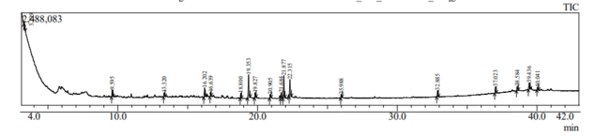
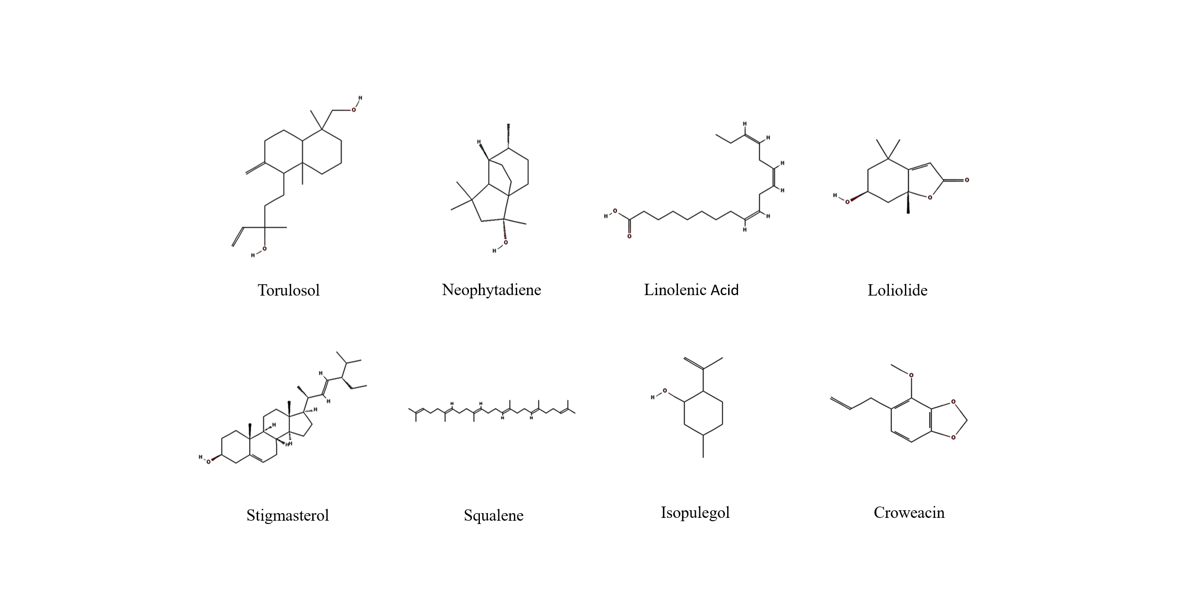
Figure 04. Showing a chromatogram of A. persicum leaf extract
Figure 05. Analysis of A. persicum leaf extract

300nm
Figure 06. Visual and UV–Vi’s analysis of ZnO NPs

Figure 07. FTIR analysis of ZnO NPs
8.8mm

Figure 08. SEM analysis of ZnO NPs

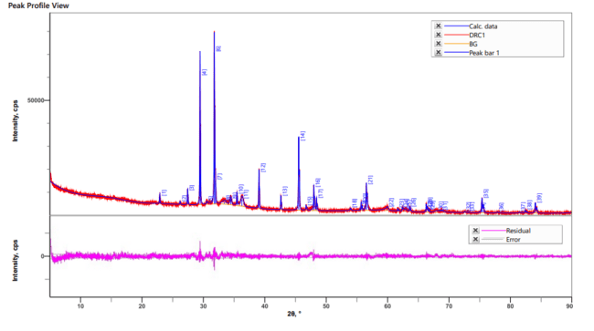

Figure 09. EDX analysis of ZnO NPs showing the presence of Zinc

Figure 10. XRD analysis of ZnO NPs
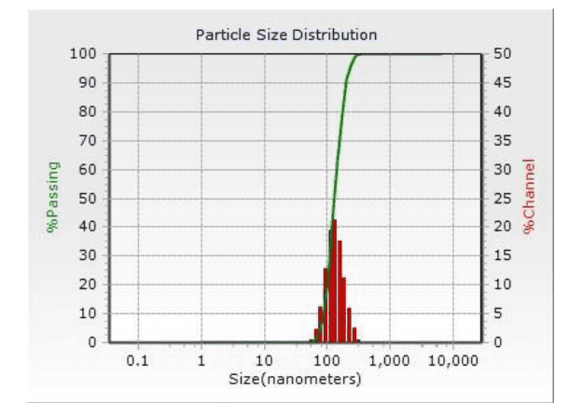
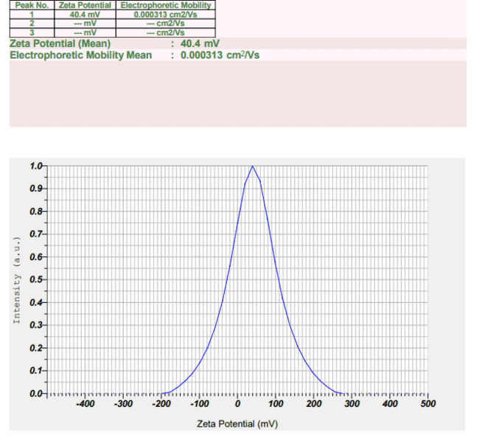
A
B
Figure 11. Zeta potential and DLS analysis of ZnO NPs.

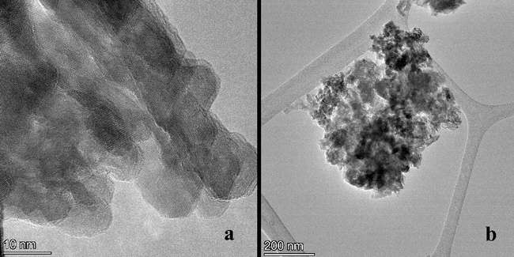
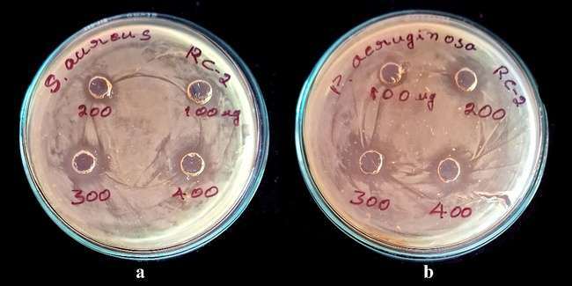
Figure 12. Transmission electron microscope images of zinc oxide nanoparticles recorded at (a) low & (b) high magnifications
A) Rc-2 ZnO Nps against S. aureus B) Rc-2 ZnO Nps against E. coli
Note: Rc-2- A. persicum Zinc oxide nanoparticles
Figure 13. Antibacterial activity of ZnO NPs. A) S. aureus & B) P. aeruginosa

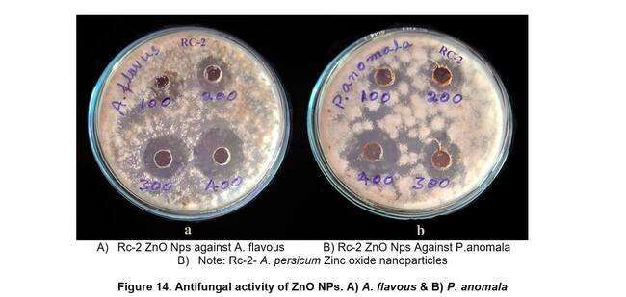
- Rc-2 ZnO Nps against A. flavous B) Rc-2 ZnO Nps Against P.anomala
- Note: Rc-2- A. persicum Zinc oxide nanoparticles

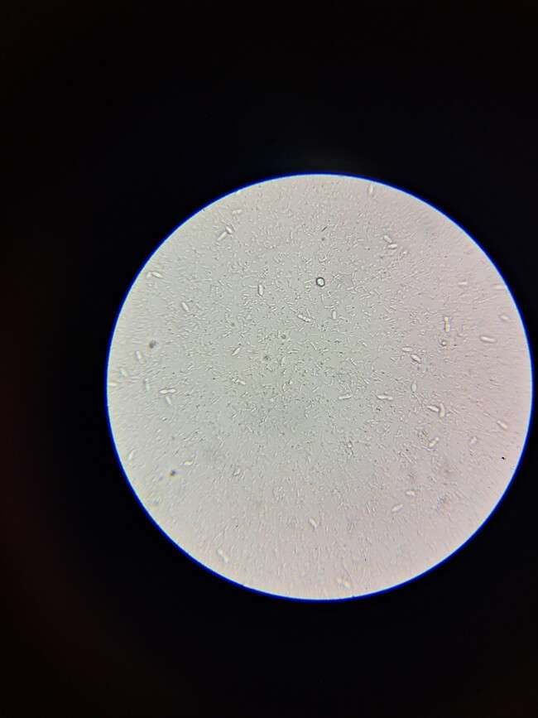
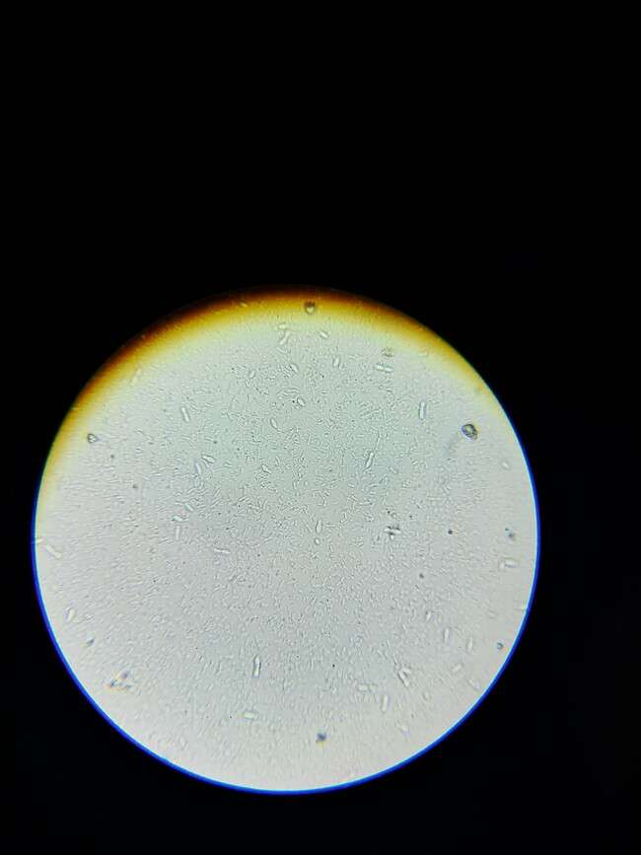
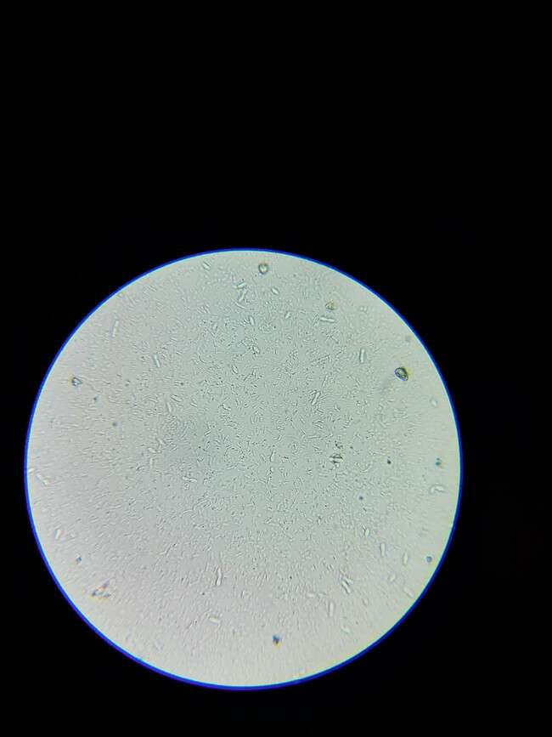
Figure 14. Antifungal activity of ZnO NPs. A) A. flavous & B) P. anomala
Blank
Std
DRC-2

Figure 15. Cytotoxicity images for the MCF7 Cell line were treated at160 µg/mL
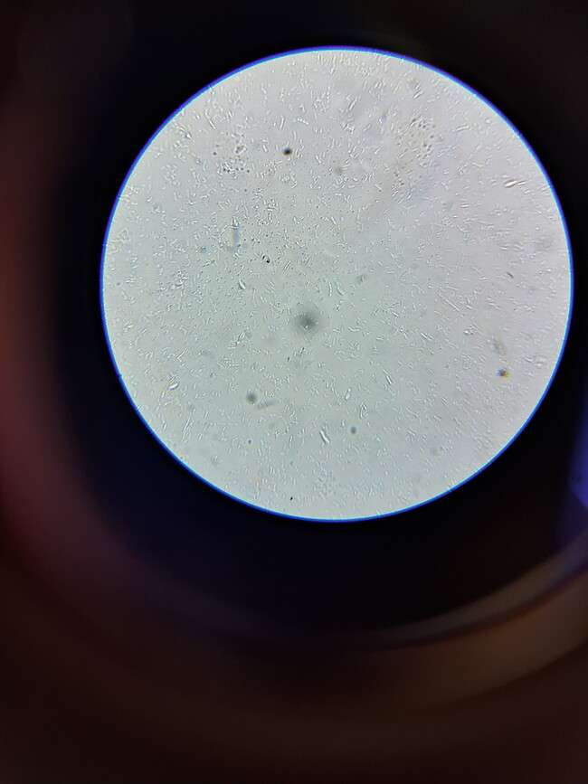
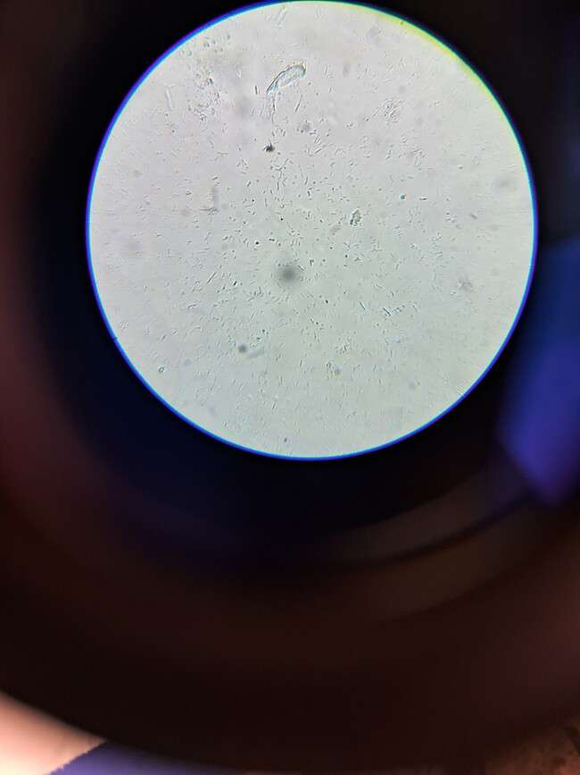
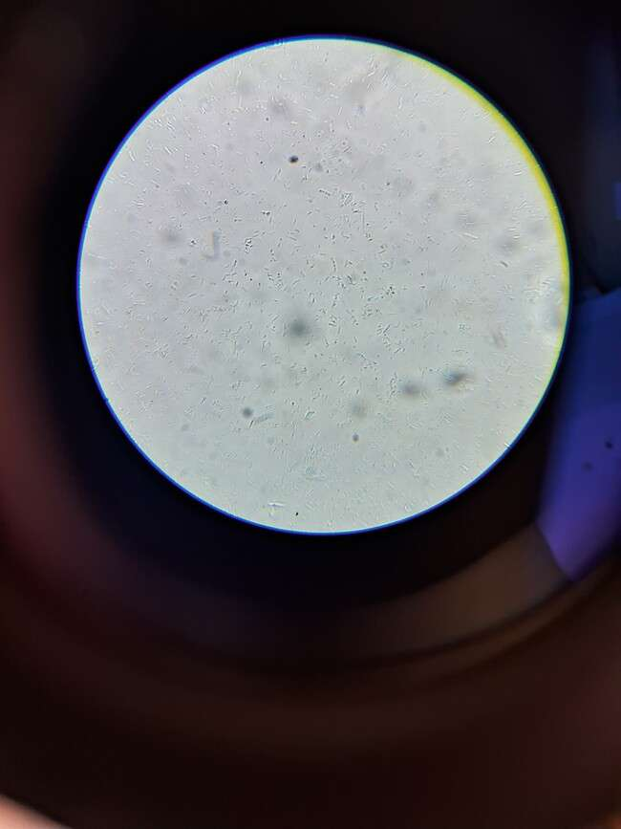
Blank
DRC-2
Std

Figure 16. Cytotoxicity images for HeLa Cancer cell line treated at160 µg/mL

