Development of Packaging and Product Variations of Taro Chips at the Wanagiri Taro Processing Group

.
ABSTRACT

Aims: The prospects and development opportunities for taro-based processed food products have recently increased. Taro chips represent a type of snack food product that is particularly popular in the Wanagiri area of the Sukasada District in Buleleng Regency. The company's objective is to increase the quantity and quality of its production. Partners encounter impediments in the realm of business management, which impede the effective functioning of both production and marketing management.
Study design: Qualitative study with an intervention-based approach.
Place and Duration of Study: Wanagiri Village, Sukasada District, Buleleng Regency on June, 20th 2024.
Methodology: The planned method for implementing activities for the development of packaging and product variations for the Wanagiri Talas Chips Processing Group, Sukasada District, Buleleng Regency, is to utilize the following; (a) The interview and discussion methods; (b) Face-to-face method will facilitate the transfer of knowledge regarding food packaging and hygienic sanitation, the processing of taro chips in a variety of flavors, storage, marketing, entrepreneurship and business management; (c) The programmed incorporates direct practice, guided by instructors who are competent in their respective fields
Results: The primary challenges encountered by partners include sub-optimal business management and unappealing product packaging. This product has the potential to become a new source of income for the group. Furthermore, this activity has demonstrated success in supporting partners from the cultivation stage to the product marketing stage. As a result of the training and hands-on experience gained, group members have become more independent and are now better equipped to develop taro products.
Conclusion: This activity enhances the knowledge and abilities of group members in the processing and marketing of taro products. Prior to the programmed, group members lacked knowledge of attractive packaging and diverse flavors of taro chips.
Keywords: packaging, appropriate technology, taro chips, independent society

1. INTRODUCTION

Food packaging is a critical step in the food production chain that aims not only to protect product quality and safety, but also to create a visual appeal that attracts consumers [1], [2], [3]. In this process, the choice of packaging materials is a key factor influencing marketing success. Packaging materials must meet food safety standards, maintain product integrity and support optimal shelf life [4], [5], [6]. In addition, packaging design plays an important role in creating brand identity and attracting consumer attention. With the right choice of colors, logos and design elements, packaging can create a positive visual experience, communicate brand values and differentiate the product from competitors in the marketplace [7], [8]. The importance of packaging is also seen in the environmental aspect, where the food industry is increasingly focusing on the development of environmentally friendly packaging [9]. The use of recyclable, environmentally friendly packaging materials and the reduction of plastic waste is an integral part of innovation in packaging design.
Taros contain a high amount of β-carotene in their corms, providing vitamin A and antioxidant benefits to the body. Β-carotene, which has a slightly different structure, is a common carotenoid known for its antioxidant properties and other potential health benefits [10], [11], [12]. Taro chips are a type of snack food processed by people in the Wanagiri area, Sukasada district, Buleleng regency, Bali province. Chips are a type of snack food in the form of thin slices of tubers, fruits or vegetables fried in vegetable oil [13], [14], [15]. As a popular snack, taro chips are often packaged in attractive designs that reflect the traditional taste and uniqueness of the product. This packaging not only protects the taro from exposure to air and moisture, which can affect its brittleness, but also gives consumers confidence in the quality and originality of the product. Aspects of quality management and safety of raw materials and products also need to be studied for business and entrepreneurship development and product marketing development [16], [17], [18].
In light of the challenges posed by the diverse processing techniques employed in the production of taro chips, it is imperative to ensure the implementation of the fundamental principles of GMP (Good Manufacturing Practice) or GFPM (Good Food Production Methods) and SSOP (Sanitation Standard Operating Procedures) in order to guarantee the production of safe and high-quality taro chips [17], [19], [20]. The issue of disparate processing techniques for taro chips underscores the necessity for the implementation of fundamental Good Manufacturing Practice (GMP) or Good Food Production Methods (GFPM) and Sanitation Standard Operating Procedures (SSOP) to ensure the production of safe and quality taro chips. Buleleng Regency boasts numerous taro processing groups, with one notable example being the Wanagiri Village group. The Wanagiri Taro Processing Group, led by Komang Diantini, was established in 2020 and currently comprises 10 members. On a daily basis, the group produces approximately 25-50 kg of taro, generating a daily income of approximately Rp. 200,000– Rp. 250,000. Processing groups maintain straightforward financial records to document income and expenditure, as well as loan activities between members. The taro products are typically sold in markets within the village and up to Sukasada District, although the packaging remains rudimentary.
The community service activities funded by Warmadewa University have the objective of enhancing the abilities and comprehension of the members of the taro processing group in Wanagiri Village to manage the local natural resources and to foster an entrepreneurial spirit. It is anticipated that through training on packaging taro chips, the product will be able to be marketed to a wider market with more attractive packaging, thereby increasing consumer interest. Furthermore, the partners are provided with knowledge about work and business management, including time management and effective business operations, which is expected to increase income and welfare.

2. methodology
2.1 Methods
The planned method for implementing activities for the development of packaging and product variations for the Wanagiri Talas Chips Processing Group, Sukasada District, Buleleng Regency, is to utilize the following:
- The interview and discussion methods will be employed in order to ascertain the difficulties encountered by the partners.
- The face-to-face method will facilitate the transfer of knowledge regarding food packaging and hygienic sanitation, the processing of taro chips in a variety of flavors, storage, marketing, entrepreneurship, and business management.
- The program incorporates direct practice, guided by instructors who are competent in their respective fields, to enable partners to apply the technology provided and to address issues about product processing and business management.

2.2 Activity Plans and Procedures
An activity plan is a series of strategic steps that have been prepared with the intention of achieving certain goals. The plan encompasses the identification of needs, the determination of targets, and the scheduling of activities to be implemented. Each stage of the plan is meticulously designed to ensure that all aspects of the activities can be conducted effectively and efficiently. The community service activity plans and procedures that will be implemented are as follows:
- A survey of the location is required to facilitate the implementation of extension activities and packaging processes.
- The interviews and subsequent question-and-answer sessions will address the challenges encountered by the partners, to formulate strategies for addressing these issues.
- The partners will be provided with material prepared by the team in the form of packaging modules for processed taro products. Additionally, they will receive guidance on sanitation and hygiene in processing, storage, marketing, entrepreneurship, and business management.
- The transfer of equipment to partners to facilitate the production of high-quality packaging for taro products.
- The implementation of Good Food Processing Methods (CPMB/GMP) and Hygienic Sanitation (SSOP) will be applied to the processing of taro chips of various flavors, with a focus on the following areas: processing, packaging, storage, marketing, entrepreneurship and business management.

3. results and discussion

3.1 Economic and Social Impact
The implementation of community service activities has had a notable effect on the enhancement of the knowledge and abilities of group members in the processing and marketing of processed taro products. The pre-test results indicate that all group members require training in the processing and marketing of processed taro products, with a particular focus on chips. Prior to the training, group members demonstrated familiarity with taro preparations but lacked expertise in packaging methods and the range of taro chip flavors. Furthermore, the group is unaware of the benefits of processing taro, which results in the sale of taro without prior processing. Following the completion of the activities, the Wanagiri Taro Processing Group was able to utilize taro as a raw material for innovative processing independently. The previously existing problem of unprocessed taro has been resolved by the transformation of this into taro chips with various flavors that are packaged attractively. The use of taro as a basic ingredient for the production of this innovative product has become a new source of income for the group.
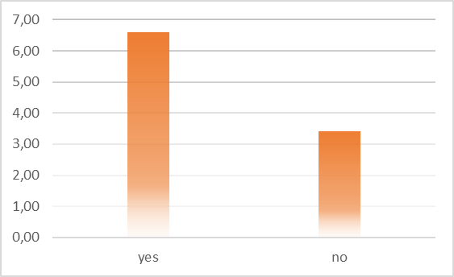
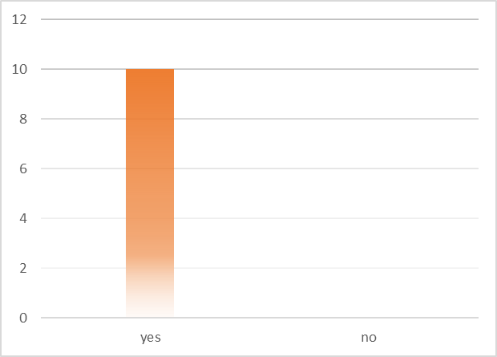
All individuals undergoing training will be provided with a packaged quantity of taro chips. Among the 10 service participants, nine encountered difficulties with the packaging process. All participants engaged in the packaging of taro using plastic materials, and expressed a desire to replace these with more distinctive packaging solutions. It is evident that participants require training regarding packaging and product variations. Of the 10 participants, only two were aware of the types of packaging that were suitable for chips. In addition, only two participants demonstrated an understanding of the role of packaging in protecting products from physical or biological damage. Furthermore, the participants demonstrated a lack of awareness regarding the information that should be included in the packaging. Of the 10 participants, only 8 had already designated a name for their product. Furthermore, only four of the ten participants undertook the task of testing the shelf life of the chips.
(a) (b)

Fig. 1. (a) Level of group knowledge about packaging before training through pre-test results; (b) posttest results of the taro group regarding packaging

3.2 Partner Contribution to Implementation
The Regional Leading Product Development Program for Processed Taro Products at the Wanagiri Taro Processing Group in Wanagiri Village is proceeding in an orderly and efficacious manner. On Thursday, 20 June 2024, a theoretical study was conducted to provide an understanding of the material on the development of processed taro products. The event was attended by 10 members of the Wanagiri Taro Processing Group and two representatives of the village administration. Following the counselling session, the participants proceeded to engage in hands-on training in the production and packaging of taro chips, incorporating novel techniques. Throughout the entire process, the partners were accompanied by the programmed staff until they were able to successfully produce the desired products, which were then marketed. All participants (100%) actively participated in the activity and expressed their desire for continued assistance in developing processed taro products as well as developing products with other raw materials in the future.
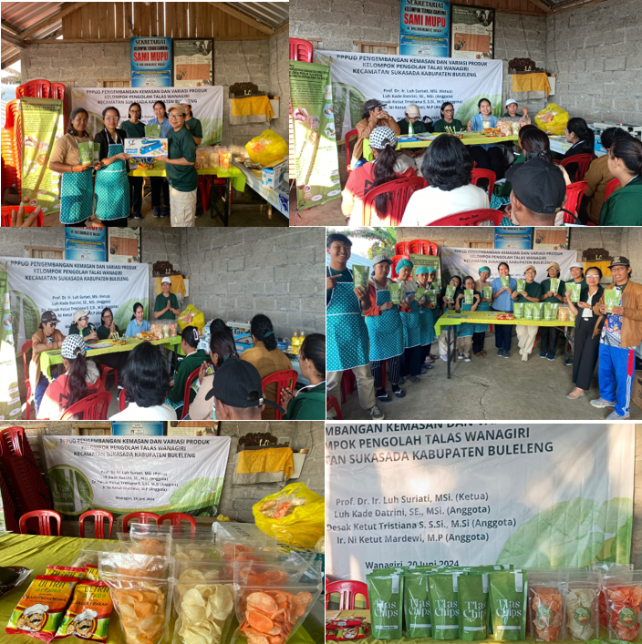
Fig. 2. A series of service activities will be undertaken, the purpose of which will be to provide an overview of the following: the packaging process; plant cultivation; waste processing; and bookkeeping. In addition, tools will be provided to each processing group

3.3. Next Stage Plan
The community service planned program in Wanagiri Village, Sukasada District, Buleleng Regency regarding taro chips, namely strengthening local capacity involving ongoing training and education for PKK members, farmers and small business owners in Wanagiri Village regarding marketing strategies, business management and product innovation. By improving local skills and knowledge, communities can continue to develop and manage their own businesses

4. Conclusion

The Regional Featured Product Development Program has demonstrably had a positive impact on the community groups involved. This activity enhances the knowledge and abilities of group members in the processing and marketing of taro products. Prior to the programmed, group members lacked knowledge of attractive packaging and diverse flavors of taro chips. Following the training, the group was able to process taro into a variety of flavored chips, which were packaged attractively. This product has the potential to become a new source of income for the group. Furthermore, this activity has demonstrated success in supporting partners from the cultivation stage to the product marketing stage. As a result of the training and hands-on experience gained, group members have become more independent and are now better equipped to develop taro products.

Disclaimer (Artificial intelligence)
Option 1:
Author(s) hereby declares that NO generative AI technologies such as Large Language Models (ChatGPT, COPILOT, etc.) and text-to-image generators have been used during writing or editing of manuscripts.
Option 2:
Author(s) hereby declares that generative AI technologies such as Large Language Models, etc. have been used during writing or editing of manuscripts. This explanation will include the name, version, model, and source of the generative AI technology and as well as all input prompts provided to the generative AI technology
Details of the AI usage are given below:
1.
2.
3.

References

1. Ghassani MM, Yuwono EC, Tanudjaja BB. Designing Branding Design Work for UMKM Dry Cakes Vania Cake & Cookies in Sidoarjo. J DKV Adiwarna. 2020;1(16).
2. Nguyen AT, Parker L, Brennan L, Lockrey S. A consumer definition of eco-friendly packaging. J Clean Prod. 2020;252:119792.
3. Ketelsen M, Janssen M, Hamm U. Consumers’ response to environmentally-friendly food packaging-A systematic review. J Clean Prod. 2020;254:120123.
4. Sohail M, Sun DW, Zhu Z. Recent developments in intelligent packaging for enhancing food quality and safety. Crit Rev Food Sci Nutr. 2018;58(15):2650-2662.
5. Gordon A, Williams R. The role and importance of packaging and labeling in assuring food safety, quality and regulatory compliance of export products II: Packaging & labeling considerations. In: Food Safety and Quality Systems in Developing Countries. Elsevier; 2020:285-341.
6. Sulistianingsih D. Public Understanding of the Dangers of Misuse of Food Product Packaging and Law Enforcement. J LITIGATION. 2015;16(1).
7. Klimchuk MR, Krasovec SA. Packaging Design: Successful Product Branding from Concept to Shelf. John Wiley & Sons; 2013.
8. Elkhattat D, Medhat M. Creativity in packaging design as a competitive promotional tool. Inf Sci Lett. 2022;11(1):135-145.
9. Gurning LR. Packaging Structure Design for Cardboard-Based Food Products as Souvenirs to Increase Sales. Magenta | Off J STMK Trisakti. 2023;7(02):1101-1111. doi:10.61344/magenta.v7i02.106
10. Nip WK. Taro. In: Processing Vegetables. Routledge; 2023:355-388.
11. Temesgen M, Retta N. Nutritional potential, health and food security benefits of taro Colocasia esculenta (L.): A review. Food Sci Qual Manag. 2015;36(0):23-30.
12. Moy JH, Wang NTS, Nakayama TOM. Processing of taro into dehydrated, stable intermediate products. In: Small-Scale Processing and Storage of Tropical Root Crops. CRC Press; 2019:223-248.
13. Chen J, Venkitasamy C, Shen Q, McHugh TH, Zhang R, Pan Z. Development of healthy crispy carrot snacks using sequential infrared blanching and hot airdrying method. LWT. 2018;97:469-475.
14. Arora M, Singhal S, Rasane P, et al. Snacks and Snacking: Impact on Health of the Consumers and Opportunities for its Improvement. Curr Nutr Food Sci. 2020;16(7):1028-1043.
15. Frîncu M, Barbu A, Ion VA, Petre A, BĂDULESCU L. Processing methods used for organic vegetable chips-review. Sci Pap Ser B Hortic. 2022;66(2).
16. Langga L, Se H. Entrepreneurship Management Training as an Effort to Increase the Income of MSME Actors in Kota Baru District, Ende Regency. Reson J Ilm Community Service. 2022;6(1):48. doi:10.35906/resona.v6i1.841
17. Suriati L, Aida FMNA, Raseetha Vani Siva Manikam, et al. The Development of Taro Processed Product in Women Farmers Group in Baru Village, Tabanan Bali Indonesia. AJARCDE | Asian J Appl Res Community Dev Empower. 2022;6(1):28-34. doi:10.29165/ajarcde.v6i1.83
18. Mangku IGP, Suriati L, Sudita DN, Situmeang P, Udayana IGB. Guidance and Assistance for Vco Development in the "Pangsan Ayu" Group, Pangsan Village, Petang District, Badung Regency. 2022;11(2):199-208.
19. Suriati L, Datrini LK, Rudianta IN. Development of Taro-based Products in the Dewi Catur Women's Farmer's Group, Catur Village Kintamani Bali. Asian J Adv Agric Res. 2022;18(3):1-8. doi:10.9734/ajaar/2022/v18i330221
20. Herawati H. Potential of Hydrocolloids as Additional Ingredients in Quality Food and Non-Food Products. J Agricultural Researcher and Developer. 2018;37(1):17. doi:10.21082/jp3.v37n1.2018.p17-25

