**EPIDEMIOLOGICAL PROFILE OF PATIENTS WITH CUTANEOUS LEISHMANIASIS IN MARANHÃO STATE, BRAZIL**

Original Research Article

# ABSTRACT

**Aims:** The present study aims to observe the epidemiological factors that lead to the high occurrence of Leishmaniasis cases in Brazil, highlighting the endemic area of Maranhão, the main factors involved in its transmission, the challenges for controlling the disease and the prospects for controlling this disease in the state.

**Study design:** This is an analytical-descriptive epidemiological study of an ecological nature.

**Place and Duration of Study:** Data were collected from the SINAN/DATASUS database related to the Maranhão state health network, covering the period from 2020 to 2024.

**Methodology:** The study analyzed data obtained from the Notifiable Diseases Information System (SINAN/SUS) through TABNET/DATASUS. Variables such as sex, age group, and education level were assessed to determine their correlation with the prevalence of cutaneous leishmaniasis in Maranhão. Ethical approval was not required due to the use of publicly available data.

**Results:** A total of 6,406 cases were recorded during the study period, with the highest prevalence among adults aged 20 to 59 years, predominantly male, and individuals with incomplete elementary education. The year 2024 showed a significant reduction in reported cases compared to previous years.

**Conclusion:** The epidemiological profile of American Cutaneous Leishmaniasis in Maranhão is influenced by sociodemographic factors, with higher prevalence among men and individuals with incomplete elementary education. The study reinforces the importance of preventive health education policies to curb the spread of the disease.

*Keywords: Cutaneous Leishmaniasis; Epidemiology; Maranhão; Socioeconomic Factors*

# 1. INTRODUCTION

Cutaneous leishmaniasis is an infectious disease caused by the protozoan of the genus Leishmania. The main species capable of transmitting the disease in Brazil are: Leishmania (Leishmania) amazonensis, L. (Viannia) guyanensis and L.(V.) braziliensis. Transmission to humans occurs through the bite of infected female mosquitoes, popularly known as the sandfly or birigui, of the phlebotomine species and genus Lutzomya. (Brazil, 2025).

​The disease can manifest itself in two forms, namely Cutaneous Leishmaniasis (CL) and Mucosal Leishmaniasis (or mucocutaneous), which present with different symptoms. CL can present painless skin lesions with delimited and elevated edges and coarse granulations, while the mucosal form can present destructive lesions at the level of the mucosa, generally in the upper airways. (Conceição; Leite Morgado 2018; Shamsudheen et al., 2021; Kirade et al., 2021).

The World Health Organization (WHO) estimates that 350 million people are exposed to the risk worldwide, with approximately two million new cases of the different clinical forms recorded each year, with Cutaneous Leishmaniasis responsible for an annual record of 0.7 to 1.3 million new cases distributed across four continents (America, Asia, Africa and Europe), making it a serious public health problem. In Brazil, LT is one of the dermatological infections that deserves the most attention, due to the occurrence of deformities and psychological impairment with the clinical course of the disease. (Santos, 2018)

The proliferation is due to climatic, historical and socioeconomic factors. Thus, the disease, which is subject to compulsory notification, represents a serious national health problem, since it is intensely neglected due to the social vulnerability of those infected. (Araújo *et.al*, 2024)

Furthermore, the country is marked by endemic locations, of greater susceptibility, such as the state of Maranhão, which has a high number of LT cases. In 2022, 1,553 cases of the disease were registered in the state, occupying the second position in relation to the number of occurrences when compared to other states, being the state of the Northeast region with the highest coefficient of detection of LT cases in 2022, with 22.92 cases/100,000 inhabitants. (Bussinguer, 2024)

In this context, the present study aims to observe the epidemiological factors that lead to the high occurrence of Leishmaniasis cases in Brazil, highlighting the endemic area of Maranhão, the main factors involved in its transmission, the challenges for controlling the disease and the prospects for controlling this disease in the state.

# 2. METHODOLOGY

**2.1 Type of study**

This is an analytical-descriptive epidemiological study of an ecological nature, with data from the Notifiable Diseases Information System (SINAN/SUS) obtained through the Information Technology Department of the Unified Health System (TABNET/DATASUS). The data were obtained through access as an individual according to the access rights granted by Law No. 12,527, sanctioned on November 18, 2011.

**2.2 Study population**

The study population was composed of the Maranhão health network, estimated at approximately 7,010,960 people.

**2.3 Inclusion and exclusion criteria**

The descriptors sex, age group and education level were used, correlating them with characteristics favorable to the persistence of the disease in the region, considering the last 4 years (2020-2024).

**2.4   Ethical aspects**

There was no need to submit this project to the research ethics committee because the scientific information provided in it was obtained by obtaining data available in a public repository, as determined by the sole paragraph of art. 1 of Brazilian Council of Health Resolution no. 510/2016. (Milhomem Rodrigues et al.,2024).

# 3. RESULTS AND DISCUSSION

The data analysis involved a survey of information on cases of Cutaneous Leishmaniasis in the last five years (2020-2024) in the public health network of Maranhão and it was observed that, during the years mentioned, 6,406 cases were registered, marked by a significant number between the years 2020 to 2023, with a substantial decrease in the year 2024, with only 676 cases, with aspects and prevalence that will be addressed below.

In figure 1, the disease is related to the age group of the population of the Maranhão macro-region, showing an apparently Gaussian-style distribution, showing a higher prevalence in the ages between 20 and 39 years, with 2,617 cases and in the ages between 40 and 59 years, with 1,731 cases, divided into mucosal and cutaneous forms, totaling 67% of the total number of cases.

Figure 1 - Analysis of the distribution of notifications of confirmed cases of Cutaneous Leishmaniasis in the health network of Maranhão by age group (2020 - 2024)

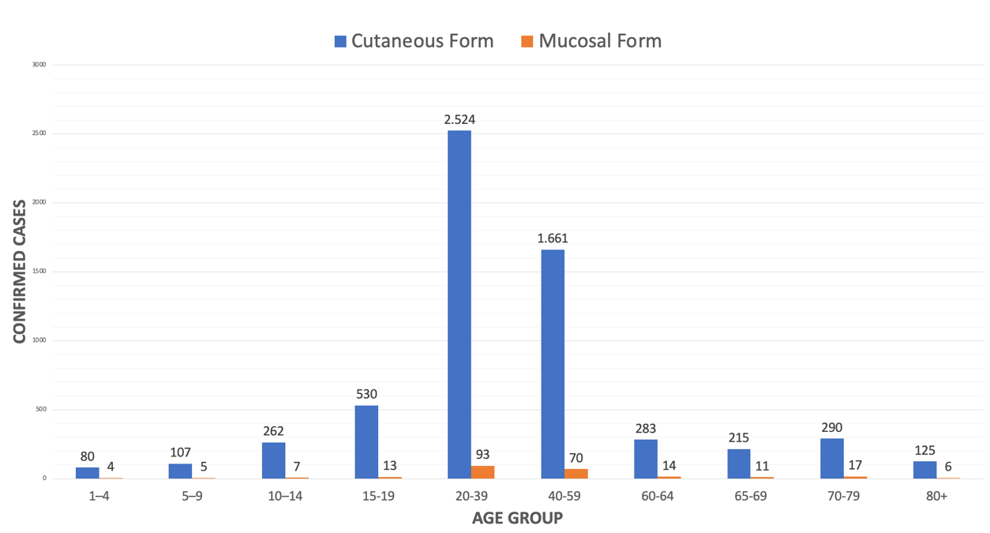

Source: Search in the SINAN/SUS database.

In this context, the high rate at these ages may be related to the greater autonomy of this age group, with entry into the job market, generating greater exposure to these people, depending on their occupation. (Oliveira et al., 2020)  On the other hand, the elderly are the least affected, this can be explained by the fact that this population is less exposed due to greater care with their health, preventing them from being exposed, for example, to the LTA vector. (Guirro et al*.,,*2023). It is worth mentioning that the levels of mucous and integumentary presentations according to Araújo et al., (2024) are subordinate to the presence of certain species of parasites in endemic regions and affect the dynamics of infections and their respective presentations.

In order to also observe whether there is a higher rate of sex among confirmed cases, we also evaluated the data for this factor, tabulating the biological sex in relation to the notifications (Figure 2), in which the data show that sex is a favorable factor for the onset of the disease, with a higher prevalence in males.

**Figure 2 - Analysis of the distribution of notifications of confirmed cases of Cutaneous Leishmaniasis in the public health network of Maranhão by sex (2020 - 2024).**

Source: Search in the SINAN/SUS database.

These data may be related to sociocultural factors, in which men are more exposed to environments where the vector is present than women, especially in rural areas, as also observed in other studies, commonly associating the male occupation and their contact with the ATL vector in their work activities, such as mining, livestock farming, agriculture (Oliveira et al, 2022). In addition, self-care behavior tends to be less frequent among men, which may contribute to the underreporting of mild symptoms and worsening of clinical conditions (Oliveira et al., 2020). In addition, this context reinforces the discrepancy between the socioeconomic vulnerability of the population, since many of the workers in this area work without personal protective equipment (PPE).

In order to clarify a possible correlation between education and the prevalence of Cutaneous Leishmaniasis, we analyzed the annual averages of confirmed cases based on stratification by series within the scope of data from the Maranhão health macroregion, as shown in figure 3.

1

**Figure 3 - Analysis of the distribution between the level of education and confirmed cases of Cutaneous Leishmaniasis in the public health network of Maranhão according to the clinical form (2020-2024).**

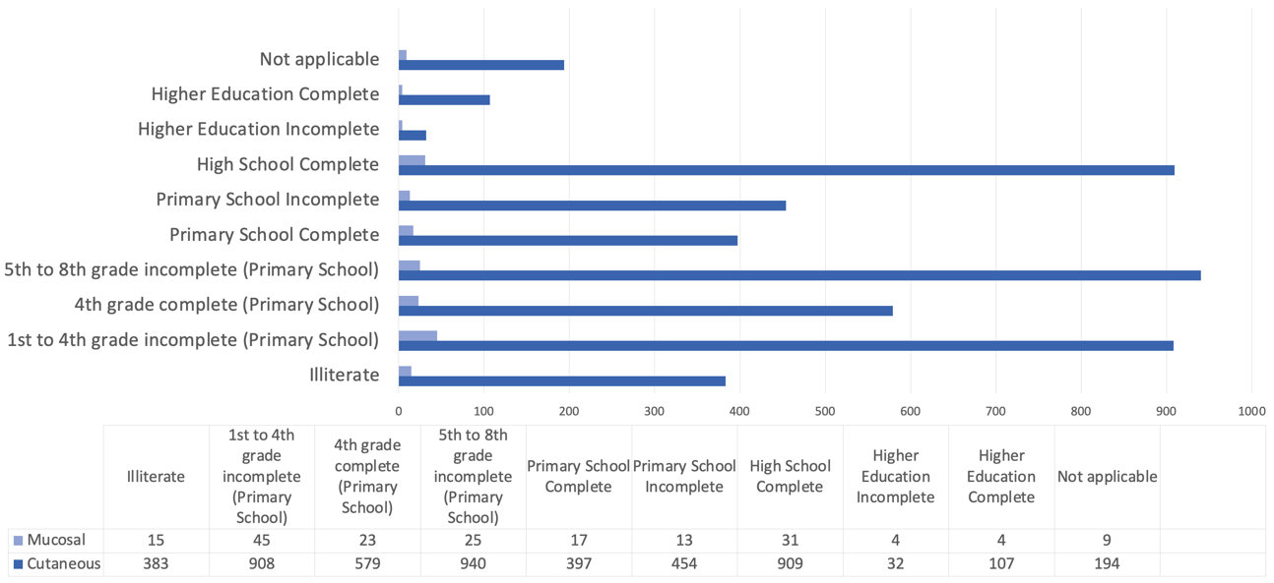Source: Search in the SINAN/SUS database.

Figure 3 shows the prevalence of confirmed cases, mainly in individuals who have incomplete 1st to 4th grade, with approximately 953 cases, as well as incomplete 5th to 8th grade, with 965 cases, and those who have only completed high school, with 940 cases. According to Oliveira et.al, (2020) and Ferreira et al., (2023) individuals with lower educational levels tend to be more vulnerable to infectious diseases due to limited understanding of the forms of transmission, prevention, and symptoms, which delays the search for care and the initiation of treatment, as well as continuous health monitoring. Furthermore, it is even more worrying in endemic and rural areas, where there is less attention and initiatives for health education campaigns.

Thus, it is evident that individuals with incomplete elementary education had a higher incidence of confirmed cases of ACL, just as Oliveira et al., 2020 highlight that ACL disproportionately affects populations in rural and peri-urban areas, characterized by lower levels of education and income, which also leads to lower adherence to treatment.

Therefore, there is a need for health education in rural areas with the aim of informing and raising awareness among the population about the disease, and it is also important to note that areas that are less privileged from a regional development perspective may be associated with a higher level of underreporting (Alencar et al., 2023)

# 4. CONCLUSION

The analysis of the data reveals an epidemiological profile of American Tegumentary Leishmaniasis that is strongly influenced by sociodemographic factors. This study indicated that the level of education was a contributing factor to the prevalence of ATL cases in Maranhão, highlighting individuals with incomplete elementary education, and also showed a predominance of males. The conclusions highlight the need for effective and preventive health education policies in order to avoid an increase in cases of this zoonosis.

Disclaimer (Artificial intelligence)

Author(s) hereby declare that NO generative AI technologies such as Large Language Models (ChatGPT, COPILOT, etc.) and text-to-image generators have been used during the writing or editing of this manuscript.

# REFERENCES

ALENCAR *et. al*,  EPIDEMIOLOGIA DA LEISHMANIOSE TEGUMENTAR AMERICANA NO NORDESTE BRASILEIRO ENTRE 2013 E 2022: UM PROBLEMA DE SUBNOTIFICAÇÃO. **The Brazilian Journal of Infectious Diseases**,  v.27, n.1, Out 2023. DOI:https://doi.org/10.1016/j.bjid.2023.103529

ARAÚJO, Q. M. S.*et al*. Caracterização epidemiológica e tendência temporal dos casos por Leishmaniose Tegumentar(LTA) na Região do Nordeste do Brasil entre os anos de 2001 a 2020. **Research, Society and Developmente**, v.13, n.7, 2024. DOI: http://dx.doi.org/10.33448/rsd-v13i7.45205

BRASIL. Ministério da Saúde. **Boletim epidemiológico de doenças tropicais negligenciadas: leishmaniose tegumentar americana**. Brasília: Ministério da Saúde, jan. 2025. (Série Epidemiológica). Link:  <https://www.gov.br/saude/pt-br/centrais-de-conteudo/publicacoes/boletins/epidemiologicos/especiais/2025/boletim-epidemiologico-de-doencas-tropicais-negligenciadas-numero-especial-jan-2025.pdf>

BUSSINGUER, P. R. R. Leishmaniose Tegumentar: aspectos clínicos, epidemiológicos e análise espacial no estado do Maranhão (2011 a 2022). 2024. 83 f. (Dissertação) Programa de Pós-Graduação em Saúde e Tecnologia - Universidade Federal do Maranhão, Imperatriz, 2024. Link: <https://tedebc.ufma.br/jspui/handle/tede/5506>

CONCEIÇÃO, F. SILVA; LEITE‑SILVA, J.; MORGADO, F. N. The binomial parasite–host immunity in the healing process and in reactivation of human tegumentary leishmaniasis. **Frontiers in Microbiology**, v. 9, art. 1308, 2018. doi: 10.3389/fmicb.2018.01308. DOI: <https://doi.org/10.3389/fmicb.2018.01308>

FERREIRA, R. *et.al*, Análise do perfil epidemiológico de pacientes com Leishmaniose Tegumentar no estado do Maranhão: um estudo retrospectivo de 2018 a 2022. **Revista Fisio &Terapia** ,  V.27, n.128, p.1, Nov. 2023. DOI: 10.5281/zenodo.10205421

GUIRRO, I. G. et al. Leishmaniose Tegumentar Americana: um estudo abrangendo macrorregiões brasileiras com enfoque nos anos de 2013 a 2018. **Brazilian Journal of Health Review**, Curitiba, v. 6, n. 4, p. 17455–17470, jul./ago. 2023.DOI: <https://doi.org/10.34119/bjhrv6n4-266>

Kirade, S., Meshram, P., Umate, R., & Wasnik, H. (2021). A Case Report on Mucocutaneous Leishmaniasis. **Journal of Pharmaceutical Research International,** 33(64A), 538–542. https://doi.org/10.9734/jpri/2021/v33i64A35915

MILHOMEM RODRIGUES, ANNA TAYNAH et al. Investigação de fatores associados a morbimortalidade hospitalar por CID: A09 no estado do Maranhão, Brasil. **Brazilian Journal of Surgery & Clinical Research**, v. 47, n. 2, 2024.

OLIVEIRA *et.al*,. A Leishmaniose Tegumentar Americana e seus fatores de riscos socioambientais no  município de Tucuruí, Pará, Brasil: Análise espacial e epidemiológica. **Revista Brasileira de Geografia Médica e da Saúde**.  V.16, p.386-396, Nov. 2020. DOI: <https://doi.org/10.14393/Hygeia16056928>

OLIVEIRA, V. J. et al,. Epidemiologia da leishmaniose visceral humana no Brasil: perspectivas da atenção à saúde pública pelo prisma da medicina veterinária. Research, Society And Development, [S.L.], v. 11, n. 15, p. 202111537034-202111537034, 14 nov. 2022. Research, Society and Development. DOI: http://dx.doi.org/10.33448/rsd-v11i15.37034.

SANTOS, G. M. Características epidemiológicas da leishmaniose tegumentar americana em um estado do nordeste brasileiro. **Archives of Health Investigation**, v. 7, n. 3, p. 103–107, Mar. 2018. DOI: http://dx.doi.org/10.21270/archi.v7i3.2687

Shamsudheen, S., Mathew, V., Venkateswarlu, B. S., Iqubal, R., Palathingal, M., Ali, T. V. A., Mathew, S., & Maheswari, D. U. (2021). A Review on Cutaneous Leishmaniasis. **Journal of Pharmaceutical Research International**, 33(60B), 2510–2519. https://doi.org/10.9734/jpri/2021/v33i60B34907