Analysis of the epidemiological impact of a public health policy against meningococcal meningitis in children in Maranhão, state of Brazil

Original Research Article

.

ABSTRACT

|  |
| --- |
| **Aims:** Over the years, Meningococcal Disease (MD), an acute infection characterized by inflammation of the meninges in response to the agent N. meningitidis, has been affecting different regions of Brazil in different ways. Therefore, the meningococcal C vaccine (MeCV) was introduced to the Brazilian vaccination schedule in 2010, following the increase in lethality associated with meningitis in the country. The state of Maranhão, in Brazil, has challenging socioeconomic characteristics, such as low coverage of basic sanitation and high prevalence of poverty, which are factors that may favor the spread of MD. Thus, this article aimed to analyze the epidemiological data of meningitis in children up to 9 years old, in the state of Maranhão, before and after the implementation of the Meningococcal C vaccine in the vaccination schedule in Brazil.  **Study design:** This is a retrospective, cross-sectional, descriptive and quantitative epidemiological study.  **Place and Duration of Study:** The study was conducted in the state of Maranhão, Brazil, using data from 2001 to 2020.  **Methodology:** The study used data from the SINAN/DATASUS and SIH/DATASUS databases, between 2001–2020, in children aged 0 to 9 years.  **Results:** Our results pointed to a reduction in the incidence of MD in children aged 0 to 9 years, especially after the implementation of MeCV, suggesting the effectiveness of the vaccine in preventing the disease. In addition, especially after the introduction of MeCV, the data show a decrease in the number of notifications of meningitis (of etiological agents in general) and in the number of hospitalizations due to bacterial meningitis. However, paradoxically, there was an increase in lethality.  **Conclusion:** These results reinforce that the introduction of the Meningococcal C vaccine (MeCV) into the Brazilian immunization program was a preventive strategy in vulnerable populations. However, the observed paradoxical increase in lethality highlights the need for further investigation into factors influencing disease outcomes, such as delays in diagnosis, access to health services, and the presence of coexisting conditions. |

*Keywords: Meningococcal Disease; Vaccine; Public Health Surveillance; Epidemiology*

1. INTRODUCTION

Meningococcal disease (MD) is an acute infection caused by the bacterium Neisseria meningitidis (meningococcus) (Brazil, 2024a). N. meningitidis is a Gram-negative diplococcus with 13 serogroups, including serogroups A, B, C, Y, and W, with serogroups B and C being the main causes of meningococcal disease (Viñoles, Patricia, Montaño & Burgos, 2017). Among the active forms of the disease, meningococcal meningitis is the most frequent and meningococcemia the most severe. It is worth noting that both can occur simultaneously (Brazil, 2024a).

Meningitis is the inflammatory process of the meninges, membranes that surround the brain and spinal cord, in response to infectious or non-infectious agents (Brazil, 2024a). Meningococcemia is characterized by the invasion of meningococcus into the bloodstream, triggering an intense inflammatory response, with fatal complications. As the disease progresses, petechiae or purpura, neurological changes, respiratory failure and septic shock may appear (Silva, Mundim, Freitas, Lima, Castro, Pereira, et al, 2023).

Clinically, bacterial meningitis commonly manifests in children starting with fever, vomiting, photophobia, headache, and may be accompanied by signs of meningeal irritation and convulsions. In general, the younger is the child, the more undiscriminated the signs and symptoms become. In infants, especially those under 1 year of age, signs of meningeal irritation are uncommon, making it important for investigation to assess protuberance and/or increased tension of the fontanels associated with fever, irritability, groaning, loss of appetite, and vomiting (Brazil, 2024a; van de BeeK, Cabellos, Dzupova, Esposito, Klein, Kloek, et al, 2016).

Comorbidities associated with individuals with a history of bacterial meningitis in childhood include: impaired neurodevelopment, highlighting behavioral and emotional disorders, hearing loss and visual disturbances, greater need for medical care and a higher risk of death during follow-up until adolescence (Snoek, Gonçalves, Horváth-Puhó, Kassel, Procter, Søgaard, et al, 2022; Mohanty, Kostenniemi, Silfverdal, Salomonsson, Iovino, Sarpong, et al, 2024). In cases of meningococcemia, fatality rates are high, with most deaths occurring in the first 48 hours (Brazil, 2024a).

The age group most susceptible to MD consists of children under 5 years of age, especially those under 1 year of age, and the most vulnerable conditions involving: asplenia, recent viral respiratory infections, close contact with carriers and less privileged socioeconomic conditions, and are therefore considered priority groups for vaccine prophylaxis. (Brazil, 2024a). The transmission of meningococcal meningitis occurs when coughing, sneezing, kissing and living in closed and crowded environments (Raysoni, 2022).

In Brazil, meningitis cases peaked during the military dictatorship. The epidemic began in 1970 in the state of São Paulo, with censure of the news coverage and health campaigns. It was only in 1974 that the pathogen was recognized and patients were treated. Since then, the National Commission for Meningitis Control has been created and prophylactic measures have been implemented, such as the importation of vaccines, isolation measures, and control of crowds (Andrade & Lopes, 2021).

Vaccination therefore acts as one of the prophylactic measures for MD. In September 2010, the Meningococcal C vaccine (MeCV) was included in the National Immunization Program (NPI) for children aged 3 to 24 months. To expand meningococcal prophylaxis, in 2020, the meningococcal vaccine against serogroups A, C, W, and Y was introduced for adolescents. In a 2024 normative instruction, made available by the Ministry of Health of Brazil, the MeCV should be administered in 2 doses, at the 3rd and 5th month of life, the reinforcement is given at 12 months of age, and the meningococcal ACWY vaccine in 1 dose for those between 11 and 14 years of age (Roteli-Martins, Neves, Magno, & Kfouri, 2022; Brasil, 2024b).

It is worth mentioning that, between 2007 and 2020, there were 87.993 confirmed cases of bacterial meningitis, where, among the etiological agents identified, meningococcal disease stood out as the most prevalent (26,436 cases), with a predominance of serogroup C (8,811 cases) (Brazil, 2024c).

In the study developed by Rodrigues & Milagres (2015), between 2007 and 2013 (transition period from the implementation of MeCV to NPI), the Northeast region stood out as the second region with the highest incidence of meningitis notifications, with just over 34 thousand confirmed cases. Among the states in the Brazilian Northeast region, state of Maranhão has challenging socioeconomic characteristics, such as low coverage of basic sanitation and high prevalence of poverty, which are factors that can favor the spread of meningitis (Santos, Saraiva & Lopes, 2024).

Based on the information presented, this work aims to analyze the epidemiological data of meningitis in children up to 9 years old, in the state of Maranhão, before and after the implementation of the Meningococcal C vaccine in the vaccination schedule, in Brazil.

2. methodology

**2.1 Type of study**

This is a retrospective, cross-sectional, descriptive and quantitative epidemiological study. The data were obtained in March 2025 through queries to the Notifiable Diseases Information System (SINAN) and Hospital Information System (SIH) databases made available by the Information Technology Department of the Unified Health System (DATASUS).

**2.2 Study Population**

The study universe consisted of cases of meningitis diagnosed in children aged 0 to 9 years, in the state of Maranhão, Brazil, from 2001 to 2020.

**2.3 Inclusion Criteria**

All data, according to the research variables, available on the SINAN/DATASUS and SIH/DATASUS platforms, regarding children aged 0 to 9 years by place of residence in the state of Maranhão were included.

**2.4 Exclusion Criteria**

All data not integrated into the National Notifiable Disease System (SINAN) due to issues of integrity or lack of recording were excluded.

**2.5 Data search and analysis**

The data were obtained by consulting the Notifiable Diseases Information System (SINAN) and Hospital Information System (SIH) databases, both made available by DATASUS. Data collection was carried out in March 2025.

The following analysis variables were listed: year of the first symptom(s); gender; age group; etiological descriptions of meningococcemia (MCC), meningococcal meningitis (MM), meningococcemia with meningococcal meningitis (MCC+MM); number of deaths and cures; and number of hospitalizations.

The files were saved in CSV format and exported to Excel 2013, and descriptive statistical analyses were performed based on these variables. Pearson's coefficient tests were applied to continuous variables and the chi-square test, followed by Fisher's exact test to calculate the odds ratio for contingency variables, according to the statistical method used in Graph Pad Prism 10 software.

For data analysis, the sample population was considered in 2 (two) different time periods: the population before the inclusion of the meningococcal C vaccine (MeCV) in the NPI between the years 2001 to 2010 and the population after the implementation of the MeCV in the NPI between the years 2011 to 2020.

**2.6 Ethical Aspects**

The research was carried out in accordance with the ethical precepts of the Brazilian National Health Council and, as it is a research with secondary data, in the public domain, ethical procedures were not necessary, as per item V, Art. 1 of CNS resolution no. 510/2016.

3. results and discussion

The analysis of meningitis data reported between 2001 and 2020 in the state of Maranhão among children aged 0 to 9 years allows us to outline an overview of this disease in light of the implications of the meningococcal C vaccine (MeCV) to assess the effectiveness of expanding public health policy, in this case the expansion of vaccination.

To understand better the scenario, we processed data on hospitalizations, deaths and discharges from the episode (Figure 1), which show the number of cases per year of the first symptom(s).

Our results show 1,990 cases of meningitis, of which the population in the scenario before the inclusion of the MeCV, that is, from 2001 to September 2010, accounted for 70.3% of these cases (n. 1,399), while the population in the scenario after the inclusion of the MeCV, from 2011 to 2020, listed 29.7% (n. 591).

***Figure 1***. Notifications, deaths and cure of meningitis in the state of Maranhão, Brazil, between children aged 0 to 9 years (2001-2020).

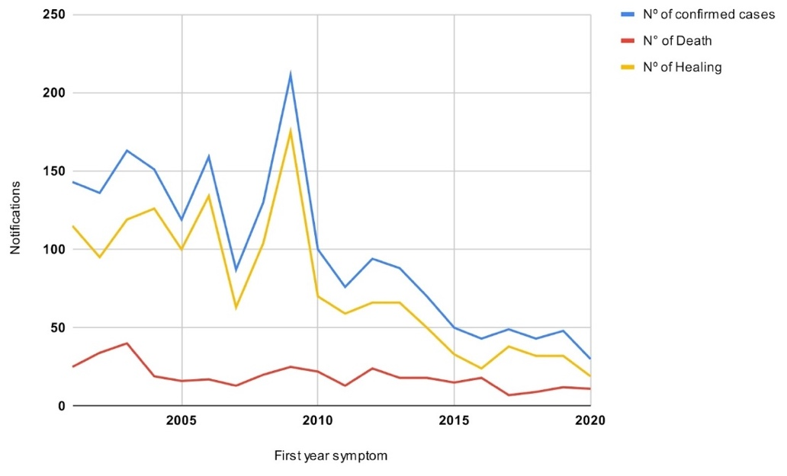

**Source**: Data from SINAN/SUS.

In order to assess the extent of the impact of the MeCV insertion on the epidemiological scenario from 2001 to 2020, we used a dimensionless Pearson correlation analysis (Figure 2).

***Figure 2***. Number of meningitis notifications in children per year in the state of Maranhão, Brazil, 2001-2020.

**Legend**: Orange line connecting the points: number of confirmed cases over the years; Solid orange line: central trend line; Black dotted line: standard deviation. **Source**: Data from SINAN/SUS.

The data show that there was a statistically significant correlation between meningitis notifications and the course of the years of notification, in the state of Maranhão, being this correlation negative, due to the values ​​p <0.0001 and r = -0.8239, evidencing a phenomenon with a downward trend in the number of cases reported per year.

To better understand the data, we used Pearson's correlation test individually in the two time periods analyzed, shown in Figure 3.

***Figure 3***. Meningitis notifications per year in children in the state of Maranhão between 2001 to 2010 and 2011 to 2020.

**Legend**: Graph A corresponds to the years 2001-2010 and Graph B corresponds to the years 2011-2020. **Source**: Data from SINAN/SUS.

The calculations showed no statistically significant correlation (p = 0.7965) between notifications per year in the population before the implementation of the MeCV to the NPI, between 2001 and 2010 (Graph A). However, they demonstrated a significant relationship (with p < 0.005) between notifications after the implementation of the MeCV vaccine, between 2011 and 2020 (Graph B), with this negative correlation (r = -0.8830) indicating, statistically, a decrease in the number of notifications for meningitis in the period in question.

In order to understand the relationship between the implementation of MeCV to the national immunization calendar and the lethality of children, we collected the numbers of notifications and deaths before (2001 - 2010) and after (2011 - 2020) this milestone.

Table 1 presents the data on notifications, deaths and mortality rates, organized according to the period before and after the implementation of the MeCV in the NPI.

**Table 1.** Notifications, deaths and fatality rate of meningitis in the state of Maranhão among children aged 0 to 9 years (2001-2021).

|  |  |  |  |
| --- | --- | --- | --- |
| Period                                                                                                  Nº of Notification Nº of Deaths         % Lethality | | | |
| 2001-2010 (Before the implementation of MeCV to the  NPI) | 1399 | 231 | 16,51 % |
| 2011-2020 (After the implementation of MeCV to the  NPI) | 591 | 145 | 24,53% |

**Source**: Data from SINAN/SUS.

In contrast, the lethality rate for the disease in the population before the addition of MeCV to the NPI (2001 - 2010) was 16.51%, while in the population after the addition of MeCV to the NPI it was 24.53%, highlighting the need for greater clarity on the subject.

In order to better elucidate the impact of the implementation of MeCV on the vaccination schedule, in relation to notifications of meningitis by N. meningitidis, we filtered the meningitis data whose etiological agent corresponds to meningococcus and applied the Pearson correlation test (Figure 4).

***Figure 4***. Number of notifications of meningococcal meningitis (MM), meningococcemia (MCC), and meningococcal meningitis with meningococcemia (MM+MCC) per year in Maranhão state, Brazil, among children aged 0–9 years (2001–2021).

**Source**: Data from SINAN/SUS.

We identified 313 reports of meningitis whose etiological agent was meningococcus. It is worth noting that this finding corresponds to 15.73% of the reports of meningitis, in general, between 2001-2020. Among this group, there are 84.66% (n. 265) reports in the period 2001-2010 and 15.34% (n. 48) in the period 2011-2020, after the increase of MeCV to NPI.

The statistical analysis of the data reported indicates a decreasing pattern in the reports of MM, MCC, MM+MCC, presenting a significant Pearson coefficient (p<0.0001) and with r = -0.8879, which demonstrates a negative correlation, and, therefore, a decreasing number of reports over the years.

In addition, we sought to identify the epidemiological profile of children in the state of Maranhão who were notified by meningitis in the period between 2001 and 2021. Figure 5 shows the prevalence by age.

***Figure 5***. Notifications of meningitis by age group, in children in the state of Maranhão, Brazil (2001-2021).

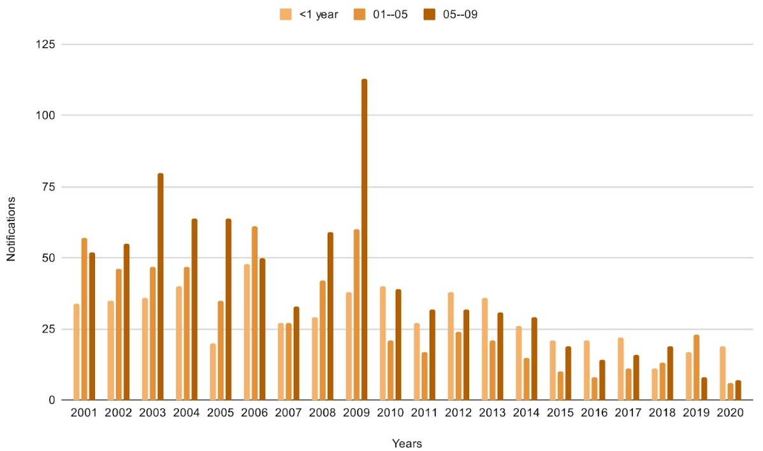

**Legend**: Graph A shows the cases reported between 2001 and 2010 and Graph B shows the cases reported between 2011 and 2020. **Source**: Data from SINAN/SUS.

In terms of absolute values, the age group from 5 to 9 years old was the most prevalent in the reporting of meningitis cases (40.96%; n. 816). However, when evaluating the period after the implementation of the vaccine, a significant reduction in the reported cases of meningitis in the age group from 5 to 9 years old was evident, from 43.53% (n. 609) in 2001-2010 to 34.9% (n. 207) from 2011-2020.

In the period after the implementation of the vaccine, children under 1 year old were the most notified, with 40.13% (n. 238) of the notifications. However, when analyzing the entire period under study (2001-2020), it is evident that the number of notifications in this age group did not fluctuate much, despite the reduction after the implementation of the MeCV.

Furthermore, the majority of reported cases throughout the study period were in male children, with 1,217 cases (61%). However, when evaluating the time periods separately, a higher number of reports of female children (546 (62.36%) was observed from 2001 to 2010, and a higher number of reports of male children (361 (61.08%) from 2011 to 2020).

To better elucidate the panorama of meningitis among children in the state of Maranhão, before and after the implementation of the MeCV to the NPI, data were sought on the number of hospitalizations due to meningitis.

***Figure 6.*** Number of hospitalizations for bacterial meningitis in children, by year of processing, in the state of Maranhão, Brazil (2001-2020).

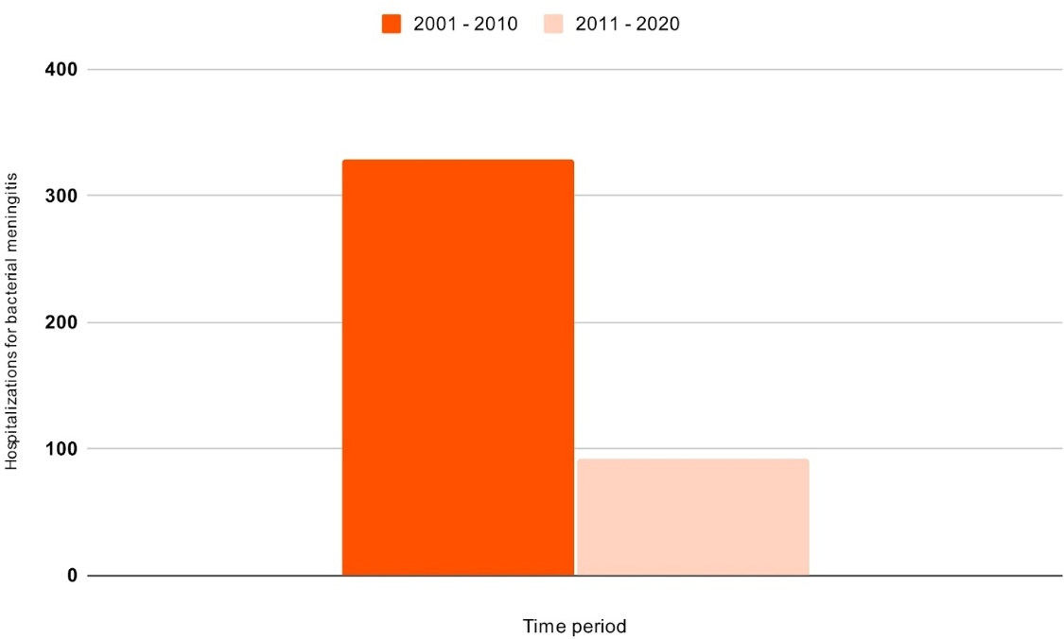

**Source**: Data from SIH/SUS.

The period before the implementation of MeCV (2001-2010) stood out for presenting 329 hospitalizations, while the period after the implementation of MeCV (2011-2020) presented 92 hospitalizations. In both periods analyzed, a statistically significant correlation was observed between the number of hospitalizations and the time period (p < 0.0001 in 2001-2010; p < 0.001 in 2011-2020), indicating that the relationship between these two variables is unlikely to be due to chance alone.

4. discussion

Around the world, different countries have demonstrated recognition of the need for and effectiveness of the Meningococcal C Vaccine (MeCV), as it has been introduced into different vaccination schedules over the years, such as in Portugal and Spain in 2001, Belgium and Canada in 2002, Australia in 2003, Germany in 2006, and France in 2010 (Ali, Jafri, Messonnier, Tevi-Benissan, Durrheim, Escola, et al 2014).

In Brazil, MeCV was introduced into the Brazilian vaccination schedule in 2010, due to the high incidence of the disease in children, as a consequence of the increased circulation of serogroup C of the meningococcus (Brazil, 2017). Currently, vaccination is the best way to prevent meningitis, but the disease is still responsible for thousands of deaths annually in Brazil and one of the factors involved in this reality is the country's low social development index, such as a shortage of prophylaxis, treatments, and information (Andrade & Lopes, 2021).

In our research, we observed a downward trend in the number of meningitis notifications in Maranhão-Brazil, between 2001 and 2020, especially between 2011 and 2020, the period after the inclusion of the meningococcal C vaccine in the vaccination schedule. This fact may also be related to the inclusion of other vaccines in the NPI, which influence the prophylaxis of meningitis, such as: BCG vaccines (against tuberculous meningitis), Pentavalent (diphtheria, tetanus, pertussis, hepatitis B and Haemophilus influenzae type B) and Pneumococcal 10-valent (conjugated) (Carneiro, Camapum, Araújo, Faria, Oliveira, Silva, et al, 2025).

One of the main etiological agents of meningitis in Brazilian children, especially in those under 1 year of age, is the bacterium N. meningitidis. This disease is closely linked to high lethality and serious consequences in childhood, such as impaired neurodevelopment, in addition to high costs to health services due to the greater demand for multidisciplinary and longitudinal monitoring (Brasil, 2024a; Snoek, Gonçalves, Horváth-Puhó, et al, 2022).

After the introduction of the vaccine, there was a reduction in the incidence rate of meningococcal disease from 1.5 (between 2007-2010) to 0.4 cases/100,000 inhabitants (2017-2020) (Brazil, 2024c). In line with this, our findings revealed a consistent downward trend in the number of meningitis notifications after the insertion of the Meningococcal C Vaccine, in 2010, in the vaccination schedule for children in the state of Maranhão. There was a reduction in the number of notifications from 265 cases reported between 2001 and 2010 to 48 cases of meningococcal meningitis, meningococcemia and both associated after the insertion of the MeCV (2011 to 2020), suggesting the efficacy and importance of prophylaxis against Neisseria meningitidis meningitis in the state.

Silva, Neto, Lopes, Cardoso, Carvalho, Lobo, et al (2024) analyzed the costs, deaths, and hospitalizations due to meningitis (viral and bacterial) in Brazil between 2008 and 2018 and, in their results, highlighted meningococcal disease as the greatest cause of victims and public spending, even though it has a lower occurrence rate when compared to viral meningitis.

Based on the data presented in our research, we can identify a significant reduction in the number of hospitalizations due to meningitis in children up to 9 years old in the state of Maranhão, decreasing from 329 (between 2001 and 2010) to 92 (between 2011 and 2020). Therefore, even with the reduction in the number of hospitalizations over the period analyzed, investment in prophylactic actions for meningococcal disease is essential, since it has a high lethality and high cost demand.

In a comprehensive study that proposed to carry out an epidemiological analysis of meningococcal disease in different regions of the world associated with the application of vaccines against Meningococcus, Brazil stood out as one of the 3 countries in South America with the highest incidence of the disease. The results also showed that in Central and South America there is a tendency for the incidence of meningococcal disease to decrease over the years in the region, with a higher prevalence of infection being observed in children under 1 year of age (Parikh, Campbell, Bettinger, Harrison, Marshall, Martinon-Torres, et al, 2020).

However, even after the introduction of MeCV, we observed that the lethality rate did not follow the same regression pattern. In the period prior to the inclusion of MeCV in the vaccination schedule, the lethality rate corresponded to 16.51% and, after this action, the lethality rate corresponded to 24.53%, raising gaps on the subject.

Other studies carried out in Brazil also point to the persistence of high lethality even after the introduction of MeCV. The researchers reinforce the continuous need for research to provide relevant data for the development of preventive policies, including vaccination campaigns and improvements in health infrastructure and training of health professionals (Santos, Saraiva & Lopes, 2024; Fontes, Silva, Araújo, Silva, Martins, Soares, et al, 2019; Rodrigues & Milagres, 2015).

In this context, the research carried out by Santos, Borges, Paiva, Quirino, Ferreira & Kusma (2021) identified a higher number of deaths from meningitis in children under one year of age, followed by the age group of 1 to 4 years, in which bacterial meningitis, especially meningococcemia, was the main cause of death. It is worth noting that, in children under 1 year of age, not only is the lethality higher, but sequelae can also occur in 1 in 5 survivors (Meningitis scenario shows an increase in the fatality rate, 2021).

Santos, Saraiva & Lopes, (2024) identified infants under one year of age as the most affected by meningitis. In our research, we also identified the age group of children under one year of age as prevalent in notifications of meningitis in children aged 0 to 9 years in Maranhão, Brazil, after the period of inclusion of the MeCV in the NPI. It is worth noting that the MeCV made available by the Brazilian Unified Health System is intended for children aged 3, 5 and 12 months, and is applied up to a maximum of 5 years. The MeCV vaccination coverage fluctuated between 2010 and 2019 in the state of Maranhão, with the years 2019 to 2022 being the consecutive period of lowest vaccination coverage.

From March 2019 to December 2020, Silva, Brandão, Vieira, Maciel, Silva, Luvisaro, Menezes, & Matozinhos (2022) evaluated the impact of the pandemic on the application of MeCV in Brazil. Their findings showed a significant reduction in vaccination coverage against meningococcus serogroup C in the country, as well as Nascimento, Silva, Soares, Souza, Souza, & Fachin (2023) and Procianoy, Junior, Lied, Jung, & Souza (2022). However, in the research by Silva et al (2022), it was possible to identify that the pandemic did not negatively influence vaccination in the northeastern region of Brazil, especially in the state of Maranhão. Corroborating the aforementioned study, the data listed in our research did not demonstrate any significant increase in notifications of meningococcal disease in children in the state.

During the entire period analyzed by this research, the data collected show a higher occurrence of meningitis in male children with 61.17%. This finding is similar to the pattern identified in other studies (Rogério, Camargo, Menegali & Silva, 2011; Dazzi, Zatti, & Baldissera, 2014; Souza, Costa, Paim, Natividade, Pereira, Andrade & Teixeira, 2012; Rodrigues & Milagres, 2015). The pattern by gender differs from the research by Silva HCG & Mezarobba N (2018), which identified the female gender as prevalent.

5. Conclusion

This study shows a reduction in the incidence of meningitis in children in the state of Maranhão, Brazil, after the implementation of the meningococcal C vaccine in the country's vaccination schedule, especially regarding meningococcal meningitis and meningococcemia. After analyzing the data, it was concluded that the child population profile in the state of Maranhão with the highest incidence of meningitis occurred in male children, with a change in the prevalent age range from children between 5 and 9 years old, before the inclusion of MeCV in the vaccination schedule, to children under 1 year old after this milestone. It is worth mentioning that the study carried out in this article was carried out using notification data available in the public domain, which limits inferences regarding the sample analyzed, in addition to the possibility of underreporting in different areas of the state, therefore, the limitations of this study are in charge of the secondary character of the data collected through the SUS Department of Informatics, which conditions the inferences performed here to the database reliability with the locoregional reality. Finally, more studies on the topic of meningitis should be carried out so that the implications of vaccination in the state of Maranhão can be better understood, such as the increase in lethality after the implementation of MeCV, which will allow the development of more effective prophylactic and therapeutic measures to mitigate this infection that continues to plague the region.

**COMPETING INTERESTS DISCLAIMER:**

Authors have declared that they have no known competing financial interests OR non-financial interests OR personal relationships that could have appeared to influence the work reported in this paper.

Author(s) hereby declare that NO generative AI technologies such as Large Language Models (ChatGPT, COPILOT, etc.) and text-to-image generators have been used during the writing or editing of this manuscript.

References

Brazil. (2024a). Ministry of Health. Secretariat of Health and Environmental Surveillance. Department of Strategic Actions in Epidemiology and Surveillance in Health and the Environment. Health Surveillance Guide, 1(6). <https://www.gov.br/saude/pt-br/centrais-de-conteudo/publicacoes/svsa/vigilancia/guia-de-vigilancia-em-saude-volume-1-6a-edicao/view>

Viñoles, F. J. C., Patricia, P., Montaño, P., & Burgos, L. M. de. (2017). Waterhouse Friderichsen syndrome secondary to fulminant meningococcemia. Med Interna (Caracas), 33(1), 51–53. <https://fi-admin.bvsalud.org/document/view/zn6dj>

Silva, V. T. de O., Mundim, R. R., Freitas, K. C. A. de, Lima, S. C. S., Castro, L. R. X. de, Pereira, M. G., et al. (2023). Meningococcemia: From diagnosis to treatment – A case study. Review of the Brazilian Health Journal, 6(6), 29706–29717. <https://doi.org/10.34119/bjhrv6n6-240>

Beek, D. van de, Cabellos, C., Dzupova, O., Esposito, S., Klein, M., Kloek, A. T., et al. (2016). ESCMID guideline: Diagnosis and treatment of acute bacterial meningitis. Microbiology and Clinical Infection, 22(3), S37–S62. <https://doi.org/10.1016/j.cmi.2016.01.007>

Snoek, L., Gonçalves, B. P., Horváth-Puhó, E., Kassel, M. N. van, Procter, S. R., Søgaard, K. K., et al. (2022). Short-term and long-term risk of mortality and neurodevelopmental impairments after bacterial meningitis during infancy in children in Denmark and the Netherlands: A nationwide matched cohort study. The Lancet Child & Adolescent Health, 6(9), 633–642. <https://doi.org/10.1016/S2352-4642(22)00155-9>

Mohanty, S., Kostenniemi, U. J., Silfverdal, S. A., Salomonsson, S., Iovino, F., Sarpong, E. M., et al. (2024). Increased risk of long-term disabilities following childhood bacterial meningitis in Sweden. JAMA Network Open, 7(1), e2352402. <https://doi.org/10.1001/jamanetworkopen.2023.52402>

Raysoni, A. U. (2022). Meningococcal Meningitis in Sub-Saharan Africa: A Review. International Journal of TROPICAL DISEASE & Health 43(9): 1-9. <https://doi.org/10.9734/IJTDH/2022/v43i930610>

Andrade, C. D. R., & Lopes, G. A. H. (2021). Brazil Republic: A history of outbreaks, pandemics and epidemics. Conjuncture Bulletin (BOCA), 5(14), 70–92. <https://revista.ioles.com.br/boca/index.php/revista/article/view/242>

Roteli-Martins, C. M., Neves, N. A., Magno, V. A., & Kfouri, R. (2022). Vaccination for meningococcal disease. RBGO Gynecology & Obstetrics, 44(9), 901–906. <https://doi.org/10.1055/s-0042-1757755>

Brazil. (2024b). National Technical Vaccination Calendar. (n.d.). Ministry of Health. <https://www.gov.br/saude/pt-br/vaccination/technical-calendar>

Brazil. (2024c). Epidemiological Situation. Retrieved October 20, 2024, from <https://www.gov.br/saude/pt-br/assuntos/saude-de-a-a-z/m/meningite/situacao-epidemiologica>

Rodrigues, E. de M. B., & Milagres, B. S. (2015). Meningitis: Epidemiological profile of the disease in Brazil from 2007 to 2013. Faculty of Education and Health Sciences, University Center of Brasília. <https://repositorio.uniceub.br/jspui/handle/235/6853>

Santos, M. K. L., Saraiva, M. P., & Lopes, N. C. (2024). Analysis of the clinical and epidemiological profile of meningitis in Maranhão from 2018 to 2023. Multidisciplinary Journal of Health. <https://doi.org/10.51161/epidemion2024/33313>

Ali, A., Jafri, R. Z., Messonnier, N., Tevi-Benissan, C., Durrheim, D., Escola, J., et al. (2014). Global practices of meningococcal vaccine use and impact on invasive disease. Health Pathog Glob, 108(1), 11–20. <https://doi.org/10.1179/2047773214Y.0000000126>

Brazil, Ministry of Health. (2017). Health Surveillance Guide. Brasilia: Ministry of Health. <https://bvsms.saude.gov.br/bvs/publicacoes/guia_vigilancia_saude_volume_1.pdf>

Carneiro, A. J. S. G., Camapum, L. F. C., Araújo, E. M. C. de, Faria, F. de S., Oliveira, G. C., Silva, J. H. C., et al. (2025). Incidence of meningitis in the state of Maranhão x pediatric immunization: An epidemiological analysis in the period from 2010 to 2024. Contributions to Social Sciences, 18(4), e16878. <https://doi.org/10.55905/revconv.18n.4-103>

Silva, A. dos R., Netto, J. S. C., Lopes, F. F. L., Cardoso, A. C. O., Carvalho, L. de A. O., Lobo, M. C. C., et al. (2024). Bacterial and viral meningitis: Data on cost, deaths, hospitalizations and internet searches in Brazil. Dialogues & Science Journal, 3(2). <https://doi.org/10.7447/1678-0493.2024v3n2p34-43>

Parikh, S. R., Campbell, H., Bettinger, J. A., Harrison, L. H., Marshall, H. S., Martinon-Torres, F., et al. (2020). The everchanging epidemiology of meningococcal disease worldwide and the potential for prevention through vaccination. The Journal of Infection, 81(4), 483–498. <https://doi.org/10.1016/j.jinf.2020.05.079>

Fontes, F. L. de L., Silva, N. D., Araújo, L. V., Silva, N. K. B. da, Martins, G. S., Soares, J. C., et al. (2019). Meningitis in a state in Northeast Brazil: Description of epidemiological characteristics over a period of 11 years. Electronic Magazine Health Collection, 25, e628. <https://doi.org/10.25248/reas.e628.2019>

Santos, J. C., Borges, K. N. G., Paiva, B. G., Quirino, H. V., & Ferreira, A. L. C. C. A. (2021). Childhood meningitis: an analysis of hospital hospitalizations in Brazil. Scientific Journal of the Goiás State School of Public Health “Cândido Santiago”, 7, E7000030.

The meningitis scenario is one of increasing lethality rate. (2021). PfizerPro.com.br. Retrieved June 7, 2025, from <https://www.pfizerpro.com.br/centro-de-atualizacao/para-ler/artigos/pediatria/cenario-das-meningites-e-de-aumento-na-taxa-de-letalidade>

Rodrigues da Silva, T. P., Brandão, L. G. V. A., Rodrigues Vieira, E. W., Santos Maciel, T. B., Ribeiro da Silva, T. M., Luvisaro, B. M. O., et al. (2022). Impact of COVID‑19 pandemic on vaccination against meningococcal C infection in Brazil. Vaccine X, 10, 100156. <https://doi.org/10.1016/j.jvacx.2022.100156> (**PMID 35340279**)

Nascimento, D. C. do, Silva, E. N. da, Soares, S. D. L., Souza, M. A. T. V. de, Souza, L. G. A. de, & Fachin, L. P. (2023). Meningococcal meningitis C: Evaluation of the incidence of the disease in the pediatric age group in Northeast Brazil after the introduction of the meningococcal C conjugate vaccine by the National Immunization Program of the Unified Health System. Brazilian Journal of Development, 9(8), 25194–25206. <https://doi.org/10.34117/bjdv9n8-131>

Procianoy, G. S., Junior, F. R., Lied, A. F., Jung, L. F. P. P., & Souza, M. C. S. C. de. (2022). Impact of the COVID-19 pandemic on the vaccination of children 12 months of age and under: An ecological study. Science & Public Health, 27(3), 969–978. <https://doi.org/10.1590/1413-81232022273.20082021>

Rogerio, L. P., Camargo, R. P. M., Menegali, T. T., & Silva, R. M. da. (2011). Epidemiological profile of meningitis in the South of Santa Catarina between 1994 and 2009. Rev Bras Clin Med, 9(3), 200–203. <https://www.researchgate.net/publication/270748836>

Dazzi, M. C., Zatti, C. A., & Baldissera, R. (2014). Profile of meningitis cases occurring in Brazil from 2009 to 2012. Uningá Review, 19(3). <https://revista.uninga.br/uningareviews/article/view/1545>

Souza, S. F. de, Costa, M. da C. N., Paim, J. S., Natividade, M. S. da, Pereira, S. M., Andrade, A. M. de S., & Teixeira, M. G. (2012). Bacterial meningitis and living conditions. Journal of the Brazilian Society of Tropical Medicine, 45(3), 323–328. <https://doi.org/10.1590/s0037-86822012000300009>

Silva, Helena, & Mezzaroba, Naiara. (2018). Meningitis in Brazil in 2015: The current overview. Santa Catarina Medicine Archives, 47, 34–46. <https://doi.org/10.63845/bvt0cr52>