Antibiotic sensitivity profiling of subclinical mastitis affected sheep and goat in organized farms of Tamil Nadu

Abstract:
Mastitis is an inflammation of the mammary gland or udder. A total of 267 numbers suspected milk samples were collected recently kidded female sheep and goats, aged 3 to 4 years, maintained in organized farms across Tamil Nadu during the period from 2021 to 2024. The suspected animals were clinically examined and showed sudden swelling in both quarter of udder and unable to feed kids and some of them are hyperthermia and anorectic. Clinical examination revealed that the mammary gland as hard, swollen, and reddish in colour, milk secretions are watery and yellowish in colour in some goats, no clinical symptoms. The body temperature remained elevated, and the animals appeared dull and depressed. Some of them also showed signs of diarrhoea and metritis. The BHI, Mac Conkey, SDA, Hichrome agar, EMP agar were used for isolation of different types of bacteria. The ABST was performed with Muller Hinton agar and the affected animal milk sample showed resistance against erythromycin, ampicillin, amoxycillin and sensitive towards ciprofloxacin, ceftriazone chloramphenicol and cefotaxime, gentamicin, enrofloxacin and gatifloxacin in ABST in case of staphylococcus. The streptococcus showed sensitivity towards ciprofloxacin, gentamicin, enrofloxacin and chloramphenicol, resistance towards cefotaxime, oxytetracycline, sulphadiazine, ceftriazone
Key words: Mastitis, goat, isolation, ABST, control of mastitis
Introduction
Mastitis is common in both dairy and meat breeds of goats raised under an intensive rearing system. It is often associated with infections caused by viruses, bacteria, mycoplasma, fungi, and their toxins. The stressful condition like high temperature, environmental changes, sudden changes of diet, malnutrition and unhygienic maintenance are predisposing factor for mastitis. Staphylococcus aureus, Streptococcus agalactiae, Streptococcus dysagalactiae, Escherichia coli, Pseudomonas are the common bacteria causing mastitis in goat and caprine arthritis encephalitis virus causing mastitis in goat and some of the yeast infection also causes mastitis due to the frequent use of penicillin along with the prolonged and repetitive use of systemic and intra-mammary infusions of antibiotics.
The annual incidence of clinical mastitis in small ruminants is generally lower than 5%, but it can increase sporadically. The prevalence of subclinical mastitis has been estimated at 5–30% (Bergonier and Berthelot, 2003, Contreras et.al., 2003), but there are only limited data available about incidence of intramammary infection (IMI) of goat and sheep in the literature. Giadinis et.al., (2012) reported that mammary infections are the primary cause of 85% of milk-drop syndrome cases in ewes. This syndrome is defined as a pathological condition at the flock level, characterised by a reduced milk yield in lactating ewes without any clinical signs specific to a particular disease.
In dairy-type sheep and goat flocks, mammary infections have important due to the reduction in milk yield, the downgrading of milk quality and the rejection of milk after antibiotic administration. Mammary infections are also important in meat production flocks, as reduced milk yield in ewes has been shown to cause suboptimal growth of their lambs (Fthenakis and Jones, 1990a). Additional costs associated with the disease include expenses for replacement ewes and veterinary care. In case of sheep, mammary infections are also of great welfare concern clinical mastitis is a disease that leads to anxiety, restlessness, changes in feeding behaviour and pain in affected animals (Fthenakis and Jones, 1990b).
Materials and method:
The milk samples (n=267 sheep -100 and goat -167) were collected from suspected animals in sterile container from the period of 2021-2024 (fig 1). The BHI, Mac Conkey, SDA, Hichrome agar, EMP agar were used for isolation of different types of microorganism present in milk and both cultural isolation and identification, catalase oxidase test, biochemical test and The antibiotic sensitivity patterns were performed with 15 different types of antibiotics by disc diffusion method by disc diffusion method using Muller Hinton agar with the isolated organism (fig.2,3,4,5,6,7,8) The isolated bacteria were biochemically characterized and confirmed by gram’s staining ( Fig. 5,6 ) and PCR by using specific primers.
Results and discussion:
The organisms as identified based on colony morphology and biochemical character. Some of the milk sample showed metallic shine colony and gram staining showed gram negative rods, E.coli (n=67) and some sample showed Staphylococcus (n=24) few of them showed Streptococcus (n=12), Pseudomonas (n=8), Klebsiella (n=18), Candida species(n=22) and Aspergillus (n=4) ( table 1 and Fig 2,7,8) and the over all percentage of above mentioned organism is 20% in case of sheep and 80% in case of goat
The affected animal milk sample showed resistance against erythromycin, ampicillin, amoxycillin and sensitive towards ciprofloxacin, ceftriazone chloramphenicol and cefotaxime, gentamicin, enrofloxacin, doxycycline and gatifloxacin in antibiotic sensitivity test in case of staphylococcus. (Fig 2,3). The streptococcus showed sensitivity towards ciprofloxacin, gentamicin, enrofloxacin and chloramphenicol, resistance towards cefotaxime, oxytetracycine, sulphadiazine, ceftriazone. The isolated Pseudomonas showed sensitivity towards sulphadiazine, ceftriazone, ciprofloxacin, gentamicin, enrofloxacin and Klebsiella showed sensitivity towards chloramphenicol, gentamicin, erythromycin, gatifloxacin, enrofloxacin and resistance towards sulphadiazine, cefotaxime, ceftriazone (table .2)
The clinically affected animals were treated with antibiotic and anti-inflammatory. The treatment for mastitis based on the results of the microbiologic culture obtained from milk samples. Dry off the affected gland and application of intramammary infusion of 2 percent chlorhexidine solution into affected udder twice at 24-hour intervals. Drugs should be administered for a period of 5 to 10 days to allow efficacy of the product. The use of antibiotics or corticosteroids are recommended in some cases. Antibiotics always selected based on antibiotic sensitivity test results. Treatment during the dry-off period is an efficient method for the cure of subclinical mastitis and for control of somatic cell counting.
Mastitis is an inflammation of the mammary gland causes a chemical and physical reaction in milk produced by sheep and goats. Mastitis more common in dairy and meat goats raised under intensive and semi-intensive system of rearing and causes economic loss to the sheep and goat farmers. The mastitis in sheep and goat was generally associated with poor management practices and injuries of mammary tissue or teats due to traumas, nursing, fly bites or other wounds to the mammary gland that provide an important barrier to infection. Some of the stressful conditions such as extreme temperatures, muddy and wet living conditions or a sudden change in diet, poor nutrition and pregnancy stress leads to immune deficiency and has a difficult time fighting off the invasion of foreign bodies that cause diseases like mastitis. Another important predisposing factor is the abnormal anatomy of the udder or teat. Mostly the infection occurs when infectious agents reach the mammary gland. The infectious microbes enters through the milk canal and interacts with the mammary tissue cells and multiplies and produce infection and some of the microbial microorganisms release toxins leads to systemic infection. The mammary tissue reacts to these toxins leads to inflammation of udder. The Coagulase-negative staphylococci species like Staphylococcus aureus, Streptococcus agalactiae, S. uberi, S. dysgalactia, and S. caprae Mycoplasma capricolu, Enterobacteria such as Escherichia coli coliforms, Pseudomonas aeruginosa, and Clostridium spp. are the most common causes of mastitis in sheep and goat. The virus like caprine arthritis-encephalitis virus (CAEV) causes mastitis in goats. The mastitis can also cause by yeast and mold infection mainly associated with the frequent use of penicillin along with the prolonged and repetitive use of systemic and intra-mammary infusions which predispose the fungal mastitis. The acute systemic form of mastitis shows elevated body temperature above 105° F and an accelerated pulse and the affected animals were depressed and lose its appetite. Clinical examination of the mammary gland revealed hardness, swelling, redness, and it was hot and sensitive to touch. Milk secretions appeared watery and yellowish, often containing flakes and clots. In most severe form of mastitis causes death in some animals. The chronic form of mastitis occurs as a persistent and incurable infection. Hussain et al.,( 2019) found that the milk proteins present in all of the milking fractions from quarters with subclinical mastitis undergo high changes and quarters with sub clinical mastitis revealed higher immunoglobulins and lower lactalbumin when compared with healthy cow and the increased proportion of immunoglobulins is due to inflammatory responses of the udder compensated for the significantly lower proportion of lactalbumin.
The udder may have hard lumps as a result of bacteria forming colonies and reactions occurring in the mammary tissues. In chronically affected animals shows agalactia and sometimes reduced milk production. The subclinical mastitis causes the most concern among producers and veterinarians because there are no visible signs of the disease. There is no swelling of the udder or detectable abnormalities in the milk to indicate the presence of mastitis. but sub-clinical form can eventually develop into the chronic clinical form of mastitis. The diagnosis based on signs and history of the herd, microbiologic milk culture, a somatic cell count (SCC) or an Enzyme-Linked Immuno Sorbent Assay (ELISA). However, the microbiological culture is the most reliable source of diagnosis of mastitis in sheep and goats. The SCC and the California Mastitis Test (CMT) are the most common tests used to diagnose mastitis in dairy goats. Misra et al., (2018) reported that the prevalence of SCM in Barbari and Jamunapari goats was found as 24.21% (23/95) and 15.12 % (13/86), respectively. In Barbari goats, the prevalence varied from 16.26% to 34.28% whereas in Jamunapari goats, it varied from 8.6% to 24.6% .
Some of the antibiotics like benzylpenicillin, cloxacillin, amoxicillin plus clavulanic acid and cefotriazone, erythromycin, thymosin, kanamycin, penicillin, ampicillin, erythromycin, or tetracycline have been recommended to treat mastitis but the cure rates may vary from animal to animal and according to the severity of the case. After treating goats with antibiotics, it is necessary to withdraw drug treatment to prevent antibiotics from building up in the milk and meat that can be hazardous to humans. Glucocorticoids can be administered early in the course of disease and administration of dexamethasone in the mammary gland has been reported to reduce swelling of udder. In addition, intramammary infusion with mastilip ointments used to treat mastitis among dairy cows is effective among sheep and goats as well. Strict hygienic practice in indoor sheep and goat farms will prevent subclinical mastitis. Patel et al 2024) found that the most effective therapeutic response for subclinical Staphylococcal mastitis in goats was produced by Ceftizoxime followed by Enrofloxacin and the least with Oxytetracycline and the overall milk production of goat were observed to increase during the study period and they found that the effective treatment protocol enhancing the udder health and the milk quality. However, observe tissue irritation after administration intramammary antibiotics.
Conclusion
In this study, most cases of mastitis in small ruminants were caused by Escherichia coli, Staphylococcus, Klebsiella, and Candida species. Antibiotic sensitivity testing showed that these pathogens were sensitive to gentamicin, erythromycin, gatifloxacin, and enrofloxacin, but resistant to oxytetracycline, cefotaxime, ceftriaxone, and sulphadiazine. However, a more in-depth study is needed to thoroughly analyze antibiotic resistance patterns.
Disclaimer (Artificial intelligence)
Hereby I declare that NO generative AI technologies such as Large Language Models
(ChatGPT, COPILOT, etc.) and text-to-image generators have been used during the writing or editing of this manuscript.
References
- Berri, M., Rousset, E., Champion, J. L., Russo, P., and Rodolakis, A. (2007, August). Goats may experience reproductive failures and shed coxiella burnetii at two successive parturitions after a Q fever infection. Research in Veterinary Science. 83(1), 47-52.
- Brouillette, E., Grondin, G., Lefebvre, C., Talbot, B. G., and Malouin, F. (2004, August). Mouse mastitis model of infection for antimicrobial compound efficacy studies against intracellular and extracellular forms of staphylococcus aureus. Veterinary Microbiology, 101(4), 253-262.
- Chávez González, Y. R., Ros Bascuñana. C., Bölske, G., Mattsson, J. G., Fernández Molina, C., and Johansson, K. E. (1995, November). In vitro amplification of the 16S rRNA genes Mycoplasma bovis and Mycoplasma agalactiae by PCR. Veterinary Microbiology. 47(1-2), 183-190
- Hötzel, I., and Cheevers, W. P. (2001, August). Host range of small-ruminant lentivirus cytopathic variants determined with a selectable caprine arthritis-encephalitis virus pseudotype system. Journal of Virology, 75(16), 7384-7391.
- Hussein, M. A. (2019). Subclinical Mastitis Survey on Milk Composition in Dairy Sheep in Kurdistan Region of Iraq. Asian Journal of Advances in Agricultural Research, 11(4), 1–7. https://doi.org/10.9734/ajaar/2019/v11i430058
- Karzis, J., Donkin, E. F., and Petzer, I. M. (2007, June). The influence of intramammary antibiotic treatment, presence of bacteria, stage of lactation and parity in dairy goats as measured by the California Milk Cell Test and somatic cell counts. Onderstepoort Journal of Veterinary Research, 74(2), 161-167.
- Kyozaire, J. K., Veary, C. M., Petzer, I. M., and Donkin, E. F. (2005, June). Microbiological quality of goat's milk obtained under different production systems. Journal of the South African Veterinary Association, 76(2), 69-73.
- Merck & Company, Incorporated. (2008). The Merck veterinary manual. New Jersey: Merck & Company, Incorporated.
- Moroni, P., Pisoni, G., Antonini, M., Ruffo, G., Carli, S., Varisco, G., and Boettcher, P. (2005). Subclinical mastitis and antimicrobial susceptibility of staphylococcus caprae and staphylococcus epidermidis isolated from two Italian goat herds. Journal of the American Dairy Science Association, 88, 1694-1704.
- Moroni, P., Vellere, F., Antonini, M., Pisoni, G., Ruffo, G., and Carli, S. (2004, June). Antibiotic susceptibility of coagulase-negative staphylococci isolated from goats' milk. International Journal of Antimicrobiological Agents, 23(6), 637-640.
- Mishra AK, Sharma N, Singh DD, Gururaj K, Abhishek, Kumar V, Sharma DK (2018) Prevalence and bacterial etiology of subclinical mastitis in goats reared in organized farms, Veterinary World, 11(1): 20-24.
- National Mastitis Council. (1990). Procedures for collecting milk samples. In Microbiological Procedures for the Diagnosis of Bovine Udder Infection (3rd ed.). Retrieved November 7, 2008.
- Poutrel B, de Crémoux R., Ducelliez M., Verneau D. (1997). Control of intramammary infections in goats: impact on somatic cell counts. Journal of Animal Science, 75(2), 566-570.
- Patel, Manoj, Devendra Kumar Gupta, Mrinal Singh, Aditya Pratap, Ajay Kumar Rai, Supnesh Jain, Nitesh Suryavanshi, Ranbir Singh Jatav, and Bhoopendra Kumar Mudiya. (2024). “Comparative Evaluation of Antibiotic Therapies for Subclinical Staphylococcal Mastitis in Goats”. Journal of Advances in Biology & Biotechnology 27 (10):1542-51.
- Schweiz, A. and Schweiz, T. (2006, December). Prevalence of subclinical udder infections and individual somatic cell counts in three dairy goat herds during a full lactation. Schweiz Arch Tierheilkd, 148(12), 641-648.
- Sela, S., Hammer-Muntz, O., Krifucks, O., Pinto, R., Weisblit, L., and Leitner, G. (2007, November). Phenotypic and genotypic characterization of Pseudomonas aeruginosa strains isolated from mastitis outbreaks in dairy herds. Journal of Dairy Research, 74(4), 425-459.

Table 1: Bacteria isolated from milk sample of suspected for mastitis and their positive percentage
S.No | Organism isolated | Sheep |  | Goat |  | Percent positivity
S.No | Organism isolated | No. of positive | Total number of sample | No. of positive | Total number of sample | Sheep | Goat
1 | Staphylococcus | 4 | 100 | 20 | 167 | 4 | 11.97
2 | E.coli | 7 | 100 | 60 | 167 | 7 | 35.92
3 | Streptococcus | 3 | 100 | 9 | 167 | 3 | 5.3
4 | Pseudomonas | - | 100 | 8 | 167 | - | 4.79
5 | Klebisella | 3 | 100 | 15 | 167 | 3 | 8.98
6 | Candida | 3 | 100 | 19 | 167 | 3 | 11.37
7 | Aspergillus | - | 100 | 4 | 167 |  | 2.39
8 | Total | 20 | 100 | 135 | 167 | 20 | 80.83
Table 2: Antibiotic sensitivity patterns for different bacterial isolates
S.No | Organism isolated | Sensitive | Resistance
1 | Staphylococcus | ciprofloxacin, ceftriazone chloramphenicol and cefotaxime, gentamicin, enrofloxacin and gatifloxacin The isolated Pseudomonas showed sensitivity towards sulphadiazine, cefriazone, ciprofloxacin, gentamici ,enrofloxacin | Erythromycin , ampicillin, amoxycillin
2 | E.coli | Ciprofloxacin , gentamicin , cefotaxime | Oxytetracycine sulphadiazine, ceftriazone, ampicillin, amoxyclav, chloramphenicol,
3 | Streptococcus | Ciprofloxacin , gentamicin enrofloxacin and chloramphenicol, | cefotaxime, oxytetracycline, sulphadiazine, ceftriazone, ampicillin, amoxyclav
4 | Pseudomonas | Sulphadiazine , ceftriazone, ciprofloxacin, gentamicin ,enrofloxacin | cefotaxime, oxytetracycline, sulphadiazine, ceftriazone, chloramphenicol, ampicillin,amoxyclav
5 | Klebisella | Chloramphenicol,gentamicin,erythromycin, gatifloxacin, enrofloxacin | Sulphadiazine , cefotaxime, ceftriazone, ampicillin,amoxyclav
6 | Candida | Ciprofloxacin , gentamicin chloramphenicol, gatifloxacin | cefataxime, oxytetracycline, sulphadiazine, cefriazone, ampicillin,amoxyclav
7 | Aspergillus | Gatifloxacin, sulphadiazine catrimazole | cefotaxime,oxytetracycine, sulphadiazine, ceftriazone, ampicillin, amoxyclav

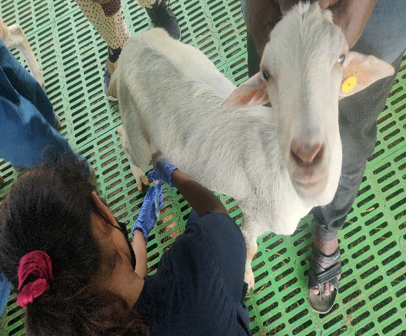  Fig 1: milk sample collection from suspected goat | 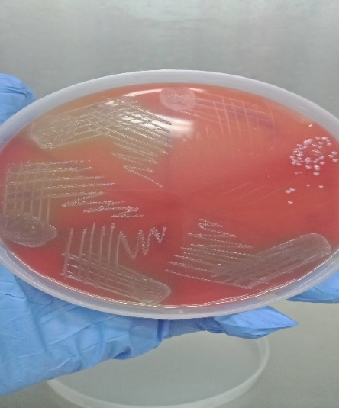  Fig 2: Isolation of Staphylococcus in blood agar
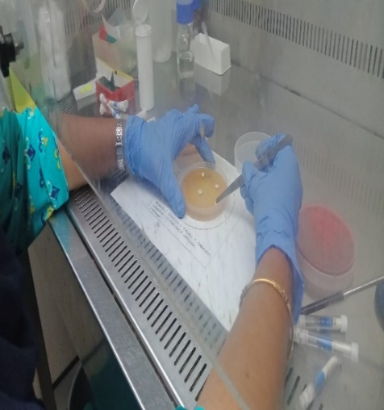  Fig 3: Antibiotic sensitivity test for isolated bacterial organism | 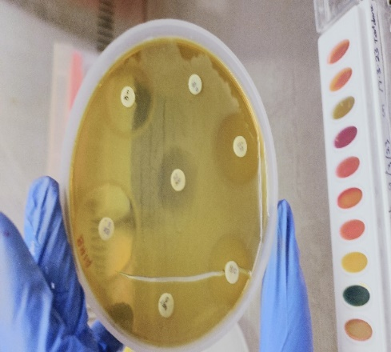  Fig 4: Analysis of antibiotic sensitivity patterns of isolated micro organism
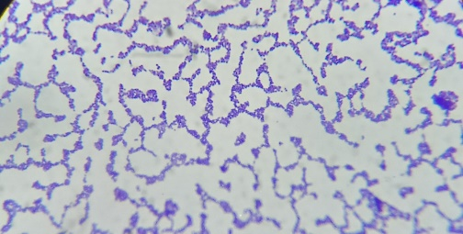  Fig 5: Gram staining of isolated organism showed Staphyloccous  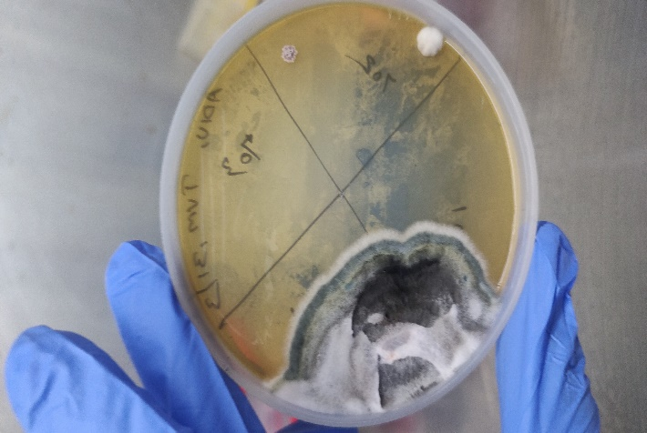  Fig 7: Isolation of Aspergillus niger from milk sample of mastitis affected goat | 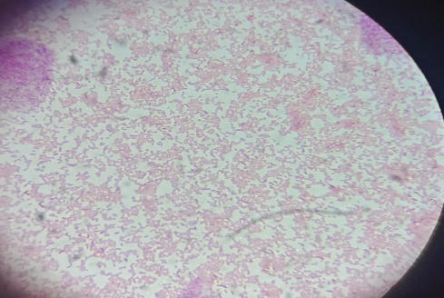  Fig 6 : Gram staining of isolated organusm shows gram negative rods E.  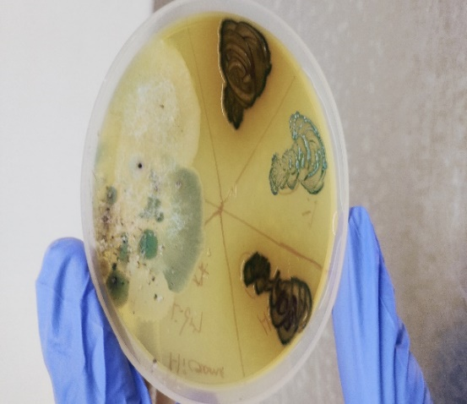  Fig 8: Isolation of Candida albicans, Candida parapsilosis, Candida tropicalis from mastitis affected goat

