**Artificial Intelligence in Remote Sensing: Advancements, Challenges, and Future Directions for Sustainable Applications**

# Abstract

This chapter explores how artificial intelligence (AI) can be incorporated into remote sensing, emphasizing how it can revolutionize a number of fields, such as agriculture, urban planning, disaster relief, and environmental monitoring. It gives a summary of how artificial intelligence (AI) methods, especially machine learning and deep learning, improve the handling, interpretation, and use of data from remote sensing. The chapter also explores the main obstacles preventing AI from being widely used in remote sensing, including issues with data accessibility, model interpretability, training complexity, and ethical considerations. It also offers a number of real-world examples that show how AI can be used to provide useful insights and facilitate data-driven decision-making. In addition to outlining future directions for research, development, and responsible implementation, this chapter provides a balanced perspective on the changing role of AI in remote sensing by addressing both the opportunities and limitations.

**Keywords:** Artificial Intelligence (AI), Remote Sensing, Machine Learning, Deep Learning Image Analysis, Environmental Monitoring

# Introduction

Remote sensing, as a field, has undergone significant advancements since its inception, moving from simple aerial photography to the current collection of high-resolution multispectral and hyperspectral data from advanced satellite constellations, unmanned aerial vehicles (UAVs), and ground-based sensors. With applications in forestry, agriculture, resource management, urban planning, climate monitoring, and agriculture, remote sensing has long offered vital insights into the physical, biological, and chemical conditions of the planet. Observing, measuring, and analyzing the earth's surface and atmospheric parameters as accurately and efficiently as possible has been the core goal of remote sensing (Dian et al., 2021; Ustin & Middleton, 2021).

But in recent years, there has been a significant change in the remote sensing scene. Rapid sensor technology development, falling satellite deployment costs, and the proliferation of Internet of Things (IoT) networks have all combined to provide a large and varied amount of geographic data. The geospatial sciences have entered what is often referred to as the "big data era" as a result of this change. Big geospatial data differs from standard datasets in that it is

characterized by high frequency (temporal resolution), heterogeneity (data kinds and formats), and high dimensionality (multispectral or hyperspectral channels) in addition to its sheer bulk. Regarding data administration, processing, and analysis, each feature poses unique difficulties (Breunig et al., 2020; Rai et al., 2022).

The use of sophisticated computing methods, especially artificial intelligence (AI), which is well-suited to manage the size and complexity of contemporary geospatial information, has been further accelerated by the emergence of big data in remote sensing. AI subfields like machine learning (ML) and, more especially, deep learning (DL) models, such as recurrent neural networks (RNNs) for temporal data and convolutional neural networks (CNNs) for spatial image analysis, have made it possible to extract valuable insights from large, frequently unstructured datasets. With a degree of precision and detail that would be difficult to get with conventional analytical techniques, these models are able to recognize and comprehend intricate spatial-temporal patterns (Roscher et al., 2023; Liang et al., 2024).

The emergence of large data in remote sensing has not only made AI adoption necessary, but it has also opened the door for the development of more sophisticated and effective AI-driven techniques. Building on this basis, the capabilities of remote sensing have been elevated to unprecedented levels by recent developments in AI algorithms, the expansion of high- resolution satellite images, and the growth of open-source platforms. These advancements have made it possible to analyze geographic data across several domains more quickly, accurately, and scalable. This chapter delves into the recent trends, applications, challenges, and future directions of AI in remote sensing during this period.

# Remote Sensing and Its Applications

Remote sensing is a technology that enables data collection without direct contact with the subject, utilizing sensors to measure or detect various types of energy, such as electromagnetic radiation and acoustic signals, emitted, reflected, or scattered by the object under investigation (Campbell & Wynne, 2011). For remote sensing, several systems and sensors have been created. The volume of remote sensing data collected has increased to astounding levels as sensors continue to improve. For instance, as of September 2021, the Earthdata Cloud included about 59 petabytes (PB) of data, according to NASA's Earth Science Data Systems (ESDS). This number is anticipated to rise to about 148 PB in 2023, 205 PB in 2024, and 250 PB in 2025, according to ESDS predictions (Earthdata, 2022).

Since remote sensing makes it possible to monitor, predict, and manage environmental, urban, agricultural, and health systems in great detail, it has become an essential tool in many different disciplines (Kaku, 2019; Wellmann et al., 2020; Arifin & Yudhatama, 2018; Segarra et al., 2020; Oerke, 2020). These apps tackle difficult problems in previously unachievable ways by fusing various data sources with cutting-edge analytical techniques. Environmental monitoring is one of the most important uses, where insights into terrestrial and aquatic ecosystems may be gained from high-resolution satellite and UAV pictures. Scientists may monitor changes in land use, animal habitats, and plant health over time by conducting ongoing observations of forests, wetlands, and marine ecosystems. By combining optical, Light Detection and Ranging (LiDAR), and SAR data, data fusion methods provide environmental analysis a multifaceted viewpoint and enable the differentiation of subtle changes like species movement, forest deterioration, and coastline erosion. Conservation initiatives, methods for adapting to climate change, and comprehension of natural processes impacted by human activity all depend on these findings (Usmani, 2024; Horak et al., 2023).

# Evolution of AI in Remote Sensing

Since its origin, remote sensing has been an enthralling journey across a variety of fields, moving beyond mapping and into environmental monitoring. However, the traditional approaches to data analysis in this field were often hampered by size and time restrictions. In this context, the emergence of AI has brought about a paradigm change by giving remote sensing unprecedented speed, accuracy, and the capacity to work with complex datasets. Fundamentally, AI gives remote sensing the benefit of automation and cognitive abilities. Under the influence of machine learning algorithms, computer programs learn to extract patterns from data so they can recognize irregularities and changes in satellite images. This ability to analyze in real time is crucial, particularly when examining dynamic events like natural disasters and human-caused activities that have a big influence on the environment.

As the number and quality of data from remote sensing platforms increase, computational platforms and efficient tools are required to manage and extract useful information from these datasets. In addition to being useful for critical tasks like noise reduction (Mohan et al., 2021), data fusion (Zhang & Zhang, 2022), object identification (Li et al., 2020), and many other significant applications, AI technologies can help manage massive quantities of observations, modeling, analysis, and environmental predictions. The importance of gathering and preserving remote sensing data is growing as AI technologies advance. Utilizing a variety of

sensors on a range of platforms, including satellites, airplanes, unmanned ground vehicles (UGVs), and unmanned aerial vehicles (UAVs) (Ghamisi et al., 2019), is necessary to collect this vast amount of data. These sensors—which include cameras, LiDAR, the Global Positioning System (GPS), and the Inertial Measurement Unit (IMU)—are crucial for detecting various forms of energy that are released, reflected, or dispersed by the objects of interest, including auditory signals and electromagnetic radiation. A thorough and in-depth examination of the Earth's surface, atmosphere, and surroundings is made possible in remote sensing by combining data from many sensors, including LiDAR, multispectral or hyperspectral imaging, and radar (Ghamisi et al., 2019). AI-powered ground and onboard processing systems take center stage in sophisticated applications, managing crucial functions like filling, scaling, filtering, and calibrating on their own (Mo et al., 2023). By seeing complex patterns and spotting irregularities, these algorithms reduce subjectivity and bias in the analysis process and enable researchers to quickly and accurately ingest, analyze, and interpret enormous volumes of remote sensing data.

# Key AI Techniques in Remote Sensing

* + 1. **Conventional Machine Learning in Remote Sensing**

Conventional machine learning techniques have been widely used by the remote sensing field for a variety of applications, including object recognition, classification, and geophysical parameter estimation. Data from multi-temporal and multi-sensor remote sensing has been successfully handled by these techniques, yielding useful information for environmental monitoring (Sun et al., 2022; Sarker, 2021; Janga et al., 2023).

The conventional machine learning methods commonly used in remote sensing include Random Forest (RF), Extreme Gradient Boosting (XGBoost), and Support Vector Machines (SVMs), which are widely applied for tasks such as classification, object detection, and geophysical parameter estimation due to their ability to handle high-dimensional, multi-sensor, and multi-temporal data effectively.

# Deep Learning in Remote Sensing

A branch of machine learning called deep learning has become a useful tool for remote sensing, solving previously unheard-of problems and opening up new possibilities for applications in remote sensing (Sun et al., 2023; Yuan et al., 2020). Hierarchical artificial neural networks are used in deep learning to find patterns in data and extract useful characteristics from big, complicated datasets. Through a process called backpropagation, the network modifies

weights and biases throughout training, improving its capacity to identify patterns and correlations as it analyzes more data. Deep learning networks progressively convert the input into representations appropriate for particular tasks including object identification, pixel-based categorization, and picture preprocessing (Zhang et al., 2016). Deep learning methods in remote sensing include techniques such as DCNNs, ResNets, YOLO, Faster R-CNN, and self- attention-based models like Transformers.

# Other AI Methods in Remote Sensing

Applications for generative adversarial networks, or GANs, in remote sensing are becoming more and more popular (Dash et al., 2023; Jozdani et al., 2022). Even with little to no labeled training data, GANs are neural networks that excel at processing complicated, high- dimensional data (Creswell et al., 2018).

Learning from unlabeled data and enhancing decision-making are two benefits of Deep Reinforcement Learning (DRL) in remote sensing. Deep neural networks and reinforcement learning (RL) approaches are combined in DRL to provide a potent framework for handling challenging issues. While deep neural networks approximate optimum policies, reinforcement learning (RL) uses an agent interacting with the environment to maximize cumulative rewards. After observing the status of the environment, the agent acts and is rewarded accordingly. With the goal of maximizing cumulative reward over time, the agent switches to a new state and modifies its policy based on the reward signal. As function approximators, deep neural networks may generalize to novel scenarios and capture intricate correlations between states and actions (Li, 2017).

Researchers and practitioners may choose the best method depending on their data and goals since each methodology has distinct advantages and is suitable for certain remote sensing activities. An outline of the main AI methods for remote sensing is given in Table 1, along with information on their benefits, drawbacks, and uses.

**Table 1 AI Models Comparison Table**

|  |  |  |  |
| --- | --- | --- | --- |
| **Technique** | **Advantages** | **Limitations** | **Applications** |
| RF | Handles multi- temporal/sensor data, provides feature  importance, reduces redundancy. | Sensitive to hyper- parameters; features may not be optimal. | Remote sensing  classification; object detection. |
| XGBoost | Differentiates subtle spectral differences;  tunable hyper-parameters; prevents overfitting. | Hyper-parameter sensitive; prone to overfitting; slower than RF. | Accurate and robust remote sensing  classification. |
| DCNNs | Learns complex hierarchical features; accurate object  recognition. | Computationally expensive; risk of  overfitting/vanishing gradients. | Image recognition, classification, object detection. |
| ResNets | Enables training deep  networks; handles noisy, high-dimensional data. | High computational resource needs for very deep models. | Image recognition and object detection. |
| YOLO | Real-time detection; efficient multi-object classification; reduces  bounding box overlaps. | Poor at detecting small objects;  requires careful anchor tuning. | Real-time object detection and  segmentation. |
| Self- Attention | Captures long-range dependencies; models spatial and spectral  relationships. | Memory intensive; requires tuning of attention  mechanisms. | Sequence modeling, image classification, time series. |
| LSTM | Captures long-term  dependencies; mitigates vanishing gradient. | Slow training on long sequences; hyper-parameter sensitive. | Sequence modeling and time series analysis. |
| GANs | Generates complex data; improves models via data augmentation. | Training instability; mode collapse;  needs careful tuning. | Image translation,  resolution enhancement, data augmentation. |
| DRL | Learns from unlabeled data; handles complex decisions; manages  redundant features. | Requires well-  designed rewards; computationally expensive. | Band selection, large- scale hyperspectral  image processing. |

# Existing Challenges of AI in Remote Sensing

This section will discuss the challenges and limitations of AI in remote sensing (Sun et al., 2022).

* ***Data Availability:*** AI training data, often sourced from satellites, aerial sensors, or ground-based instruments, is not always easily accessible due to proprietary rights or government control. This can hinder the development and application of AI in remote sensing.
* ***Training Optimization:*** Optimizing the performance of AI models requires careful consideration and mathematical understanding. Selecting suitable loss functions is crucial for improved accuracy, such as cross-entropy loss for land cover classification or mean squared error (MSE) loss for regression tasks. Imbalanced datasets can pose challenges when certain classes are rare or underrepresented, leading to bias towards the majority class.
* ***Data Quality****:* Data quality directly influences the model's performance and generalization capability. Accurate ground truth labels can be difficult due to limited observations, subjective interpretations, or human errors. Inconsistencies in spatial resolution, spectral characteristics, or temporal patterns can introduce biases and complicate the training process.
* ***Uncertainty:*** Uncertainty arises from various sources, including atmospheric conditions, sensor limitations, data acquisition techniques, and natural variability. AI models trained on static datasets may need adjustments to adapt to these dynamic variations.
* ***Model Interpretability:*** Interpretability ensures the trustworthiness and validation of AI model outputs, especially in sensitive applications like environmental monitoring or disaster response. Techniques such as model explainability, feature importance analysis, and visualization methods can help shed light on the reasoning behind the model's predictions.
* ***Integrity and Security:*** Maintaining integrity and security in remote sensing data involves prioritizing transparency, fairness, and accountability throughout the development and training processes. Protecting data integrity involves safeguarding it from unauthorized modifications, tampering, or cyberattacks, which can compromise personal privacy through detailed imagery capturing identifiable features or activities.

# Current and Future Practical AI Applications in Remote Sensing

This section examines current and prospective concepts that might enhance useful AI applications. Some of these concepts may inspire future applications that have revolutionary effects on environmental management, and workarounds for them may already be underway.

# Wildfire Detection and Management

AI is being used more and more in wildfire control (Jain et al., 2020), using remote sensing technology and sophisticated algorithms to facilitate early identification and quick reaction. By taking into account past fire data, weather trends, and topographical information, AI systems evaluate data from satellites, drones (Bouguettaya et al., 2022), and sensors to watch wildfires in real time and make precise predictions about fire behavior. This data-driven strategy lessens the negative effects of wildfires on ecosystems and communities while increasing firefighting

efficiency.

AI can handle large-scale data processing and pattern recognition, identifying hidden connections in weather and fire data. Drones with thermal imaging sensors and AI can quickly identify fires, resulting in lower costs and faster reaction times. ESA's Prometheus system forecasts wildfire behavior using satellite data and AI. A network of sensors gathers real-time data, fed into AI algorithms for analysis. Investments in technology, communication networks, and infrastructure are required to fully realize AI's promise. Benefits include reduced damages, faster reaction times, and increased firefighter safety.

# Illegal Logging and Deforestation Monitoring

AI can identify unlawful encroachments, logging practices, and changes in forest cover by examining satellite and drone footage. Deforestation may be monitored and places that need protection can be identified using this data. AI combined with satellite photography is revolutionizing deforestation monitoring by detecting changes in forest cover and illicit logging in real time. The implementation entails using cutting-edge AI algorithms and efficiently exploiting technology such as the Google Earth Engine (GEE) (Amani et al., 2020). During the pre-processing phase of an AI model, satellite imaging data on changes in forest cover is gathered from various remote sensing technology sources and then cleaned and organized. After then, the algorithms are used to examine the data and spot trends in illicit logging operations within a certain region. This aids in decision-making and eventually results in tangible steps to stop deforestation and punish illicit loggers responsible. As AI technology develops, it's expected to create even more creative and effective forest protection applications (Mujetahid et al., 2023). Global Forest Watch (GFW), which uses satellite images and sophisticated algorithms to track deforestation worldwide and notify governments, non- governmental organizations, and stakeholders, is a noteworthy illustration of this strategy.

# Coastal and Marine Ecosystem Monitoring

AI can monitor marine species, identify marine pollution, detect changes in coral reefs (Gonzalez-Rivero et al., 2020), and assist in the sustainable management of coastal resources (Figure 1) to safeguard coastal and marine ecosystems. Analyzing photos or films of marine habitats using image recognition algorithms is one prominent trend in marine research. These algorithms are useful tools for tracking changes in animal populations and identifying regions where ecological harm is being caused by human activity since they can identify creatures or items of interest. Underwater noises may also be analyzed by ML algorithms (Lou et al., 2023). It might be difficult to comprehend underwater soundscapes, but machine learning can identify

and separate certain sounds from background noise. Researchers and managers may keep an eye on shifts in ecosystem dynamics and learn a lot about how marine ecosystems have changed thanks to this capacity (Ditria et al., 2022). High-definition (HD) digital camera picture sequences taken by fixed underwater stations, autonomous underwater vehicles (AUVs), and remotely operated vehicles (ROVs) in different maritime areas may be analyzed using computer vision algorithms in marine research. By offering information on fish abundance, species composition, and quantity in various places, this technology makes it easier to identify regions where fish may be active in their natural environment.

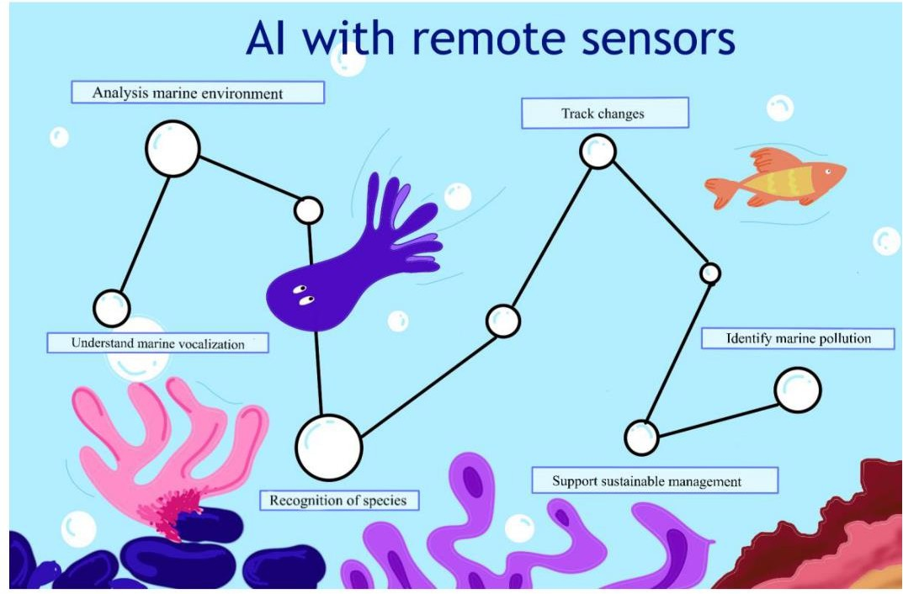

***Figure 1*** *AI with remote sensors for coastal and marine ecosystem monitoring*

# Biodiversity Conservation and Habitat Monitoring

The precision and effectiveness of biodiversity monitoring may be improved by using sophisticated image analysis methods, such as object recognition and classification, which can provide insightful information for tracking species populations, identifying and monitoring habitats, and evaluating ecological connections. The protection and sustainable use of biological and environmental assets are enhanced by AI (Silvestro et al., 2022). Large volumes of satellite images and other remote sensing data may be processed using GEE, which incorporates AI for geospatial data processing (Tong et al., 2023). Consider installing AI- powered cameras that can provide real-time data on population trends and dispersion as well as automatically identify and count species in faraway locations. This data is crucial for directing conservation initiatives and evaluating the success of restoration programs. AI applications that examine a wealth of scientific literature, news stories, and social media

postings (Toivonen et al., 2019) on biodiversity and environmental challenges are another trend. Researchers and policymakers may remain current on the most recent advancements in the area by using NLP algorithms to extract pertinent information, recognize patterns, and spot trends.

# Airborne Disease Monitoring and Forecasting

A proactive and data-driven approach to public health is envisioned for the future of AI and remote sensing, which might enable us to identify epidemics early, intervene quickly, and carry out focused interventions (Tong et al., 2023). AI can detect hotspots and risky regions by tracking factors like population density, weather patterns, and air quality. Real-time monitoring of disease-prone regions can be achieved using AI-enabled remote sensing systems. Accurate disease forecasting models can be produced by combining remote sensing inputs with AI algorithms trained on historical data. This information helps public health organizations plan ahead, allocate healthcare facilities, implement preventive measures, and prepare resources to reduce outbreak impact. AI also aids in early illness detection and diagnosis (Vaishya et al., 2020). By examining factors like air pollution levels, urbanization trends, and human mobility, AI and remote sensing can help prioritize treatments, create preventative measures, and allocate resources effectively. AI-powered tools can also educate communities and increase public awareness of airborne illnesses.

# Precision Forestry/Agriculture

AI, LiDAR, and hyperspectral images work together to offer comprehensive data on species composition, biomass, and forest structure, enabling effective and sustainable forestry management . Temperature fluctuations may allow for the observation of changes in trees even before outward symptoms manifest, and sophisticated thermal imaging methods can identify small temperature changes in trees as early signs of insect infestation or disease outbreaks. Furthermore, non-invasive acoustic sensors provide real-time information into the health and growth dynamics of trees as well as ongoing monitoring. These sensors let forest managers quickly address any problems by identifying abnormalities like wind-induced stress or structural deficiencies (Janga et al., 2023).

Furthermore, data from short-range remote sensing technology helps see different artifacts on tree trunks, offering important information about their present and future health. An algorithm called YOLOv5-tassel is used to identify tassels in RGB footage captured by unmanned aerial vehicles (UAVs), and it has a lot of promise for precision agriculture (Liu et al., 2022). The

likelihood of finding these artifacts is greatly increased by using AI algorithms. By accurately measuring the qualities and features of trees, whether they are standing or laying, this technology integration makes it easier to assess the health of trees and make well-informed decisions on forestry management techniques.

# Urban Heat Island Mitigation

AI may assist urban planners optimize green infrastructure, create heat mitigation methods, and enhance urban liveability by recognizing heat trends, plant cover, and surface materials. An integrated system may deliver spatiotemporal granularity and reliable forecasts of the urban heat island phenomena by combining AI with data from urban sensor networks and satellite remote sensing. Predicting UHI (Figure 2) at certain periods, assisting in the creation of mitigation plans, and developing pertinent policies to offset its impacts are all made possible by this predictive skill (Lyu et al., 2022).

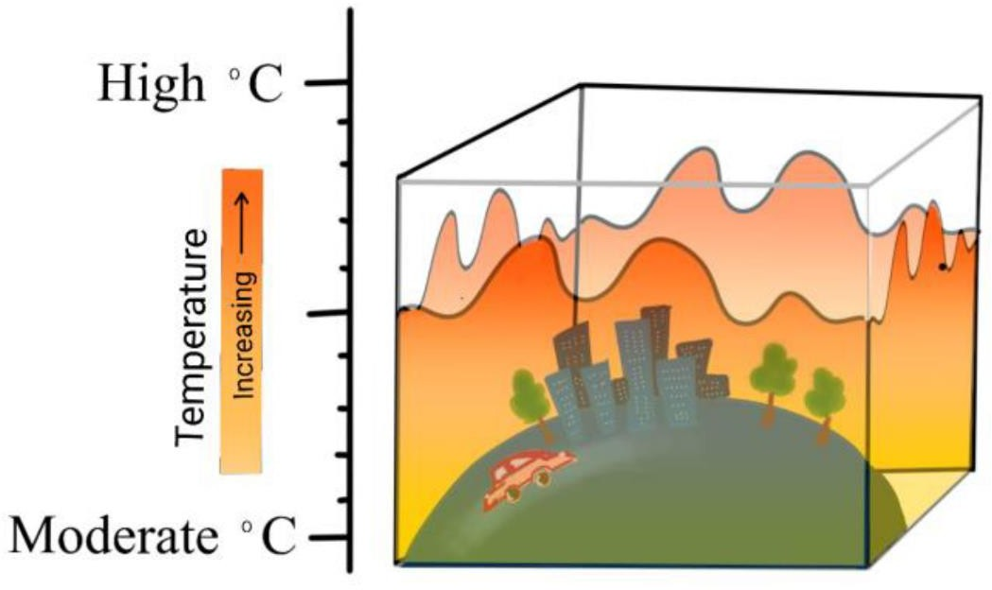

***Figure 2*** *Urban heat island illustration.*

# Precision Water Management

By combining meteorological and soil data with AI systems, precise irrigation suggestions, crop water stress prediction, and resource allocation can be made, improving water conservation and efficiency. Neural network architectures may be used for semantic segmentation in water management applications, especially when removing water bodies from remote sensing photos (Sun et al., 2023). AI algorithms are advancing digital picture categorization techniques for evaluating irrigation water consumption. These techniques use multi-temporal picture data from remote sensing systems like Landsat and Sentinel-2 to create detailed crop maps across multiple growing seasons. These technologies enable accurate and

economical water resource management, and can also improve urban water environments through Adaptive Intelligent Dynamic Water Resource Planning (AIDWRP).

# Disaster Resilience Planning

AI-powered remote sensing can aid in disaster response plans, early warning systems, and resilient urban designs by assessing population exposure and infrastructure vulnerability. It provides real-time evacuation information, shelter locations, and crucial information about impacted regions. AI Lab researchers use big data to create models for readiness, recovery, and mitigation. Predictive analytics uses meteorological and seismic data to predict evacuations and assess damage, distribute resources, and rank recovery efforts. AI also evaluates pre- disaster vulnerability, identifying high-risk locations using remote sensing data (Cao, 2023).

# Conclusion

In the field of remote sensing, artificial intelligence has quickly become a transformative force, allowing for previously unheard-of breakthroughs in precision agriculture, urban planning, public health, environmental monitoring, and disaster management. AI systems can conduct real-time analysis, reveal hidden patterns, and assist in well-informed decision-making across a range of industries by utilizing large and intricate datasets from satellite, aerial, and ground- based sensors. The use of AI has completely changed how we view, analyze, and respond to data from remote sensing, from disease outbreak prediction to wildfire detection.

Nevertheless, there are certain difficulties in applying AI to remote sensing. Its full potential is still limited by problems like interpretability, model uncertainty, inconsistent data quality, training optimization, and limited data availability. Furthermore, issues with security, equity, and data integrity highlight the necessity of responsible AI development and governance.

Notwithstanding these challenges, recent and developing applications such as precision water management, urban heat island mitigation, illegal logging detection, and biodiversity monitoring showcase the revolutionary potential of AI when used carefully. Many of the current constraints can be methodically overcome as technology develops and as frameworks for cooperation between governments, academic institutions, and private businesses grow stronger.

Building trust and guaranteeing fair access to AI-driven remote sensing solutions will require increasing transparency, improving data sharing protocols, and making investments in explainable AI models. The future of AI in remote sensing ultimately rests not only in

innovation but also in its responsible, inclusive, and sustainable application, which synchronizes technological advancement with the welfare of society and the environment.

**COMPETING INTERESTS:**

No financial support used

Disclaimer (Artificial intelligence)

Author(s) hereby declare that NO generative AI technologies such as Large Language Models (ChatGPT, COPILOT, etc) and text-to-image generators have been used during writing or editing of manuscripts

# References

Amani, M., Ghorbanian, A., Ahmadi, S. A., Kakooei, M., Moghimi, A., Mirmazloumi, S. M., Moghaddam, S. H. A., Mahdavi, S., Ghahremanloo, M., & Parsian, S. (2020). Google earth engine cloud computing platform for remote sensing big data applications: A comprehensive review. *IEEE Journal of Selected Topics in Applied Earth Observations and Remote Sensing*, *13*, 5326–5350.

Arifin, S., & Yudhatama, D. (2018). Analysis of land use spatial pattern change of town development using remote sensing. *International Journal of Remote Sensing and Earth Sciences (IJReSES)*, *15*(1), 93–102.

Bouguettaya, A., Zarzour, H., Taberkit, A. M., & Kechida, A. (2022). A review on early wildfire detection from unmanned aerial vehicles using deep learning-based computer vision algorithms. *Signal Processing*, *190*, 108309.

Breunig, M., Bradley, P. E., Jahn, M., Kuper, P., Mazroob, N., Rösch, N., Al-Doori, M., Stefanakis, E., & Jadidi, M. (2020). Geospatial data management research: Progress and future directions. *ISPRS International Journal of Geo-Information*, *9*(2), 95.

Campbell, J. B., & Wynne, R. H. (2011). *Introduction to remote sensing*. Guilford press.

Cao, L. (2023). AI and data science for smart emergency, crisis and disaster resilience.

*International Journal of Data Science and Analytics*, *15*(3), 231–246.

Creswell, A., White, T., Dumoulin, V., Arulkumaran, K., Sengupta, B., & Bharath, A. A. (2018). Generative adversarial networks: An overview. *IEEE Signal Processing Magazine*, *35*(1), 53–65.

Dash, A., Ye, J., & Wang, G. (2023). A review of generative adversarial networks (GANs) and its applications in a wide variety of disciplines: from medical to remote sensing. *IEEE Access*, *12*, 18330–18357.

Dian, R., Li, S., Sun, B., & Guo, A. (2021). Recent advances and new guidelines on hyperspectral and multispectral image fusion. *Information Fusion*, *69*, 40–51.

Ditria, E. M., Buelow, C. A., Gonzalez-Rivero, M., & Connolly, R. M. (2022). Artificial

intelligence and automated monitoring for assisting conservation of marine ecosystems: A perspective. *Frontiers in Marine Science*, *9*, 918104.

Earthdata. (2022). *Earthdata Cloud Evolution*. https://[www.earthdata.nasa.gov/eosdis/cloud-](http://www.earthdata.nasa.gov/eosdis/cloud-) evolution

Ghamisi, P., Rasti, B., Yokoya, N., Wang, Q., Hofle, B., Bruzzone, L., Bovolo, F., Chi, M., Anders, K., & Gloaguen, R. (2019). Multisource and multitemporal data fusion in remote sensing: A comprehensive review of the state of the art. *IEEE Geoscience and Remote Sensing Magazine*, *7*(1), 6–39.

Gonzalez-Rivero, M., Beijbom, O., Rodriguez-Ramirez, A., Bryant, D. E. P., Ganase, A., Gonzalez-Marrero, Y., Herrera-Reveles, A., Kennedy, E. V, Kim, C. J. S., & Lopez- Marcano, S. (2020). Monitoring of coral reefs using artificial intelligence: A feasible and cost-effective approach. *Remote Sensing*, *12*(3), 489.

Horak, J., Voumik, L. C., & Popescu, G. H. (2023). Remote sensing data fusion techniques, multimodal behavioral predictive and mobile location analytics, and spatial cognition and context awareness algorithms in the metaverse economy. *Linguistic and Philosophical Investigations*, *22*, 77–93.

Jain, P., Coogan, S. C. P., Subramanian, S. G., Crowley, M., Taylor, S., & Flannigan, M. D. (2020). A review of machine learning applications in wildfire science and management. *Environmental Reviews*, *28*(4), 478–505.

Janga, B., Asamani, G. P., Sun, Z., & Cristea, N. (2023). A review of practical ai for remote sensing in earth sciences. *Remote Sensing*, *15*(16), 4112.

Jozdani, S., Chen, D., Pouliot, D., & Johnson, B. A. (2022). A review and meta-analysis of generative adversarial networks and their applications in remote sensing. *International Journal of Applied Earth Observation and Geoinformation*, *108*, 102734.

Kaku, K. (2019). Satellite remote sensing for disaster management support: A holistic and staged approach based on case studies in Sentinel Asia. *International Journal of Disaster Risk Reduction*, *33*, 417–432.

Li, J., Li, Y., He, L., Chen, J., & Plaza, A. (2020). Spatio-temporal fusion for remote sensing

data: An overview and new benchmark. *Science China Information Sciences*, *63*, 1–17.

Li, Y. (2017). Deep reinforcement learning: An overview. *ArXiv Preprint ArXiv:1701.07274*.

Liang, M., Li, H., Liu, R. W., Lam, J. S. L., & Yang, Z. (2024). PiracyAnalyzer: Spatial temporal patterns analysis of global piracy incidents. *Reliability Engineering & System Safety*, *243*, 109877.

Liu, W., Quijano, K., & Crawford, M. M. (2022). YOLOv5-Tassel: Detecting tassels in RGB UAV imagery with improved YOLOv5 based on transfer learning. *IEEE Journal of Selected Topics in Applied Earth Observations and Remote Sensing*, *15*, 8085–8094.

Lou, R., Lv, Z., Dang, S., Su, T., & Li, X. (2023). Application of machine learning in ocean data. *Multimedia Systems*, *29*(3), 1815–1824.

Lyu, F., Wang, S., Han, S. Y., Catlett, C., & Wang, S. (2022). An integrated cyberGIS and machine learning framework for fine-scale prediction of Urban Heat Island using satellite remote sensing and urban sensor network data. *Urban Informatics*, *1*(1), 6.

Mo, Y., Xu, Y., Liu, Y., Xin, Y., & Zhu, S. (2023). Comparison of gap-filling methods for producing all-weather daily remotely sensed near-surface air temperature. *Remote Sensing of Environment*, *296*, 113732.

Mohan, E., Rajesh, A., Sunitha, G., Konduru, R. M., Avanija, J., & Ganesh Babu, L. (2021). A deep neural network learning‐based speckle noise removal technique for enhancing the quality of synthetic‐aperture radar images. *Concurrency and Computation: Practice and Experience*, *33*(13), e6239.

Mujetahid, A., Nursaputra, M., & Soma, A. S. (2023). Monitoring illegal logging using google earth engine in Sulawesi Selatan Tropical Forest, Indonesia. *Forests*, *14*(3), 652.

Oerke, E.-C. (2020). Remote sensing of diseases. *Annual Review of Phytopathology*, *58*(1), 225–252.

Rai, P. K., Mishra, V. N., & Singh, P. (2022). *Geospatial technology for landscape and environmental management: sustainable assessment and planning*. Springer.

Roscher, R., Rußwurm, M., Gevaert, C., Kampffmeyer, M., dos Santos, J. A., Vakalopoulou, M., Hänsch, R., Hansen, S., Nogueira, K., & Prexl, J. (2023). Data-centric machine learning for geospatial remote sensing data. *ArXiv Preprint ArXiv:2312.05327*.

Sarker, I. H. (2021). Deep learning: a comprehensive overview on techniques, taxonomy, applications and research directions. *SN Computer Science*, *2*(6), 420.

Segarra, J., Buchaillot, M. L., Araus, J. L., & Kefauver, S. C. (2020). Remote sensing for precision agriculture: Sentinel-2 improved features and applications. *Agronomy*, *10*(5), 641.

Silvestro, D., Goria, S., Sterner, T., & Antonelli, A. (2022). Improving biodiversity protection through artificial intelligence. *Nature Sustainability*, *5*(5), 415–424.

Sun, Z., Cristea, N., & Rivas, P. (2023). *Artificial intelligence in earth science: best practices and fundamental challenges*. Elsevier.

Sun, Z., Sandoval, L., Crystal-Ornelas, R., Mousavi, S. M., Wang, J., Lin, C., Cristea, N., Tong, D., Carande, W. H., & Ma, X. (2022). A review of earth artificial intelligence. *Computers & Geosciences*, *159*, 105034.

Toivonen, T., Heikinheimo, V., Fink, C., Hausmann, A., Hiippala, T., Järv, O., Tenkanen, H., & Di Minin, E. (2019). Social media data for conservation science: A methodological overview. *Biological Conservation*, *233*, 298–315.

Tong, D. Q., Gill, T. E., Sprigg, W. A., Van Pelt, R. S., Baklanov, A. A., Barker, B. M., Bell,

J. E., Castillo, J., Gassó, S., & Gaston, C. J. (2023). Health and safety effects of airborne soil dust in the Americas and beyond. *Reviews of Geophysics*, *61*(2), e2021RG000763.

Usmani, M. (2024). *Fusion of Remote Sensing and Citizen Science Information Through Machine Learning for Geospatial Analysis*.

Ustin, S. L., & Middleton, E. M. (2021). Current and near-term advances in Earth observation for ecological applications. *Ecological Processes*, *10*(1), 1.

Vaishya, R., Javaid, M., Khan, I. H., & Haleem, A. (2020). Artificial Intelligence (AI) applications for COVID-19 pandemic. *Diabetes & Metabolic Syndrome: Clinical Research & Reviews*, *14*(4), 337–339.

Wellmann, T., Lausch, A., Andersson, E., Knapp, S., Cortinovis, C., Jache, J., Scheuer, S., Kremer, P., Mascarenhas, A., & Kraemer, R. (2020). Remote sensing in urban planning: Contributions towards ecologically sound policies? *Landscape and Urban Planning*, *204*, 103921.

Yuan, Q., Shen, H., Li, T., Li, Z., Li, S., Jiang, Y., Xu, H., Tan, W., Yang, Q., & Wang, J. (2020). Deep learning in environmental remote sensing: Achievements and challenges. *Remote Sensing of Environment*, *241*, 111716.

Zhang, L., & Zhang, L. (2022). Artificial intelligence for remote sensing data analysis: A review of challenges and opportunities. *IEEE Geoscience and Remote Sensing Magazine*, *10*(2), 270–294.

Zhang, L., Zhang, L., & Du, B. (2016). Deep learning for remote sensing data: A technical tutorial on the state of the art. *IEEE Geoscience and Remote Sensing Magazine*, *4*(2), 22– 40.