***Comparative evaluation of power generating capacity of a low head river using conventional small hydropower and hydrokinetic turbines: A case study on Ona River, Oyo State, Nigeria***

**ABSTRACT**

The demand for electricity is growing rapidly around the world as economic development spreads to emerging economies. Among hydro, wind, solar, biomass and geothermal energies, hydro power can be considered as the most exciting and sustainable renewable energy resource for electricity generation, providing 19% of the planet’s electricity. A considerable amount of the global electricity production is obtained from hydropower, but with an insignificant contribution from low head rivers (i.e. ≤ 5m). The interest among researchers towards exploring and harnessing energy from low-head hydro resources is gaining more prominence in recent years. Therefore, this study was designed to investigate the competitiveness of the hydrokinetic turbine (HKT) against conventional hydro turbines for harnessing the hydropower available in low-head rivers. A vertical axis hydrokinetic turbine using NACA 0021 airfoil profile and a cross-flow turbine were the technologies employed for the study. Hydrological data were collected from the Ona River in Ibadan, Nigeria. The data were used as input for a computer simulation.In respect of the two hydropower generation technologies considered in this study. The set of mathematical equations used in the design steps for cross flowcross-flow turbine was used and computed using MATLAB. The simulation results were used to develop a scorecard for the evaluation of the two technologies. This study revealed that HKT is more suitable for a zero or low head river than a conventional hydro-turbine, such as cross-flow turbine.

**Keywords**: Hydrokinetic; Hydropower; Turbine; Low Head and Ona River

1. **INTRODUCTION**

Without mincing words, energy remains the life wire of socio-economic growth and development across the globe. Energy is crucial for a country's development, with renewable and non-renewable sources being the most environmentally friendly (Zabihi,2024). The demand for electricity is growing rapidly around the world as economic development spreads to emerging economies (Yüksel, 2007). It has been reported that nearly 1.4 billion people worldwide do not have access to electricity, while about 85% of them are from rural communities (Kaygusuz, 2007 and Lata-Garcia et al., 2018). Renewable energy resources are gaining global attention due to depleting fossil fuels and their harmful environmental effects associated with emission of Green House Gases (GHG) have made it imperative to consider alternative ways in which affordable, clean and readily available energy sources can be harnessed (Singal and Saini,2007; Kolekar et al., 2013 and Akinyemi et al., 2015). Urgent action is needed to cut carbon and greenhouse gas emissions to ensure a comfortable human existence in the following years in light of the environmental risks witnessed over the past several decades (Lin et al.,2022)

Among hydro, wind, solar, biomass and geothermal energies, hydro power can be considered as the most exciting and sustainable renewable energy resource for electricity generation (Altnbilek, 2005; Akorede et al, 2010; Kolekar et al., 2013), providing 19% of the planet’s electricity (Paris, 2002; Rahman et al., 2017). Hydropower is a renewable, low-emission source of electricity baseload available throughout much of the world as an alternative to electricity conventionally provided by thermal combustion of fossil fuels; however, the global hydropower sector as it stands relies upon surface water flows of substantial and predictable volume (Wasti et al.,2022; Fan et al.,2023). The interest of researchers in small hydropower (SHP) development (Yanmaz, 2007; Abbasi and Abbasi, 2011; Sachdev et al., 2015;) and hydrokinetic (HKT) technology (Kumar and Saini, 2014; Kumar and Pandey, 2017), for power production using ‘zero head’ turbines is growing tremendously. The authors describe hydrokinetic resource as small hydro energy generation, and it is a recently developed turbine technology which makes use of kinetic energy from flowing rivers, tides and water streams to generate electricity.

Some research efforts on hydrokinetic for electricity generation have been reported. A hydrokinetic system is an electromechanical device that converts the kinetic energy of water flow into electrical energy through a generator and power electronics converter (Ibrahim et al.,2021). Ismail and Batalha (2015) studied the hydrokinetic turbines' blade profiles of a river in Brazil. Four blade profiles were investigated. Computational Fluid Dynamics (CFD) simulations showed that circular arc profiles are more efficient and produce more power. The work of Els and Junior (2015) considered the evolution of the hydrokinetic technology for rural electrification in Brazil. An attempt was made by the authors to integrate hydrokinetic electricity generated into the national grid. Salau et al (2017) carried out hydrokinetic power estimation in selected rural communities in Oke Ogun, Nigeria. At a head of 0.3 metres, the authors estimated 36.4 MW as the total theoretical hydrokinetic power potential for the ten (10) basins considered in the study. Some other research works have also been documented (Ruopp et al., 2014; Gunawan et al., 2015; Niebuhr et al., 2018).

With respect to low or no-head hydro resources, research concerns are shifting from the conventional Small hydro power (SHP) scheme with run of water to hydrokinetic turbine technology, where run of water is not required (Chica and Perez 2015; Bir et al. 2011; Adejumobi et al. 2013; Kusakana, 2015). Notwithstanding, in-depth literature review shows that the available experimental data for the deployment of hydrokinetic in West African countries such as Nigeria is not robust. Therefore, this research was designed to investigate the competitiveness of HKT over the conventional SHP scheme by evaluating their power generating potential from low-head river using the River Ona in Ibadan, Nigeria as a case study.

1. **BACKGROUND** 
   1. **Demand for Low-Head Turbine Technology**

Hydropower, large and small, remains by far the most important of the renewables for electrical power production worldwide (Ramachandra and Shruthi, 2007). The water resources in the low head category are the ones with heads less than ten metres (Mosonyi, 1988; Hall,.2004). Senior (2009) revealed that much of the world's available hydropower potential has already been utilised, hence there is a need to focus attention on hydropower sites with very low head differences, which are sites with vertical distances through which water falls is less than 5 metres. Figure 1 shows that the demand side of hydropower technology is the one that can derive significant power output from low-head water resources.

|  |
| --- |
|  |

**Figure 1:** Established Hydropower Machines and Demand for New Technology (Senior, 2009)

The low head poses a challenge to power generation through the conventional small hydropower system, but the emergence of the hydrokinetic technology has facilitated the means to harness hydropower in flowing water bodies with or without head. However, HKT is yet to be well established, and several research studies have been done and are still in progress towards improving the technology (Fo, 2003; Laws and Epps 2016; Vermaak et al. 2014) .

* 1. **Conventional SHP**

Conventional hydro-turbines convert water pressure into mechanical shaft power, which can be used to drive an electricity generator or other machinery (Paish, 2002; Purohit, 2008). The power available is proportional to the product of pressure head and volume flow rate (Ramachandra and Shruthi, 2007; Kaldellis et al. 2001). The general formula for any hydro system’s power output is:

$P=hρgQH$ 1

where *P* is the mechanical power produced at the turbine shaft (Watts), h is the hydraulic efficiency of the turbine, *ρ* is the density of water (kg/m3), *g* is the acceleration due to gravity (m/s2), *Q* is the volume flow rate passing through the turbine (m3/s), and has demonstrated in Figure 2is the effective pressure head (m) of water across the turbine

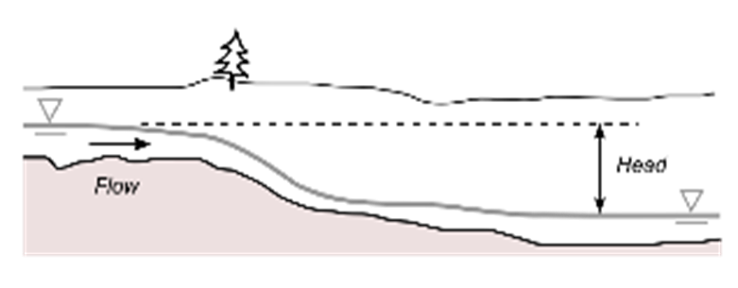

**Figure 2:** Hydro Power Basics (Paish, 2002)

* 1. **Hydrokinetic Turbine Technology**

The function of hydrokinetic turbines is to capture the kinetic energy of flowing water and transfer it into a shaft. Hydrokinetic turbines can only capture a fraction of the kinetic energy in the water that passes through their cross section. The fraction is known as the power coefficient, Cp (Tewari et al. 2015; Bustamante et al. 2015; Rumpfkeil et al. 2015) . The power captured by a hydrokinetic turbine can be expressed as:

$P_{capture}= C_{p}P_{theory}= \frac{1}{2}ρC_{p}Av^{3}$ 2

Similar to wind turbines, the power coefficient, Cp, of a hydrokinetic turbine depends on the Tip-Speed Ratio. By definition, Tip-Speed Ratio (TSR) λ is the ratio of the speed of the blade at its tip to the speed of the flowing water (Jones, 1950; Rumpfkeil et al., 2015).. The formula for TSR is as shown in equation 3.

$λ= \frac{Speed at the tip of the blade}{Water flowing speed}= \frac{ωR}{v}$ 3

The relation between TSR and the power coefficient Cp can be understood intuitively. If the turbine’s blades spin too slowly, then most of the water will pass through the rotor without being captured by the blades. However, if the turbine spins too fast, then the blades will always travel through used, turbulent water. There must be enough time lapses between two blades travelling through the same location so that new water can enter and the next blade can harness the power from that new water, not the used, turbulent water (Riegler, 1983)

1. **MATERIALS AND METHOD**
   1. **Site Selection and Hydrological Data Collection**

The selected source of water for this work is the River Ona in Ibadan, located inside the University of Ibadan, Oyo State, Nigeria, as shown in Figure 3.

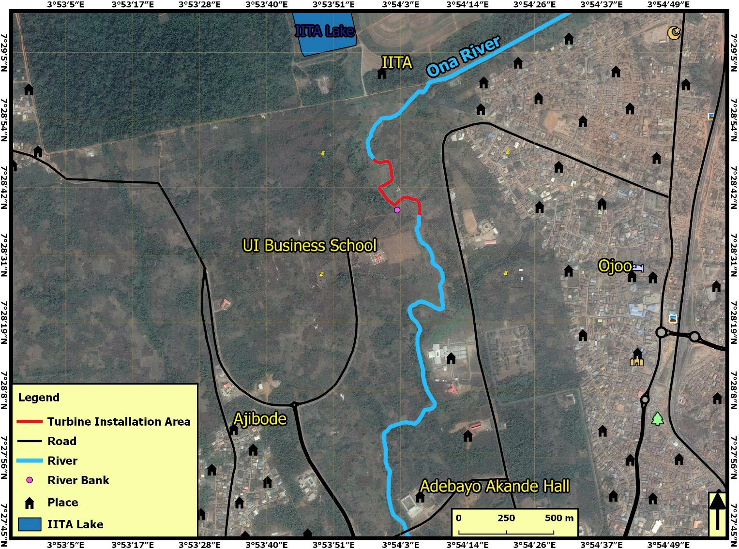

Figure 3. Aerial View of Ona River (Google earth)

A critical starting point in SHP development is the estimation of the power potential of a proposed site. Every other key component of the scheme, such as turbine selection and sizing, depends on the estimated power potential of the site. The hydrological data collected at the site were elevations (m) at various points along the river to determine the head (m) of the river and velocity (m/s) of the river, and flow (m3/s). Figure 4 shows the site visit and survey activities. The power potential was calculated for conventional SHP and hydrokinetic turbine schemes for River Ona using hydrological data collected during the site visit. This was used for the preliminary designs for both technologies for the purpose of comparative evaluation.

Figure 4: Taking hydrological data at the Ona River

* 1. **Design of Cross-Flow Turbine (Conventional SHP)**

The set of mathematical equations used in the design steps for cross-flow turbine in Nasir (2013) was used and computed using MATLAB. The mathematical equations used are as follows:

**(a) Turbine Power (Pt) in Watts**

The electrical power of the turbine in watts was determined with equation 4 using the data gathered in the field as inputs:

$P_{t}= ρgη_{t}H_{n}Q$ 4

where,

ρ = the water density (1000 kg/m3),

g = the acceleration due to gravity (9.81 m/s2)

Hn = Net head (m)

Q = Flow rate (m3/s)

**(b) Turbine Efficiency (ηt):**

$η_{t}= \frac{1}{2}C^{2}\left(1+ψ\right)\cos^{2}\left(α\right) 5$

where,

C = Nozzle roughness coefficient

ψ = Blade roughness coefficient

α = angle of attack (o)

Mockmore and Merryfield (1949) revealed that the angle of attack (α) should be kept as small as possible and stated (16o) can be obtained without much inconvenience.

**(c) Turbine Speed (N):**

$N= \frac{513.25H_{n}^{0.745}}{\sqrt{P_{t}}}$ 6

**(d) Runner Outer Diameter (Do)**

$D_{o}=40\frac{\sqrt{H_{n}}}{N}$ 7

**(e)** **Calculation of Blade Spacing (tb):**

$t_{b}=0.174D_{o}$ 8

**(f) Radial Rim Width (a):**

$a=0.174D_{o}$ 9

**(g) Runner Blade Number (n):**

$n=\frac{πD_{o}}{t_{b}}$ 10

**(h) Water Jet Thickness (tj):**

$t_{j}=0.29D_{o}$ 11

**(i) Runner Length, L (m):**

$L=\frac{QN}{50H_{n}}$ 12

**(j) Distance between Water Jet and the Center of Runner Shaft (y1):**

13

**(k) Distance between Water Jet and the Center of Inner Periphery Runner Shaft (y2):**

14

**(l) Diameter of the Runner**

$D_{i}=D_{o}-2a$ 15

**(m) Radius Blade Curvature, Rc (m)**

16

* 1. **Design of Hydrokinetic Turbine**

Below are the governing equations used for the preliminary design of hydrokinetic turbine using NACA0021 hydrofoil as stated in Khan et al. (2009); Kolekar (2013); Liu (2014); Kolekar and Banerjee (2015) :

$λ= \frac{R_{t}ω_{t}}{V_{w}}$ 17

$P_{t}= \frac{1}{2}C_{p}\left(λ\right)ρA_{t}V_{w}^{3}$ 18

$P_{t}= ω_{t}T_{t}$ 19

$T_{t}= \frac{P_{t}}{ω_{t}}= \frac{1}{2}C_{p}\left(λ\right)ρA_{t}V_{w}^{3}$ 20

$λ= \frac{C_{p}\left(λ\right)}{C_{t}\left(λ\right)} ⇒ C_{p}= \frac{R_{t}ω_{t}}{V_{w}}C_{t}$ 21

$σ= \frac{Bc}{2πR_{t}}$ 22

$Re= \frac{ρV_{w}c}{μ}$ 23

where

𝜆 = Tip Speed Ratio (i.e. the ratio of blade tip speed to fluid speed)

At = Cross-sectional area turbine flows through

CP = power coefficient

Ct = turbine coefficient

ωt = Turbine rotational speed (rad/s)

R*t* = radius of turbine (m)

Ww = flow speed of water (m/s)

σ = solidity (σ) that is defined as the ratio of blade chord length times the number of blades to turbine circumference.

B = number of turbine blades

c = length of blade cord

Re = Reynolds number

ρ = density

μ = dynamic viscosity of water (Pa.s)

* 1. **Comparative Evaluation of the two technologies**

The two technologies, cross-flow turbine for conventional SHP and hydrokinetic turbine design parameters, were compared to evaluate their power generating potential using Ona River hydrological data as a case study under various boundary conditions and scenarios. A scorecard Matrix was developed with the following as the major evaluation criteria:

* The technically feasible power output
* Ease and Cost of fabrication
* Scalability
* Cost-benefit analysis
* Ease of technology transfer

1. **RESULTS AND DISCUSSION**

**4.1 Hydrological Data**

Table 1 shows the hydrological data collected at the Ona River, which were major inputs for the preliminary design of the two SHP technologies under evaluation.

**Table 1:** Hydrological Data for Ona River

|  |  |
| --- | --- |
| DESCRIPTION | **DATA** |
| Location | Stream along the Ona River behind UI School of Business, U.I. |
| Coordinates | 7° 28′ 38.6″ N  3° 54′ 2.3″E |
| Gross Head (Hg) | 2m |
| Water Velocity (vw) | 0.1m/s |
| Flow rate (Q) | 0.95839 m3/s |
| Maximum Depth | 0.5 m |
| Average Width | 9 m |

**4.2 Power Outputs**

As observed in the hydrological data, the river has a very low head of 2 m and a low velocity of about 0.1 m/s. This makes the river practically difficult to be utilised for power generation at its present state with conventional SHP, and the river may require some kind of a dam that creates an artificial water head, which should be large enough to propel a water turbine (Fleisinger et al. 2014). For HKT to be ,utilised, the stream velocity will also need to be increased, which can be achieved through channel augmentation (Vermaak et al. 2014; Ait-mohammed et al. 2014; Mukherji 2010)

The predicted potential power output for the two SHP technologies was based on the possibility of creating an artificial head to achieve higher head and augmenting the flow channel to increase stream velocity in the case of conventional SHP and hydrokinetic turbine, respectively.

Figures 5 and 6 show how the simulated power outputs vary with the increase in head and velocity of the stream in the case of conventional SHP and hydrokinetic turbine technology, respectively. The values obtained for the maximum possible power outputs were 56 kW at 6 m Head and 400 kW at 3m/s for conventional SHP and hydrokinetic turbine technology, respectively.

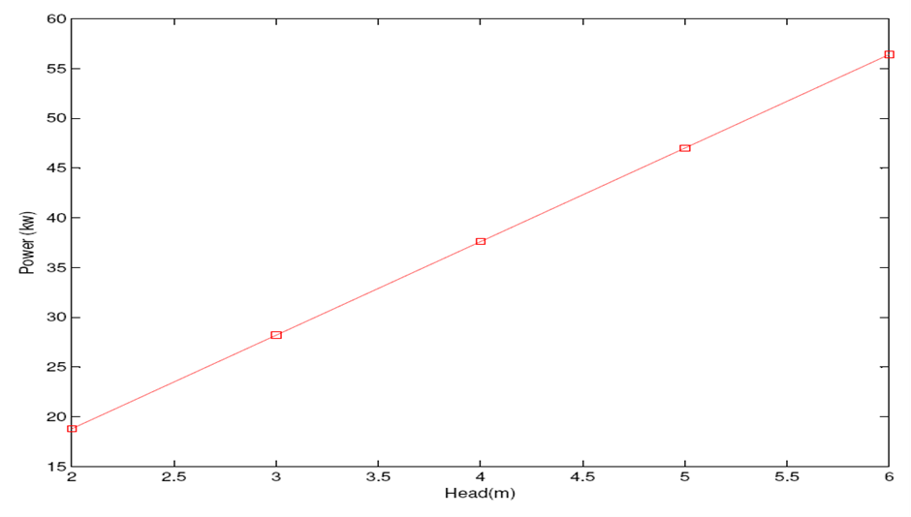

Figure 5: Variation of Power Output of Cross Flow Turbine with increase in Head (m) of the river

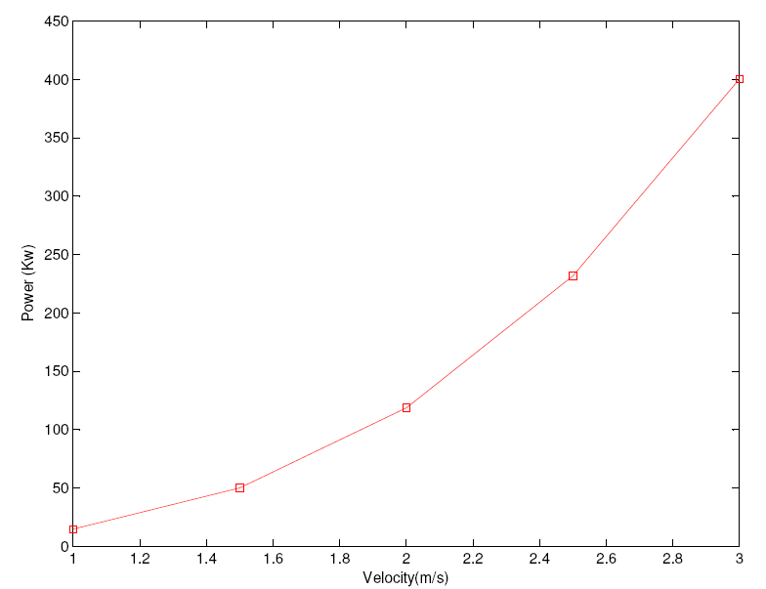

Figure 6: Variation of Estimated Power Output of Hydrokinetic Turbine with increase in Velocity of the river

**4.3 Design Parameters for Cross-Flow Turbine**

Table 2 shows the simulated design parameters for cross-flow turbine for power output ranging from 18 – 47 kW.

The design parameters indicate the dimensions of the components of the mechanical part of the turbine. Figure 7 shows the components of a typical cross-flow turbine

**Table 2:** Design Parameters for Cross-flow Turbine at Various Heads

|  |  |  |  |  |
| --- | --- | --- | --- | --- |
| HEAD (m) | **2** | **3** | **4** | **5** |
| Power (Kw) | 18.80 | 28.21 | 37.61 | 47.01 |
| Turbine efficiency (%) | 70 | 70 | 70 | 70 |
| Runner speed (rpm) | 325 | 359 | 386 | 407 |
| Length of runner (m) | 10.2 | 15.3 | 20.3 | 25.4 |
| Number of blades | 18 | 18 | 18 | 18 |
| Runner outer diameter(m) | 0.034 | 0.041 | 0.048 | 0.054 |
| Runner inner diameter(m) | 0.127 | 0.155 | 0.179 | 0.2 |
| Blade spacing (m) | 0.034 | 0.041 | 0.048 | 0.054 |
| Water jet thickness (m) | 0.056 | 0.069 | 0.08 | 0.089 |
| Distance between the water jet and the shaft centre | 0.023 | 0.028 | 0.032 | 0.036 |
| Distance between water jet and inner periphery of runner (m) | 0.01 | 0.012 | 0.014 | 0.015 |
| Radius of blade curvature (m) | 0.032 | 0.039 | 0.049 | 0.05 |

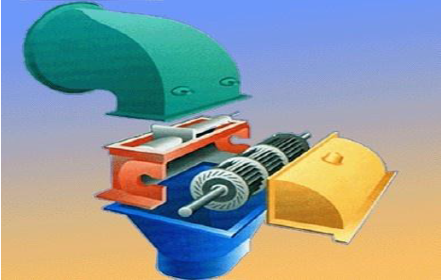

Figure 7: Components of a typical cross-flow turbine (Nasir,2013)

**4.4 Design Parameters for HKT**

Tables 3 show the simulated design parameters for a 50 kW HKT turbine. The design parameters indicate the dimensions of the components of the mechanical parts of the turbine. Figure 8 shows the components of a typical HKT turbine

**Table 3.** Design Parameters for Hydrokinetic Turbine

|  |  |
| --- | --- |
| **Parameters** | **Values** |
| Expected Power | 50 Kw |
| Water Velocity | 3 m/s |
| Radius | 3.1 m |
| Height of the Blade | 1.4 m |
| No of Blade | 3 |
| Tip Blade Ratio | 4 |
| Blade Hydrofoil Model | NACA 0021 |
| Turbine Rotational Speed | 371 rpm |
| Turbine Angular Velocity | 3.94rad/s |
| Turbine Torque | 12.68 Nm |

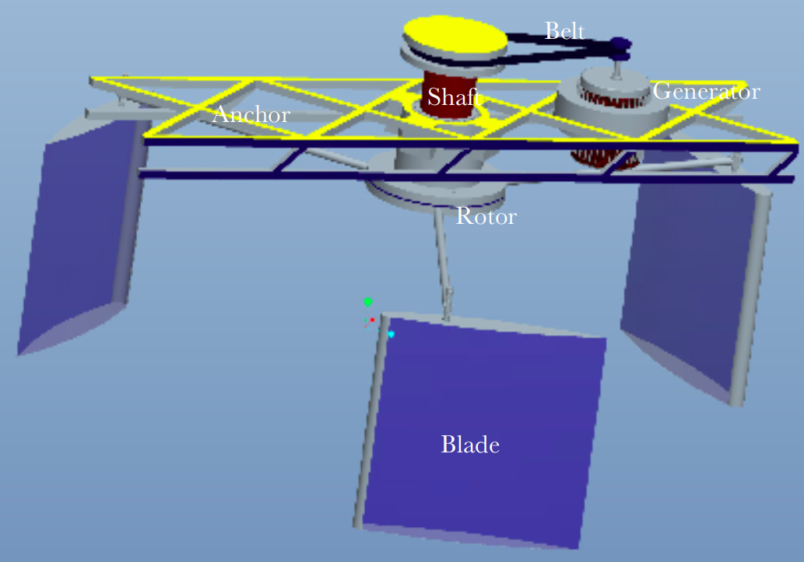

Figure 8: Conceptual design of Vertical Hydrokinetic

**4.5 Technology Evaluation**

The main objective of this work is to conduct a comparative evaluation of the two SHP technologies mentioned earlier to justify the choice of hydrokinetic turbine technology over the conventional small hydropower scheme. Table 4 shows a technology evaluation selection matrix with a set of criteria to enable the selection of the best technology for a SHP scheme suitable for the proposed site. The table clearly shows that hydrokinetic turbine technology is a better option than cross-flow turbine technology.

**Table 4:** Technology Selection Criteria Scorecard

|  |  |  |  |
| --- | --- | --- | --- |
| S/N | **Criteria** | **Cross-Flow Turbine Technology** | **Hydro Kinetic Turbine** |
| 1 | Technically Feasible Power Output | 1 | 2 |
| 2 | Cost of Fabrication | 1 | 2 |
| 3 | Ease of Fabrication | 1 | 2 |
| 4 | Ease of Installation | 1 | 2 |
| 5 | Modularity | 1 | 2 |
| 6 | Scalability | 1 | 2 |
| 7 | Maintenance and Serviceability | 2 | 1 |
| 8 | Amount of Civil Work | 1 | 2 |
|  | Overall Score | 9 | 15 |
|  | NOTE:  2 = Comparatively Higher or Better  1 = Comparatively Lower or Worse |  |  |

1. **CONCLUSION**

The preliminary investigation in this research entailed the development of MATLAB code for modelling of both conventional Small Hydro Power (SHP) and Hydrokinetic Turbine (HKT) for the purpose of justifying the choice of more suitable technology for the water resources with or without head using hydrological data for Ona river as a case study. The findings of this research revealed the advantage of HKT technology over the conventional SHP technology for low or zero head water resources in terms of technically feasible power output, manufacturability, modularity and scalability. Further research works are required to explore more opportunities associated with the advent of this HKT technology.

Disclaimer (Artificial intelligence)

Option 1:

Author(s) hereby declare that NO generative AI technologies such as Large Language Models (ChatGPT, COPILOT, etc.) and text-to-image generators have been used during the writing or editing of this manuscript.

Option 2:

Author(s) hereby declare that generative AI technologies such as Large Language Models, etc. have been used during the writing or editing of manuscripts. This explanation will include the name, version, model, and source of the generative AI technology and as well as all input prompts provided to the generative AI technology

Details of the AI usage are given below:

1.

2.

3.

**References**

1. Yüksel, I. 2007. Development of Hydropower: A Case study in developing countries, energy sources, Part B: Economics, Planning, and Policy 2(2): 113-121
2. Kaygusuz, K.2007. Energy for sustainable development: key issues and challenges. Energy Source Part B Econ Planning Policy 2: 73-83.
3. Lata-Garcia, J., Jurado-Melguiz, F., Sanchez-Sainz, Reyes-Lopezi, C. Fernandez-Ramirez, L.2018.Optimal sizing hydrokinetic-photovoltaic system for electricity generation in a protected wildlife area of Ecuador. Turkish Journal of Electrical Engineering and Computer Sciences 26: 1103-1114.
4. Singal, S.K.and Saini, R.P.2007. Analytical approach for cost estimation of low head small hydro power schemes. International Conference on Small Hydropower - Hydro Sri Lanka, 22-24 October 2007.
5. Kolekar, N., Hu, Z.,Banerjee. A, and Du, X. 2013. Hydrodynamic Design and Optimization of hydro‐kinetic turbines using a robust design method. Proceedings of the 1st Marine Energy Technology Symposium April 10‐11, 2013, Washington, D.C.
6. Akinyemi, O.S., Chambers, T. L. and Liu, Y..2015. Evaluation of the power generation Capacity of hydrokinetic generator device using computational analysis and hydrodynamic Similitude. Journal of Power and Energy Engineering 3:71-82.
7. Altnbilek, D., 2005. Water and hydropower for sustainable development. International Symposium; Water For Development World Wide, Resources Development in Turkey 104-114.
8. Akorede, M F, Hizam, H., Aris, I.B. and Kadir, Z. 2010. A review of strategies for optimal placement of distributed generation in power distribution systems. Research Journal of Applied Sciences
9. Parish, O..2002. Small hydro power: technology and current Status. Renewable and Sustainable Energy Reviews 6 :537–556.
10. Rahman, M.S. Nabil, I.M. and Alam, M.M. 2017.Global analysis of a renewable micro hydro power generation plant. AIP Conference Proceedings 1919, 020014; doi: 10.1063/1.5018532.
11. Yanmaz, M., 2007. A Case Study On Feasibility Assessment Of Small Hydropower Scheme. M.Sc Thesis, The Graduate School of Natural and Applied Sciences of Middle East Technical University.
12. Abbasi, T. and Abbasi, S.A., 2011. Small hydro and the environmental implications of its extensive utilization. Renewable and sustainable energy reviews 15(4): 2134-2143.
13. Sachdev, H., Akella, A. and Kumar, N. 2015. Analysis and evaluation of small hydropower plants: A bibliographical survey. Renewable and Sustainable Energy Reviews 51: 1013-1022.
14. Kumar, A. and Saini, R. P.2014. Development of hydrokinetic power generation system: A Review. International Journal of Engineering Science & Advanced Technology 4(6,):464-477.
15. Kumar, A. and Pandey, A. 2017. Cost assessment of hydrokinetic power generation. International Journal of Advance Research in Science and Engineering 6(2):224-233.
16. Ismail, K. A.R. and Batalha, T.P. 2015. A comparative study on river hydrokinetic turbines blade profiles. Int. Journal of Engineering Research and Applications 5 (5) (Part -1):1-10.
17. Els, R.H. and Junior A.C.P.B..2015. The Brazilian experience with hydrokinetic turbines. Energy Procedia 75:259 – 264.
18. Salau, W., Paul, I.I. and Ganiyu A. A..2017. SWAT analysis of Ikere Gorge basin for hydrokinetic power estimation in selected rural settlements of Oke Ogun, Nigeria. Ruhuna Journal of Science 8: 24-43.
19. Ruopp, A., Ruprecht, A., Riedelbauch, S., Arnaud, G. and Hamad, I. 2014. Development of a hydro kinetic river turbine with simulation and operational measurement results in comparison. IOP Conference Series: Earth and Environmental Science. 22: 1-11.
20. Gunawan, B., Roberts, J. and Neary, V.2015. Hydrodynamic effects of hydrokinetic turbine deployment in an irrigation canal. Proceedings of the 3rd Marine Energy Technology Symposium April 27-29, Washington DC.
21. Niebuhr, C., Dijk, M. and Bhagwan. J. 2018.Technical and practical valuation of hydrokinetic turbine integration into xeisting canal infrastructure in South Africa: A Case Study. Proceedings 2018, 2, 595 MDPI.
22. Chica, E. Perez, F., Rubio-Clemente, A. and Agudedo, S. 2015. Design of a hydrokinetic turbine. Energy and Sustainability, VI: 137.
23. Bir, G.S., Lawson, M.J. and Li, Y.2011. Structural design of a horizontal-axis tidal current turbine composite blade. ASME 30th International Conference on Ocean, Offshore, and Arctic Engineering, p.14..
24. Adejumobi, I.A., Adebisi, O.I. and Oyejide, S.A., 2013. Developing Small Hydropower Potentials for Rural. International Journal of Research and Reviews in Applied Sciences, 17(1):.105–110.
25. Kusakana, K., 2015. Feasibility analysis of river off-grid hydrokinetic systems with pumped hydro storage in rural applications. Energy Conversion and Management, 96;.352–362.
26. Ramachandra, T. and Shruthi, B., 2007. Spatial mapping of renewable energy potential. Renewable and Sustainable Energy Reviews 11(7): 1460-1480.
27. Mosonyi, E., 1988. Water Power Development: Low-Head Hydropower Utilization. Developments in Hydraulic Engineering-.
28. Hall, D. 2004. Water energy resources of the United States with emphasis on low head/low power resources. Power Resources: Appendix C-Validation Study. United States. Doi:10.2172/1218176.
29. Senior, J.A., 2009. Hydrostatic pressure converters for the exploitation of very low head hydropower potential. University of Southampton.
30. Fo, G.L.T. 2003. The state of art of Hydrokinetic power in Brazil
31. Laws, N.D. and Epps, B.P., 2016. Hydrokinetic energy conversion: Technology, research, and outlook. Renewable and Sustainable Energy Reviews 57: 1245-1259.
32. Vermaak, H.J., Kusakana, K. and Koko, S.P., 2014. Status of micro-hydrokinetic river technology in rural applications: A review of literature. Renewable and Sustainable Energy Reviews, 29:625–633.
33. Purohit, P.2008. Small hydro power projects under clean development mechanism in India: A preliminary assessment. Energy Policy, 36(6):2000–2015.
34. Kaldellis, J.K., Kavadias, K. and Christinakis, E., 2001. Evaluation of the wind-hydro energy solution for remote islands. Energy Conversion and Management, 42(9):1105–1120.
35. Tewari, U., Norta, D. and Kolmsee, K., 2015. Hydrokinetic energy for enlightening the future of rural communities in Uttarakhand.
36. Bustamante, C.A., Florez, W. F. Power, H. and Hill, A.F. 2015. Hydrokinetic turbine location analysis by a local collocation method with Radial Basis Functions for two-dimensional Shallow Water equations. WIT Transactions on Ecologoy and the Environment 195:3-13.
37. Rumpfkeil, M.P., Verma, A.K. and Saini, R.P., 2015. Efficiency Measurement Techniques of Hydro Kinetic Turbines : a Review. International Conference on Hydropower for Sustainable Development, p268–285.
38. Jones, B.1950. Elements of Aerodynamics,
39. Riegler, G., 1983. Principles of energy extraction from a free stream by means of wind turbines. Wind Engineering, .7(2) :115–126.
40. Mockmore, C. and Merryfield, F., 1949. The Banki water turbine.
41. Khan, M.J., Bhuyan, G., Igbal, M.T. and Quaicoe, J.E. 2009. Hydrokinetic energy conversion systems and assessment of horizontal and vertical axis turbines for river and tidal applications: A technology status review. Applied Energy, 86(10),: 1823–1835.
42. Liu, M., 2014. Hydrokinetic Turbine Power Converter and Controller System Design Implementation. The University of British Columbia.
43. Kolekar, N. and Banerjee, A., 2015. Performance characterization and placement of a marine hydrokinetic turbine in a tidal channel under boundary proximity and blockage effects. Applied Energy, 148:121-133.
44. Ait-mohammed, M., Tarfaoui, M. & Laurens, J.M., 2014. Predictions of the Hydrodynamic Performance of Horizontal Axis Marine Current Turbines Using a Panel Method Program. (12).
45. Mukherji, S.S., 2010. Design and critical performance evaluation of horizontal axis hydrokinetic turbines. Master Thesis Missouri University of Science and Technology.
46. Lin, C. Y., Chau, K. Y., Tran, T. K., Sadiq, M., Van, L., & Phan, T. T. H. (2022). Development of renewable energy resources by green finance, volatility and risk: empirical evidence from China. Renewable Energy, 201, 821-831.
47. Wasti, A., Ray, P., Wi, S., Folch, C., Ubierna, M., & Karki, P. (2022). Climate change and the hydropower sector: A global review. Wiley Interdisciplinary Reviews: Climate Change, 13(2), e757.
48. Fan, J. L., Huang, X., Shi, J., Li, K., Cai, J., & Zhang, X. (2023). Complementary potential of wind-solar-hydro power in Chinese provinces: Based on a high temporal resolution multi-objective optimization model. Renewable and Sustainable Energy Reviews, 184, 113566.
49. Ibrahim, W. I., Mohamed, M. R., Ismail, R. M. T. R., Leung, P. K., Xing, W. W., & Shah, A. A. (2021). Hydrokinetic energy harnessing technologies: A review. Energy Reports, 7, 2021–2042.
50. Zabihi, A. (2024). Assessment of Faults in the Performance of Hydropower Plants within Power Systems. Energy, 7(2).