*Case report*

**Pregnancy-Related Autoimmune Hemolytic Anemia in a Sickle Cell and Beta-Thalassemia Trait Patient: A rare case report**

.

ABSTRACT

|  |
| --- |
| The presence of autoimmune hemolytic anemia (AIHA) further complicates the clinical landscape. The coexistence of sickle cell anemia and AIHA during pregnancy poses significant risks, including severe anemia, increased likelihood of crises, and heightened maternal and fetal morbidity. We report a case of 29-year-old pregnant patient with sickle cell anemia (sca) and β-thalassemia trait, complicated by autoimmune hemolytic anemia (aiha). She presented with severe anemia and jaundice at 36 weeks, requiring transfusions, plasma exchange, and hemodialysis due to inadequate response to transfusions. The interplay of oxidative stress, immune dysregulation, and pregnancy-related changes exacerbated aiha. This case highlights the challenges of managing AIHA in SCA during pregnancy and the need for coordinated care to optimize maternal and fetal outcomes. Ongoing research is vital to improve management strategies and outcomes, enabling better care for affected patients and their infants. Through coordinated multidisciplinary efforts, healthcare providers can enhance the health and well-being of mothers and their children. |

*Keywords: Sickle cell anaemia, Beta Thalassemia Trait, Autoimmune hemolytic anaemia, direct coombs test, indirect coombs test*

1. INTRODUCTION

Anaemia in pregnancy is common, however, only a few cases of pregnancy-associated autoimmune haemolytic anaemia have been documented. Typically, such cases involve a positive direct antiglobulin test and have the potential to cause haemolytic disease of the fetus and newborn (Creeper & Graham, 2023; Surendhar et al., 2024). Pregnancy puts extra stress on a woman’s body, raising the risk of sickle cell complications. Having sickle cell disease also raises the risk of problems with the pregnancy and with the developing baby (Roberts et al., 2025; Leroy-Melamed et al., 2025). A distinct array of challenges arises during pregnancy with sickle cell anemia, as the underlying hematologic condition markedly heightens the risk of complications for both the mother and the developing fetus. Sickle cell anemia, is a genetic disorder, which leads to chronic hemolytic anemia, vaso-occlusive crises, and various organ dysfunctions. These complications can be exacerbated during pregnancy due to physiological changes. (1)

In addition, the presence of autoimmune hemolytic anemia (AIHA) further complicates the clinical landscape. The coexistence of sickle cell anemia and AIHA during pregnancy poses significant risks, including severe anemia, increased likelihood of crises, and heightened maternal and fetal morbidity. (1)

This case illustrates the intricate challenges faced in managing a pregnancy complicated by these two hematologic conditions, emphasizing the need for comprehensive and coordinated care to optimize outcomes for both mother and child.

2. **Case Presentation**

A 29-year-old female, gravida 2, para 1, living 1 (G2P1L1), with a history of full-term normal delivery, presented at 36 weeks and 4 days of gestation with jaundice and severe anemia. She was diagnosed with sickle cell anemia with a compound beta-thalassemia trait.

**Initial Presentation**

On admission, her hemoglobin (Hb) was 6 g/dL. Blood samples were sent for 2 units of packed red blood cells (PRBC). Initial immunohematology testing showed:

Table 1 : Initial immunohematology test result of the patient

|  |  |
| --- | --- |
|  | Initial presentation |
| Indirect Coombs Test (ICT): | Positive |
| Direct Coombs Test (DCT): | Negative |
| Autoantibody screen | Negative |
| Antibody identification panel | Positive for anti-c and anti-E antibodies |

Fig 1 : Initial immunohematology testing of the patient

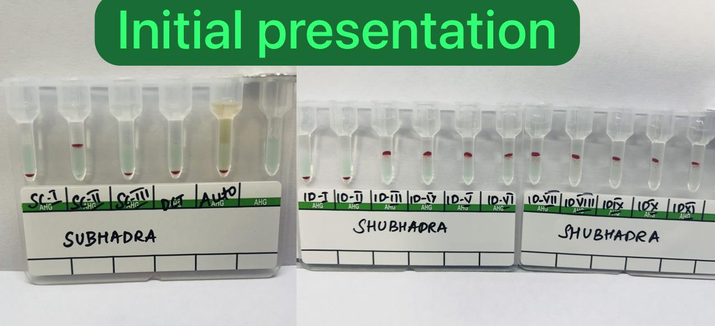

Two units of c- and E-negative PRBCs were issued and transfused. During her hospital stay, she was diagnosed with sickle cell anemia complicated by a sickle cell crisis.

**Antigen-Negative Blood Calculation:**  
The formula used:  
 N = X

{(1-PA1) (1-PA2)}

Where  **N** = Average number of units to be screened

**X** = Number of antigen-negative units required

**PA1** = Phenotype prevalence of the first alloantibody antigen

**PA2** = Phenotype prevalence of the second alloantibody antigen

The prevalence of c and E were 58.1%, and 19.4% respectively

Using that Formula, we got 6 units which are crossmatched and issued 2 units which came to be compatible. There was an increment of 1.2 g/dl after one transfusion.

**Complications During Labor**

During Labor, she experienced a further decline in Hb levels, necessitating additional blood transfusions. Blood samples were again sent to the blood bank, revealing:

Table 2 : Immunohematology test result during labor

|  |  |
| --- | --- |
|  | During labor |
| Indirect Coombs Test (ICT): | 4+ |
| Direct Coombs Test (DCT): | 2+ |
| Autoantibody screen | 2+ |
| Antibody identification panel | Pan-reactive (4+) |

Fig 2 : Immunohematology Test Results Conducted During Labor

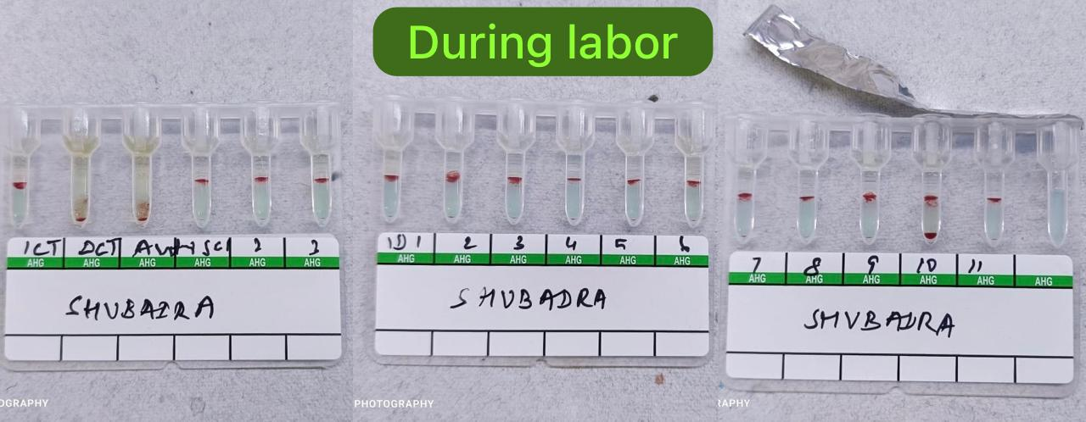

The patient had a pan-reactive antibody screening panel, prompting auto-adsorption before crossmatching. The patient's RBCs were washed 6 times with normal saline. Then, 200µL of the washed RBCs and 200µL of serum were incubated at 37°C for 45 minutes, allowing auto-adsorption of circulating autoantibodies onto the RBCs. This auto-adsorbed serum was then used for crossmatching. Simultaneously, thermal amplitude and monoclonal/polyclonal AHG testing suggested warm autoimmune hemolytic anemia (AIHA) with reactivity at 37°C and the IgG phase.

Crossmatching of 24 units yielded no compatible units. Hence, the best-matched units were issued, considering selecting units with reactions less than those of the autoantibody. Despite transfusing 4 units of PRBCs, her Hb levels did not improve.

**Advanced Interventions**

Given the lack of response to transfusions and increased creatinine levels, the patient underwent 5 cycles of plasma exchange and hemodialysis. Following these interventions, her Hb levels stabilized, and she responded to further blood transfusions.

3. discussion

Autoimmune hemolytic anemia (AIHA) is characterized by the destruction of red blood cells (RBCs) due to autoantibodies, complement activation, and the involvement of activated immune cells, including macrophages and T lymphocytes. The immune system's components, such as autoantibodies, cytokines, complement, phagocytes, and lymphocytes, play significant roles in AIHA pathogenesis. (2)

AIHA can be classified into several serological types: warm autoimmune hemolytic anemia (wAIHA), cold agglutinin disease (CAD), mixed-type AIHA, and paroxysmal cold hemoglobinuria (PCH). (2) wAIHA accounts for approximately 75% of cases, involving IgG antibodies that bind to RBCs at 37°C, while CAD comprises about 15% of cases with IgM antibodies binding at lower temperatures. (4,5) Diagnosis is primarily based on positive direct antiglobulin tests (DATs) and auto control to detect anti-RBC antibodies. (14)

Clinically, AIHA is often indicated by symptoms like jaundice and hepatosplenomegaly, with laboratory findings including increased reticulocyte counts, spherocytes, and positive DATs confirming the presence of immunoglobulins and/or complement on erythrocytes. (3)

Sickle cell hemoglobinopathies are inherited disorders caused by a mutation in the β-globin gene, resulting in the substitution of valine for glutamic acid. This group includes sickle cell trait, a heterozygous condition that is generally, sickle cell-β-thalassemia, which combines features of both sickle cell disease and β-thalassemia, resulting in abnormal haemoglobin production and reduced β-globin synthesis This leads to severe anemia, fatigue, jaundice, vascular dysfunction, inflammation, oxidative stress, and hypercoagulability, with high levels of reactive oxygen species (ROS) contributing to membrane and protein damage (10,11). The prevalence rate is 0.47% for sickle cell-β-thalassemia, with crises triggered by factors like low oxygen, cold, or illness. (7,9)

Pregnancy allows the fetus to develop without immune rejection, resembling an allograft. T helper cells, particularly Th2, promote immune tolerance, while Th1 and Th17 cells can trigger rejection. Successful pregnancies see Th2 cells producing IL-4 and IL-10, suppressing Th1 and Th17 responses, and alleviating autoimmune symptoms. After childbirth, decreased Th2 cytokines can lead to increased Th1 and Th17 activity, potentially worsening autoimmune conditions that were stable during pregnancy. (2)

Thus, the modulation of immune responses during pregnancy and the postpartum period can have complex effects on autoimmune diseases, potentially offering temporary relief during pregnancy but leading to challenges in the postpartum phase. (2)

Pregnancy presents unique challenges for women with sickle cell disease (SCD) due to physiological adaptations that exacerbate SCD complications. These include cardiovascular changes, increased oxygen consumption, and alterations in plasma volume. These changes can lead to exacerbated anemia, cardiovascular stress, and complications such as vaso-occlusive crises. Pregnancy can also affect the placental circulation due to red cell sickling, endothelial damage, and chronic inflammation. (5,8)

In AIHA, immune dysregulation, environmental triggers, and oxidative stress play pivotal roles. Autoreactive T and B cells are central to its pathogenesis. Elevated levels of Th17 cells, which promote inflammation, are observed in AIHA patients and correlate with disease activity. Imbalances between Th17 cells and Tregs, influenced by cytokine gene polymorphisms, are crucial. T follicular helper (Tfh) cells and T follicular regulatory (Tfr) cells play key roles in B cell differentiation and antibody regulation in autoimmune hemolytic anemia (AIHA). Environmental factors, such as infections and oxidative stress, further contribute to AIHA. Pregnancy can trigger AIHA, highlighting the complex interplay between hormonal changes and immune responses, which occurred in the above case. (3,12)

Oxidative stress and free radicals link sickle cell anemia (SCA) to autoimmune hemolytic anemia (AIHA), especially during pregnancy and postpartum. SCA generates reactive oxygen species (ROS), exacerbating inflammation and RBC damage. Hormonal changes during pregnancy activate autoreactive T and B cells, increasing AIHA risk. In Postpartum, a decrease in Th2 responses may further predispose individuals with SCA to AIHA, highlighting the interplay between oxidative stress and immune modulation. (2,10,12)

Autoantibody frequency varies: 1% to 28.2% in β-thalassemia, 0.8% to 42% in sickle cell disease, and up to 61% in hereditary spherocytosis, with warm IgG antibodies found in about half of positive DAT cases. Triggers for autoantibody development include pregnancy, transfusions, infections, and surgery. Clinically significant AIHA is less common, with prevalence rates between 1.8% and 6.4%. (14)

In SCA, an imbalance between Th17 and Treg cells leads to increased inflammation, with oxidative stress driving Th17 overactivation (3).

Treatment for AIHA varies based on its type and severity. First-line therapy typically involves prednisone (60–100 mg daily) for 2–3 weeks, followed by a taper over 3–6 months. This approach has an initial response rate of about 80%, with a 30–40% sustained remission rate after a year. Rituximab may be added for severe cases or used as a second-line treatment if steroids are ineffective, with a response rate of 70–80% in 3–6 weeks. Splenectomy is considered if rituximab fails, showing a 70% response rate. Other options include azathioprine, cyclophosphamide, and bortezomib, with limited evidence for high-dose cyclophosphamide or stem cell transplantation in ultra-refractory cases (3). Emergency treatments such as high-dose intravenous methylprednisolone, IVIG, and therapeutic plasma exchange are reserved for acute AIHA, with therapeutic plasma exchange potentially enhancing remission rates and improving hematological parameters. (13,14)

4. Conclusion

The coexistence of autoimmune hemolytic anemia (AIHA) with sickle cell anemia and β-thalassemia during pregnancy presents significant clinical challenges, including heightened risks of severe anemia and complications for both mother and fetus. Effective management requires a tailored approach that accounts for the physiological changes of pregnancy and the complexities of each condition.

Understanding the role of immune dysregulation and oxidative stress in AIHA is crucial for developing targeted therapies. Continuous monitoring and adjustments in treatment are essential, especially postpartum when the risk of exacerbation is high. Ongoing research is vital to improve management strategies and outcomes, enabling better care for affected patients and their infants. Through coordinated multidisciplinary efforts, healthcare providers can enhance the health and well-being of mothers and their children.

Consent (where ever applicable)

All authors declare that written informed consent was obtained from the patient for publication of this case report and accompanying images . A copy of the written consent is available for review by the Editorial office/Chief Editor/Editorial Board members of this journal.

Ethical approval (where ever applicable)

Not applicable

Disclaimer (Artificial intelligence)

Option 1:

Author(s) hereby declare that NO generative AI technologies such as Large Language Models (ChatGPT, COPILOT, etc.) and text-to-image generators have been used during the writing or editing of this manuscript.

Option 2:

Author(s) hereby declare that generative AI technologies such as Large Language Models, etc. have been used during the writing or editing of manuscripts. This explanation will include the name, version, model, and source of the generative AI technology and as well as all input prompts provided to the generative AI technology

Details of the AI usage are given below:

1.

2.

3.

References

1. Rao, P. V., Sheela, C. N., Anandram, S., & Ross, C. R. (n.d.). Autoimmune hemolytic anaemias in pregnancy: Experience in a tertiary care hospital in South India. *[Journal name not provided]*.
2. Michalak, S. S., Olewicz-Gawlik, A., Rupa-Matysek, J., Wolny-Rokicka, E., Nowakowska, E., & Gil, L. (2020). Autoimmune hemolytic anemia: Current knowledge and perspectives. *Immunity & Ageing*, 17(1), 38. <https://doi.org/10.1186/s12979-020-00208-7>
3. Deng, J., Zhou, F., Wong, C. Y., Huang, E., & Zheng, E. (2020). Efficacy of therapeutic plasma exchange for treatment of autoimmune hemolytic anemia: A systematic review and meta-analysis of randomized controlled trials. *Journal of Clinical Apheresis*, 35(4), 294–306. <https://doi.org/10.1002/jca.21790>
4. Ali, S., Mumtaz, S., Shakir, H. A., Khan, M., Tahir, H. M., Mumtaz, S., Mughal, T. A., Hassan, A., Kazmi, S. A. R., Sadia, Irfan, M., & Khan, M. A. (2021). Current status of beta-thalassemia and its treatment strategies. *Molecular Genetics & Genomic Medicine*, 9(12), e1788. <https://doi.org/10.1002/mgg3.1788>
5. Shegekar, T., & Pajai, S. (2023). A comprehensive review of pregnancy in sickle cell disease. *Cureus*, 15(6), e41165. <https://doi.org/10.7759/cureus.41165>
6. Rao, P., Raj, E. A., Natesan, S., & Gudi, N. (n.d.). Prevalence of sickle cell disease, sickle cell trait and HBS-beta-thalassemia in India: A systematic review and meta-analysis.
7. Smith-Whitley, K. (2019). Complications in pregnant women with sickle cell disease. *Hematology American Society of Hematology Education Program*, 2019(1), 359–366. <https://doi.org/10.1182/hematology.2019000039>
8. MSD Manual. (n.d.). Sickle cell disease. <https://www.msdmanuals.com/en-in/home/blood-disorders/anemia/sickle-cell-disease#More-Information_v14431415>
9. Piccinni, M. P., Lombardelli, L., Logiodice, F., Kullolli, O., Parronchi, P., & Romagnani, S. (2016). How pregnancy can affect autoimmune diseases progression? *Clinical and Molecular Allergy*, 14, 11. <https://doi.org/10.1186/s12948-016-0048-x>
10. Aboderin, F. I., Oduola, T., Davison, G. M., & Oguntibeju, O. O. (2023). A review of the relationship between the immune response, inflammation, oxidative stress, and the pathogenesis of sickle cell anaemia. *Biomedicines*, 11(9), 2413. <https://doi.org/10.3390/biomedicines11092413>
11. Wang, Q., & Zennadi, R. (n.d.). The role of RBC oxidative stress in sickle cell disease: From the molecular basis to pathologic implications.
12. Gilli, S., Pericole, F. V., Fernandes, L. G., Ribeiro, K. A. R., Castilho, L., Costa, F. F., & Saad, S. T. O. (n.d.). Th17/Treg imbalance in sickle cell disease and hydroxyurea therapy.
13. Fattizzo, B., & Barcellini, W. (2022). Autoimmune hemolytic anemia: Causes and consequences. *Expert Review of Clinical Immunology*, 18(7), 731–745. <https://doi.org/10.1080/1744666X.2022.2089115>
14. Motta, I., Giannotta, J., Ferraresi, M., Barbullushi, K., Revelli, N., Graziadei, G., Barcellini, W., & Fattizzo, B. (n.d.). Autoimmune hemolytic anemia as a complication of congenital anemias: A case series and review of the literature.
15. Creeper, K., & Graham, D. (2023). Pregnancy‐associated haemolytic anaemia: A cause not to be forgotten. Obstetric Medicine, 16(1), 59-61.
16. Roberts, L. R., Fider, C. O., Sahin, S., Frederick, J., Nation, I., & Montgomery, S. (2025). Love vs. Risk: Women with Sickle Cell Disease Face Reproductive Decision-Making Dilemmas. International Journal of Environmental Research and Public Health, 22(3), 342.
17. Leroy-Melamed, M., Wolford, T., Smith, S., Adewale, V., Bloomberg, M., McGirr-Crowley, A., & McGann, P. T. (2025). Reproductive justice and sickle cell disease: a call for a whole-person approach to care. The Lancet Haematology, 12(3), e176-e177.
18. Surendhar, A., Bharath, G., Gunaseelan, R., Karthikeyan, U., & Kumar, M. S. (2024). Is Anemia in Pregnant Women an Emerging Crisis? A Study Carried from Southern Coastal Public Teaching Hospital, India. Asian Research Journal of Gynaecology and Obstetrics, 7(1), 374–380. https://doi.org/10.9734/arjgo/2024/v7i1246