**Precision Agriculture: Opportunities, Challenges and Future Perception in India**

**Abstract**

Agriculture plays a vital role in India's economy. 54.6 % of the total workforce is engaged in agriculture and allied sector activities (Census 2011) and accounts for 18.4 % of India's GVA at current prices during 2022-23. In recent times, precision farming has transformed traditional practices by leveraging cutting-edge technologies such as IoT, GPS, remote sensing, and data analytics to enhance efficiency and productivity in farming. Precision farming enhances agricultural efficiency by enabling accurate monitoring of soil moisture, weather conditions, seed quality, and yield forecasts. This approach tackles variations within and across fields, optimizing crop output while minimizing resource wastage. Precision agriculture offers transformative solutions to pressing issues like water scarcity, soil degradation, and stagnating farm incomes through site-specific crop management, precision irrigation, and real-time field monitoring. The government initiatives such as Digital India and PM-KISAN have begun promoting agri-tech integration; our findings suggest that accelerating PA adoption requires multi-stakeholder collaboration. Critical interventions include subsidized technology access, farmer education programs, and policy frameworks supporting scalable implementation. The study further highlights emerging opportunities in AI-driven decision support systems, drone-based surveillance, and low-cost sensor networks that could redefine India's agricultural future. These insights provide policymakers with actionable strategies to bridge the gap between PA's potential and practical implementation.

**Keywords:** Precision farming, smart agriculture, adoption challenges, farmer awareness, India agricultural policy

**Introduction**

Agriculture is experiencing a transformative shift as producers increasingly embrace Precision Farming, an advanced management approach that enhances yields and lowers input costs by ensuring precise, timely, and location-specific field operations. This knowledge-based technology optimizes resource use by employing the right data in the optimum amounts at the right places (Bhattacharyay et al., 2020). Currently, only half of India's cropped area is irrigated, despite agriculture supporting two-thirds of the population. With rising food demands, scientists, researchers, farmers, and policymakers must collaborate to develop innovative production-enhancing techniques. Traditional manual methods face challenges due to limited awareness and technological constraints among agricultural workers. While Indian farmers possess generations of farming expertise, many remain hesitant to adopt modern agricultural practices. Machine learning (ML) offers transformative potential by rapidly and accurately analyzing vast datasets, enabling real-time decision-making through computational adaptation. ML techniques are broadly categorized into supervised and unsupervised learning (Singh, 2022). The integration of information technology, particularly data mining, in agriculture aligns with the objectives of precision agriculture (PA), aiming to optimize productivity through data-driven insights.

The agriculture sector has a vital role in Indian economy, as it accounts for about 50% of employment in the country (Sunder, 2018). According to the Economic Survey 2017–2018, the agriculture and allied sector accounted for 15.4% of the gross domestic product (GDP) in 2017–2018. Whereas overall GDP has grown by an average of 6.5% during 2012–2013 to 2017–2018, agricultural sector GDP has increased by only 2.1% during the same period (Griffin et al., 2018).

This growing disparity between agricultural resources and population needs demands innovative solutions from the scientific community, farming experts, and government bodies. India is facing a serious challenge in the productivity of food grains per hectare which is abysmally low (Kadiyala et al., 2014). The productivity per hectare of food grains in India is nearly half of the developed countries and it is three fourth of the world average. Similarly, the per capita availability of food grain in the country is almost not even two-thirds of the world (Swaminathan and Bhavani, 2013). Precision Agriculture and Precision Farming are used synonymously and have become buzz words globally and several developments have taken place in the tools and technologies that are part of this approach (Singh, 2006).

**Precision Agriculture:** Precision agriculture is often misunderstood in developing countries as a complex, technology-driven approach suited only for large-scale farms in the developed world (Shafi et al., 2019). However, precision agriculture particularly precision nutrient management holds significant potential for smallholder farms in less developed regions. Dr. William Dar, former Director General of ICRISAT (International Crops Research Institute for the Semi-Arid Tropics), highlighted this in a 2009 Economic Times article, where he described how ICRISAT researchers boosted grain yields in nutrient-deficient African soils by carefully applying micro-doses of fertilizers. This demonstrates that precision nutrient management can be implemented effectively on small farms without relying on high-tech solutions. Similarly, Dobermann and Cassman (1996) predicted over two decades ago that precision nutrient management could spark an on-farm revolution in Asia’s Rice-Wheat Cropping Systems. Supporting this, Wong et al. (2004) presented case studies showcasing how farmers successfully adapted techniques to manage field variability, further proving that precision agriculture is scalable and adaptable to diverse farming contexts. This evidence underscores that precision agriculture is not just about advanced technology but also about smarter, more efficient resource use making it a viable solution for sustainable farming in both developed and developing regions.

The adoption of precision farming in developing countries like India faces several limitations, including:

* **Small landholdings** – Over 58% of operational holdings in India are less than 1 hectare, with only Punjab, Rajasthan, Haryana, and Gujarat having more than 20% of farmland exceeding 4 hectares.
* **Diverse cropping systems and market inefficiencies** – Varied agricultural practices and supply chain gaps hinder uniform implementation.
* **Lack of technical expertise and advanced technology** – Farmers often lack access to knowledge and tools like GIS, GPS, and remote sensing.
* **High costs** – Precision agriculture technologies remain expensive for small-scale farmers.

**Precision Agriculture in India: From Food Scarcity to Sustainable Abundance**

India's agricultural transformation through the Green Revolution stands as a remarkable success story. Through coordinated efforts between policymakers, agricultural scientists, and farmers, the nation overcame its food deficit status - once disparaged as a 'begging bowl' - to achieve grain self-sufficiency and even surplus production. This agricultural renaissance enabled landmark initiatives like the National Food Security Act, guaranteeing subsidized food provisions for economically vulnerable populations. However, the production-centric approach of the 1960s-70s came with significant environmental costs. Intensive farming practices led to soil degradation, groundwater depletion, and ecological imbalances through excessive chemical inputs. Emerging challenges like climate change have further complicated agricultural sustainability. These realities necessitate a paradigm shift from the Green Revolution's yield-maximization model to an 'Evergreen Revolution' concept proposed by Dr. Swaminathan (2000).

**This new agricultural revolution emphasizes:**

* Development of biofortified crop varieties with enhanced nutritional value
* Improved resource-use efficiency (water, fertilizers, pesticides)
* Climate-resilient and pest-resistant cultivars
* Systems-based farming approaches that optimize productivity while preserving ecosystems

Modern precision agriculture technologies offer viable solutions to achieve these goals. By implementing data-driven farming techniques, India can enhance output per unit of land and water while minimizing environmental stress (Bucci et al., 2018). The transition from chemical-intensive to knowledge-intensive farming represents the most sustainable path forward for Indian agriculture - one that ensures both food security and ecological balance for future generations (Sishodia et al., 2020).

**The Critical Need for Precision Farming in Indian Agriculture**

India prepares to meet its projected food grain demand of 480 million tons by 2050, the agricultural sector must confront mounting challenges including climate variability, resource depletion, and increasing pest pressures (Cisternas et al., 2020). The adoption of precision farming technologies has transitioned from being optional to absolutely essential for ensuring future food security**.**

**Current Agricultural Challenges:**

* Rapidly diminishing soil fertility and water resources
* Stagnation in farm productivity and profitability
* Increasing fragmentation of agricultural land holdings
* Escalating impacts of climate change on crop yields
* Growing imbalance between input costs and output prices

**Precision Agriculture Solutions:**

**Indian farmers can implement precision agriculture through two complementary approaches**

**Adaptive Precision Farming (Soft Approach):**

* Leverages generations of indigenous farming knowledge
* Utilizes observational techniques for crop management
* Incorporates low-cost monitoring methods suitable for smallholders
* Technology-Driven Precision Farming (Hard Approach):
* Employs advanced tools like GPS-guided equipment
* Utilizes remote sensing through satellites and drones
* Implements variable-rate technology for optimized input application

**Modern Precision Farming Ecosystem:**

* IoT sensors for real-time field monitoring
* AI-powered predictive analytics for decision support
* Automated irrigation and nutrient delivery systems
* Cloud-based farm management platforms
* Mobile applications for small-scale farmers
* Implementation Benefits:
* 30-50% reduction in water and fertilizer usage
* 15-25% increase in crop yields through optimized practices
* Significant decrease in environmental contamination
* Improved resilience to climate variability
* Enhanced profitability through input cost reduction

**The Path Forward:**

* For India's agricultural sector, precision farming offers transformative potential:
* Enables development of location-specific crop varieties
* Empowers farmers with data-driven decision making
* Facilitates transition to sustainable intensification
* Bridges the gap between traditional knowledge and modern technology

The integration of precision agriculture represents the most viable pathway to transform India's Green Revolution into an Evergreen Revolution - one that achieves sustainable productivity while preserving ecological balance (Lokhande, 2021). This technological transformation requires collaborative efforts between farmers, researchers, policymakers, and technology providers to ensure inclusive adoption across India's diverse agricultural landscape.

**Various Technologies are used for Precision Farming:**

* Global Positioning System (GPS) receivers
* Differential Global Positioning System (DGPS)
* Geographic information systems (GIS)
* Remote sensing
* Variable Rate Applicator
* Combine harvesters with yield monitors

**The necessity of the Global Positioning System (GPS):** The Global Positioning System (GPS) has transformed modern positioning capabilities, evolving from its original purpose as a navigation tool into a vital global utility. Its widespread adoption stems from reliable, high-precision positioning, timing, and directional data available in all weather conditions worldwide (Ajai, 2002). In precision agriculture, GPS satellites transmit signals that enable receivers to determine exact locations in real-time, even during movement. This continuous, accurate geolocation capability facilitates detailed mapping of crop conditions, soil properties, and water resources across agricultural fields. Farmers utilize either handheld or equipment-mounted GPS receivers to precisely revisit specific areas for targeted sampling or treatment, enabling data-driven decision making and site-specific crop management. The system's seamless integration with farming operations has made it an indispensable tool for modern agricultural practices, combining military-grade positioning technology with practical agricultural applications to enhance productivity and resource efficiency.

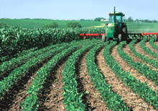

**Fig 1. Contour farming in practice**

**GPS role in Precision Agriculture:**

Precision agriculture optimizes farming by applying the right practices at the optimal time and location. While advanced technologies and data analytics guide decision-making, successful implementation ultimately depends on skilled farm managers effectively using standard equipment like planters, sprayers, and harvesters (Colvin and Kerkman, 1999). The approach combines cutting-edge analysis with practical field operations to maximize efficiency and productivity.

**DGPS Differential Global Positioning Systems**

DGPS or Differential GPS is a technique used to improve and enhance the accuracy of the Global Positioning System (GPS). A standard GPS system typically offers an accuracy of ±15 meters, while Differential GPS (DGPS) enhances precision to ±3 centimeters. This improvement is achieved by using multiple high-accuracy ground reference stations that detect errors in satellite signals. These reference stations calculate the discrepancies and transmit correction data to nearby DGPS receivers, allowing them to adjust the satellite-derived positions in real time. As a result, DGPS significantly reduces positioning errors, delivering ultra-precise location data for applications requiring centimeter-level accuracy. DGPS improves the accuracy and integrity of standard GPS. DGPS works by placing a GPS receiver at a known location, this is called a reference station.The reference station knows its exact location, and therefore can calculate the difference between the GPS derived positions and the true position. The reference station calculates the errors in the GPS signals by comparing its known position to the position derived from the satellite signals. The stations actually calculate the differences between measured and actual ranges for each of the satellites visible from that station. This calculated difference is called the “differential correction” for that satellite. In real time DGPS, the correction signals are broadcast from the reference station and used immediately by the roving GPS to correct the position data being collected. There are two main sources of real time DGPS that USDA uses.

**Remote sensing**: Remote sensing plays a crucial role in modern agriculture, utilizing advanced technologies such as UAVs (drones), satellites, and other platforms. These systems operate on a similar principle: capturing electromagnetic energy emitted by the sun, which travels to Earth in the form of light waves (Liaghat & Balasundram, 2010). Much like ocean waves, light waves have measurable wavelengths the distance between consecutive peaks. The electromagnetic spectrum encompasses all solar radiation, but only a small portion of these wavelengths is relevant for agricultural remote sensing. Notably, thermal wavelengths are particularly useful for monitoring soil moisture levels and detecting water stress in crops. This capability enables precise assessment of crop water needs at a sub-field scale, supporting variable-rate irrigation strategies for optimized water use (Torrion et al., 2014).

**Remote Sensing Applications in Modern Agriculture**

* **Ground bases:** Infrared thermometer, spectral radiometer, Pilot-Balloons and radars.
* **Air Bases:** Aircraft air based remote sensing tools.
* **Satellite based:** The digital image processing, using powerful computers

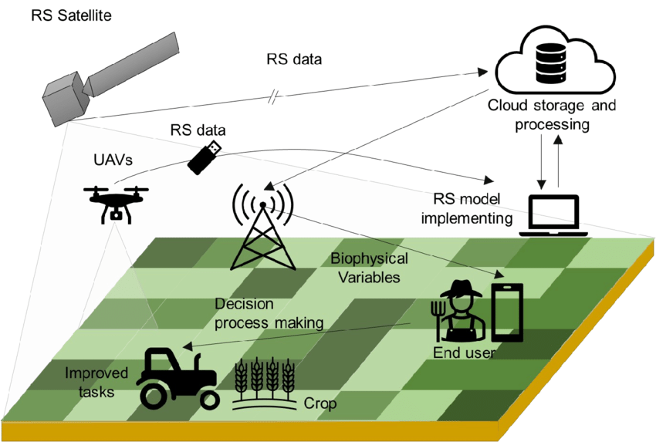

**Fig 2. Framework of precision agriculture**

**2**. **Global Position System**: GPS is a positioning system based on a network of satellites that continuously transmit coded information. The information transmitted from the satellites can be interpreted by receivers to precisely identify locations on earth by measuring distances from the satellites.**3. Geographical information System**: A Geographical Information System (GIS) is a computer-based tool that allows users to capture, store, manipulate, analyze, manage, and visualize geographic or spatial data. It integrates hardware, software, and data for processing geographically referenced information.

In the field of agriculture, GIS enhances productivity and sustainability through data-driven decision-making. It enables precision farming by providing insights into crop health, soil conditions, and irrigation requirements. Soil analysis using GIS helps farmers determine soil fertility, pH levels, and moisture content. GIS is used for monitoring pest outbreaks, allowing for timely and targeted pesticide applications.

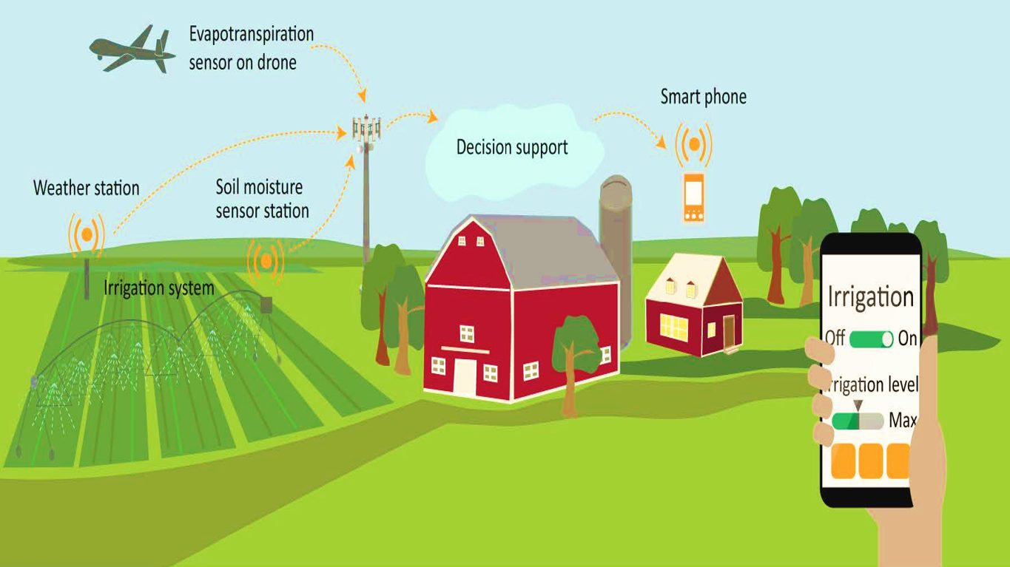

**Fig 3. Automated Irrigation system in precision farming**

**OPPORTUNITIES IN PRECISION AGRICULTURE**

1. **Higher Crop Yields** – AI and data analytics optimize planting, irrigation, and fertilization for maximum productivity.
2. **Resource Efficiency** – Sensors and drones enable precise water, pesticide, and fertilizer use, reducing waste.
3. **Cost Savings** – Automation lowers labor and input costs while boosting profitability.
4. **Sustainability** – Minimized chemical runoff and efficient resource use support eco-friendly farming.
5. **Climate Resilience** – Predictive analytics help farmers adapt to extreme weather and changing conditions.
6. **Smart Automation** – Self-driving tractors and robotic harvesters improve efficiency and reduce labor shortages.
7. **Data-Driven Decisions** – Real-time monitoring and AI insights enhance farm management.
8. **New Business Models** – Agri-tech startups enable pay-per-use sensors, drone scouting, and AI advisory services.
9. **Global Food Security** – Precision tech helps meet rising food demand with limited arable land.
10. **Government Support** – Subsidies and grants encourage adoption in developing economies.

**CHALLENGES FOR PRECISION AGRICULTURE**

The agriculture sector is continuously challenged by the shortage of skilled laborers and low productivity. The advancement in technology has introduced tractors, cultivators, and plows that require minimum human dependency (Mehta et al., 2021).

1. **High Cost**: Precision agriculture is fully supported by the technologies such as GPS, drones, and sensors. These technologies are very costly and require large investments in the starting. Challenges and constraints remain in precision agriculture despite its progress. Sophisticated technology can create challenges in terms of accessibility and pricing, which can hinder small-scale farmers from adopting it (H.J. Smidt 2022).
2. **Lack of technical expertise knowledge and technology**: The deployment and use of technologies, as well as interpretation of the captured data, require a high level of awareness and skilled person.
3. **Not Viable for Small Land Holdings**: Precision farming requires significant investments and is more conducive to mechanized farming, with proximate sensors typically deployed on farm machinery like tractors. The returns from small landholdings may be too little (due to low absolute output, even if the yield is high) to justify the high investments required in precision farming.
4. **The high costs of precision agriculture technologies and mechanized systems** are primarily feasible for large-scale farms. Small landholdings face limited returns due to low total production volumes, even when crop yields are high. This makes it difficult to justify the substantial investments required for precision farming tools, creating a significant adoption barrier for smallholder farmers.
5. **Security Risks**: Precision farming tech is vulnerable to cyber-attacks by hackers, terrorists, or hostile states, risking food supply disruptions. In 2021, a ransom ware attack shut down 20% of U.S. beef plants, with one firm paying $11 million.
6. **Data Collection**: The prevalence of segregated smallholder farms in the country complicates the process of data gathering.
7. **Lack of Centralized Repository**: A unified agricultural database (weather, soil, crops) is crucial for AI-powered precision farming.
8. **Cadastral Data**: For improved analytics, cadastral data, which includes administrative boundaries and geo-coded soil data, should be made available through public sources.
9. **Disparate Data**: Rich data sets, such as soil health cards on micro-nutrients, are disparate and not interoperable, which limits analytics and value creation.
10. **Affordability**: The technological interventions used in precision farming are unaffordable for Indian farmers.

**CHALLENGES IN ADOPTING PRECISION AGRICULTURE IN INDIA**

1. The adoption of precision farming in India is yet in the nascent stage due to its unique pattern of land holdings, poor infrastructure, lack of farmers inclination to take the risk, social and economic conditions and demographic conditions
2. The small size of landholdings in most of the Indian agriculture limits economic gains from currently available precision farming technology.

**Precision Farming Success Factors**: The effectiveness of precision farming depends on the quality of information provided to farmers and how quickly they adopt it. Competition among service providers can drive success in this field. Research on precision agriculture is expanding across institutions in India.viz.

* The **Space Applications Center (ISRO), Ahmedabad**, is testing remote sensing, GIS, and GPS for variability mapping at a Punjab potato farm.
* The **M.S. Swaminathan Foundation (Chennai)** and **NABARD** are implementing variable-rate input applications in a Tamil Nadu village.
* **IARI (New Delhi)** and **PDCSR (Modipuram)** are conducting precision farming trials in collaboration with **CIAE (Bhopal)**.

In the coming years, GPS-enabled precision agriculture could help Indian farmers adopt advanced technologies sustainably boosting yields without harming land or crop quality.

* **Exponential Growth Anticipated:** Estimate suggest the Indian precision agriculture market could grow at a CAGR of over 10% in the next few years, reaching close to USD 220 million by 2031. Market analysts project that the precision farming sector in India will grow at a CAGR of 12%, supported by government subsidies for modern farming tools.
* **Favorable Factors:** Several factors contribute to this optimistic outlook:
  + **Growing Population and Food Demand:** India needs to optimize production to feed its population sustainably.
  + **Focus on Sustainable Agriculture:** The need to reduce input wastage and environmental impact aligns with precision agriculture principles.
  + **Technological Advances:** Reduce the cost of sensors; increasing the availability of affordable data analytics, and expanding drone use make these tools more accessible.
  + **Government Initiatives:** Programs like the Digital Agriculture Mission and subsidies on farm equipment promote technology adoption.

**Conclusion:** Precision Agriculture empowers farmers to optimize the use of crop inputs more effectively including irrigation, tillage, harvesting, fertilizers and use of pesticides. More effective use of inputs means more crop yield and/or quality, without polluting the environment. However, it has proven difficult to determine the cost benefits of Precision Agriculture management. Precision farming provides a new solution using a system approach for today’s agricultural issue such as the need to balance productivity with environmental concerns.

* It is based on advanced information technology.
* It includes describing and modeling variation in soil and plant species and integrating agricultural practices to meet site-specific requirements.
* It aims at increased economic return as well as at reducing the energy input and the environmental impact of agriculture.
* Disclaimer (Artificial intelligence)
* Option 1:
* Author(s) hereby declare that NO generative AI technologies such as Large Language Models (ChatGPT, COPILOT, etc.) and text-to-image generators have been used during the writing or editing of this manuscript.
* Option 2:
* Author(s) hereby declare that generative AI technologies such as Large Language Models, etc. have been used during the writing or editing of manuscripts. This explanation will include the name, version, model, and source of the generative AI technology and as well as all input prompts provided to the generative AI technology
* Details of the AI usage are given below:
* 1.
* 2.
* 3.

**References:**

1. Ajai, (2002), GPS and its applications, Training course on Remote Sensing and GIS Applications in Agriculture, May 27th –7th June, 2002, RRSSC- Bangalore, pp: 89-99.
2. Ancha Srinivasan, (1999), Precision farming in Asia: Progress and prospects. Precision AgricultureProceedings of the 4th international conference. PP. 623-640.
3. Bucci, G., Bentivoglio, D. and Finco, A. (2018) ‘Precision agriculture as a driver for sustainable farming systems: state of art in literature and research’, Calitatea, Vol. 19, No. Sl, pp.114–121.
4. Colvin, T.S. and Kerkman, E. W., (1999), Precision Agriculture Requires precise tuning. Precision AgricultureProceedings of the 4th international conference. PP. 1083-1088.
5. C.R. Mehta, N.S. Chandel, T. Senthilkumar Status, challenges and strategies for farm mechanization in India Agric. Mech. Asia Afr. Lat. Am., 45 (2014), pp. 43-50
6. Dobermann A, Cassman KG (1996) Precision Nutrient Management in Intensive Irrigated Rice Systems – The Need for Another On-Farm Revolution Better Crops and Plant Food 10(2), 20-25.
7. Griffin, T.W., Shockley, J.M. and Mark, T.B. (2018) ‘Economics of precision farming’, in Shannon, D.K., Clay, D.E. and Kitchen, N.R. (Eds.): Precision Agriculture Basics, pp.221–330, Madison, WI: Am. Soc. Agron.
8. H.J. Smidt, O. Jokonya Factors affecting digital technology adoption by small-scale farmers in agriculture value chains (AVCs) in South Africa Inf. Technol. Dev., 28 (3) (2022), pp. 558-584.
9. Kadiyala, S., Harris, J., Headey, D., Yosef, S. and Gillespie, S. (2014) ‘Agriculture and nutrition in India: mapping evidence to pathways’, Annals of the New York Academy of Sciences, Vol. 1331, No. l, pp.43–56.
10. Kamilaris, A., & Prenafeta-Boldú, F. X. (2018). Deep learning in agriculture: A survey. Computers and electronics in agriculture, 147, 70-90
11. Liakos, K. G., Busato, P., Moshou, D., Pearson, S., & Bochtis, D. (2018). Machine learning in agriculture: A review. Sensors, 18(8), 2674.
12. Sunder, S. (2018) India Economic Survey (2018): Farmers Gain as Agriculture Mechanisation Speeds Up, But More RandD Needed [online] https://www.fmancialexpress.com/budget/india economic-survey-2018-for-farmers-agriculture-gdpmsp/1034266/ (accessed 14 March 2019).
13. Swaminathan, M.S. and Bhavani, R.V. (2013) ‘Food production and availability – essential prerequisites for sustainable food security’, The Indian Journal of Medical Research, Vol. 138, No. 3, p.383.
14. Swaminathan, M.S. (2000) ‘Towards an Evergreen Revolution in India’, NFI Bulletin, Nutritional Foundation of India, Vol. 21, No. 2, pp.1–4.
15. Singh, A.K. (2006). Precision farming lecture. http:// www.iasri.res.in/design/ebook/EBADAT/6 Other%20Useful%20Techniques/14 Precision%20Farming%20Lecture.pd
16. Torrion, J.A., S.J. Maas, W. Guo, J.P. Bordovsky, and A.M. Cranmer (2014). A three-dimensional index for characterizing crop water stress. Remote Sensing 6:4025–4042.
17. Wong TFM, Stone PJ, Lyle G, Wittwer K (2004) PA for all - is it the Journey, Destination or Mode of Transport that’s Most Important? In the CD-ROM proceedings of the 7th International Conference on Precision Agriculture, St. Paul., MN, USA.