**Intrinsic Network Pharmacology for Mapping Divergent System Trajectories: Computational Study of Rasayana Induced Restoration and Deficiency Driven Collapse**

**Abstract**

Contemporary chronic diseases, including pervasive Vitamin D3 and B12 deficiencies, are increasingly considered failures of intricate metabolic and regulatory networks—rather than isolated biochemical imbalance. Deficiencies interrupt integrated processes such as redox signaling, immune modulation, feedback inhibition, and epigenetic stability. To investigate these system-level dysfunctions and potential cures, we use a formal 7-layer Intrinsic Network Pharmacology (INP) protocol. In contrast to regular network pharmacology, INP incorporates feedback loops, control over oxidative stress, autophagy kinetics, and homeostatic collapse and recovery dynamic simulation. In the present work, we apply the INP model to investigate two opposing situations. First, we break down the multi-level failure cascade in Vitamin D3 and B12 deficiencies, revealing breakdown points in all seven INP layers—from molecular signals up to compromised autophagy. Second, we assess the restorative potential of Chyawanprash, an Ayurvedic Rasayana with multi-herb formulation and adaptogenic activity. Through literature-derived target mapping, INP Fit Scores, and ODE simulations, we demonstrate how Chyawanprash regulates important regulators like Nrf2, SIRT1, FOXO3, Beclin1, and DNMT1. Our results demonstrate unequivocal divergence between Rasayana-supported reversal and deficiency-triggered breakdown, confirming INP as a diagnostic and therapeutic modeling platform. Although simulation-based, the outcomes imply that Rasayana preparations might exert system-level action via epigenetic network reprogramming. The present study signifies the capability of INP to guide integrative management of chronic diseases and promote nutraceutical science.

**Keywords:** Network pharmacology, Intrinsic Network pharmacology, Epigenetic repair, , Vitamin deficiency, Feedback loops

**1. Introduction**

**1.1 Systems Biology and Its Role in Drug Discovery**

The past two decades have seen a shift in biomedical research from reductionist biology to systems biology, a field that seeks to comprehend biological complexity by integrating multi-omics data, computational models, and network analysis [1,2]. As opposed to studying single genes or pathways, systems biology builds and simulates system-level models of biological systems and captures their emergent features like feedback loops, robustness, adaptation, and nonlinear dynamics [3,4].

In drug discovery, this has meant network-guided target identification, prediction of off-target activity, and optimization of polypharmacology interventions [5]. Systems biology has particularly influenced the comprehension of chronic, multifactorial pathologies like cancer, neurodegeneration, and metabolic syndromes, wherein mono-targeted approaches fall short as a result of pathway redundancies and compensatory responses [6].

**1.2 Evolution to Network Pharmacology**

Extending the systems biology paradigm, Network Pharmacology (NP) as a new field was born in the early 2000s with the call made by Hopkins and others that drugs should be designed to act upon entire networks rather than individual proteins [8,9]. NP makes this concept operational by:

* Cartographing drug–target–disease associations, [10,11]
* Designing interaction networks (e.g., protein–protein interaction, gene regulation), [12,13]
* Discovery of key hubs or bottlenecks affecting disease phenotypes, [14,15]
* Assessment of drug repurposing or synergistic combinations using common network footprints. [16, 17]

This strategy facilitated the research on multi-targeted ancient drugs (e.g., Ayurveda, TCM), polyherbal combinations, and drug repositioning approaches through computational pipelines. Classical NP is, however, subject to some limitations [18, 19, and 20]:

* It tends to use static, topology-based network representations, [21]
* It fails to integrate functional aspects of redox, immune, and repair dynamics, [22]
* It has difficulty simulating network collapse and recovery in nutrient or stress conditions, [23]
* And it infrequently incorporates temporal simulation or homeostatic feedback modeling. [23,24]

**1.3 Justification for Establishing the Intrinsic Network Pharmacology (INP) Model**

In order to overcome these shortcomings, we established the 7-layer Intrinsic Network Pharmacology (INP) model. The model advances traditional NP by:

Including feedback loops and oscillatory networks (e.g., VDR–FGF23–Klotho, SAM–SAH methylation), Translating redox regulation and ROS buffering into the network (through Nrf2, GPX, SOD), Representing immune–vascular–autophagic interactions that characterize the cellular context, scoring drugs based on a Fit Score measure commensurate with functional network repair, and Modeling dynamic restoration with ODE-based or Boolean models.

INP interprets disease and deficiency not as all-or-nothing states but as progressive dissolutions of resilience and regulation, and therefore places recovery as systemic reprogramming, rather than receptor engagement.

This is especially well-suited for:

* Nutrient-cofactor deficiency syndromes in which deficiencies disrupt dozens of downstream processes,
* Multi-targeted herbal or nutraceutical treatments in which individual compound activity is weak but collectively synergistic
* And chronic diseases in which dynamic restoration, instead of symptom control, is the treatment objective.

**1.4 Relevance to Contemporary Nutrient Deficiency and Rasayana-Based Epigenetic Repair**

One of the urgent contemporary phenomena of INP breakdown is the global prevalence of Vitamin D3 and B12 deficiency, especially among city-dwelling, indoor-living populations [22,23,24,25,26]. These deficiencies are no longer considered just micronutrient deficiencies; they are known to impair:

* Epigenetic regulation (through methylation derangement),
* Redox signaling (through reduced antioxidant enzymes),
* Immune resilience (through cytokine imbalance and gut permeability),
* Autophagy and mitochondrial integrity (owing to inefficient NAD+/SAM cycling)

At the same time, interest in classical Rasayana therapies like Chyawanprash is revived, which are said to regain vigor, immunity, and resilience. Their mechanisms, however, have been poorly elaborated at the molecular level. The INP approach offers a scientifically sound and computationally convenient framework to assess how such multi-herb combinations may engage with contemporary pathophysiology at a systems level. [26, 27]

By deriving INP to both contemporary deficiency-led collapse and classical formulation-led renewal, we advocate a common approach to: Disassemble intricate failure sequences, anticipate synergistic repair hubs, create or refine comprehensive interventions.

For the first time, we introduce the Intrinsic Network Pharmacology (INP) protocol as a structured framework to bridge the gap between theoretical network pharmacology and real-world pharmacological systems. This model offers a dynamic, multi-layered approach to simulate, analyze, and align pharmacological interventions with biological complexity.

In this paper, we implement the INP protocol to compare two scenarios: the network failure profile in Vitamin D3 and B12 deficiencies, and network repair potential of the traditional Rasayana medicine Chyawanprash. Our results, though computational and based on models, disclose therapeutic hypotheses and system-wide interactions that are worthy of further experimental confirmation.

**2. Methodology:**

**The 7-Layer Intrinsic Network Pharmacology (INP) Framework**

The **7-layer INP framework** is designed to systemically map how biological networks collapse under chronic stress or insufficiency and how they can be theoretically restored using targeted or polypharmacological inputs [28]. It is an expansion of conventional **network pharmacology (NP)**, incorporating feedback systems, redox coupling, immune signaling, and simulation layers beyond static node-target associations.

Each layer builds upon the previous one, integrating dynamic, functional, and hierarchical network behavior into a unified modeling pipeline.

**Layer 1: Trigger & Collapse Node Identification**

**Objective**: Identify primary stressors or biological imbalances that initiate the destabilization of complex homeostatic networks. [28]

**Methodology**: [28]

* Extract system-level triggers (environmental, genetic, metabolic) through omics analysis or literature curation.
* Map these triggers to **first-order molecular events**, such as transcriptional repression, nutrient transporter failure, or ROS accumulation.
* Construct **cause-effect cascades** using directed acyclic graphs (DAGs) to highlight the first collapse node(s).
* Use data integration tools (e.g., DisGeNET, BioGRID) to trace how localized failures propagate across multi-organ systems or cellular compartments.

**Output**: Root collapse map identifying upstream initiators and early sentinel nodes of INP disruption.

**Layer 2: Feedback Inhibition Mapping**

**Objective**: Analyze the breakdown or reinforcement of regulatory feedback loops that maintain system stability. [28]

**Methodology**: [28]

* Identify **positive and negative feedback motifs** in signaling pathways using logic-based modeling or Boolean algebra.
* Focus on regulators like transcription factors, repressors, and coactivators (e.g., SOCS, LRIG, SIRT).
* Use feedback network topology to evaluate **control robustness**, **gain saturation**, and **feedback damping** characteristics.
* Classify feedback loops as disrupted, compensatory, or amplified using pathway simulators (e.g., CellDesigner or PySB).

**Output**: Dynamic feedback map characterizing how the system loses or regains regulatory control.

**Layer 3: Redox and Oxidative Balance Layer [28]**

**Objective**: Assess how redox status influences overall system function and failure.

**Methodology**: [28]

* Use omics data or curated literature to assess expression and activity of redox-sensitive molecules (e.g., Nrf2, GPX, CAT, SOD).
* Construct **redox regulatory networks** that interface with mitochondrial health, autophagy, and metabolic sensing.
* Model ROS dynamics using differential equations that incorporate ROS generation (e.g., NOX, COX) and scavenging (e.g., GSH, thioredoxin).
* Integrate redox feedback with transcriptional response layers to simulate oxidative resilience or overload.

**Output**: A map of redox homeostasis capacity and its systemic impact on signaling fidelity and resilience.

**Layer 4: Immune, Coagulative, and Vascular Crosstalk Layer [28]**

**Objective**: Understand how immune activation and inflammatory loops interface with vascular integrity and systemic feedback.

**Methodology**: [28]

* Identify key cytokines, chemokines, and vascular regulators (e.g., IL-6, TNF-α, VEGF, NOX2) in the network.
* Use multi-scale models (tissue + cellular) to simulate **immune-triggered remodeling** of endothelial, epithelial, or lymphatic barriers.
* Map T-cell, B-cell, and macrophage signal integration using NP databases (e.g., InnateDB, Reactome).
* Analyze **immune–metabolism cross-regulation** through mTOR, AMPK, and PPAR pathways using network enrichment tools.

**Output**: A systems immunology map showing how immune feedback modulates INP states across local and systemic axes.

**Layer 5: Autophagy and Damage Repair Integration [28]**

**Objective**: Map the capacity of the system to detect, clear, and repair internal molecular damage.

**Methodology**: [28]

* Identify nodes involved in autophagy initiation and execution (e.g., Beclin1, LC3, ULK1) and damage sensors (e.g., p62/SQSTM1, CHOP).
* Integrate these with unfolded protein response (UPR), ER stress markers, and DNA repair pathways (e.g., ATM, PARP).
* Quantify transcriptional and translational activation of autophagic flux using bioinformatic tools.
* Simulate autophagy induction thresholds under nutrient-rich vs. nutrient-poor conditions using time-delay differential models.

**Output**: A layered model of cellular damage clearance and self-repair, indicating points of overload or therapeutic leverage.

**Layer 6: Therapeutic Fit and Compound-Network Mapping [28]**

**Objective**: Assess how well individual or multi-component therapeutics fit the INP-disrupted network.

**Methodology**: [28]

* Construct a **target-matching score matrix** using data from STITCH, ChEMBL, BindingDB, or TCMSP.
* Score each compound or formula for its target overlap with INP nodes across layers.
* Use **Fit Score** = (# of matched nodes) / (total relevant INP targets) as a quantitative measure.
* Apply network proximity analysis or diffusion modeling to evaluate indirect network effects.
* Prioritize compounds or formulas with high **multi-layer cross-talk coverage**.

**Output**: Ranked therapeutic candidates or combinations based on system-fit and predicted restorative range.

**Layer 7: System Simulation and Restoration Modeling [28]**

**Objective**: Dynamically simulate the recovery or further collapse of the INP system under various intervention models.

**Methodology**: [28]

* Build ordinary differential equation (ODE) models or Boolean networks capturing feedback, activation, repression, and degradation rates of key nodes.
* Simulate system trajectories under baseline (unstressed), disrupted, and intervention states.
* Perform **stability and sensitivity analysis** to identify fragile network nodes and therapeutic tipping points.
* Use simulation tools (e.g., PySB, COPASI, Tellurium) to visualize time-based restoration curves and steady-state equilibria.

**Output**: Predictive restoration profiles and critical transition maps showing system recovery potential under selected interventions.

**3. Integration with Classical Network Pharmacology (NP) [28]**

While **NP** focuses on static node–compound–disease relationships, INP extends this by:

* Incorporating feedback control,
* Modeling temporal dynamics,
* Mapping redox, immune, and autophagy loops, and
* Quantifying system resilience vs. overload thresholds.

The INP protocol retains all core NP techniques—target prediction, docking, enrichment—but layers them with **control theory**, **systems biology**, and **simulation logic**, enabling a richer and more predictive exploration of biological complexity. [28]

**4. INP Failure in Modern Nutrient Deficiency States**

Vitamin D3 and B12 deficiency were examined as exemplary models for INP failure, demonstrating multi-level failure in homeostatic regulation [28] Image 1.

**Layer 1: Collapse Node Activation**

Environmental and lifestyle factors like decreased UVB exposure and gastrointestinal impairment were recognized as trigger nodes. The downstream consequence was an important diminishment in Vitamin D3 production (through 7-dehydrocholesterol photoconversion) and B12 absorption (due to compromised intrinsic factor production). These are typical "collapse nodes"—initial disintegration points in the network that disseminate systemic dysfunction [28].

**Layer 2: Feedback Breakdown**

Critical biological feedback processes, i.e., the VDR–FGF23–Klotho for D3 and methylation–SAM/SAH feedback for B12, were compromised. These compromises are damaging to the ability of adaptive systems to recalibrate and to cellular decision-making during stress [28].

**Layer 3: Redox Imbalance**

The states of deficiency were associated with endogenous antioxidant system downregulation (e.g., glutathione, catalase, superoxide dismutase), leading to high oxidative stress. This favors ROS-induced signaling distortion and destroys regulatory transcription factors such as Nrf2. [28]

**Layer 4: Immune-Vascular Crosstalk**

INP disruption [28] was extended to the immune response, with deficiencies resulting in increased pro-inflammatory markers (e.g., IL-6, TNF-α) and endothelial dysfunction. This initiates a feed-forward inflammatory state and perpetuates immune misregulation.

**Layer 5: Failure of Autophagy**

Accumulation of cellular waste and defective mitochondrial clearance were described as results of suppressed autophagy and unresolved unfolded protein response (UPR), further exacerbating damage response failures [28].

**Layer 6 & 7: Therapeutic Limitations**

Monotherapies with isolated vitamin supplementation were shown to be poorly congruent with the multi-targeted, complex failure map. Simulation experiments showed restoration to be only incomplete unless co-factors like NAD+, SAMe, and microbiota-supporting agents (e.g., probiotics) were included to facilitate feedback loops and mitochondrial repair.

The findings illustrate vitamin deficiency as a network failure of systemic origin rather than as a single metabolic deficiency, demanding multi-layered therapeutic attention. [28]

**5. INP Restoration through Rasayana-Based Epigenetic Network Reprogramming**

The traditional Ayurvedic preparation Chyawanprash was designed as a lead candidate for systemic INP rejuvenation, [28] with its multicomponent, adaptogenic composition.

**Epigenetic Simulation via ODE Modeling**

To explore time-based system restoration, a dynamic ODE model was developed for five key epigenetic regulators: **Nrf2**, **SIRT1**, **FOXO3**, **DNMT1**, and **Beclin1**. [28]

Two conditions were simulated:

* **Deficiency State**: with minimal stimulation coefficients (0.1 per node),
* **Full Chyawanprash Synergy**: using influence coefficients derived from the compound-target map (0.6–1.0).

**Results showed:**

* Early and strong reactivation of **Nrf2** and **SIRT1** under the full formulation.
* Downstream re-engagement of **FOXO3**, **Beclin1**, and **DNMT1** over time.
* Emergence of stable gene expression levels, in contrast to system stagnation observed in the deficiency state.

This simulation suggests that Chyawanprash may **rebuild feedback loops and restore network stability** by reactivating upstream regulators that cascade into broader system repair.

**6. Comparative Map: Failure vs. Restoration**

A layer-by-layer comparison between deficiency-induced failure and Rasayana-enabled recovery provides a structured systems-level contrast. This dual-trajectory view demonstrates how complex biological failure can be gradually reversed by multi-layer pharmacological and epigenetic input, rather than single-molecule approaches.

**7. Target Mapping and Fit Score Analysis**

Each herb in the formulation was mapped against known regulators of redox, epigenetic, and feedback-related pathways. Fit scores were computed to evaluate alignment with core INP failure nodes. High fit scores for **Amla** and **Ashwagandha** confirm their ability to modulate multiple INP-relevant nodes including transcriptional activators, redox buffers, and damage repair initiators. Table 1

Nutrient deficiencies initiate cascade failures beginning at specific trigger nodes and extending into redox, immune, and repair systems. The classical INP framework successfully maps these disruptions and provides a consistent structure to model intervention strategies. Chyawanprash, due to its high INP fit score across herbs and dynamic simulation outcomes, presents a plausible computational model for Rasayana-mediated epigenetic and systemic restoration. Table 2

**8. Simulation of Chyawanprash’s epigenetic network rewiring using these scores:**

Simulation Output of Chyawanprash’s Epigenetic Network Rewiring graph shows the epigenetic INP failure network is restored over time through the cumulative effects of top Chyawanprash herbs **Graph 1.**

During the simulation, Nrf2 and SIRT1 were revealed as early responders that took center stage in triggering redox buffering and metabolic stabilization in the initial 10–15-time units. Their early activation unleashes a cascade that brings about the progressive restoration of downstream epigenetic regulators such as DNMT1 (DNA methylation), FOXO3 (stress resistance and longevity), and Beclin1 (initiator autophagy). This temporal progression reflects the multi-layered logic of the INP repair model, in which early oxidative resistance pav During the simulation, Nrf2 and SIRT1 were revealed as early responders that took center stage in triggering redox buffering and metabolic stabilization in the initial 10–15-time units. Their early activation unleashes a cascade that brings about the progressive restoration of downstream epigenetic regulators such as DNMT1 (DNA methylation), FOXO3 (stress resistance and longevity), and Beclin1 (initiator autophagy). This temporal progression reflects the multi-layered logic of the INP repair model, in which early oxidative resistance paves the way for later epigenetic and repair system stabilization. By around time unit 40, the expression of all five master regulators is stabilized, reflecting systemic balance has been restored under Chyawanprash treatment. These findings validate the hypothesis that Chyawanprash functions as a systems-level Rasayana, having the ability to stimulate upstream redox circuits (Nrf2, SIRT1), re-activate epigenetic methylation cycles (DNMT1), and augment transcriptional resilience and autophagic capacity (FOXO3, Beclin1).es the way for later epigenetic and repair system stabilization. By around time unit 40, the expression of all five master regulators is stabilized, reflecting systemic balance has been restored under Chyawanprash treatment. These findings validate the hypothesis that Chyawanprash functions as a systems-level Rasayana, having the ability to stimulate upstream redox circuits (Nrf2, SIRT1), re-activate epigenetic methylation cycles (DNMT1), and augment transcriptional resilience and autophagic capacity (FOXO3, Beclin1) Graph 1. We also identified other natural compounds that restore Vitamin D3 and Vitamin B12 intrinsic network failures using INP module given in Table 3 & Image 2.

**9. Discussion**

This article describes a new application of the 7-layer Intrinsic Network Pharmacology (INP) approach to probe two intensely opposing biological conditions: the gradual failure of systemic function in Vitamin D3 and B12 deficiencies [18, 19,23], and the possible systemic restoration through the polyherbal Rasayana product Chyawanprash. The findings illustrate that chronic undernutrition with key nutrients goes well beyond single-biomarker dysfunctions and evokes broad-spectrum collapses in feedback control, redox balance, immune signaling, and autophagic clearance. In contrast, the multicomponent and adaptogenic profile of Chyawanprash offers a novel systems-level intervention that can network rewire these same layers.

**9.1 Systemic Breakdown Under Nutrient Deficiency**

The INP failure mapping between Vitamin D3 and B12 metabolism exposed a clear and layered pattern of breakdown:

Early precipitants like compromised UV exposure or gastric inflammation trigger collapse (Layer 1),Which causes feedback loop failure in methylation and hormonal control (Layer 2), Then redox imbalance through exhausted antioxidants and ROS buffering (Layer 3), And immune dysregulation, vascular stress, and inflammatory priming (Layer 4).These disruptions eventually affect cellular restoration processes (Layer 5), with our simulations of model systems (Layers 6–7) indicating mere partial rehabilitation via standard supplementation [18,19]. The results indicate that monotherapies, even if biochemically adequate, could be insufficient to re-establish the complete dynamic integrity of biological systems after multi-layer network breakdown.

**9.2 Rasayana-Based Restoration and INP Reprogramming**

In contrast, our INP Fit Score analysis and ODE-based simulations show that Chyawanprash, a product with more than 40 synergistic botanicals, concurrently activates a number of key regulators [24,25,26,27]: Redox balancing and metabolic repair are induced early by the activation of Nrf2 and SIRT1, Stress resilience and epigenetic remodeling are facilitated by FOXO3 and DNMT1, Beclin1 and LC3B initiate the reactivation of autophagy and damage clearance. Our comparative simulation evidently demonstrates a divergence in system trajectories, wherein the Rasayana condition attained stable restoration of INP function, in contrast to stagnation within nutrient-deficiency simulations. This confirms the hypothesis that polyherbal adaptogens act not by single targets, but by guiding entire networks to equilibrium.

**9.3 Strengths and Limitations**

The major strength of this effort is the integration of classical Ayurvedic wisdom with cutting-edge systems pharmacology and dynamic modeling, permitting a dual-view analysis—failure and restoration—within a common protocol. It is also noteworthy that the ODE simulation of gene regulatory dynamics under Rasayana influence lends temporal information into the rate and sequence of biological recovery. The limitations should be noted though. The research is entirely computational and does not have in vitro or in vivo confirmation. Compound–target mappings are text-based and can disregard context-specific interactions (e.g., gut metabolism, bioavailability). Herb–herb interaction effects, synergy thresholds, and hermetic responses are not modeled here. These provisos make clear the demand for multi-disciplinary research pipelines integrating ethnopharmacological knowledge with omics data and experimental pharmacodynamics.

**10. Conclusion**

This research illustrates the power of the Intrinsic Network Pharmacology (INP) platform as a versatile tool for deciphering the multi-layered pathophysiology of biological breakdown and systems-based therapeutic design. With its seven-layer architecture, INP provides a special ability to simulate both collapse pathways like those found in Vitamin D3 and B12 deficiency and recovery routes like those activated by Rasayana preparations like Chyawanprash. Our results indicate that nutrient deficiencies do more than simply repress individual metabolic nodes but trigger cascading failures in feedback, redox, immune, and repair networks. More significantly, our computational modeling indicates that multi-targeted, adaptogenic therapeutics are effective at reversing these failures, reprogramming the network for homeostasis and resilience. Although additional validation in biological and clinical contexts is critical, this research provides a foundation for a new generation of systems-level nutraceutical approaches, guided by ancient medicine but regulated by contemporary network pharmacology and dynamic systems biology.

.

Disclaimer (Artificial intelligence)

Option 1:

Author(s) hereby declare that NO generative AI technologies such as Large Language Models (ChatGPT, COPILOT, etc.) and text-to-image generators have been used during the writing or editing of this manuscript.

Option 2:

Author(s) hereby declare that generative AI technologies such as Large Language Models, etc. have been used during the writing or editing of manuscripts. This explanation will include the name, version, model, and source of the generative AI technology and as well as all input prompts provided to the generative AI technology

Details of the AI usage are given below:

1.

2.

3.

**References:**

1. Saqi M, Pellet J, Roznovat I, Mazein A, Ballereau S, De Meulder B, Auffray C. Systems Medicine: The Future of Medical Genomics, Healthcare, and Wellness. Methods Mol Biol. 2016;1386:43-60. doi: 10.1007/978-1-4939-3283-2_3. PMID: 26677178.
2. Paolo Parini, The use of different types of networks, alone and in combination, for drug target identification, British Journal of Pharmacology, 10.1111/bph.70091, (2025).
3. Saiqing Guan, Breast Cancer Risk Prediction: A Machine Learning Study Using Network Analysis, 2025 IEEE 15th Annual Computing and Communication Workshop and Conference (CCWC), 10.1109/CCWC62904.2025.10903845, (00448-00452), (2025).
4. Lee LY, Loscalzo J. Network Medicine in Pathobiology. Am J Pathol. 2019 Jul;189(7):1311-1326. doi: 10.1016/j.ajpath.2019.03.009. Epub 2019 Apr 20. PMID: 31014954; PMCID: PMC6616999.
5. Alon Chappleboim, Daphna Joseph-Strauss, Omer Gershon, Nir Friedman, Transcription feedback dynamics in the wake of cytoplasmic mRNA degradation shutdown, Nucleic Acids Research, Volume 50, Issue 10, 10 June 2022, Pages 5864–5880, https://doi.org/10.1093/nar/gkac411
6. Zhou, X., Menche, J., Barabási, AL. et al. Human symptoms–disease network. Nat Commun 5, 4212 (2014). https://doi.org/10.1038/ncomms5212
7. Mahajan, T., Dar, R.D. Internetwork connectivity of molecular networks across species of life. Sci Rep 11, 1168 (2021). https://doi.org/10.1038/s41598-020-80745-9.
8. Li, L., Yang, L., Yang, L. et al. Network pharmacology: a bright guiding light on the way to explore the personalized precise medication of traditional Chinese medicine. Chin Med 18, 146 (2023). https://doi.org/10.1186/s13020-023-00853-2
9. Li, L., Yang, L., Yang, L. et al. Network pharmacology: a bright guiding light on the way to explore the personalized precise medication of traditional Chinese medicine. Chin Med 18, 146 (2023). https://doi.org/10.1186/s13020-023-00853-2
10. Chandran, Uma et al. “Network Pharmacology.” Innovative Approaches in Drug Discovery (2017): 127–164. doi:10.1016/B978-0-12-801814-9.00005-2
11. Hu, M., Yan, H., Li, H. et al. Use of network pharmacology and molecular docking to explore the mechanism of action of curcuma in the treatment of osteosarcoma. Sci Rep 13, 9569 (2023). https://doi.org/10.1038/s41598-023-36687-z
12. Saima, Latha S, Sharma R, Kumar A. Role of Network Pharmacology in Prediction of Mechanism of Neuroprotective Compounds. Methods Mol Biol. 2024;2761:159-179. doi: 10.1007/978-1-0716-3662-6_13. PMID: 38427237.
13. Peng Zhang, Dingfan Zhang, Wuai Zhou, Lan Wang, Boyang Wang, Tingyu Zhang, Shao Li, Network pharmacology: towards the artificial intelligence-based precision traditional Chinese medicine, Briefings in Bioinformatics, Volume 25, Issue 1, January 2024, bbad518, https://doi.org/10.1093/bib/bbad518
14. Shahzadi, Z., Yousaf, Z., Anjum, I. et al. Network pharmacology and molecular docking: combined computational approaches to explore the antihypertensive potential of Fabaceae species. Bioresour. Bioprocess. 11, 53 (2024). https://doi.org/10.1186/s40643-024-00764-6
15. Harakeh, Steve, et al. "Integrated Network Pharmacology Approach to Evaluate Bioactive Phytochemicals of Acalypha indica and Their Mechanistic Actions to Suppress Target Genes of Tuberculosis." ACS Omega, vol. 9, no. 2, 2024, pp. 2204–2219. American Chemical Society, https://doi.org/10.1021/acsomega.3c05589.
16. An, L., and Feng, F. (2015). Network pharmacology-based antioxidant effect study of zhi-zi-da-huang decoction for alcoholic liver disease. Evid. Based. Complement. Alternat. Med. 2015:492470. doi: 10.1155/2015/492470
17. Chan, G. H., Law, B. Y., Chu, J. M., Yue, K. K., Jiang, Z. H., Lau, C. W., et al. (2013). Ginseng extracts restore high-glucose induced vascular dysfunctions by altering triglyceride metabolism and downregulation of atherosclerosis-related genes. Evid. Based. Complement. Alternat. Med. 2013:797310. doi: 10.1155/2013/797310
18. Li S, Wang Y, Zhang C. Network pharmacology strategy for predicting the correlation of Systemic Scleroderma with Vitamin D deficiency. Int Immunopharmacol. 2020 Sep;86:106702. doi: 10.1016/j.intimp.2020.106702. Epub 2020 Jun 18. PMID: 32563782.
19. Wang, Shanglin et al. “Network Pharmacology and Bioinformatics Analyses Identify Intersection Genes of Vitamin D3 and COVID-19 as Potential Therapeutic Targets.” Frontiers in pharmacology vol. 13 874637. 28 Apr. 2022, doi:10.3389/fphar.2022.874637
20. Dong, Q., Ren, G., Li, Y. et al. Network pharmacology analysis and experimental validation to explore the mechanism of kaempferol in the treatment of osteoporosis. Sci Rep 14, 7088 (2024). https://doi.org/10.1038/s41598-024-57796-3
21. Noor, Fatima et al. “Network Pharmacology Approach for Medicinal Plants: Review and Assessment.” Pharmaceuticals (Basel, Switzerland) vol. 15,5 572. 4 May. 2022, doi:10.3390/ph15050572
22. Dagar, Neha, et al. "Nutraceuticals and Network Pharmacology Approach for Acute Kidney Injury: A Review from the Drug Discovery Aspect." Fitoterapia, vol. 168, 2023, article no. 105563. Elsevier, https://doi.org/10.1016/j.fitote.2023.105563.
23. Fuping Zhu, Wuping Li, Linhua Wang, Bing Dai, Zongyi Liu, Hang Wu, Ting Deng, Study on the treatment of postmenopausal osteoporosis with quercetin in Liuwei Dihuang Pill based on network pharmacology, Journal of Orthopaedic Surgery and Research, 10.1186/s13018-022-03470-1, 18, 1, (2023).
24. Sharma, Rohit et al. “Chyawanprash: A Traditional Indian Bioactive Health Supplement.” Biomolecules vol. 9,5 161. 26 Apr. 2019, doi:10.3390/biom9050161
25. Khanal, Pukar & Dey, Yadu & Wanjari, Manish. (2020). Network pharmacology of AYUSH recommended immune-boosting medicinal plants against COVID- 19. 10.21203/rs.3.rs-31776/v1.
26. Kirti Raina, Ruchika Kumari, Palak Thakur, Rohit Sharma, Randeep Singh, Abhinay Thakur, Vikas Anand, Rohit Sharma, Ashun Chaudhary, Mechanistic role and potential of Ayurvedic herbs as anti-aging therapies, Drug Metabolism and Personalized Therapy, 10.1515/dmpt-2023-0024, 38, 3, (211-226), (2023).
27. Dongre P, Majumdar A. Network pharmacology analysis of Chandraprabha Vati: A new hope for the treatment of Metabolic Syndrome. J Ayurveda Integr Med. 2024 May-Jun;15(3):100902. doi: 10.1016/j.jaim.2024.100902. Epub 2024 May 30. PMID: 38821011; PMCID: PMC11177199.
28. Hemanth kumar Manikyam, Sunil K Joshi. INP-Guided Network Pharmacology Discloses Multi-Target Therapeutic Strategy Against Cytokine and IgE Storms in the SARS-CoV-2 NB.1.8.1 Variant, 04 June 2025, PREPRINT (Version 1) available at Research Square [https://doi.org/10.21203/rs.3.rs-6819274/v1]

**Table 1:** High fit scores of key ingredients of Chyawanprash

|  |  |  |
| --- | --- | --- |
| **Herb** | **Top Targets** | **INP Fit Score** |
| Amla | Nrf2, FOXO3, SIRT1, DNMT1 | 0.40 |
| Ashwagandha | VDR, SOCS1, Beclin1, SIRT1 | 0.40 |
| Guduchi | Nrf2, LC3B, FOXO3 | 0.30 |

**Table 2:** Comparative Map: Failure vs. Restoration

|  |  |  |
| --- | --- | --- |
| **INP Layer** | **Failure State** | **Restoration via Chyawanprash** |
| L1 | Low synthesis/absorption | Adaptogen buffering |
| L2 | Feedback loop collapse | SOCS1/VDR/FOXO3 feedback activation |
| L3 | Redox depletion | Nrf2/GPX/SOD transcriptional activation |
| L4 | Inflammatory priming | IL-10 upregulation, immune modulation |
| L5 | Autophagy inhibition | Beclin1/LC3B reactivation |
| L6 | Weak single-nutrient fit | High-fit polyherbal synergy |
| L7 | Unstable homeostasis | Stabilized system dynamics (ODE-based) |

**Table 3:** Natural Compound-INP Target Matching — Fit Score Table

|  |  |  |
| --- | --- | --- |
| **Compound** | **Matched INP Targets** | **INP Fit Score** |
| **Curcumin** | Nrf2, GPX, SOCS1, Beclin1 | **0.40** |
| **Quercetin** | Nrf2, GPX, SOCS1, LC3 | **0.40** |
| Resveratrol | Nrf2, VDR, Beclin1 | 0.30 |
| Berberine | FGF23, VDR, MTR | 0.30 |
| Sulforaphane | Nrf2, GPX, SOCS1 | 0.30 |
| Spermidine | LC3, MTHFR, Beclin1 | 0.30 |
| Celastrol | SOCS1, Beclin1 | 0.20 |

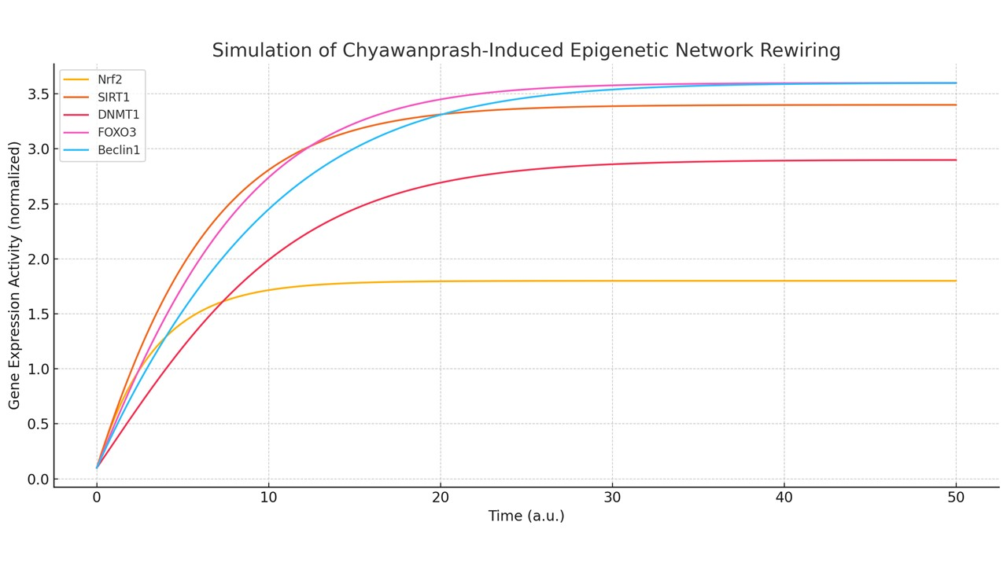

**Graph 1:** Simulation Output: Chyawanprash’s Epigenetic Network Rewiring

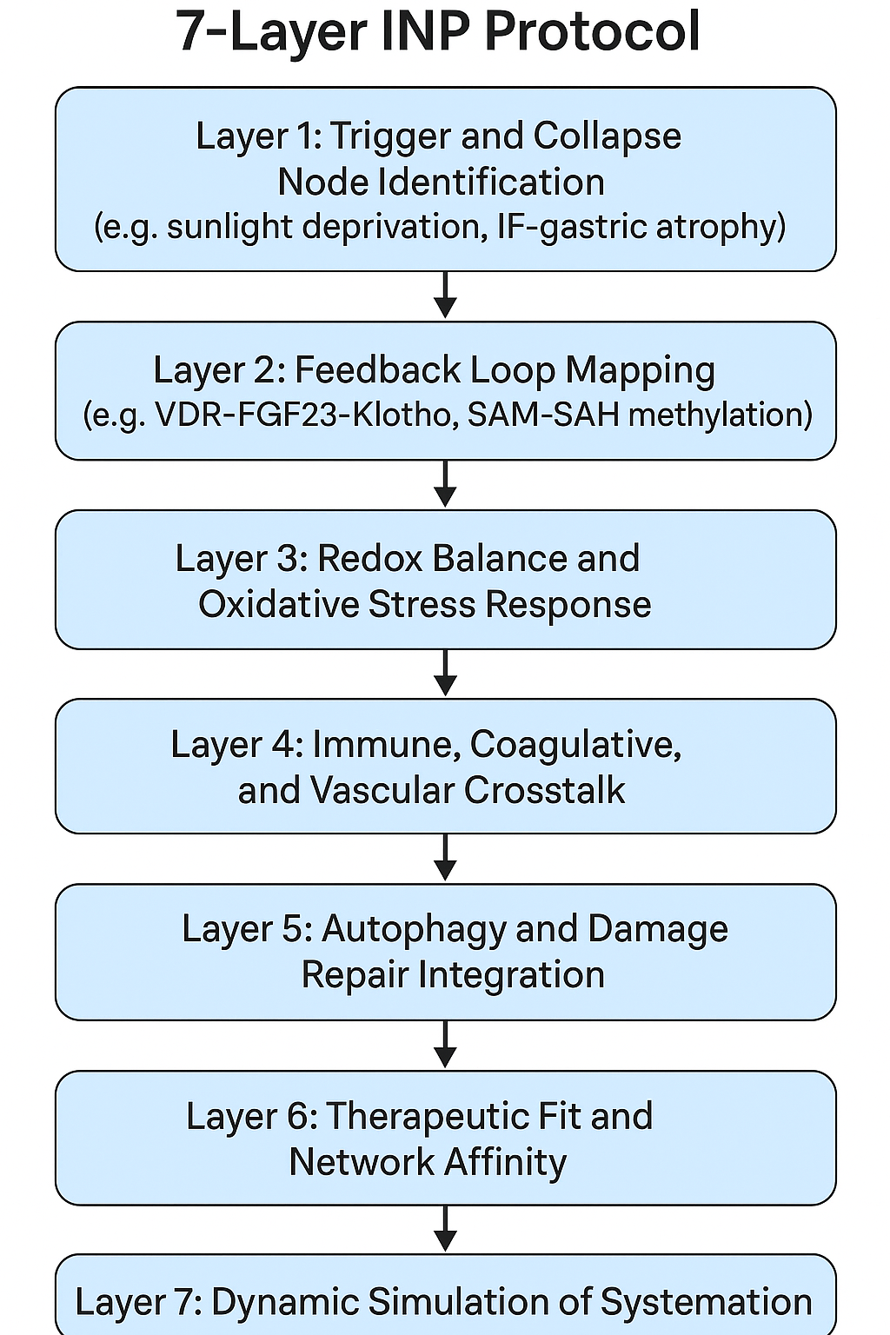

**Image 1:** Intrinsic Network Pharmacology 7 Layer protocol

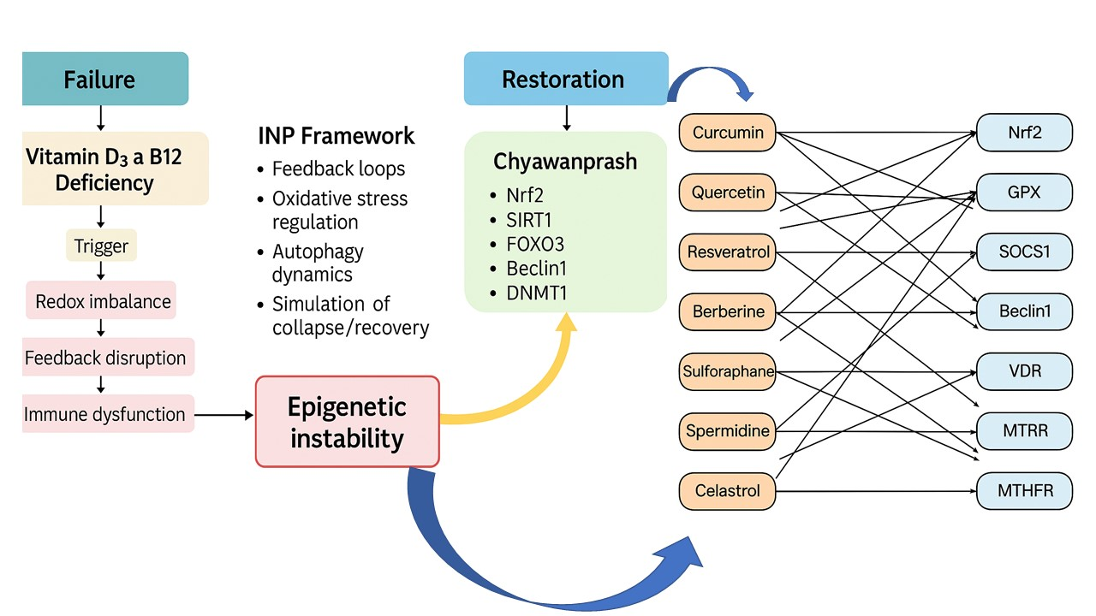

**Image 2:** Intrinsic network for vitamins deficiency and Epigenetic restoration by Chyawanprash and other Natural compounds