PREVALENCE STUDY ON FELINE TRYPANOSOMIASIS IN AND AROUND HYDERABAD, INDIA

Abstract
Aim:
To determine the prevalence of Trypanosomiasis in cats in and around Hyderabad, and to study the associated clinical signs and therapeutic management.
Study Design:
The study involved cats presented to the Veterinary Clinical Complex (VCC), College of Veterinary Science, Rajendra Nagar, Hyderabad, as well as those referred from local dispensaries with clinical signs suggestive of Trypanosomiasis, such as fever and unilateral or bilateral corneal opacity. Data were analyzed based on breed, age, and gender.
Place and Duration of Study:
The study was conducted at the VCC, College of Veterinary Science, Rajendra Nagar, Hyderabad, from September 2024 to March 2025.
Methodology:
Suspected cases were screened for Trypanosomiasis using wet blood film examination, Giemsa stained blood smears along with hematological and biochemical analyses.The data obtained was subjected to statistical analysis.

Results:
Out of 1002 cats examined, 16 (1.6%) were diagnosed with Trypanosomiasis. The majority of affected cats were Domestic Short Hair (DSH) breed (62.5%), and young males (less than 1 year of age) were predominantly affected. The most common clinical signs included corneal opacity (87.5%), fever (81.25%), lymphadenopathy (75%), Inappetence (56.25%), pale mucous membranes (50%), turbidity in the anterior chamber (43.75%) and dehydration (31.25%). Microscopic examination of wet blood films revealed motile, spindle-shaped trypomastigote forms of Trypanosoma spp., which were also confirmed in Giemsa-stained blood smears. Hematological and biochemical findings included anemia, eosinophilia, and hypoglycemia.
Treatment and Outcome:
Affected cats were treated with Diminazene aceturate at a dosage of 3.5 mg/kg body weight for five consecutive days, along with supportive symptomatic therapy. All treated cats showed complete clinical recovery following the full course of treatment.
Conclusion:
Trypanosoma spp were detected in some cats presented at VCC College of Veterinary Science, Rajendranagar, Hyderabad.In cats, unlike in dogs, Diminazene aceturate must be administered for five consecutive days to achieve complete recovery. Interruption of the treatment regimen may lead to relapse.
Keywords: Feline, Trypanosomiasis, Corneal opacity, Diminazene aceturate

INTRODUCTION
Trypanosomiasis is a significant and widespread disease that affects both humans and various animals, including cats [12]. The infection is caused by Trypanosoma brucei and Trypanosoma evansi in animals. [8]. Natural infections of Trypanosomiasis in cats are rarely reported, as cats are more resistant to the disease compared to other vertebrates, making it less common in this species. The disease is transmitted by tsetse flies in sub-Saharan Africa such as Stomoxys, Tabanus, and Triatomid bugs, and it can also be spread by the ingestion of dead animals infected with Trypanosoma spp [10]. There are three forms of Trypanosomiasis: acute, subacute, and chronic, with the acute form being highly fatal. Clinical signs typically appear 2–3 weeks after the fly bite, beginning with a local skin inflammatory reaction (chancre) at the bite site. The parasites multiply within the chancre and subsequently spread to nearby lymph nodes, lymph vessels, and eventually enters into the bloodstream, leading to parasitemia [1]. The clinical signs vary depending on the severity of the infection and the species of Trypanosoma involved. Signs may include fever, anorexia, anemia, enlargement of superficial lymph nodes, conjunctivitis, and limb edema [15]. The most effective method for diagnosing Trypanosoma infections in cats is through a thin blood smear, stained with a Romanowsky stain (such as Giemsa), and examined under a microscope at 1,000× magnification[14] but the species specific diagnosis can be done through Polymerase chain reaction (PCR)[9]. This study aims to explore the prevalence of Trypanosomiasis in cats at Rajendra Nagar, Hyderabad and its diagnosis and therapeutic management of the disease.
MATERIAL AND METHODS
The present case study was conducted on cats presented at Veterinary Clinical Complex (VCC), College of Veterinary Science, Rajendra Nagar, Hyderabad during the period from September 2024 to March 2025. A total of 1002 cats presented at VCC were screened for Trypanosomia spp in cats. The data pertaining to breed, age and sex was recorded. Detailed physical and clinical examination was done and observations were recorded. Wet blood film examination was carried out by using blood samples collected from superficial ear vein (Figure 2). Blood samples were collected from the cephalic vein into a sterile vials with and without EDTA and subjected to further analysis. Heamtological parameters were estimated using EDAN haematology analyzer and biochemical parameters were estimated using EXIGO Veterinary biochemistry analyzer. Blood smear examination was done to rule out hemoprotozoans. In all affected cats, history of flea infestation was noticed. Diagnosis of Trypanosomiasis was done based on history, clinical signs, wet blood film, blood smear examination and hemato-biochemical findings. The data obtained was subjected to statistical analysis as per the method described by Snedecor and Cochran (1994)[13] by using SPSS 20.00 version. All affected cats were treated with Diminazene aceturate @ 3.5 mg/kg bwt for five consecutive days along with symptomatic therapy ( Inj DNS, Melonex and Tribivet).
RESULTS
Out of 1002 cats screened, 16 cats found to be infected with Trypanosomiasis thus the overall prevalence was found to be 1.6 per cent. Among the affected cats nine were aged above 1 year (56.25%) and seven were below 1 year of age (43.75%). Male animals (10/16, 62.5%) were most commonly affected when compared to female animals (6/16,37.5%). Among affected cats ten were DSH breed and four were belongs to Persian breed and three were mixed breed cats. The clinical signs recorded were corneal opacity (unilateral or bilateral) (14/16), lymphadenopathy(12/16), fever (13/16), lethargy (10/16), pale mucosa (8/16), turbidity in the anterior chamber (7/16), inappetence (9/16), and dehydration (5/16) (Figure 1). Examination of the wet blood film revealed transparent, spindle-shaped trypomastigote forms of Trypanosoma spp. exhibiting vigorous movement (Figure 3). Hematological analysis showed anemia (7.34 ± 0.22) and eosinophilia (4.23± 0.34), while serum biochemistry revealed hypoglycemia (43.34 ± 1.22) in the infected cats (Tables 1 and 2). Additionally, Trypanosoma species were identified on the Giemsa-stained blood smears (Figure 4). Trypanosoma infected cats were treated with Diminazene aceturate @ 3.5 mg/kg bwt for five consecutive days along with symptomatic therapy. Complete clinical recovery was noticed after therapy in all the treated cats (Figure 5)

Figure 1: Clinical signs exhibited by Trypanosoma affected cats

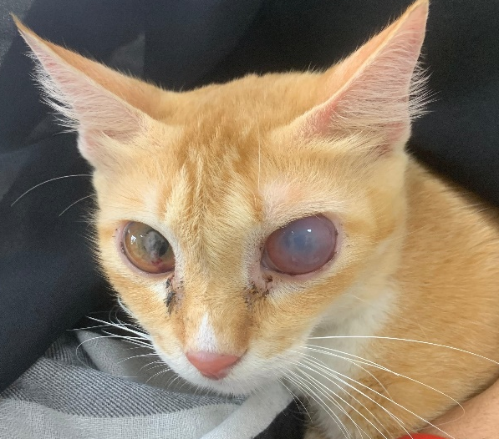 | 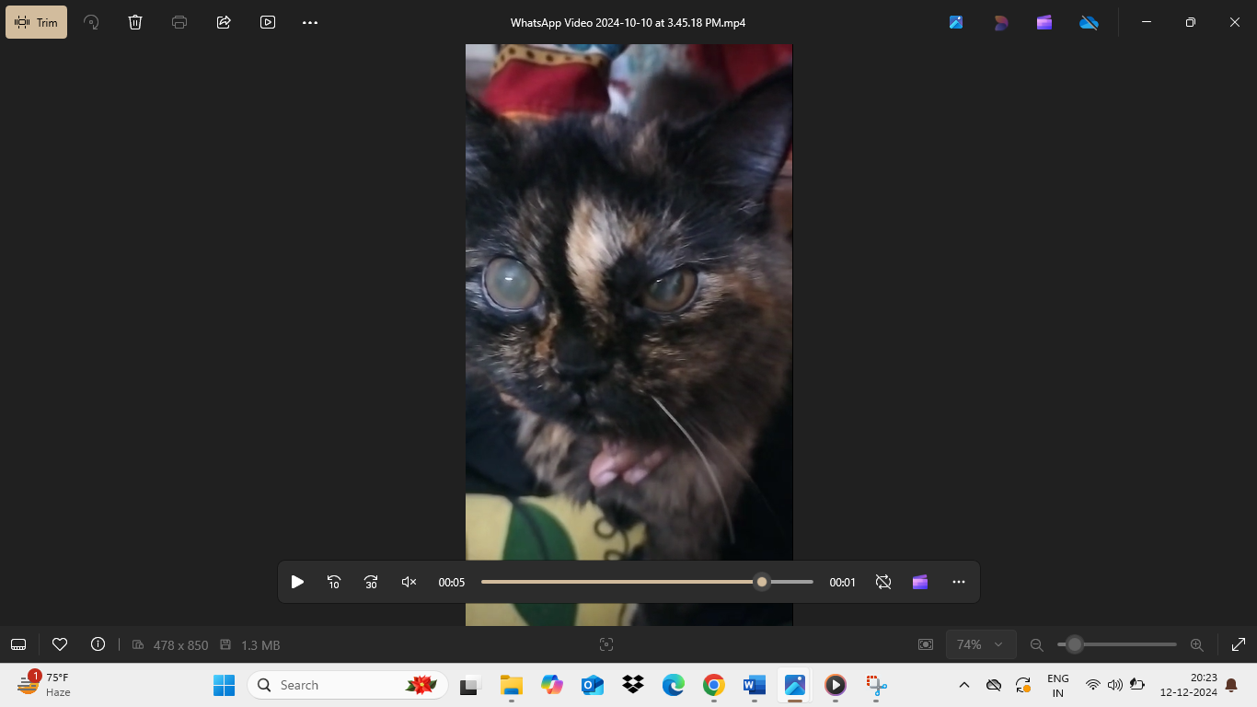
Unilateral corneal opacity | Bilateral corneal opacity
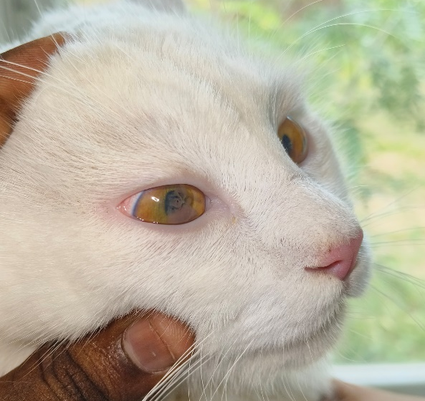 | 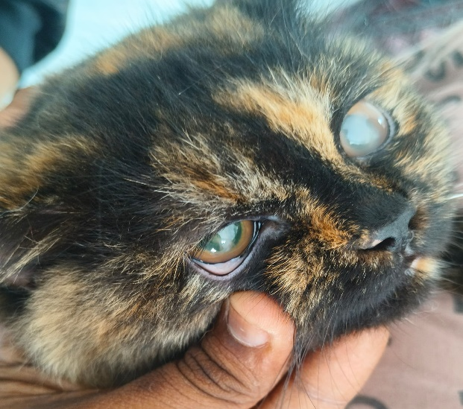
Cloudiness in Anterior chamber | Pale mucosa

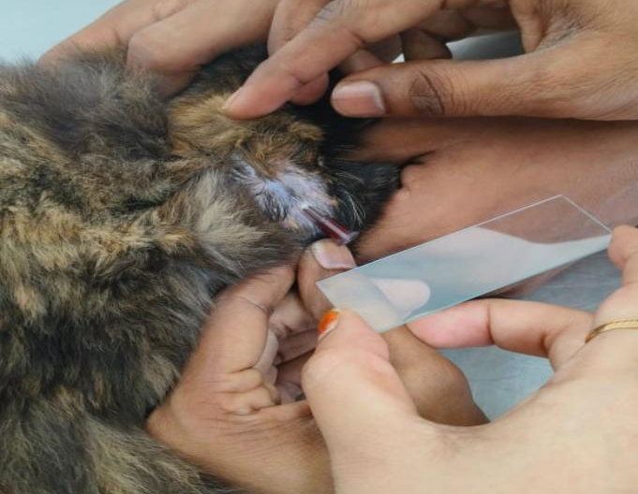 | 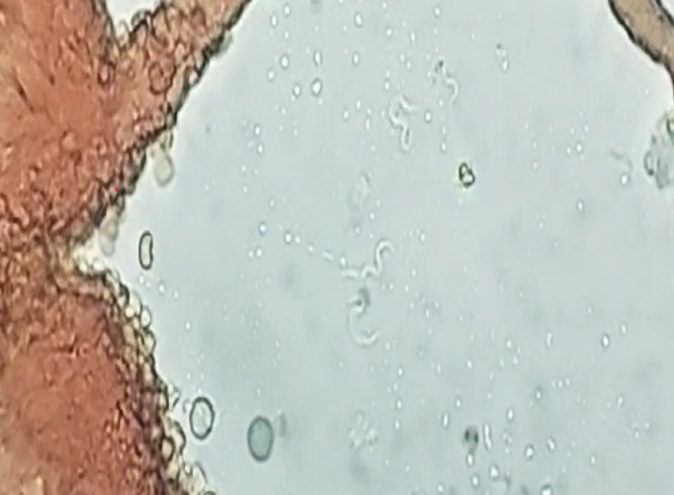
Figure 2 : Collection of peripheral blood from ear vein | Figure 3: Wet blood film showing transparent Trypomastigotes under oil immersion; 100x magnification
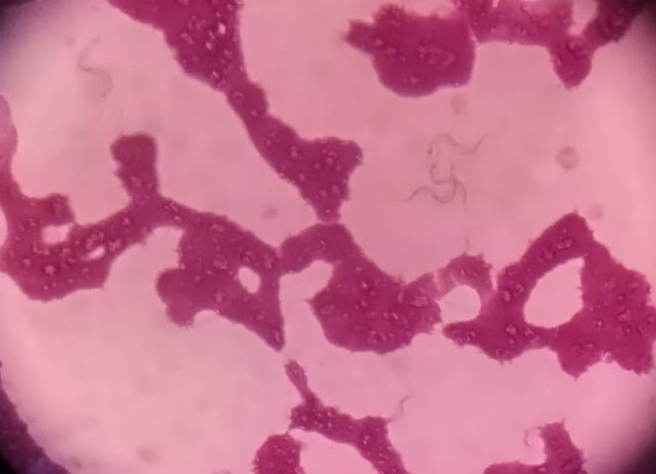 | 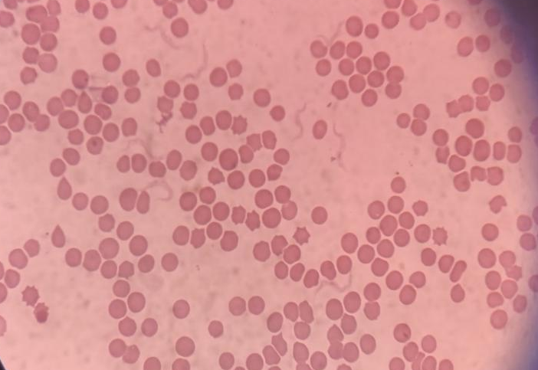
Figure 4: Giemsa stained blood smears showing Trypomastigotes under oil immersion; 100x magnification

Figure 5: Images showing clinical recovery
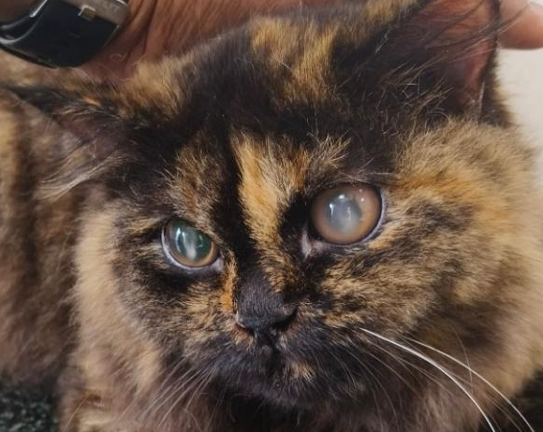 | 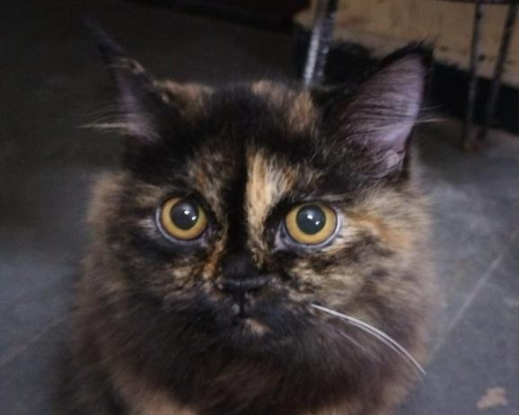
Before Therapy | After Therapy

Table :1 Mean± SE values of Hematological findings in affected cats
Parameter | Infected cats (n=16) | Reference values*
Hb (g/dl) | 7.34 ± 0.22 | 9.3-15.3
TEC (10³/μL) | 3.90 ± 0.50 | 4.6-10
TLC 10⁶/μL) | 7.69 ± 0.25 | 5.5-19.5
PCV (%) | 22.41 ± 0.46 | 28-49
PLT (x105 /)uL) | 2.02± 0.67 | 2-5
Neutrophils (%) | 56.40 ± 0.34 | 35-85
Lymphocytes (%) | 29.16 ± 0.45 | 12-45
Monocytes (%) | 7.45 ± 0.12 | 2-9
Eosinophils (%) | 4.23± 0.34 | 0
* Reference values taken from Merck Manual

Table :2 Mean± SE values of serum biochemical findings in affected cats
Parameter | Infected cats (n=16) | Reference values*
ALT(U/L) | 27.04 ± 1.33 | 10-100
ALP(U/L) | 58.34 ± 1.67 | 6-102
AST(U/L) | 34.34 ± 0.32 | 10-100
Total protein(g/dL) | 7.34 ± 0.45 | 5.2-8.8
Albumin(g/dL) | 2.34 ± 0.67 | 2.5-3.9
Total bilirubin(mg/dL) | 0.24 ± 0.56 | 0.1-0.3
BUN (mg/dL) | 17.34 ± 0.40 | 10-30
Creatinine (mg/dL) | 1.34 ± 0.92 | 0.8-1.8
Glucose (mg/dL) | 43.34 ± 1.22 | 60-100
* Reference values taken from Merck Manual

Discussion and conclusion
In Present study 16 out of 1002 cats were found to be infected with Trypanosoma spp thus the prevalence was found to be 1.6 percent. Domestc short hair (DSH) breed cats (62.5%) were most commonly affected. Male, young animals (<I year) were most commonly affected which is agreement with findings of Mohammed et.al (2022)[8]. The most commonly observed clinical signs were corneal opacity (87.5%), fever (81.25 %), lymphadenopathy (75%), inappetence (56.25%), pale mucosa (50%), turbidity in the anterior chamber (43.75%) and dehydration (31.25%). Ocular involvement is thought to occur via the localization of organisms or associated immune complexes in the uveal tract with deposition along the inner surface of the cornea. Damage to the corneal endothelium, with resultant corneal edema, or granular deposits along the inner corneal surface may cause clouding of the cornea[5]. Anaemia could be attributed to damage of erythrocyte membrane caused by lipid peroxidation [3] and the virulence of the infecting parasite population, age, nutritional status and breed of the host influence the severity of anemia[10]. Eosinophilia noticed in affected animals might be due to parasitemia. The microscopic examination of blood smears stained with Giemsa in this study showed trypomastigotes of Trypanosoma spp. Hypoglycaemia observed among the Trypanosoma infected cats might be due to competition of Trypanosoma oraganisms with host for the glucose and low food intake. A single dose of Diminazene aceturate DIM @ 3.5 mg/kg Bwt was reported to completely eliminate Trypanosomes from the bloodstream, just few hours after its administration [11] but it has no curative efficacy.
In addition, single dose of DIM was found ineffective for the treatment of Trypanosomosis in horses, mules, dogs, cats and buffalos [4,6]. The reason for this was suggested either due to the inability of the drug to cross the blood–brain barrier or due to insufficient doses to control the T. evansi infection [7] and even relapse may be seen in cats that were discontinued therapy. Moreover, treatment of rats and cats with single dose of DIM for five consecutive days were found effective without intoxications and relapses [4]. Although PCR is the most accurate diagnostic test for identifying Trypanosoma species, it was not performed due to financial constraints. However, despite the lack of species identification, all the cats treated showed positive response to Dimenazene aceturate, and complete clinical recovery was observed in all the cases.

Disclaimer (Artificial intelligence)
Option 1:
Author(s) hereby declare that NO generative AI technologies such as Large Language Models (ChatGPT, COPILOT, etc.) and text-to-image generators have been used during the writing or editing of this manuscript.

REFERENCES
- Aloba, W.A., Zaki, D. and Hasan, M.H. (2022). Detection of Dirofilaria immitis antigenia cats in Mosul city. Iraqi Journal of Veterinary Sciences, 36(1), 57–60.
- Brun R, Jenni L. (1987) .Human serum resistance of metacyclic forms of Trypanosoma brucei brucei, T. brucei rhodesiense and T. gambiense. Parasitology Research,73, 218-223.
- Da Silva, A.S., Wolkmer P, Costa M.M. (2009a). Lipid peroxidation in cats experimentally infected with Trypanosoma evansi. Parasitology Research, 106,157-161.
- Da Silva A.S., Zanette R.A., Wolkmer P. (2009b). Diminazene aceturate in the control of Trypanosoma evansi infection in cats. Veterinary Parasitology,165, 47–50. doi: 10.1016/j.vetpar.2009.06.025.
- Greene C.E, (2012).Textbook of Infectious disease of the Dog and Cat .4th edition .
- Howes F., Da Silva A.S., Athayde C.D.L.,(2011) . A new therapeutic protocol for dogs infected with Trypanosoma evansi. Acta Scientiae Veterinariae, 39,1–4.

- Masocha W, Rottenberg M.E., Kristensson K (2007). Migration of African trypanosomes across the blood-brain barrier. Physiology & Behaviour, 92,110–114.
- Mohammed, N.H., Moosa, D.A. and Altaliby, M.A.M. (2022). Diagnostic study of trypanosomiasis of cats in Mosul, Iraq. Open Veterinary Journal, 12(5),688–692.
- Njiru, Z.K., Constantine, C.C., Guya, S., Crowther, J., Kiragu, J.M., Thompson, R.C.A. and Davila, A.M.R (2005). The uses ITS1 rDNA PCR in detection of pathogenic African trypanosomes. Parasitology Research, 95, 186–192.
- Nwoha, R.I.O. 2013. A review on trypanosomosis in dogs and cats. African Journal of Biotechnology, 12(46), 6432–6442.
- Peregrine A.S., Mamman M. Pharmacology of diminazene: a review (1993). Acta Tropica,54,185–203.
- Panigrahi, P.N., Mahendran, K., Jena, S.C., Behera, P., Mahajan, S., Arjun, K. and Dey, S. (2015). Trypanosome evansi infection in a German shepherd dog-Apparent successful treatment using serial low dose of diminazena aceturate. Veterinay Parasitolgy Regional Studies and Reports, 1(2), 70–74.
- Snedecor G.W and Cochran W.G (1994). Statistical methods, 8th Edition, Iowa State University Press, USA.
- Umeakuana, P. U., Gibson, W., Ezeokonkwo, R. C., & Anene, B. M. (2019). Identification of Trypanosoma brucei gambiense in naturally infected dogs in Nigeria. Parasites & vectors, 12(1), 420.
- Zenad, M.M. and Radhy, A.M. (2020). Clinical serological and antigenic study of feline panlenkopenia virus in cats in Baghdad. Iraqi Journal of Veterinary Sciences, 34(2), 435–439.

