**The Supershear Earthquake (M 7.7) in Mandalay, Myanmar on 28th March 2025**

**ABSTRACT**

On March 28, 2025, at 12:50:52 PM local time in Myanmar, a powerful earthquake with a moment magnitude(Mw) of 7.7 struck near Mandalay in Upper Myanmar. The quake lasted approximately 85 seconds, with an epicenter at latitude 21.996ºN and longitude 95.926ºE, at a shallow depth of 10km. A second earthquake of magnitude 6.4 followed just 12 seconds later. Both events occurred along the Sagaing Fault within its fault zone. These quakes caused widespread destruction across central Myanmar and were followed by numerous aftershocks, including a Mw 5.1 quake on March 30, 2025. A detailed study of these events is essential to understand their seismic mechanisms. Fault characteristics were investigated using satellite imagery, seismic data, fault plane solutions, and active tectonic assessments. Findings show that the epicenter is located near the Yega Inn tectonic lake, a pull-apart basin formed by extensional faulting and minor strike-slip motion. Resonance amplification in lake-bed sediments contributed to the earthquake's intensity.

*Keywords****:*** *earthquake, remote sensing, tectonic lake, amplification, sedimentation*

**1. INTRODUCTION**

Myanmar lies at the convergence of two continental plates – the Burma Plate and the Sunda Plate. The Sagaing Fault acts as a dextral(right-lateral) strike-slip fault and transform boundary separating these plates (Curray et al., 1979; Le Dain et al., 1984) To the south, it connects with the Central Andaman spreading center, where ENE-trending ridges are offset by NNW-oriented transform faults (Eguchi et al., 1979). Spreading in the Central Andaman Basin began around 11 million years ago, with active seafloor spreading since 4-5 million years ago (Khan & Chakraborty, 2005). The Sagaing Fault trends roughly 351º (N9ºW) and accommadates movement at 30 mm/year, with a 27 mm/year northward component (Curray, 2005; Vigny el al., 2003). Much of the motion is absorbed by en echelon fault segments within 3-5 1cm-wide transform valley.

**2. TETONIC GEOMORPOLOGY OF THE SAGAING FAULT**

Extending over 1,000 km north to south across Myanmar, the Sagaing fault is marked by sag ponds, pull-apart basins, pressure ridges, and scarps. Geomorphic features were interpreted using high-resolution topographic maps, SRTM-DEM data, Landsat 7 imagery, and aerial photography. Fault segments display en echelon patterns-right-or left-stepping – and the fault is particularly striking in satellite imagery due to its linear, well-defined appearance. Fault interaction has created both compressional and extensional zones, leading to normal faults and localized seismic activity. ENE-WSW transfer faults connect the NNW-SSE trending segments, forming tectonic basins and uplifted zones. Understanding these geomorphic features is essential for evaluating seismic hazards in the Sagaing Fault region (Fig.1).

C:\Users\Acer\Desktop\Yega_L742 (New).tif

Fig. 1. Satellite image showing location of Yega In (lake) on the Sagaing fault

(a) 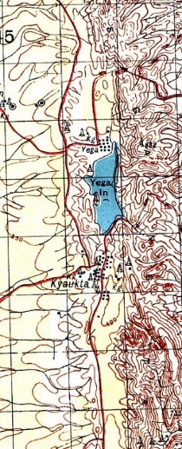 (b) 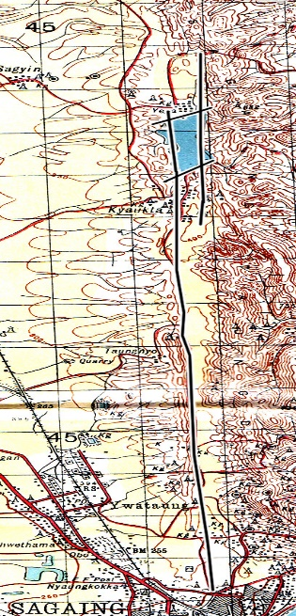

Fig.2. (a)Location of Yega In on topographic map (b) Satellite image of Yega In

Showing the lake with bounding faults of strike-slip and normal fault

**3. TECTONIC LANDFORMS ALONG THE SAGAING FAULT**

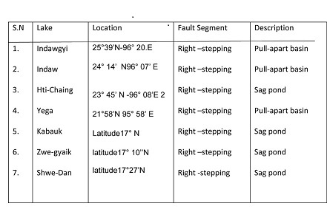

Table 1. Information of Tectonic lake along the Sagaing fault

These basins reflect zones of extension between en echelon fault segments. Earthquake initiation often occurs at fault segment tips and propagates along planes with accumulated stress. Historical earthquakes show that repeated activity has expanded these basin, and will likely continue doing so Fig.(2).

Historical earthquakes correlated with these basins include:

* 1930 Bago earthquake – Kabauk Inn,
* 1839 Ava earthquake 1956 Sagaing earthquake 2025 Mandalay earthquake – Yega Inn
* 2012 Thabeikkyin earthquake – fault gorge at 23°N
* 1949, 1991 Tagaung earthquake– sag pond at 24°N1931
* Kamaing earthquake – Indawgyi Lake (Table 1)

**4. ACTIVE DEFORMATION ALONG THE SAGAING FAULT**

The 2025 earthquake near Mandalay was particularly destructive due to supershear rupture\_ where fault rupture propagates faster than the shear wave velocity, increasing ground shaking. The quake affected a 400km zone along the Mandalay-Sagaing-Naypyidaw corridor, with widespread structural collapse and human causalities, supershear rupture- where fault rupture propagates faster than the shear wave velocity, increasing ground shaking. The quake affected a 400km zone alone the Mandalay-Sagaing-Naypyidaw corridor, with widespread structural collapse and human casualties.

(a) 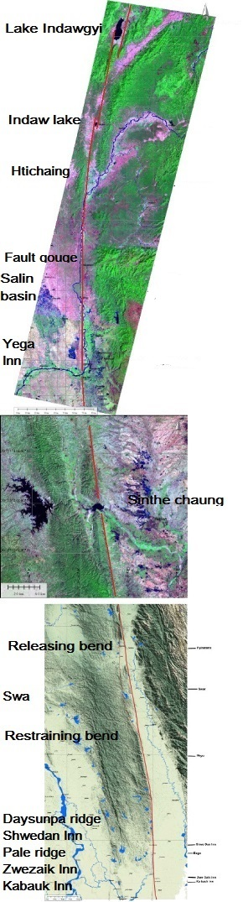 (b) 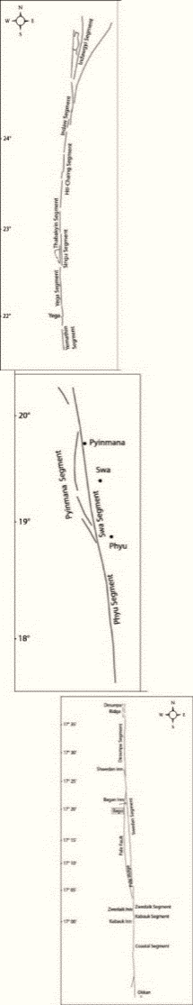

Fig.3. Landsat TM images of the Sagaing Fault. (a) A mosaic of satellite images of Sagaing fault zone along the length, showing tectonic geomorphic features developed by differential motion of Sagaing fault. (b) Line drawing of the Sagaing fault showing structural features at different location along its length The fault can be divided into 3 parts of upper, middle and lower, based on long-term geomorphic and structural features of the fault zone. In the upper part, these segments are as follow (from north to south):the Indawgyi, Indaw, Htichaing, Thabeikkyin ,Singu and Yega segments. These segments, each 50-180 km long and a half kilometer to 5 km wide are linked by step-overs or bends with 125 km long. The satellite image shows a series of tectonic lakes developed between these segments: Lake Indawgyi, Indaw Lake, Singu sag pond and Yega Inn and many other features in the northern part of Myanmar.

**5. DAMAGGE CAUSED BY THE EARTHQUAKE**

The Sagaing Fault displays both extensional and compressional step-overs, contributing to the formation of pull-apart basins and uplift zones. Segments range from 50-180 km in length, separated by 125 km-long bends. These regions show clear signs of seismic amplification due to graphic effects like scraps and sediment-filled basins. Empirical models relate fault length to earthquake magnitude. For example:

log (L) = 0.066M – 2.83 (Utsu, 1961) log (L) = 0.66M – 2.83 (Utsu, 1961)

This implies a 100km fault segment could generate a Mw 7.5 earthquake. The Saging Fault comprises at least 15 segment, many of which have ruptured in the past century, making them critical in hazard assessment. Satellite imagery helps delineate these en echelon segments, indicating zones still accumulating strain. Yega Inn, the epicentral region of the 2025 event, has now released this energy but remains a high-rish area due to clustering of epicenters. Between 1929 and 2012, eight Mw > 7.0 earthquake struck different segments, emphasizing the region’s seismic potential.

**6. CONCLUSION**

The Sagaing Fault is a major right-lateral strike-slip fault demarcating the Burma-Sunda plate boundary Spanning over 1,000km, it is capable of producing large earthquake due to ongoing strain accumulation. Remote sensing and structural analysis reveal complex tectonic regimes, including extensional pull-apart basins and strike-slip faulting. Segments of the fault have ruptured repeatedly over the past century. Earthquake generation along these segments is tied to the accumulated stress and fault geometry.

Disclaimer (Artificial intelligence)

Option 1:

Author(s) hereby declare that NO generative AI technologies such as Large Language Models (ChatGPT, COPILOT, etc.) and text-to-image generators have been used during the writing or editing of this manuscript.

Option 2:

Author(s) hereby declare that generative AI technologies such as Large Language Models, etc. have been used during the writing or editing of manuscripts. This explanation will include the name, version, model, and source of the generative AI technology and as well as all input prompts provided to the generative AI technology

Details of the AI usage are given below:

1.

2.

3.

**REFERENCES**

1. Bender, F. (1983). *Geology of Burma*, Gebruder Borntraeger, Berlin, Stuttgart, 293 pp.
2. Chhibber, H. L. (1934). *The Geology of Burma* Macmillan and Co., London, 538 pp.
3. Chamot-Rooke, N., C. Rangin, C. Nielsen, (2001). Timing and kinematics of Andaman basin opening. Eos Transactions Supplement 82 (20).
4. Curray, J.R. (2005). Tectonics and history of the Andaman Sea region, J. Asian Earth Sci. 25, 187-232.
5. Curray, J.R.,D.G. Moore, L.A. Lawver, F.J. Emmel, R.W. Raitt, M. Henry, and R. Kieckhefer (1979). Tectonics of the Andaman Sea and Burma, in Geological and Geophysical Investigations of Continental Margins, J.S. Watkins, L. Montadert, and P.W. Dickerson (Editors), American Association of Petroleum Geologists Memoir, 29, 189-198.
6. Curray, J.R., F.J. Emmel, D.G. Moore, R.W. Raitt, (1982). Structure, tectonics and geological history of the northeastern Indian Oceanan. In: Nairn, A.E.M., Stehli, F.G. (eds.), the Ocean Basins and Margins. The Indian Ocean, vol.c. Plenum Press, New York, 399-450.

11.Hla Hla Aung, Reinterpretation of Historical Earthquakes for the period (1929-1931), Myanmar, Advances in Geosciences, vol.31, Solid Earth Section, (2011). [www.asiaoceania.org](http://www.asiaoceania.org)

12. Hla Hla Aung. Dynamic evolution of the Sagaing fault, 9th AOGS Conference paper,2012

13. Hough,S.E.,(2004), Finding Faults in California: an earthquake tourist guide, Mountain Press Publishing Company, Missoula, Montana

14. Hough, S.E., Earthquakes News Scientist, weekly 7 january 2012

15.Hurukawa, N., (2011(, Two seismic gaps on the Sagaing fault, Myanmar, derived from relocation of historical earthquake since (1918), Geophysical Research Letters,vol.38, pp.1-5.

16.Mark Van der Meijde and Muhammad Shafique (2010), The Importance of Topography in seismic Amplification, ITC News, pp. 2-4, 2010**-**2**.**

17.Nielsen, C., N. Chamot-Rooke and C. Rangin the ANDAMAN Cruise Team (2004). From partial to full strain partitioning along the Indo-Burmese hyper-oblique subduction, *Mar. Geol*. **209**, 303-327, doi: 10.1016/j.margeo. 2004.05.001.

18.Socquet, A., C. Vigny, N. Chamot-Rooke, C. Rangin, W. Simons, C. Rangin, and B.Ambrosius (2006), Indian and Sunda Plates motion and deformation along their boundary in Myanmar determined by GPS, J. Geophys. Res., 111,B05406. doi: 10.1029/2005JB003877.

19.Tsutsumi, H., and T. Sato (2009), Tectonic geomorphology of the southernmost Sagaing Fault and Surface rupture associated with the May 1930 Pegu (Bago) earthquake, Myanmar, Bull. Seisomol. Soc. Am., 99, 2155-2168, doi: 10.1785/0120080113.

20.Utsu,T. (1992), Destructive earthquakes in the world, 1500-1992, in Earthquake Disaster Reduction Handbook, pp.1-24, Bldg.Res.Inst. Tsukuba, Japan

21. Vigny, C., A. Socquet, C. Rangin, N. Chamot-Rooke, M. Pubellier, M.-N. Bouin, G. Bertrand, and M. Becker, (2003). Present-day crustal deformation around Sagaing Fault, Myanmar. *J. Geophys. Res.,* 108 (B11),2533, doi: 10.1029/2002 JB001999.

**SOURCES**: Data and quotes in the manuscript are drawn from news agencies, reports, INGO, NGO reports among others. Thee provide a comprehensive picture of the quake’s timing, strength, damage and response.