Awareness and Adoption of UPI Facilities among Working-Class Women in An Academic Institution- A Study with Special reference to Assam Agricultural University, Jorhat

Abstract
The rapid growth of digital payment systems in India has reshaped the financial ecosystem, with the Unified Payments Interface (UPI) playing a key role in enabling fast, secure, and cashless transactions. UPI allows users to transfer money instantly using mobile phones, contributing significantly to financial inclusion, especially in underserved areas. Despite its widespread adoption, gaps remain in awareness and usage, particularly among specific demographic groups. This study examines the awareness, usage patterns, and perceptions of UPI services among working-class women at Assam Agricultural University, Jorhat. A random sample of 50 respondents was surveyed using a structured questionnaire, and the data were analyzed using descriptive statistics, t-tests, and Garret ranking techniques. Although most respondents owned Android smartphones and held savings accounts, only 42 per cent had installed banking apps. Awareness of mobile banking was reported by 56 per cent, and online security concerns were prevalent 49 per cent were aware of internet fraud, while 5 per cent had experienced financial loss due to cybercrime. UPI was mainly used for small transactions like mobile recharges, grocery shopping, and DTH payments, with limited use for higher-value payments such as utility bills or rent. Interestingly, educational level showed no significant impact on UPI adoption. The findings underscore the need for targeted digital literacy initiatives, simplified user interfaces, and stronger cyber security awareness. In conclusion, while UPI has revolutionized its effective use among working-class women requires focused efforts to build trust, enhance accessibility, and promote financial empowerment through inclusive digital practices.

Key Words
Digital Payments, Unified Payment Interface (UPI), Financial Inclusion, Working Women, Digital Literacy, Mobile Banking
Introduction
As of March 2022, India's Currency in Circulation (CIC) reached ₹31.33 lakh crore, accounting for 13.7% of its GDP, up from ₹13 lakh crore in 2014. This indicates a substantial rise in cash usage over the years. A high dependency on cash brings with it several challenges, such as production and storage costs, risks associated with counterfeit currency, and, most importantly, the lack of a digital transaction trail, contributing to tax evasion. These issues are expected to be further magnified as the economy continues to grow (Gochhwal, 2017).
To modernize the payment landscape and reduce cash reliance, the Reserve Bank of India (RBI) has introduced several initiatives promoting digital payments. Among the most impactful was the establishment of the National Payments Corporation of India (NPCI), tasked with developing affordable retail digital payment systems. In August 2016, NPCI launched the Unified Payments Interface (UPI)—a mobile-based payment platform that enables real-time bank transfers. UPI takes advantage of India’s high mobile penetration by transforming smartphones into digital wallets for consumers and merchants, thereby advancing the goal of universalizing digital payments (World Bank, 2023; Reserve Bank of India, 2023).
India is rapidly progressing toward digitization, particularly after the announcement of demonetization on 8 November 2016. This policy shift significantly accelerated the adoption of digital payments, offering fintech companies an unprecedented opportunity to expand their market presence. UPI is widely regarded as a convenient and user-friendly method for online transactions, especially among youth and students (Kolte & Humbe, 2020). Multiple factors have contributed to the rise of digital payments: increased smartphone penetration, support from non-banking financial institutions, simplified payment interfaces, the growth of the fintech sector, and government incentives such as tax breaks and digital literacy campaigns. These developments have collectively fostered a favourable environment for digital payment adoption in India (Neema & Neema, 2016).
According to the report, individuals are increasingly cognizant of digital payment systems and opt for UPI applications due to their user-friendly interface and robust security measures (Sonali and Kamaraj, 2024). Interoperability between banks is also a unique feature of UPI. Unlike e-wallets earlier, a user doesn’t need to store money in a separate wallet for each app (Narayanan,2021). Digital payments often involve lower transaction fees compared to traditional methods and also can eliminate the need for money orders or cashier's checks, which often come with additional fees (Vipin, 2020).
This research paper delves into the awareness and adoption of UPI among working women in India, aiming to identify the factors influencing their engagement with digital payments. While over 200 million women have access to mobile internet, only 37% report using it, and an even smaller percentage actively engage in digital financial transactions. Barriers such as limited digital literacy, concerns over security, and lack of trust in digital platforms continue to impede widespread adoption.
Particularly for working women who often juggle professional responsibilities with household management, digitalization can majorly enhance women’s social and financial autonomy (Kulkarni, 2021). Understanding the unique challenges and motivations of this demographic is crucial for designing targeted interventions that promote UPI adoption. Therefore, the present study seeks to understand the

- Level of awareness and actual usage of UPI services among working women belonging to various age and income groups at Assam Agricultural University, Jorhat.
- To examine the challenges and perceptions related to the safety, accessibility, and usability of UPI services among the respondents

3. Methodology
A cross-sectional survey design was employed to investigate the awareness, usage patterns, and user perceptions of Unified Payments Interface (UPI) services among working-class women. A total of 50 respondents were selected using a random sampling technique from various departments of Assam Agricultural University, Jorhat, Assam.
Data were collected through a structured questionnaire, which comprised four sections: (i) Demographic profile, (ii) Awareness of UPI services, (iii) Usage behavior, and (iv) Perceived advantages and challenges associated with UPI transactions. Prior to administration, the questionnaire was reviewed for content validity by subject matter experts.
Quantitative data obtained from the responses were analyzed using descriptive statistics, including frequencies and percentages, to summarize participant characteristics and response trends. Inferential analysis was conducted using the Student’s t-test to examine statistical significance between selected variables. Additionally, the Garret Ranking Technique was applied to identify and prioritize the key factors influencing user preferences and perceived challenges related to UPI service utilization.
All analyses were performed using standard statistical software, and results were interpreted within the context of the study objectives.

4. Results
4.1 Demographic Profile of Respondents
Age Distribution: The majority of respondents (47%) were aged between 35–45 years, followed by 33 per cent in the 25–35 age group, and 20 per cent in the 45–55 age group (Fig.1). Educational Qualification: About 56.66 per cent of respondents had education up to high school. Graduates and postgraduates accounted for 13.33 per cent each, while 6.66 per cent had completed higher secondary education, and another 6.66 per cent were uneducated (Fig 2).
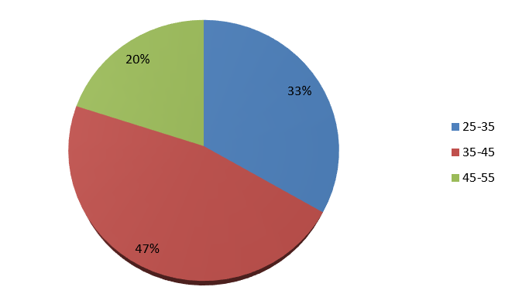 | 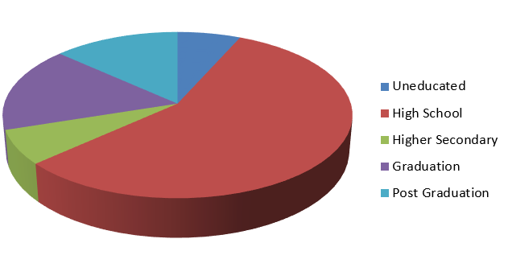
Figure 1. The age group of the respondents | Figure 2. The educational level of the respondents
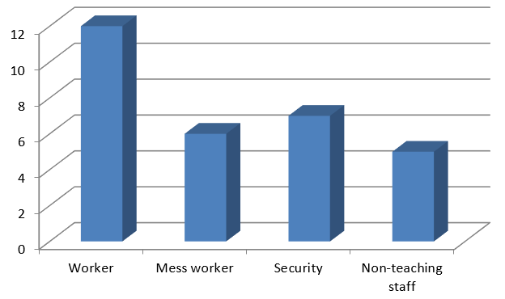 | 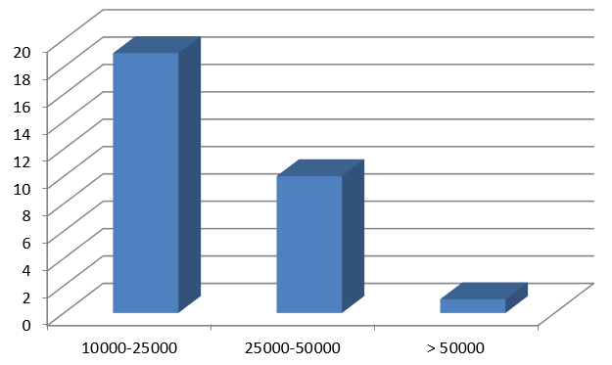
Figure 3. Occupation of the respondents | Figure 4. Monthly Income of the respondents
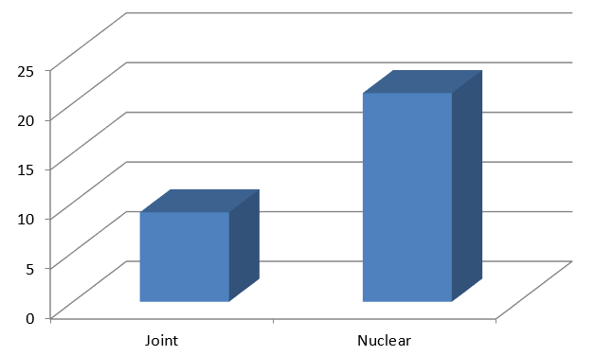
Figure 5. The family type of the respondents

Occupation: Respondents were engaged in various roles – 40 per cent as general workers, 23.33 per cent in security services, 20 per cent as mess workers, and 16.66 per cent as clerical staff (Fig 3). Regarding monthly income of the respondents showed that a significant portion (63.33%) earned between ₹10,000–₹25,000 monthly, 33.33 per cent earned ₹25,000–₹50,000, and 3.33 per cent earned above ₹50,000 (Fig 4). Family Type: The majority (70%) belonged to nuclear families, while 30 per cent were from joint families (Fig 5).
4.2 Awareness and Usage of UPI
Analysis of data in Table 1 revealed that, 90 per cent of respondents owned Android smart phones. Only 42 per cent had installed banking applications. About 56 per cent were aware of mobile banking services. Almost half of the respondent’s i.e. 49 per cent of respondents was aware of internet frauds and a very meager per cent (5%) had experienced financial losses due to cyber incidents. UPI usage was primarily for mobile recharges, DTH payments, grocery shopping, and small transactions. Usage for large expenses like rent, utility bills, and investments was minimal.
Table 1. Knowledge of respondents on UPI payment facility
Statement | Yes | No
Do you have an Android phone | 45  (90.00) | 5  (10.00)
Do you know how to use an android phone | 41  (82.00) | 9  (18.00)
Is any banking app installed | 21  (42.00) | 29  (58.00)
Are you aware of mobile banking services | 28  (56.00) | 22  (44.00)
Do you think mobile banking is safe | 24  (48.00) | 26  (52.00)
Do you think mobile banking benefits you | 26  (52.00) | 24  (48.00)

4.3 Statistical Analysis
Educational Level and UPI Usage: The t-test showed no significant difference in UPI usage between respondents with lower education levels and those with higher qualifications (Table 2). Preference for UPI Usage (Table 3): Garret ranking revealed mobile recharge as the top use, followed by DTH payments, grocery shopping, general shopping, vegetable purchases, rent payments, electricity bills, and loan repayments.
Table 2. t-test value for usage of UPI payment facility
Details | Mean | S.D | t-value
Low/No Education | 9.80 | 3.302 | 0.166^{N.S}
Higher Education | 9.60 | 2.633

Table. 3 Preference of UPI for different payment purposes
Payment type | Mean | Rank
DTH | 66.13793 | 2
Mobile Recharge | 68.4139 | 1
Grocery payment | 65.31034 | 3
Vegetable payment | 63.55172 | 5
Electric bill | 61.58621 | 7
Shopping | 63.75862 | 4
Loan | 60.55172 | 8
House rent | 62 | 6
5. Discussion
The demographic data suggest that the study sample comprised primarily middle-aged individuals from nuclear families, with a moderate level of education and income. These characteristics likely influenced their comfort with digital payment systems like UPI. Recent study shows that the majority of the older women respondents (>40 years) have installed UPI on their own mobile but they still tend to prefer cash transactions over UPI in day-to-day life. The study also indicates that the age and occupation of women have an impact on the awareness about the knowledge of UPI and its configuration. (Thakkar, 2022). Shivam and Pranshu (2020) concluded that elderly people are not at all attracted to use mobile payment applications for digital payments and education, whereas undergraduate and postgraduates are more attracted towards mobile payment application.
The high rate of smartphone ownership (90%) indicates strong potential for digital banking. However, the comparatively low usage of banking apps (42%) and moderate awareness of mobile banking (56%) reflect a gap between technological access and digital financial adoption. The perceived credibility/trust is an important determinant of technology adoption in urban women (Manrai et al., 2022). This suggests the need for more targeted digital literacy initiatives, especially focusing on financial technologies. Security concerns are significant barriers to adoption.
With 49 per cent aware of cyber threats and 5 per cent having experienced financial fraud, apprehensions about online transactions may be discouraging wider UPI use. In a recent study, 81.4% of people faced problems such as pending transaction while using UPI (Kumar,2022). In comparison, UPI is considered to be more user-friendly and safer than other online banking or digital payment methods (Mahesh and Bhat, 2021).
Trust-building measures and consumer protection mechanisms must be emphasized to improve uptake. The statistical analysis confirms that education level does not significantly impact UPI usage—implying that even individuals with minimal formal education can adopt digital payments if they are properly guided. The Garret ranking emphasizes the use of UPI for low-risk, everyday expenses like recharges and groceries, while more sensitive or high-value payments such as rent and loans are less commonly transacted digitally. This reflects both behavioral caution and limited confidence in digital financial tools for high-stakes transactions. Kumar (2022) observed that 73.4% of people use UPI to buy grocery items, and personal items. Addressing these trust deficits and improving user experience can help expand the functional scope of UPI usage.
5. Conclusion
Digitalization has transformed financial transactions by offering convenience, speed, and transparency. This study highlights that while UPI usage is growing, particularly for minor and retail payments, working-class women still face barriers due to limited awareness, safety concerns, and low confidence in digital platforms. Although most respondents possess bank accounts and mobile phones, a significant proportion remains hesitant to engage fully with UPI due to fear of fraud and lack of support in financial decision-making. Thus, the study draws attention to the "last-mile" gap in digital literacy and security awareness, especially among marginalized groups, aligning with concerns raised by the World Bank (2022) about unequal digital access.
The study concludes that trust, awareness, and user education are keys to increasing UPI adoption among women. Strengthening cyber security, improving user experience, and launching targeted training programs can empower women to make informed digital transactions. In a study, Velmathi (2019) suggested that necessary steps have to be taken to create awareness on e-banking/internet banking services as most of the people do not trust digital payment system as they have presumed it as complicated.
However, the lack of correlation between education level and UPI usage indicates that with the right support and awareness efforts, digital payment systems can be successfully adopted across educational backgrounds. Moreover, enhancing financial inclusion through digital literacy not only benefits individual users but also contributes to broader economic development. To ensure that no group is left behind in India’s digital transformation, dedicated outreach and support for working-class women are vital. Strengthening these areas can bridge the digital divide and promote more inclusive financial participation.
References
- Gochhwal, R. (2017). Unified payment interface—An advancement in payment systems. American Journal of Industrial and Business Management, 7(10), 1174–1191. https://doi.org/10.4236/ajibm.2017.710084
- Kapri, A., & Karna, N. (2023). Unified Payment Interface: A way towards a cashless journey. E-Commerce for Future & Trends, 10(1), 35–39.
- Khan, S., & Jain, S. (2018). A study on the usage of e-payments for sustainable growth of online business. IOSR Journal of Business and Management (IOSR-JBM), 20(5), 74–81.
- Kolte, D.M. and Humbe, D.V.R., 2020. Study of UPI/BHIM payment system in India. International Journal of Science and Research (IJSR), 9(12), 228-232.
- Kulkarni, L., & Ghosh, A. (2021). Gender disparity in the digitalization of financial services: challenges and promises for women’s financial inclusion in India. Gender, Technology and Development, 25(2), 233–250. https://doi.org/10.1080/09718524.2021.1911022
- Kumar, P. A. (2022). A study on customer satisfaction of using UPI apps & transactions & payments (BBA Project). Sathyabama Institute of Science and Technology, Chennai.
- Mahesh, A., & Bhat, G. (2021). Digital payment service in India—A case study of Unified Payment Interface. International Journal of Case Studies in Business, IT, and Education, 5(1), 256–265. http://doi.org/10.5281/zenodo.5091207
- Manrai, R., Yadav, P. D., & Goel, U. (2022). Factors affecting adoption of digital payments by urban women: understanding the moderating role of perceived financial risk. Technology Analysis & Strategic Management, 36(10), 2385–2397. https://doi.org/10.1080/09537325.2022.2139237
- Narayanan, J. (2021). A study on growth of UPI apps in India after COVID outbreak. International Journal of Emerging Technologies and Innovative Research, 8(9), c333–c338.
- Neema, K., & Neema, A. (2016). UPI (Unified Payment Interface)–A new technique of digital payment: An explorative study. International Journal of Current Research in Multidisciplinary, 3(10), 1–10.
- Reserve Bank of India. (2023). Handbook of Statistics on the Indian Economy 2022–23. Retrieved from https://www.rbi.org.in
- Shivam, T., & Pranshu, D. (2020). A Study on Adoption of Digital Payment through Mobile Payment Application with Reference to Gujarat State. International Journal of Trend in Scientific Research and Development, 4(3), URL: https://www.ijtsrd.com/papers/ijtsrd30790.pdf
- Sonali, M.D. and kamaraj, R. (2024). A study on customer awareness and satisfaction of UPI transaction with special reference to kelambakkam block.
- Thakkar, J., & Thakkar, P. (2022). Digital Payments Revolution: A Study of Awareness, Acceptance, and Usage of Unified Payments Interface Technology Among Selected Women in India. 2022 OPJU International Technology Conference on Emerging Technologies for Sustainable Development (OTCON), Raigarh, Chhattisgarh, India, 2023, 1-6.
- Velmathi, N. (2019). A Study on Digital Payment Awareness among Small Scale Vendors. International Journal of Trend in Scientific Research and Development, 4 (1), URL: https://www.ijtsrd.com/papers/ijtsrd29649.pdf
- Vipin, C. A. (2020). Digital Payment Evolution: Trends, Technologies, and Transformations. International Journal of Trend in Scientific Research and Development, ISSN: 2456-6470, Vol.4(3), URL: https://www.ijtsrd.com/papers/ijtsrd30788.pdf
- World Bank, 2022. The Global Findex Database 2021: Financial Inclusion, Digital Payments, and Resilience in the Age of COVID-19. Washington, DC: World Bank. Available at: https://globalfindex.worldbank.org/ [Accessed 22 May 2025].
- World Bank. (2023). Broad money (% of GDP). Retrieved from https://data.worldbank.org/indicator/FM.LBL.BMNY.GD.ZS

Appendix
Structured Questionnaire
Background details:-
Name: Age:
Sex: Education:
Occupation: Family type:
No.of members: Income:

PART - Ι
- Do you have android phone
a)Yes b) No
- Do you know how to use android phone
a)Yes b) No
- Is any banking app installed
a)Yes b) No
- Are you aware of mobile banking services
a)Yes b) No
- Do you think mobile banking is safe
a)Yes b) No
- Do you think mobile banking benefits you
a)Yes b) No

PART - ΙΙ.
- Are you familiar with UPI payment?

- Yes b) No

- Do you know about UPI online transaction?

- Yes b) No

- Have you transferred money using UPI payment facility?

- Yes b) No

- Which type of UPI payment have you used?

- Yes b) No

- UPI payment facility is very reliable

- Yes b) No

- Do you know how to check your balance through UPI?

- Yes b) No

- Do you think, UPI is useful to everyone?

- Yes b) No

Payment type | Strongly agree | Agree | Neutral | Disagree | Strongly disagree
DTH
Mobile recharge
Grocery payment
Vegetable payment
Electric bill
Shopping
Loan
House rent

