**Investigation into the energy efficiency of a zeolite-water adsorption solar cooling system's conservation chamber built from local materials**

**ABSTRACT :**

The cold room of an adsorption-based solar cold production unit installed in an open-air area is subject to heat and mass transfer, resulting in fluctuations in temperature and humidity. This paper presents a study of the impact of four (04) different types of composite materials on the regulation of the interior ambience of an agri-food preservation unit by solar cold produced by zeolite/water adsorption. We propose these formulation on the basis of the materials most commonly used in construction in Burkina Faso. After determinig their thermophysical properties, we began by comparing the materials cut laterite blocks (BLT), compressed earth blocks (BTC), refractory clay and cement breeze block. BLT, then adobe, have a longer heat diffusion time than BTC and hollow breeze-block. They therefore offer better thermal inertia. Thus, the shell of the sideboard is a BTC-insulator-aluminum formulation. The insulation is either imported polystyrene or a locally-formulated straw panel. The useful volume of the sideboard is 100 L. The results show that, for a given insulation thickness, heat loss increases with volume. Considering the maximum of the straw panel from 20 mm to 200 mm, the energy saving is 2600 kJ/day. Theoretically, this energy saving would enable us to produce 7.5 kG/day of ice. For polystyrene, the gain is 1,200 kJ/day. Furthermore, the overall het transfer coefficient decreases with increasing thickness. For a thickness of 20 mm, it is 0.25 W/m2K for polystyrene and 0.55 W/m2K for compressed strawboard. When the thickness is increased by 180 mm, for example, these values drop to 0.02 W/m2K and 0.15 W/m2K respectively. These results for both insulating materials can be explained, in part, by their insulating properties. Polystyrene has a thermal conductivity 4 times lower than that of compressed strawboard.

**Key words :** local materials ; thermo-physical properties ; thermal insulation ; energy efficiency

# **INTRODUCTION**

The post-harvest conservation of agricultural produce remains a global challenge. Losses of agricultural produce are estimated at over 40% of total production (D. Bonnel, 2012 ; N. Albitar, 2011). Added to this are rainfall deficits and climatic vagaries, which contribute enormously to increasing the gap in agricultural produce needed to satisfy world demand in general and sub-Saharan countries in particular. Consequently, controlling post-harvest losses is a means of achieving food self-sufficiency. Previous studies (A. T. A. Merzaia-blama, 2008 ; M. Z. Assane, 2009 ; R. Guissou et al., 2012 ; CEFCOD, 2013) have shown a lack of adequate conservation devices or systems. It should be noted that the preservation of each product requires specific conditions of temperature, hygrometry and ventilation. To adapt to this requirement, man has developed several methods (A. A. Kader, 1985 ; A. S. RAKOTONARIVO, 2003 ; A. F. L. Camelo, 2007 ; F. J. J. RANDRIAMANARIVONTSOA, 2008 ; W. Endalew et al., 2014 ; Boukaré OUEDRAOGO, 2017) : natural cold in northern countries, drying or desiccation, salting, smoking, sugaring, preservation in alcohol. More recently, we have pasteurisation, simple and ultra-high temperature (UHT) sterilisation, refrigeration, freezing, industrial dehydration, freeze-drying, the use of food additives (preservatives), vacuum or controlled atmosphere packaging and ionisation. Adsorption solar refrigerators are one of the technologies used to produce cold for preserving products. These systems are mainly made up of a collector-reactor, a condenser and an evaporator placed in the enclosure to be cooled (H. M. Henning et al., 2001 ;M. Duminil, 2002 ; H. M. Henning & E. Wiemken, 2004**)**. This enclosure, known as a casing, is subjected to all the thermal stresses associated with the external and internal environments. In this article, the aim is to find an envelope that will considerably reduce the heating of the internal environment of the enclosure. We will therefore be looking to formulate composite walls with the lowest thermal conductivity, thermal diffusivity and thermal effusivity and a high heat capacity.

# **2. MATERIALS AND METHODS**

## **2.1.** **Cold room modelling**

### **2.1.1. Characterisation of the bricks**

Figure 1 shows the experimental set-up, based on the hot-plane principle. It is such that the four faces of one wall out of six are thermally insulated by a wooden box and polystyrene. the dimensions of the wall are :

$$h×w×e=0.3 m×0.6 m×0.12 m$$

where,

*h* = height , *w* = length and *e* = thickness.

A heating plate, connected to an electrical voltage source, emits a constant heat flux density P = 300 W/m2 on one side of the wall and the other side is exposed to the ambient air. We made small holes on the two side faces at dimensions *h = 0.09 m, h = 0.31m and h = 0.56m*.

Inside these holes are type K thermocouples, 1% accuracy, which we immobilise with scotch tape to ensure good adhesion. The other ends of the thermocouples are connected to a GRAPHTEC Corporation data logger, model GL 200A, version Ver2.04, which is used to monitor the temperature profiles of the measurement points.

The voltage and current values measured using a voltcraft vc 521 multimeter at the plate terminals are 241.2 V and 220 mA respectively, with an accuracy of ± 1.2%.

The cut laterite blocks (BLT) were extracted from the Laye quarry, 30 km north of Ouagadougou, and the compressed earth bricks (BTC) were manufactured by Zi-matériaux.

The results of the temperature measurements were recorded by the data acquisition system at regular six-minute intervals over a period of eight hours. The relative humidity (RH) measured in the experiment chamber is RH = 59%. The average value of the ambient temperature is Ta = 27°C during the handling period, from August to September.

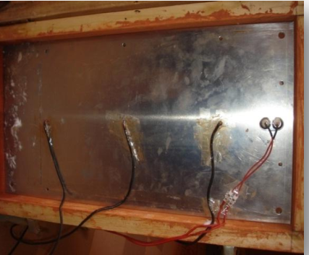

(a)

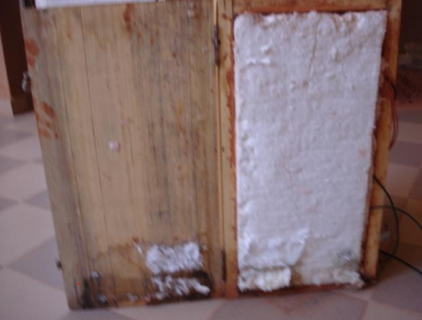

(b)

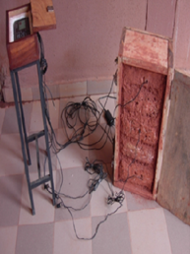

(c)

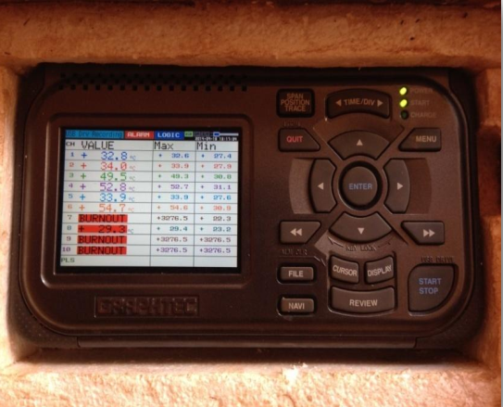

(d)

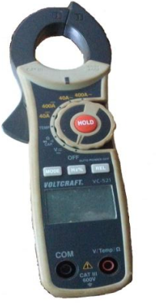

(e)

**Figure 1 :** **Experimental set-up ((a) heating plate and position of thermocouples, (b) position of polystyrene, (c) general view, (d) view of datalogger, (e) multimeter)**

### **2.1.2. Sideboard design**

The cabinet studied is part of a solar cold production unit using zeolite/water adsorption to preserve food products. The vertical walls are made up of brick, insulation and aluminium. The use of aluminium as an internal facade protects the insulation against internal humidity, which can reach 90% depending on the type of products to be preserved. The floor is made of reinforced concrete and the roof of wood with an external adobe rendering. Figure 2 shows a mock-up of a cold store measuring 3m x 3m x 3m. ArchCard software was used to draw the model.

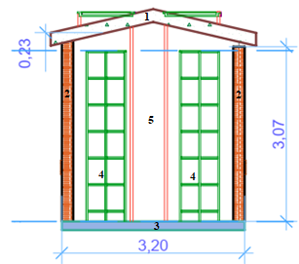

(b) 1-toiture ; 2-mur latéral ; 3- plancher ; 4-claies ; 5-allée.

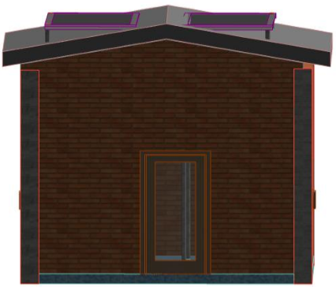

(a) **south façade**

**Figure 2 : drawing of the mock-up of the side wall ((a) south façade; (b) section B-B)**

## **2.2. Assessment of the cold store heat balance**

* **Simplifying assumptions**

In this study, we consider the following assumptions:

* heat propagation by conduction is unidirectional;
* solar radiation received on a surface is uniform. We consider the averages received on each of the walls over the course of a day's exposure to solar radiation;
* Air can be considered a perfect gas and is transparent to solar radiation;
* the composite materials for the walls represent a single, homogeneous and isotropic material. Their thermo-physical properties are constant.
* **On the walls**

The description of the thermal behaviour of the structure is based on the nodal method (D. Y. K. Toguyeni et al., 2012 ; Compaoré Abdoulaye, 2017 ; C. Abdoulaye, 2018). Consider a node (i) corresponding to a part of the structure. The time variation of the energy in this node is equal (neglecting infiltration) to the algebraic sum of the exchanged flux densities :

 (1)

Where,

* N is the number of internal loads  ;
*  represents the convective exchanges between the *ith* surface *Ai*at temperature  and the zone of air at temperature  ;
*  is the term representing heat exchanges with the outside due to ventilation and air renewal;
*  represents the loads linked to the system.

The heat input power for a zone i is given by :

 (2)

 represents the gains through the walls ;

 corresponds to gains linked to thermal bridges ;

 represents air infiltration and renewal.

For all *m* zones in the sideboard, we have :

 (3)

The overall volumetric heat loss coefficient G (W/m-3.K-1), generally used to characterise a building envelope, is defined. It is evaluated in relation to the habitable volume of the building, taking into account the coefficients of heat exchange by conduction, convection and air exchange.

 (4)

V being the volume in m3 of the building, it follows that :

 (5)

We also define the overall surface heat transfer coefficient (Ubat), obtained by the ratio between the building's total heat transfer coefficient and its total surface area of losses from the protected volume. It is given by the following relationship :

 (6)

## **Air change rate**

Heat exchange by ventilation is important in taking into account the thermal gains or losses of the building.

Equation (7) expresses the exchanges by air renewal in the cold room :

 (7)

N being the air change rate and V the volume of the room.

For the purposes of the numerical simulation, we have used the values of certain thermophysical constants of the materials used in the formulation of the casing envelope, which are not characterised in this study. These values are given in Table 1 below.

**Table 1:** **Thermo-physical properties of building materials**

|  |  |  |  |  |  |
| --- | --- | --- | --- | --- | --- |
|  | *Specific heat (J/kg.K)* | *density (kg/m3)* | *Thermal conductivity (W/m.K)* | Thermal diffusivity (10-7 m2/s) | Thermal Effusivity (J/m2 s1/2 oC) |
| *Concrete floor* (Boukaré OUEDRAOGO, 2017) | *840* | *2240* | *1.4* | *7.44* | *1623.03* |
| *plywood (*Kodjo Dodji GBEDEMA, 2019) | *2720* | *600* | *0.14* | *0.63* | *477.995* |
| Refractory clay (Boukaré OUEDRAOGO, 2017) | 3252.885  ± 22.4 | 1768.352 | 0.838 | 1.456  ± 0.003 | 2195.026 |
| Hollow cement blocks (D. Y. K. Toguyeni, 2012) | 1050 | 1275.510 | 0.785 | 5.861 | 1025.348 |

# **RESULTS AND DISCUSSION**

## **3.1. Temperature profile and material properties**

Using the values collected from the data acquisition system, we plot the temperature profiles of the faces *e = 0 m* and *e = 0.12 m*.

From the initial temperature of 25°C, despite the plate emitting a constant heat flux density, we see disparate temperature profiles for the three measurement points. The same is true of the opposite side, which is subject to natural convection.

Furthermore, the lower part of the wall heats up less than the upper part, even though we know that temperature decreases with altitude. We think that the high level of humidity in the soil on which the experimental set-up is based is responsible for the rapid cooling of the lower part of the wall, hence the results observed in Figures 3.a) and 3.b).



**Figure 3.a :** Longitudinal evolution of temperature at the level of faces $e=0 m$*: case of BLT*



**Figure 3.b :** Longitudinal evolution of temperature at the level of faces $e=0.12 m$*: case of BLT*

We also note that after six (06) hours of heating, the temperature profiles stabilise. Steady state is therefore reached. Using relations (8) to (11) and the experimental values, we obtain the thermal conductivity, the thermal mass capacity, the thermal diffusivity and the thermal effusivity for BLT and BTC respectively. These values are given in Tables 2 and 3 below.

$λ=\frac{P×e}{S×ΔT}$ (8)

$C_{p}=\frac{P×t}{m×ΔT}$ (9)

$α=\frac{λ}{ρ×C_{p}}$ (10)

$E=\sqrt{ρ×λ×C_{p}}$ (11)

**Table 2:** Thermophysical properties of BLT

|  |  |  |  |  |  |
| --- | --- | --- | --- | --- | --- |
|  | *density (kg/m3)* | *Thermal conductivity (W/m.K)* | *Specific heat (J/kg.K)* | Thermal diffusivity (10-7 m2/s) | Thermal Effusivity (J/m2 s1/2 oC) |
| Results | $$2214.286$$ | $$0.537±0.045$$ | $$7901±0.043$$ | $$4.0879±0.083$$ | $$2655.972±0.033$$ |
| *(*Kodjo Dodji GBEDEMA, 2019) | **-** | 0.827 | - | 3.60 | 1378.9 |

**Table 3 :** *Thermophysical properties of BTC*

|  |  |  |  |  |  |
| --- | --- | --- | --- | --- | --- |
|  | *density (kg/m3)* | *Thermal conductivity (W/m.K)* | *Specific heat (J/kg.K)* | Thermal diffusivity (10-7 m2/s) | Thermal Effusivity (J/m2 s1/2 oC) |
| Results | $$1937.875 ±0.033$$ | $$0.559±0.032$$ | $$1418.364±0.033$$ | $$2.879±0.043$$ | $$3834.972±0.035$$ |
| (Emmanuel OUEDRAOGO et al., 2015) | 1835.450 ± 27.532 | 0.556  ± 0.006 | 1417  ± 0.018 | 2.140  ± 0.023 | 1202.291  ± 10.720 |

The values of the thermophysical properties of BLT and BTC found are of the same order of magnitude as those found previously by other authors. For example, the results of the work by Emmanuel OUEDRAOGO et al. (2015).

For BLT, our results are in line with the results of the work of Kodjo Dodji GBEDEMA (2019). The differences in values observed may be linked either to the source from which the soil was extracted or to the method used to formulate the BTC.

## **3.2. Heat diffusion through characterised materials**

* **Heat transfer kinetics**

The thermal inertia of a material is defined by its ability to diffuse heat within it. This diffusion is a function of thermal conductivity, heat capacity and density; these three thermal quantities being linked by equation (3) above. In this section, we will compare the diffusion capacity of the materials that will make up the outer shell of the cold room, based on the time taken for thermal excitation on one side of a sample to be felt on the opposite side. This time *t* is obtained by multiplying the surface heat capacity Cp by the thermal resistance R :

$λ=\frac{P×e}{S×ΔT}$**(8)**

$C_{p}=\frac{P×t}{m×ΔT}$**(9)**

$α=\frac{λ}{ρ×C_{p}}$**(10)**

$E=\sqrt{ρ×λ×C_{p}}$**(11)**

Figure 4 shows the heat diffusion field through samples of the above materials. It can be seen that for the same thickness of 15 cm, the heat propagation times in BLT and adobe are the longest. So, for these two materials, the thermal disturbance received by the outer face takes much longer to be felt on the opposite face. This is justified by their low diffusion speed. These two materials therefore offer the best thermal inertia for insulation purposes.



**Figure 4 :** Heat propagation in characterised materials

To investigate this further, Figure 5 shows the heat diffusion kinetics within the formulated composite materials. These curves allow us to define, for a wall thickness of 26.3 cm, the time required for a thermal stress on one side to reach the opposite side. Overall, we can see that whatever the composite material, this propagation time is greater than 100 hours (corresponding to more than 4 days). In particular, walls made of BLT + insulation + aluminium have better thermal inertia. Based on these results, we can therefore disregard heat gain inside the cold room by conduction through the walls.



**Figure 5 :** Heat diffusion in composite materials

* **Temperature field through the walls of the envelope**

The study of the temperature profile within the walls enables us to predict, approximately, the temperature at the level of the inner faces of the walls that make up the structure's envelope and therefore the indoor environment. At the same time, this study enables us to see which material best resists heat transmission in the refrigeration chamber and to be able to assess the heat flow through the walls when calculating the dimensions.

Figure 6 shows the temperature distribution within the walls of the wall after twelve (12) hours of exposure. It can be seen that the temperature decreases with thickness, whatever the insulation used. The curves stabilise at a thickness of 0.2 m. This value therefore makes it possible to define a useful thickness for the insulation to be used. The figure also shows that cut laterite blocks (BLT) are more resistant to heat transfer. In fact, BLTs achieve the lowest outlet temperatures (35 °C) with a much lower inlet temperature than other materials for the same value of heat flux emitted by the slab. Next come compressed earth bricks, adobe and cement blocks.

We now change the insulation, using a straw panel instead of expanded polystyrene. Figure 7 shows the results obtained. The results are similar to those in Figure 6. There is a slight decrease in the interior temperature for all four materials (adobe, BLT, BTC and hollow breeze block).



**Figure 6:** Temperature variation as a function of wall thickness (insulation: polystyrene, Ta_max = 41.7 °C, t=12h)



**Figure 7 :** Temperature changes as a function of wall thickness (insulation: 7 cm thick straw board; Tamax = 41.7 °C; t =12h)

From the two figures above, we can see that the cut laterite blocks result in lower internal temperatures for a wall subjected to the conditions mentioned above.

It should be noted that these results are in line with previous publications (Boukaré OUEDRAOGO, 2017 ; D. Toguyeni et al., 2013 ; COMPAORE, A. et al., 2017) on thermal comfort in homes using passive air conditioning. Indeed, analysis of these publications shows that dwellings built using local materials such as BTC, BLT and adobe have a better thermal response than those built using modern cement blocks.

## **3.3. Energy savings based on choice of materials**

Figures 8 and 9 show the variations in thermal energy gain as a function of the volume of the enclosure to be cooled for different thicknesses of two insulating materials. Overall, for a given thickness, heat loss increases with volume. If we consider a volume of 100 litres, we can save 2600 kJ of energy per day by increasing the thickness of the compressed straw panel by 180 mm.

Theoretically, this energy would allow the formation of 7.5 kg of ice (Lfg = 334 kJ/kg). Under the same conditions, polystyrene saves 1200 kJ of energy per day. By comparing these results, we can therefore conclude that around 600 kJ of energy can be saved per day by using polystyrene instead of compressed strawboard.

Furthermore, the curves in Figure 10 show that the overall heat transfer coefficient decreases as the thickness of the insulation increases. For a thickness of 20 mm, its value is 0.25W/m2K for polystyrene and 0.55W/m2K for compressed strawboard. When the thickness is increased by 180 mm, for example, these values drop to 0.02W/m2K and 0.15W/m2K respectively. Polystyrene therefore offers better resistance to heat transfer. These different observations about the two insulants can be explained, in part, by their insulating properties. For example, polystyrene has 4 times lower thermal conductivity than compressed strawboard.



**Figure 8 :** Variation in heat loss as a function of the volume of the hutch for different thicknesses of compressed straw board



**Figure 9 :** Variation in heat loss as a function of cabinet volume for different thicknesses of polystyrene



**Figure 10 :** Variation in overall heat transfer coefficient as a function of insulation thickness for two types of insulation

Results from previous studies (C. Henry & B. Joseph, 1999 ; D. Toguyeni et al., 2013 ; COMPAORE, A et al. 2017) show that indoor air temperatures were relatively lower in earthen buildings than in cement block buildings. In addition, energy consumption was higher in cement block buildings than in earthen buildings. Finally, they found lower thermal performance coefficients in BLT, BTC and adobe buildings than in hollow breezeblock buildings.

# **CONCLUSION**

In this article, we studied the thermophysical properties of a number of local building materials that can be used as warehouse envelopes. It was found that walls made of (BLT-Polystyrene-Aluminium) and (BLT-Strawboard-Aluminium) respectively have the most advantageous thermophysical properties for thermal insulation of the structure. However, their surface heat transmission coefficients are the highest. This coefficient, also known as the heat loss coefficient, characterises a material's resistance to heat transfer. The lower the coefficient, the more resistant the material.

Analysis of the temperature fields of the interior walls of the sideboard revealed that temperatures were relatively lower in earthen constructions (adobe, BLT, BTC) than in hollow breeze blocks.

The evaluation of the energy gains of the sideboard shows a considerable advantage in using an envelope composed of earth-polystyrene-aluminium. This was confirmed by the thermal performance coefficients. In fact, the thermal performance coefficients are lower when the envelope of the side wall is built from earth (adobe, BTC, BLT) than from hollow breezeblock.

***DEFINITIONS, ACRONYMS, ABBREVIATIONS***

|  |
| --- |
| $θ_{Z }$ Air temperature at the thermal zone, *K* |
| $θ_{E }$ Ambient air temperature outside, *Ka* |
| $C_{Z }$ Thermal capacity of the air at the thermal zone *J.kg-1 K-1,* |
| Coefficient of exchange by convection of the air with surface *i, W.m-2 K* |
| Area of surface *i, m2* |
| , air mass flow rate, *kg.s-1* |
| represents the costs associated with the system, W |
| $E_{ref }$ Cooling energy, *kWh* |
| N air change rate |
| V the volume of the room, *m-3* |
| Cooling base temperature, *K* |
| $G$ Coefficient of heat loss, *W.m-3 .K-1* |
| Point thermal transfer coefficient, *W.K-1* |
| Length of linear thermal bridge n, *m* |
| $N$ Hourly air renewal rate, *h-1* |
| , Volumetric heat and volumetric air, *W.m-3 .K-1,W.kg-1 .K-1* |
| Overall heat transfer coefficient, *W.m-2 K-1* |
| Coefficient of surface transmission of the building component j of the building envelope, *W.m-2 K-1* |
| Linear thermal transmission coefficient n, *W.m-1 K-1* |
| *density kg.m-3* |
| , *Thermal conductivity W.m-1.K-1* |
| , Thermal diffusivity *10-7 .m2 .s-1* |
| Thermal Effusivity *J.m-2 .s1/2 oC* |

References

**Abdoulaye, C. (2018). Study of the thermal performance of a typical habitat in Burkina Faso. Application: contribution to the establishment of thermal regulations. Doctoral thesis, Joseph KI-ZERBO University.**

**Albitar, N. (2011). “Comparative study of drying processes coupled with texturing by instantaneous expansion (DIC), in terms of kinetics and nutritional quality. Application to the recovery of agri-food waste.” Doctoral thesis, edited by the University of La Rochelle.**

**Bonnel, D. (2012). The preservation of foodstuffs in refuges. Summary report, edited by the University of Le Mirail 31000. Toulouse, France.**

**Boukare Ouedraogo (2017). Design, construction and study of the operation in natural convection of a solar cell for the preservation of agri-food products: application to onions. Doctoral thesis., Ouagadougou University, Professor Joseph Ki-Zerbo. Camelo, A. F. L. (2007). Manual for the Preparation and Sale of Fruits and Vegetables. FAO.**

**CEFCOD. (2013). Reference Situation of the Main Agricultural Sectors in Burkina Faso, Burkina Faso.**

**COMPAORE, A., OUEDRAOGO, B., GUENGANE, H., MALBILA, E., and BATHIEBO, D.J. (2017). Role of Local Building Materials on the Energy Behavior of Habitats in Ouagadougou. IRA International Journal of Applied Sciences (ISSN 2455-4499), 8(2), 63-72. doi:http://dx.doi.org/10.21013/jas.v8.n2.p3**

**David Toguyeni, and Ousmane Coulibaly. (2013). Study of the influence of local insulation materials on cooling loads of a house made of breeze block or laterite in a dry tropical climate. Renewable Energy Review 16(4): 733–740. https://doi.org/10.54966/jreen.v16i4.414.**

**Duminil, M. (2002). Refrigerating Machines, Engineering Techniques. Energy Engineering Treatise. BE 9730, BE 9734. https://doi.org/10.51257/a-v1-b9730a.**

**Endalew, W., A. Getahun, A. Demissew, and T. Ambaye. (2014). Storage performance of naturally ventilated structure for bulb onion. Agric Eng Int: CIGR Journal, 16(3): 97–101.**

**Guissou, R., Cissé, K., and Pouya, T. 2012. Analysis of incentives and penalties for onions in Burkina Faso. Burkina Faso.**

**Henning, H. M., Erpenbeck T., Hinderburg, and Santamaria, C. I. S. (2001). The potential of solar energy use in desiccant cooling cycles. International Journal of Refrigeration 24(3):220-229. DOI:10.1016/S0140-7007(00)00024-4.**

**Henning, H. M., and Wiemken, E. (2004). Solar-assisted air conditioning of buildings: overview on technologies and state-of-the-art. In Mediterranean Congress of Climatization. Lisbon, Portugal.**

**Henry, C. and Joseph, B. (1999). Heat transfer, Application to housing, Study using the nodal ellipses method. Paris, France.**

**Kader, A. A. (1985). Postharvest biology and technology: an overview. Postharvest Technol. Hortic. Crop., (2): 3–7.**

**Kodjo Dodji GBEDEMA, (2019). Multi-criteria characterization study of the most common building materials on the Ouagadougou market. Master's thesis, 2nd foundation.**

**MAROU ZARAFI Assane. (2009). Economic potential of new and old agricultural and forestry products in the Sahel (cash or industrial crops, shrubs and trees). At a regional exchange conference on market dynamics in West Africa, the example of onions and sesame, Bamako, Mali, July 2009.**

**RAKOTONARIVO, A. S. (2003). Design of cold rooms for fruits and vegetables: development of a standard manual. Engineering Thesis, University of Antananarivo.**

**RANDRIAMANARIVONTSOA, F. J. J. (2008). Contribution to the Study of Improving Postharvest Preservation of Citrus Fruits for Export (Case of Ambohijafy). Agrarian Engineering Thesis, University of Antananarivo.**

**Toguyeni, D. Y. K., Coulibaly, O., Ouedraogo, A., Koulidiati, J., Dutil, Y., and Rousse, D. (2012). “Study of the Influence of Roof Insulation Involving Local Materials on Cooling Loads of Houses Built of Clay and Straw.” Energy Built., 50:74–80. DOI: 10.1016/j.enbuild.2012.03.021. Touzi, A., and Merzaia-Blama, A. (2008). Preservation of agri-foodstuffs by drying in Saharan regions. In Renewable Energy Review, 267–272. Algiers, Algeria.**