**Efficacy of bio - nano silver particles of *Trichoderma viride* on the mycelial growth and sclerotial viability of *Rhizoctonia solani***

**Abstract**

A total of 10 *Trichoderma* isolates were obtained from 10 rhizosphere samples The antagonistic effects of ten isolates of *Trichoderma* spp. were assessed based on their ability to inhibit the *Rhizotonia solani* by dual culture technique. Among the ten *Trichoderma* isolates tested, NRT-1 isolate showed maximum percentage of inhibition (68.5%). It was observed that NRT-1 showed overgrowth of pathogen by 0.2cm and was most effective compared to all other test isolates of *Trichoderma*. Effect of NRT-1 Trichoderma isolatesilver nano particles on mycelial growth of *R. solani* at three different concentrations *i.e.,* 75, 100 and 125 ppm were tested.Among the three concentrations, the highest inhibition (88.19 %) wasobserved at 125 ppm followed by 100 ppm (52.93 %). The effect ofTrichodermasilver nano-particles were, also, tested on sclerotial viability of *R. solani in vitro*. Among the four tested concentrations (50, 75, 100 and 125ppm) the highest per cent inhibition was observed at 125 ppm (85 %) followedby 100 ppm (47.50 %).

**Key Words :** Bio- Nano silver particles, sclerotia, *Rhizoctonia solani*, sheath blight.

**1. Introduction**

Rice is affected by several fungal, bacterial and viral diseases. As many as thirty five fungal, eight bacterial and twenty viral and mycoplasmal diseases were reported on rice (Ou, 1985). Of these, rice sheath blight, caused by *Rhizoctonia solani* Kuhn. is second only to, and often rivals rice blast in importance. It is a prominent disease in irrigated rice ecosystem. Currently, this disease is distributed in almost all the rice growing states. A modest estimation of losses due to sheath blight disease alone in India has been upto 54.3%. In fact, the disease has become the most important in the southern rice producing areas of the United States over the last 10 years. Yield losses as much as 50% were reported in susceptible cultivars when all the leaf sheaths and leaf blades are infected (Roy, 1993).

Poor weed management and frequency of irrigation aggravates the disease incidence due to micro climate. The fungus produces brown sclerotia depending upon the environmental conditions (Ou, 1985). Sclerotia are superficial, more or less globose but flattened, white when young and becomes brown. Individual sclerotium measures up to 5mm but may unite to form large mass in culture (Ou, 1985). The fungus survives in the soil for years as hard, resistant structures.

The pathogen is known to cause the damage at different stages *viz.*, seed germination, seedling establishment and vegetative growth phase. As a result, productivity and quality of grains and seeds are reduced considerably.

Nanotechnology is an emerging field in the area of interdisciplinary research especially in biology. Nano silver particles are used for control of various plant pathogens and compared with synthetic fungicides (Min *et al*., 2009). Jo *et al*. (2009) studied the effect of various forms of silver nanoparticles on two plant pathogenic fungi, *Bipolaris sorokiniana* and *Magnaporthe grisea.* Keeping the difficulties in use of fungicides and application of biocontrol agents in rice ecosystem, bio-nano silver preparations could offer a possible solution for the ever threatening sheath blight pathogen *R. solani*. Taking into consideration of the above facts, the present research studies were initiated with a view of finding out the effects of biogenic nano silver on the growth of the fungus, *R. solani* and survival of sclerotia*.*

**2. Materials and Methods:**

The present experiments were carried out in the Department of Plant Pathology, S.V. Agricultural College, Tirupati, and Agricultural Research Station, Nellore, of Acharya N.G. Ranga Agricultural University, Guntur, Andhra Pradesh. Sheath blight susceptible variety of rice NLR-34449 (Nellore Mahsuri) was used in present studies. The test pathogen *R. solani* was isolated from sclerotial bodies attached to the diseased portion of rice plants.

**2.1 Isolation and identification of native antagonistic *Trichoderma* spp. from rhizosphere of rice**

A total of 10 samples were collected from healthy plants present in sheath blight affected paddy fields of Nellore and Chittoor districts shade dried. Serial dilution technique (Johnson and Curl, 1972) was used to isolate *Trichoderma* spp**.** from rhizosphere of rice. To get 10-1 dilution, 10 g of this soil was dissolved in 90 ml of sterile distilled water, from that 1 ml of soil suspension was taken and added to 9 ml of sterile distilled water to get 10-2 dilution. This was repeated until a dilution of 10-4 for the isolation of fungi.

Antagonistic mycoflora were isolated on *Trichoderma*Selective Medium (TSM). One ml of final dilution of soil suspension was poured on to sterilized Petri-plates and then medium was poured at lukewarm stage. Plates were rotated gently to get uniform distribution of soil suspension in the medium. The plates were incubated at 28 + 10C and observed at frequent intervals for the development of colonies. Three days old colonies of *Trichoderma* were picked up and purified by single hyphal tip method. Identification of *Trichoderma* was done based on mycological keys described by Barnett *et al*. (1972).

**2.2 Antagonistic potential of Trichoderma isolates against *R.solani***

Allten isolates of *Trichoderma* spp. were evaluated for their antagonistic activity *Rhizotonia solani* by dual culture technique on PDA plate (Dennis and Webster, 1971).

**2.2.1 Dual culture technique**

The antagonistic activity ofTrichoderma isolates of rice rhizosphere soil was determined by dual culture technique under *in vitro* conditions.

Mycelial discs measuring 6 mm diameter from four day old cultures of both fungal antagonist and the test pathogen were placed at equidistant on sterile Petri-plates containing PDA medium. The Petri-plates were then incubated at 28 ± 2°C. Three replications were maintained in each treatment. Suitable controls were kept without antagonist. Growth of antagonists, pathogen were measured after recording full growth of the pathogen in control plate. Per cent inhibition of mycelial growth of test pathogen was calculated by the formula:



Where;

I = Per cent reduction in growth of test pathogen,

C = Radial growth (mm) in control and

T = Radial growth (mm) in treatments.

**2.3 Extra cellular synthesis of silver nanoparticles from culture filtrate of effective Trichoderma isolate.**

**2.3.1 Production of biomass of Trichoderma isolate**

A seven day old pure culture of Trichoderma isolate was inoculated in 250 ml conical flasks containing 100 ml of Potato Dextrose Broth (PDB) and the culture flasks were incubated at 28 ± 1oC. The biomass was harvested at 4 DAI, 6 DAI, 8 DAI, 12 DAI, and 15 DAI through sterilized Whatman No.1 filter paper. After the harvesting of biomass, the culture filtrate was used for the synthesis of silver nanoparticles.

**2.3.2 Synthesis of silver nanoparticles**

Fifty ml of aqueous solution of 1mM Silver nitrate (AgNO3) was treated with 50 ml of Trichoderma culture filtrate for the extra cellular synthesis of silver nanoparticles in a 250 ml conical flask. The whole mixture was incubated at room temperature for 24 hrs. The color change of silver nitrate from colorless to brown color indicates the formation of silver nanoparticles through reduction of silver ionic forms (Ag+) to Ag0.

**2.4 Characterization of synthesized silver nanoparticles**

**2.4.1 UV-Visible spectroscopy**

The reduction of silver ions was monitored by UV-Vis spectrum of the reaction mixture at 24 hrs. The spectra of the surface plasmon resonance of AgNPs in the reaction mixture were recorded using UV–Vis spectrophotometer (Shimodzu, UV-2450) at wavelengths between 200 to 800 nm.

**2.4.2 Particle Size and Zeta potential Analyzer**

The aqueous suspension of the synthesized silver nanoparticles was filtered through a 0.22 μm syringe driven filter unit and the size of the distributed silver nanoparticles were measured by using the principle of Dynamic Light Scattering (DLS) technique made in a Nan-opartica SZ-100 series compact scattering spectrometer.

**2.4.3 Transmission Electron Microscopy (TEM)**

Transmission Electron Microscopy was performed on JEOL (JEM-1010) instrument, with an accelerating voltage of 80 kV after drying of a drop of aqueous AgNPs on the carbon-coated copper TEM grids Samples were dried and kept under vacuum in desiccators before loading them onto a specimen holder. The particle size distribution of silver nanoparticles was evaluated using ImageJ 1.45s software.

**2.5 Efficacy of bio nano silver particles of Trichoderma against *R. solani***

Trichoderma silver nano preparations were prepared at Nanotechnology Department, IFT, RARS, Tirupati.

**2.5.1 Poisoned Food Technique**

Poisoned food technique was used to assess the efficacy of bio-nano silver particles of *Trichoderma* isolates against *R. solani*. The procedure followed was described by Nene and Thapliyal (1993) for fungicidal assay. Three different conc. i.e., 75, 100, 125 ppm of bio nano silver were used in the present investigation by mixing appropriate quantity of bio-nano silver solution in equivalent mass of double strength PDA. Poisoned PDA plates were inoculated with 6 mm culture disc of (2 day old) of *R. solani* for poisoned food technique. Plates were incubated at 25±2 0C and observed for mycelial growth in case of fungal cultures. Appropriate control with pathogen check was maintained for comparison. Experimental design used was CRD and four replications were maintained per concentration.

Observations were recorded on mycelial growth of the fungus and per cent inhibition in pathogen growth was calculated by using the following formula (Vincent *et al*., 1927).

**2.5.2 Effect of bio nano particles of Trichodermaon viability of sclerotia of *R. solani in vitro.***

Four different concentrations *i.e.,* 50, 75,100,125 ppm of bio nano silver solutions were used in the present investigation by mixing appropriate quantity of bio nano silver solution in distilled water. Ten sclerotia of *R. solani* were taken for each replication and dipped into the respective nano silver solution for 24 hr. Control was maintained by dipping sclerotial bodies in distilled water. Then the sclerotia were retrieved and placed on the PDA medium for testing their viability. Experimental design used was CRD and four replications were maintained per concentration. Per cent inhibition of sclerotial germination was calculated.

Experiments were conducted in Completely Randomized Design (CRD). Data was analyzed by following the statistical methods outlined by Gomez and Gomez (1984).

**3. Results** **and Discussion**

**3.1 Isolation and identification of native antagonistic *Trichoderma* spp. from rhizosphere of rice**

A total of 10 samples were collected from healthy plants present in sheath blight affected paddy fields of Nellore and Chittoor districts. Colonies of *Trichoderma* spp. were obtained on Trichoderma selective medium on 7th day after inoculation. The antagonistic *Trichoderma* spp. purified from mother cultures were grown separately on their respective medium and also maintained in PDA slants for further experimental studies. A total of 10 Trichoderma isolates were obtained from 10 rhizosphere samples (Table 1 and Fig.1).

Table. 1 List of Trichoderma isolates

|  |  |
| --- | --- |
| S. No. | Isolates |
| 1 | NRT1 |
| 2 | NRT 2 |
| 3 | NRT 3 |
| 4 | NRT 4 |
| 5 | NRT 5 |
| 6 | CRT6 |
| 7 | CRT 7 |
| 8 | CRT 8 |
| 9 | CRT 9 |
| 10 | CRT 10 |

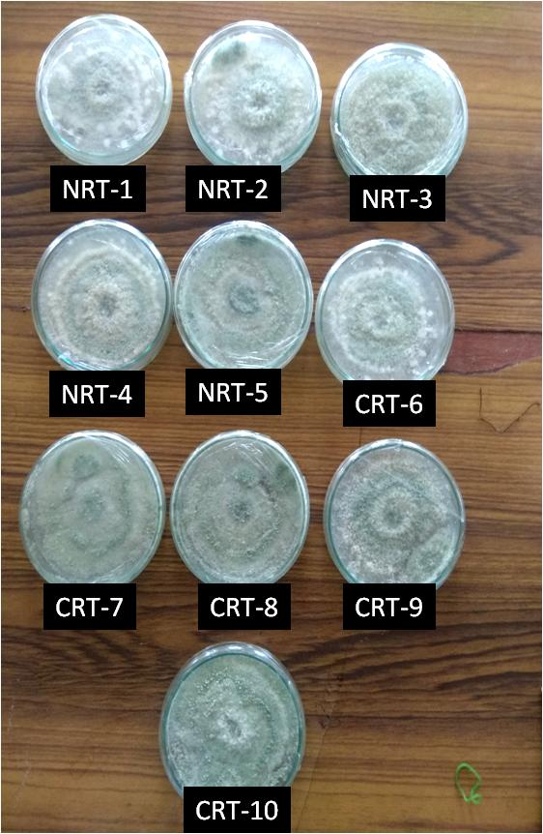

Fig. 1. Trichoderma isolates isolated from rice rhizosphere soil.

**3.2 Evaluation of the antagonistic activity of *Trichoderma* spp. against sheath blight pathogen *in vitro.***

The antagonistic effects of ten isolates of *Trichoderma* spp. were assessed based on their ability to inhibit the *R. solani* by dual culture technique. Data on per cent inhibition of pathogen over control, over growth of Trichoderma on pathogen, over growth of pathogen on *Trichoderma* and zone of inhibition indicated the growth of respective fungi in dual culture. Zone of inhibition was considered as interaction of two equal forces, *i.e.,* both the fungi are equally potent, overgrowth reflected the potential of one over the other in occupying the other’s domain. Hence in the present investigation, overgrowth was considered as one of the important criteria for selection of potential *Trichoderma* isolates.

**3.3 Screening of Trichoderma isolates against *R. solani***

All the Trichoderma isolates were screened against *R. solani*, by dual culture technique. The interactions of *Trichoderma* isolates with *R. solani* were recorded on fourth day after inoculation. Among the ten Trichoderma isolates tested, NRT-1 isolate showed maximum percentage of inhibition (68.5%). It was observed that NRT-1 showed overgrowth of pathogen by 0.2cm and was most effective compared to all other test isolates of Trichoderma.

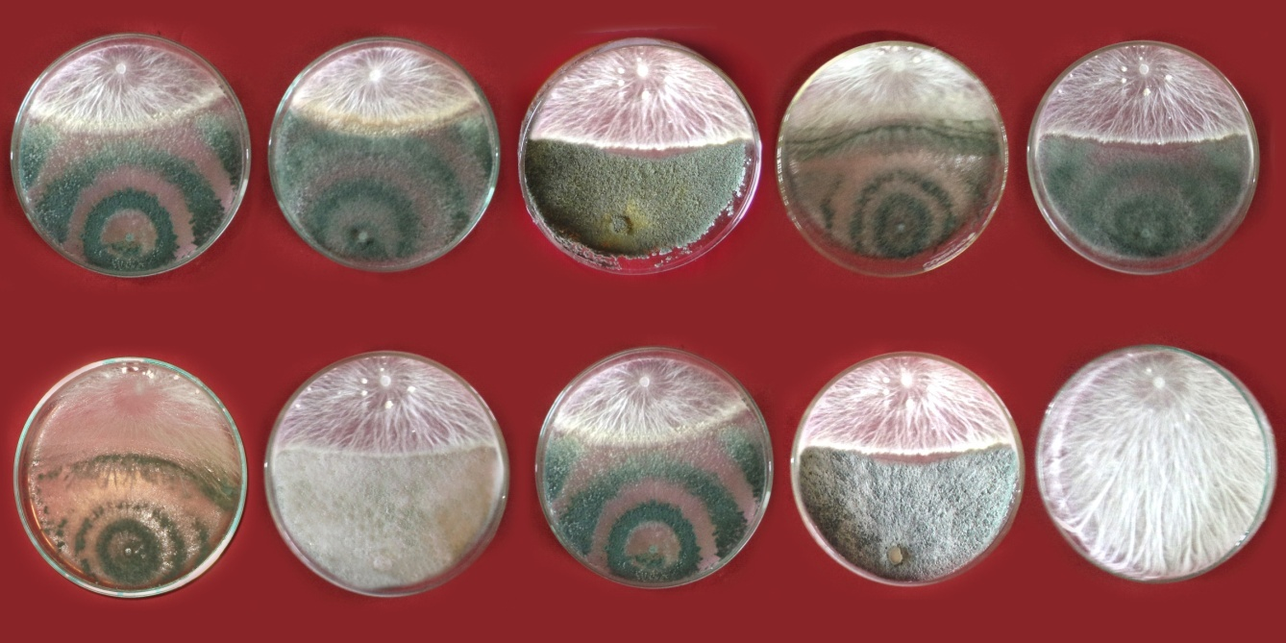 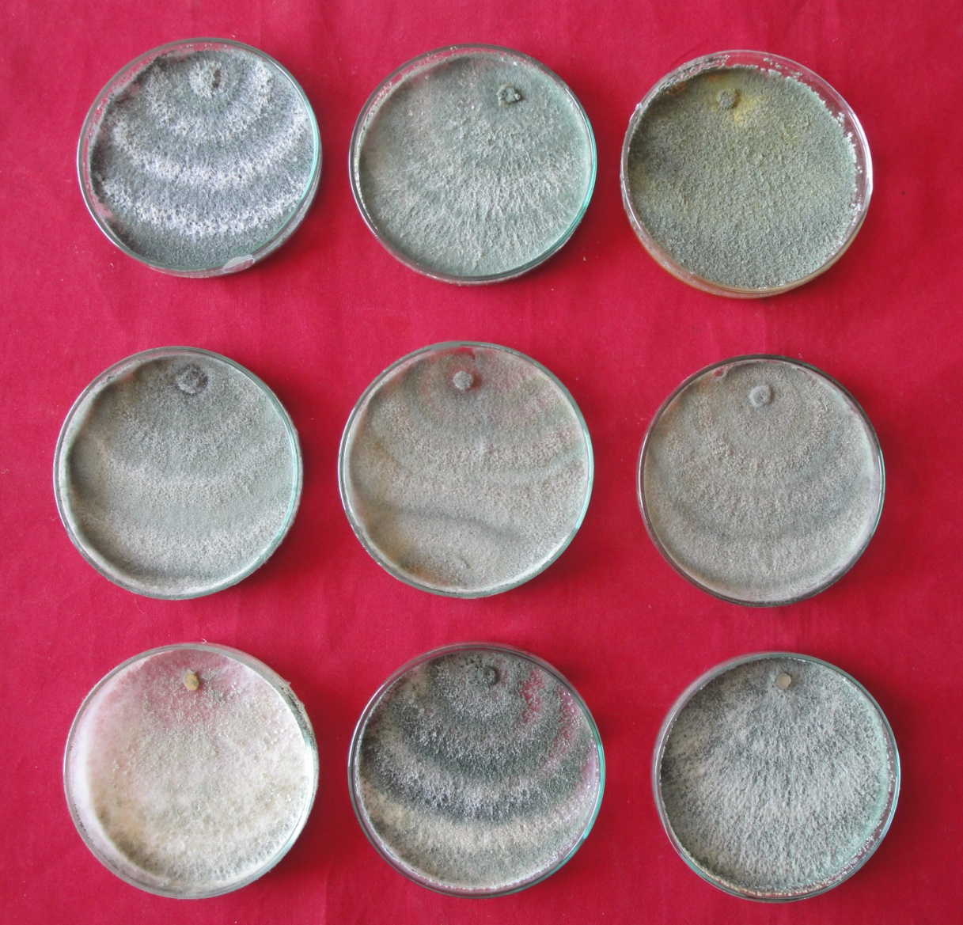

Fig. 2..(A) NRT-1 isolate against *R.solani and* (B) Trichoderma isolate NRT-1. alone

Table 2. Efficacy of Trichoderma isolates against *R.solani*

|  |  |  |  |  |  |
| --- | --- | --- | --- | --- | --- |
| **S. No.** | **Treatment** | **Growth of *R. solani***  **(cm)** | **Growth of *Trichoderma***  **(cm)** | **Over growth of *Trichoderma***  **(cm)** | **Per cent**  **inhibition** |
| 1 | NRT1 | 2.50 | 4.52 | 0.2 | 68.50  (55.83) |
| 2 | NRT 2 | 3.00 | 4.00 | - | 62.50  (52.22) |
| 3 | NRT 3 | 3.25 | 3.85 | 0.1 | 59.30  (50.34) |
| 4 | NRT 4 | 3.10 | 5.90 | - | 61.25  (51.48) |
| 5 | NRT 5 | 4.25 | 2.75 | - | 46.87  (43.19) |
| 6 | CRT6 | 4.13 | 2.87 | - | 48.37  (44.05) |
| 7 | CRT 7 | 3.85 | 3.15 | - | 51.87  (46.05) |
| 8 | CRT 8 | 2.99 | 4.01 | - | 62.62  (52.29) |
| 9 | CRT 9 | 3.04 | 3.96 | - | 62.00  (51.92) |
| 10 | CRT 10 | 3.52 | 3.48 |  | 56.00  (48.43) |
| 11 | Control | 8.00 | 0 |  | 0.00  (0.00) |
|  | C.D. |  |  |  | 0.952 |
|  | SE(m) |  |  |  | 0.323 |
|  | SE(d) |  |  |  | 0.456 |
|  | C.V. |  |  |  | 1.239 |

**3.4 Cultural and morphological characterization**

The effective isolate of *Trichoderma*spp. were subjected to cultural and morphological characterization. The observations on colony growth, colony color, conidiophores branching, conidiation, conidial color, conidia shape, chlamydospore production, spore ball, sterile appendages, phialides shapes, phialides alignment were recorded (Gams and Bissett, 1998).

NRT-1 recorded 90 mm growth within 48 h. The colony color changes from white to light green with production of conidia. Taxonomic identification of NRT-1 isolate of *Trichoderma*spp. up to species level was done based on colony morphology and microscopic observation. Isolate NRT-1 showed white to light green sporulation . Conidiation was in pustules. Conidiophore branched sparingly. Phialides were flask shaped disposed in convergent verticels terminally on branches. There were no sterile appendages. Conidial shape was globose. Chlamydospores were infrequent or not formed. Spores were formed in balls. Based on these features this isolate was identified as *Trichoderma asperellum (T. viride)*

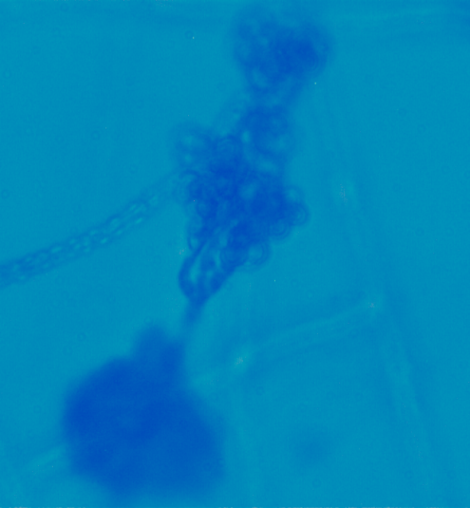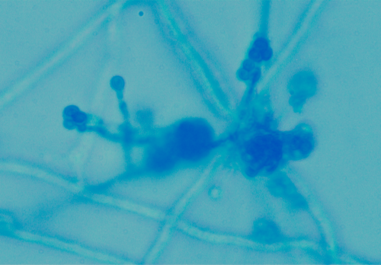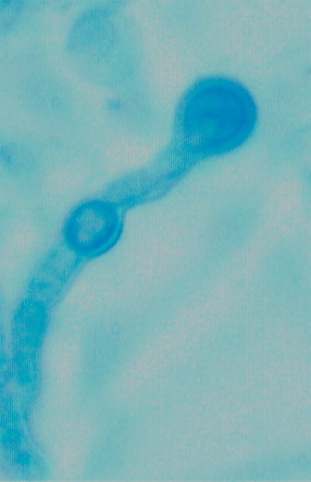

**Fig. 3. a. Microscopic photographs of *Trichoderma* isolate NRT-1 representing spore balls and convergent, flask shaped phialides b. Globose conidia c. Intercalary and terminal chlamydospore at (400X).**

**3.5 Synthesis and charactererization of bio nano particles of silver nitrate using bio control agent**

**3.5.1 Synthesis of bio nano particles**

Silver is being used as an antimicrobial agent. Several formulations are in the market using silver nano particles for medical use. The size of the particles to be called as nano should be less than 100 nm. Recently nano particles are being synthesized using microbial agents. Microbes have the tendency to convert silver nitrate ions into nano silver particles through intracellular and extracellular means.

The bio silver nano conversion was attempted using Potato Dextrose Broth (PDB) culture filtrate of one isolate of *Trichoderma* (NRT-1), only mycelial mat and spore suspension (10-8 spores/ml) of NRT-1 isolate. Bio-nano conversion was also attempted using uninoculated autoclaved PDB for comparison.

When culture filtrate of Trichoderma isolate NRT-1 (10 ml) was mixed with 90 ml of 170 ppm silver nitrate solution, change in colour was observed from initially transparent solution to colloidal brown solution in 24 hours.(Fig. 4)

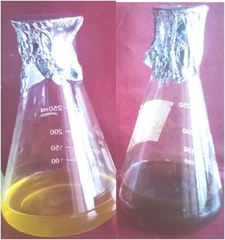

**Fig. 4.** **Synthesis of silver nanoparticles:**

1. ***Trichoderma* sp. (NRT-1) culture filtrate,**
2. **1 mM AgNO3 solution after 24 hrs incubation with Trichoderm*a* culture filtrate.**

**3.5.2 UV-Visible spectroscopy**

When absorbance peak was observed using UV-VIS spectrophotometer, peak was formed with absorbance maximum at around 450 nm wavelength.(Fig. 5)

Devi *et al*. (2013) reported that conversion of silver nitrate into nano silver is judged by the brown coloured colloidal formation with absorbance peak from 400 nm to 450 nm

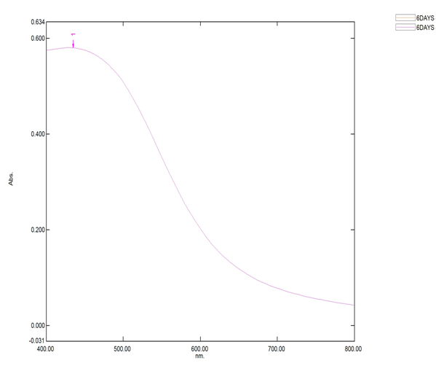

**Fig. 5. Nano solution peak was formed with absorbance maximum at around 450 nm wavelength.**

**3.5.3 Particle Size Analysis**

The Dynamic Light Scattering (DLS) study provides the details about the particle size The average size of the silver nanoparticles in the solution was 30.5 nm .

**3.5.4 Zeta potential measurement**

The value of Zeta potential of the silver nanoparticles as -23.2 mV with a single peak (Plate 6) signified that the presence of repulsion among the synthesized silver nanoparticles. If all the particles in suspension have a large negative or positive zeta potential then they will tend to repel with each other and there will be no tendency of the particles to agglomerate. The relatively high Zeta potential of -23.2 mV indicates particles are highly dispersed.



**Fig. 6:The Zeta potential measurement of synthesized silver noanoparticles.**

**3.5.5 Transmission Electron Microscopy (TEM) analysis**

The Transmission Electron Microscopy studies characterized the shape and size of the synthesized silver nanoparticles (Fig 7 ). In general particles were spherical in shape and the sizes of the silver nanoparticles were found in the range of 35 nm.

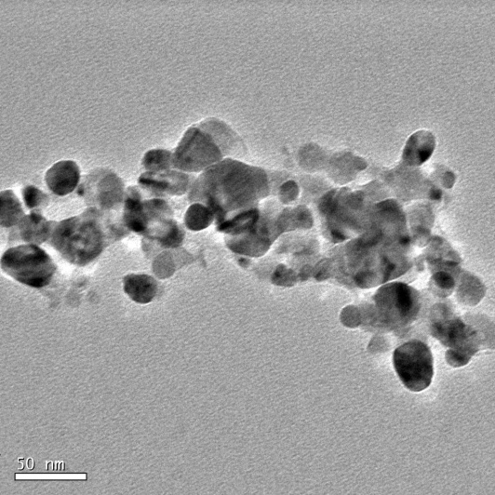

**Fig. 7 . TEM Micrographs showing the spherical shape of Ag nanoparticles with the mean size 35nm synthesized using Trichodermaisolate NRT-1.**

**3.6 Evaluation of the efficacy of bio nano silver particles of *Trichoderma* against *R. solani***

**3.6.1 Effect of Trichoderma silver nano particles on mycelial growth of *R. solani***

In the present investigation, efforts were made to test the effect of nano preparations on the growth of the fungus using poisoned food technique. Trichoderma silver nano preparation of 170 ppm was collected from Dept. of nanotechnology, IFT, RARS, Tirupati.Poisoned food technique was used to assess the efficacy of bionano silver of Trichoderma isolates against *R. solani*. Three different concentration *i.e.,* 75, 100, 125 ppm were prepared from 170 ppm silver nitrate or silver nano preparation and used in the present investigation by mixing appropriate quantity of bio-nano silver preparation in equivalent mass of double strength PDA. The results were presented in the Table (3).

**Table 3. Effect of Trichoderma silver nano particles on mycelial growth of** ***R. solani***

|  |  |  |
| --- | --- | --- |
| **S. No.** | **Concentration of silver nano particles solution in ppm** | **Per cent inhibition** |
| 1 | 75 | 53.32  (46.88)** |
| 2 | 100 | 42.47  (40.65) |
| 3 | 125 | 88.39  (70.06) |
| 4 | Control | 0.00  (0.00) |
|  | CD (P=0.01) | 1.57 |
|  | SEm± | 0.50 |
|  | SEd± | 0.71 |
|  | CV (%) | 2.57 |

**\*\*** Figures in parentheses are angular transformed values.

All the three concentrations of Trichoderma silver nano particles significantly inhibited the mycelial growth of the test pathogenover control (0 % inhibition). Among the three concentrations of bio nano silver, highest inhibition occurred at 125 ppm concentration (88.19 %) followed by 100 ppm (52.93 %). At 75 ppm 42.20 % inhibition was observed which is significantly lower than that of 125,100 ppm but higher than control (Fig 8).

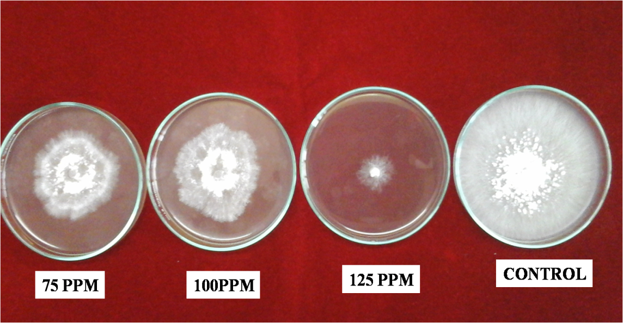

**Fig. 8. *In vitro* efficacy of Trichodermasilver nano preparations on mycelial growth *R. solani* by poisoned food technique.**

**3.6.2 Effect of Trichoderma silver nano-particles on sclerotial viability of *R. solani*  *in vitro*.**

In the present investigation four different concentrations *i.e.,* 50, 75,100,125 ppm were prepared from 170 ppm silver nitrate or silver nano preparation by mixing appropriate quantity of bio-nano silver solution in distilled water. Ten sclerotia of the test pathogen were taken for each replication and dipped into the respective nano silver solution for 24 hr. Control was maintained by dipping sclerotial bodies in distilled water. Then the sclerotia were retrieved and placed on the PDA medium for testing their viability. The results are presented in the Table (4).

**Table 4. Effect of Trichodermasilver nano-particles on sclerotial viability of** ***R. solani***

|  |  |  |  |
| --- | --- | --- | --- |
| **S. No.** | **Concentration of silver nano-particles solution in ppm** | **Per cent germination** | **Per cent inhibition** |
| 1 | 50 | 100  (90.00) | 0.00  (0.00)** |
| 2 | 75 | 87.50  (72.08) | 12.50  (17.88) |
| 3 | 100 | 52.50  (46.42) | 47.50  (43.54) |
| 4 | 125 | 15.00  (22.49) | 85.00  (67.47) |
| 5 | Control | 100.00  (90.00) | 0.00  (0.00) |
|  | CD (P=0.01) | 9.31 | 9.30 |
|  | SEm± | 3.06 | 3.05 |
|  | SEd± | 4.33 | 4.32 |

**\*\*** Figures in parentheses are angular transformed values.

Based on the per centage inhibition, bio nano silver at 125 ppm was found to be effective *i.e.,* 85 % inhibition of sclerotial germination, which is significantly higher than all other treatments followed by 100 ppm (47.50 % ) .Whereas, at 75 ppm 12.50 % inhibition, at 50 ppm no inhibition which are least effective and insignificant with control (Fig. 9).

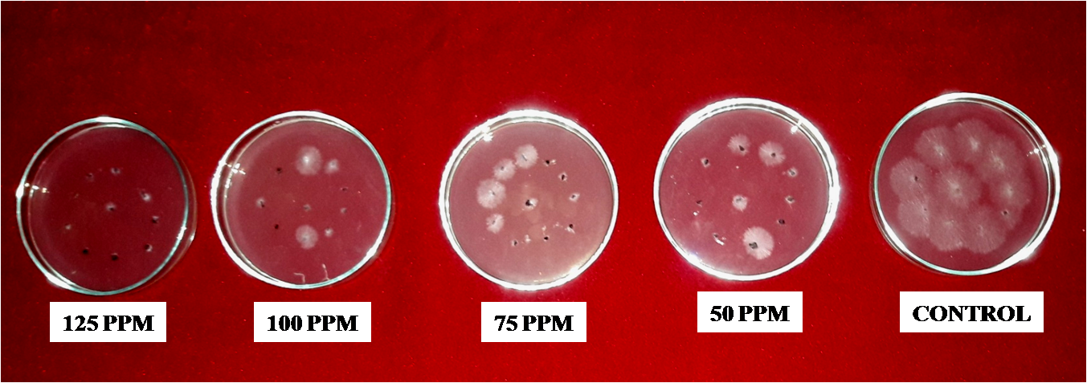

**Fig. 9. *In vitro* efficacy of *Trichoderma* silver nano-preparations on viability of sclerotia.**

Papaiah *et al*. (2014) reported the efficacy of silver bio-nano particles prepared using *Agaricus bisporus* against *R. solani*. Similar results were obtained by Elgorban *et al*. (2015), who assessed inhibitory effect of Ag NPs at different concentrations. Generally, more suppression of fungal radial growth was noticed at a concentration of 0.0019 mol. L-1. The highest inhibition was observed against *R. solani* AG-2-2, *R. solani* AG-6 and *R. solani* AG-5 with 77.77, 73.60 and 71.10% of linear growth inhibition, respectively, when compared to the control.

**4. Conclusions**

Among the ten *Trichoderma* isolates tested, NRT-1 isolate showed maximum percentage of inhibition (68.5%). Effect of NRT-1 Trichoderma isolatesilver nano particles on mycelial growth of *R. solani* at three different concentrations *i.e.,* 75, 100 and 125 ppm were tested.Among the three concentrations, the highest inhibition (88.19 %) wasobserved at 125 ppm .The effect of *Trichoderma* silver nano particles was also tested on sclerotial viability, highest per cent inhibition was observed at 125 ppm (85 %) .Therefore *Trichoderma* silver nano particles fit as one of the Integrated disease management strategy for rice sheath blight disease.

**Conflict of Interest**

I read the statement of policy pertaining to the conflict of interest.

To the best of my knowledge and belief, except as disclosed here with, neither I nor any person with whom I had a personal or business relationship has an indirect or direct interest in any organization or individual which proposes to enter into a transaction with the affiliate.

If I find any direct or indirect interest in any individual or organization which proposes to enter into a transaction with the Affliate, I will make full disclosure of such interest before any negotiation of such transaction and shall not be present for any discussion of or vote in connection with the matter.

Without the exception.

Except as described in attached statement**.**

**Date : 22-05-2025 ????**

**Full Name: ?????**

**COMPETING INTERESTS DISCLAIMER:**

Authors have declared that they have no known competing financial interests OR non-financial interests OR personal relationships that could have appeared to influence the work reported in this paper.

**References**

**Please write references according to the journal’s system, then check them with those on the manuscript.**

Elgorban, A.M., Samawaty, A.E.M E., Yassin, M.A., Sayed, S.R., Adil, S.F., Elhindi, K.M., Bakri, M and Khan, M. (2015). Antifungal silver nanoparticles: synthesis, characterization and biological evaluation. *Biotechnology & Biotechnological equipment, agriculture and environmental biotechnology*. 1-7 online Journal.

Gams, W and Bissett, J. (1998). Morphology and identification of *Trichoderma*. *Applied Environmental Microbiology*. 65: 3-34.

Gomez, K.A and Gomez A.A. (1984). *Statistical Procedures for Agriculture Research.* 2nd ed. Jhon wiley and Sons. Newyork.

Jo, Y., Kim, B.H and Jung, G. (2009). Antifungal activity of silver ions and nanoparticles on Phytopathogenic fungi. *Plant Disease.* **93**: 1037-1043.

Lee, F.N and Rush, M.C. (1983). Rice Sheath Blight: A major Rice Disease. *Plant Disease.* **67(**7): 829-832.

Min, J.S., Kim, K.S., Kim, S.W., Jung, J.H., Lamsal, K., Kim, S.B., Jung, M., Lee, Y.S. (2009). Effects of colloidal silver nanoparticles on sclerotium-forming phytopathogenic fungi. *Journal of Plant Pathology*. **25:** 376 -380.

Nene and Thapliyal .(1986). Fungicides in Plant Disease Control. *Oxford and IBH Publishing* *House,* New Delhi. 163.

Ou, S.H. (1985). *Rice Diseases* . CAB International, Leutralsales, Fanham Royals Slough, UK: 272-285.

Papaiah, S., Goud, S.T.E., Prasad B.S., Vemana. K and Narasimha, G. (2014). Silver nanoparticles, a potential alternative to conventional anti-fungal agents to fungal pathogens affecting crop plants; *International Journal of Nano Dimensions.* **5(**2): 139-144.

Roy, A.K. (1993). Sheath blight of rice in India. *Indian Phytopathology*. 46: 97-205.

Vincent, J. M. (1927). Distortion of fungal hyphae in presence of certain inhibitors. *Nature* 159: 850.