***Original Research Article***

**HISTOARCHITECTURAL STUDIES OF TEAT IN KOSALI COW**

**ABSTRACT**

The present study was conducted on thirty six samples of teat of Kosali cows procured from central plain region of the Chhattisgarh state and divided into two groups - lactating and non-lactating/ non-pregnant stages with eighteen cows in each group. Lactating and non-lactating/ non-pregnant stages were further categorized as early, mid and late groups, each with six animals. The lining epithelium of teat cistern was mostly cuboidal with patches of bistratified cuboidal and columnar in lactating and non-lactating Kosali cows. Mucosa showed mostly circular folds in lactating and longitudinal folds in non-lactating stage. The stratum corneum of the epidermis was apparently two times thicker in lactating than non-lactating stage. In both stages, Furstenberg’s rosette was lined by cuboidal, bistratified cuboidal and stratified squamous nonkeratinized epithelium. The teat canal was lined by a stratified squamous epithelium in initial part, distally keratinization was increased. The percentage decrease in the different parameters between mid and late stages was higher (60%) as compared to early and mid-stages (40%) in lactating as well as non-lactating Kosali cow.

***Key Words:*** *Kosali cow; teat cistern; Furstenberg’s rosette; teat canal; Histology*

**1. INTRODUCTION**

Kosali breed has been registered as first breed from the Chhattisgarh. These cows are small sized, possessing red coat colour, stumpy horn and horizontal ear (Jain *et al*., 2017, Jain *et al*., 2018 and Jain *et al.*, 2019). Average lactation length and dry period of Kosali cows are 230.7 ± 9.11 and 190.8 ± 8.19 days, respectively, under rural management conditions in the breeding tract (Jain et al., 2019). Lactation period of Kosali cows was classified by Sahu *et al.* (2018) as early stage (5 to 90 days), mid stage (91 to 180 days) and late stage (above 181 days). The histo-morphometrical study of teat at different stages of lactation is helpful to understand normal structure, increase the background information in the physiology, reproduction, medicine, livestock production and management, genetics and pathology. Teat act as main protective barrier against mastitis. Due to high mastitis resistance and scarcity of literature for this newly established Kosali breed of cattle, present work was undertaken.

**2. MATERIALS AND METHODS**

The histomorphometrical studies were conducted at Department of Veterinary Anatomy, College of Veterinary Science & A.H., Anjora, Durg (C.G.), Dau Shri Vasudev Chandrakar Kamdhenu Vishwavidyalaya, Durg (C.G.). The experiment was conducted on teats of thirty-six Kosali cows procured from different districts of the Chhattisgarh. The samples were collected from animals immediately after death from farmers house, State Veterinary hospitals. Representative samples of mammary gland were collected from the identical sites and fixed in 10% neutral buffered formalin for 24-48 hours. The fixed tissue samples were processed in alcohol-xylene sequence, embedded and blocked-in paraffin wax at 58˚-60˚C melting point. Sections of 3-8 microns thickness were cut and stained with Hematoxylin and Eosin method (Singh and Sulochana, 1997). The data obtained from various parameters were analyzed by One Way ANOVA and Independent Sample T-Test statistical methods (Snedecor and Cochran, 1994). The teats were categorized into two groups (eighteen each) as lactating and nonlactating by ascertaining the status of mammary gland for stage of lactation and dry period as below:

Group I. Lactating stage - 18

1. Early lactating stage (5 - 90 days) - 6
2. Mid lactating stage (Above 90 - 180 days) - 6
3. Late lactating stage (Above 180 - 230 days) - 6

Group II. Nonlactating/ Non-pregnant stage - 18

1. Early non-lactating/non-pregnant stage (Date of dry - 60 days) - 6
2. Mid non-lactating/non-pregnant stage (Above 60 – 120 days) - 6
3. Late non-lactating/non-pregnant stage (Above 120 - 190) - 6

**3. RESULTS AND DISCUSSION**

The wall of teat consisted of three layers, the outer layer was the skin formed by epidermis and dermis. The middle thick layer was the fibro-muscular-vascular. The inner layer, mucosa was superficial and deep layers of lamina propria and lining epithelium of the teat.

* 1. **Teat cistern region (*Pars papillaris sinus lactiferi*)**

The mammary gland cistern continued distally as teat cistern (teat sinus/ sinus papillaris) in both the groups. This observation was in accordance to the findings of El-Ghousien *et al.* (2004) in cow, Samuelson (2007) in cow, Atyia (2009) in small ruminants, Paul *et al.* (2013) in cow, Naik *et al.* (2015) in cow, ALsadi and Fadeal (2018) in cow and Senthilkumar *et al.* (2020) in small ruminants. The lining epithelium of teat cistern was mostly cuboidal with patches of bistratified cuboidal and columnar in lactating and non-lactating Kosali cows. This finding was similar to the earlier reports of El-Ghousien *et al.* (2004), Samuelson (2007), Atyia (2009), Naik *et al.* (2015), ALsadi and Fadeal (2018) and Senthilkumar *et al.* (2020), whereas Paul *et al.* (2013) and Tataru *et al*. (2022) have reported keratinized and non-keratinized epithelium, respectively. The sub-epithelial stroma was made up of loose connective tissue with blood vessels. Glandular parenchyma of teat cistern had lobule with alveoli and duct, which was highly reduced in non-lactating stage. Mucosa showed mostly circular folds of variable dimension in lactating stage, whereas in non-lactating stage mostly longitudinal folds of variable dimension were seen (Figure 1, 2). Presence of narrow teat cistern, a greater number of longitudinal folds and tight musculature of the teat of non-lactating Kosali cows may help to hold less amount of milk in the teat cistern and protect them from microbial invasions. These findings were confirmed by Paul *et al.* (2013), Naik *et al.* (2015) and ALsadi and Fadeal (2018). The epidermis of teat cistern was stratified squamous keratinized in both stages. The stratum corneum was apparently two times thicker in lactating cow than non-lactating cow. The dermis showed blood vessels, nerve fibre bundles, fibroblast cells, smooth muscle layer, lymphocytes, plasma cells and macrophages. In lactating stage, the vascularization was comparatively higher. Similar observations were also confirmed by Naik *et al.* (2015). In papillary layer,. The height and width of epithelium, diameter of nuclei of the epithelium and thickness of epidermis of teat cistern were significantly higher in early lactation as compared to mid and late lactations in lactating Kosali cows and were significantly higher in early dry period as compared to mid and late periods in non-lactating Kosali cows. Further, they were significantly higher in lactating cows as compared to non-lactating cows in early, mid and late stages (Table 1). The percentage decrease in the height and width of epithelium, diameter of nuclei of the epithelium and thickness of epidermis of teat cistern between mid and late stages was higher (60%) as compared between early and mid-stages (40%) in lactating as well as non-lactating Kosali cow (Table 2). Decrease in values of all parameters were corelative with the decrease in the milk production efficiency of the udder.

* 1. **Furstenberg’s rosette region**

Furstenberg’s rosette situated between the teat canal and teat cistern and mucosal folds in this region appeared as finger-like projections in petal-like fashion or rosette of a flower. These observations were in agreement to the earlier findings of Nickerson and Akers (2002) in cow, Paul *et al.* (2013) in cow, Naik *et al.* (2015) in cow, Senthilkumar *et al.* (2020) in small ruminants and Rainard *et al.* (2022) in cow. Mucosal folds of Furstenberg’s rosette were primary as well as secondary. These folds were projected into the lumen and caused to incomplete closure of teat canal. Similar reports were also coined by Naik *et al.* (2015) and Senthilkumar *et al.* (2020). Furstenberg’s rosette was lined by cuboidal, bistratified cuboidal and stratified squamous nonkeratinized epithelium in lactating and non-lactating Kosali cows. This finding was supported by Nickerson and Akers (2002), Senthilkumar *et al.* (2020) and Rainard *et al.* (2022). The epithelial layer was thicker at the invaginated part and thinner at the projected part. Similar observation was also noticed by Paul *et al.* (2013). Clusters of empty alveoli in form of very small lobules were observed only in few areas in mucosa. In non-lactating stage, such alveoli were not observed. Macrophages, lymphocytes, plasma cells and polymorphonuclear leucocytes were present in the connective tissue surrounding the alveoli (Figure 3). Furstenberg’s rosette associated lymphoid tissue (FALT) were present in diffuse and dense form as lymphoid follicles and provided specific response locally against the antigens and this region had an important role in mucosal immune defence of teat end (Figure 6). These statements were confirmed by Naik *et al.* (2015), Senthilkumar *et al.* (2020) and Rainard *et al.* (2022) in cow. The epidermis of the teat at rosette region was lined by stratified squamous keratinized epithelium in both stages (Figure 5). The dermis was fibro-muscular with large number of blood vessels and nerve fibres. These observations were in agreement of findings of Naik *et al.* (2015) and Senthilkumar *et al.* (2020) in cow. Number of mucosal folds, height and width of epithelium, diameter of nuclei of the epithelium and thickness of epidermis of rosette of Furstenberg were significantly higher in early lactation as compared to mid and late lactations in lactating cows and were significantly higher in early dry period as compared to mid and late periods in non-lactating cows. Further, they were significantly higher in lactating cows as compared to non-lactating cows in early, mid and late stages (Table 1). Number of mucosal folds was similar to the observations of Paul *et al.* (2013) and Senthilkumar *et al.* (2020) in cow. The percentage decrease in number of mucosal folds, height and width of epithelium, diameter of nuclei of the epithelium and thickness of epidermis of rosette of Furstenberg between mid and late stages was higher (60%) as compared between early and mid-stages (40%) in lactating as well as non-lactating Kosali cow (Table 2). Decrease in values of all parameters are concurrent to the decrease in the secretory activity of the udder.

* 1. **Teat canal region**

Teat canal was lined by a stratified squamous epithelium in initial part, distally keratinization was increased and patches of fully keratinized and moderately keratinized epithelium were seen in both lactating and non-lactating Kosali cows which was continuous with that of the outer teat skin. The teat canal was surrounded by circularly arranged bundles of connective tissue and [smooth muscle](https://www.sciencedirect.com/topics/agricultural-and-biological-sciences/smooth-muscle) fibres. Fibres were arranged longitudinally immediately adjacent to the epithelial lining and in a circular fashion around the canal deep in the connective tissue, which contained vessels, nerves, lymphatics, fibroblast cells, smooth muscle layer, lymphocytes, plasma cells, macrophages and sweat gland.  Continued desquamation of the cells surrounding the teat canal lumen resulted in the formation of [keratin](https://www.sciencedirect.com/topics/agricultural-and-biological-sciences/keratin), contributed to teat plug formation, serving as a barrier to bacteria penetration. These statements were confirmed by Nickerson and Akers (2002), El-Ghousien *et al.* (2004), Samuelson (2007), Paul *et al.* (2013) and ALsadi and Fadeal (2018) in cow and Senthilkumar *et al.* (2020) in small ruminants. The vascularization was comparatively higher in lactating stage (Figure 7, 8). In papillary layer,. Maximum, minimum and average diameters, height and width of epithelium and diameter of nuclei of the epithelium of teat canal near the rosette, at mid part and at teat orifice of teat canal were significantly higher in early lactation as compared to mid and late lactations in lactating Kosali cows and were significantly higher in early dry period as compared to mid and late periods in non-lactating Kosali cows. Further, they were significantly higher in lactating cows as compared to non-lactating cows in early, mid and late stages (Table 1). However, Nickerson and Akers (2002) recorded that diameter of teat canal decreased from proximal to distal end and they also noticed that the teat canal increased in diameter with advancement of lactating stage. Panchal and Vyas (2005) recorded higher diameter of teat canal in buffalo as compared to diameter of teat canal near the rosette and at mid-part but lower than diameter of teat canal at orifice. The percentage decrease in maximum, minimum and average diameters, height and width of epithelium and diameter of nuclei of the epithelium of teat canal near the rosette, at mid part and at teat orifice of teat canal between mid and late stages was higher (60%) as compared between early and mid-stages (40%) in lactating as well as non-lactating Kosali cow (Table 2). The external skin of teat canal was lined by stratified squamous keratinized layer in both lactating and non-lactating Kosali cows. The teat opening or papillary ostium (Ostium papillae) was lined by stratified squamous keratinized epithelium thrown into longitudinal folds and the sphincter muscles fibres around the teat opening. These observations were in agreement with the findings reported by Atyia (2009), Naik *et al.* (2015) and ALsadi and Fadeal (2018). Thickness of epidermis of teat skin near the rosette of Furstenberg, at mid part and at teat orifice of teat canal were significantly higher in early lactation as compared to mid and late lactations in lactating Kosali cows and was significantly higher in early dry period as compared to mid and late periods in non-lactating Kosali cows. Further, it was significantly higher in lactating cows as compared to non-lactating cows in early, mid and late stages (Table 1). The percentage decrease in thickness of epidermis of teat canal near the rosette, at mid part and at teat orifice between mid and late stages (60%) was higher as compared between early and mid-stages (40%) in lactating as well as non-lactating Kosali cow (Table 2). Decrease in values of all parameters are corelative with the decrease in the milk productivity of the udder.

**4. CONCLUSION**

The lining epithelium of teat cistern was cuboidal with patches of bistratified cuboidal and columnar in lactating and non-lactating Kosali cows. Glandular parenchyma was highly reduced in non-lactating stage. Mucosa showed circular folds in lactating stage and longitudinal folds in non-lactating stage. The stratum corneum of the epidermis was apparently two times thicker in lactating stage than non-lactating stage. Furstenberg’s rosette hadprimary and secondary mucosal folds . which projected into the lumen and caused to incomplete closure of teat canal. In lactating and non-lactating Kosali cows, Furstenberg’s rosette was lined by cuboidal, bistratified cuboidal and stratified squamous nonkeratinized epithelium. Furstenberg’s rosette associated lymphoid tissue (FALT) were present in diffuse and dense form as lymphoid follicles. The teat canal was lined by a stratified squamous epithelium in initial part, distally keratinization was increased and patches of fully keratinized and moderately keratinized epithelium were seen in both lactating and non-lactating Kosali cows, it was continuous with that of the outer teat skin. All histo-morphometrical parameters of teat cistern, rosette of Furstenberg and teat canal were significantly higher in early lactation as compared to mid and late lactations in lactating Kosali cows and were significantly higher in early dry period as compared to mid and late periods in non-lactating Kosali cows. Further, they were significantly higher in lactating cows as compared to non-lactating cows in early, mid and late stages. The percentage decrease in the above parameters between mid and late stages was higher (60%) as compared between early and mid-stages (40%) in lactating as well as non-lactating Kosali cow. Average diameters of teat canal were higher at orifice than midpart and near the rosette of Furstenberg. Height and width of epithelium and diameter of nuclei were increased serially from teat cistern, Furstenberg’s rosette and teat canal. Thickness of epidermis was increased orderly from udder skin to annular fold, teat cistern, rosette of Furstenberg, teat canal near the rosette, teat canal at mid part and teat canal at teat orifice.

**Disclaimers**

The views and conclusions expressed in this article are solely those of the authors and do not necessarily represent the views of their affiliated institutions. The authors are responsible for the accuracy and completeness of the information provided, but do not accept any liability for any direct or indirect losses resulting from the use of this content.

**INFORMED CONSENT**

All animal procedures and handling techniques for experiments were approved by the Institutional Animal.

**ETHICAL APPROVAL**

Animal Ethic committee approval has been collected and preserved by the author(s).

**DISCLAIMER (ARTIFICIAL INTELLIGENCE)**

Author(s) hereby declares that no generative AI technologies such as Large Language Models, etc. have been used during the writing or editing of manuscripts. This explanation will include the name, version, model, and source of the generative AI technology and as well as all input prompts provided to the generative AI technology.

Details of the AI usage are given below:

1. No

**REFERENCES**

ALsadi, S. E., & Fadeal, T. H. (2018). Anatomical and Histological Study in the Udder of Local Iraqi Cattle (*Bovidae caprinae*). *Basrah Journal of Veterinary Research*, 17(3), 544-555. <https://www.researchgate.net/publication/367379592>.

Atyia, M. A. (2009). Anatomical, Histological and Radiological Study of the Mammary Gland of Small Ruminants. *Basrah Journal of Veterinary Research*, 8(2), 10-22.

El-Ghousien, S. S., Shafie, M. M., Ashour, G., & Badreldin, A. L. (2004). Comparative Study of the Udder Structure in Buffaloes and Cattle: 2-Histological Constitution of the Mammary Tissue. *Egyptian Journal of Animal Production,* 41, 335-352. <https://ejap.journals.ekb.eg/article/108354.>

Jain, A., Barwa, D. K., Jain, T., Singh, M., Mukherjee, K., & Gendley, M. K. (2017). Geographical Distribution, Management Practices and Utility of Kosali Cattle at Native Tract. *International Journal of Science, Environment and Technology*, 6(6), 3420 – 3426. <https://www.academia.edu/83946420.>

Jain, A., Barwa, D. K., Singh, M., Mukherjee, K., Jain, T., Tantia, M. S., Raja, K. N., & Sharma, A. (2018). Physical Characteristics of Kosali Breed of Cattle in its Native Tract. *Indian Journal of Animal Sciences*, 88(12), 1362–1365. <https://doi.org/10.56093/ijans.v88i12.85762>.

Jain, A., Barwa, D. K., Singh, M., Mukherjee, K., Jain, T., Tantia, M. S., Raja, K. N., & Sharma, A. (2019). Reproductive and Productive Performances of Kosali Cattle in its Native Environment. *Indian Journal of Dairy Science,* 72(2), 182-185. <https://epubs.icar.org.in/index.php/IJDS/article/view/84614>.

Naik, S. G., Prasad, R. V., Jamuna, K. V., & Ramkrishna, V. (2015). Histological and Histochemical Studies on the Teat of Malnad Gidda Cows of Karnataka. *Indian Journal of Veterinary Anatomy,* 27(1), 33-35. <https://epubs.icar.org.in/index.php/IJVA/article/view/49610>.

Nickerson, S. C., & Akers, R. M. (2002). Mammary Gland Anatomy in Encyclopedia of Dairy Sciences, 1st Edn., Academic Press, 3, 1680-1689.

Panchal, K. M., & Vyas, Y. L. (2005). The Anatomy of Udder of Buffalo: A Complete Monologue. Department of Anatomy and Histology, Anand Agricultural University, Anand, Gujarat.

Paul, S., Das, P., & Ghosh, R. K. (2013). Comparative Cellular Structure of Udder and Teat of Desi and Crossbred Cows in Reference to Mammary Gland Immunity. *Indian Journal of Veterinary Anatomy*, 25(1), 16-17. <https://epubs.icar.org.in/index.php/IJVA/article/view/30739>.

Rainard, P., Gilbert, F. B., & Germon, P. (2022). Immune Defences of the Mammary Gland Epithelium of Dairy Ruminants. *Frontier in Immunology*, 13, 1031785. <https://www.frontiersin.org/journals/immunology/articles/10.3389/fimmu.2022.1031785/full>.

Sahu, J., Bhonsle, D., Mishra, S., Khune, V. N., & Chaturvedani, A. K. (2018). Factors Affecting the Milk Composition of Kosali Cow. *International Journal of Current Microbiology and Applied Sciences*, 7(8), 3795-3801. <https://www.ijcmas.com/7-8-2018/Jyoti%20Sahu,%20et%20al.pdf>.

Samuelson, D. A. (2007). Text book of Veterinary Histology. Saunders Elsevier Inc., Missouri, pp. 474-483. <https://www.worldcat.org/title/textbook-of-veterinary-histology/oclc/901404201>.

Senthilkumar, S., Kannan, T. A., Ramesh, G., & Sumathi, D. (2020). Histological and Immunohistochemical Studies of Furstenberg’s Rosette in Sheep and Goat. *Journal of Animal Research*, 10(1), 123-126. <https://www.researchgate.net/publication/340428590.>

Singh, U. B., & Sulochana, S. (1997). Handbook of Histological and Histochemical Techniques. 2nd Edn., Premier Publishing House Kothi, Hyderabad, pp. 42-63.

Snedecor, G. W., & Cochran, W. G. (1994). Statistical Methods. 9th Edn., Iowa State University Press, Ames, Iowa.

Tataru, M., Stan, F., Martonos, C. O., Gal, A., Marza, S. M., Purdoiu, R. C., Lacatus, R., Damian, A., Sonea, C., Miresan, V., & Papuc, I. (2022). Morphology of the Mammary Gland in Romanian Buffalo. *Anatomia Histologia Embryologia*, 00, 1–9. <https://www.researchgate.net/publication/357751774>.

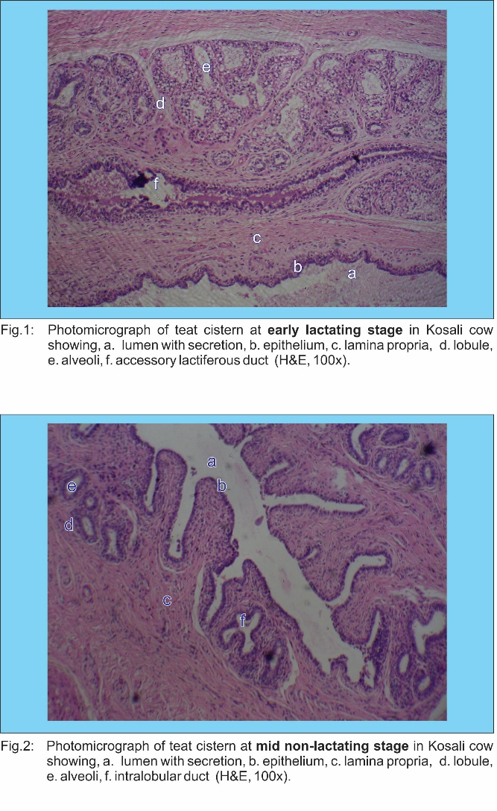

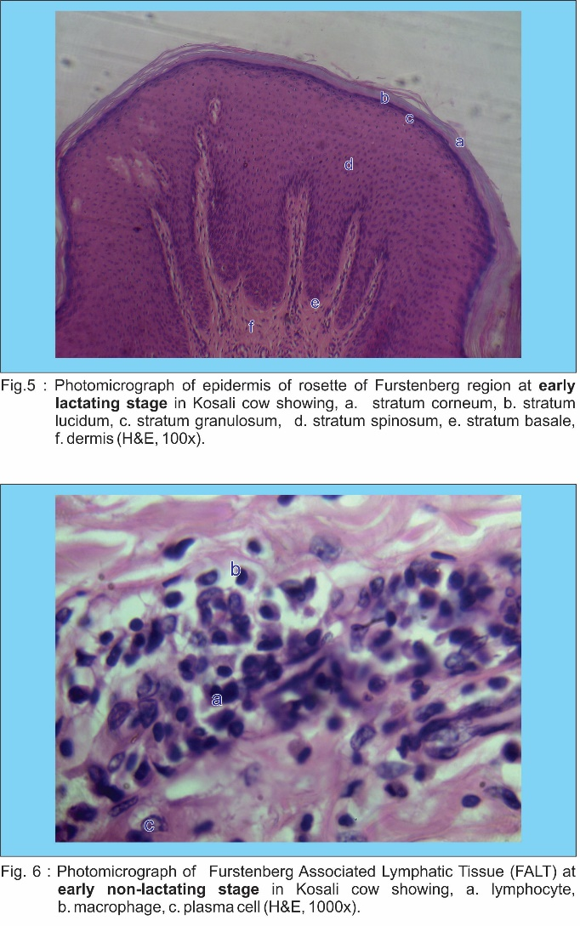

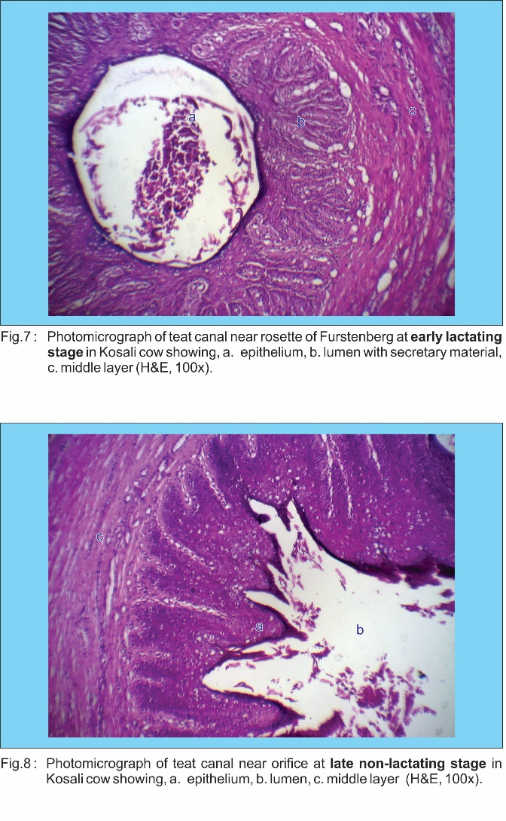

**Table 1: Mean ± SE (µm) histo-morphometrical parameters of teat of lactating and non-lactating Kosali cows:**

|  |  |  |  |  |  |
| --- | --- | --- | --- | --- | --- |
| **S.**  **No.** | **Parameters** | **Groups** | **Stages** | | |
| **Early** | **Mid** | **Late** |
|  | Height of the epithelium of teat cistern (µm) | Lactating | 23.88 ± 0.18a* | 22.24 ± 0.16b* | 19.87 ± 0.14c* |
| Non lactating | 17.95 ± 0.12a | 16.63 ± 0.10b | 14.65 ± 0.08c |
|  | Width of the epithelium of teat cistern (µm) | Lactating | 21.34 ± 0.18a* | 19.74 ± 0.15b* | 17.26 ± 0.13c* |
| Non lactating | 15.87 ± 0.11a | 14.11 ± 0.09b | 11.56 ± 0.07c |
|  | Diameter of nuclei of the epithelium of teat cistern (µm) | Lactating | 14.89 ± 0.11a* | 13.68 ± 0.10b* | 11.86 ± 0.09c* |
| Non lactating | 10.16 ± 0.08a | 9.09 ± 0.07b | 7.44 ± 0.06c |
|  | Thickness of epidermis of skin of teat cistern (µm) | Lactating | 449.45 ± 15.06a* | 413.34 ± 13.05b* | 356.98 ± 11.03c* |
| Non lactating | 337.91 ± 10.03a | 270.48 ± 9.01b | 165.56 ± 7.01c |
|  | Number of mucosal folds of rosette of Furstenberg | Lactating | 28 ± 0.33a* | 26 ± 0.28b* | 23 ± 0.24c* |
| Non lactating | 18 ± 0.21a | 16 ± 0.19b | 13 ± 0.17c |
|  | Height of the epithelium of rosette of Furstenberg (µm) | Lactating | 25.67 ± 0.20a* | 24.38 ± 0.19b* | 22.45 ± 0.16c* |
| Non lactating | 20.34 ± 0.14a | 18.48 ± 0.13b | 15.77 ± 0.11c |
|  | Width of the epithelium of rosette of Furstenberg (µm) | Lactating | 23.75 ± 0.19a* | 21.68 ± 0.17b* | 18.59 ± 0.15c* |
| Non lactating | 16.73 ± 0.14a | 14.88 ± 0.13b | 12.12 ± 0.12c |
|  | Diameter of nuclei of the epithelium of rosette of Furstenberg (µm) | Lactating | 16.15 ± 0.15a* | 14.91 ± 0.13b* | 12.98 ± 0.11c* |
| Non lactating | 11.35 ± 0.10a | 10.04 ± 0.09b | 8.13 ± 0.07c |
|  | Thickness of epidermis of skin of rosette of Furstenberg (µm) | Lactating | 592.46 ± 16.76a* | 525.76 ± 15.25b* | 428.19 ± 13.91c* |
| Non lactating | 367.98 ± 11.98a | 306.12 ± 9.13b | 212.67 ± 7.81c |
|  | Maximum diameter of lumen of teat canal near rosette of Furstenberg (µm) | Lactating | 820.46 ± 24.87a* | 749.99 ± 20.66b* | 648.48 ± 18.57c* |
| Non lactating | 586.67 ± 16.18a | 529.13 ± 14.71b | 445.76 ± 13.67c |
|  | Minimum diameter of lumen of teat canal near rosette of Furstenberg (µm) | Lactating | 598.48 ± 17.41a* | 533.58 ± 15.29b* | 435.79 ± 12.84c* |
| Non lactating | 389.56 ± 11.17a | 359.95 ± 10.62b | 316.98 ± 9.46c |
|  | Average diameter of lumen of teat canal near rosette of Furstenberg (µm) | Lactating | 709.47 ± 21.14a* | 641.78 ± 17.98b* | 542.14 ± 17.70c* |
| Non lactating | 488.12 ± 13.68a | 444.54 ± 12.66b | 381.37 ± 11.56c |
|  | Height of the epithelium of teat canal near rosette of Furstenberg (µm) | Lactating | 97.39 ± 2.96a* | 91.39 ± 2.57b* | 82.69 ± 2.17c* |
| Non lactating | 76.23 ± 1.98a | 71.86 ± 1.65b | 65.56 ± 1.43c |
|  | Width of the epithelium of teat canal near rosette of Furstenberg (µm) | Lactating | 78.23 ± 2.04a* | 70.44 ± 1.58b* | 59.17 ± 1.27c* |
| Non lactating | 52.29 ± 1.06a | 48.18 ± 0.95b | 41.78 ± 0.83c |
|  | Diameter of nuclei of the epithelium of teat canal near rosette of Furstenberg (µm) | Lactating | 17.86 ± 0.16a* | 16.28 ± 0.13b* | 13.88 ± 0.12c* |
| Non lactating | 11.82 ± 0.10a | 10.69 ± 0.08b | 9.02 ± 0.05c |
|  | Thickness of epidermis of skin of teat canal near rosette of Furstenberg (µm) | Lactating | 672.34 ± 17.27a* | 612.38 ± 15.18b* | 524.54 ± 13.56c* |
| Non lactating | 458.67 ± 11.05a | 399.89 ± 9.16b | 312.86 ± 6.68c |
|  | Maximum diameter of lumen of teat canal at middle part (µm) | Lactating | 1675.98 ± 35.67a* | 1354.59 ± 30.68b* | 874.56 ± 25.81c* |
| Non lactating | 739.16 ± 21.45a | 648.86 ± 19.87b | 516.72 ± 14.75c |
|  | Minimum diameter of lumen of teat canal at middle part (µm) | Lactating | 709.34 ± 20.45a* | 667.14 ± 18.56b* | 604.78 ± 16.62c* |
| Non lactating | 564.26 ± 14.76a | 528.84 ± 12.44b | 475.53 ± 10.03c |
|  | Average diameter of lumen of teat canal at middle part (µm) | Lactating | 1192.66 ± 28.06a* | 1010.86 ± 24.62b* | 739.67 ± 21.22c* |
| Non lactating | 651.71 ± 18.10a | 588.85 ± 16.16b | 496.12 ± 12.39c |
|  | Height of the epithelium of teat canal at middle part (µm) | Lactating | 377.53 ± 14.44a* | 310.78 ± 12.56b* | 212.45 ± 9.98c* |
| Non lactating | 198.44 ± 8.38a | 164.12 ± 7.88b | 114.67 ± 5.18c |
|  | Width of the epithelium of teat canal at middle part (µm) | Lactating | 286.68 ± 9.86a* | 229.59 ± 7.28b* | 147.36 ± 4.46c* |
| Non lactating | 122.16 ± 4.43a | 108.98 ± 3.86b | 89.56 ± 2.35c |
|  | Diameter of nuclei of the epithelium of teat canal at middle part (µm) | Lactating | 19.16 ± 0.18a* | 17.48 ± 0.16b* | 15.03 ± 0.14c* |
| Non lactating | 13.72 ± 0.11a | 12.36 ± 0.08b | 10.36 ± 0.06c |
|  | Thickness of epidermis of skin of teat canal at middle part (µm) | Lactating | 703.45 ± 20.63a* | 653.45 ± 18.89b* | 578.68 ± 16.56c* |
| Non lactating | 507.89 ± 12.78a | 450.87 ± 10.15b | 363.12 ± 7.43c |
|  | Maximum diameter of lumen of teat canal at orifice (µm) | Lactating | 3067.18 ± 56.49a* | 2536.45 ± 48.27b* | 1765.85 ± 40.55c* |
| Non lactating | 1473.48 ± 34.58a | 1246.37 ± 30.56b | 898.27 ± 20.23c |
|  | Minimum diameter of lumen of teat canal at orifice (µm) | Lactating | 965.24 ± 26.36a* | 861.15 ± 24.97b* | 706.58 ± 22.43c* |
| Non lactating | 617.93 ± 20.12a | 581.25 ± 16.44b | 524.85 ± 11.87c |
|  | Average diameter of lumen of teat canal at orifice (µm) | Lactating | 2016.21 ± 41.42a* | 1698.80 ± 36.62b* | 1236.22 ± 31.49c* |
| Non lactating | 1045.70 ± 27.35a | 913.81 ± 23.50b | 711.56 ± 16.05c |
|  | Height of the epithelium of teat canal at orifice (µm) | Lactating | 681.05 ± 20.45a* | 595.49 ± 18.54b* | 467.93 ± 16.83c* |
| Non lactating | 397.53 ± 14.82a | 335.65 ± 13.02b | 241.87 ± 12.71c |
|  | Width of the epithelium of teat canal at orifice (µm) | Lactating | 531.59 ± 19.98a* | 458.66 ± 17.08b* | 345.47 ± 13.29c* |
| Non lactating | 276.78 ± 11.16a | 208.56 ± 7.18b | 107.36 ± 4.46c |
|  | Diameter of nuclei of the epithelium of teat canal at orifice (µm) | Lactating | 21.06 ± 0.21a* | 19.58 ± 0.18b* | 17.39 ± 0.15c* |
| Non lactating | 15.22 ± 0.12a | 13.91 ± 0.09b | 11.98 ± 0.07c |
|  | Thickness of epidermis of skin of teat canal at orifice (µm) | Lactating | 822.14 ± 24.54a* | 743.78 ± 22.85b* | 627.98 ± 19.53c* |
| Non lactating | 599.65 ± 17.76a | 541.85 ± 15.16b | 453.23 ± 13.73c |

a, b, c in each row, means with different superscripts are significantly different (p<0.05)

* in each column, means with different superscripts are significantly different (p<0.05)