Original Research Article
Nutritional aspects of pollen diets and evaluation of the acceptance of pollen diets by honey bees

Abstract
The exotic honeybee Apis mellifera L. provides highly valued pollination services for a wide variety of agricultural crops and ranks as the single pollinator for crops most frequently worldwide. In Himachal Pradesh, bee keeping relies on the migration of bee colonies to other states by beekeepers, particularly during winters, due to the scarcity of bee flora. Thus, to keep honeybee colonies strong during dearth periods, indigenous alternative pollen sources need to be evaluated as a part of good management practices for beekeeping. The studies were carried out at the experimental farm and laboratory of Apiculture of the Department of Entomology, Dr. Y.S. Parmar University of Horticulture and Forestry, Nauni, Solan (H.P.) from 2020--2021. Various ingredients, such as defatted soya flour, wheat flour, yeast, gram powder, skim milk, various grain flour, sugar, honey, and water, were used. These mixtures were used at different ratios to evaluate their influence on colony parameters, e.g., the brood area, honey store, pollen store, and honeybee-strength of A. mellifera. The colonies were fed various pollen diets via the frame feeding method at 14-day intervals during the rainy-autumn and spring-summer seasons.

Keywords: Apis mellifera, Pollination, Pollen substitutes, Pollen diets, Hive bees.
Introduction
The honeybee A. mellifera is the most common pollinator of crops globally and provides highly valued pollination services for a wide range of agricultural crops (Hung et al. 2018). A. mellifera is native to western Asia, Africa, and Europe. Since the 17th century, when humans first introduced A. mellifera to other continents, it has spread to East Asia, Australia, North America, and South America. Approximately one million native honeybee (A. cerana) and European bee (A. mellifera) colonies exist at this time. Owing to its high output, A. mellifera beekeeping is focused on most regions of the nation and is quickly becoming established. It has extended to Punjab, Himachal Pradesh, and Jammu.
Like all living things, honeybees need water, proteins, carbohydrates, minerals, fats, lipids, vitamins, and other nutrients for healthy growth and development. The gathering of nectar, pollen, and water provides the necessary nutrients for these diets. Honeybees gather nectar from floral or extrafloral nectarine-rich blooms, which meets their needs for carbohydrates. Proteins, minerals, lipids, and vitamins are all provided by the pollen that honeybees collect from a variety of flowering plants. Honeybees exclusively consume pollen, which also provides all the essential lipids, vitamins, and minerals for a bee colony's healthy growth and development, as their primary source of protein. It has been reported that 10 to 20% of colonies per year perish from malnutrition. Different types of pollen substitutes are used to feed honeybee colonies during floral dearth, viz., powdered skim milk, soybean products, brewer’s yeast, fish meal and meat scraps (Shehata 2016).
A diet composed of soybean flour supplemented with vitamin B complex and methionine was found to be the best diet for strengthening colonies (Saleem et al. 2003). Additionally, honeybee colonies supplemented with pollen substitutes such as soybean flour, maize flour, and wheat flour have been reported to contain greater brood areas than those not supplied with pollen substitutes (Castagmino et al. 2004). Yasin (2009) evaluated various flours, viz., Arhar, Maize, Rice, Wheat, Soyabean, Bajra and Gram, as pollen substitutes and evaluated the availability of pollen resources for A. mellifera. Pollen substitutes must be palatable and digestible to bees and should satisfy the nutritional requirements of honey bees. It should have a proper taste and texture so that it is consumed by bees in optimal amounts (Saffari et al. 2010). Soy flour is also acceptable as a protein feed for bees (Dodologlu and Emsen 2007; Pande et al. 2011). During lien periods (June--July), beekeepers often feed honey bee colonies with pollen supplements such as defatted soybean, maize and gram flour when natural pollen supplies are not sufficient to promote colony development and health (Saffari et al. 2010; Rashid et al. 2013).
The high cost, lack of protein quality or other nutritional requirements, presence of toxic or pathogenic agents, and poor palatability of the many components utilized in the creation of pollen substitution meals are common problems. Commercially produced honeybee pollen has inferior nutritional value and is more expensive than raw pollen. Therefore, the primary need of beekeepers is the development of an affordable and tolerable pollen substitute diet, especially in developing nations where summers are extremely harsh and dry, where there is a floral shortage coupled with high temperatures, and where there are frequent pests, predators, and enemies of honeybees (Sihag and Gupta 2013).

Materials and methods
The experiment was conducted at the Apiculture Research Experimental Farm, which is located at an altitude of 1256 amsl, latitude of 35.30°N and longitude of 77.70°E and represents the midhill zone of Himachal Pradesh (India) from 2020--2021. The effects of different pollen diets were observed. The composition and preparation of different pollen substitutes and diets are described in Table 1. Data on the amount of diet consumed by A. mellifera within 14 days of feeding every month on a daily basis were collected to study the acceptance of pollen-containing diets by A. mellifera. The difference between the initial and final weights was recorded as the amount of food consumed at the end of the 14-day period, and the amount of food consumed every fortnight was determined. Additionally, the chemical compositions of the pollen-containing diets were also analysed via standard methods. The chemical parameters analysed were crude protein (AOAC, 2012), moisture content (Rangana, 2009), crude fat (AOAC, 2012), sugars (reducing and total sugars) (Lane and Eynon, 1923), ash content, crude fibre content and carbohydrate content (Rangana, 2009). The data recorded for various parameters were statistically analysed via MS Excel and OPSTAT (completely randomized design, factorial).

Table 1. Composition of pollen diets
S.No. | Treatments | Composition | Preparation of diet
1. | Pollen substitute 1 | Defatted soya flour = 150 g; Wheat flour = 150 g; Deactivated yeast = 100 g; Sugar = 266 g; Water = 134 ml (Total = 800 g + 40 ml Rum) | Defatted soy flour (DSF) and wheat flour was mixed in equal parts by weight. In separate beaker, a mixture of approximately two parts of sugar (266 g) and one part of water (134 ml) was prepared and mixed with the previous mixture. The kneaded pollen substitute was kept overnight for proper penetration of sugar in the mixture. To make the feed more attractive to bees 40 ml “dark rum” was added to 800 g of substitute before feeding. 200 g of this substitute was filled in bee frames and one frame was given to each colony by using frame feeding method.
2 | Pollen substitute 2 | Yeast (42%) = 336 g; Gram Powder (4%) = 32 g; Skim milk (4%) = 32 g; Sugar = 200 g; Water = 200 ml  (Total = 800 g) | 800 g of Pollen substitute 2 diet was prepared by mixing 32 g each of gram powder and skim milk, 336 g of yeast which were further mixed with an equal amount of 200 g sugar and 200 ml water. The mixture was kept as such for approximately 2 hours. 200 g of this pollen substitute diet was filled in the bee frame and one frame was given to each colony by using frame feeding method.
3. | Pollen substitute 3 | Various grain flour (3%) =150 g; Skim milk (3%) =150 g; Dried yeast (2%) =100 g; Honey (8%) = 400 g  (Total = 800 g) | The diet consisted of various grain flour (multigrain atta, 150 g), skim milk powder (150 g), dried yeast (100 g) and honey (400 g), all these ingredients were mixed. The mixture was kept as such for 3-4 hours. 200 g of this substitute was filled in the bee frame and one frame was given to each colony by using frame feeding method.
4. | Pollen supplement | Pollen 55-60% + Honey (45-40%) | Pollen supplement diet pollen was collected from A. mellifera colonies by installing pollen trap at the entrance of bee colonies. The collected corbicular pollen was stored in deep freezer (-17°C). Mixture of honey and pollen with 55-60% of pollen was prepared. 200 g of pollen supplement was filled in the frame and one frame was given to each colony using frame feeding method.
5. | Control |  | No artificial pollen diet was given.

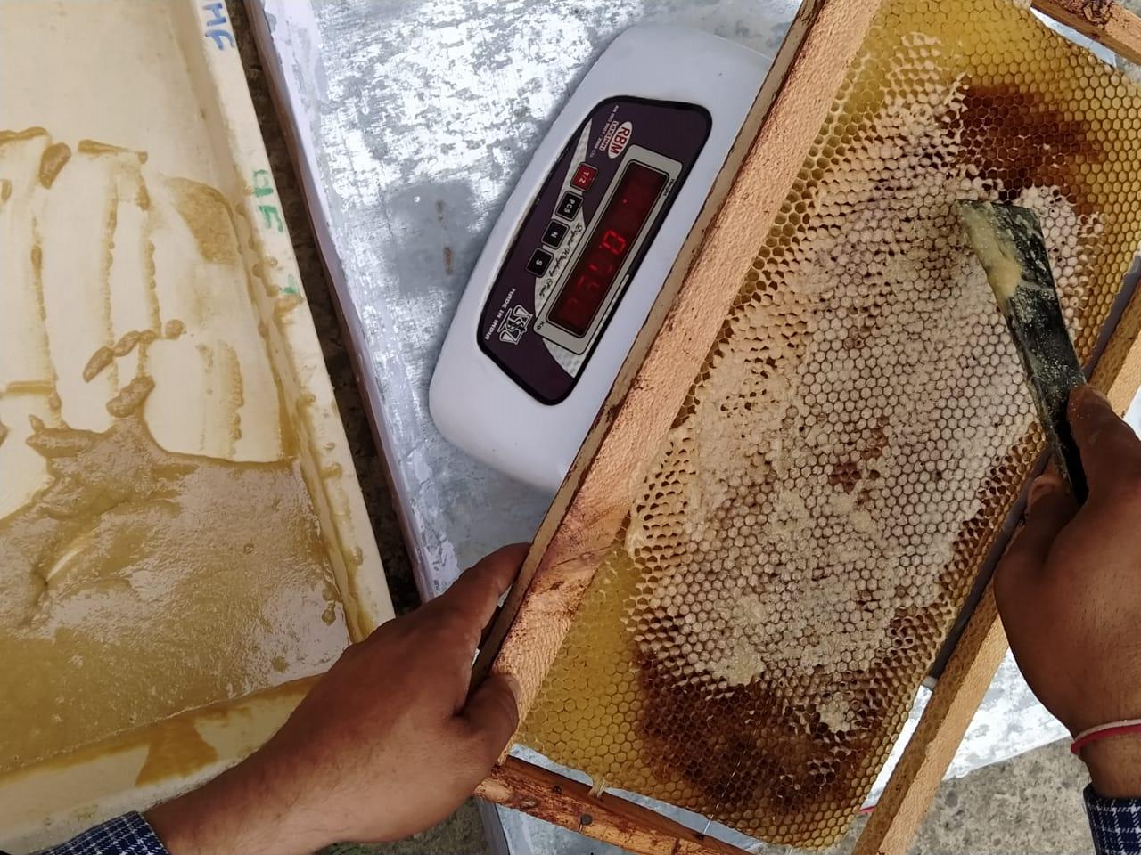

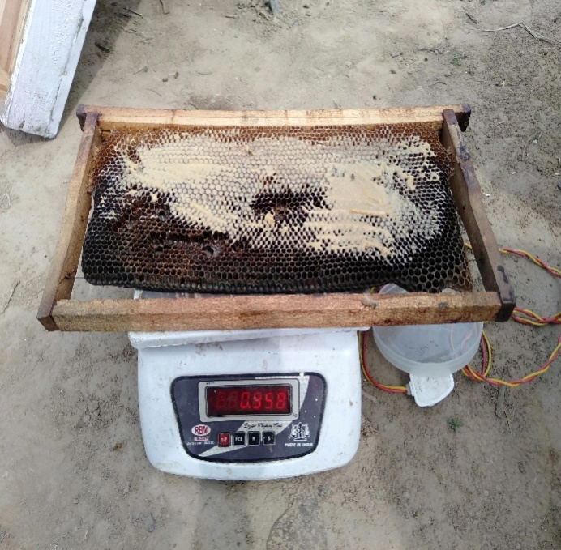

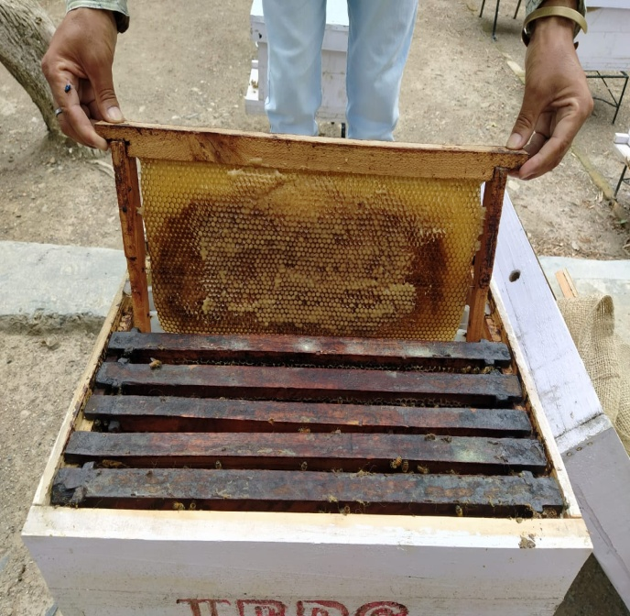

Fig. 1: Feeding of pollen diets to bee colonies via the frame feeding method

CHEMICAL COMPOSITION OF POLLEN DIETS
The chemical compositions of the pollen-containing diets were analysed via standard methods. The chemical parameters analysed were as follows: crude protein content, moisture content, crude fat content, sugars (reducing and total sugars), ash content, crude fibre content and carbohydrate content.
- Estimation of crude protein (%)
The crude protein content was determined via the method of AOAC (2012) via a semiautomatic instrument, i.e., KjelTRON (KDIGB 6 M & KjelDISTEA). The appearance of a clear bluish green color indicated the completion of digestion. The crude protein content was calculated by multiplying the percentage of nitrogen by a factor of 6.25. A parallel blank was run to eliminate error.
Nitrogen (%) = | (Sample titre- Blank titre) × Normality of HCl × 14 | × 100
Nitrogen (%) = | Weight of sample × 1000 | × 100

Crude protein (%) = % of nitrogen × 6.25
- Estimation of moisture content (%)
The moisture content was estimated by drying the weighed sample to a constant weight in a hot air oven at 70 ± 2°C. The dried sample was then cooled to room temperature in a desiccator before weighing (Ranganna 2009). The moisture percentage was calculated as follows:

Moisture (%) | = | (Weight of fresh sample - Weight of dried sample) | × | 100
Moisture (%) | = | Weight of fresh sample | × | 100

- Estimation of crude fat (%)
Fat content was determined via the method of AOAC (2012) via an automatic Sox-Tron fat extraction system (Model: Sox-2 version 0.1). The fat content was calculated via the following formula:

Crude fat (%) = | W₂-W₁ | x 100
Crude fat (%) = | W | x 100
where:
W₁ = Empty weight of collection vessels
W₂ = Final weight of collection vessels
W = Initial weight of sample

- Estimation of sugars (%)
4.1 Reducing sugars (%)
The reducing sugar content was estimated via the Lane and Eynon (1923) volumetric method by using Fehling’s A and Fehling’s B solutions with methylene blue as an indicator. The appearance of a brick red precipitate was noted as the endpoint. Reducing sugars were estimated as percentages and calculated via the following formula:
Reducing sugars (%) = × 100

where factor = 0.05
4.2 Total sugars (%)
The total sugar content was estimated via the Lane and Eynon (1923) volumetric method by titrating the prepared sample. After hydrolysis with citric acid (5 g citric acid to 50 mL clarified solution), the sample was heated for 10 minutes for complete inversion of sugars (Ranganna 2009). The total sugars were estimated as percentages and calculated as follows:
Total sugars (%) = × 100

where factor = 0.05
- Estimation of ash content (%)
Total ash was determined gravimetrically by taking the known weight of fresh and dried samples in tarred silica crucibles given by Ranganna (2009). The ash content of the samples was calculated and expressed as a percentage on a fresh weight basis as follows:
Weight of ash
Ash (%) = _________________________________ x 100
…………Weight of sample taken

- Estimation of crude fibre (%)
Crude fibre estimation was performed via the FibroTRON-FRB-2 instrument methodology (Ranganna 2009). The percentage of crude fibre was calculated via the following formula:

Crude fibre (%) = | W₂-W₁ | x 100
Crude fibre (%) = | W | x 100
- Estimation of carbohydrate (%)
The total carbohydrate content as a percentage dry weight basis was determined by mathematically determining the % moisture, % ash content, % crude protein and % crude fat parameters and then deducting them from 100 (Ranganna 2009) as follows:
Total carbohydrate content = 100 - (% moisture content + % ash content + % crude protein + % crude fat).

Results and Discussion
In the spring–summer season, 2021 A. mellifera preferentially consumed Pollen supplement (100%), followed by Pollen substitute 3 (91.40%), Pollen substitute 1 (87.81%) and Pollen substitute 2 (80.62%) (Fig. 1).

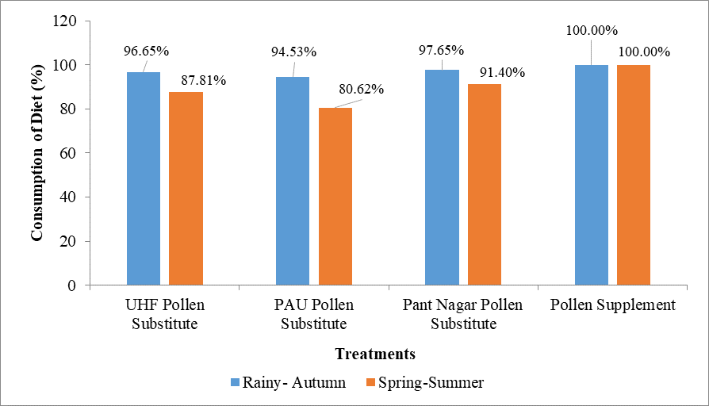

Fig. 2 Percent diet consumption of pollen by A. mellifera during different seasons

The consumption of all the diets was higher in the spring–summer season than in the rainy–autumn season, except for the pollen supplement, which was fully utilized in both seasons. As evident from the results presented above, diet T₄ (Pollen supplement) was completely consumed earlier, followed by T₃ (Pollen substitute 3). These results support the previous findings of Kumari and Kumar (2020), who reported that A. mellifera completely consumed bee support (defatted soy flour, brewer’s yeast, parched grams, spy protein hydrolysate, and sugar) (100%) from May--July. These results are consistent with the findings of Islam et al. (2020), who reported that a diet that included soybean flour was consumed the most (71.90 g) from June to October 2018 by A. mellifera.
The present observations contrast with the findings of Mahfouz (2016), who reported the maximum consumption rate of defatted soyean flour by A. mellifera in the winter season. These findings are also supported by the reported diets consisting of soya flour-1part, brewer’s yeast-1part, soya protein hydrolysate-1part, sugar-1part, and glucose-1part, which have also been shown to be best for A. mellifera during the dearth period, i.e., April–September (Kumar and Agrawal, 2014). Ger chickpea was consumed the most (83.9%) by A. mellifera colonies during the dearth period of June--October (Pande and Karnatak, 2014). In the present study, full consumption (100%) of pollen supplement was recorded, which supports the findings of Dodologlu and Emsen (2007), who also recorded complete feed consumption of a diet consisting of honey and pollen cake when provided as supplementary feed for A. mellifera during the spring season.
Table 2. Chemical compositions of various pollen diets for Apis mellifera L.

Treatment | Moisture (%) | Ash (%) | Crude fibre (%) | Crude protein (%) | Crude fat (%) | Carbohydrate (%) | Reducing sugars (%) | Total sugars (%)
T1 | 9.44 | 1.55 | 28.57 | 29.02 | 4.32 | 55.71 | 16.33 | 23.64
T2 | 8.57 | 1.26 | 20.53 | 23.99 | 2.99 | 63.18 | 12.50 | 42.95
T3 | 10.69 | 1.46 | 24.49 | 27.24 | 5.32 | 55.26 | 28.33 | 50.33
T4 | 13.31 | 3.54 | 14.53 | 30.55 | 2.35 | 50.24 | 31.33 | 35.13
T5 | 11.01 | 2.48 | 13.07 | 33.72 | 1.97 | 50.80 | 20.85 | 39.99
CD _{(0.05)} | NS | NS | 8.35 | 8.43 | 2.29 | NS | 2.93 | 5.32

The chemical composition of the pollen substitute and pollen supplement diets was also studied (Table 2). The moisture content in the various treatments varied from 8.57% to 13.31%, with no significant difference among the diets. The ash content varied from 1.26% to 3.54%. The highest crude fibre content was found in T₁ (28.57%), which was statistically at par with T₃ (24.49%) and T₂ (20.53%), whereas the lowest crude fibre content was found in T₅ (13.07%), which was statistically at par with T₄ (14.53%). The highest crude protein content was found in T₅ (33.72%), which was statistically at par with T₄ (30.55%), T₁ (29.02%) and T₃ (27.24%), whereas the lowest crude protein content was found in T₂ (23.99%). The highest crude fat content was found in T₃ (5.32%), which was statistically at par with T₁ (4.32%), whereas the lowest crude protein content was found in T₅ (1.97%), which was statistically at par with T₂ (2.99%) and T₄ (2.35%).
The total carbohydrate content varied from 50.24% (pollen supplement) to 63.18% (pollen substitute 2), with no significant effect among the pollen diets. The percentage of reducing sugars was significantly greater in T4, the pollen supplement (31.33%), and the lowest percentage of reducing sugars was found in T₄, the pollen supplement (14.53%). In contrast, total sugars were statistically highest in T₃, Pollen substitute 3 (50.33%), and lowest in T₁, Pollen substitute 1 (23.64%).

Chalmers (1980) reported an average moisture content of 7.7%-0.5% in pollen substitute diets. The observation of the crude protein content (23.99% to 33.72%) supports the previous findings of Zheng et al. (2014), where the dietary protein content ranged from 29.5%-34.0% in pollen diets, and this protein content was recommended to maximize the reproduction rate of honey bee colonies in early spring. Li et al. (2012) fed a pollen substitute diet consisting of protein levels ranging from 15–35% and reported that dietary protein of 30–35% is optimal for the colony development of A. mellifera, which is supported by the findings of the present study, where a statistically high protein content of 33.72% was recorded in Corbicular pollen compared with other diets. The ash content (mineral content) varied from 1.26–3.54% in the present investigations, and ash contents of 3.54% and 2.48% were recorded in the pollen supplement and corbicular pollen, respectively. An ash content of 2.5–6.5% has also been reported for plant pollen (Herbert and Shimanuki, 1978), and further addition of 1% pollen ash to an artificial honey bee diet increased brood rearing.

CONCLUSION
Pollen substitutes, viz., the UHF Solan pollen substitute, PAU pollen substitute, Pant Nagar pollen substitute and pollen supplement, were evaluated for consumption. All three pollen substitutes were accepted by A. mellifera colonies, and the consumption rate within 14 days ranged from 80.62% to 97.65% during both seasons. Chemical analysis of the pollen substitute, pollen supplement and corbicular pollen revealed that the contents of crude fibre, crude protein, crude fat, reducing sugars and total sugars ranged from 13.07% to 28.57%, 23.99% to 33.72%, 1.97% to 5.32%, 12.50% to 31.33% and 23.64% to 50.33%, respectively. However, no significant differences were observed among the different diets with respect to moisture content, ash content or carbohydrate content. On the basis of the results of the present study, various pollen substitutes had positive effects on the colony parameters and honey stores of A. mellifera compared with those of the control.

COMPETING INTERESTS DISCLAIMER:
Authors have declared that they have no known competing financial interests OR non-financial interests OR personal relationships that could have appeared to influence the work reported in this paper.

REFERENCE:
- AOAC. 2012. Association of Official Analytical Chemists - Official Method of Analysis. 11th ed. Washington DC.
- Castagmino G L B, Message D, Marcro J P and Fernandes E. 2004. Evaluation of the nutritional efficiency of pollen substitute by brood and pollen area measurement in Apis mellifera. Revista Ceres 51: 307-315.
- Chalmers W T. 1980. Fish meals as pollen-protein substitutes for honeybees. Bee World 61: 89-96.
- Dodologlu A and Emsen B. 2007. Effect of supplementary feeding on honey bee colony. Journal of Applied Animal Research 32: 199-200.
- El-Sherif E, Naglaa G, Lotfy Y and Sobhia S. 2017. Effect of feeding some diets as a pollen grains supplements during spring season on some activities of honey bee colonies. Egyptian Academic Journal of Biological Sciences 10: 181-193.
- Herbert E W and Shimanuki H. 1978. Chemical composition and nutritive value of bee-collected and bee-stored pollen. Apidologie 9: 33-40.
- Hung K L J, Kingston J M, Albrecht M, Holway D A and Kohn J R. 2018. The worldwide importance of honey bees as pollinators in natural habitats. Proceedings of The Royal Society Biological Sciences 285: 2017-2140.
- Islam N, Mahmood R, Sarwar G, Ahmad S and Abid S. 2020. Development of pollen substitute diets for Apis mellifera ligustica colonies and their impact on brood development and honey production. Pakistan Journal of Agricultural Research 33: 381-388.
- Kumar R and Agrawal O P. 2014. Comparative performance of honeybee colonies fed with artificial diets in Gwalior & Panchkula region. Journal of Entomology and Zoology Studies 2: 104-107.
- Kumari, I. and Kumar, R. 2020. Pollen substitute diet for Apis mellifera: Consumption and effects on colony parameters in subtropical Himalaya. Indian Journal of Agriculture Research 54: 147-153.
- Lane J H and Eynon L. 1923. Methods for determination for reducing and nonreducing sugars. Journal of Sciences 42: 32-37.
- Li C, Xu B, Wang Y, Feng Q and Yang W. 2012. Effects of dietary crude protein levels on development antioxidant status, and total midgut protease activity of honey bee (Apis mellifera ligustica). Apidologie 43: 576-586.
- Mahfouz H M. 2016. Impact of winter feeding with some protein pollen supplement diets on the biological activities of honeybees. Journal of Plant Protection and Pathology 7: 307-310.
- Pande R, Firake D M and Karnatak A K. 2011. Development of pollen substitutes for dearth period management of honeybee (Apis mellifera) colonies in foothills of Shivalik range of Himalayas. Indian Journal of Agricultural Sciences 81: 861-866.
- Pande R, Firake D M and Karnatak A K. 2011. Development of pollen substitutes for dearth period management of honeybee (Apis mellifera) colonies in foothills of Shivalik range of Himalayas. Indian Journal of Agricultural Sciences 81: 861-866.
- Ranganna S. 2009. Handbook of Analysis and Quality Control of Fruits and Vegetable Products. 2nd ed. Tata Mack Graw Hill publishing Company Limited. New Delhi. India.
- Rashid R, Wagchoure E S and Sarwar G. 2013. Influence of supplemental diets on Apis mellifera L. colonies for honey production. Pakistan Journal of Agricultural Research 26: 290-294.
- Saffari A, Kevan P J and Atkinson J. 2010. Consumption of three dry pollen substitutes in commercial apiaries. Journal of Apicultural Science 54: 13-20.
- Saleem M, Ramzan M and Manzoor Z. 2003. Effect of some pollen substitute diets on development of Apis mellifera L. colonies. The Journal of Animal and Plant Science 13: 39-40.
- Shehata I A A. 2016. Evaluation of Carniolan and Italian honey bee colonies fed on artificial diets in dearth and flowering periods under Nasr city conditions. International Journal of Environment 5: 19-25.
- Sihag R C and Gupta M. 2013. Testing the effects of some pollen substitute diets on colony buildup and economics of bee keeping with Apis mellifera L. Journal of Entomology 10: 120-135.
- Yasin, M. 2009. Studies on the efficacy of various flours as pollen substitutes and availability of pollen resources for the honey bees Apis mellifera L. M.Sc. Thesis. GB Pant University of Agriculture and Technology, Pantnagar. 118p.
- Zheng B. Wu Z and Xu B. 2014. The effects of dietary protein levels on the population growth, performance, and physiology of honey bee workers during early spring. Journal of Insect Science 14: 191.

