***Case report***

**"Tuberculosis-Induced Sudden Death in a Buffalo: A Case Report Highlighting Diagnostic Challenges"**

ABSTRACT

Bovine tuberculosis (bTB), primarily caused by Mycobacterium bovis, is a chronic infectious disease of domestic and wild animals with significant zoonotic implications. This report describes a fatal case of pulmonary tuberculosis in a buffalo (Bubalus bubalis), emphasizing the diagnostic challenges and public health concerns associated with the disease. A mature female buffalo was brought to the Veterinary Clinical Complex (VCC) with clinical signs including anaemia, anorexia, respiratory distress, poor body condition, severe weight loss and exercise intolerance. The animal was admitted to the In-Patient Department (IPD) for symptomatic treatment. Despite supportive care, the buffalo collapsed and died suddenly on the second day of hospitalization. Post-mortem examination revealed multiple caseous and calcified granulomas in the whole thoracic cavity. Histopathological analysis showed granulomatous inflammation with Langhans giant cells. Ziehl-Neelsen staining confirmed the presence of acid-fast bacilli (AFB), consistent with Mycobacterium bovis infection. These findings led to a definitive diagnosis of pulmonary tuberculosis. This case highlights the importance of including tuberculosis in the differential diagnosis of buffaloes presenting with chronic wasting and respiratory signs. Early detection and confirmation through post-mortem and laboratory diagnostics are critical on order to prevent further spread. Given its zoonotic potential, this report underscores the need for routine surveillance, public health education, and integrated One Health approaches to manage bTB in livestock. (Your study did to highlight the proposed One Health approach)

Key words: tuberculosis, Mycobacterium bovis, buffalo, Langhans giant cells, acid fast bacilli

INTRODUCTION

Tuberculosis is a chronic, progressive, granulomatous and infectious disease caused by microorganisms belonging to the *Mycobacterium tuberculosis* complex (MTC) and can affect human beings and various animal species. Among these, *Mycobacterium bovis* is an important infection pathogen, resulting in zoonotic tuberculosis in humans and bovine tuberculosis (bTB) in animals, and is currently endemic in many parts of the world. In India, the prevalence of bTB in cattle is estimated to be 7.3%, i.e., around 21.8 million cattle are affected with bovine tuberculosis. This burden is expected to eventually rise in the upcoming years due to several contributing factors like the rapid intensification of the dairy industry, enhanced cattle rearing methods and growing focus on improving the per-animal productivity (Srinivasan et al., 2018). In areas of endemicity, infection can spill over to cattle, other domestic animals, vulnerable wildlife species and humans (Zachary et al., 2017). Due to this its zoonotic potential, *M. bovis* results not only in significant sources of infection but also has a substantial impact on economics and trade barriers of countries where bTB is widespread, primarily in Africa and Southeast Asia (WHO, 2017). Due to a lack of routine surveillance data, the actual burden of zoonotic TB is likely underestimated. Nonetheless, in 2016 there were an estimated 147,000 new cases of zoonotic TB in humans, and 12,500 related deaths globally (WHO, 2017). India particularly bears a heavy toll of tuberculosis; according to the Global Tuberculosis Report 2021, about 26% of the TB cases reported worldwide in 2020 were from India and 34% of TB deaths globally in humans in 2020, the highest of any nation (WHO, 2021). Furthermore, the National Tuberculosis Prevalence Survey (2019–2021) reported a TB prevalence of 3,120 cases per million population in India for the year 2021.

In a country with such a high human TB burden, it is imperative to implement effective strategies to curb the spread of the disease as early as possible. In buffaloes, the disease often manifests subclinically, making detection and control challenging but advanced stages may show signs of debilitation and respiratory distress. Water buffaloes are susceptible to a range of infectious diseases including foot-and-mouth disease, bovine viral diarrhea, brucellosis, leptospirosis, fasciolosis, babesiosis, theileriosis, and tuberculosis - all of which have significant economic implications. Moreover, buffaloes also play a role in transmitting zoonotic diseases like schistosomiasis (Batista et al., 2020, Villanueva et al., 2018), human Q fever, *Coxiella burnetii* in milk (Khademi et al., 2019), and Mycobacterium bovis, further contributing to the zoonotic spread of tuberculosis. Bovine tuberculosis is a chronic disease that poses an impact on both animal and human public health. It Bovine tuberculosis remains a big obstacle to achieving the universal control program that aims to end tuberculosis by 2030 (WHO, 2019). Human infection with *M. bovis* has been documented since the 19th and early 20th centuries and primarily linked to the consumption of raw or unpasteurized milk (Thoen et al., 2007). Despite advancements in food safety and veterinary practices, zoonotic transmission of M. bovis continues to pose a challenge, particularly in low- and middle-income countries where routine surveillance and pasteurization practices may be inadequate. The causative agent of bovine tuberculosis is *Mycobacterium bovis*, a member of Mycobacteriaceae family and the genus Mycobacterium. The bacteria is short, non-capsulated, not flagellated, non-motile, facultative intracellular, and aerobic (Andreazza et al., 2015). Transmission occurs primarily through aerosolized particles released when infected animals cough or sneeze. Moreover, the digestive and respiratory systems serve as the basic route of infection. However, aerosol exposure to *M. bovis* is considered to be the most frequent route of infection among cattle, but infection by ingestion of contaminated feed or water, direct contact with infected animals or interaction with wildlife reservoirs can also occur (OIE Manual. 2016). It is characterized by the development of non-vascular granulomas or tubercles which occur most frequently in lungs, lymph nodes, liver, intestine, and kidney. Clinical signs typically include emaciation, chronic coughing, and progressive weight loss. Furthermore, beef and/or [buffalo](https://www.sciencedirect.com/topics/veterinary-science-and-veterinary-medicine/buffalo" \o "Learn more about buffalo from ScienceDirect's AI-generated Topic Pages) meat consumption in India is 42g/capita/month (NSSO, 2014). India is also the second largest exporter of meat products in the world. About 1.5 million tons of buffalo meat is produced in India annually, accounting for about 30% of total meat production (CPCB, 2017). This highlights the importance of buffalo health to the Indian economy and human health.

**History and Clinical Presentation:**

A mature female buffalo 7 years of age seven years old female buffalo was presented to the Veterinary Clinical Complex (VCC) with symptoms of anaemia, anorexia, respiratory distress, poor body condition and exercise intolerance. The owner reported progressive weight loss and reduced productivity. The animal had been exhibiting these signs for an unspecified period prior to its presentation. Clinical examination revealed emaciation, dullness, open mouth breathing (Fig.1) and mild tachypnea.

No specific localized lesion or abnormality was detected externally. Due to the severity of its condition, it was admitted to the **In-Patient Department (IPD)** for close monitoring and treatment. The buffalo was managed **symptomatically** upon admission, with supportive treatment aimed at stabilizing its condition. However, no significant clinical improvement was observed. On the **second day of hospitalization**, the buffalo **suddenly collapsed** and **died within minutes**, despite emergency intervention. Given the unexpected nature of the death, a **post-mortem examination** was conducted to determine the cause.

MATERIAL AND METHODS

Suspected tuberculosis lesions from tissue segments were collected and kept in 10% formalin directly. Samples were trimmed into small specimens involving containing tubercles. The samples were sent to the pathology laboratory for further processing. All samples were routinely processed by histological technique, sectioned at 4- 5µm, stained with Haematoxylin and Eosin, and examined under light microscopy connected with to a camera and image analyzer. The microscopical examination of the tissue sections confirmed the features of tuberculosis granulomatous lesions. The lesions appeared as oval or round with a non-regular central area of mineralized necrotic caseous substance covered by a solid broad layer of collagenous connective tissue invaded by diverse inflammatory cells. The granular necrotic caseous substance stained weakly to moderately eosinophilic, accompanied by the focal accumulation of basophilic chromatin debris that appeared as dotting of diffuse zones. Moreover, numerous neutrophils and degenerated leucocytes were scattered throughout the necrotic foci, accompanied by small or large mineralized foci. Layers of inflammatory cells circumscribed caseous necrotic lesions were seen that was invaded with numerous epithelioid macrophages, multinucleated cells, lymphocytes, macrophages, and Langhan's giant cells that were enclosed completely by solid collagenous connective/fibrous capsule. For microbiological investigation, a group of tubercles were collected, kept in a sterile container, and transferred to the clinical pathology laboratory. The sheath of the tubercles was removed, and the contents were homogenized manually using a sterile glass mortar. The homogenized tissue was suspended in 10 ml of 4% NaOH in a test tube, shaken thoroughly, and settled for 10 minutes. Finally, the sample was centrifuged for 10 minutes at 3000 rpm, and then sediment was collected after the upper supernatant layer was discarded. Thereafter, sterile normal saline was added and appropriately mixed with sediment and centrifuged at 3000 rpm for 10 minutes. This process was repeated 3 times to neutralize the sample completely. The supernatant was removed, and direct smears were prepared from the sediment on a cleaned glass slide, stained with conventional acid-fast stain (Ziehl Neelsen staining). The slides were allowed to air-dry and examined by with a light microscope under an oil immersion objective lens (X100) to investigate the presence of acid-fast bacilli, which is considered a primary diagnostic tool. The examination of slides revealed somewhat curved and red rods that were seen alone or aggregated as clusters, indicating the tuberculosis bacilli.

POST-MORTEM FINDINGS

The necropsy revealed the following findings suggestive of **Tuberculosis** (Fig. 2,3,4,5,6).

* **Multiple caseous granulomas** in the lungs and associated lymph nodes (mediastinal and bronchial),
* **Adhesions and fibrosis** in pleural surfaces,
* **Firm, enlarged lymph nodes** with central necrosis,
* **Extensive nodules** scattered throughout lung parenchyma,
* On histopathology, **granulomatous lesions** with central necrosis surrounded by epithelioid macrophages and Langhans giant cells,
* **Acid-fast bacilli (AFB)** were demonstrated in tissue samples using **Ziehl-Neelsen staining.**

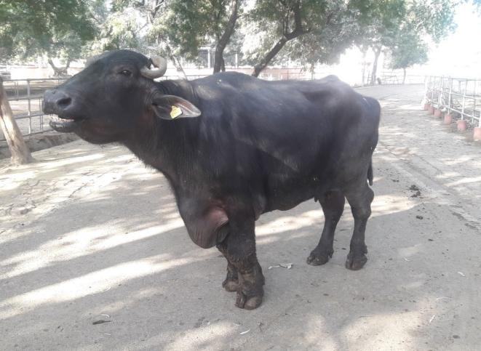

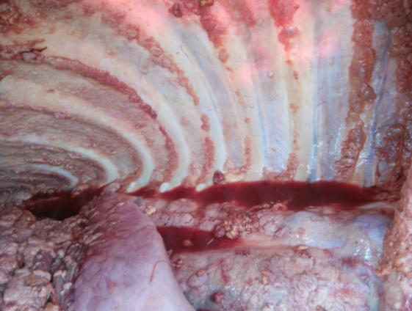

Fig. 2. Presence of multiple nodules in the thoracic cavity.

Fig. 1. Open mouth breathing in the animal.

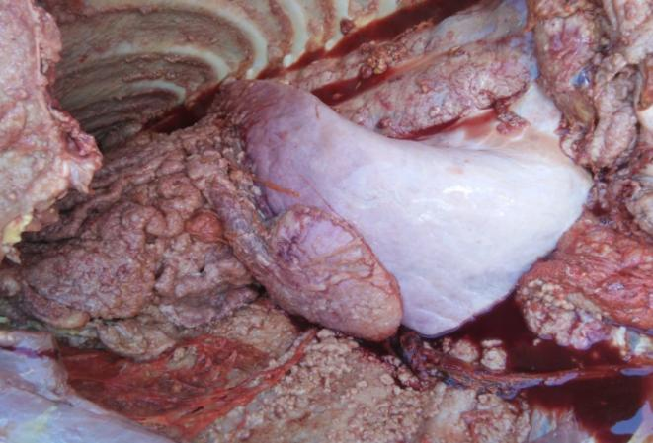

Fig. 3. Presence of caseated nodules with adhesions in lungs in the thoracic cavity.

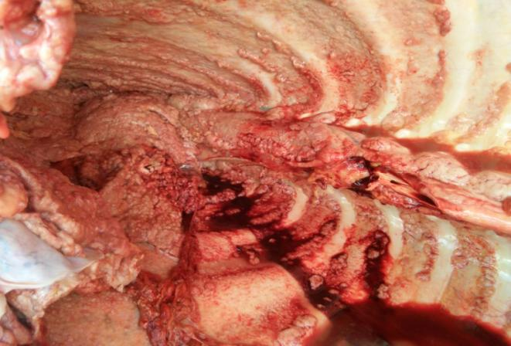

Fig. 4. Showing the thoracic cavity and its occupance with the tubercles.

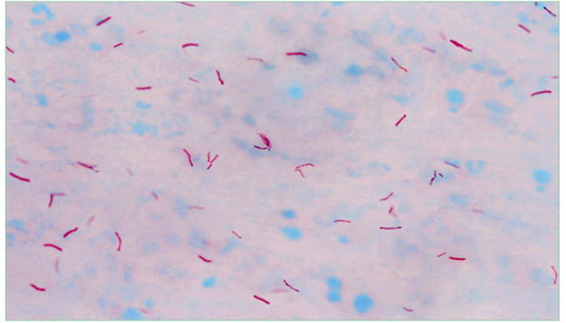 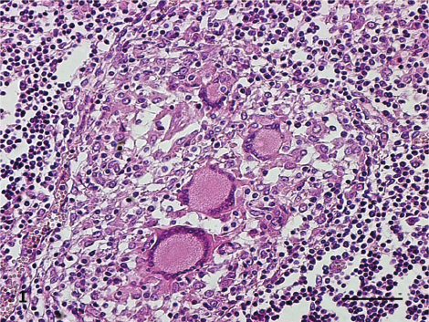

Fig. 6. G**ranulomatous lesions** with central necrosis surrounded by epithelioid macrophages and Langhans giant cells.

Fig. 5. Acid fast bacilli suggestive of *M. bovis*. (add magnification)

RESULTS AND DISCUSSION

Tuberculosis in buffaloes is often misdiagnosed due to its slow progression and the presence of non-specific clinical signs. Sudden death in this case was most likely due to respiratory failure resulting from severe pulmonary involvement. The case was diagnosed according to the gross and microscopic lesions as tuberculosis due to Mycobacterium bovis. This disease is responsible for significant economic losses in livestock industry, including body condemnation and decreased milk production. In addition to these losses, it incurs serious public health concerns and cost of the eradication programs are also high (Buddle et al., 2015). *Mycobacterium bovis* belongs to a group of microorganisms of dominant clinical importance called the *Mycobacterium tuberculosis* complex that causes tuberculosis in humans and animals. *Mycobacterium tuberculosis* is the primary cause of human tuberculosis and contains a massive range of genetic lineages. Zoonotic tuberculosis is caused by *M. Bovis*, *M. suricattae*, *M. orygis*, *M. caprae*, *M. Canetti*, *M. pinnipedii*, *M. mungi*, and *M. microti*, and they are less well-understood animal-associated subspecies. In this case study, the clinical signs were largely non-specific and only became evident upon postmortem examination and histopathological findings, which confirmed that this was a case of tuberculosis. Gross pathology of this case revealed thousands of various sized typical tubercula, ranging from small miliary foci to large tubercles and abscesses. Additionally, these lesions were characteristic of tuberculosis, seen as caseated calcified tubercles surrounded by dense connective tissue infiltrated by various inflammatory cells. The tubercles revealed mineralized materials near the outer fibrous capsule in a lamellar pattern. The granulomatous lesions were extensively distributed both in the thoracic and associated lymph nodes. These gross pathological appearances are suggestive of tuberculosis. Histopathological examination supported the gross lesions and diagnosis of tuberculosis was supported by the results of a direct smear from a lesion stained by Ziehl-Neelsen stain that showed red, straight, and slightly curved acid fast rods, seen singly or in clusters indicating the tubercle bacilli. (Kindly include a paragraph discussing the limitations of the diagnostic methods used, i. e. gross lessons, histology, and Z-N staining because these do not give a confirmatory diagnosis of tuberculosis since some bacteria (e.g. Nocardia) may cause similar lesions. You may then add that confirmatory diagnostic tools like PCR or culture are challenging in resource limited settings and owing to the high prevalence on the disease in the region, preliminary finding like clarion this should serve as a call to public health authorities)

CONCLUSIONS

This case highlights the importance of considering **tuberculosis** in buffaloes with chronic weight loss, respiratory distress, weakness and exercise intolerance. Timely diagnosis through necropsy and laboratory confirmation is essential to control transmission and protect both animal and human health. Bovine TB is a silent threat with serious public health implications. Recognizing clinical signs early and enforcing biosecurity measures can prevent outbreaks.

**Recommendations:**

* **Veterinarians:** Promote regular screening (e.g. tuberculin testing) in herds, especially where animals show signs of emaciation or respiratory issues.
* **Farmers:** Avoid close contact with sick animals, ensure milk is boiled or pasteurized before consumption, and isolate or cull suspected cases promptly.
* **Authorities:** Strengthen surveillance and implement a One Health approach involving both veterinary and human health sectors.

REFERENCES

OIE Manual of Diagnostic Tests and Vaccines for Terrestrial Animals 2016. 2016 - Chapter 2.4.6. Bovine Tuberculosis

Zachary JF, Huff TG, Britton R. Pathologic basis of veterinary disease. St. Louis [Missouri]: Elsevier; 2017.

Batista HR, Passos CTS, Nunes Neto OG, Sarturi C, Coelho APL, Moreira TR, et al. Factors associated with the prevalence of antibodies against Brucella abortus in water buffaloes from Santarém, Lower Amazon region, Brazil. Transbound Emerg Dis 2020; 67: 44-8.

Villanueva MA, Mingala CN, Tubalinal GAS, Gaban PBV, Nakajima C, Suzuki Y. Emerging Infectious Diseases in Water Buffalo: An Economic and Public Health Concern. London: IntechOpen 2018.

Khademi P, Ownagh A, Mardani K, Khalili M. Prevalence of Coxiella burnetii in milk collected from buffalo (water buffalo) and cattle dairy farms in Northwest of Iran. Comp Immunol Microbiol Infect Dis 2019; 67: 101368.

WHO. The End TB Strategy 2018. Retrieved from: HTTPS: //www.who.int/tb/ strategy/en/ (accessed July 1, 2019).

WHO. Roadmap for Zoonotic Tuberculosis. 2017; Retrieved from: https://www.who.int/tb/publications/2017/zoonotic_TB/ en/ (accessed July 1, 2019).

Thoen CO, Lobue P, Enarson AD, Kaneene BJ, de Kantor NI. Tuberculosis: a re-emerging disease of animals and humans. Vet Ital 2007; 45: 135-181.

Andreazza D, Boos GS, Boabaid FM, Wouters ATB, Wouters F, Souza SO, Menegat MB, Driemeier D. Caracterização histológica e imuno- histoquímica das lesões de tuberculose em bovinos e de linfadenite granulomatosa em suínos. Pesquisa Veterinária Brasileira 2015; 35; 2: 129-136.

S. Srinivasan, L. Easterling, B. Rimal, X.M. Niu, A.J.K. Conlan, P. Dudas, V. Kapur, Prevalence of Bovine Tuberculosis in India: a systematic review and meta-analysis, Transbound. Emerg. Dis. 65 (2018) 1627–1640.

WHO, Global Tuberculosis Report 2021. https://www.who.int/publications/i /item/9789240037021, 2021

National tuberculosis Prevalence Survey 2019–2021, 2021

NSSO, Household Consumer Expenditure, NSS 68th Round Sch1.0 Type 1: July 2011—June 2012 558, 2014, p. 457. http://mospi.nic.in/sites/default/files/publi cation_reports/Report_no558_rou68_30june14.pdf.

Central Pollution Control Board, Revised Comprehensive Industry Document on Slaughter Houses Central. https://cpcb.nic.in/openpdffile.php?id=TGF0ZXN0Rm lsZS8xNzVfMTUxMTI2NDE0MV9tZWRpYXBob3RvODkzOS5wZG

Buddle BM, de Lisle GW, Griffin JF, Hutchings SA. Epidemiology, diagnostics, and management of tuberculosis in domestic cattle and deer in New Zealand in the face of a wildlife reservoir. N Z Vet J 2015; 63(Suppl 1): 19-27.