Influence of chelated Fe and Zn co-application on soil physicochemical characteristics during lentil developmental stages

Abstract
Lentil is a key pulse crop in developing nations, yet its productivity and nutritional value are often limited by micronutrient deficiencies, particularly iron (Fe) and zinc (Zn). A randomized block design with 10 treatments under a rice system including RDF alone (T10), and combinations of iron (Fe) or zinc (Zn) or both applied through basal application, bio-priming, nutripriming, and foliar spray: T1–Fe (basal + foliar), T2–Fe (bio-priming + nutripriming), T3–Fe (basal + bio-priming + nutripriming), T4–Zn (basal + foliar), T5–Zn (bio-priming + nutripriming), T6–Zn (basal + bio-priming + nutripriming), T7–Fe+Zn (basal + foliar), T8–Fe+Zn (bio-priming + nutripriming), and T9–Fe+Zn (basal + bio-priming + nutripriming).This study evaluated the impact of chelated Fe and Zn applied through various agronomic approaches—including basal application, nutripriming, and biopriming—on soil chemical properties and micronutrient dynamics under lentil cultivation. Soil pH, EC, oxidizable carbon, CEC, and available macronutrients were moderately influenced by treatments, with the highest nutrient enrichment observed in T3 and T9. A consistent decline in DTPA-extractable Fe and Zn was recorded from vegetative to post-harvest stages. Notably, T3 (Fe+Zn via basal + Bp + Np) and T9 (Fe+Zn via basal + Bp + Np) significantly enhanced Fe (29.72 mg kg⁻¹ at tillering) and Zn (1.20 mg kg⁻¹ at flowering), respectively. In contrast, RDF (T10) consistently resulted in the lowest micronutrient levels. Combined application of chelated Fe and Zn, particularly through integrated methods, proved effective in improving micronutrient availability in lentil-growing soils, supporting sustainable pulse production and biofortification goals.
Keywords: Chelated fertilizer, Fe, Zn, different growth stages and Lentil

Introduction:
Among pulses, lentil are the staple foods of developing nations. Lentils are among the most significant rabi crops in India, and their production has always been substantial. India used to be the world's top producer of lentils until Canada recently surpassed it. The only pulse crop whose production area has remained consistent over time is lentil. In most developing, low-income nations in Asia and Africa, apart from cereals like rice or wheat, pulses like lentils are major staple foods. In some nations, they may make up as much as 55% of the dietary energy. Fe is the third most limiting nutrient for plant development and metabolism, possibly due to the limited solubility of the oxidized ferric form in aerobic environments (Zuo and Zhang, 2011; Samaranayke et al. 2012). Zn acts as a cofactor in several enzymes, including SOD (superoxide dismutase), which plays a role in the detoxification of ROS (reactive oxygen species), such as hydrogen peroxide and superoxide radicals (Cakmak and Tansely 2000). Zn plays a role in membrane stabilization, protein synthesis, and the production of hormones such as auxins and gibberellins, which are crucial in plant development (Salami and Kenefick, 1970). According to Barak and Helmke (1993), Zn is the only nutrient that regulates all six kinds of enzymes, such as oxidoreductases, hydrolases, transferases, isomerases, lysases, and ligases. The availability of Zn influences the metabolic activities of Fe in plants, and a Zn shortage may cause Fe absorption to increase to dangerous levels, showing the interaction between Fe and Zn (Narwal and Malik, 2011). More than 2 billion people globally, or one in every three people, suffer from micronutrient deficiencies, especially Zn and Fe (WHO), often known as "hidden hunger" (Godecke et al. 2018). According to UN statistics, 821 million people worldwide were reported undernourished in 2018. Micronutrient availability is poor in millions of hectares of land worldwide, including India. Zinc (Zn) deficit in Indian soils has increased to 47%, whereas iron (Fe) deficiency has decreased to 13% (Singh 2009). For 50% of the soils examined in India, Zn deficiency is the most pervasive micronutrient deficiency (Reza et al. 2017; Shukla et al. 2017, 2018). By adding micronutrients like Fe and Zn to the grains of basic crops that people consume, the malnutrition issue can be solved. Utilizing bio-fortified crops for food can reduce the prevalence of micronutrient deficiencies by increasing people's ability to consume enough micronutrients daily throughout their lives. By improving the availability of micronutrients in soils and enhancing bioavailability by boosting their absorption and translocation in the edible sections of plants, two key strategies can address the problems. The most widely used agronomic biofortification solutions, such as applying micronutrients to the soil and leaves, are accessible. This tactic requires sufficient time and resources. Through Zn fertilisation and other management techniques, agronomic procedures aim to increase the grain's Zn content (Cakmak, 2008). According to Farooq et al. (2012), (2018), micronutrients can be supplied by soil, foliar, or seed treatments. Micronutrient use efficiency is low approx. 2-5% of applied fertilizer and chelated micronutrient sources have a unique mechanism for enhanced diffusion of Fe/Zn transported throughout the plant system. Chelates are organic chemical complexes in which the metal part of the molecule is held so tightly that it cannot react with other substances, which could convert it to an insoluble form. Chelates are considerably easier to absorb by the plant's structure, quickly translocated through the plant system, and absorbed by the plant's leaves and roots. Securing the nutritional quality of crops is crucial in modern agriculture, particularly when it comes to vital minerals like Iron (Fe) and Zinc (Zn). Artificial chelates, like EDDHHA-Fe and EDTA-Zn, have become well-liked sources of these essential micronutrients created to improve grain enrichment in agronomic practices. Keeping all the background information in view, the current study was formulated to improve Fe/Zn bioavailability using a low-input application-based strategy.

2.) Material and Methods
2.1) Experimental site:
Field experiments were conducted at the experimental farm of Bihar Agricultural University, Sabour, Bhagalpur (Bihar) in a lentil crop during the consecutive Rabi seasons of 2021-2022.
2.2) Experimental details:
A field experiment was conducted on alluvial soil using a randomized block design (RBD) with 10 treatments and 3 replications, involving lentil (var. HUL-57, RDF: 20:40:00 NPK), where iron (Fe-EDDHA, 6% Fe) and zinc (Zn-EDTA, 12% Zn) were applied through nutripriming (2.5 g/kg seed), bio-priming with FeSB and ZnSB (@ 5 mL/kg seed), soil application (5 kg/ha each), and foliar spray (0.1% solution, 2 sprays).
2.3) Treatment structure for the field experiment
The experiment comprised ten treatments under a rice-lentil system including RDF alone (T10), and combinations of iron (Fe) or zinc (Zn) or both applied through basal application, bio-priming, nutripriming, and foliar spray: T1–Fe (basal + foliar), T2–Fe (bio-priming + nutripriming), T3–Fe (basal + bio-priming + nutripriming), T4–Zn (basal + foliar), T5–Zn (bio-priming + nutripriming), T6–Zn (basal + bio-priming + nutripriming), T7–Fe+Zn (basal + foliar), T8–Fe+Zn (bio-priming + nutripriming), and T9–Fe+Zn (basal + bio-priming + nutripriming).

2.4) Experimental Site Description
i) Location and Site
Bhagalpur situated 52.73m above mean sea level and comes under the Agro-climatic Zone IIIA's middle Gangetic plain region. It lies under 87°19' E longitude and 25°50' N latitude.
ii) Weather and Climate
The experimental site experiences a subtropical climate with hot-arid summers followed by cold and somewhat precipitous winters. Based on observations taken at the meteorological observatory of the Bihar Agricultural University, Sabour, the meteorological data collected during the experimentation period 15 Nov 2022 to 15 April 2022 of the Rabi seasons. The weather remained normal during the whole farming season. During the crop period, Observed weather data of Rabi season varied for relative humidity that was 82 -100 % at 7:00 AM and 2:00 PM decreased to 33 -88 %. Rainfall was recorded on 30th December, 4th February and 5th February only and the rest of the months experienced little or no rainfall.
iii) Soils
The soils in the study region belong to the taxonomic order "Inceptisols" and come under the subgroup "Typic Ustifluvents". According to genetic characterization, the Ganga River recently deposited deep, medium to coarse-textured soils ranging from white to light grey in hue. Rocks including granite, amphibolites, schists, quartzites, and gneiss are responsible for forming these soils. In Table 1, the chemical characteristics of the initial soil of the experiment are listed in detail.
iv) Chemical properties of experimental soil
Soil pH and electrical conductivity (EC) were measured using a glass electrode pH and EC meter, respectively (Jackson, 1973), organic carbon was estimated by the wet digestion method (Walkley and Black, 1934), available nitrogen by the alkaline permanganate method (Subbiah and Asija, 1956), available phosphorus by the 0.5 M NaHCO₃ (pH 8.5) method (Olsen et al., 1954), available potassium using 1N ammonium acetate (pH 7.0) (Black, 1965), cation exchange capacity by neutral normal NH₄OAc extraction (Jackson, 1973), DTPA-extractable Fe and Zn by atomic absorption spectrophotometer (Lindsay and Norvell, 1978). The soil was slightly alkaline with a pH of 7.97 and an electrical conductivity (EC) of 0.31 dS m⁻¹ at 25 °C; it contained 4.92 g kg⁻¹ organic carbon, a cation exchange capacity of 19.78 cmol(p⁺) kg⁻¹, available nitrogen, phosphorus, and potassium contents of 179.54, 19.99, and 187.36 kg ha⁻¹ respectively, DTPA-extractable Fe and Zn concentrations of 22.47 and 0.77 mg kg⁻¹ respectively.
2.5) Field preparation and Sowing:
Lentil variety 'HUL-57' was sown with bio-primed seeds (Enterobacter spp.), line-sown at 30×10 cm spacing with a seed rate of 40 kg ha⁻¹, and received two foliar sprays of chelated Fe and Zn at branching (20.12.2021) and pre-blooming (20.02.2022) before being harvested at maturity
2.6) Fertilizer Application: Lentil, the full doses of DAP and potash were applied at sowing along the seed furrows.
Statistical analysis
The experimental data obtained after analysis of soil and plant samples were statistically analyzed using standard analysis of variance (ANOVA) as described by Gomez and Gomez (1984) to determine the comparative effect of different treatments. Critical difference (CD) at a 5 % probability level and p values were used to examine the differences among treatment means. Data were also subjected to analysis of correlation (Gomez and Gomez, 1984) through the requisite statistical computations to predict the cause and effect of the relationship of various treatments on the soil and plant parameters. SPSS (v 23.0) statistical package was used to analyse data.

3.) Result:
3.1) Effect of Fe and Zn Management Approaches on Soil Chemical Properties
The data presented in table 1 showed the soil pH values ranged from 7.62 in treatment T2 (Fe applied through nutripriming and biopriming) to 7.74 in T10 (RDF). Electrical conductivity (EC) varied between 0.30 dS m⁻¹ in T8 (combined Fe and Zn through nutripriming and biopriming) and 0.37 dS m⁻¹ in T9 (combined Fe and Zn through basal, nutripriming, and biopriming). Oxidizable carbon content ranged from 5.06 g kg⁻¹ in T10 (RDF) to 5.30 g kg⁻¹ in T9. Cation exchange capacity (CEC) was lowest in T2 (19.09 cmol(p⁺) kg⁻¹) and highest in T3 (21.78 cmol(p⁺) kg⁻¹), where Fe was applied through basal, nutripriming, and biopriming. Available nitrogen content varied from 179.40 kg ha⁻¹ in T1 (Fe through basal and foliar) to 214.08 kg ha⁻¹ in T9. Available phosphorus ranged from 19.09 kg ha⁻¹ in T2 to 20.35 kg ha⁻¹ in T9, and available potassium ranged from 180.29 kg ha⁻¹ in T10 to 187.66 kg ha⁻¹ in T9.

3.2) Effect of different treatments on DTPA extractable iron and zinc in soil at different growth stages of lentil
3.2.1) DTPA-Extractable Iron (Fe)
A consistent decreasing trend in DTPA-Fe (Fig.1) was observed across all treatments from tillering to post-harvest stages. Tillering Stage: DTPA-Fe content ranged from 18.62 mg kg⁻¹ in T10 (RDF) to 29.72 mg kg⁻¹ in T3 (Fe+Zn basal + Bp + Np). Treatments T9 (27.08) and T1 (26.89) were statistically at par with T3. Sole Zn applications led to a decline in Fe content compared to both sole and combined Fe applications. Flowering Stage: A similar trend was recorded, with the lowest Fe concentration in T10 (15.62 mg kg⁻¹) and the highest in T3 (25.86 mg kg⁻¹). Treatments T1 (24.55) and T9 (24.19) remained statistically at par with T3. Post-Harvest: The lowest Fe level was again observed in T10 (12.54 mg kg⁻¹), while the highest was in T3 (20.28 mg kg⁻¹), followed closely by T1 (18.82 mg kg⁻¹), which was statistically at par with T3
.
3.2.2) DTPA-Extractable Zinc (Zn)
DTPA-Zn also showed a general decreasing trend (Fig. 2) from branching to post-harvest stages across all treatments. Branching Stage: Zn content varied from 0.80 mg kg⁻¹ in T10 (RDF) to 1.29 mg kg⁻¹ in T6 (Zn basal + Bp + Np). Treatments T9 (1.20), T4 (1.22), and T7 (1.17) were statistically at par with T6. Sole Fe applications led to a reduction in Zn levels compared to Zn-based treatments. Flowering Stage: T10 (RDF) recorded the lowest Zn (0.70 mg kg⁻¹), while T6 (Zn basal + Bp + Np) had the highest (1.20 mg kg⁻¹). Treatments T4 (1.13), T7 (0.95), and T9 (1.04) were statistically similar to T6. Post-Harvest: The lowest Zn value was in T10 (0.61 mg kg⁻¹) and the highest in T9 (0.97 mg kg⁻¹), with T4 (0.90), T5 (0.83), T6 (0.93), T7 (0.90), and T8 (0.89) statistically at par with T9. Overall, combined application of Fe and Zn, particularly in T3 and T9, significantly enhanced the availability of micronutrients in soil during lentil growth, while RDF consistently showed the lowest nutrient availability across stages.

Table 1:Treatment effect on important chemical properties of soil after harvesting of lentil crop
Lentil After Harvest
 | Treatment | pH | ECe  (dS m⁻¹) | Oxidisable  organic carbon (g kg⁻¹) | CEC  (cmol (p+) g kg⁻¹) | Available  nitrogen (kg ha⁻¹) | Available  P₂O₅ (kg ha⁻¹) | Available  K₂O (kg ha⁻¹)
T₁ | Fe basal and foliar | 7.68 | 0.33 | 5.23 | 20.57 | 179.40 | 19.43 | 182.67
T₂ | Fe Np+Bp | 7.62 | 0.32 | 5.15 | 20.50 | 188.79 | 19.09 | 177.93
T₃ | Fe basal+ Np+Bp | 7.66 | 0.35 | 5.26 | 21.78 | 195.60 | 20.20 | 185.05
T₄ | Zn basal+ Foliar | 7.68 | 0.35 | 5.17 | 20.70 | 200.32 | 19.18 | 179.70
T₅ | ZnNp+Bp | 7.63 | 0.33 | 5.12 | 20.56 | 189.07 | 19.04 | 175.63
T₆ | Zn Basal+Np+Bp | 7.65 | 0.36 | 5.19 | 20.83 | 206.94 | 20.23 | 183.50
T₇ | Fe+Zn+ Basal and Foliar | 7.72 | 0.33 | 5.28 | 20.77 | 200.98 | 20.20 | 176.11
T₈ | Fe+Zn Np+Bp | 7.7 | 0.3 | 5.13 | 20.73 | 196.41 | 19.63 | 186.94
T₉ | Fe+Zn+ Basal+Np+Bp | 7.65 | 0.37 | 5.30 | 21.33 | 214.08 | 20.35 | 187.66
T₁₀ | RDF | 7.74 | 0.35 | 5.06 | 20.24 | 197.28 | 19.13 | 180.29
SEm(±) |  | 0.1 | 0.04 | 0.02 | 0.09 | 0.48 | 8.66 | 0.64
CD (5 %) |  | NS | NS | NS | NS | NS | NS | NS

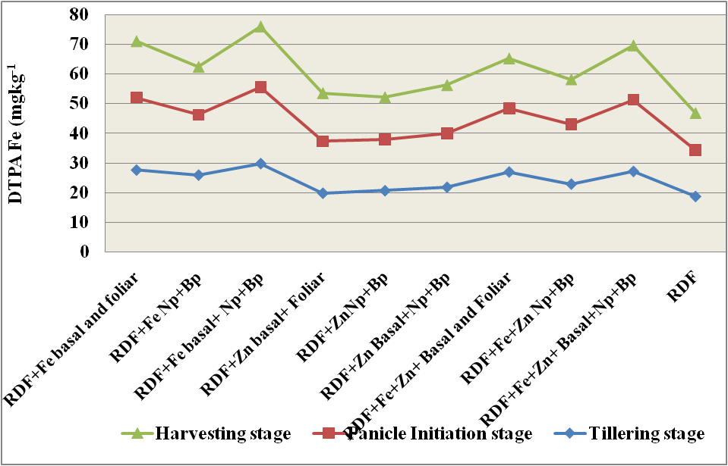
Fig.1 Treatment effect on extractable DTPA Fe at different growth stage of lentil crop
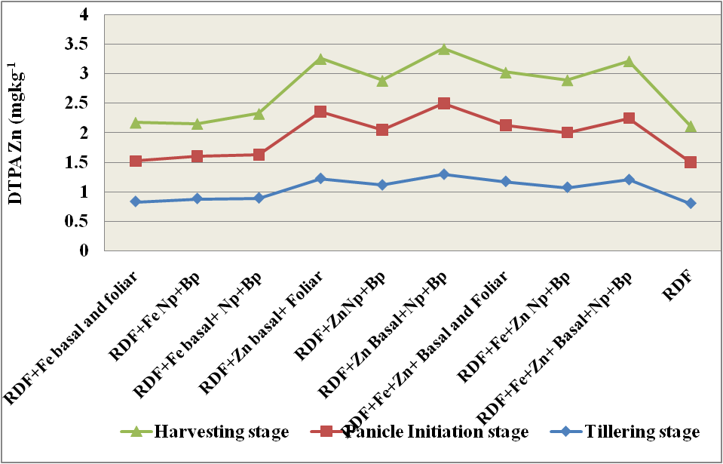
Fig .2 Treatment effect on extractable DTPA Zn at different growth stage of lentil crop
4.) Discussion:
The relationship between plant traits, soil characteristics, and the interactions between plant roots and surrounding soil microbes determines the availability of nutrients in the rhizosphere (Dotaniya and Meena, 2015). Although modest changes were noted among treatments, the major chemical characteristics, such as pH, EC, OC, Available Nitrogen, Phosphorus, and Potassium, were not significantly affected by the varied sources of Fe and Zn or their respective application methods since every treatment received fertilizers as per the recommended dose.
Treatments that constituted bacterial biopriming resulted in slightly lower soil pH. Microbial incorporations are responsible for the slight acidity of the rhizospheric soil as well as the transformation, transportation, and solubilization of metals inside the plant parts. pH decrease is caused by the microorganisms' production of CO₂, which raises pCO₂ and eventually becomes carbonic acid. Fe compounds have limited solubility in soils. Our findings demonstrated that a slight pH fall was noted in the treatment involving simultaneous applications of Fe and Zn with biopriming. A slight increase in organic carbon was also observed for the treatments where biopriming was done, which could be because of comparatively higher root biomass and greater microbial activity. The post-harvest soil under lentil had higher nitrogen content this might be because the roots of the lentil crop fixed some N. A similar trend was also observed with P and potassium content in the post-harvest soil. These observations were recorded even if the effect of treatments was statistically non-significant.

Effect of treatments on DTPA extractable Fe and Zn in soil under rice and lentil cropping
A higher value of initial DTPA-Fe and Zn in soil was observed because soil taken before crop sowing which is fallow, means no standing crop. Rhizospheric roots interfere with nutrient availability; it causes acidification of the rhizospheric zone which triggers more availability of nutrients that ultimately get more uptake by the root of plants. High pH value and a low organic matter concentration, reason for which can retards the Fe and Zn fixation ability of soil and reduce the bioavailability of Fe and Zn, thus inhibiting Fe and Zn uptake in plant roots (Alloway. 2008). To tackle these issues, chelated form of Fe and Zn sources was used; having slow release and lower ability for complex formation. In our study, Fe and Zn application induced significant availability of Fe and Zn concentration in soil at each growth stage; and the treatments having combined applications of Fe and Zn as basal report to be highest concentrations in soil (Fig.1 and 2). The result of DTPA extracted Fe and Zn presented in the previous chapter report to be significant differences at different critical growth stage but there was no significant differences among the treatments having sole or combined applications of particular nutrients. The result is similar to the finding of Li et al. (2007). With the advancement of the crop growth stage, the decline of DTPA extractable Fe and Zn for both crops was observed. Higher values were experienced in the treatments having basal application along with priming done for respective nutrients. The inoculation of microorganisms through biopriming helps in the solubilisation and transformation of nutrients in rhizospheric soil and makes them available in soil solutions.
Talukdar et al. (2009) found a substantial correlation between organic carbon and DTPA extractable Zn and Fe in surface soils of different series. These findings explain how complexing agents produced by organic matter increase the availability of these minerals in soil. No correlation was found between soil pH, and DTPA extractable Zn and Fe reported by Pati and Mukhopadhya (2011). This suggests that the aforementioned soil features do not affect the distributions of cationic micronutrients accessible within this soil series. Organic matter content in soil has a supplemental effect on the flourishing of microorganisms. According to Azarmi et al. (2011) the effects of treatments involving microorganisms applied through priming, such as Fe and Zn solubilizers, play a role in root proliferations, developed root systems, and the production of various organic acids in the rhizosphere, such as fumaric acids, citric acids, and gluconic acids. Alternatively, slight pH reductions lead to boost solubility and mobilizations of the insoluble compounds, which increases the accessibility of micronutrients for plant uptake. A study by Dhaliwal et al. (2021) revealed no correlation between DTPA-Zn and total zinc, confirming the widespread occurrence of zinc shortage without reference to total zinc levels in soils.

Conclusion:
The present study clearly demonstrates that the mode of application and combination of chelated micronutrients significantly influenced soil physicochemical properties and the availability of DTPA-extractable iron (Fe) and zinc (Zn) across different growth stages of lentil under a rice-lentil cropping system. Treatments involving integrated application strategies—particularly T3 (Fe + Zn through basal, biopriming, and nutripriming) and T9 (Fe + Zn through basal, nutripriming, and biopriming) consistently outperformed the recommended dose of fertilizers (T10) in enhancing soil nutrient status. Soil pH remained within a narrow range, indicating minimal impact from treatments; however, EC, oxidizable carbon, and cation exchange capacity (CEC) showed notable improvements under integrated micronutrient applications. The highest CEC and organic carbon were recorded in T3 and T9, reflecting better nutrient-holding capacity and organic matter status. Likewise, the availability of macronutrients N, P, and K also peaked in these treatments, signifying improved soil fertility. A consistent decreasing trend in DTPA-Fe and DTPA-Zn concentrations was observed from the vegetative to the post-harvest stage, underlining the progressive uptake of these nutrients by the lentil crop. Among the treatments, T3 and T9 maintained the highest levels of Fe and Zn availability across all stages, while T10 (RDF) persistently recorded the lowest values. Sole applications of Zn or Fe did not match the efficacy of combined and integrated treatments, suggesting a positive interaction and synergistic effect when both micronutrients are applied together through multiple agronomic approaches. These findings emphasize that combined application of Fe and Zn, particularly through basal, biopriming, and nutripriming techniques, is a highly effective strategy for enhancing soil micronutrient dynamics and improving nutrient use efficiency in pulse-based cropping systems. Adoption of such low-input, resource-efficient interventions holds promise for supporting sustainable intensification, improving soil health, and contributing to agronomic biofortification in micronutrient-deficient soils.
References:
Alloway BJ., (2008). Zinc in Soils and Crop Nutrition. Second Edi. International Zinc Association
Azarmi R, Hajieghrari B, Giglou A (2011) Effect of Trichoderma isolates on tomato seedling growth response and nutrient uptake. African journal of Biotechnology, 10(31): 5850-5855.
Black CA (1965) Methods of Soil Analysis Parts 12 American Society of Agronomy1nc Publisher Madisson Wisconsin USA 1-1378.
Dhaliwal SS, Sharma V, Shukla AK,Verma V, Sandhu PS, Behera SK,Hossain A (2021) Interactive effects of foliar application of zinc iron and nitrogen on productivity and nutritional quality of Indian mustard (Brassica juncea L). Agronomy, 11(11): 2333.
Dotaniya, M. L., & Meena, V. D. (2015). Rhizosphere effect on nutrient availability in soil and its uptake by plants: a review. Proceedings of the National Academy of Sciences, India Section B: Biological Sciences, 85, 1-12.
Gomez KA, Gomez AA (1984) Statistical Procedures for Agricultural Research. IRRI, Loss Banos, Manila.
Jackson ML (1967) Soil chemical analysis. Prentice Hall of India Pvt Ltd New Delhi pp, 134–144.
Li JXY,ang XE, He ZL, Jilani G Sun CY, Chen S M (2007) Fractionation of lead in paddy soils and its bioavailability to rice plants. Geoderma, 141: 174–180.
Lindsay WL, Norvell WA (1978) Development of a DTPA soil test for zinc iron manganese and copper. Soil SciSoc Am J, 42(3):421– 428.
Olsen S, Cole C, Watanabe F, Dean L (1954) Estimation of available phosphorus in soils by extraction with sodium bicarbonate. USDA Circular Nr 939, US Government Print Office, Washington, D.C
Pati R,Mukhopadhya D (2011) Distribution of cationic micronutrients in some acid soils West Bengal. Journal of the Indian Society of Soil Science,59:125-33.
Subbiah BV, Asija GL (1956) A rapid procedure for the estimation of available nitrogen in soils. Current Science 25: 254-260
Talukdar D. (2012). Total flavonoids, phenolics, tannins andantioxidant activity in seeds of lentil and grass pea.International Journal of Phytomedicine, 4: 537-542
Walkley A Black I (1934) An examination of Degtjareff method for determining soil organic matter and a proposed modification of the chromic acid in soil analysis. Exp Soil Sci ,79:459–465.

