Original Research Article
Association of Wilsonomyces carpophilus with shot hole and canker of plum (Prunus salicina L.) in Himachal Pradesh

.
ABSTRACT

Recently, during routine surveys of plum orchards, Wilsonomyces carpophilus was detected as a causal agent of shot hole and canker in plum in Himachal Pradesh, which induced small, purplish-brown spots that enlarged and turned brown, often with a lighter center. These spots were seen on leaves, buds, and twigs, while infected tissues died and fell out leaving visible holes in the leaves. In severe cases, shoot blight with leaves turning brown and dropping prematurely were observed, where tiny, dark brown bumps (sporodochia), the spore-forming structures developed at the center of twig and leaf lesions. Shot hole was most severe in spring and summer, especially in wet weather. Morphological characterization of shot hole causing agent in plum revealed W. carpophilus, which had septate thin-walled hyphae of 2.0–4.9 mm and sympodial conidiophores. The association of W. carpophilus with shot hole disease in plum has been recorded for the first time, though, other Prunus spp. were found to be infected by this fungus. This was further confirmed through pathogenicity assay in which tested plum shoot exhibited disease symptoms similar to the originally infected plum shoots used for pathogen isolation.

Keywords: Shot-hole, plum, Wilsonomyces carpophilus, Himachal Pradesh, pathogenicity

1. INTRODUCTION
Plum (Prunus salicina L.) is a major temperate fruit crop ranking next to peach for its economic significance, which thrives very well in low hill and sub mountainous tracts where high chilling requiring fruits like apple and cherry cannot grow well. Plum fruits are delicious and juicy in taste with exquisite flavor, and are cultivated across the world including USA, China, Japan, and Europe. However, its yield is drastically affected by various diseases such as brown rot, bacterial shot-hole, and a red spot among others (Kleina et al., 2018; Wu et al., 2018; Wei et al., 2021).
Shot hole and canker is an important disease of stone fruits or Prunus species prevalent in the major plum producing countries in the world from temperate to semiarid regions including India, which is caused by various pathogens including Wilsonomyces carpophilus Lev., also known as Stigmina carpophila and Coryneum beijerinckii (Ogawa et al. 1995; Adaskaveg et al., 1990; Ashkan and Asadi, 1971; Bubici et al., 2010). Xanthomonas pruni (identified as a primary causal agent), Thyrostroma carpophilum, Ascospora beijerinckii and Clasterosporium carpophylum (Woodward, 1999), all had induced identical disease symptoms (Ivanová et al., 2012). This disease is also known as clasterosporiosis, Coryneum blight, California peach blight, fruit spot, winter blight and postular spot, which was first reported on peach trees in France in 1843 and subsequently reported in all continents of the world including South East Asia (Väcäroju et al., 2008).
Members of Prunus spp. including almonds, cherries, ornamental plums, nectarines, peaches, and apricot were found affected by shot-hole disease, which was first reported in India in 1968 (Munjal and Kulshrestha, 1968), and Kullu, Mandi, Solan and Shimla districts of Himachal Pradesh (Gupta et at., 1973b). In plum, shot hole was predominantly caused by Pantoea agglomerans, a gram-negative bacterium in Guizhou Province of China (Ran Shu et al., 2022). The fungus of shot hole produces black fruiting bodies on the necrotic cankers and twigs, which produce numerous conidia that are thick walled, ellipsoidal or fusiform. Blight symptoms appear on twigs, leaves and fruits. On twigs, small purple and slightly raised pustules appear which later develop into necrotic canker.
On leaves, dark brown, scattered lesions enlarge rapidly and lead to abscission. The intensity of the infestation becomes severe with rising day temperature and occurrence of frequent rains from spring to summer (Verma et al., 2005). Consequent upon, several holes of 0.1 to 0.3 mm of diameter appear on the leaves. Owing to shot hole severity, the leaves become sieved, therefore, net photosynthetic leaf area is reduced and translocation of photosynthate from leaves to fruits may be insufficient (Verma et al., 2005) due to wilting of infected leaves, which seriously weaken and reduces fruit production. The present investigation was undertaken to study symptomatology and etiology of the shot hole disease in plum orchards in Himachal Pradesh.

2. material and methods
  - Symptomatology and identification of pathogen
During the spring and summer 2024, stem of the defoliated Prunus salicina L. plants showing discoloration, piercing, purple to brownish spots with canker or necrosis, were sampled from a plum orchard in the farm of Fruit Science, UHF, Nauni, Himachal Pradesh. They were examined with a compound microscope at 400× and 1000× magnification and also used for pathogen isolation. The samples were washed thoroughly with tap water, dissected into pieces (3-4 mm) from the margins of the healthy and infected tissues using sterile scalpel blade, surface sterilized using 1% NaOCl for 3 min and rinsed with sterile distilled water (3 times). Dissected tissues were dried on sterile blotting paper and inoculated onto potato dextrose agar (PDA) media in Petri dishes and incubated at 25±2°C for a week in dark under BOD incubator. A pure culture was obtained through repetitive sub-culturing and hyphal-tip method, which also examined under microscope for mycelial growth pattern and spore morphology.
  - Pathogenicity
W. carpophilus isolate was used for pathogenicity testing of twigs in which detached shoots from young peach tree were treated with mycelial bits from a pure culture of W. carpophilus as per Uddin et al. (1997) guidelines. Collected shoots from a healthy plum tree were cut into 10 -30 cm fragments, washed with running tap water, surface disinfested using 70% ethanol for 30 seconds and 1% NaOCl for 5 min and finally rinsed with sterile water three times. An agar plug from 3 days old pure fungal culture was placed on the bark of dried shoot fragments and sealed with sterile moist cheese cloth (Dhingra and Sinclair 1985). Control shoots treated with sterile blocks of PDA and incubated with three pathogen treated shoots at 25±2 °C for two weeks in growth chamber. The disease severity was evaluated by estimating the lesion length of lesions at each spot from 7th to 14th days post inoculation. Data were subjected to analysis of variance using online OpStat software (Sheoran 2010) and mean values were compared through Duncan’s multiple range test.
3. results and discussion

The infected leaves and twigs of plum collected from plum orchards were brought to the laboratory during spring and summer seasons of the year 2024. The symptoms of the disease were observed on twigs as canker and as shot hole on the leaves. In details, small purple to brownish spots with a lighter center seen on leaves, buds, and twigs of infected trees with visible holes in the leaves. Shoot blight with leaves turning brown and drooping prematurely were observed. The associated pathogen was isolated into pure culture by using the standard isolation procedure and was identified as Wilsonomyces carpophilus based on morphological and cultural characters (Adaskaveg et al., 1990).
Hyphae were thin-walled, septate and branched with 2.0–4.9 mm in diameter, sub-hyaline to golden brown (Fig. 2). Conidiophores in sporodochia were sympodial, conidia fusoid with apical cell ovate and basal cell truncate, 2.5–5 mm at base and 2–4 transverse septa (Fig. 2 and 4). Twig lesions in plum were mostly 2.2–9.4 mm in diameter (Fig. 2 and 4).
Pathogenicity assay has resulted similar disease symptoms in the artificially treated plum shoot parts as shown by the given fungal isolate in naturally infected plum trees, which validated the Koch’s postulates and association of W. carpophilus with plum’s shot-hole and canker disease.
Shot-hole disease of stone fruits was caused by S. carpophila, Wilsonomyces carpophilus and Coryneum beijerinkii, which may be confused in some cases with bacterial spot disease caused by X. arboricolapv due to very similar symptoms (Randhawa and Civerolo, 1985). Wilsonomyces carpophilus, a Deuteromycetes is the major causal agent of shot hole of apricot and peach in Iran (Yousefi and Shahri, 2014), apricot in Pakistan (Hussain et al., 2023) and plum in Italy (Bubici et al., 2010) and Hungary (Molnár et al., 2022). T), and cherry and peach in USA (Grove, 2002, while Burkholderia contaminans and Pseudomonas syringae pv. Syringae were identified as SHD causal agent of cherry in South Korea (Han et al., 2021).
The characteristic symptoms of SHD are recorded mainly on leaves and fruits with less frequently in twigs (more common in peach), dormant buds (more frequent in almond) (Highberg and Ogawa, 1986) and flower calyxes. On plum trees, 1-2 mm circular spots, discolored to reddish and usually surrounded by a chlorotic margin, were appeared on the leaves. Later on, spots get enlarged, may coalesce and become brown, necrotic with light brown centre (Fig.1). Finally, dead tissues inside spots commonly detach from surrounding healthy tissues resulting typical shot-hole syndrome (Fig. 1). On twigs, symptoms begin as small black spots, which later increase with a pale and sink centre and longitudinal cracks on the periderm from which gum exudates were extruded (Molnár et al., 2022; Adaskaveg et al., 1990; Teviotdale et al., 1997).
The pathogen overwinters in twig cankers and blighted or dormant buds as mycelium and infections originate from conidia dispersions by water splashes due to rainfall or overhead sprinkler irrigations (Ogawa and English, 1991). The disease development is dependent on the duration of leaf wetness and temperatures. In almond, cherry and peach, predictive models were obtained under controlled conditions, which demonstrated optimal conditions for infection and symptom development were wetness periods higher than 24 h and temperatures of 15-25 ºC (Shaw et al., 1990; Grove, 2002).

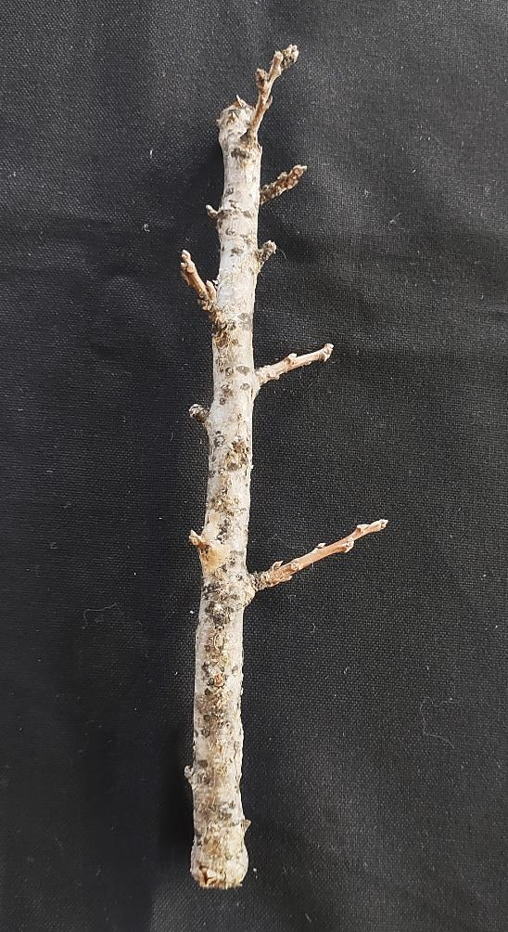 | 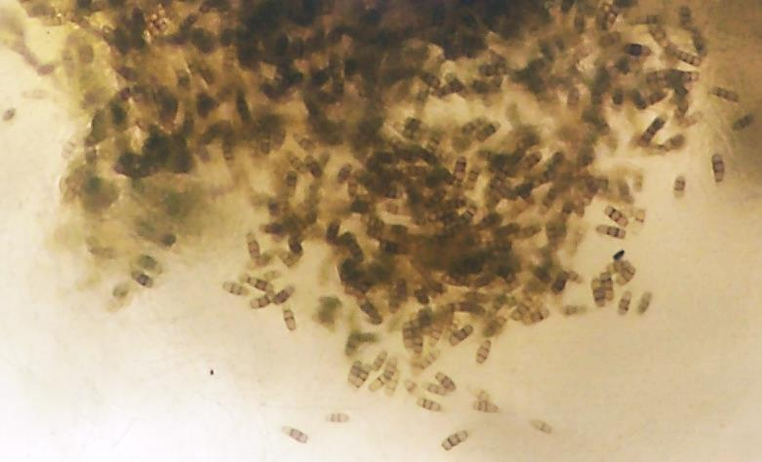
Fig. 1. Symptoms of canker on plum shoot | Fig. 2. Microscopic view of causal agent from infected shoot (100X magnification)
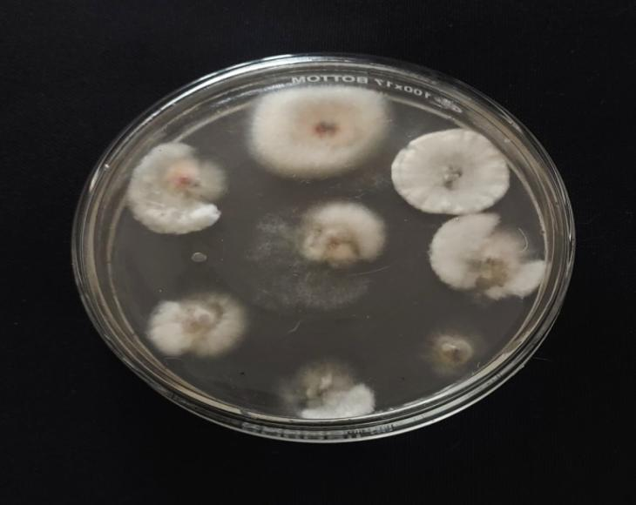 | 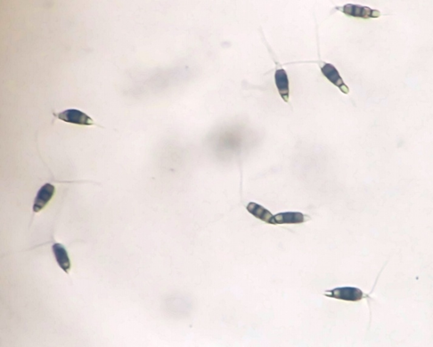
Fig. 3. Isolation of associated pathogen on PDA plate | Fig. 4. Conidia of Wilsonomyces carpophilus (400X magnification)

4. Conclusion

Wilsonomyces carpophilus identified as a causal agent of shot hole and canker disease in plum in Himachal Pradesh, which induced small, purplish-brown spots that enlarge and turn brown, often with a lighter center. The identity of the pathogen was determined based on morphological characteristics such as septate thin-walled hyphae and sympodial conidiophores, whereas pathogenicity assay has provided proof for authenticity of the Koch’s postulates. A comprehensive study is required in geographically broader area to determine host range of the pathogen, genetic variability within species and pathogenicity patterns in different crop species.

References

Adaskaveg, J.E., Ogawa, J.M., and Butler, E.E. 1990. Morphology and ontogeny of conidia in Wilsonomyces carpophilus gen. nov., and comb. nov., causal pathogen of shot hole disease of Prunus species. Mycotaxon, 37: 275–290.
Ashour, W. E. And Allam, M. E. (1954). Shot-hole disease of stone fruits caused by Clasterosporium carpophilum. Nature 173, 456; doi: 10.1038/173456a0.
Bubici, G., D’Amico, M., and Cirulli, M. (2010). Field reactions of plum cultivars to the shot-hole disease in southern Italy. Crop Protection, 29(12): 1396-1400.
Han, V. C., Yu, N. H., Park, A. R., Yoon, H., Son, Y. K., Lee, B. H., and Kim, J. C. (2021). First report of shot-hole on flowering cherry caused by Burkholderia contaminans and Pseudomonas syringae pv. syringae. Plant Disease, 105(12), 3795-3802.
Hussain, A., Ali, S., Muhammad, M., Akram, W., Hussain, S. M., and Dawar, K. (2023). Spatial distribution and risk associated with shot hole disease in apricot (Prunus armeniaca L.) in Northern Pakistan. Archives of Phytopathology and Plant Protection, 56(6), 433-451.
Ivanová, H., Kaločaiová, M., Bolvanský, M. 2012. Shot-hole disease on Prunus persica- the morphology and biology of Stigmina carpophila. Folia oecol., 39: 21–27.
Grove, G. G. (2002). Influence of temperature and wetness period on infection of cherry and peach foliage by Wilsonomyces carpophilus. Canadian Journal of Plant Pathology, 24(1), 40-45.
Leonov, N., & Bulgakov, T. 2020. Biological protection of plum from shot hole disease in the humid subtropics of the Krasnodar region (Russia). In BIO Web of Conferences (Vol. 21, p. 00035). EDP Sciences.
Molnár, B.; Szabó, S.; Holb, I.J. 2022. Temporal dynamics of incidence of shot hole disease affected by training systems and cultivar susceptibilities in an integrated plum orchard. Journal of Fungi 8: 580.
Ogawa, JM and English, HE. 1991. Diseases of Temperate Zone Fruit and Nut Crops, 123 Oakland (CA): University of California, Division of Agriculture and Natural Resources.
Randhawa, P. S., and Civerolo, E. L. 1985. A detached-leaf bioassay for Xanthomonas campestris pv. pruni. Phytopathology, 75(9), 1060-1063.
Sahzad, A. and N.A. Mir. 1996. Host range of W. carpophilus (syn. S.carpophila) causing shot hole disease of almond and other stone fruits. Plant Disease Research, 11(2): 143-145.
Shaw, D. A., Adaskaveg, J. E., and Ogawa, J. M. 1990. Influence of wetness period and temperature on infection and development of shot-hole disease of almond caused by Wilsonomyces carpophilus. Phytopathology, 80(8), 749-756.
Sheoran OP. 2010. Online statistical analysis (OPSTAT) software developed by Chaudhary Charan Singh Haryana Agricultural University, Hisar, India.
Shu R, Yin X, Long Y, Yuan J and Zhou H (2022) Detection and control of Pantoea agglomerans causing plum bacterial shot-hole disease by loop-mediated isothermal amplification technique. Frontiers in Microbiology, 13:896567.
Teviotdale, B. L., Goodell, N., and Harper, D. 1997. Effect of infection by the shot‐hole fungus, Wilsonomyces carpophilus, on drop and quality of almond fruit 1. EPPO Bulletin, 27(4), 493-500.
Verma, V. O., Pradheep, K., Rana, J. C., and Sharma, S.K. 2005. Identification of resistance source against shot hole-a fungal disease in peach (Prunus persica L.) germplasm. Indian Journal of Plant Genetic Resources, 18(02), 252-254.
Youssefi, A., and Hajian Shahri, M. 2014. Shot hole disease, survival and pathogenicity of the causal agent on stone fruit trees in Northeast Iran. Journal of Crop Protection, 3(4), 563-572.

