Assessment of Wheat Yield Gaps and Potential for Yield Enhancement in Haryana, India

Abstract
This study analyses wheat yield disparity in Haryana, India, utilizing statistical and geographical methods to assess 15 years of district-level data from 2006 to 2020. In numerous domains, there exists a considerable underutilization of productivity potential, as demonstrated by the yield gap, defined as the disparity between the observed average yield and the achievable yield (Olympic mean). Yield gaps exceeding 750 kg/ha were noted in districts such as Panchkula, Karnal, and Yamunanagar, indicating significant opportunities for agronomic improvement. Districts like Charki Dadri and Bhiwani exhibited performance levels approaching saturation. A Weather Risk Index was developed to address climatic variability, utilizing the standard deviation of de-trended yield. High-gap zones were visualized through spatial analysis with ArcMap 10.8, which facilitated the classification of districts based on risk exposure and yield potential. The findings underscore the importance of district-specific strategies, indicating that high-gap, low-risk regions require inputs to enhance yield, while high- risk areas necessitate interventions to bolster resilience. This research presents a scalable model for strategic agricultural planning that enhances food security, reduces vulnerability, and boosts productivity.
Keywords: Wheat Production, Olympic Mean, Normal Yield, Yield Gap Whether Risk Index and Climate Resilience

Introduction
Agriculture is a crucial part of India's economy, contributing to GDP, employment, and foreign exchange earnings. Forecasting is crucial for decision-makers in economic and non-economic fields, helping them make accurate decisions about storage, distribution, pricing, marketing, and import-export. Factors like precipitation fluctuations and economic conditions influence crop productivity, which helps evaluate efforts to increase production and predict future levels (Kumar et al., 2019). Wheat, the most important food-grain in India, is the staple food for millions, particularly in northern and north-western regions. Major productivity increases have been observed in Haryana, Punjab, and UP, with higher coverage reported in Madhya Pradesh (Kodan et al., 2012). The Green Revolution Programme (GRP) has contributed to the high growth of wheat crops in Haryana. The total production of food grains in India has increased from 50.82 million tonnes in 1950/51 to 230.67 million tonnes in 2007/07. However, India has not achieved 100% hunger-free status, causing a significant hindrance to the nation. The crop economy deserves special attention in the global economic scenario, with regular growth patterns, productivity variations, and cost structures allowing farmers to increase margins without affecting consumers. The government should make systematic efforts to ensure food security and increase export share despite meeting domestic requirements. The Indian economy, particularly in Haryana, has seen significant changes since the mid-sixties due to the development of High-Yielding Wheat Varieties (HYVs)(Nisha et al., 2019). A study examining the area, production, and yield of wheat crops in Uttar Pradesh from 1971-2010 revealed that productivity showed higher growth rates due to increased growth rates of area and productivity (Handral et al., 2017). The cubic model was found to be the best estimation method for wheat crop estimation in India. Haryana, a predominantly agricultural economy, has seen a decline in pluses production, particularly in regions that have experienced the Green Revolution. The annual compound growth rate of cereal production in the country has been estimated at 2%, while pluses production has increased at a lower rate of 1%. The decline in pulse production raises concerns about nutritional security and indicates structural transformation of state agriculture. The enhanced share of cereals in Haryana is due to increased irrigation facilities, which can cultivate varied types of crops (Ohlan, 2012). However, information at the national or state level is insufficient for effective human efforts due to regional differences in needs and resource endowments. District-level agricultural planning is needed to measure agricultural activity levels and formulate district-specific policies. Understanding these changes in cropping patterns over the years is crucial for effective agricultural planning. The productivity of global agricultural commodities must rise to meet the food demands of the growing population. It is anticipated that by 2050, an extra 1 billion metric tonnes of grains per year would be required to satisfy demand. Necessitate an increase in output from 2.1 to 3.0 billion metric tonnes (Hatfield & Beres, 2019). This necessitates either enhancing agricultural yields by bridging the gap between potential and actual yields or by augmenting the potential yield of crops. Introduced the notion of potential yield in agriculture and the significance of include potential yield in assessing the advancement of crop management initiatives. Many contend that narrowing the yield gap is more feasible than augmenting the prospective yield. Dadrasi et al., (2025) states that for the improvisation of yield target of 50%, then 40% Nitrogen application is required. (Dey, 2020) examined that wheat crop area in India was more stable than production and yield. Area expansion growth was faster than production growth, with positive yield growth throughout the study period. Export unit price showed positive growth in period I, but declined in period II. Wheat export unit price remained stable in three sub - sequent periods and overall period. However, wheat production instability increased in period III due to increased yield instability. Hou et al (2024) stated that yield gaps are due to drought and loss of soil moisture that alleviates yield. (Singh & Supriya, 2017) evaluated the growth in area, production, and productivity of wheat in India using various growth models. Wheat, a crucial cereal crop, is essential for providing vitamins and minerals to the growing population. The study aims to plan for the future by addressing food and nutritional security challenges and meeting domestic demand.
(Devi et al., 2021) examined the instability and sustainability of wheat production in Haryana, India, a major wheat producer. Using data from the Haryana Statistical Abstract from 1980-81 to 2018-19, the study found an increasing trend pattern in area, production, and yield. Haryana ranks second in wheat yield sustainability after Punjab. The findings can help food and nutrition security policymakers predict production behaviors and provide insights into potential production scenarios. (Kumar et al., 2019) aimed to forecast wheat yield in Haryana using annual time-series data from 1980-81 to 2009-10. Various models were compared, and the best fit was selected using the Akaike Information Criterion (AIC). The model, ARIMA (0,2,2), was found to be the best for forecasting wheat yield in Haryana. The forecasted yields ranged from 4620.91 kg/hectare in 2017 to 4862 kg/hectare in 2022. (R. Singh et al., 2014) investigated the yield gap in wheat yield after the Green Revolution in India. It identifies production constraints and uses a hybrid approach to quantify the gap from 2001-02 to 2010-11. The analysis shows a decline in yield gaps due to research and extension efforts. The study identifies region-specific production constraints and suggests research priorities to bridge these gaps. (Daloz et al., 2021) examined the impact of climate change on wheat yields in the Indo- Gangetic Plain (IGP), a major wheat-production region in India and the world. It uses a regional climate model and crop model to understand the direct and indirect impacts on wheat yields at four sites across Punjab, Haryana, Uttar Pradesh, and Bihar. Results show that climate change's direct effects result in yield losses of 1% to 8%, while indirect impacts, such as decreased water availability, lead to higher yield losses. (Shettigar et al., 2019) aimed to assess factors affecting wheat productivity in Haryana, India. It was conducted in five districts and interviewed 100 farmers. The majority followed the Rice-wheat, Cotton-wheat, Bajra-wheat, Sorghum-wheat, and Guar-wheat crop rotation. Most farmers reported limited availability of recently released varieties, unavailability of desired varieties, and lack of training in new technologies. Lack of knowledge about plant protection and fertilizer doses was also a barrier. High costs of agro-chemicals, low risk bearing capacity, irregular rainfall, and disease control were identified as barriers. Despite the literature provides significant insights into the patterns, development, and volatility of wheat production in India, especially in Haryana, it highlights aspects such as climate change, technology adoption, policy implications, and forecasting models. A notable research gap remains in the holistic integration of socio-economic, technical, and climatic factors into a cohesive analytical framework to evaluate their collective influence on wheat yield and sustainability. Although individual studies have concentrated on growth patterns, yield forecasting, climate impacts, and farmer constraints, there is a paucity of interdisciplinary research that concurrently investigates how climate variability, access to modern inputs, farmer awareness, and institutional support collectively affect the stability of wheat production and yield discrepancies. Furthermore, there is an absence of current micro-level, farmer-centric research conducted beyond 2020 that addresses rising concerns such as input price volatility, labour shortages, and the use of digital technologies in wheat farming. Addressing this deficiency is essential for developing focused solutions to improve productivity, sustainability, and resilience in wheat production systems. With this understanding, the study focuses on estimating the growth rates of wheat yield over the period 2006–2020, conducting a yield gap analysis for wheat production, and identifying areas with potential for yield improvement.

Materials
The yield data was downloaded for the 22 districts of Haryana state for Wheat crop from Directorate of Economics and Statistics website for the period 2006 to 2020 (https://data.desagri.gov.in/website/crops-apy-report-web). The Department of Agriculture, Haryana, as well as validated statistical summaries, were among the secondary sources that were used in order to ascertain the district-by- district wheat yield (in kilograms per hectare) and the seeded area (in hectares) and in order to map yield gaps in ArcGIS, statistical data was coupled to spatial boundaries by using a digital shapefile of Haryana districts.
Methodology
This research employs a quantitative and geospatial framework to assess the discrepancy in wheat output across Haryana's districts. ArcGIS is used in conjunction with time-series yield statistics, variability analysis, and spatial mapping in order to locate regions that are vulnerable to climate-related risks, yield instability, and unrealized production.

Study Area
The research encompasses each of the 22 districts that make up the state of Haryana, which is located in the northwest region of India and is well-known for its extensive wheat growing in semi-arid and subtropical climates. This study examines the performance of yields and the effects of climate over a period of fifteen years, with a particular emphasis on the rabi seasons that span from 2006 to 2020.
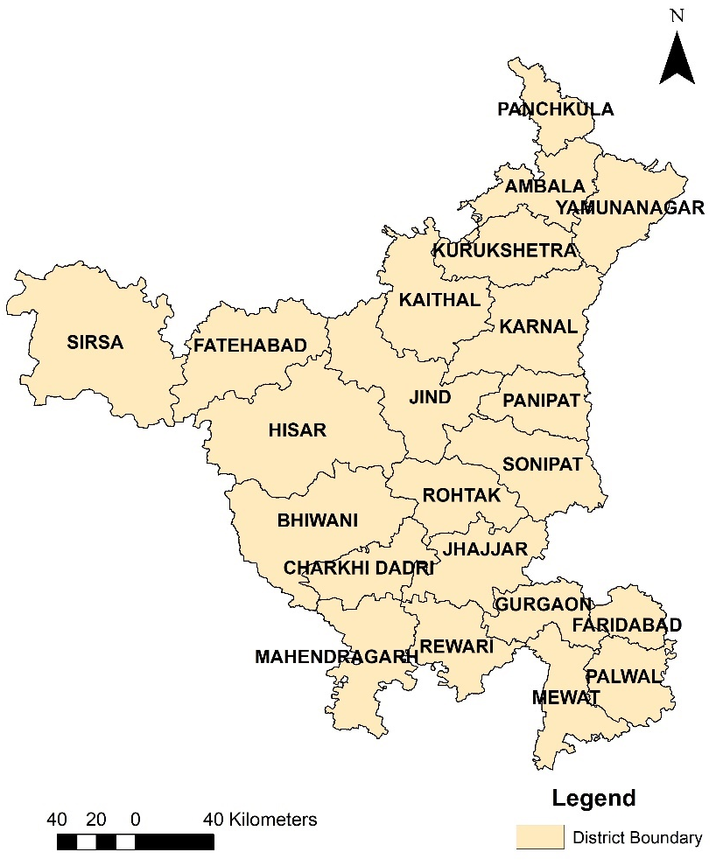

Fig. 1 Study Area
Yield Gap Analysis
The difference between each district's normal yield and Olympic mean yield was calculated as the Yield Gap (YG):

Yield Gap = Attainable Yield – Normal Yield
Normal Yield: The 15-year average of the annual wheat yields from 2006 to 2020.
The Olympic Mean, or Attainable Yield, is the mean of the three highest yields recorded over the same time period, excluding extreme outliers and representing performance that is close to optimal under ideal circumstances.

Scope for yield improvement
To quantify the extent to which current yields can be improved, the scope for yield improvement (%) was calculated as

𝑆𝑐𝑜𝑝𝑒 𝑜𝑓 𝑖𝑛𝑐𝑟𝑒𝑚𝑒𝑛𝑡 (%) = (
𝑌𝑖𝑒𝑙𝑑 𝑔𝑎𝑝

𝑂𝑙𝑦𝑚𝑝𝑖𝑐 𝑚𝑒𝑎𝑛

) × 100
This normalized metric enables comparison across district with different base yield and helps prioritize intervention zone based on their relative performance gaps.

Weather risk and yield variability analysis
Yield fluctuations often result from climatic variability rather than agronomic inefficiency. To isolate this influence:
- A de-trending process was applied to each district’s yield time series to eliminate technological and policy-based growth effect.
- The standard deviation of de-trended yields was used to compute the weather risk index (WRI)
𝑊𝑅𝐼 = 𝜎𝐷𝑒−𝑡𝑟𝑒𝑛𝑑𝑒𝑑 𝑦𝑖𝑒𝑙𝑑
Districts with high WRI values are considered more vulnerable to weather and require risk mitigation strategies.

Spatial analysis using ArcGIS
Spatial analysis was conducted using ArcGIS, where yield gap data was integrated with the Haryana district shape file to produce a series of thematic maps. These included district- wise Yield Gap Maps, Scope for Improvement Maps, and Weather Risk Overlay Maps. The visual outputs generated from this analysis provided policy-relevant insights by enabling the classification of districts into three key categories: High Gap – Low Risk (suitable for yield enhancement strategies), High Risk – Low Gap (demanding climate- resilient approaches), and Moderate Zones (requiring integrated interventions). This spatial mapping approach helped in identifying region-specific priorities for policy formulation and agricultural planning in Haryana.

Results And discussion
This section provides a thorough examination of Haryana's wheat cultivation trends, yield gaps, weather hazards, and spatial disparities across districts. In order to comprehend land-use consistency, the study first assesses the average area under wheat cultivation along with its variability using district-wise time-series data (2006–2020). The goal of the following analysis is to determine the yield gap, which is the difference between the normal yield (long-term average) and the achievable yield (Olympic mean of the top three years). An evaluation of weather risk, which is based on the variability of de-trended yield, and the potential for yield improvement, which is expressed as a percentage of the achievable yield, are added to this. Figures showing district-wise area variability (Figure 2), satellite derived classified Wheat area (Figure 3), Coefficient of Variation of Wheat yield (Figure 4), Average Wheat yield (Figure 5), yield gaps (Figure 6), and the correlation between weather risk and yield improvement potential (Figure 7) are used to visualize the results. Based on agroclimatic conditions and productivity potential, these findings collectively offer practical insights for region-specific interventions, aiding in the prioritization of districts for yield enhancement, risk management, or policy support.

Table 1 Average and Std Deviation of the District Wise in Area

Districts | Avg. of crop area in ha | Std deviation (SQ.M)
Ambala | 92690.5 | 22697
Bhiwani | 151207 | 30291.3
Charki dadri | 41147.5 | 24136.1
Faridabad | 45224.7 | 29898.6
Fatehabad | 187919 | 2261.72
Gurgaon | 47686.9 | 4035.55
Hisar | 225756 | 5674.74
Jhajjar | 101417 | 6152.1
Jind | 205858 | 32288.5
Kaithal | 173272 | 19926.3
Karnal | 165586 | 39091.2
Kurukshetra | 110203 | 7559.09
Mahendragarh | 55362.1 | 44929.8
Mewat | 77992.7 | 7901.97
Palwal | 87265.6 | 26709
Panchkula | 21930 | 18327
Panipat | 91815.9 | 22969.5
Rewari | 46448.1 | 4629.37
Rohtak | 99187.2 | 15931.4
Sirsa | 290211 | 12173.7
Sonipat | 144710 | 5168.1
Yamunanagar | 81293.9 | 18640.1

Table 1 presents the average area of wheat cultivation, expressed in hectares, along with the corresponding standard deviation, measured in square meters, for each district in Haryana over a 15-year period from 2006 to 2020. This table provides a quantitative framework for evaluating the extent and consistency of wheat cultivation across various regions. Sirsa, with an average area of 290,211 hectares, is the largest wheat-growing region, followed by Hisar at 225,756 hectares, Jind at 205,858 hectares, and Fatehabad at 187,919 hectares, as indicated by the analysis. These districts are the state's main wheat-producing areas due to their relatively flat terrain, access to irrigation, and established agricultural infrastructure. The wheat-growing areas in Panchkula (21,930 ha) and Charki Dadri (41,147 ha) are significantly smaller, likely due to geographic location, urban proximity, or crop diversification factors.

The standard deviation values indicate the year-to-year variability in cultivated area, thereby revealing the operational consistency of wheat farming across districts. Fatehabad exhibits the lowest variability (SD = 2,261.72) alongside the highest average area, suggesting a highly stable wheat farming system. Faridabad (SD = 29,898 ha) and Mahendragarh (SD = 44,930 ha) exhibit notable variability in area, potentially attributable to alternative crop selections, water scarcity, or changing land use patterns.
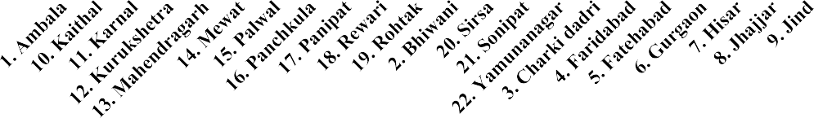
District wise Crop area and Std. Deviation
350000.00
300000.00
250000.00
200000.00
150000.00
100000.00
50000.00
0.00
Avg. of crop area in ha
Std deviation (SQ.M)

Fig. 2 District wise Crop area and Std. Deviation
Figure 2 illustrates the correlation between the average area and its standard deviation across districts. This visual comparison highlights the distinction between low-area- high-variability zones, such as Mahendragarh and Faridabad, and high-area-high- stability zones, including Sirsa and Fatehabad, thereby reinforcing the tabular findings. These differences necessitate localized planning strategies; yield enhancement can be focused on districts with stable areas, whereas risk mitigation and land-use rationalization may be required in districts with variable areas.

Table 2 District Wise data

District | Normal Yield | Olympic mean(max) | Yield Gap | Weather risk | Scope of Increment
Ambala | 4278 | 4890 | 612 | 8.37 | 14.31
Bhiwani | 4079.33 | 4403.33 | 324 | 6.24 | 7.94
Charki dadri | 4670 | 4853.33 | 183.33 | 32.64 | 3.93
Faridabad | 4333.33 | 4926.67 | 593.33 | 12.55 | 13.69
Fatehabad | 4986 | 5406.67 | 420.67 | 6.18 | 8.44
Gurgaon | 4465.33 | 4976.67 | 511.33 | 9.89 | 11.45
Hisar | 4582 | 5010 | 428 | 6.62 | 9.34
Jhajjar | 4370.67 | 4930 | 559.33 | 8.71 | 12.8
Jind | 4616 | 5176.67 | 560.67 | 8.46 | 12.15
Kaithal | 4725.33 | 5126.67 | 401.33 | 6.06 | 8.49
Karnal | 4746 | 5510 | 764 | 11.57 | 16.1
Kurukshetra | 4716.67 | 5183.33 | 466.67 | 6.78 | 9.89
Mahendragarh | 4468.67 | 4880 | 411.33 | 7.42 | 9.2
Mewat | 4046.67 | 4503.33 | 456.67 | 8.79 | 11.29
Palwal | 4480.77 | 4976.67 | 495.9 | 37.35 | 11.07
Panchkula | 3304.67 | 4136.67 | 832 | 11.09 | 25.18
Panipat | 4772.67 | 5323.33 | 550.67 | 9.18 | 11.54
Rewari | 4563.33 | 4986.67 | 423.33 | 9.34 | 9.28
Rohtak | 4228 | 4806.67 | 578.67 | 10.17 | 13.69
Sirsa | 4852 | 5280 | 428 | 7.26 | 8.82
Sonipat | 4673.33 | 5236.67 | 563.33 | 8.85 | 12.05
Yamunanagar | 4373.33 | 5123.33 | 750 | 11.34 | 17.15

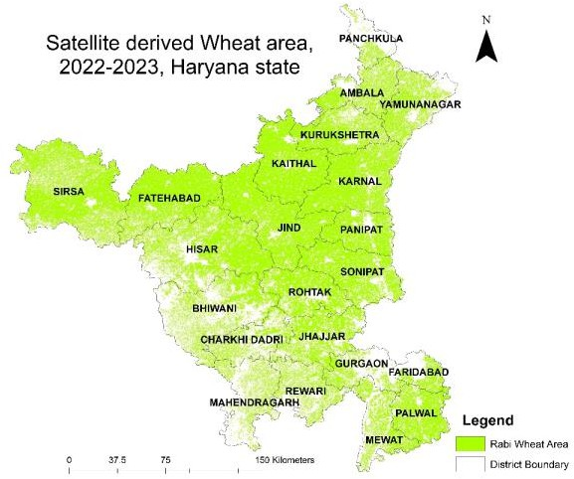

Fig. 3 Satellite derived Wheat Area, 2022 – 2023
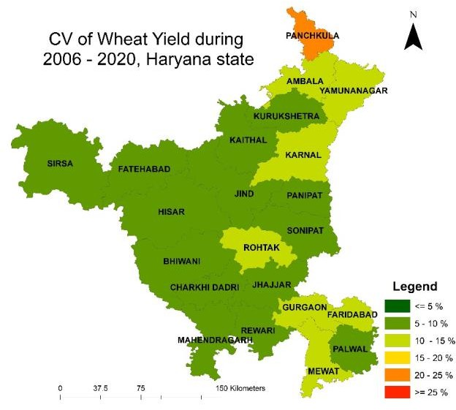
Fig. 4 Coefficient of Variation of Wheat Yield during 2006 – 2020, Haryana state

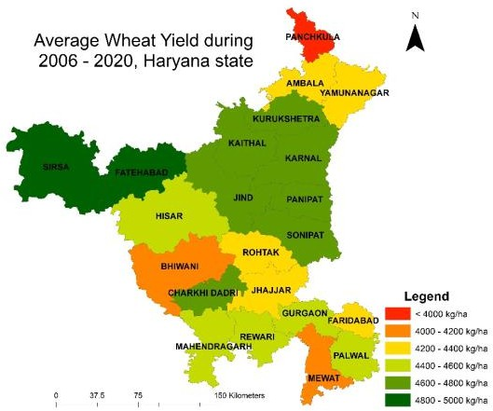

Fig. 5 Average Wheat Yield during 2006 – 2020, Haryana state

Table 2 provides a comparative analysis of wheat yield performance by district, presenting the normal yield, Olympic mean maximum yield, yield gap, weather risk, and potential for increment (%). This comprehensive evaluation facilitates the identification of districts exhibiting high potential alongside those that are underperforming. The Olympic mean, derived from the average of the top three yielding years, mitigates the influence of outliers and serves as a proxy for achievable yield, in contrast to the normal yield, which reflects the long-term average yield. The yield gap, representing the untapped potential within each district, is defined as the difference between these two yields. The districts exhibiting the largest absolute yield gaps are Panchkula (832 kg/ha), Karnal (764 kg/ha), and Yamunanagar (750 kg/ha), indicating substantial potential for productivity enhancement. These regions consistently underperform due to factors such as input availability, agronomic inefficiencies, and climate-related challenges, despite experiencing favorable conditions in certain years. Charki Dadri demonstrates the smallest yield gap (183.33 kg/ha), suggesting that yields align closely with their maximum potential, though they may be constrained by infrastructure or environmental factors. This analysis is enhanced by the weather risk index, which indicates the extent to which yield performance is affected by climatic variability. Districts such as Palwal (37.35%) and Charki Dadri (32.64%) exhibit high sensitivity to extreme weather events, including hailstorms, temperature stress, and irregular rainfall. Districts including Fatehabad (6.18%), Kaithal (6.06%), and Bhiwani (6.24%) demonstrate greater stability in performance, likely due to enhanced risk mitigation and irrigation coverage. The potential for improvement relative to theoretical limits is quantified by the scope for increment, represented as a percentage of the Olympic mean. This indicator is crucial for establishing policy priorities. The leading three regions—Panchkula (25.18%), Yamunanagar (17.15%), and Karnal (16.10%)—necessitate immediate intervention via extension services, improved seed varieties, and precision agriculture techniques.
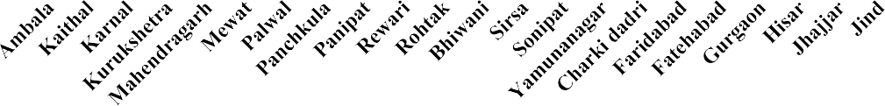
Conversely, Charki Dadri (3.93%) and Bhiwani (7.94%) exhibit limited potential for enhancement, attributable to ecological limitations or the implementation of near- optimal practices.
Yield Gap
1000.00
900.00
800.00
700.00
600.00
500.00
400.00
300.00
200.00
100.00
0.00
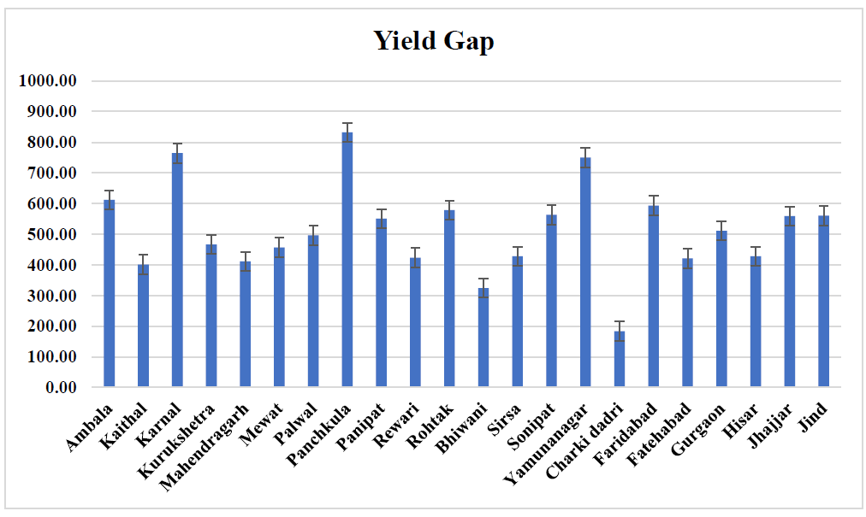

Fig. 6 Yield Gap district wise
Figure 6 illustrates the Yield Gap (Kg/ha) for wheat across the districts of Haryana, calculated by subtracting the normal yield (observed long-term average) from the Olympic mean yield (attainable). The Yield Gap metric quantifies unrealized productivity, offering a framework for assessing areas where strategic interventions may enhance wheat output. The figure indicates that Panchkula exhibits the largest yield gap at 832 kg/ha, followed by Karnal at 764 kg/ha and Yamunanagar at 750 kg/ha. The observed disparities indicate that, despite certain years exhibiting optimal soil and climate conditions (as demonstrated by Olympic yields), average productivity remains substantially below its potential. This indicates that suboptimal agronomic practices, irregular input application, or infrastructure bottlenecks may hinder consistent performance across all years. Districts classified in the second tier of intervention priority, such as Kurukshetra (466.67 kg/ha), Palwal (495.90 kg/ha), Rohtak (578.67 kg/ha), and Sonipat (563.33 kg/ha), demonstrate moderately high yield gaps. Improved extension services, the dissemination of technology (including real-time nutrient advisories and precision sowing), and timely access to high-quality inputs can significantly benefit these districts. Conversely, Charki Dadri (183.33 kg/ha), Bhiwani (324.00 kg/ha), and Kaithal (401.33 kg/ha) exhibit the smallest yield gaps. The narrower gaps in these regions may result from either near-optimal agronomic performance or inherent ecological constraints that limit significant yield increases. The focus in these areas should priorities yield stability preservation, reduction of production costs, and enhancement of input efficiency rather than aggressive intensification. The gap between districts' actual performance and their attainable

potential is an important insight derived from Figure 6. The significant yield gaps observed in the central and northern districts, including Karnal and Kurukshetra, indicate inconsistencies or suboptimal resource utilization, despite their established historical productivity. Despite historically low yields, certain southern districts, including Bhiwani and Charki Dadri, demonstrate relatively minor gaps, suggesting they are functioning close to their ecological limits. ( Why mentioning low gap yield as negative first by giving inherent ecological constraints and then later as close to their ecological limits and similarly change reasons for more yield gaps also{ it should be negative)
This graph serves as a critical diagnostic tool for policy prioritization. Yield improvement programs should priorities districts such as Karnal and Panchkula, which exhibit significant yield gaps and stable weather conditions. Low-risk interventions, sustainability methods, and conservation agriculture should be implemented in low-gap districts. The figure highlights the importance of localized agronomic techniques in reducing the yield gap and enhancing wheat productivity sustainably.
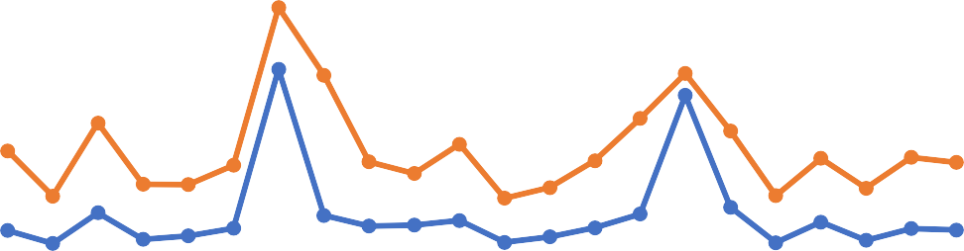
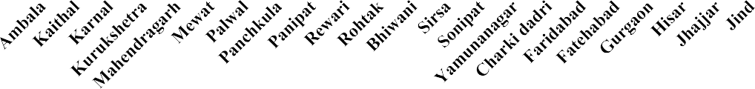
11.57
Scope of Increment
6.78 7.42 8.79
11.099.18 9.3410.17
7.94 8.82
6.24 7.26 8.85
11.34
12.558.44
6.18
9.34
9.89
6.62 8.71
8.46
10.00
6.06
0.00
Weather risk
13.69
Scope for Yield improvement vs Weather risk
60.00
11.07
50.00

40.00
37.3525.18
30.00 14.31
16.10
3.93
32.64
17.15
8.37
13.69
20.00
8.49
11.29
9.89 9.20
11.549.28
12.05
11.45 12.8012.15

Fig. 7 Scope for Yield improvement vs Weather risk

The potential for yield enhancement (%) for each district, as indicated by Table 2, is compared to the associated Weather Risk Index (%) in Figure 7. This bivariate plot illustrates how climatic variability affects the potential to close yield gaps across the various agro-climatic zones of Haryana.
The analysis indicates a clear inverse relationship: districts experiencing moderate weather risk possess a greater capacity for yield enhancement via agronomic or policy interventions, while those facing higher weather risk generally exhibit limited potential for improvement. Panchkula exhibits the most significant potential for yield improvement at 25.18%, coupled with a moderate weather risk of 11.09%. Consequently, it is identified as a high-priority district for yield-maximization initiatives. Karnal (16.10% scope, 11.57% risk) and Yamunanagar (17.15% scope,

11.34% risk) are both situated in a strategically beneficial area, where substantial yield enhancements can be achieved under manageable climatic conditions. In contrast, Charki Dadri (3.93% scope, 32.64% risk) and Palwal (11.07% scope, 37.35% risk) occupy the high-risk–low-opportunity quadrant. Due to the extreme climatic variability in these districts, conventional intensification methods may not provide substantial practical advantages. Adaptive irrigation, climate-smart agriculture, and index-based weather insurance offer greater benefits for these regions compared to productivity models that depend significantly on inputs.
In districts like Kaithal (8.49% scope, 6.06% risk) and Fatehabad (8.44% scope, 6.18% risk), yield enhancement presents a low-risk opportunity, characterized by moderate improvement potential and relatively low weather risk. They may serve as the focal point for technology diffusion initiatives such as real-time crop monitoring, improved fertilizer application, and mechanized sowing.
Figure 7 serves as a diagnostic tool that effectively categorizes districts into four strategic groups. High scope and moderate risk indicate that yield scaling is suitable for Karnal, Yamunanagar, and Panchkula. Palwal advocates for innovations capable of withstanding significant risks. Limited Scope, Minimal Risk: Bhiwani, Kaithal: Efficiency optimization is necessary; however, the optimal yield has likely been attained. Charki Dadri presents a high-risk, low-scope scenario; therefore, the focus should be on enhancing resilience rather than intensification. (Why results are not matched with previous studies of researchers)

Conclusion
This study's focused evaluation of wheat yield variations throughout Haryana that uncovers a substantial gap between actual on-field performance and agronomic potential. We assessed the yield gap between districts and identified regions with substantial agronomic limitations and considerable productivity potential via Olympic mean calculations and long-term production averages. The findings indicate that, despite optimal growing circumstances, regions such as Panchkula, Karnal, Yamunanagar, and Faridabad have significant yield discrepancies, sometimes exceeding 750 kg/ha. The primary reasons of these discrepancies are inefficient agricultural practices, inconsistent input utilization, and insufficient infrastructure. Charki Dadri and Bhiwani exhibit narrower gaps, suggesting that their production threshold is nearing or that yield increase is limited by ecological factors. The correlation between weather risk and the possibility of yield enhancement is a significant conclusion from the investigation. Districts exhibiting significant yield gaps, like Karnal and Panchkula, are well- positioned for yield-enhancement initiatives owing to their comparatively stable climatic conditions; conversely, districts facing greater weather risks, such as Palwal and Charki Dadri, necessitate adaptive, resilience-oriented strategies rather than mere input intensification. The yield gap distribution was effectively shown by the incorporation of ArcGIS-based spatial mapping, enabling targeted policy intervention. The paper recommends the immediate use of precision agricultural technology,
extension services, and advanced seed types to assist high-gap, low-risk regions. High- risk areas should focus on enhancing climate-resilient infrastructure, diversifying cropping systems, and implementing agricultural insurance mechanisms.
In summary, a district-specific, climate-conscious, and data-informed approach is essential to bridge the wheat production gap in Haryana. This methodology enhances yield results while promoting climate-smart agriculture, state-level food resilience, and farmer income security by aligning productivity measures with localized opportunities and limitations. The study's results and methods serve as a scalable paradigm for analogous evaluations of other crops and agroclimatic regions in India.

References
Dadrasi, A., Weinzettel, J., Wei, G., Vačkářová, D., & Frouz, J. (2025). Closing global yield gap of rainfed wheat by optimizing nitrogen and phosphorus inputs. Science of The Total Environment, 977, 179367.
Daloz, A. S., Rydsaa, J. H., Hodnebrog, Ø., Sillmann, J., van Oort, B., Mohr, C. W., ... & Zhang, T. (2021). Direct and indirect impacts of climate change on wheat yield in the Indo-Gangetic plain in India. Journal of Agriculture and Food Research, 4, 100132.
Devi, M., Kumar, J., Malik, D. P., & Mishra, P. (2021). Forecasting of wheat production in Haryana using hybrid time series model. Journal of Agriculture and Food Research, 5, 100175.
Dey, A., & Dinesh, R. (2020). Rice and wheat production in India: An overtime study on growth and instability. Journal of Pharmacognosy and Phytochemistry, 9(2), 158-161.
Handral, A. R., Singh, A. L. K. A., Singh, D. R., Suresh, A., & Jha, G. K. (2017). Scenario of changing dynamics in production and productivity of major cereals in India. Indian J Agric Sci, 87(10), 1371-1376.
Hatfield, J. L., & Beres, B. L. (2019). Yield gaps in wheat: path to enhancing productivity. Frontiers in plant science, 10, 1603.
Hou, M., Li, Y., Biswas, A., Chen, X., Xie, L., Liu, D., ... & Siddique, K. H. (2024). Concurrent drought threaten wheat and maize production and widen crop yield gaps in the future. Agricultural Systems, 220, 104056.
Kodan, A. S., Yadav, A., Kumar, V., & Mehra, S. (2012). Determinants of wheat productivity, with special reference to Haryana. IUP Journal of Agricultural Economics, 9(1), 20.
Kumar, A., Deepankar, P. K., PK, M., & Kumar, A. (2019). Wheat yield forecasting in Haryana: A time series approach. Bull. Env. Pharmacol. Life Sci, 8(3), 63-69.
Nisha, Nain, M., & Aneja, D. R. (2019). Growth analysis of area, production and productivity of wheat crop in Haryana and India.
Ohlan, R. (2012). Performance and Suitability of Growing Crops in Haryana: District-Level Analysis. Available at SSRN 2798010.
Shettigar, S., Shivaraj, K., & Shettigar, S. (2019). A study to assess the factors affecting adherence to exercise in the Indian population. Cureus, 11(11).
Singh, M., & Supriya, K. (2017). Growth rate and trend analysis of wheat crop in Uttar Pradesh, India. Int. J. Curr. Microbiol. Appl. Sci, 6(7), 2295-2301.

