**Advances in Migraine Therapy: A Comprehensive Review**

**ABSTRACT**

Migraine is a common and disabling condition that affects a large proportion of the global population. Although conventional treatments have been able to help many, there is still a considerable number of patients who experience suboptimal results or unbearable side effects. Recent breakthroughs in migraine therapy open doors to promising new pharmacological and non-pharmacological options. This review looks at the latest advances in migraine treatment with a focus on CGRP inhibitors, Gepants, Ditans, and Neuromodulation techniques. The emergence of monoclonal antibodies against calcitonin gene-related peptide has transformed management equally for acute and preventive migraines. This includes drugs such as erenumab, fremanezumab, and galcanezumab, which have been developed and are targeted in nature; they have proven to have better efficacy with fewer adverse effects than conventional drugs. Similarly, gepants-ubrogepant, rimegepant-for acute migraines have yielded promising results; these drugs act orally, without the cardiovascular dangers of triptans. Ditans, including lasmiditan, are a new class of acute treatments for migraine that act at the 5-HT1F receptor, offering an alternative to patients who have contraindications to triptans.

**Keywords:** Migraine, CGRP inhibitors, neurological, Gepants, Ditans

# INTRODUCTION

A migraine is characterized by very intense pulsating headaches, often accompanied by nausea, sensitivity to light and sound, and visual disturbances. Unlike the usual headaches, migraines tend to be more severe and can take several hours or even several days to pass. They normally occur in cycles and begin with signs (aura) that cause them to go into headache phase, followed by a period of fatigue once the headache phase is over. There are a number of stimuli that may precipitate migraines, such as stress, hormonal changes, food intake, and environmental stimuli. These may have significant effects on day-to-day living and productivity. Millions are affected worldwide. Managing migraines can be achieved through lifestyle modification, medication, and learning what individual triggers are.

Migraine is classified as a primary headache disorder, meaning it is not caused by another medical condition. Instead, it results from abnormal neurological and vascular processes [1].Now a day, delivering of active ingredients with a level of comfort, presentation and bioavailability and these studies is infringement the difficulty of conventional method. Various factors are examined like choice of excipients, bioavailability, stability and cost effectiveness [30]

# PREVALENCE OF MIGRAINE

Migraine affects a large portion of the global population, with estimates of prevalence ranging from 12% to 15%:

Global: The 1-year prevalence of migraine is estimated at 15% worldwide. US: A 2018 survey found that 15.3% of adults in the US experience migraine or severe headache. Women vs men: Migraine is about three times more common in women than in men. In a US survey, 17.1% of women and 5.6% of men reported having migraine symptoms. Age: Migraine is most common in people aged 20 to 50 years. (What WHO said about the disease complications/ epidemiological burden / mortality and morbidity.)

Geographical regions: Prevalence varies by region, with Nepal having the highest prevalence and China having the lowest [2].

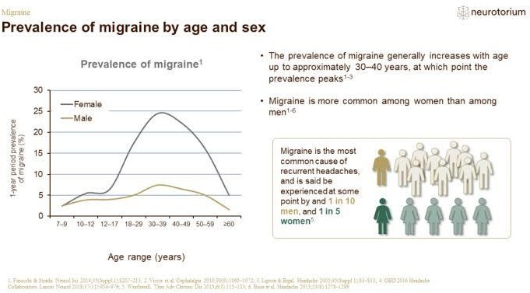

**Fig 1: Prevalence of Migraine in Global**

# TYPES OF MIGRAINE

1. **Chronic Migraine**: Refers to migraines that occur on 15 or more days per month for at least three months [3].
2. **Acute migraine: -** An acute migraine is a throbbing pain and pulsing sensation [4].

### Causes:- (with complete pathogenesis pathways)

* 1. Genetic Factors
* 2. Neurological Factors
* 3. Vascular Factors
* 4. Hormonal Factors
* 5. Environmental and Lifestyle Factors
* 6. Sensory Triggers
* 7. Stress
* 8. Sleep deprivation
* 9. Radiation [5][6].

Difference between general Headache and Migraine/ how migraine is different from the other similar disorders of brain.

**RECENT MIGRAINE THERAPY (Complete status of all drugs requires with long treatments therapies and reported ADRs of each that are used to for treatments)**

**(A)SYMPTOMATIC THERAPY**

Symptomatic therapy for migraines focuses on relieving the immediate symptoms during a migraine attack. The primary goals are to reduce pain, alleviate associated symptoms (like nausea and sensitivity to light/sound), and restore normal functioning. Drugs used in Symptomatic Therapy

1. **Pain relievers:** Available over-the-counter is over-the-counter NSAIDs and prescription analgesics including ibuprofen and naproxen.
2. **Traipains:** Over the counter triptans selective serotonin receptor agonist and sumatriptan rizatriptan will cut headache intensity by constricting the blood vessels and inhibit pathways leading to the pain [7].
3. **Ergotamines:** DHE (dihydroergotamine), and ergotamine may be used in severe migraine as they cause constriction of the blood vessels and reduced the pain.
4. **Anti-nausea Drugs:** Metoclopramide and prochlorperazine can be used to treat nausea and vomiting related to migraine [7].

### Nonsteroidal Anti-Inflammatory Drugs (NSAIDs):

* 1. Examples: Ibuprofen, Aspirin, Naproxen.
  2. Reduces inflammation and relieved to moderate headache pain.

### Acetaminophen:

* 1. **Example:** Paracetamol.
  2. Can be used for mild headache pain; less effective for severe attacks compared to NSAIDs [8]

### Ergotamines

**Examples:** Dihydroergotamine, Ergotamine

* + **Other Adjunctive Therapies:** Cold compresses, rest, and dark, quiet environments can be added [8].

## **(a)Acute Migraine in Children**

Mechanism: Serotonin (5-HT) receptor agonists that reduce vasodilation and neuronal sensitization in migraine**.[9]**

### Examples:

* + Sumatriptan (nasal spray, injection), Rizatriptan (oral), Zolmitriptan (nasal spray)
* **Usage:** Approved for use in children ages 6 and older, typically for moderate- to-severe migraines [10].
* **Recent Advances:** Rizatriptan has shown to be effective and safe in children, with a relatively quick onset of action, making it a preferred choice. Sumatriptan nasal spray is also used, particularly when oral administration is difficult due to nausea.

## **(b)Triptan group of Drugs**

### Ergotamines

* **Examples:** Dihydroergotamine, Ergotamine

### Triptans

* **Mechanism:** Selective serotonin (5-HT) agonists that target 5-HT1B/1D receptors on blood vessels and trigeminal neurons.

### Examples:

* (subcutaneous, oral, nasal spray)
* Rizatriptan, Zolmitriptan, Naratriptan (oral and nasal)

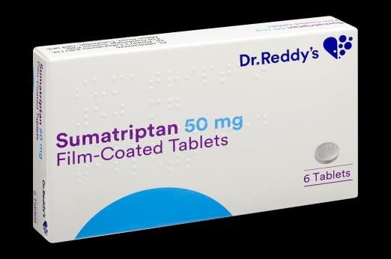

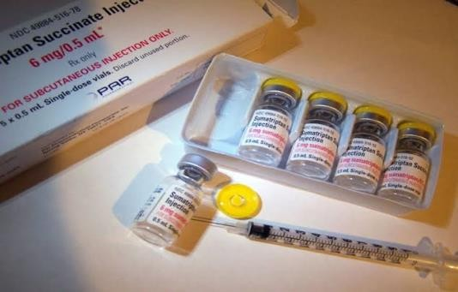

m

### Fig 2: Sumatriptan Injection Fig 3: Sumatriptan Tablet

(Identified research gap in above mentioned therapies described)

# (c) Herbal and Nutritional Supplements in Children (Always write with Regular Daily Intake as per body weight/ age)

* **Magnesium:** Low magnesium levels have been linked to migraines, and supplementation may help prevent attacks.
* **Riboflavin (Vitamin B2):** Studies suggest it may help reduce migraine frequency in children [11].
* **Coenzyme Q10:** This antioxidant has shown some efficacy in reducing migraine frequency [12].
* **Butterbur:** Some studies support its use for migraine prevention in children, but concerns about safety (e.g., liver toxicity) limit its us



**Fig 4: Herbal Formulation in migraine**

## (**d)Chronic Migraine in Women**

Chronic migraine is a prevalent and disabling neurological condition, particularly affecting women. It is defined as having headaches on 15 or more days per month, of

Which at least 8 days meet criteria for migraine, for a period of three months or longer. Below is a breakdown of key aspects of chronic migraine in women:

### Triggers (Nutrition Over-use and their risk Factors)

Common triggers include:

* **Hormonal changes**: Menstrual cycle, pregnancy, postpartum period, and menopause.
* **Lifestyle factors**: Stress, poor sleep, dehydration, and irregular meal patterns.
* **Environmental triggers**: Weather changes, bright lights, or strong smells.
* **Dietary factors**: Caffeine, alcohol, and specific foods like aged cheeses or processed meats.(13)

### Impact on Women

* **Quality of Life**: Chronic migraines significantly impair daily activities, work productivity, and social interactions.
* **Mental Health**: Higher risk of anxiety and depression compared to episodic migraine sufferers.
* **Family and Caregiving Roles**: Balancing responsibilities with frequent debilitating headaches can add stress.

### Special Considerations for Women

* **Pregnancy**: Many preventive migraine medications are contraindicated, so non-pharmacological therapies are preferred.
* **Menopause**: Hormone fluctuations during this phase may worsen or improve migraines; individualized management is key [14].

**Calcitonin Gene-Related Peptide (CGRP) Antagonists**

CGRP antagonists have emerged as a significant breakthrough in migraine management. These medications work by inhibiting the activity of CGRP, a molecule involved in migraine pathophysiology. They are available in both injectable monoclonal antibody forms and oral formulations:

* **Injectable Monoclonal Antibodies**: Medications such as erenumab, fremanezumab, and galcanezumab are administered monthly or quarterly and have been approved for migraine prophylaxis in adults.
* **Oral CGRP Receptor Antagonists (Gepants)**: Drugs like ubrogepant and rimegepant are used for acute migraine treatment, while atogepant is approved for preventive therapy. These oral options provide flexibility and are particularly beneficial for individuals who prefer not to use injectable medications.(15)

**Personalized Therapy**

Migraine pathophysiology has led to more personalized treatment strategies, considering individual patient profiles, comorbidities, and preferences. This approach aims to enhance treatment efficacy and patient satisfaction.These developments represent significant progress in chronic migraine management, offering new avenues for relief, particularly for women who are disproportionately affected by this condition [16]

# (e)Botulinum Toxin Injections

* Botulinum toxin type A, the FDA-approved drug for the administration of chronic migraines.
* It is believed that Botox inhibits the release of neurotransmitters causing pain and blocks the activation of the trigeminal nerve in migraine pathogenesis.
* The injections are given at various points in the head and neck every 12 weeks. Chronic migraines have been decreased in frequency and severity with Botox injections.
* For chronic migraines, patients who are non-responsive to other preventive treatments can be improved by Botox. [17]

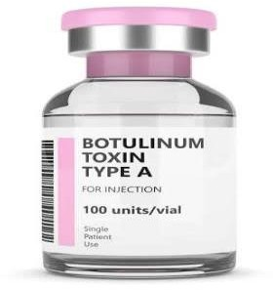

**Fig 5: Botulinum toxin injection**

## **(B)NON-PHARMACOLOGIC THERAPY (Describe overuse of devices based damages and other physical and peripheral damages caused by devices)**

## **Devices benefit over other therapies**

1. **Neuromodulation Devices**

* Cefaly Device: A wearable device that provides transcutaneous electrical nerve stimulation (TENS) to the forehead to reduce migraine frequency.
* sTMS: Single-pulse transcranial magnetic stimulation is a non-invasive device that targets the brain’s cortex to reduce migraines.
* Transcranial Direct Current Stimulation (tDCS): This technique uses a low electrical current to modulate brain activity and reduce the frequency of migraines.
* The sphenopalatine ganglion (SPG) stimulation system is a non-invasive neuromodulation device for migraine relief.
* The SPG system targets the sphenopalatine ganglion, a nerve cluster that is involved in the transmission of pain during a migraine [18].
* Patients can use a small device placed in the mouth to deliver electrical stimulation to this nerve, effectively reducing the frequency and severity of migraines.
* These devices are designed for home use and offer a promising option for patients seeking to manage migraines without systemic medications [18][19].

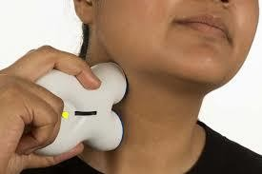

### Fig6: Neuromodulation Device

(**b)Cognitive Behavioral Therapy (CBT)**

* Mechanism: Addresses the psychological and behavioral factors contributing to migraine. Advancements: Studies continue to show that CBT can reduce

Migraine frequency and intensity, especially in patients with stress-related or chronic migraine [20].

### Transcranial Magnetic Stimulation (TMS)

* Transcranial Magnetic Stimulation (TMS) is a non-invasive neuromodulation treatment that employs magnetic pulses to stimulate the areas of the brain where the attacks of migraine are initiated.
* TMS has been approved by the FDA for acute treatment of migraine and has been used in decreasing the frequency of attacks and its symptoms.
* It is generally used on the forehead and gives the motor cortex magnetic pulses that would modulate cortical excitability in reducing susceptibility to migraines.
* In studies, it has been reported that TMS could provide notable relief from migraine attacks without many side effects. In this regard, it remains an attractive option for the patients who seek non-pharmacological treatment [21][22].

### Cefaly Device (Transcutaneous Electrical Nerve Stimulation)

* The Cefaly device is a headband-like device that uses TENS stimulation to the trigeminal nerve, which is the primary nerve involved in migraine attacks.
* FDA approved for the prevention of migraines, the device sends electrical impulses to the forehead and has been shown to reduce the frequency and severity of migraines over time.
* The Cefaly device is a non-invasive, drug-free treatment for chronic migraines that can be used at home. It is best suited for patients who prefer not to use medication or have contraindications to drug therapy [23][24].

### Genetic Research and Personalized Medicine

* New genetic research opens the door to personalized migraine treatments for an individual based on their genetic profile.
* Some studies have identified several genes that have an increased risk of developing migraines. These include genes associated with serotonin regulation, ion channels, and vascular function [25].
* Personalized medicine focuses on the matching of the most effective treatment with patients based on their unique genetic makeup, thereby allowing for more precise and efficient care.
* Biomarkers (biological indicators) research is also opening doors to more accurate treatment outcome predictions, which can help tailor therapy selection for the individual patient [25][26].

### (c)New Preventive Medications

* Beta-blockers, antiepileptics, and antidepressants have been used for ages in the prevention of migraines; however, new forms and formulations are being developed with better efficacy and fewer adverse effects.
* Lasmiditan, a ditan (serotonin 5-HT1F receptor agonist) is also being studied in the prevention of patients of chronic migraine [27].
* New formulations of already existing medications, such as topiramate and valproic acid, are being adjusted to make them more efficacious and less harmful thereby making the whole experience of suffering from these migraines much better for the patients.
* CGRP antagonists have also been studied for their possible use in prevention, adding to their current use only in acute treatment [28]. (New preventive medication all advantages as require)

### (d)Advances in Diagnostics and Monitoring of Migraines (Classify the Diagnostic tools: biochemistry based/imaging based etc.etc.)

* The progress with diagnostic tools, such as the improved MRI and fMRI, have gradually enhanced our knowledge regarding brain involvement in migraine disease diagnosis.
* Mobile applications as well as wearable technologies continue to be developed and launched to monitor the frequency of migraines, triggers and how severe they are. It increases the management of more treatment options and a very more personalized approach.
* The continuous biomarker research is also assisting in identifying objective measures of migraine for faster diagnosis and effective treatment planning [29].

**Conclusion**

In conclusion, recent advancements in migraine therapy are significantly enhancing treatment options and offering new hope for individuals suffering from this often disabling condition. The introduction of CGRP inhibitors, neuromodulation devices, and botulinum toxin injections has revolutionized how migraines are managed, allowing for more targeted and effective interventions. These innovations, coupled with alternative therapies like acupuncture, biofeedback, and lifestyle modifications, enable healthcare providers to create personalized treatment plans that address the unique needs of each patient.

However, the complexity of migraines—due to varying triggers, severity, and individual responses to treatment—underscores the importance of a tailored approach. While these advancements provide promising alternatives for many, they are not one-size-fits-all solutions. Working closely with healthcare professionals to identify the most suitable therapy based on a patient's specific medical history, migraine patterns, and lifestyle is crucial to achieving optimal outcomes.

Looking ahead, the future of migraine treatment is bright, with ongoing research and technological innovations poised to refine and expand available options. As our understanding of the underlying mechanisms of migraines continues to deepen, new therapies are likely to emerge, offering even more precise and effective ways to manage the condition. Ultimately, with the right combination of treatments and continued collaboration between patients and healthcare providers, the quality of life for migraine sufferers can be greatly improved, providing hope for a better future.

**Reference:**

* 1. Goadsby, P. J., Holland, P. R., Martins-Oliveira, M., Hoffmann, J., Schankin, C., & Akerman, S. (2017). Pathophysiology of Migraine: A Disorder of Sensory Processing. Physiological Reviews, 97(2), 553– 622. DOI:10.1152/physrev.00034.2015
  2. Waters, W. E., & O'connor, P. J. (1975). Prevalence of migraine. Journal of Neurology, Neurosurgery & Psychiatry, 38(6), 613-616.
  3. Dodick, D. W. (2006). Chronic daily headache. *New England Journal of Medicine*, *354*(2), 158-165.
  4. Colman, I., Brown, M. D., Innes, G. D., Grafstein, E., Roberts, T. E., & Rowe, B. H. (2005). Parenteral dihydroergotamine for acute migraine headache: a systematic review of the literature. *Annals of emergency medicine*, *45*(4), 393-401.
  5. Goadsby, P. J., Holland, P. R., & Steiner, T. J. (2017). Pathophysiology of migraines. The Lancet Neurology, 16(1), 44–54.
  6. Charles, A. (2018). The pathophysiology of migraine: Implications for clinical management. The Lancet Neurology, 17(2), 174–182.
  7. Ramadan, N. M., & Buchanan, T. M. (2006). New and future migraine therapy. Pharmacology & therapeutics, 112(1), 199-212.
  8. Silvestrini, M., Cupini, L. M., Calabresi, P., Floris, R., & Bernardi, G. (1992). Migraine with aura-like syndrome due to arteriovenous malformation. The clinical value of transcranial Doppler in early diagnosis. *Cephalalgia*, *12*(2), 115-119.
  9. Antonaci, F., Ghiotto, N., Wu, S., Pucci, E., & Costa, A. (2016). Recent advances in migraine therapy. *Springerplus*, *5*(1), 637.
  10. WorldHealthOrganizationFactsheetNo.277:HeadacheDisorders( Available)at:<http://www.who.int/mediacentre/factsheets/fs277/en/).October> 2012 (Accessed July 17, 2014)
  11. Goadsby, P. J., Holland, P. R., & Silberstein, S. D. (2017). Pathophysiology and acute treatment of migraine. The Lancet Neurology, 16(4), 304–314.
  12. Charles, A. (2018). The preventive treatment of migraine. New England Journal of Medicine, 379(6), 553–563.
  13. American Headache Society (2019). The acute and preventive treatment of migraine in adults. Headache: The Journal of Head and Face Pain, 59(1), 1-18.
  14. Holland, S., Silberstein, S. D., Freitag, F., Dodick, D. W., Argoff, C., & Ashman, E. (2012). Evidence-based guideline update: NSAIDs and other complementary treatments for episodic migraine prevention in adults. Neurology, 78(17), 1346–1353.
  15. Sun-Edelstein, C., & Mauskop, A. (2009). Dietary supplements for migraine prophylaxis: A review of the evidence. Cephalalgia, 29(4), 314–326.
  16. Aurora, S. K., Dodick, D. W., Turkel, C. C., DeGryse, R. E., Silberstein, S. D., Lipton, R. B., ... & Brin, M. F. (2010). OnabotulinumtoxinA for treatment of chronic migraine: results from the double-blind, randomized, placebo-controlled phase of the PREEMPT 1 trial. *Cephalalgia*, *30*(7), 793-803.
  17. Dodick, D. W., Turkel, C. C., DeGryse, R. E., Aurora, S. K., Silberstein, S. D., Lipton, R. B.& Brin, M. F. (2010). OnabotulinumtoxinA for treatment of chronic migraine: Pooled results from the double‐blind, randomized, placebo‐controlled phases of the PREEMPT clinical program. *Headache: The Journal of Head and Face Pain*, *50*(6), 921-936.
  18. Lipton, R. B., Dodick, D. W., Silberstein, S. D., Saper, J. R., Aurora, S. K., Pearlman, S. H., ... & Goadsby, P. J. (2010). Single-pulse transcranial magnetic stimulation for acute treatment of migraine with aura: a randomised, double-blind, parallel-group, sham-controlled trial. *The Lancet Neurology*, *9*(4), 373-380.
  19. Starling, A. J., & Tepper, S. J. (2018). Transcranial magnetic stimulation (TMS) for headache disorders. Headache, 58(5), 811–816.
  20. American Headache Society (2019). Guidelines for the use of neuromodulation devices in migraine treatment. Headache: The Journal of Head and Face Pain, 59(1), 1-18.
  21. Schoenen, J., Vandersmissen, B., Jeangette, S., Herroelen, L., Vandenheede, M., Gérard, P., & Magis, D. (2013). Migraine prevention with a supraorbital transcutaneous stimulator: a randomized controlled trial. *Neurology*, *80*(8), 697-704.
  22. Chou, D. E., Shank, N., & Klein, B. (2020). Efficacy of external trigeminal nerve stimulation for acute treatment of migraine attacks: A randomized controlled trial. Cephalalgia, 40(2), 125–134.
  23. Schoenen et al., Neurology, 2013; Chou et al., Cephalalgia, 2020.
  24. Yarnitsky, D., Dodick, D. W. (2019). Remote electrical neuromodulation (REN) for acute treatment of migraine. Headache, 59(8), 1240–1252.
  25. Gormley, P., Anttila, V., Winsvold, B. S. (2016). Meta-analysis of 375,000 individuals identifies 38 susceptibility loci for migraine. Nature Genetics, 48(8), 856–866.
  26. Ferrari, M. D., Klever, R. R., Terwindt, G. M. (2019). Migraine pathophysiology: Lessons from genetics. The Lancet Neurology, 18(2), 101–111.
  27. The Migraine Trust. (2023). NICE announces approval of atogepant for preventive use on the NHS in England. Retrieved from.
  28. Dodick, D. W.(2019). "Clinical trials on CGRP inhibitors." NEJM.
  29. Gallagher, R. M., & Cutrer, F. M. (2002). Migraine: diagnosis, management, and new treatment options. AMERICAN JOURNAL OF MANAGED CARE, 8(3; SUPP), S58-S73.
  30. Gnanarajan G , Rathaur H, kothiyal P. (2018).Formulation and Evaluation of Sublingual tablet of Olanzapine. JETIR, 7(5),68-81